Supplementary File A: Methodological Detail

Experiment 1
Screening. Participant screening was done via Prolific. Criteria were people residing in the UK and who had not taken part in previous pilots or experiments conducted as part of this paper. We eliminated participants who spent less than two standard deviations of the mean time completing the experiment. We checked for outliers who were 3 standard deviations away from the mean investment amount in either point estimates or ranges. All participants were included in the analysis.
Experiment length. Participants spent on average 6.53 (SD=3.84) minutes completing the experiment.
Question phrasing. The task sequence was in the order in which the methods are described in the main paper. The main body of the experiment (after consent and demographics were provided) consisted of the following questions:
Instructions. “Imagine you have money you would like to invest in a particular industry. You will be shown a series of scenarios where you can invest in a company in that industry. Each time you move to the next block of questions, you have a new amount of money you can invest and a company will appear. Treat each decision as a new decision. Bonus payment: One of your investment decisions will be selected at random and the amount of money you make will be calculated. The amount will be calculated as: amount not invested + (amount invested * actual growth). The highest earning participants will receive a bonus payment.”
Example trial. Participants were shown each company as per Figure A.1. “Imagine you have £5000 you would like to invest. A company presents to you their expected growth after one year. How much of your £5000 do you invest in Company A (text entry)?


Figure S.1: Example stimuli used to depict a company along with its expected growth in Experiment 1.

Preference question. Two companies as per Figure A.1 were presented next to each other. Participants were asked: “Based solely on the above information, which company do you prefer (C, I or neither)?”
Returns. “You invest £1000 in Company C. Roughly how much money do you expect to end up with after one year (include your original investment - no need to spend much time on this)?”

Experiment 2
Screening. Identical to Experiment 1.
Experiment length. Participants spent on average 7.49 (SD=4.22) minutes completing the experiment.
Question phrasing. The task sequence was in the order in which the methods are described in the main paper. The main body of the experiment (after consent and demographics were provided) consisted of the following questions:
Instructions. “Imagine you have £5000 in your pension that you can invest in a fund. You will be shown a series of scenarios with funds you can invest in. When you move to the next page, you have a NEW £5000 EACH TIME. Treat each scenario as a new decision, independent of the other decisions you have made. Bonus payment: One of your investment decisions will be selected at random and the amount of money you make will be calculated. The amount will be calculated as: amount not invested + (amount invested * actual growth). The highest earning participants will receive a bonus payment.”
Example trial. Participants were shown each as per Figure A.2. “Imagine you have £5000 in your pension that you can invest in a fund. You have the opportunity to invest it in the following fund. How much of your £5000 do you invest in Company A (text entry)? How confident are you in this investment (scale from 0 (not at all) to 10 (extremely))?
Preference question. Identical to Experiment 1 with three companies.


Figure S.2: Example stimuli used to depict an investment fund along with its expected growth in Experiments 2, 3, 4, 5 and 6.

Experiment 3
Screening. Identical to Experiment 1.
Experiment length. Participants spent on average 8.22 (SD=3.60) minutes completing the experiment.
Question phrasing. The task sequence was in the order in which the methods are described in the main paper. The main body of the experiment (after consent and demographics were provided) consisted of the following questions:
Instructions. Identical to Experiment 1.
Example trial. Identical to Experiment 2 without the confidence question.
Preference question. Identical to Experiment 1 with stimuli as per Figure A.2.
Ratings. Each company was presented as per Figure A.2 and participants were asked: “How accurate do you think Fund B’s expected growth is (scale from 0 (not at all) to 10 (extremely))? How confident are you in the analyst who provided Fund B’s expected growth (scale from 0 (not at all) to 10 (extremely))?”.
Returns. Each company as presented as per Figure A.2 and participants were asked: “Imagine that you invest £1000 in Investment Fund F. Counting your initial investment, roughly how much do you expect to end up with after one year (minimum and maximum amount sliders)?

Experiment 4
Screening. Identical to Experiment 1.
Experiment length. Participants spent on average 4.00 (SD=3.41) minutes completing the experiment.
Question phrasing. The task sequence was in the order in which the methods are described in the main paper. The main body of the experiment (after consent and demographics were provided) consisted of the following questions:
Instructions. Identical to Experiment 1 (participants in the joint mode of evaluation condition read £10 000 instead of £5000)
Example trial. Identical to Experiment 3 (participants in the joint mode of evaluation condition read £10 000 instead of £5000).

Experiment 5
Screening. Identical to Experiment 1.
Experiment length. Participants spent on average 8.94 (SD=7.10) minutes completing the experiment.
Question phrasing. The task sequence was in the order in which the methods are described in the main paper. The main body of the experiment (after consent and demographics were provided) consisted of the following questions:
Instructions 1. “You will be shown a series of funds you can invest in from two portfolios (Portfolio A and Portfolio B). Before making investment decisions, you will have the opportunity to see how the two portfolios were previously predicted to perform and how they actually performed, as many times as you like. Bonus payment: Your investment decisions could result in a bonus payment (which will be explained later).”
Experience task. The experience task was as Figure S.3 for each fund.
Instructions 2. “Imagine you have £5000 in your pension that you can now invest in a fund. You will be shown funds from the two portfolios you saw previously (Portfolio A and Portfolio B). When you move to the next page, you have a NEW £5000 EACH TIME. Treat each scenario as a new decision, independent of the other decisions you have made. Bonus payment: One of your investment decisions will be selected at random and the amount of money you make will be calculated. The amount will be calculated as: amount not invested + (amount invested * actual growth). The highest earning participants will receive a bonus payment.”
Example trial. Identical to Experiment 3, with the presentation of the fund matching the layout and wording in the experience task: “Investment Fund A₁: Expected Annual Growth: 2%”.
Preference question. Identical to Experiment 1 with funds per the example trial.
Ratings. Participants were presented funds as per the example trial and asked: “How certain are you of this fund’s actual growth (scale from 1 (very uncertain) to 7 (very certain))? How confident are you in the analyst who provided this fund’s expected growth (scale from 1 (very unconfident) to 7 (very confident))?”
Returns. The returns question was identical to Experiment 4 with funds as per the example trial.

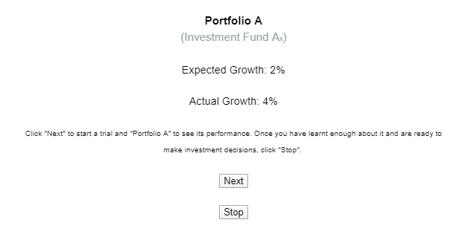
Figure S.3: Screenshot of the experience task used in Experiment 6.

Supplementary File B: Demographics and financial background

In every experiment, we collected information about participants’ demographics and financial background before the main task. In Experiment 1, participants were asked whether they have ever held financial assets (yes currently, yes previously, no) and how much investment experience they have (7-point scale). They were asked whether they have ever studied a finance-related course (yes at university, yes at school, no) and how much financial knowledge they have (7-point scale). Finally, they were asked whether they expect a company’s growth to be predictable (7-point scale). In all subsequent experiments, we used an 11-point scale for clarity of presentation and asked whether they expect the future value of an investment to be predictable. Participant characteristics can be found in Table B.1.

Table S.1: Participant characteristics
Characteristic | Exp 1 | Exp 2 | Exp 3 | Exp 4 | Exp 5
Age (in years) | M=35 (12)¹ | M=36 (12) | M=36 (13) | M=40 (13) | M=36 (11)
Gender | 31% male | 30% male | 36.5% male | 33.5% male | 31% male
Highest education
Secondary | 40% | 30% | 42% | 38.5% | 43.5%
Undergraduate | 41% | 47% | 39.5% | 40.9% | 41%
Postgraduate | 19% | 24% | 12.5% | 20.6% | 15.5%
Finance course
None | 67% | 69% | 77% | 67% | 71%
At school | 17.5% | 16% | 12.5% | 16.9% | 16%
At university | 14% | 16% | 10.5% | 15.6% | 13%
Financial assets
None | 63.5% | 63% | 68% | 44% | 69.5%
Previously | 13.5% | 15% | 9% | 14% | 16%
Currently | 23% | 22% | 23% | 42% | 14.5%
Knowledge | M=3.21 (1.1) | M=4.62 (1.9) | M=4.41 (2.1) | M=5.06 (2.1) | M=4.39 (2.1)
Experience | M=2.21 (1.3) | M=2.28 (2.3) | M=2.20 (2.4) | M=3.41 (2.7) | M=2.32 (2.4)
Predictability | M=4.26 (1.0) | M=4.27 (1.9) | M=3.96 (2.0) |  | M=3.79 (2.0)
¹Values in parentheses are standard deviations.

Supplementary File C: Accuracy question in Experiment 3

In Experiment 3, participants were shown four funds in randomized order (1%, 3%, -1 to 3%, 1 to 5%). For each fund, they were asked to indicate how accurate they perceived the expected growth to be (11-point scale). When the range included a loss, point estimates (M=5.90, SD=2.04) were perceived as more accurate than ranges (M=4.89, SD=2.19). When the range did not include a loss, point estimates (M=5.74, SD=1.86) were also perceived as more accurate than ranges (M=5.08, SD=1.96).
We ran a repeated-measures ANOVA with presentation format and loss in range as within-subject factors on accuracy. We found a main effect of format (F_{1,199}=40.61, p<.001, η_{p}²=0.17): participants rated point estimates as more accurate according to a simple effects analysis (mean difference=0.84, p<.001). We did not find a main effect of loss in ranges (F_{1,199}=0.02, p=.891, η_{p}²<.001), but we found an interaction between format and loss in range (F_{1,199}=4.98, p=.027, η_{p}²=0.02): there was a stronger effect of format when the range included a loss (t₁₉₉=6.06, p<.001, d=0.43) than when it did not (t₁₉₉=4.86, p<.001, d=0.34). We then tested whether the difference in accuracy was related to the difference in investments in point estimates and ranges. This was not the case when the range included a loss (r_{s}=0.08, df=198, p=.239), but it was when the range did not include a loss (r_{s}=0.19, df=198, p=.006).
However, we did not provide participants with a definition of accuracy, which could refer to either precision or hit rate. It is therefore not clear whether participants perceive point estimates as more precise or more likely to be realized (or both). This precludes clear conclusions from this current data, which would benefit from further exploration in future research.

Supplementary File D: Multilevel model on the first trial in Experiments 1-3

We ran a multi-level analysis on the amount participants invested on the first trial they completed for Experiments 1-3 (see Table D.1). The data were hierarchically ordered at two levels: investment amount (N=632) was clustered within the experiment (N=3). Model 1 was the null model where we did not include fixed effects, with experiment as the random factor. Model 2 added to this the presentation format (point, range) and expected growth predictors.

Table S.2: Multilevel analysis for predicting investment amount
 | Model 1 | Model 2
Format |  | b=70 (127), p=.584
Growth |  | b=117 (47), p=.014
Experiment | b=109763 (121141), p=.365 | b=424697 (473765), p=.370
-2 Log Likelihood | 11308 | 11282
Values in parentheses refer to standard errors.

Model 2 was a better fit to the data than Model 1 (ꭓ²=26, df=2, p<.001). Participants invested more as expected growth increased, as in Experiments 1-3 when investments were analyzed within-subjects and evaluation mode had a more joint feel. However, participants did not significantly invest less in ranges when investments were analyzed between-subjects.

Supplementary File E: Additional experiments

Verbal statements of uncertainty
We included verbal statements about investment uncertainty alongside the expected growth, similar to what is communicated in the field.
Method
We used a 2 (presentation format) x 3 (statement) design where presentation format was manipulated within-subjects and statement between-subjects. Participants were randomly allocated to a statement group. 246 participants from the UK were recruited using Prolific.
The investment task was the same as Experiment 2, with a few variations. Expected growth for point estimates was 2, 2.5, 3, 3.5 or 4%. For ranges, it was a 2% range either side of the point estimates (0-4%, 0.5-4.5%, 1-5%, 1.5-5.5%, 2-6%). Participants were shown a statement accompanying each fund (Loss: ‘Your investment may lose value’; Predictability: ‘Do not take the expected growth as a guarantee’; Control: ‘Investment decisions must be taken seriously’). After the task, participants were shown two funds (point estimate: 3%; range: 1-5%) along with the same statement as in the investment task and asked which they prefer based on that information. Participants also had the option to select neither.
Results
Investments. We ran a mixed-model ANOVA with presentation format as a within-subjects factor and statement as a between-subjects factor (see Figure D.1). Participants invested more in point estimates (M=2371, SD=1318) than ranges (M=2137, SD=1289) (F_{1,243}=36.20, p<.001, η_{p}²=0.13). There was a difference between investments in point and ranges in the loss condition (t₈₀=2.11, p=.037, d=0.24), the predictability condition (t₈₁=4.98, p<.001, d=0.55) and the control condition (t₈₂=3.34, p=.001, d=0.37). These remained significantly different after applying the False Discovery Rate procedure. Nonetheless, the loss statement did diminish the effect of presentation format: it was weaker in the loss condition compared to the predictability (t₁₆₁=-3.88, p<.001, d=0.61) and control conditions (t₁₆₂=-2.55, p=.012, d=0.40), which were comparable (t₁₆₃=0.52, p=.61, d=0.08), leading to an interaction between presentation format and statement (F_{2,243}=5.33, p=.005, η_{p}²=0.04). Finally, the statement itself did not affect investment amount (F_{2,243}=1.53, p=.218, η_{p}²=0.01).
Preference. In the loss condition, 68% of participants preferred point estimates, 26% preferred ranges and 6% preferred neither, with more preferring point estimates to ranges (ꭓ²=15.22, df=1, p<.001, w=0.45). In the predictability condition, 66% preferred point estimates, 29% ranges and 5% neither, with more preferring point estimates to ranges (ꭓ²=11.54, df=1, p=.001, w=0.38). In the control condition, 83% preferred point estimates, 17% ranges and 6% neither, with more preferring point estimates to ranges (ꭓ²=36.45, df=1, p<.001, w=0.66). Preferences did not clearly differ across conditions (ꭓ²=4.61, df=2, p=.10), although there was a reduction in the preference for point estimates in the predictability condition compared to the control condition (ꭓ²=4.31, df=1, p=.038).
Verbal statements did not eliminate the preference for point estimates. Telling participants their investment can lose value reduced the difference in investments between point estimates and ranges, but it remains nonetheless.

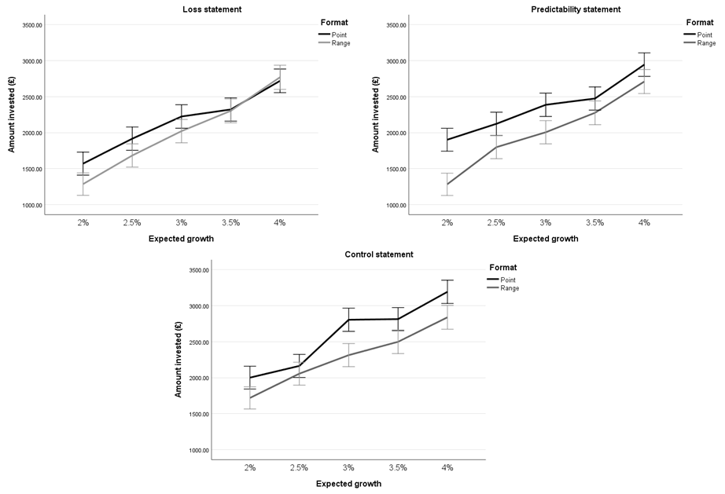 Figure S.4: Amount invested in each fund by statement group. Error bars represent 1 SE.

Verbal descriptions of risk vs uncertainty
We test whether verbally framing the context as one of risk is more likely to make consumers more confident in precise forecasts and therefore more drawn to them when investing. Indeed, precise forecasts are more realistic in a context of risk as outcomes and their associated probabilities can be calculated, unlike in a context of uncertainty.
Method
The experiment was a 2 x 3 mixed design where the presentation format of expected growth was varied within-subjects (point estimate, range) and the frame was varied between-subjects (no frame, risk, uncertainty). 300 participants residing in the UK were recruited using Prolific. Participants were either presented with no frame, a risk frame or an uncertainty frame before investing in funds and asked multiple choice questions about the text if they had received a frame to increase attention to it. Participants receiving the risk or uncertainty frame were told that the investment analyst who manages the funds has some advice to share.
Risk. The risk frame was as follows: “Choosing companies to invest in is a lot like rolling a dice. Some investments pay off and others don’t, but it’s easy to calculate the odds that a given company will be successful. This is because highly trained analysts have a huge amount of data at their disposal to work out the odds. They then use mathematical formulas and models to analyse this data and calculate the precise risks involved in undertaking a project. That can clearly indicate how likely a company is to succeed or fail. This is just like rolling a dice, where you know how likely it is that you will roll a 1 or a 6. For example, pharmaceuticals can be a very profitable industry. There is lots of data available on the kinds of treatments and technologies that will be needed to meet future demands in healthcare, as well as plenty of data on the health trajectory of populations. This has been the case particularly during the Covid-19 pandemic, where the need and demand for treatments for hospitalised patients and vaccines for the general population have been very clear. Vaccine doses were bought in large quantities by governments all over the world, making it easy to calculate the odds of success of an investment in pharmaceutical companies.”
Uncertainty. The uncertainty frame was as follows: “Choosing companies to invest in is a lot like playing poker. Some investments pay off and others don't, but it's impossible to know in advance which ones will be successful, or even to calculate the odds that a given company will be successful. This is because even highly trained analysts have no way of knowing all the possible risks involved in running a company. They might have data and models at their disposal, but these are incomplete and will lead to errors. There are too many factors to take into account and some that simply cannot be anticipated. This is just like playing poker, where it’s impossible to predict the behaviour of the players and to know in advance the exact likelihood of your hand winning. For example, real estate has been one of the most profitable industries of all time. Ordinarily, starting a new project or company in the sector would likely be lucrative and it would be possible to know the odds of success. However, launching it later on in 2019, just before the Covid-19 global pandemic stalled the housing market, is unlikely to lead to success, at least in the short term. However, at the time the investment was made, it would not have been possible to foresee that the odds of success would be hugely impacted by a global pandemic. Even if a pandemic could have been predicted, it was impossible to know how governments and financial actors would react and the impact on the housing market.”
Predictability scale. After receiving the frame, participants answered 7 questions relating to whether they think it is possible for the investment analyst to make predictions about future returns (5-point scale; 1-definitely not, 5-definitely yes). These were created for the purpose of this study and include whether it is possible for the analyst to use models to predict future returns; use past data to predict future returns; accurately predict future returns; know in advance how the fund will perform in the future; know whether I will win or lose money from my investment in the future; list all the possibilities that might happen with this fund in the future; know the probabilities of prices going up versus down.
Investment task. The investment task was analogous to Experiment 2, with some variations. In the point estimate scenarios, the fund’s expected growth was either 3, 4, 5, 6 or 7%. In the range scenarios, the fund’s expected growth was a 2% range either side of the values from the point estimate condition (either 1-5%, 2-6%, 3-7%, 4-8% or 5-9%). Participants were asked how much they want to invest in each fund, how confident they are in their investment (5-point scale) and how confident they are in the analyst (5-point scale). After the task, they were shown two funds – one with a point estimate of expected growth (5%) one with a range (3-7%) – and asked which they prefer, with the option to select neither. They were then asked why they preferred a given fund (free text entry).
Results
Predictability. Participants who received the risk frame were more likely to report that the investment analyst could predict the future performance of funds (M=3.55, SD=0.44) than those who received the uncertainty frame (M=2.58, SD=0.69) (t₁₉₆=11.81, p<.001, d=1.68). Those who received the control frame (M=3.21, SD=0.54) perceived less predictability than those who received the risk frame (t₁₉₈=-4.85, p<.001, d=-0.69) but more than those who received the uncertainty frame (t₂₀₀=7.23, p<.001, d=1.02). These findings remained significant when correcting for multiple comparisons using the False Discovery Rate method.
To explore whether the absence of information about uncertainty meant participants perceived the context as predictable, we ran a one-sample t-test against the midpoint of the scale with participants in the control frame. They perceived the context as significantly more predictable (M=3.21) than the midpoint of the scale (t₁₀₁=3.89, p<.001, d=0.39), which suggests they perceived the context as closer to one of risk than uncertainty.
Investments. Participants invested more in point estimates (M=2731, SD=1324) than ranges (M=2645, SD=1266) (F_{1,297}=3.983, p=.047, η_{p}²=0.01) (see Figures 10-11). They also invested more as expected growth increased (F_{4,1188}=79.44, p<.001, η_{p}²=0.21), as confirmed by a linear contrast (F_{1,299}=24.65, p<.001, η_{p}²=0.08). There was an interaction between presentation format and expected growth (F_{4,1188}=6.85, p<.001, η_{p}²=0.02), whereby the effect of presentation format decreased as expected growth increased. There was a marginally significant effect of frame (F_{2,297}=2.81, p=.062, η_{p}²=0.02). There was no interaction between presentation format and frame (F_{2,297}=0.49, p=.616, η_{p}²<0.01) or between presentation format, expected growth, and frame (F_{8,1188}=0.56, p=.810, η_{p}²<0.01).
There was an interaction between expected growth and frame (F_{4,1188}=2.08, p=.035, η_{p}²=0.01), whereby investments differed by frame for higher expected growth (6, 7%) (F_{2,297}=5.23, p=.006, η²=0.03) but not lower expected growth (3, 4, 5%) (F_{2,297}=1.37, p=.255, η²=0.01). When the expected growth was higher, those who received the uncertainty frame invested less than those who received the risk frame (mean difference=-524, p=.013) and control frame (mean difference=-501, p=.017). As this finding is not central to our hypotheses, and given the number of comparisons required to interpret it, post-hoc analyses have not been conducted.
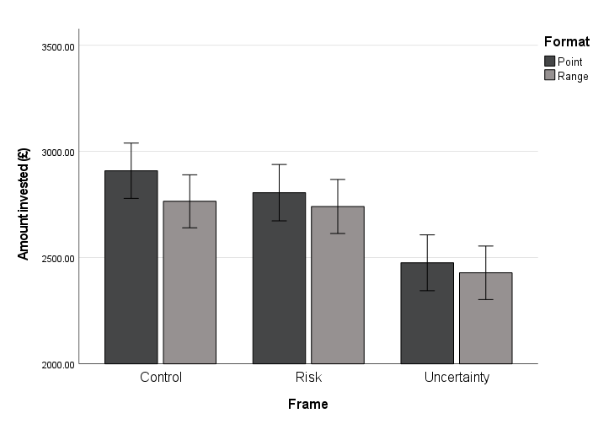
Figure S.5: Average amount invested by frame. Error bars represent 1 SE.

These findings do not support Hypothesis 3. Indeed, those who received the risk frame were not more likely to invest in point estimates compared to ranges than those who received the uncertainty frame (t₁₉₆=0.17, p=.866, d=0.02).

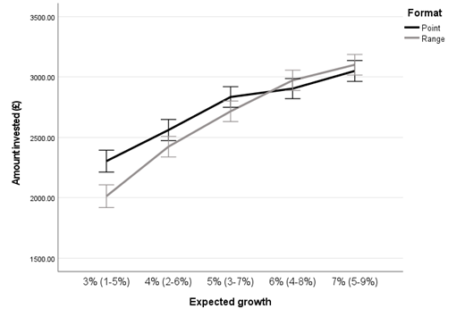
Figure S.6: Average amount invested across participants as a function of a fund’s expected growth. Error bars represent 1 SE.

Preference. Overall, 54% of participants preferred point estimates, 45% preferred ranges and 1% preferred neither. In the control frame, 58% preferred point estimates, 40% ranges and 2% neither. In the risk frame, 50% preferred point estimates, 49% ranges and 1% neither. In the uncertainty frame, 54% preferred point estimates, 45% ranges and 1% neither. The preference for point estimates was not stronger compared to ranges (ꭓ²=2.65, df=1, p=.104, w=0.09) and this did not vary by frame (ꭓ²=1.43, df=2, p=.489). This is comparable to the equivalent trial in the investment task, where participants did not significantly invest more in point estimates compared to ranges (t₂₉₉=1.74, p=.084, d=0.10).
Confidence in investment. Participants were more confident when investing in point estimates (M=3.58, SD=0.72) than ranges (M=3.50, SD=0.69) (F_{1,297}=7.61, p=.006, η_{p}²=0.03). They were also more confident in their investment as expected growth increased (F_{4,1188}=16.40, p<.001, η_{p}²=0.05). There was a main effect of frame (F_{2,297}=4.00, p=.021, η_{p}²=0.03), whereby participants were more confident investing when shown the risk frame compared to the uncertainty frame (mean difference=0.24, t=2.61, p=.028), with confidence in the control frame not significantly different from in the risk (p=.883) or uncertainty fame (p=.080). There was no interaction between presentation format and frame (F_{2,297}=0.09, p=.917, η_{p}²<0.01), no interaction between expected growth and frame (F_{4,1188}=0.75, p=.647, η_{p}²<0.01) and no interaction between presentation format, expected growth and frame (F_{8,1188}=0.52, p=.842, η_{p}²<0.01). There was an interaction between presentation format and expected growth (F_{4,1188}=5.75, p<.001, η_{p}²=0.02), which we do not analyze further given that this finding is not central to our hypotheses and plotting this interaction does not suggest meaningful comparisons can be made.
Confidence in analyst. Participants were more confident in the analyst as expected growth increased (F_{4,1188}=6.41, p<.001, η_{p}²=0.02). There was a main effect of frame (F_{2,297}=7.91, p<.001, η_{p}²=0.05), where participants were more confident in the analyst when shown the risk frame (mean difference=0.33, t=3.49, p=.002) or the control frame (mean difference=0.32, t=3.40, p=.002) compared to the uncertainty frame. There was no main effect of presentation format (F_{1,297}=3.36, p=.068, η_{p}²=0.01), no interaction between presentation format and frame (F_{2,297}=0.15, p=.864, η_{p}²<0.01), no interaction between expected growth and frame (F_{4,1188}=0.98, p=.453, η_{p}²=0.01) and no interaction between presentation format, expected growth and frame (F_{8,1188}=0.68, p=.709, η_{p}²=0.01). There was an interaction between presentation format and expected growth (F_{4,1188}=3.49, p=.008, η_{p}²=0.01), which we do not analyze further given that this finding is not central to our hypotheses and plotting this interaction does not suggest meaningful comparisons can be made.
Confidence as a mediator. Confidence in the investment was correlated with investments for point estimates (r_{s}=0.42, p<.001) and ranges (r_{s}=0.35, p<.001). Confidence in the analyst was also correlated with investments for point estimates (r_{s}=0.41, p<.001) and ranges (r_{s}=0.30, p<.001). We analyzed whether confidence mediated the effect of presentation format using the MEMORE macro for SPSS (Montoya & Hayes, 2017). Confidence in the investment mediated the difference in investments between point estimates and ranges (b=33.89, 95% CI[9.31, 65.58]), whereas confidence in the analyst did not significantly (b=27.49, 95% CI[-1.73, 65.99]) (see Figure 12). This suggests there is evidence that confidence in the investment affects investment decisions over-and-above confidence in the analyst, but no significant evidence for the converse.
It seems that providing consumers with a verbal description of the context being one of uncertainty does not mitigate the preference for precise forecasts, which could be problematic if precise forecasts provide consumers with the illusion of certainty.

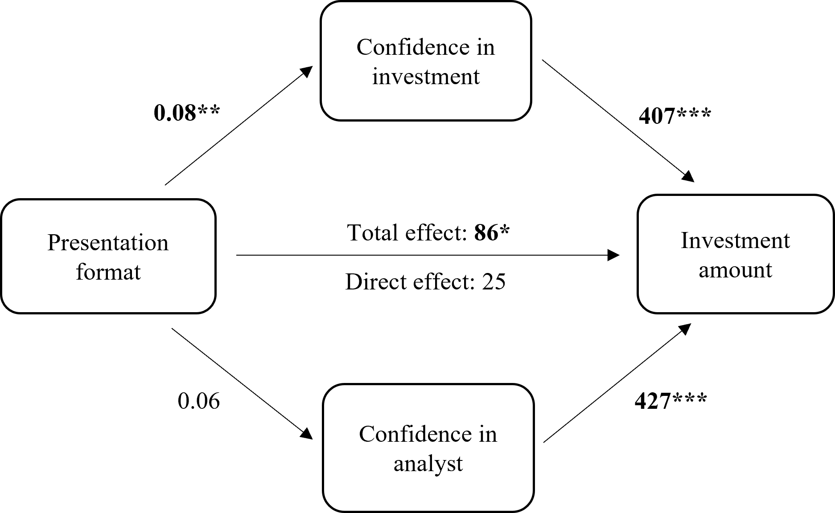
Figure S.7: The effect of presentation format (point estimate coded as 0, range coded as 1) on investment amount mediated by confidence in the investment and confidence in the analyst.

Graphical representations of uncertainty
We tested whether a graphical representation of variable past performance affects the preference for point estimates, to explore whether consumers can learn about the uncertainty of financial markets from past performance.
Method
Presentation format (1-point, 2-range) was manipulated within-subjects. 201 participants residing in the UK were recruited using Prolific.
The investment task was the same as Experiment 2, with a few variations. Each fund was accompanied by a graph of its performance over the previous year. The expected growth was 3% in the point estimate scenario and 1-5% in the range scenario. The past performance graph showed an average performance of 3%, with variation throughout the year between 1-5%. There were two graphs (see Figure D.2) which displayed the same set of performance values (with a mean of 3%) but distributed differently so they appeared different. Half the participants were shown the point estimate fund with graph A and the range fund with graph B and the other half were shown the reverse. The preference question was the same as Experiment 2, with the addition of the past performance graph for each fund.
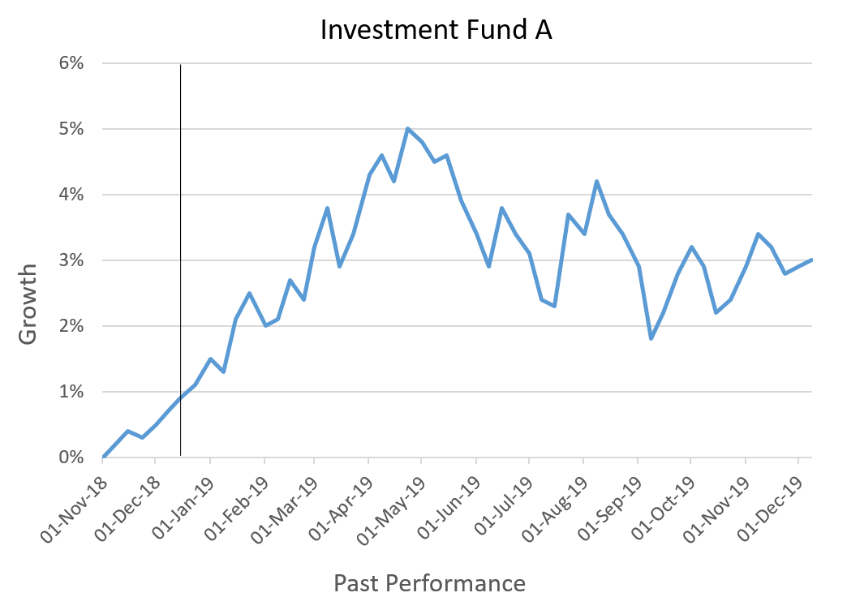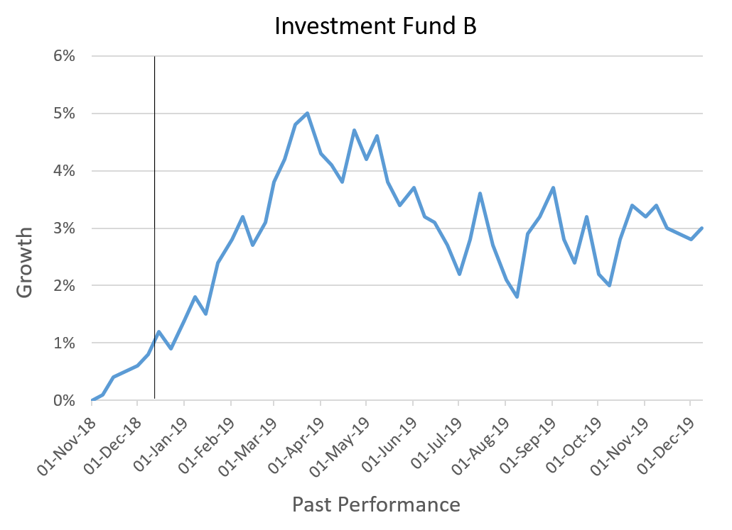
Figure S.8: Past performance graphs A and B.
Results
Investments. Participants invested more in point estimates (M=2338, SD=1488) than ranges (M=2092, SD=1462) (t₈₀=3.73, p<.001, d=0.26). This difference is comparable to the control condition in Experiment 4 (t₂₈₂=-0.40, p=.689, d=0.05).
Preference. 63.7% of participants preferred funds with point estimates, 30% preferred ranges and 6.5% preferred neither, with more preferring point estimates to ranges (ꭓ²=24.60, df=1, p<.001, w=0.36). Compared to the control condition in Experiment 4, fewer preferred point estimates (ꭓ²=6.57, df=1, p=.010).
Past performance graphical representations do not eliminate the preference for point estimates, suggesting consumers do not infer that precise forecasts are limited when seeing that past performance is variable.

Supplementary File F: Moderating effects of experience in Experiment 5

We tested whether the number of trials experienced across both point estimates and ranges moderated the effect of presentation format on perceived certainty, confidence in the analyst and investment amounts using the MEMORE macro for SPSS (Montoya & Hayes, 2017). Overall, there is some evidence that more experience drew participants away from point estimates.
The moderating effect of experience on the relationship between presentation format and certainty approached significance (b=-0.01, 95% CI[-0.03,0.01], p=.081). Participants who experienced less than 1 trial perceived point estimates as more certain (b=0.47, 95% CI[0.17,0.73], p=.002). Participants who experienced 18 trials perceived point estimates as more certain (b=0.29, 95% CI[0.07,0.50], p=.009). Participants who experienced 36 trials did not perceive point estimates as more certain (b=0.10, 95% CI[-0.21,0.40], p=.532).
Experience moderated the relationship between presentation format and confidence in the analyst (b=-0.01, 95% CI[-0.03,-0.01], p=.024). Participants who experienced less than 1 trial were more confident in the analyst who provided point estimates (b=0.31, 95% CI[0.02,0.59], p=.038). Participants who experienced 18 trials were not more confident in the analyst who provided point estimates (b=0.07, 95% CI[-0.13,0.27], p=.499). Participants who experienced 36 trials were not more confident in the analyst who provided point estimates either (b=-0.17, 95% CI[-0.45,0.12], p=.258).
The moderating effect of experience on the relationship between presentation format and investment amount approached significance (b=-7, 95% CI[-14,0.25], p=.058). Participants who experienced less than 1 trial were close to investing more in point estimates (b=126, 95% CI[-52,305], p=.165). Participants who experienced 18 trials did not invest more in either (b=4, 95% CI[-122,130], p=.948). Participants who experienced 36 trials were close to investing more in ranges (b=118, 95% CI[-297,61], p=.195).

