Supplemental Materials for
Long-Term Effectiveness of Inoculation Against Misinformation:
Three Longitudinal Experiments

Rakoen Maertens¹, Jon Roozenbeek^{1,2}, Melisa Basol¹, and Sander van der Linden¹
¹ Department of Psychology, University of Cambridge
² Department of Slavonic Studies, University of Cambridge

Author Note
Rakoen Maertens https://orcid.org/0000-0001-8507-5359
Jon Roozenbeek http://orcid.org/0000-0002-8150-9305
Melisa Basol https://orcid.org/0000-0003-1480-6462
Sander van der Linden https://orcid.org/0000-0002-0269-1744
We have no conflict of interest to disclose.
Correspondence concerning this article should be addressed to Rakoen Maertens, Department of Psychology, University of Cambridge, Downing Street, CB2 3EB Cambridge, United Kingdom. Email: rm938@cam.ac.uk
Supplement 3
Information S1 3
Table S1 6
Table S2 8
Table S3 10
Table S4 11
Table S5 12
Table S6 13
Table S7 14
Table S8 15
Table S9 16
Table S10 17
Table S11 18
Table S12 20
Table S13 21
Figure S1 22
Figure S2 23
Figure S3 24
Figure S4 25
Figure S5 26
Analysis S1 27
Declaration S1 29
Repository S1 31

Supplement

Information S1
Real News Items (Experiment 1)

Real News Items (Experiment 2)
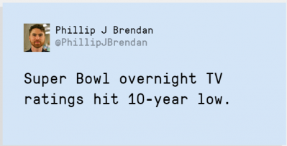
Real News Items (Experiment 3)
T1/T2

T3
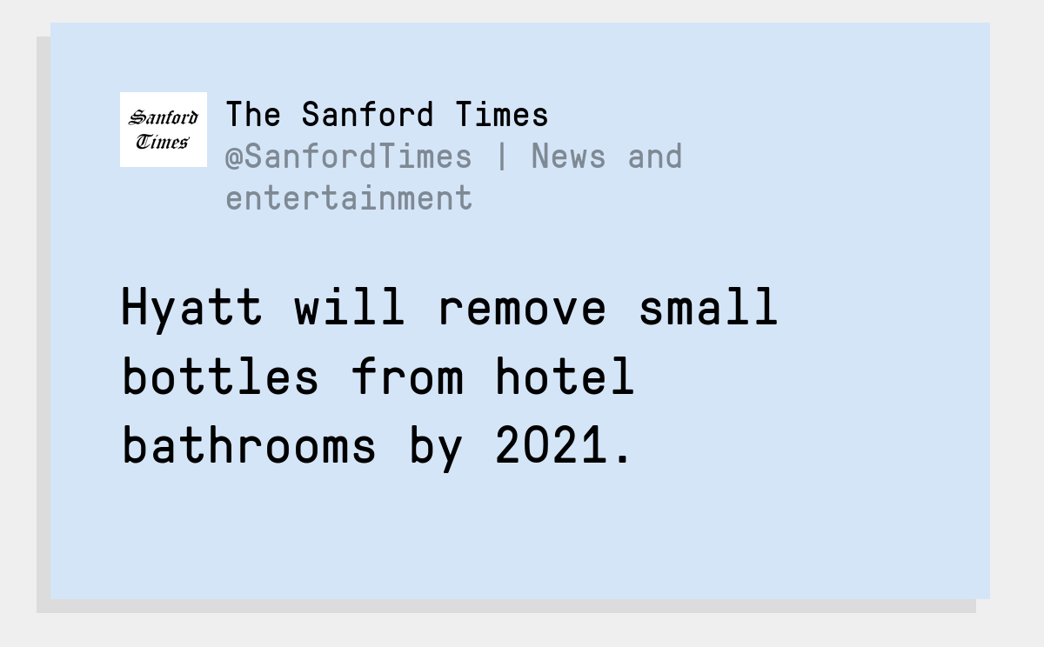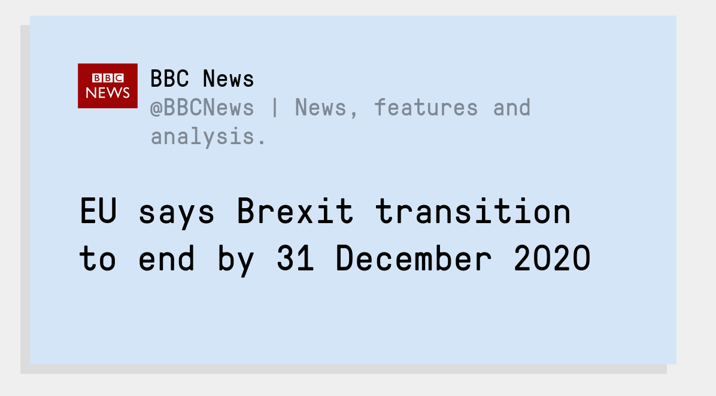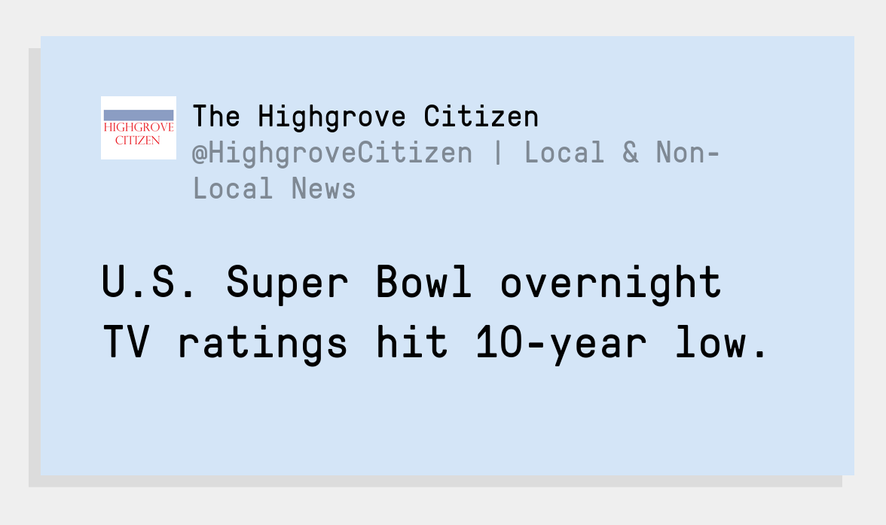
Discrediting Items
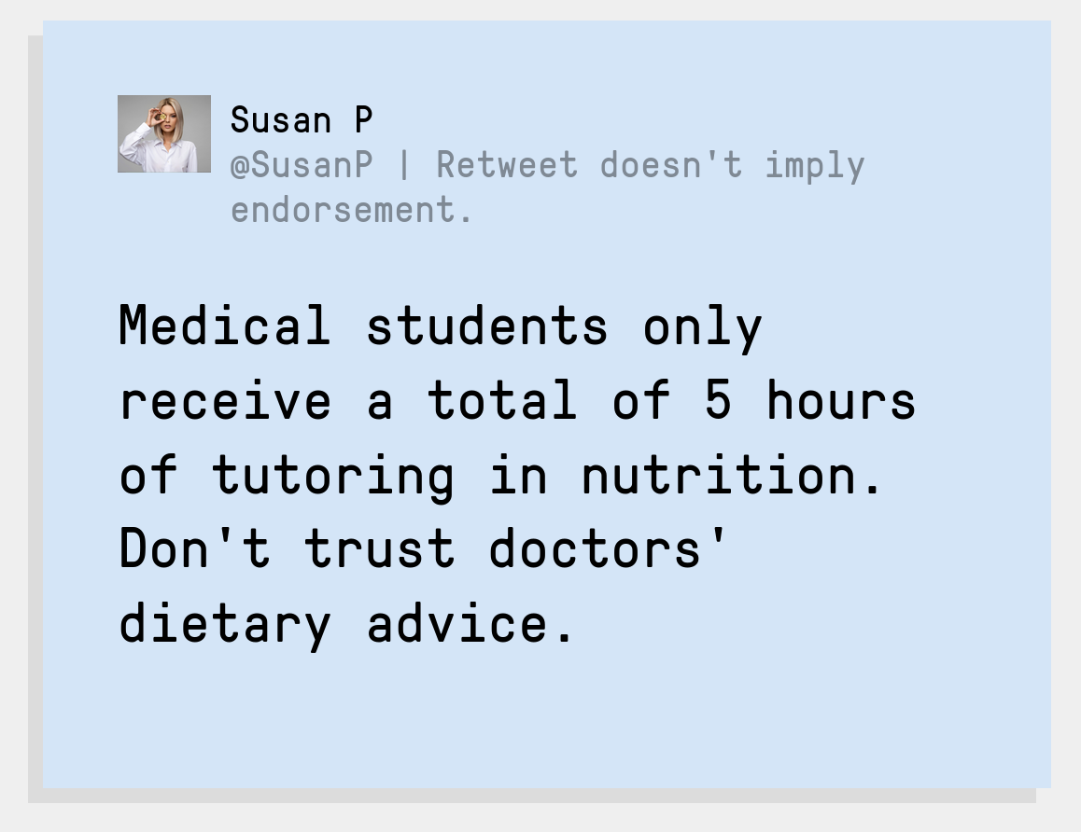
Emotion Items


Polarisation Items
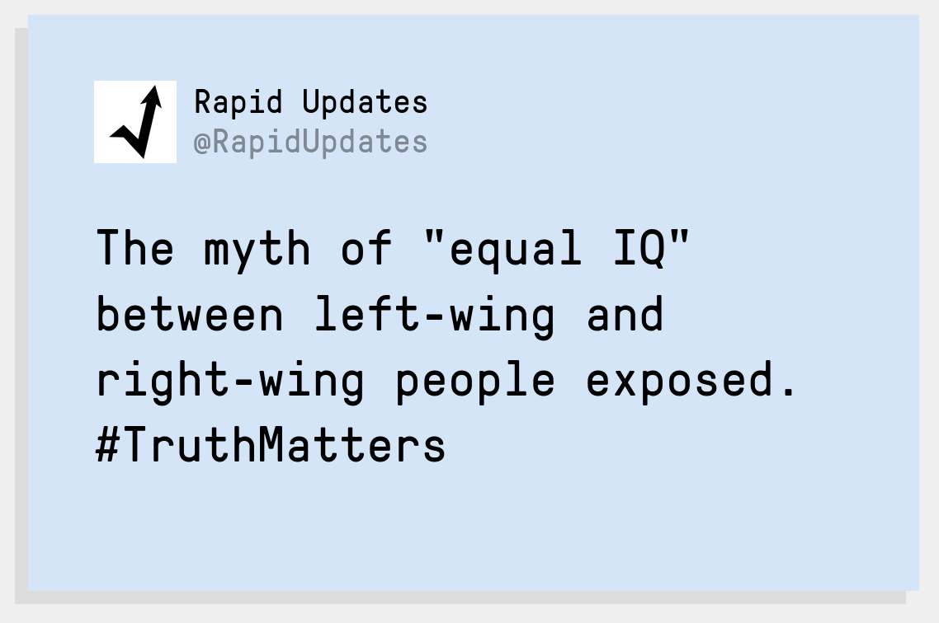
Impersonation Items
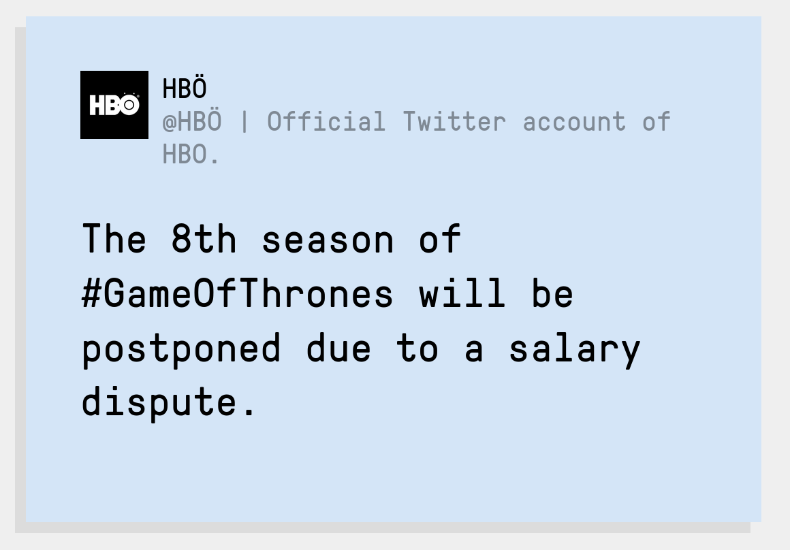
Conspiracy Items

Trolling Items
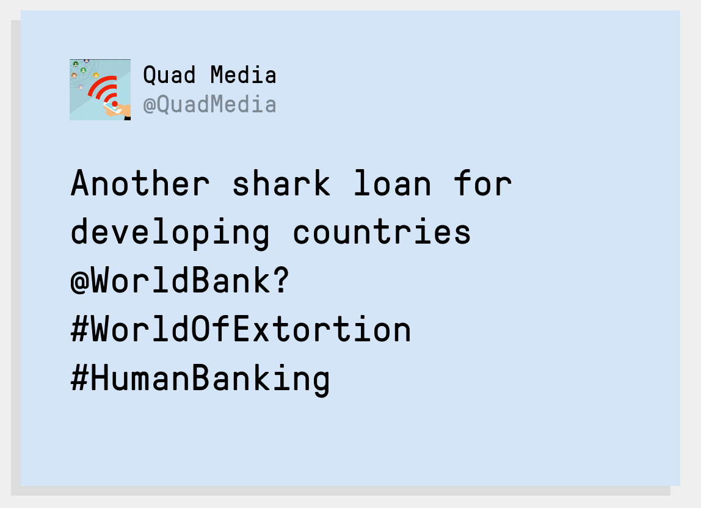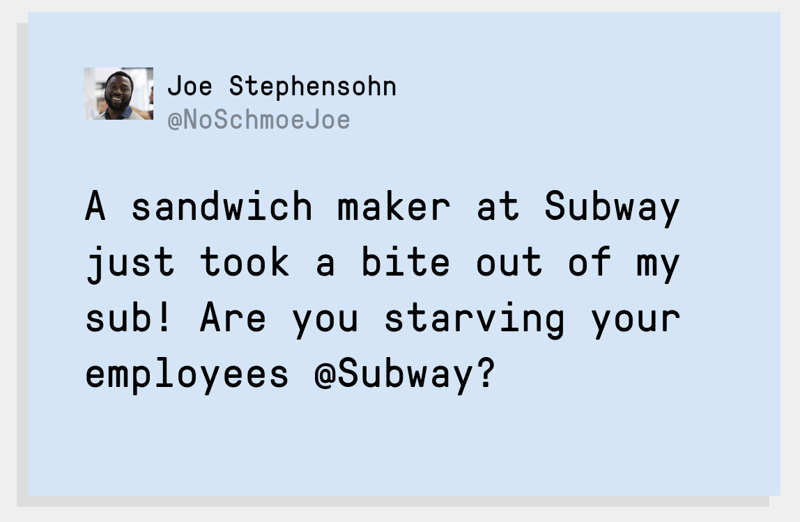

Table S1
Sample Composition for Experiment 1: Demographics with Modal Class in Bold
 |  | Age
 |  | 18-29 | 30-49 | Over 50 | Total
T1 | n | 82 | 59 | 10 | 151
 | % | 54.30% | 39.07% | 6.62% | 100.00%
T5 | n | 63 | 45 | 10 | 118
 | % | 53.39% | 38.14% | 8.47% | 100.00%
 |  | Gender
 |  | Female | Male | Other | Total
T1 | n | 79 | 70 | 2 | 151
 | % | 52.32% | 46.36% | 1.32% | 100.00%
T5 | n | 60 | 57 | 1 | 118
 | % | 50.85% | 48.31% | 0.85% | 100.00%
 |  | Political Affiliation
 |  | Liberal | Moderate | Conservative | Total
T1 | n | 72 | 50 | 29 | 151
 | % | 47.68% | 33.11% | 19.21% | 100.00%
T5 | n | 56 | 36 | 26 | 118
 | % | 47.46% | 30.51% | 22.03% | 100.00%
 |  | Education
 |  | (<) High school | Some college | Higher degree | Total
T1 | n | 37 | 39 | 75 | 151
 | % | 24.50% | 25.83% | 49.67% | 100.00%
T5 | n | 28 | 26 | 64 | 118
 | % | 23.73% | 22.03% | 54.24% | 100.00%
 |  | Social Media Use
 |  | Never | Rarely | Sometimes | Regularly | Daily | Total
T1 | n | 3 | 12 | 16 | 28 | 92 | 151
 | % | 1.99% | 7.95% | 10.60% | 18.54% | 60.93% | 100.00%
T5 | n | 3 | 8 | 15 | 19 | 73 | 118
 | % | 2.54% | 6.78% | 12.71% | 16.10% | 61.86% | 100.00%
 |  | Twitter Use
 |  | Never | Rarely | Sometimes | Regularly | Daily | Total
T1 | n | 53 | 41 | 22 | 10 | 25 | 151
 | % | 35.10% | 27.15% | 14.57% | 6.62% | 16.56% | 100.00%
T5 | n | 44 | 32 | 10 | 8 | 24 | 118
 | % | 37.29% | 27.12% | 8.47% | 6.78% | 20.34% | 100.00%
 |  | Primary Language
 |  | English | Italian | Polish | Spanish | Other | Total
T1 | n | 59 | 22 | 22 | 12 | 36 | 151
 | % | 39.07% | 14.57% | 14.57% | 7.95% | 23.84% | 100.00%
T5 | n | 41 | 19 | 19 | 10 | 29 | 118
 | % | 34.75% | 16.10% | 16.10% | 8.47% | 24.58% | 100.00%
 |  | Country
 |  | UK | Italy | Poland | Spain | Other | Total
T1 | n | 44 | 26 | 23 | 11 | 47 | 151
 | % | 29.14% | 17.22% | 15.23% | 7.28% | 31.13% | 100.00%
T5 | n | 30 | 22 | 20 | 9 | 37 | 118
 | % | 25.42% | 18.64% | 16.95% | 7.63% | 31.36% | 100.00%

Table S2
Sample Composition for Experiment 2: Demographics with Modal Class in Bold
 |  | Age
 |  | 18-24 | 25-44 | Total | NA
T1 | n | 86 | 1 | 87 | 107
 | % | 98.85% | 1.15% | 100.00%
T3 | n | 64 | 1 | 65 | 45
 | % | 98.46% | 1.54% | 100.00%
 |  | Gender
 |  | Female | Male | Total | NA
T1 | n | 37 | 50 | 87 | 107
 | % | 42.53% | 57.47% | 100.00%
T3 | n | 28 | 37 | 65 | 45
 | % | 43.08% | 56.92% | 100.00%
 |  | News Consumption
 |  | Low | Medium | High | Total
T1 | n | 38 | 45 | 111 | 194
 | % | 19.59% | 23.20% | 57.22% | 100.00%
T3 | n | 16 | 19 | 75 | 110
 | % | 14.55% | 17.27% | 68.18% | 100.00%
 |  | Political Interest
 |  | Low | Medium | High | Total
T1 | n | 69 | 40 | 85 | 194
 | % | 35.57% | 20.62% | 43.81% | 100.00%
T3 | n | 35 | 19 | 56 | 110
 | % | 31.82% | 17.27% | 50.91% | 100.00%
 |  | Political Affiliation
 |  | Liberal | Moderate | Conservative | Total | NA
T1 | n | 109 | 36 | 39 | 184 | 10
 | % | 59.24% | 19.57% | 21.20% | 100.00%
T3 | n | 66 | 15 | 23 | 104 | 6
 | % | 63.46% | 14.42% | 22.12% | 100.00%
 |  | Education
 |  | < High school | High school | Higher degree | Total | NA
T1 | n | 16 | 36 | 18 | 70 | 124
 | % | 22.86% | 51.43% | 25.71% | 100.00%
T3 | n | 13 | 28 | 13 | 54 | 56
 | % | 24.07% | 51.85% | 24.07% | 100.00%
 |  | Ethnicity
 |  | Asian | Black, African, Caribbean | Multi-racial | White | Total | NA
T1 | n | 6 | 4 | 3 | 73 | 86 | 108
 | % | 6.98% | 4.65% | 3.49% | 84.88% | 100.00%
T3 | n | 4 | 3 | 1 | 57 | 65 | 45
 | % | 6.15% | 4.62% | 1.54% | 87.69% | 100.00%

Table S3
Raw Means of Reliability Ratings in Experiment 1, Pretest (T1) vs. Posttest (T2), Indices in Bold
 | Reliability Rating
Condition | M_{T1} | M_{T2} | M_{diff} | 95% CI_{diff} | Cohen’s d
Control Group (n = 60)
Real News Index | 5.85 | 5.87 | 0.02 | [-0.09, 0.12] | 0.04
Fake News Index | 3.47 | 3.39 | -0.08 | [-0.17, 0.01] | -0.24
Discrediting | 3.72 | 3.58 | -0.14 | [-0.31, 0.02] | -0.23
Emotion | 3.53 | 3.43 | -0.10 | [-0.28, 0.08] | -0.14
Polarization | 3.31 | 3.35 | 0.04 | [-0.13, 0.20] | 0.06
Impersonation | 3.47 | 3.42 | -0.06 | [-0.22, 0.11] | -0.09
Conspiracy | 3.63 | 3.51 | -0.12 | [-0.28, 0.04] | -0.19
Trolling | 3.16 | 3.05 | -0.11 | [-0.25, 0.03] | -0.20
Inoculation Group (n = 58)
Real News Index | 5.71 | 5.30 | -0.41 | [-0.64, -0.18] | -0.46
Fake News Index | 3.29 | 2.68 | -0.61 | [-0.78, -0.43] | -0.92
Discrediting | 3.70 | 2.85 | -0.84 | [-1.14, -0.55] | -0.75
Emotion | 3.21 | 2.74 | -0.47 | [-0.73, -0.21] | -0.48
Polarization | 3.11 | 2.41 | -0.71 | [-0.95, -0.46] | -0.77
Impersonation | 3.60 | 2.99 | -0.60 | [-0.87, -0.33] | -0.59
Conspiracy | 3.17 | 2.63 | -0.55 | [-0.88, -0.22] | -0.43
Trolling | 2.92 | 2.45 | -0.47 | [-0.68, -0.25] | -0.57

Table S4
Raw Means of Reliability Ratings in Experiment 1, T2 vs. T3, Indices in Bold
 | Reliability Rating
Condition | M_{T2} | M_{T3} | M_{diff} | 95% CI_{diff} | Cohen’s d
Control Group (n = 60)
Real News Index | 5.87 | 5.69 | -0.18 | [-0.40, 0.04] | -0.21
Fake News Index | 3.39 | 3.37 | -0.02 | [-0.14, 0.10] | -0.04
Discrediting | 3.58 | 3.40 | -0.18 | [-0.41, 0.05] | -0.20
Emotion | 3.43 | 3.43 | -0.01 | [-0.19, 0.18] | -0.01
Polarization | 3.35 | 3.32 | -0.03 | [-0.25, 0.20] | -0.03
Impersonation | 3.42 | 3.56 | 0.14 | [-0.10, 0.39] | 0.15
Conspiracy | 3.51 | 3.49 | -0.02 | [-0.19, 0.16] | -0.02
Trolling | 3.05 | 3.02 | -0.03 | [-0.26, 0.19] | -0.04
Inoculation Group (n = 58)
Real News Index | 5.30 | 5.25 | -0.05 | [-0.32, 0.23] | -0.04
Fake News Index | 2.68 | 2.62 | -0.06 | [-0.20, 0.09] | -0.10
Discrediting | 2.85 | 2.92 | 0.07 | [-0.17, 0.31] | 0.08
Emotion | 2.74 | 2.63 | -0.11 | [-0.38, 0.16] | -0.11
Polarization | 2.41 | 2.39 | -0.02 | [-0.25, 0.22] | -0.02
Impersonation | 2.99 | 2.71 | -0.29 | [-0.52, -0.05] | -0.32
Conspiracy | 2.63 | 2.69 | 0.06 | [-0.18, 0.30] | 0.07
Trolling | 2.45 | 2.40 | -0.06 | [-0.29, 0.17] | -0.07

Table S5
Raw Means of Reliability Ratings in Experiment 1, T3 vs. T4, Indices in Bold
 | Reliability Rating
Condition | M_{T3} | M_{T4} | M_{diff} | 95% CI_{diff} | Cohen’s d
Control Group (n = 60)
Real News Index | 5.69 | 5.66 | -0.03 | [-0.25, 0.19] | -0.03
Fake News Index | 3.37 | 3.31 | -0.06 | [-0.21, 0.08] | -0.11
Discrediting | 3.40 | 3.38 | -0.02 | [-0.28, 0.25] | -0.02
Emotion | 3.43 | 3.42 | -0.01 | [-0.23, 0.22] | -0.01
Polarization | 3.32 | 3.26 | -0.06 | [-0.30, 0.18] | -0.07
Impersonation | 3.56 | 3.29 | -0.27 | [-0.51, -0.04] | -0.30
Conspiracy | 3.49 | 3.46 | -0.03 | [-0.27, 0.20] | -0.04
Trolling | 3.02 | 3.03 | 0.01 | [-0.22, 0.24] | 0.01
Inoculation Group (n = 58)
Real News Index | 5.25 | 5.09 | -0.17 | [-0.44, 0.11] | -0.16
Fake News Index | 2.62 | 2.48 | -0.14 | [-0.31, 0.03] | -0.21
Discrediting | 2.92 | 2.74 | -0.18 | [-0.45, 0.09] | -0.18
Emotion | 2.63 | 2.49 | -0.14 | [-0.35, 0.07] | -0.17
Polarization | 2.39 | 2.41 | 0.02 | [-0.25, 0.29] | 0.02
Impersonation | 2.71 | 2.56 | -0.15 | [-0.45, 0.15] | -0.13
Conspiracy | 2.69 | 2.56 | -0.13 | [-0.36, 0.11] | -0.14
Trolling | 2.40 | 2.15 | -0.25 | [-0.51, 0.02] | -0.25

Table S6
Raw Means of Reliability Ratings in Experiment 1, T4 vs. T5, Indices in Bold
 | Reliability Rating
Condition | M_{T4} | M_{T5} | M_{diff} | 95% CI_{diff} | Cohen’s d
Control Group (n = 60)
Real News Index | 5.66 | 5.47 | -0.19 | [-0.50, 0.11] | -0.17
Fake News Index | 3.31 | 3.20 | -0.11 | [-0.27, 0.05] | -0.17
Discrediting | 3.38 | 3.39 | 0.01 | [-0.25, 0.26] | 0.01
Emotion | 3.42 | 3.37 | -0.06 | [-0.30, 0.19] | -0.06
Polarization | 3.26 | 3.19 | -0.07 | [-0.38, 0.24] | -0.06
Impersonation | 3.29 | 3.09 | -0.20 | [-0.47, 0.07] | -0.19
Conspiracy | 3.46 | 3.22 | -0.24 | [-0.51, 0.03] | -0.23
Trolling | 3.03 | 2.94 | -0.09 | [-0.31, 0.14] | -0.10
Inoculation Group (n = 58)
Real News Index | 5.09 | 5.18 | 0.09 | [-0.11, 0.29] | 0.12
Fake News Index | 2.48 | 2.49 | 0.00 | [-0.15, 0.15] | 0.01
Discrediting | 2.74 | 2.68 | -0.05 | [-0.28, 0.18] | -0.06
Emotion | 2.49 | 2.57 | 0.07 | [-0.13, 0.28] | 0.09
Polarization | 2.41 | 2.40 | -0.01 | [-0.25, 0.24] | -0.01
Impersonation | 2.56 | 2.48 | -0.07 | [-0.34, 0.19] | -0.07
Conspiracy | 2.56 | 2.56 | 0.00 | [-0.23, 0.23] | 0.00
Trolling | 2.15 | 2.23 | 0.08 | [-0.18, 0.34] | 0.08

Table S7
Raw Means of Reliability Ratings in Experiment 2, Pretest (T1) vs. Posttest (T2), Indices in Bold
 | Reliability Rating
Condition | M_{T1} | M_{T2} | M_{diff} | 95% CI_{diff} | Cohen’s d
Control Group (n = 56)
Real News Index | 4.69 | 4.57 | -0.12 | [-0.38, 0.14] | -0.12
Fake News Index | 3.41 | 3.34 | -0.08 | [-0.16, 0.01] | -0.24
Discrediting | 3.43 | 3.57 | 0.14 | [-0.07, 0.35] | 0.17
Emotion | 3.65 | 3.55 | -0.10 | [-0.29, 0.10] | -0.13
Polarization | 3.15 | 2.93 | -0.21 | [-0.42, -0.01] | -0.28
Impersonation | 3.57 | 3.64 | 0.07 | [-0.11, 0.25] | 0.11
Conspiracy | 3.67 | 3.45 | -0.23 | [-0.45, 0.00] | -0.27
Trolling | 3.01 | 2.88 | -0.13 | [-0.33, 0.07] | -0.18
Inoculation Group (n = 54)
Real News Inde | 4.62 | 4.23 | -0.39 | [-0.68, -0.10] | -0.36
Fake News Index | 3.14 | 2.64 | -0.50 | [-0.72, -0.28] | -0.63
Discrediting | 3.38 | 2.82 | -0.56 | [-0.90, -0.22] | -0.45
Emotion | 3.34 | 2.76 | -0.58 | [-0.87, -0.29] | -0.55
Polarization | 2.87 | 2.60 | -0.27 | [-0.58, 0.04] | -0.24
Impersonation | 3.31 | 2.65 | -0.66 | [-1.01, -0.31] | -0.52
Conspiracy | 3.14 | 2.57 | -0.56 | [-0.85, -0.27] | -0.53
Trolling | 2.81 | 2.46 | -0.36 | [-0.62, -0.09] | -0.37

Table S8
Raw Means of Reliability Ratings in Experiment 2, T2 vs. T3, Indices in Bold
 | Reliability Rating
Condition | M_{T2} | M_{T3} | M_{diff} | 95% CI_{diff} | Cohen’s d
Control Group (n = 56)
Real News Index | 4.57 | 4.52 | -0.05 | [-0.36, 0.26] | -0.04
Fake News Index | 3.34 | 3.32 | -0.01 | [-0.22, 0.20] | -0.02
Discrediting | 3.57 | 3.48 | -0.08 | [-0.40, 0.23] | -0.07
Emotion | 3.55 | 3.63 | 0.07 | [-0.23, 0.38] | 0.06
Polarization | 2.93 | 3.14 | 0.21 | [-0.14, 0.56] | 0.16
Impersonation | 3.64 | 3.37 | -0.27 | [-0.57, 0.03] | -0.24
Conspiracy | 3.45 | 3.51 | 0.06 | [-0.28, 0.40] | 0.05
Trolling | 2.88 | 2.82 | -0.07 | [-0.34, 0.21] | -0.06
Inoculation Group (n = 54)
Real News Index | 4.23 | 4.60 | 0.38 | [0.06, 0.69] | 0.32
Fake News Index | 2.64 | 2.90 | 0.26 | [0.05, 0.46] | 0.34
Discrediting | 2.82 | 3.11 | 0.29 | [-0.03, 0.61] | 0.25
Emotion | 2.76 | 3.14 | 0.38 | [0.09, 0.68] | 0.36
Polarization | 2.60 | 2.88 | 0.28 | [0.00, 0.55] | 0.28
Impersonation | 2.65 | 2.77 | 0.12 | [-0.24, 0.48] | 0.09
Conspiracy | 2.57 | 2.94 | 0.36 | [0.05, 0.68] | 0.31
Trolling | 2.46 | 2.57 | 0.11 | [-0.15, 0.38] | 0.11

Table S9
Attrition Analysis in Experiment 1 (N = 118), Logistic Regression Incomplete (0) vs. Complete (1)
 | b | OR | 95% CI_{OR} |  | SE | z | p
 |  |  | LL | UL
(Intercept) | -0.87 | 0.42 | 0.02 | 10.14 | 1.60 | -0.54 | 0.59
Age | 0.03 | 1.03 | 0.98 | 1.08 | 0.02 | 1.21 | 0.23
Education | 0.18 | 1.20 | 0.89 | 1.65 | 0.16 | 1.15 | 0.25
GenderMale | 0.05 | 1.06 | 0.39 | 2.82 | 0.50 | 0.11 | 0.91
GenderOther | -0.94 | 0.39 | 0.01 | 11.67 | 1.54 | -0.61 | 0.54
Ideology | -0.05 | 0.95 | 0.67 | 1.35 | 0.18 | -0.28 | 0.78
SocialMediaUse | -0.01 | 0.99 | 0.63 | 1.53 | 0.22 | -0.03 | 0.98
TwitterUse | 0.09 | 1.09 | 0.81 | 1.51 | 0.16 | 0.57 | 0.57
Language_CategoryOther | 0.66 | 1.94 | 0.59 | 6.10 | 0.59 | 1.13 | 0.26
Country_CategoryOther | 0.38 | 1.47 | 0.42 | 5.26 | 0.64 | 0.60 | 0.55
CRT | 0.07 | 1.07 | 0.46 | 2.51 | 0.43 | 0.16 | 0.88
Note. Total N = 118. CI = confidence interval; LL = lower limit; UL = upper limit.

Table S10
Exploratory Analysis in Experiment 1, Fake News Difference Scores T2-T1
 | b | β | 95% CI_{β} |  | SE | t | p
 |  |  | LL | UL
(Intercept) | 0.10 | 0.00 | -0.71 | 0.71 | 0.36 | 0.29 | 0.78
Inoculation | -0.54 | -0.46 | -0.66 | -0.26 | 0.10 | -5.29 | <0.001
Age | 0.00 | -0.03 | -0.04 | -0.02 | 0.01 | -0.28 | 0.78
Education | 0.00 | -0.01 | -0.08 | 0.06 | 0.03 | -0.14 | 0.89
GenderMale | -0.03 | -0.03 | -0.25 | 0.19 | 0.11 | -0.31 | 0.76
GenderOther | -0.44 | -0.07 | -1.19 | 1.05 | 0.56 | -0.78 | 0.44
SocialMediaUse | -0.08 | -0.15 | -0.25 | -0.04 | 0.05 | -1.52 | 0.13
TwitterUse | 0.06 | 0.16 | 0.09 | 0.23 | 0.04 | 1.68 | 0.10
Language_CategoryOther | -0.15 | -0.12 | -0.43 | 0.18 | 0.15 | -0.98 | 0.33
Country_CategoryOther | 0.23 | 0.17 | -0.16 | 0.50 | 0.17 | 1.38 | 0.17
CRT | -0.04 | -0.04 | -0.24 | 0.17 | 0.10 | -0.40 | 0.69
Ideology | 0.01 | 0.03 | -0.06 | 0.11 | 0.04 | 0.28 | 0.78
Note. Total N = 118. CI = confidence interval; LL = lower limit; UL = upper limit.

Table S11
Sample Composition in Experiment 3: Demographics with Modal Class in Bold
 |  | Age
 |  | 18-29 | 30-49 | Over 50 | Total
T1 | n | 85 | 12 | 2 | 99
 | % | 85.86% | 12.12% | 2.02% | 100.00%
T3 | n | 73 | 11 | 2 | 86
 | % | 84.88% | 12.79% | 2.33% | 100.00%
 |  | Gender
 |  | Female | Male | Other | Total
T1 | n | 27 | 71 | 2 | 100
 | % | 27.00% | 71.00% | 2.00% | 100.00%
T3 | n | 20 | 65 | 2 | 87
 | % | 22.99% | 74.71% | 2.30% | 100.00%
 |  | Political Affiliation
 |  | Liberal | Moderate | Conservative | Total
T1 | n | 50 | 33 | 17 | 100
 | % | 50.00% | 33.00% | 17.00% | 100.00%
T3 | n | 41 | 29 | 17 | 87
 | % | 47.13% | 33.33% | 19.54% | 100.00%
 |  | Education
 |  | (<) High school | Some college | Higher degree | Total
T1 | n | 34 | 22 | 44 | 100
 | % | 34.00% | 22.00% | 44.00% | 100.00%
T3 | n | 31 | 17 | 39 | 87
 | % | 35.63% | 19.54% | 44.83% | 100.00%
 |  | Social Media Use
 |  | Never | Rarely | Sometimes | Regularly | Daily | Total
T1 | n | 1 | 8 | 10 | 20 | 61 | 100
 | % | 1.00% | 8.00% | 10.00% | 20.00% | 61.00% | 100.00%
T3 | n | 1 | 7 | 9 | 16 | 54 | 87
 | % | 1.15% | 8.05% | 10.34% | 18.39% | 62.07% | 100.00%
 |  | Twitter Use
 |  | Never | Rarely | Sometimes | Regularly | Daily | Total
T1 | n | 19 | 28 | 11 | 18 | 24 | 100
 | % | 19.00% | 28.00% | 11.00% | 18.00% | 24.00% | 100.00%
T3 | n | 16 | 26 | 9 | 14 | 22 | 87
 | % | 18.39% | 29.89% | 10.34% | 16.09% | 25.29% | 100.00%
 |  | Primary Language
 |  | Polish | Portuguese | English | Spanish | Other | Total
T1 | n | 28 | 26 | 13 | 9 | 24 | 100
 | % | 28.00% | 26.00% | 13.00% | 9.00% | 24.00% | 100.00%
T3 | n | 26 | 22 | 10 | 8 | 21 | 87
 | % | 29.89% | 25.29% | 11.49% | 9.20% | 24.14% | 100.00%
 |  | Country
 |  | Portugal | Poland | Italy | UK | Other | Total
T1 | n | 28 | 27 | 9 | 6 | 30 | 100
 | % | 28.00% | 27.00% | 9.00% | 6.00% | 30.00% | 100.00%
T3 | n | 24 | 25 | 8 | 6 | 24 | 87
 | % | 27.59% | 28.74% | 9.20% | 6.90% | 27.59% | 100.00%

Table S12
Raw Means of Reliability Ratings in Experiment 3, Pretest (T1) vs. Posttest (T2), Indices in Bold
 | Reliability Rating
Condition | M_{T1} | M_{T2} | M_{diff} | 95% CI_{diff} | Cohen’s d
Experiment 1 (n = 70)
Real News Item | 5.96 | 5.47 | -0.49 | [-0.74, -0.23] | -0.46
Fake News Index | 3.54 | 2.85 | -0.68 | [-0.88, -0.49] | -0.83
Discrediting | 4.36 | 3.46 | -0.90 | [-1.27, -0.53] | -0.57
Emotion | 2.54 | 2.44 | -0.10 | [-0.47, 0.27] | -0.06
Polarization | 2.96 | 2.36 | -0.60 | [-0.88, -0.32] | -0.52
Impersonation | 4.46 | 3.37 | -1.09 | [-1.55, -0.62] | -0.56
Conspiracy | 3.51 | 2.83 | -0.69 | [-1.06, -0.31] | -0.44
Trolling | 3.39 | 2.66 | -0.73 | [-1.09, -0.37] | -0.48
Experiment 3 (n = 87)
Real News Item | 5.90 | 5.33 | -0.56 | [-0.88, -0.25] | -0.38
Fake News Index | 3.48 | 2.83 | -0.65 | [-0.84, -0.46] | -0.72
Discrediting | 3.98 | 3.24 | -0.74 | [-1.09, -0.38] | -0.44
Emotion | 2.84 | 2.34 | -0.49 | [-0.80, -0.19] | -0.34
Polarization | 3.02 | 2.59 | -0.44 | [-0.75, -0.12] | -0.30
Impersonation | 4.01 | 2.97 | -1.05 | [-1.51, -0.59] | -0.49
Conspiracy | 3.57 | 2.91 | -0.67 | [-1.01, -0.33] | -0.42
Trolling | 3.48 | 2.95 | -0.53 | [-0.81, -0.25] | -0.40
Note. All results in this table are based on Set A items only.

Table S13
Raw Means of Reliability Ratings in Experiment 3, T2 vs. T3, Indices in Bold
 | Reliability Rating
Condition | M_{T2} | M_{T3} | M_{diff} | 95% CI_{diff} | Cohen’s d
Experiment 1 (n = 70)
Real News Item | 5.47 | 5.29 | -0.19 | [-0.57, 0.20] | -0.12
Fake News Index | 2.85 | 2.63 | -0.23 | [-0.44, -0.01] | -0.25
Discrediting | 3.46 | 2.73 | -0.73 | [-1.15, -0.30] | -0.41
Emotion | 2.44 | 2.63 | 0.19 | [-0.19, 0.56] | 0.12
Polarization | 2.36 | 2.67 | 0.31 | [-0.02, 0.65] | 0.22
Impersonation | 3.37 | 2.53 | -0.84 | [-1.47, -0.22] | -0.32
Conspiracy | 2.83 | 2.86 | 0.03 | [-0.43, 0.49] | 0.01
Trolling | 2.66 | 2.34 | -0.31 | [-0.69, 0.06] | -0.20
Experiment 3 (n = 87)
Real News Item | 5.33 | 5.76 | 0.43 | [0.06, 0.79] | 0.25
Fake News Index | 2.83 | 2.79 | -0.05 | [-0.25, 0.16] | -0.05
Discrediting | 3.24 | 3.09 | -0.15 | [-0.53, 0.23] | -0.08
Emotion | 2.34 | 3.08 | 0.74 | [0.39, 1.08] | 0.46
Polarization | 2.59 | 3.01 | 0.43 | [0.07, 0.79] | 0.25
Impersonation | 2.97 | 2.38 | -0.59 | [-1.12, -0.06] | -0.24
Conspiracy | 2.91 | 2.71 | -0.20 | [-0.53, 0.14] | -0.13
Trolling | 2.95 | 2.45 | -0.51 | [-0.85, -0.16] | -0.31
Note. All results in this table are based on Set A for T2 and Set B for T3.

Figure S1
Reliability Ratings of News Items, Separated by Time and Condition in Experiment 1
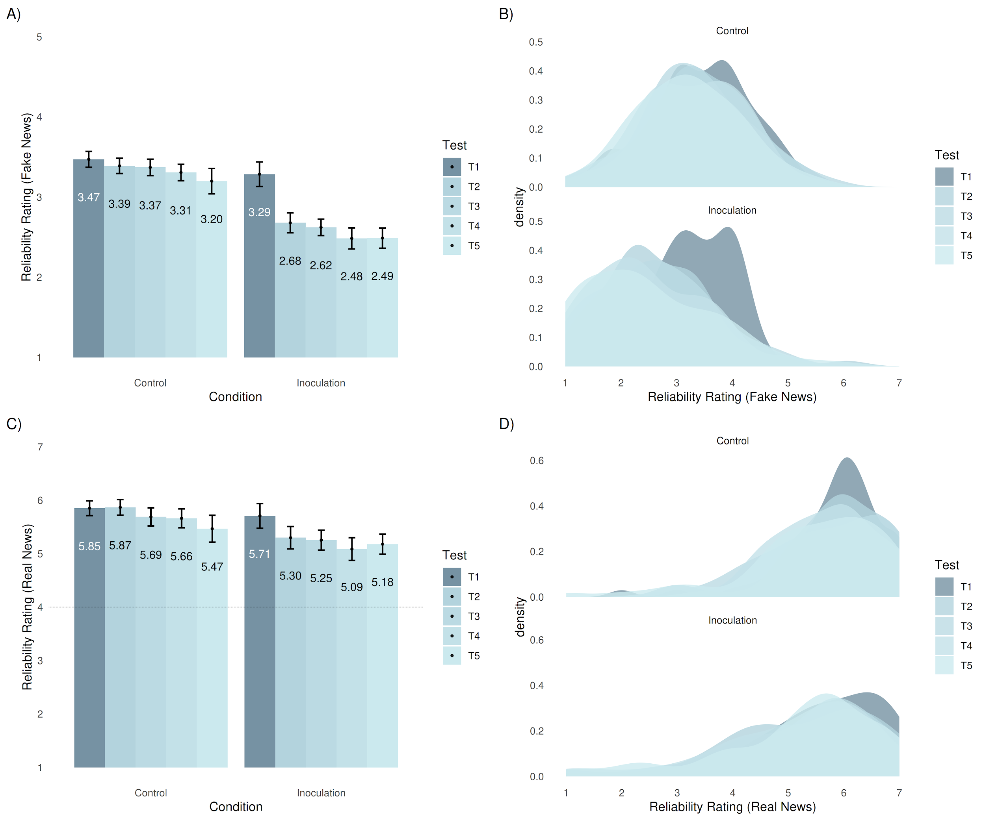
Note. Bar charts (A, C) and density plots (B, D) of fake news (upper row) and real news (lower row) reliability ratings in Experiment 1. N = 118. Error bars represent 95% confidence intervals.

Figure S2
Reliability Ratings of News Items, Separated by Time and Condition in Experiment 1
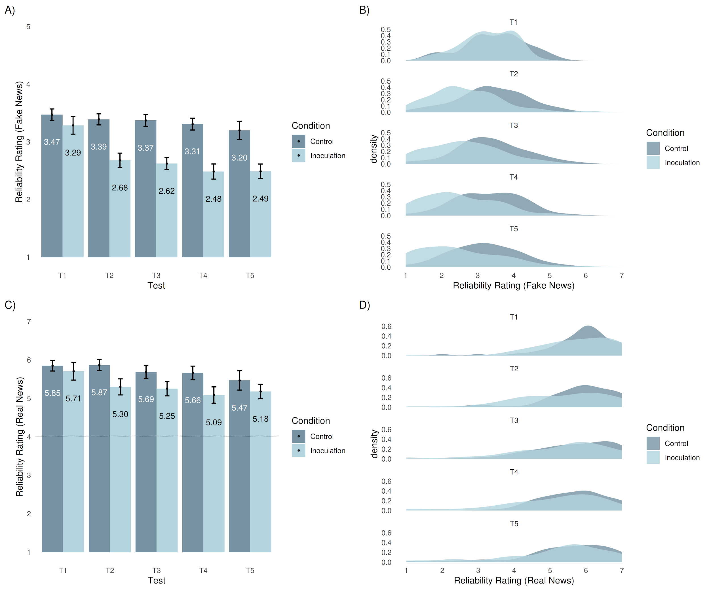
Note. Bar charts (A, C) and density plots (B, D) of fake news (upper row) and real news (lower row) reliability ratings in Experiment 1. N = 118. Error bars represent 95% confidence intervals.

Figure S3
Reliability Ratings of News Items, Separated by Time and Condition in Experiment 2
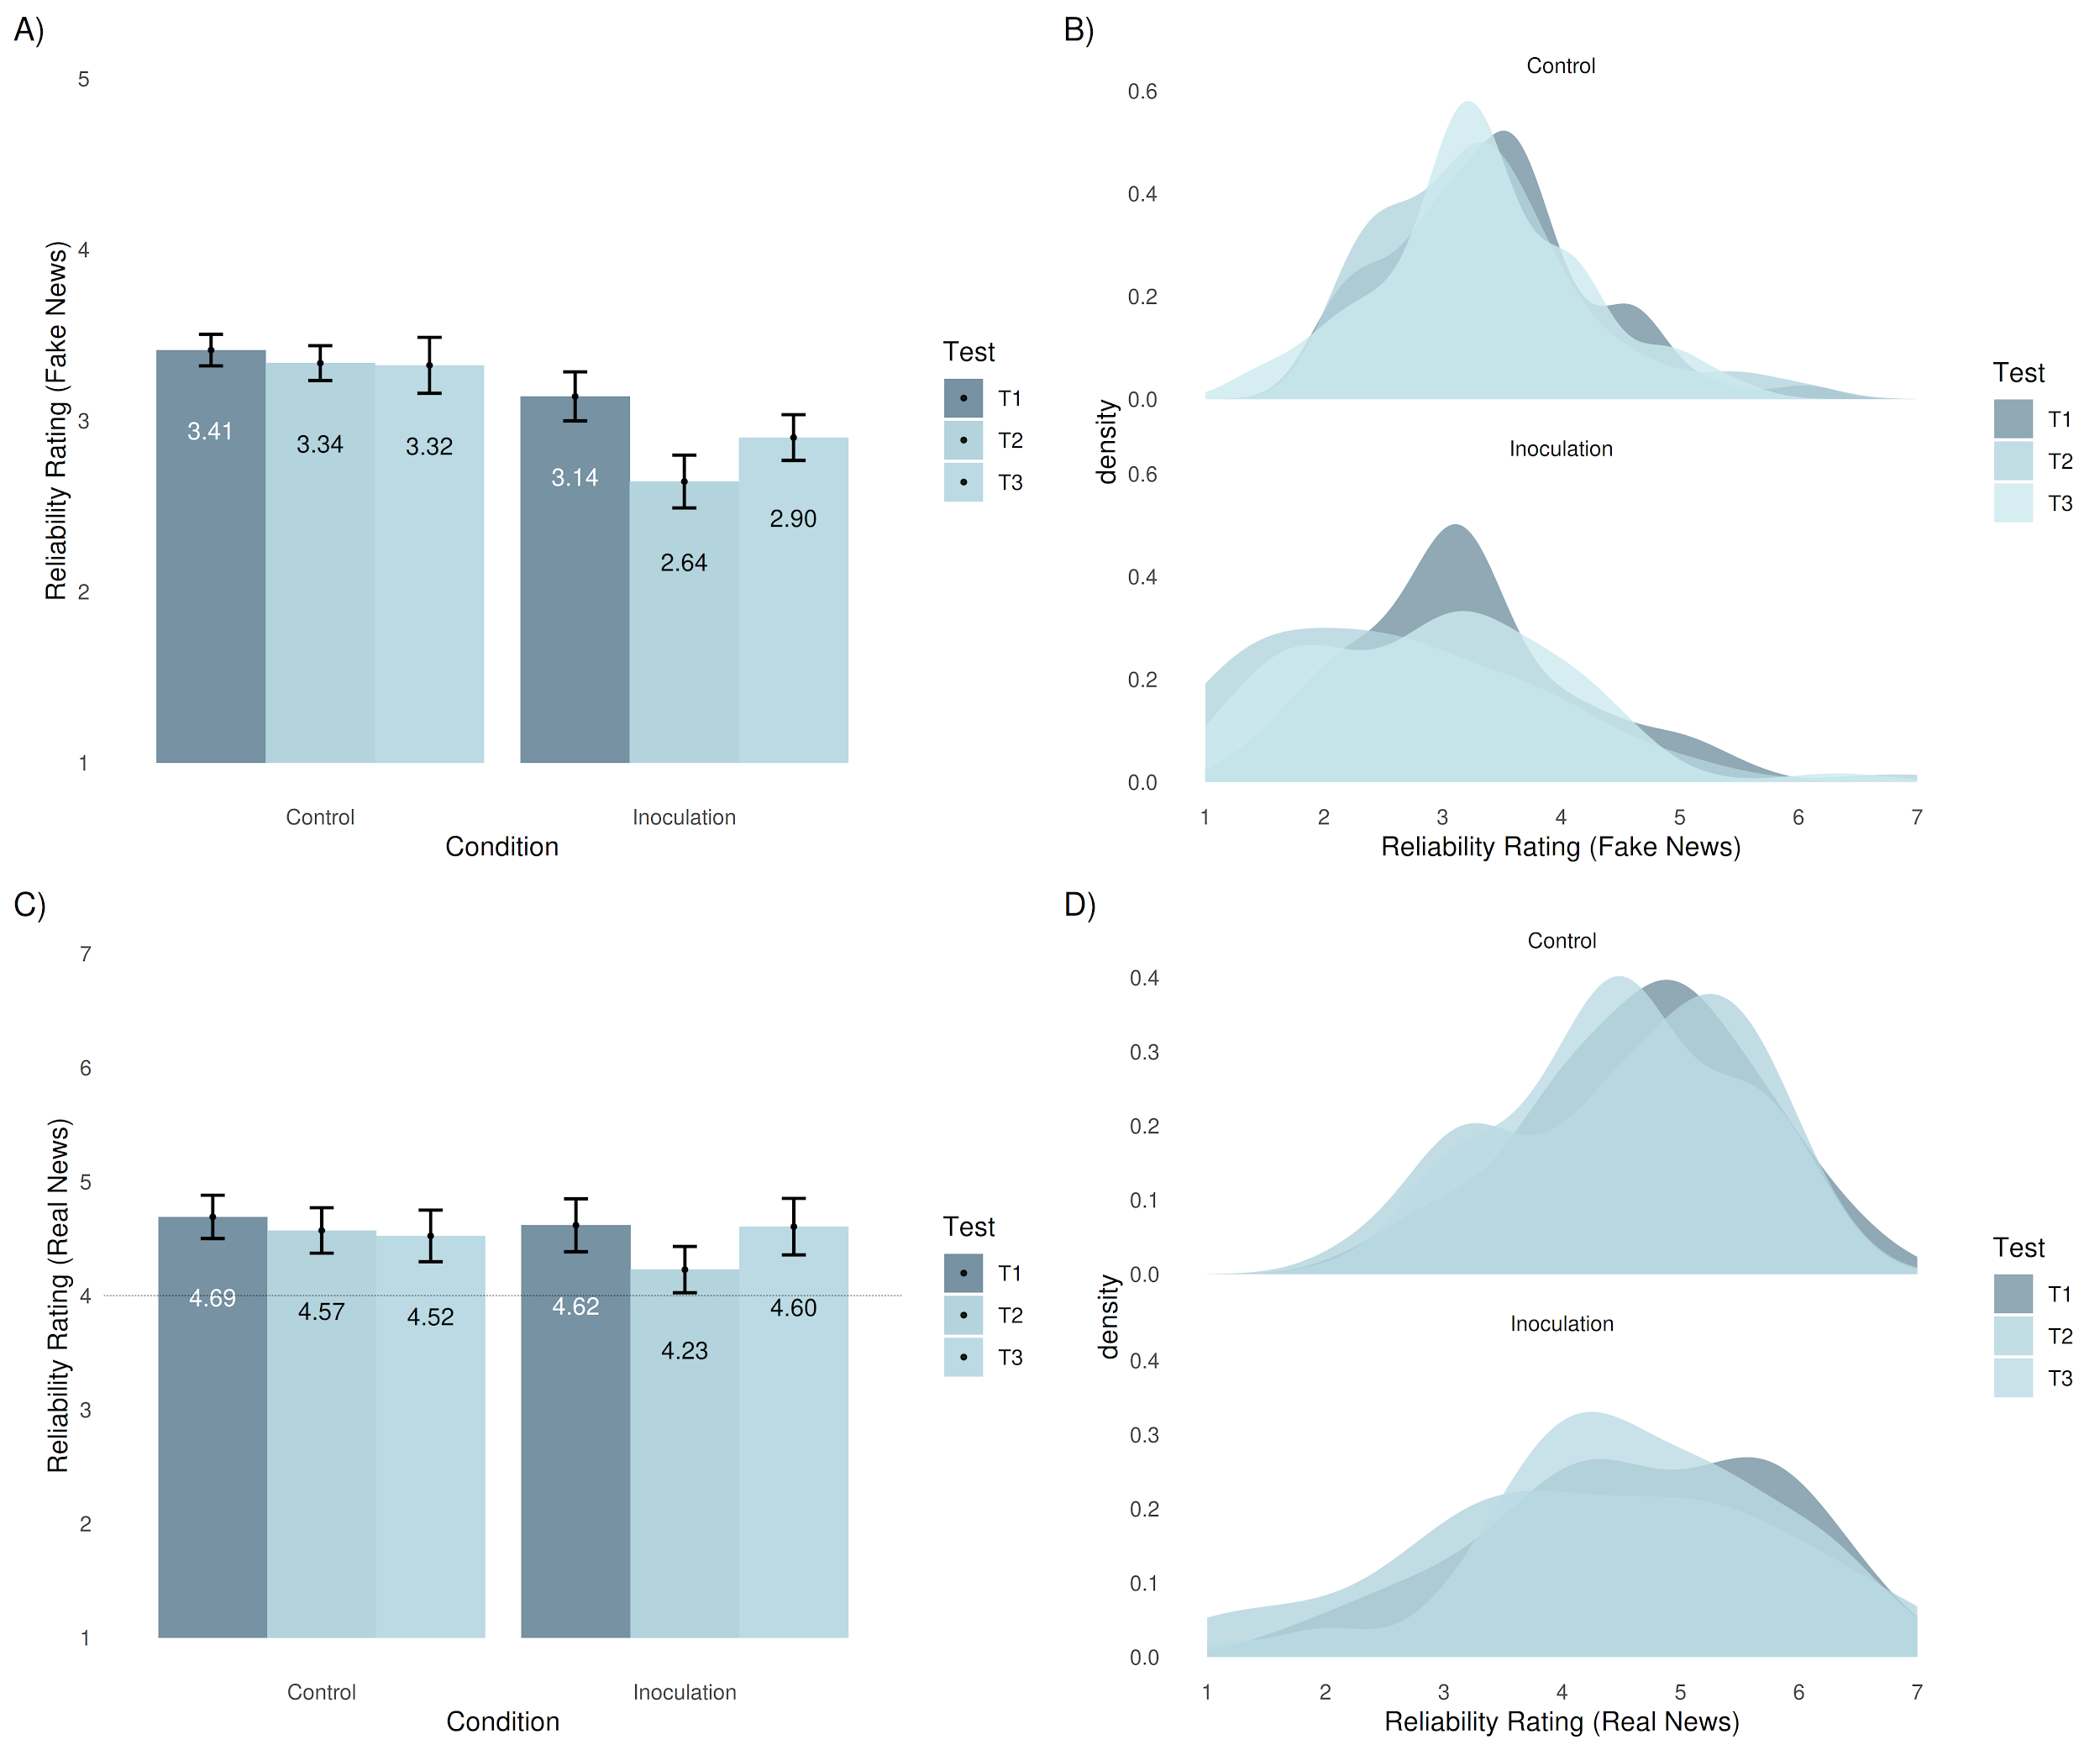
Note. Bar charts (A, C) and density plots (B, D) of fake news (upper row) and real news (lower row) reliability ratings in Experiment 2. N = 110. Error bars represent 95% confidence intervals.

Figure S4
Reliability Ratings of News Items, Separated by Time and Condition in Experiment 2
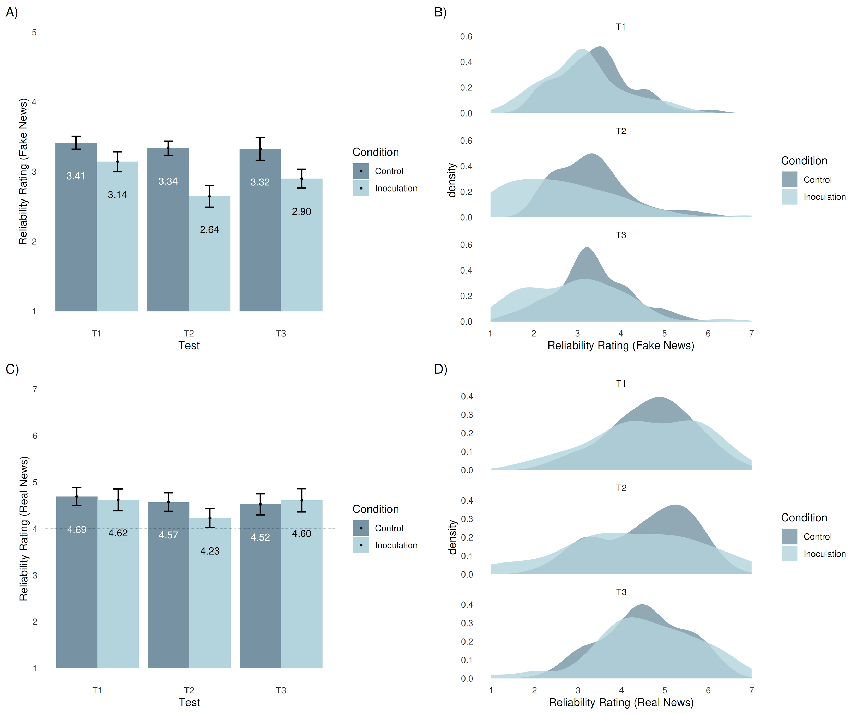
Note. Bar charts (A, C) and density plots (B, D) of fake news (upper row) and real news (lower row) reliability ratings in Experiment 2. N = 110. Error bars represent 95% confidence intervals.

Figure S5
Scree Plot Based on All 18 Fake News Items in Experiment 1 (N = 118) at T1
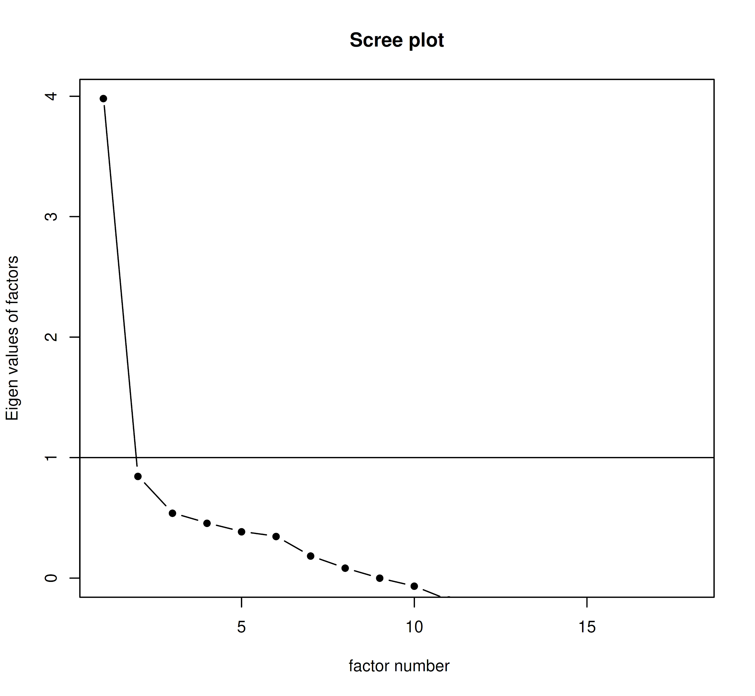

Analysis S1
Exploratory analyses of key demographic variables in inoculation group (n = 58). Panel A: pretest aggregated fake news reliability ratings. Panel B: T5-T1 difference score of these ratings.
Ideology
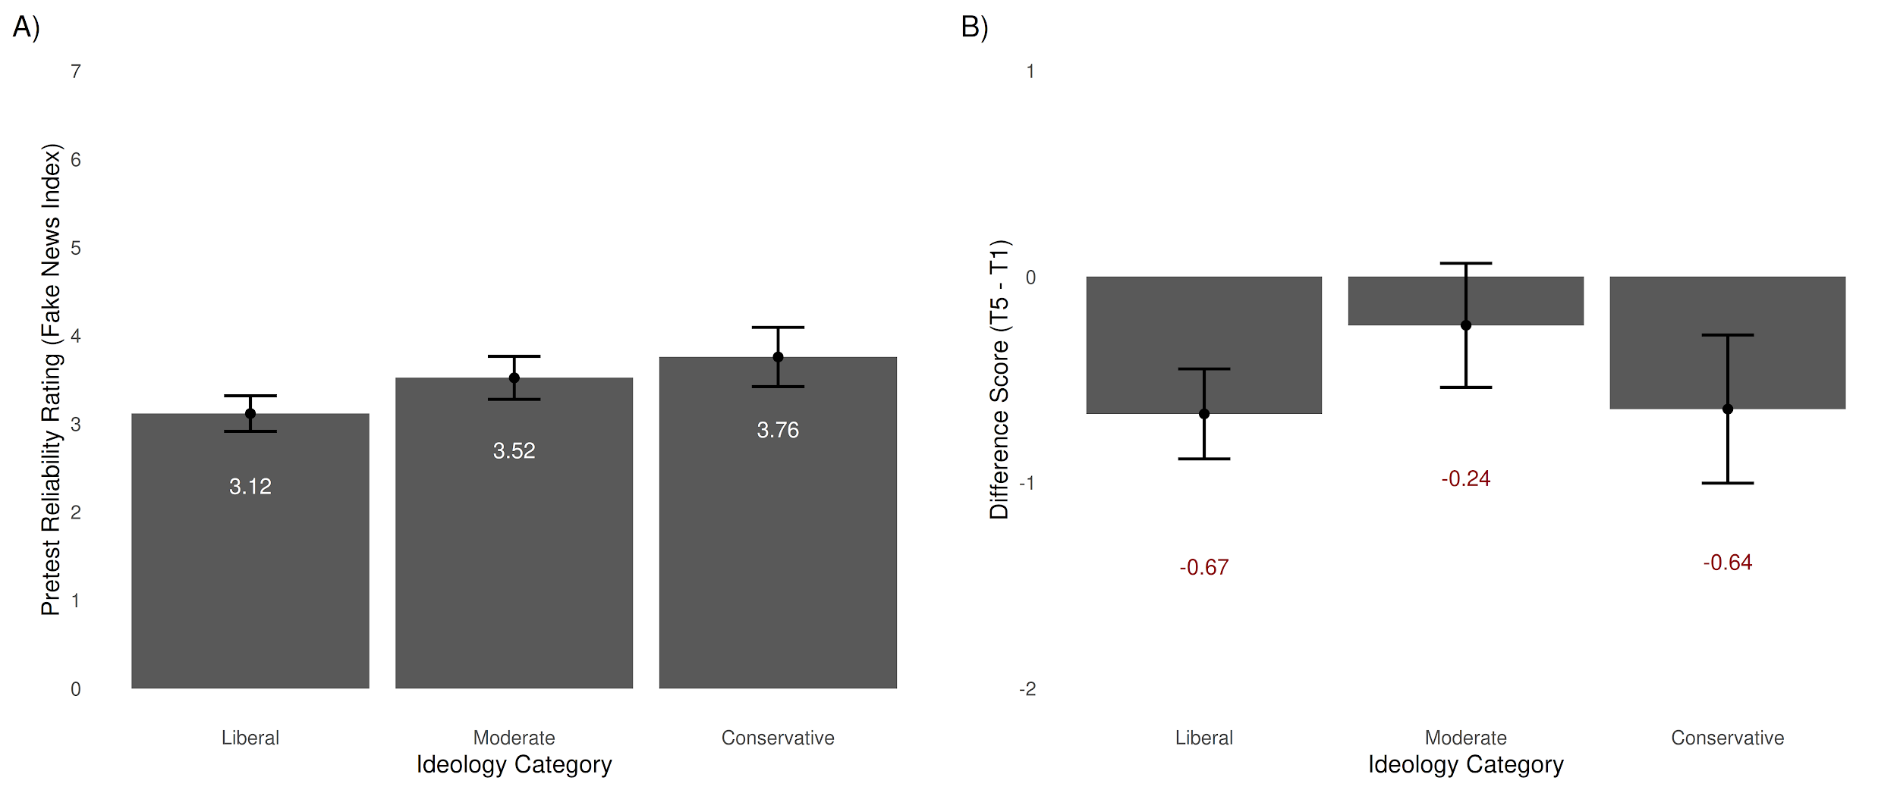
Education
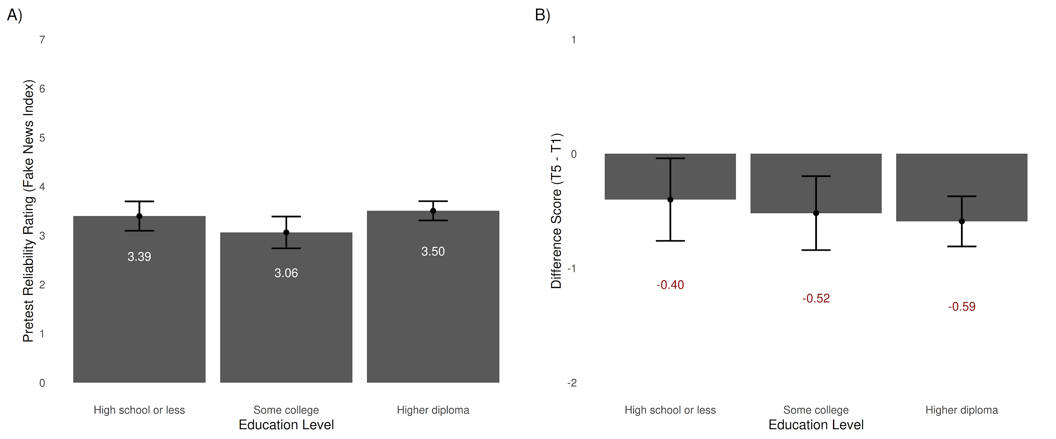
Age
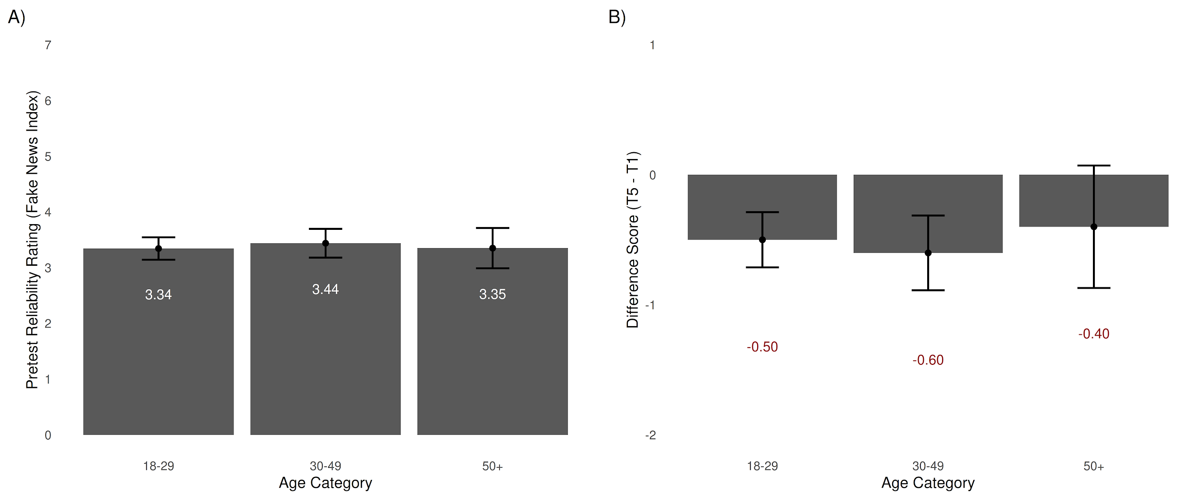Gender
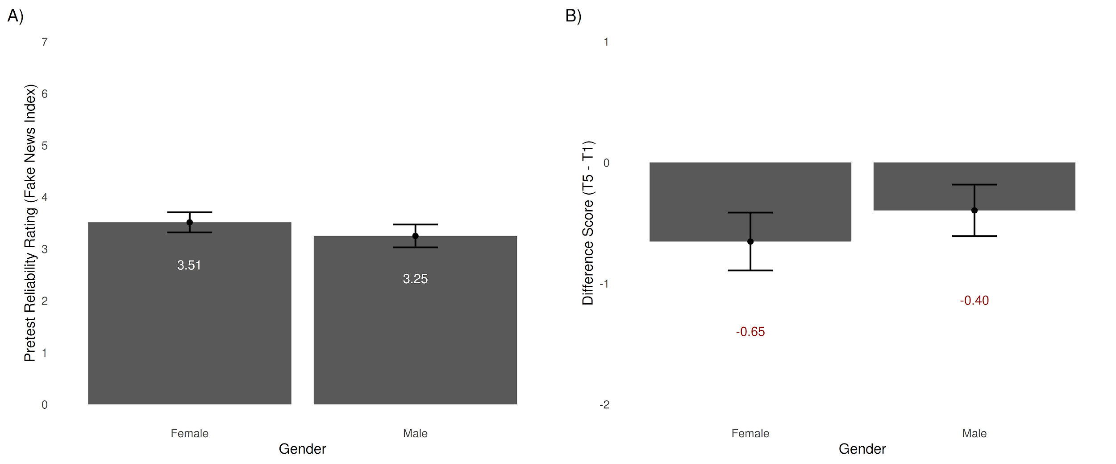

Declaration S1
Deviations From Pre-Registrations
Experiment 1 (https://aspredicted.org/xn6qy.pdf)
Experiment 2 (no pre-registration)
Experiment 3 (https://aspredicted.org/ka2at.pdf)
Analyses
- At a later stage, we decided to extend Experiment 1 with two additional follow-ups. To prevent multiple testing artefacts, instead of testing seven different news categories for each hypothesis test and each time (7 x 2 x 5 = 70 tests), we have aggregated all 18 fake news items in one index with good internal consistency (M = 3.28, SD = 0.84, Cronbach’s alpha = 0.81) and use this index for each analysis (1 x 2 x 5 = 10 tests). However, for completeness, we have included the raw means and within-group difference scores for all subcategories for each timepoint in Supplementary Tables S3-S8. All data are available in the datasets as well, which can be found in Supplementary Repository S1.
- While the pre-registered hypothesis H₁ aims to test a pure inoculation effect, the rmANCOVA model in the analysis section does not allow this because it is confounded with the time variable. For this reason, we decided to split the H₁ and H₂ analyses in a normal ANCOVA and a rmANCOVA respectively, for an unbiased hypothesis test.
- Experiment 1 and Experiment 2 use different ‘real news’ items (see Supplementary Information S1 for a comparison of the different items). We have decided not to focus on real news for this project; however, analyses for real news items can be found in Supplementary Tables S3-S8 and have been plotted in Supplementary Figures S1-S4 (see Panels C and D).

Experiment 1
- We have extended our initial design to allow two extra follow-ups. A comparison of the initial design, comparing T1 to T2, and T2 to T3 in, can be found in Supplementary Tables S3-S4.
Experiment 2
- As this experiment was initially part of a different study, an additional dependent variable (confidence ratings, 1-7) was included for each news item. This measure was not analysed for this project.

Experiment 3
- The pre-registration mentioned the standardisation of the different item sets. However, after finding that the data was comparable between both the item sets used within and between the two experiments, we kept the original scale. This was done to provide more clarity and interpretability of the results.
- During the one-week delay period, we decided to change the design by adding five extra real news items for the follow-up measure, equalising the fake:real ratio to 6:6.
- We have added an additional T2-T1 between-groups difference score analysis, to provide more clarity on the similarity of the baseline inoculation effect between the two experiments.
- Real news analyses were not included in the pre-registration and have been added in the Exploratory section.

Repository S1
OSF Repository of Materials Used in Experiment 1, Experiment 2, and Experiment 3
OSF Inventory
https://doi.org/10.17605/OSF.IO/2DTKB
- Pre-registration
A copy of the original pre-registration from AsPredicted.
- Materials
All items used for pretest and posttest measurements.
- Experiment 1
  - Dataset
Full anonymised dataset.
  - Analysis Code
Full R scripts used for analyses, starting from raw dataset.

- Experiment 2
  - Dataset
Full anonymised dataset.
  - Analysis Code
Full R scripts used for analyses, starting from raw dataset.
- Experiment 3
  - Dataset
Full anonymised dataset.
  - Analysis Code
Full R scripts used for analyses, starting from raw dataset.

The real news index has proven to be unreliable due to the low item count. A related study provides evidence that using Bad News the reliability ratings of real news items in fact goes up (Roozenbeek, Maertens, et al., 2020), and that the opposite results found here are potentially due to an interaction between the specific item set and the pretest-posttest design.
The real news index has proven to be unreliable due to the low item count. A related study provides evidence that using Bad News the reliability ratings of real news items in fact goes up (Roozenbeek, Maertens, et al., 2020), and that the opposite results found here are potentially due to an interaction between the specific item set and the pretest-posttest design.

