Supplemental Material

Attention and prediction error as mechanisms for theory protection?

Evan J. Livesey¹, Yvonne Y. Chan¹, Shu Chen¹, Hilary J. Don^{1,2}

¹The University of Sydney
²University College London

Parameter analysis
The use of randomly sampled parameter sets for each simulated participant was intended to estimate the general predictions of the model under a range of parameter values. This approach does not directly address whether a single parameter set could account for all observed phenomena across studies. To assess whether there is systematicity across the successful parameters in the different simulations, we have plotted the distribution of parameters for successful and unsuccessful simulations (Figure S1), as well as for successful simulations by experiment (Figure S2). For greater clarity of the pattern of parameter distributions, we counted successful simulations as those that produced a difference in ratings in the predicted direction >= .2, and unsuccessful simulations as those that predicted a difference in test ratings < 0. This gave 3196 successful and 2214 unsuccessful simulations. Although there is a large spread in successful simulation parameters, the overall pattern of results suggest that successful simulations are associated with more attention shifting, higher attention capacity, and lower context salience. Low values of exemplar specificity also produce more unsuccessful simulations. See Table S1 for a summary of the model parameters.

Figure S1.
Distributions of parameters in successful and unsuccessful simulations.
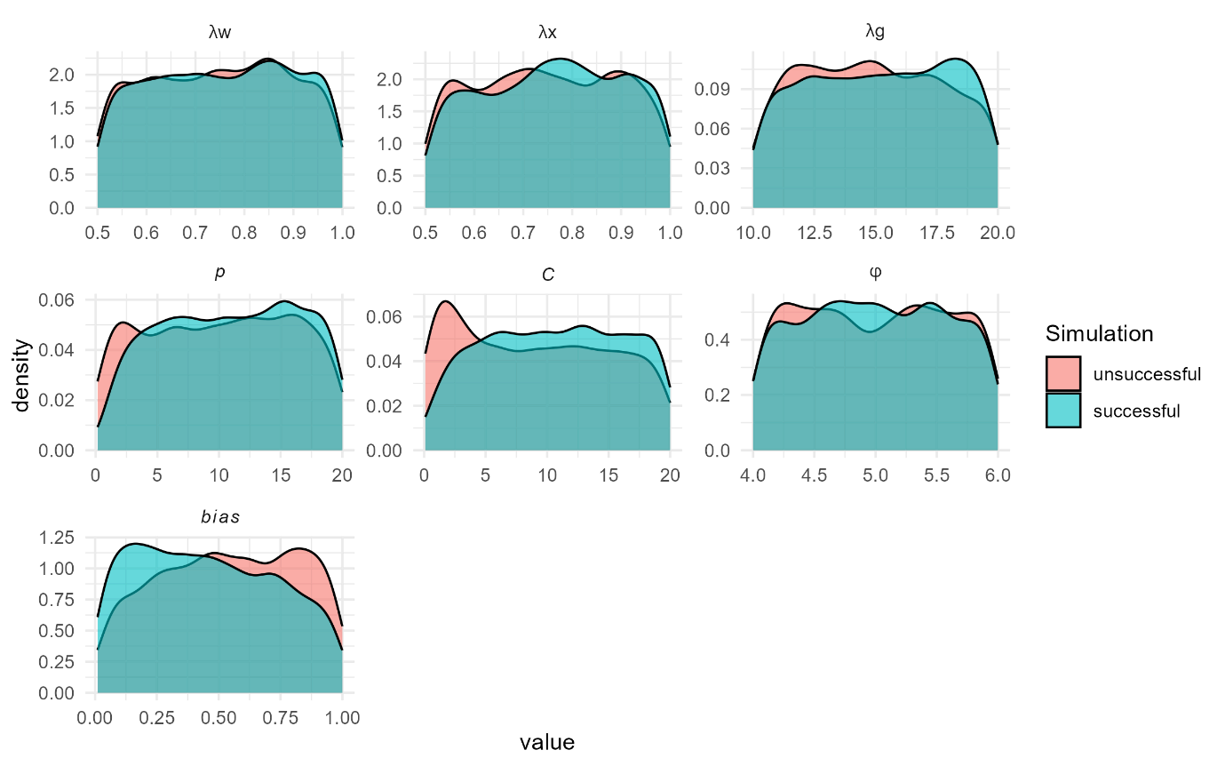

Figure S2.
Distributions of parameters in successful simulations, split by study.
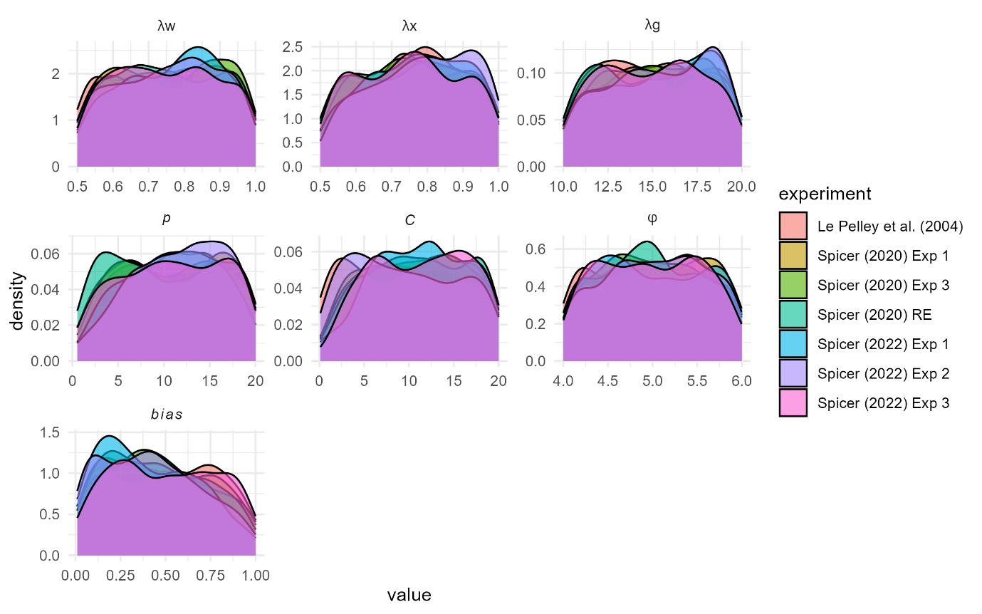

Table S1.
Summary of EXIT model parameters
Parameter | Symbol | Range | Description
Learning rate | λw | 0.5 – 1.0 | Governs how quickly associations update across trials. Higher values mean faster learning.
Attention learning rate | λx | 0.5 – 1.0 | Controls how much of the attention shift from one trial is retained into the next.
Attention shift rate | λg | 10.0 – 20.0 | Determines how quickly attention shifts during a single trial.
Attention capacity | P | 0.1 – 20.0 | Capacity constraint on attention
Exemplar specificity | c | 0.1 – 20.0 | Higher values indicate higher specificity of the exemplar nodes.
Choice decisiveness | Φ | 4.0 – 6.0 | High values produce more deterministic responding; low values allow more probabilistic or noisy choices.
Salience of the context | Bias | 0.01 – 1.0 | The relative salience of the context cue, all other cue saliences are fixed at 1.

