Supplemental Table S1

Descriptives of Teen Dating Violence, Post-Traumatic Stress Symptoms, Depressive Symptoms, and Substance Use at Baseline and Follow Up
Individual Behaviors or Symptoms | Frequency at baseline (%) | Frequency at follow up (%)
Teen dating violence behaviors
CADRI-5: I did something to make him/her feel jealous
No | 495 (84.8) | 532 (91.1)
Yes | 89 (15.2) | 52 (8.9)
CADRI-6: He/She did something to make me feel jealous
No | 489 (84.7) | 525 (89.9)
Yes | 95 (16.3) | 59 (10.1)
CADRI-9: I brought up something bad that he/she had done in the past
No | 505 (86.5) | 536 (91.8)
Yes | 79 (13.5) | 48 (8.2)
CADRI-10: He/She brought up something bad that I had done in the past
No | 501 (85.8) | 521 (89.2)
Yes | 83 (14.2) | 63 (10.8)
CADRI-11: I threw something at him/her
No | 544 (93.2) | 568 (97.3)
Yes | 40 (6.8) | 16 (2.7)
CADRI-12: He/She threw something at me
No | 544 (93.2) | 569 (97.4)
Yes | 40 (6.8) | 15 (2.6)
CADRI-13: I said things just to make him/her angry
No | 490 (83.9) | 526 (90.1)
Yes | 94 (16.1) | 58 (9.9)
CADRI-14: He/She said things just to make me angry
No | 481 (82.4) | 511 (87.5)
Yes | 103 (17.6) | 73 (12.5)
CADRI-15: I spoke to him/her in a hostile or mean tone of voice
No | 495 (84.8) | 521 (89.2)
Yes | 89 (15.2) | 63 (10.8)
CADRI-16: He/She spoke to me in a hostile or mean tone of voice
No | 495 (84.8) | 517 (88.5)
Yes | 89 (15.2) | 67 (11.5)
CADRI-21: I insulted him/her with put downs
No | 555 (95.0) | 559 (95.7)
Yes | 29 (5.0) | 25 (4.3)
CADRI-22: He/She insulted me with put downs
No | 545 (93.3) | 551 (94.3)
Yes | 39 (6.7) | 33 (5.7)
CADRI-27: I ridiculed or made fun of him/her in front of others
No | 538 (92.1) | 571 (97.8)
Yes | 46 (7.9) | 13 (2.2)
CADRI-28: He/She ridiculed or made fun of me in front of others
No | 537 (92.0) | 561 (96.1)
Yes | 47 (8.0) | 23 (3.9)
CADRI-29: I kept track of who he/she was with and where he/she was
No | 498 (85.3) | 533 (91.3)
Yes | 86 (14.7) | 51 (8.7)
CADRI-30: He/She kept track of who I was with and where I was
No | 492 (84.2) | 527 (90.2)
Yes | 92 (15.8) | 57 (9.8)
CADRI-31: I blamed him/her for the problem
No | 524 (89.7) | 525 (89.9)
Yes | 60 (10.3) | 59 (10.1)
CADRI-32: He/She blamed me for the problem
No | 504 (86.3) | 519 (88.9)
Yes | 80 (13.7) | 65 (11.1)
CADRI-33: I kicked, hit, or punched him/her
No | 544 (93.2) | 97.9)
Yes | 40 (6.8) | 12 (2.1)
CADRI-34: He/She kicked, hit, or punched me
No | 551 (94.3) | 565 (96.7)
Yes | 33 (5.7) | 19 (3.3)
CADRI-35: I accused him/her of flirting with another guy/girl
No | 508 (87.0) | 531 (90.9)
Yes | 76 (13.0) | 53 (9.1)
CADRI-36: He/She accused me of flirting with another girl/guy
No | 502 (86.0) | 537 (92.0)
Yes | 82 (14.0) | 47 (8.0)
CADRI-39: I slapped him/her or pulled his/her hair
No | 554 (94.9) | 573 (98.1)
Yes | 30 (5.1) | 11 (1.9)
CADRI-40: He/She slapped me or pulled my hair
No | 550 (94.2) | 571 (97.8)
Yes | 34 (5.8) | 13 (2.2)
CADRI-43: I threated to end the relationship
No | 524 (89.7) | 543 (93.0)
Yes | 60 (10.3) | 41 (7.0)
CADRI-44: He/She threatened to end the relationship
No | 518 (88.7) | 541 (92.6)
Yes | 66 (11.3) | 43 (7.4)
CADRI-47: I pushed, shoved or shook him/her
No | 547 (93.7) | 567 (97.1)
Yes | 37 (6.3) | 17 (2.9)
CADRI-48: He/She pushed, shoved or shook me
No | 544 (93.2) | 564 (96.6)
Yes | 40 (6.8) | 20 (3.4)
Trauma symptoms
TSC-1: Having bad dreams or nightmares
No | 195 (33.4) | 148 (25.3)
Yes | 389 (66.6) | 436 (74.7)
TSC-3: Scary ideas or pictures just popping into my head
No | 265 (45.4) | 211 (36.1)
Yes | 319 (54.6) | 373 (63.9)
TSC-7: Remembering things that happened that I didn’t like
No | 192 (32.9) | 131 (22.4)
Yes | 392 (67.1) | 453 (77.6)
TSC-8: Going away in my mind, trying not to think
No | 235 (40.2) | 145 (24.8)
Yes | 349 (59.8) | 439 (75.2)
TSC-10: Remembering scary things
No | 258 (44.2) | 216 (37.0)
Yes | 326 (55.8) | 368 (63.0)
TSC-18: Feeling scared of men
No | 429 (73.5) | 465 (79.6)
Yes | 155 (26.5) | 119 (20.4)
TSC-19: Feeling scared of women
No | 490 (83.9) | 523 (89.6)
Yes | 94 (16.1) | 61 (10.4)
TSC-24: Can’t stop thinking about something bad that happened to me
No | 328 (56.2) | 401 (68.7)
Yes | 256 (43.8) | 183 (31.3)
TSC-30: Remember things I don’t want to remember
No | 273 (46.7) | 288 (49.3)
Yes | 311 (53.3) | 296 (50.7)
TSC-34: Wish bad things had never happened
No | 277 (47.4) | 258 (44.2)
Yes | 307 (52.6) | 326 (55.8)
Depressive symptoms
PHQ-1: Feeling down, depressed, irritable, or hopeless?
No | 323 (55.3) | 287 (49.1)
Yes | 261 (44.7) | 297 (50.9)
PHQ-2: Little interest or pleasure in doing things?
No | 291 (49.8) | 290 (49.7)
Yes | 293 (50.2) | 294 (50.3)
PHQ-3: Trouble falling asleep, staying asleep, or sleeping too much?
No | 247 (42.3) | 152 (26.0)
Yes | 337 (57.7) | 432 (74.0)
PHQ-4: Poor appetite, weight loss, or overeating?
No | 348 (59.6) | 377 (64.6)
Yes | 236 (40.4) | 207 (35.4)
PHQ-5: Feeling tired, or having little energy?
No | 218 (37.3) | 128 (23.6)
Yes | 366 (62.7) | 446 (76.4)
PHQ-6: Feeling bad about yourself- or feeling that you are a failure, or that you have let yourself or your family down?
No | 341 (58.4) | 355 (60.8)
Yes | 243 (41.6) | 299 (39.2)
PHQ-7: Trouble concentrating on things like school work, reading, or watching TV?
No | 295 (50.5) | 235 (40.2)
Yes | 289 (49.5) | 349 (59.8)
PHQ-8: Moving or speaking so slowly that other people could have noticed? Or the opposite- being so fidgety or restless that you were moving around a lot more than usual?
No | 406 (69.5) | 463 (79.3)
Yes | 178 (30.5) | 121 (20.7)
PHQ-9: Thoughts that you would be better off dead, or of hurting yourself in some way?
No | 430 (73.6) | 493 (84.4)
Yes | 178 (30.5) | 91 (15.6)
Substance use
SUQ-1: Marijuana
No | 446 (76.4) | 509 (87.2)
Yes | 138 (23.6) | 75 (12.8)
SUQ-4: Opiates
No | 565 (96.7) | 572 (97.9)
Yes | 19 (3.3) | 12 (2.1)
SUQ-5: Stimulants
No | 557 (95.4) | 573 (98.1)
Yes | 27 (4.6) | 11 (1.9)
SUQ-6: Alcohol
No | 434 (74.3) | 501 (85.8)
Yes | 150 (25.7) | 83 (14.2)

Note. CADRI = Conflict in Adolescent Dating Relationships Inventory (CADRI) to assess teen dating violence. Substance use was assessed by asking adolescents’ use of each substance in the past 6 months. TSC = Trauma Symptoms Checklist for Children to assess post-traumatic stress. PHQ-9 = Patient Health Questionnaire-9 to assess depressive symptoms. Numbers next to the measure (e.g., PHQ-1) represent the item number in the questionnaire.

Supplemental Table S2

Spearman Correlations Between Physical and Psychological Perpetration and Victimization with Distress Outcomes
Distress outcomes | Physical perpetration | Psychological perpetration | Physical victimization | Psychological victimization
Baseline
Post-traumatic stress | 0.07 | 0.13 | 0.06 | 0.12
Depressive symptoms | 0.12 | 0.18 | 0.10 | 0.20
Marijuana | 0.23 | 0.22 | 0.21 | 0.23
Opiates | 0.12 | 0.05 | 0.11 | 0.05
Stimulants | 0.13 | 0.04 | 0.15 | 0.06
Alcohol | 0.20 | 0.18 | 0.16 | 0.16
Follow up
Post-traumatic stress | 0.03 | 0.06 | 0.01 | 0.09
Depressive symptoms | 0.03 | 0.07 | -0.01 | 0.07
Marijuana | 0.28 | 0.36 | 0.26 | 0.38
Opiates | 0.20 | 0.12 | 0.19 | 0.11
Stimulants | 0.15 | 0.13 | 0.14 | 0.12
Alcohol | 0.21 | 0.32 | 0.24 | 0.31
Note. Physical victimization, psychological victimization, physical perpetration and psychological perpetration were assessed via the Conflict in Adolescent Dating Relationships Inventory (CADRI). Substance use was assessed by asking adolescents’ use of each substance in the past 6 months. Post-traumatic stress symptoms was assessed via the PTS subscale in the Trauma Symptoms Checklist for Children (TSCC) and depressive symptoms via the Patient Health Questionnaire-9 (PHQ-9).

Supplemental Table S3

Top Five Edge Weights in Parsimonious Baseline Network
Node 1 | Node 2 | Average Odds Ratios [95%CI]
CADRI-47: I pushed, shoved or shook him/her | CADRI-48: He/She pushed, shoved or shook me | 4.89 [-5.69, 15.47]
CADRI-15: I spoke to him/her in a hostile or mean tone of voice | CADRI-16: He/She spoke to me in a hostile or mean tone of voice | 4.29 [3.17, 5.40]
CADRI-9: I brought up something bad that he/she had done in the past | CADRI-10: He/She brought up something bad that I had done in the past | 3.87 [2.85, 4.90]
CADRI-29: I kept track of who he/she was with and where he/she was | CADRI-30: He/She kept track of who I was with and where I was | 3.84 [2.90, 4.89]
CADRI-13: I said things just to make him/her angry | CADRI-14: He/She said things just to make me angry | 3.65 [2.43, 4.86]
CADRI 21: I insulted him/her with put downs. | CADRI-22: He/She insulted me with put downs | 3.31 [-6.34, 12.96]

Note. CADRI = Conflict in Adolescent Dating Relationships Inventory (CADRI) to assess teen dating violence. The average odds ratios represent the relationship between nodes or edge strength. Numbers next to the measure (e.g., CADRI-47) represent the item number in the questionnaire.

Supplemental Figure S4

Differences in Edges for Parsimonious Baseline Model
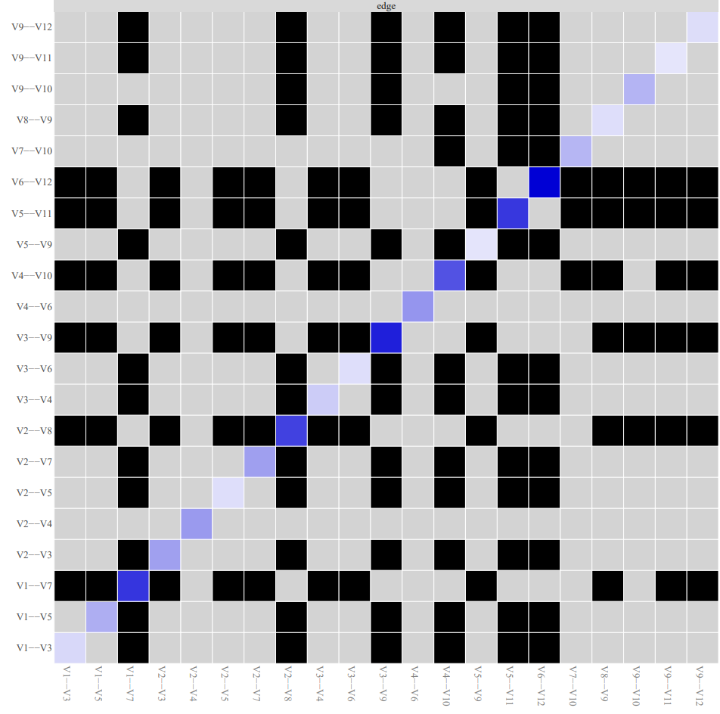

Note. Black boxes indicate edges that are different from one another.

Supplemental Table S5

Top Five Edge Weights in Baseline Network by Gender Identity
Node 1 | Node 2 | Average Odds Ratios [95% CI]
Female
CADRI-48: He/She pushed, shoved or shook me | CADRI-47: I pushed, shoved or shook him/her | 4.71 [-9.30, 18.72]
CADRI-16: He/She spoke to me in a hostile or mean tone of voice | CADRI-9: I brought up something bad that he/she had done in the past | 3.30 [-2.54, 11.35]
CADRI-30: He/She kept track of who I was with and where I was | CADRI-29: I kept track of who he/she was with and where he/she was | 3.95 [0.53, 7.38]
CADRI-14: He/She said things just to make me angry | CADRI-13: I said things just to make him/her angry | 3.46 [-2.09, 9.00]
CADRI-22: He/She insulted me with put downs | CADRI-21: I insulted him/her with put downs | 3.14 [-5.51, 11.79]
Male
CADRI-48: He/She pushed, shoved or shook me | CADRI-47: I pushed, shoved or shook him/her | 5.46 [-1.63, 12.54]
CADRI-16: He/She spoke to me in a hostile or mean tone of voice | CADRI-15: I spoke to him/her in a hostile or mean tone of voice | 3.97 [-2.21, 10.15]
CADRI-10: He/She brought up something bad that I had done in the past | CADRI-9: I brought up something bad that he/she had done in the past | 3.64 [-3.03, 10.32]
CADRI-14: He/She said things just to make me angry | CADRI-13: I said things just to make him/her angry | 3.20 [-3.02, 9.43]
CADRI-22: He/She insulted me with put downs | CADRI-21: I insulted him/her with put downs | 3.20 [-8.64, 15.05]
Note. CADRI = Conflict in Adolescent Dating Relationships Inventory (CADRI) to assess teen dating violence. The average odds ratios represent the relationship between nodes or edge strength. Numbers next to the measure (e.g., CADRI-48) represent the item number in the questionnaire.

Supplemental Figure S6

Differences in Edges in Baseline Network by Gender Identity
- Female
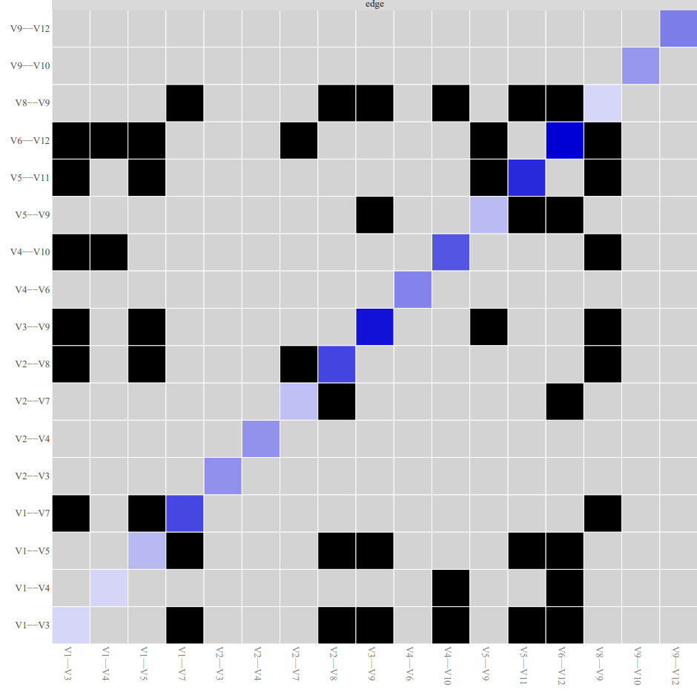

- Male
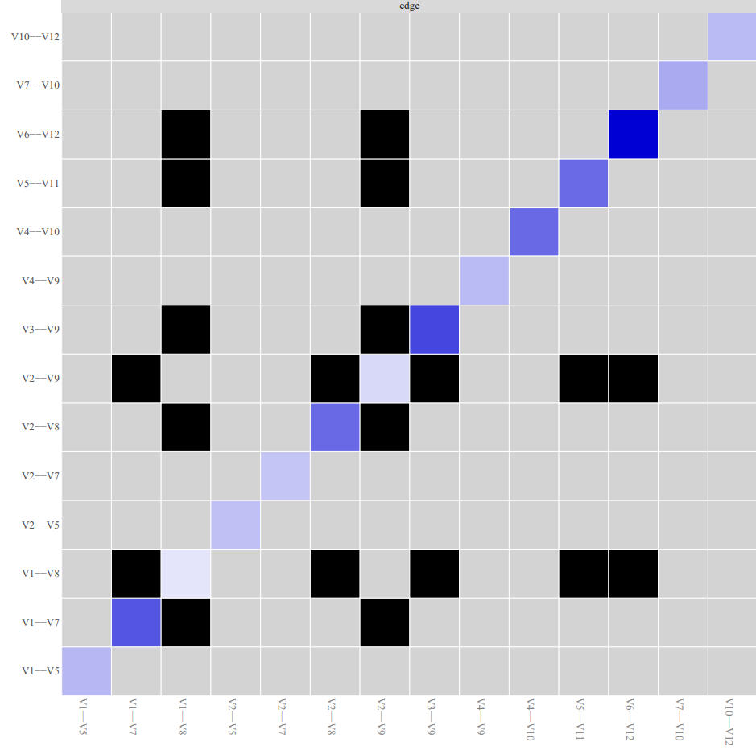
Note. Black boxes indicate edges that are different from one another.

Supplemental Table S7

Top Five Nodes with the Highest Expected Influence in Baseline Network by Gender Identity
 | Expected Influence
Female
CADRI-15: I spoke to him/her in a hostile or mean tone of voice | 8.97
CADRI-22: He/She insulted me with put downs | 8.51
CADRI-14: He/She said things just to make me angry | 8.04
CADRI-47: I pushed, shoved or shook him/her | 7.73
CADRI-16: He/She spoke to me in a hostile or mean tone of voice | 7.70
Male
CADRI-47: I pushed, shoved or shook him/her | 8.57
CADRI-22: He/She insulted me with put downs | 7.38
CADRI-9: I brought up something bad that he/she had done in the past | 7.09
CADRI-14: He/She said things just to make me angry | 7.07
CADRI-30: He/She kept track of who I was with and where I was | 6.77
Note. CADRI = Conflict in Adolescent Dating Relationships Inventory (CADRI) to assess teen dating violence. Numbers next to the measure (e.g., CADRI-15) represent the item number in the questionnaire.

Supplemental Figure S8

Ranking of Expected Influence in Baseline Network by Gender Identity
- Female
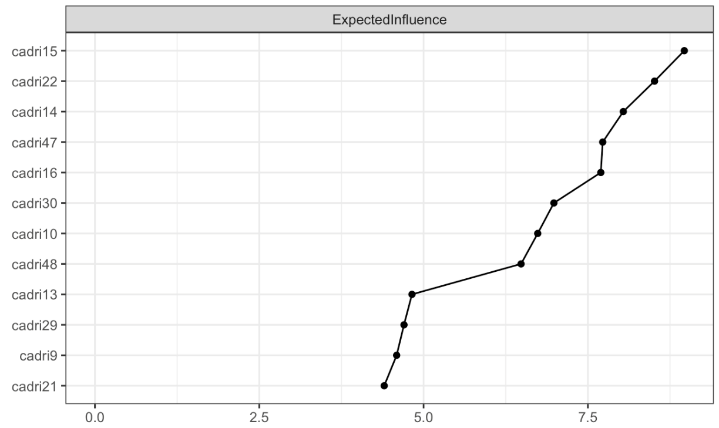
- Male
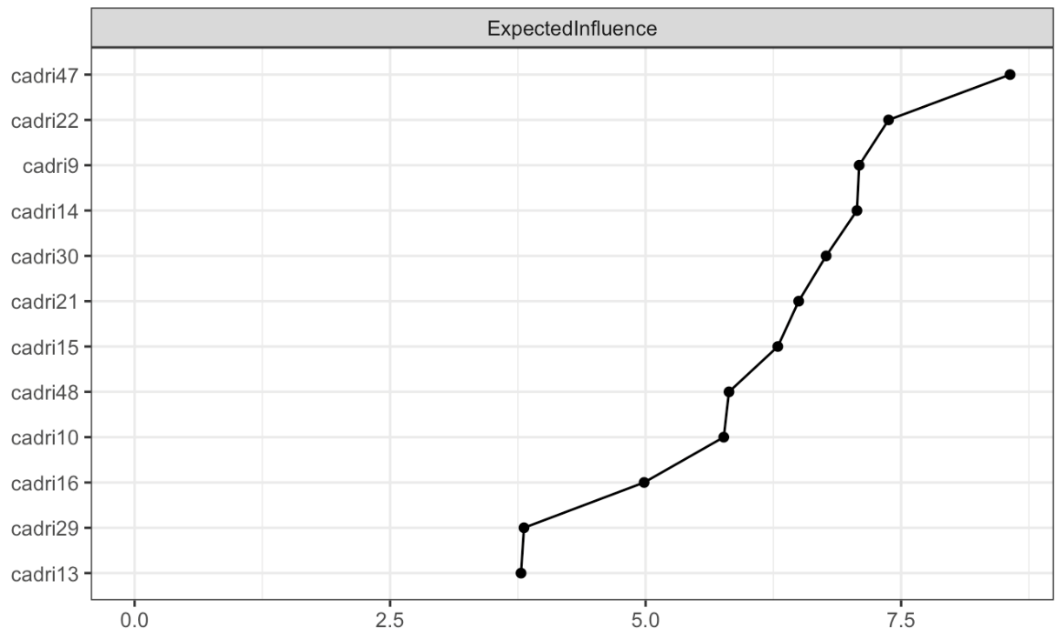

Supplemental Table S9

Top Five Highest Edge Weights in Baseline Network of Adolescents by Racial/Ethnic Identity
Node 1 | Node 2 | Average Odds Ratios [95% CI]
White
CADRI-14: He/She said things just to make me angry | CADRI-13: I said things just to make him/her angry | 11.90 [4.59, 19.21]
CADRI-14: He/She said things just to make me angry | CADRI-47: I pushed, shoved or shook him/her | 6.36 [-0.56, 13. 28]
CADRI-10: He/She brought up something bad that I had done in the past | CADRI-9: I brought up something bad that he/she had done in the past | 5.63 [-3.22, 14.49]
CADRI-14: He/She said things just to make me angry | CADRI-15: I spoke to him/her in a hostile or mean tone of voice | 5.56 [0.20, 10.92]
CADRI-14: He/She said things just to make me angry | CADRI-22: He/She insulted me with put downs | 4.87 [-1.48, 11.22]
Non-White
CADRI-30: He/She kept track of who I was with and where I was | CADRI-29: I kept track of who he/she was with and where he/she was | 4.92 [1.18, 8.65]
CADRI-48: He/She pushed, shoved or shook me | CADRI-47: I pushed, shoved or shook him/her | 4.57 [-5.94, 15.07]
CADRI-16: He/She spoke to me in a hostile or mean tone of voice | CADRI-15: I spoke to him/her in a hostile or mean tone of voice | 4.35 [0.62, 8.09]
CADRI-10: He/She brought up something bad that I had done in the past | CADRI-9: I brought up something bad that he/she had done in the past | 3.64 [2.55, 4.73]
CADRI-22: He/She insulted me with put downs | CADRI-21: I insulted him/her with put downs | 3.53 [-10.16, 17.21]
Black
CADRI-30: He/She kept track of who I was with and where I was | CADRI-29: I kept track of who he/she was with and where he/she was | 6.13 [-1.54, 13.80]
CADRI-48: He/She pushed, shoved or shook me | CADRI-47: I pushed, shoved or shook him/her | 4.63 [-1.77, 11.03]
CADRI-10: He/She brought up something bad that I had done in the past | CADRI-9: I brought up something bad that he/she had done in the past | 4.57 [-3.66, 12.81]
CADRI-16: He/She spoke to me in a hostile or mean tone of voice | CADRI-15: I spoke to him/her in a hostile or mean tone of voice | 3.78 [-2.47, 10.03]
CADRI-14: He/She said things just to make me angry | CADRI-13: I said things just to make him/her angry | 2.96 [-6.74, 12.67]
Non-Black
CADRI-48: He/She pushed, shoved or shook me | CADRI-47: I pushed, shoved or shook him/her | 4.30 [-3.79, 12.38]
CADRI-16: He/She spoke to me in a hostile or mean tone of voice | CADRI-15: I spoke to him/her in a hostile or mean tone of voice | 4.23 [0.11, 8.35]
CADRI-14: He/She said things just to make me angry | CADRI-13: I said things just to make him/her angry | 4.05 [1.68, 6.42]
CADRI-22: He/She insulted me with put downs | CADRI-21: I insulted him/her with put downs | 3.94 [-13.47, 21.36]
CADRI-30: He/She kept track of who I was with and where I was | CADRI-29: I kept track of who he/she was with and where he/she was | 3.54 [-0.17, 7.25]
Hispanic
CADRI-22: He/She insulted me with put downs | CADRI-21: I insulted him/her with put downs | 4.88 [-2.44, 12.21]
CADRI-30: He/She kept track of who I was with and where I was | CADRI-29: I kept track of who he/she was with and where he/she was | 4.61 [-3.52, 12.74]
CADRI-48: He/She pushed, shoved or shook me | CADRI-47: I pushed, shoved or shook him/her | 4.22 [-3.01, 11.45]
CADRI-16: He/She spoke to me in a hostile or mean tone of voice | CADRI-15: I spoke to him/her in a hostile or mean tone of voice | 3.98 [-5.26, 13.22]
CADRI-14: He/She said things just to make me angry | CADRI-13: I said things just to make him/her angry | 3.92 [-1.16, 9.00]
Non-Hispanic
CADRI-10: He/She brought up something bad that I had done in the past | CADRI-9: I brought up something bad that he/she had done in the past | 4.95 [0.46, 9.44]
CADRI-48: He/She pushed, shoved or shook me | CADRI-47: I pushed, shoved or shook him/her | 4.77 [-5.63, 15.18]
CADRI-16: He/She spoke to me in a hostile or mean tone of voice | CADRI-15: I spoke to him/her in a hostile or mean tone of voice | 4.34 [0.36, 8.33]
CADRI-30: He/She kept track of who I was with and where I was | CADRI-29: I kept track of who he/she was with and where he/she was | 3.57 [1.50, 5.65]
CADRI-14: He/She said things just to make me angry | CADRI-13: I said things just to make him/her angry | 3.22 [0.73, 5.70]
Multiracial
CADRI-14: He/She said things just to make me angry | CADRI-13: I said things just to make him/her angry | 8.76 [0.66, 16.85]
CADRI-14: He/She said things just to make me angry | CADRI-30: He/She kept track of who I was with and where I was | 8.19 [-1.60, 17.98]
CADRI-16: He/She spoke to me in a hostile or mean tone of voice | CADRI-15: I spoke to him/her in a hostile or mean tone of voice | 5.33 [-2.43, 13.09]
CADRI-16: He/She spoke to me in a hostile or mean tone of voice | CADRI-48: He/She pushed, shoved or shook me | 4.60 [-2.86, 12.06]
CADRI-30: He/She kept track of who I was with and where I was | CADRI-29: I kept track of who he/she was with and where he/she was | 3.51 [-4.83, 11.85]
Non-Multiracial
CADRI-48: He/She pushed, shoved or shook me | CADRI-47: I pushed, shoved or shook him/her | 4.67 [-12.64, 21.98]
CADRI-30: He/She kept track of who I was with and where I was | CADRI-29: I kept track of who he/she was with and where he/she was | 4.47 [2.84, 6.09]
CADRI-16: He/She spoke to me in a hostile or mean tone of voice | CADRI-15: I spoke to him/her in a hostile or mean tone of voice | 4.23 [3.10, 5.36]
CADRI-10: He/She brought up something bad that I had done in the past | CADRI-9: I brought up something bad that he/she had done in the past | 3.66 [2.36, 4.97]
CADRI-14: He/She said things just to make me angry | CADRI-13: I said things just to make him/her angry | 3.57 [2.34, 4.81]
Note. CADRI = Conflict in Adolescent Dating Relationships Inventory (CADRI) to assess teen dating violence. The average odds ratios represent the relationship between nodes or edge strength. Numbers next to the measure (e.g., CADRI-15) represent the item number in the questionnaire.

Supplemental Figure S10

Difference in Edges in Baseline Network by Racial/Ethnic Identity
- White
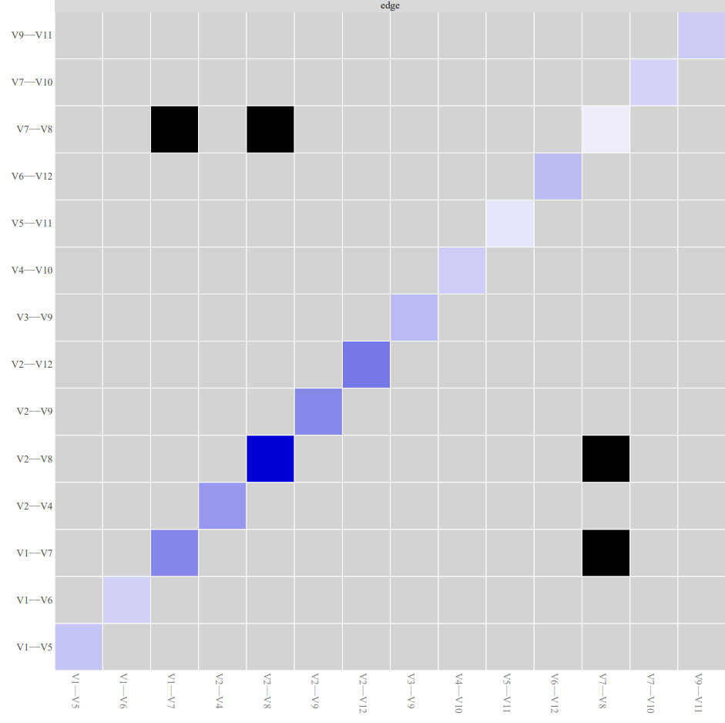

- Non-White

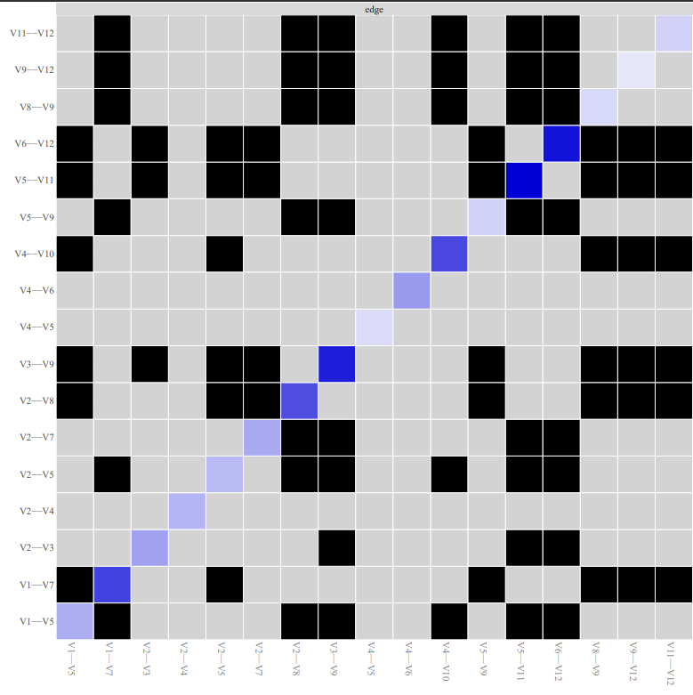

- Black
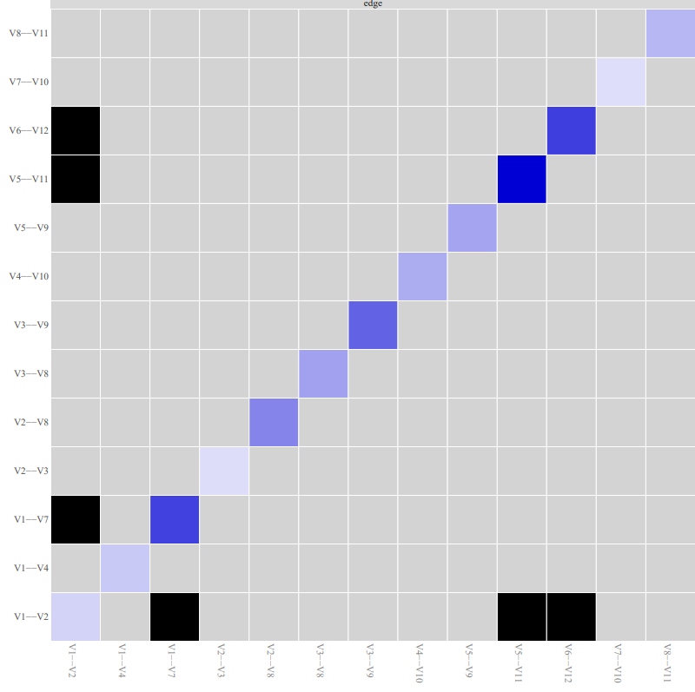

- Non-Black

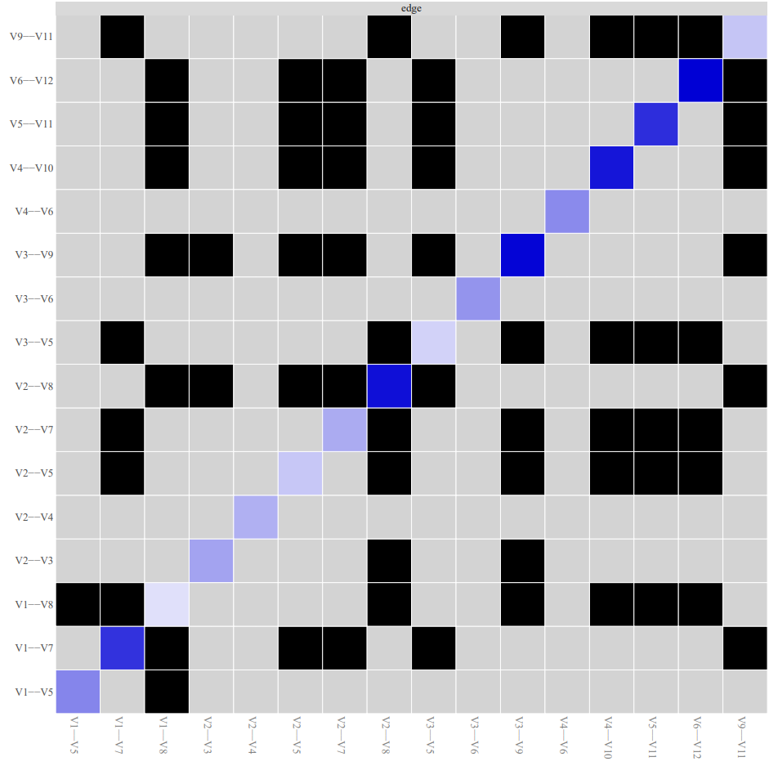

- Hispanic
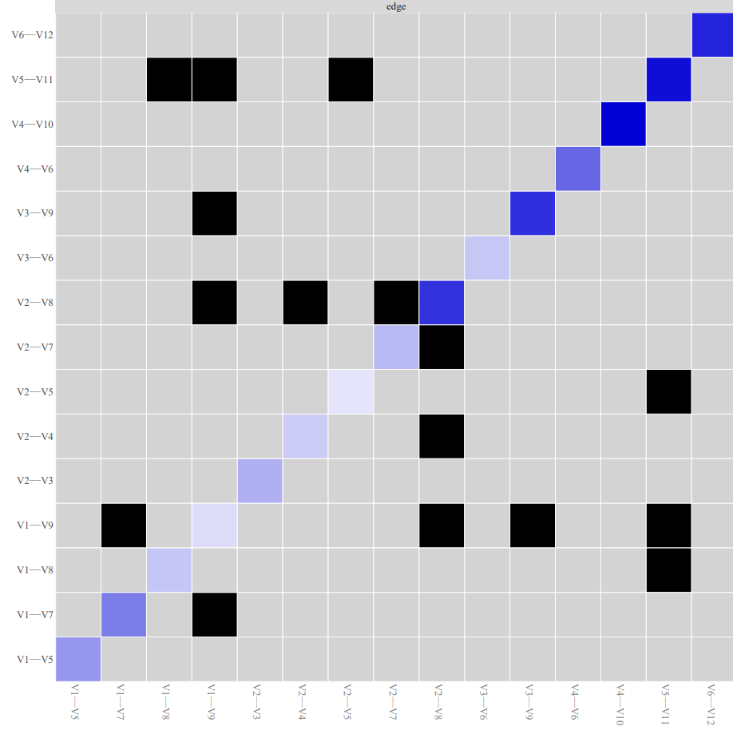

- Non-Hispanic
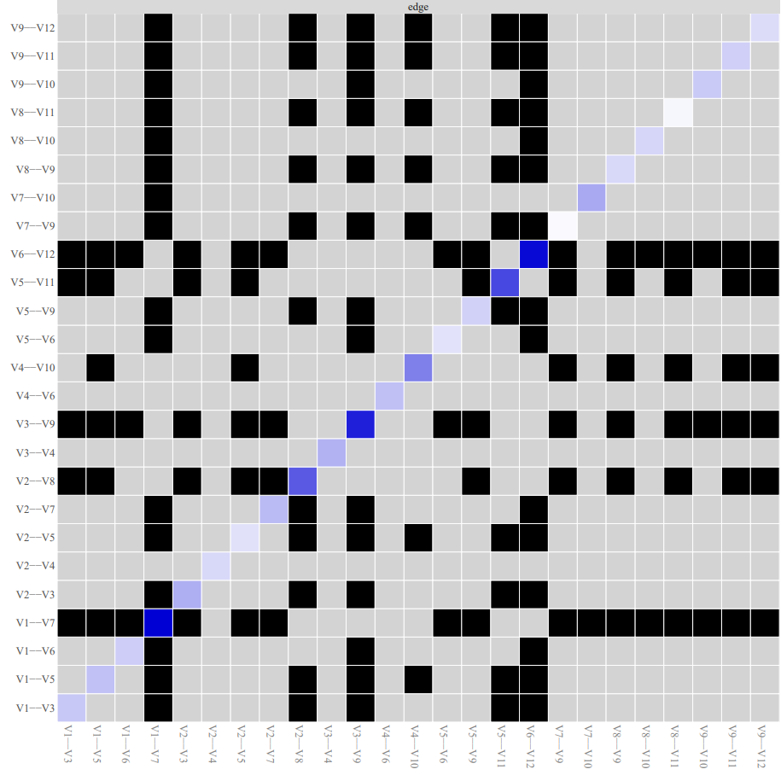

- Multiracial
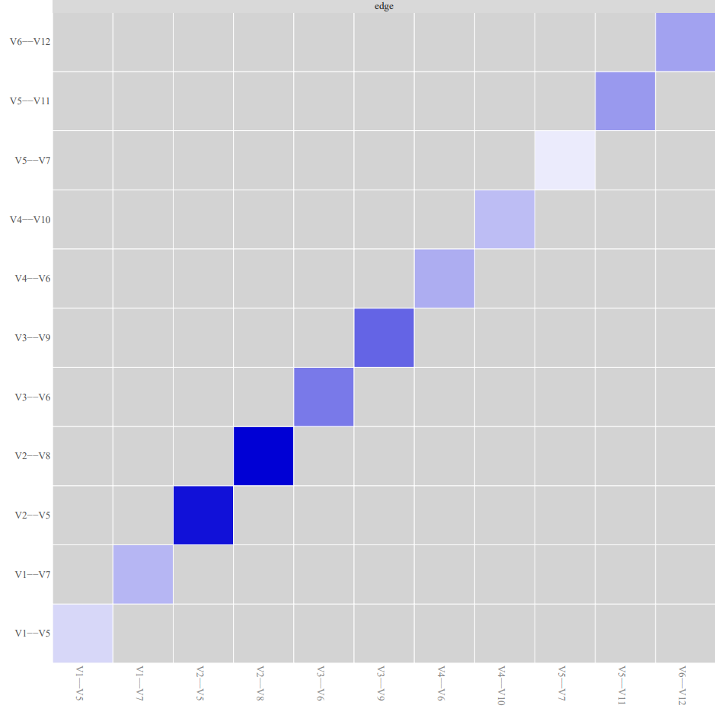

- Non-Multiracial

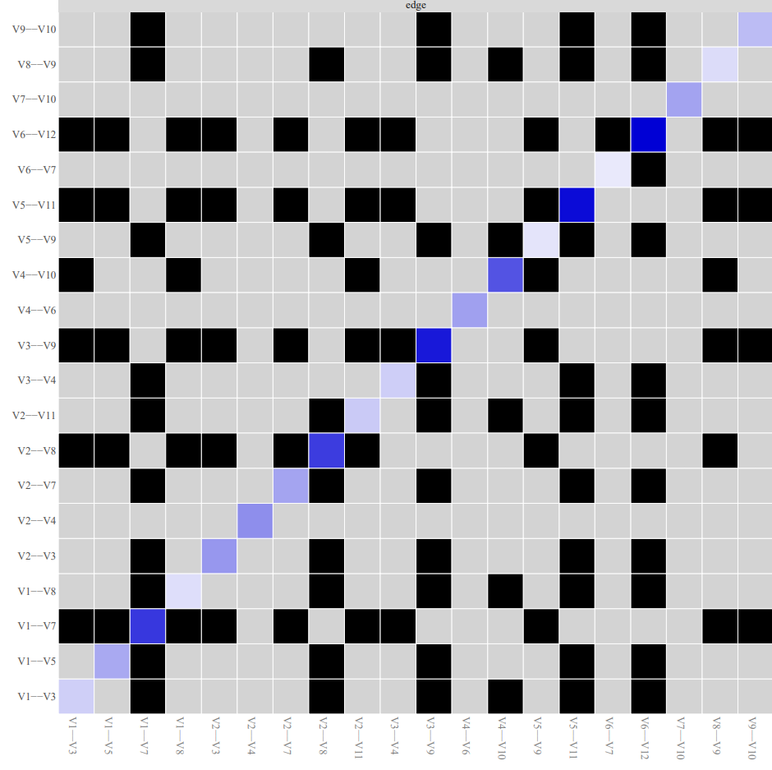
Note. Black boxes indicate edges that are different from one another.

Supplemental Table S11

Top Five Nodes with the Highest Expected Influence in Baseline Network by Racial/Ethnic Identity
 | Expected Influence
White
CADRI-14: He/She said things just to make me angry | 24.05
CADRI-13: I said things just to make him/her angry | 12.74
CADRI-15: I spoke to him/her in a hostile or mean tone of voice | 11.46
CADRI-47: I pushed, shoved or shook him/her | 9.53
CADRI-9: I brought up something bad that he/she had done in the past | 8.88
Non-White
CADRI-30: He/She kept track of who I was with and where I was | 9.41
CADRI-14: He/She said things just to make me angry | 8.95
CADRI-22: He/She insulted me with put downs | 8.27
CADRI-16: He/She spoke to me in a hostile or mean tone of voice | 7.72
CADRI-15: I spoke to him/her in a hostile or mean tone of voice | 7.63
Black
CADRI-30: He/She kept track of who I was with and where I was | 10.11
CADRI-13: I said things just to make him/her angry | 8.44
CADRI-29: I kept track of who he/she was with and where he/she was | 8.05
CADRI-10: He/She brought up something bad that I had done in the past | 7.14
CADRI-16: He/She spoke to me in a hostile or mean tone of voice | 7.07
Non-Black
CADRI-16: He/She spoke to me in a hostile or mean tone of voice | 9.53
CADRI-14: He/She said things just to make me angry | 9.28
CADRI-13: I said things just to make him/her angry | 8.52
CADRI-22: He/She insulted me with put downs | 8.09
CADRI-30: He/She kept track of who I was with and where I was | 7.30
Hispanic
CADRI-22: He/She insulted me with put downs | 9.48
CADRI-14: He/She said things just to make me angry | 8.85
CADRI-48: He/She pushed, shoved or shook me | 8.19
CADRI-16: He/She spoke to me in a hostile or mean tone of voice | 7.28
CADRI-30: He/She kept track of who I was with and where I was | 7.13
Non-Hispanic
CADRI-15: I spoke to him/her in a hostile or mean tone of voice | 8.73
CADRI-16: He/She spoke to me in a hostile or mean tone of voice | 8.66
CADRI-10: He/She brought up something bad that I had done in the past | 8.57
CADRI-9: I brought up something bad that he/she had done in the past | 8.15
CADRI-48: He/She pushed, shoved or shook me | 7.54
Multiracial
CADRI-14: He/She said things just to make me angry | 16.81
CADRI-30: He/She kept track of who I was with and where I was | 13.85
CADRI-48: He/She pushed, shoved or shook me | 10.61
CADRI-16: He/She spoke to me in a hostile or mean tone of voice | 10.02
CADRI-13: I said things just to make him/her angry | 8.76
Non-Multiracial
CADRI-14: He/She said things just to make me angry | 9.09
CADRI-16: He/She spoke to me in a hostile or mean tone of voice | 8.18
CADRI-48: He/She pushed, shoved or shook me | 8.15
CADRI-22: He/She insulted me with put downs | 8.13
CADRI-30: He/She kept track of who I was with and where I was | 8.08
Note. CADRI = Conflict in Adolescent Dating Relationships Inventory (CADRI) to assess teen dating violence. Numbers next to the measure (e.g., CADRI-15) represent the item number in the questionnaire.

Supplemental Figure S12

Ranking of Expected Influence in Baseline Network by Racial/Ethnic Identity
- White
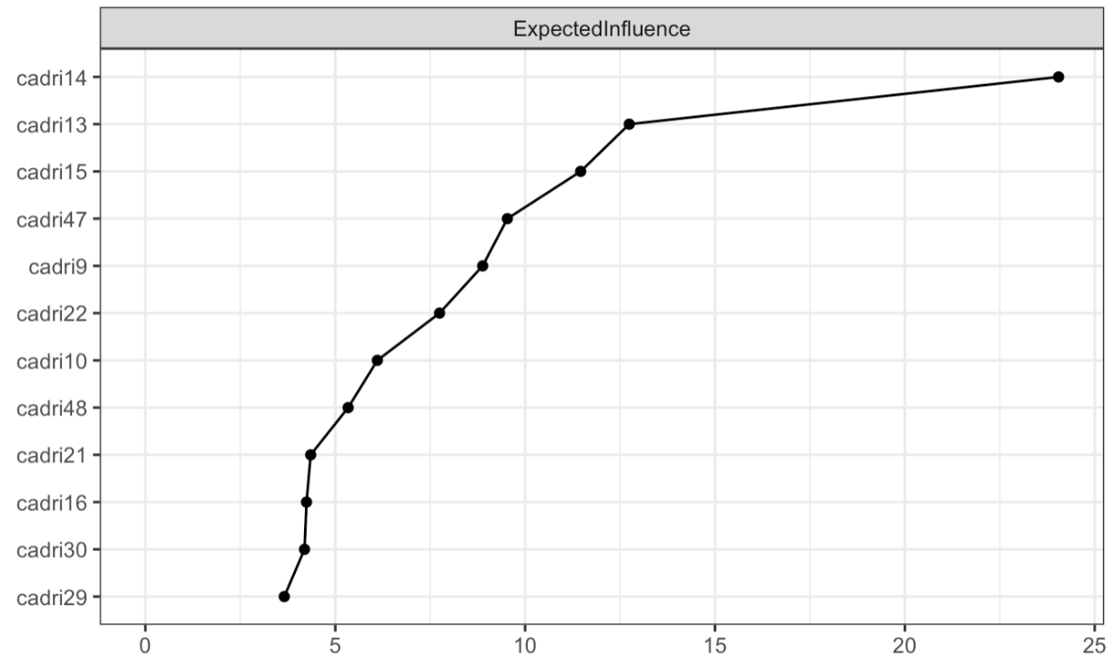
- Non-white
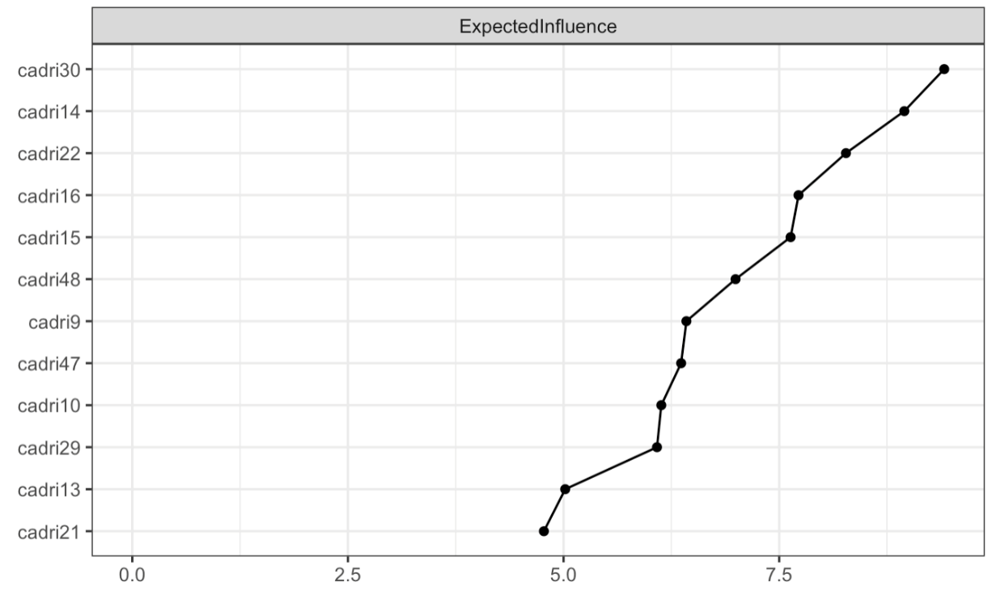

- Black
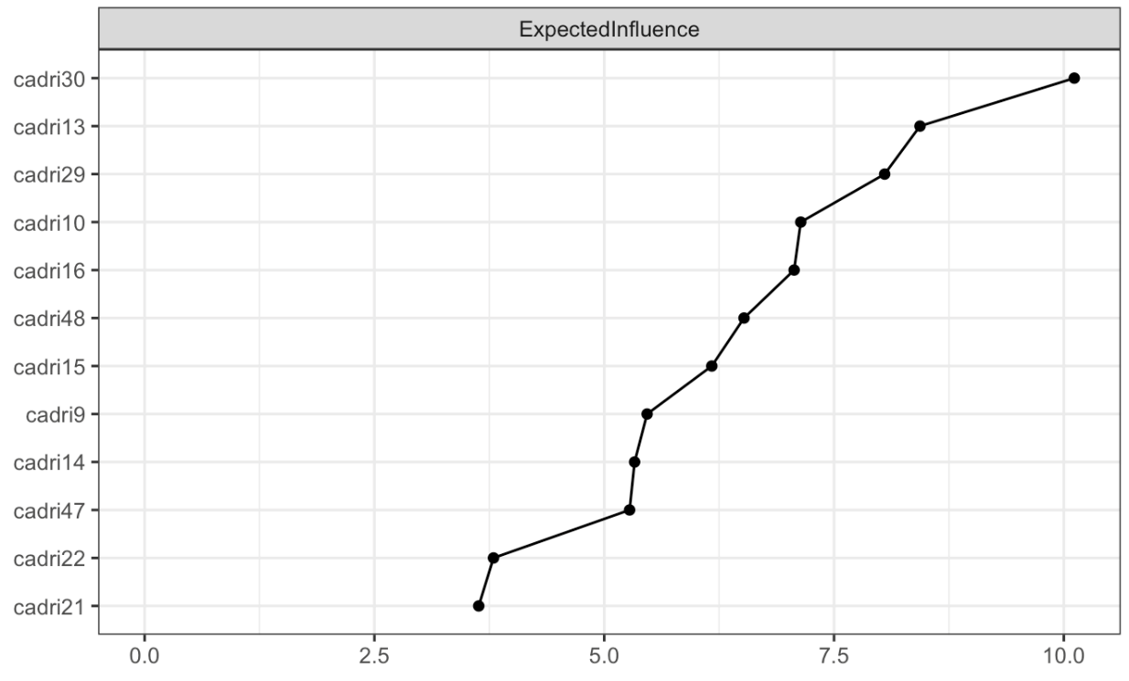
- Non-Black
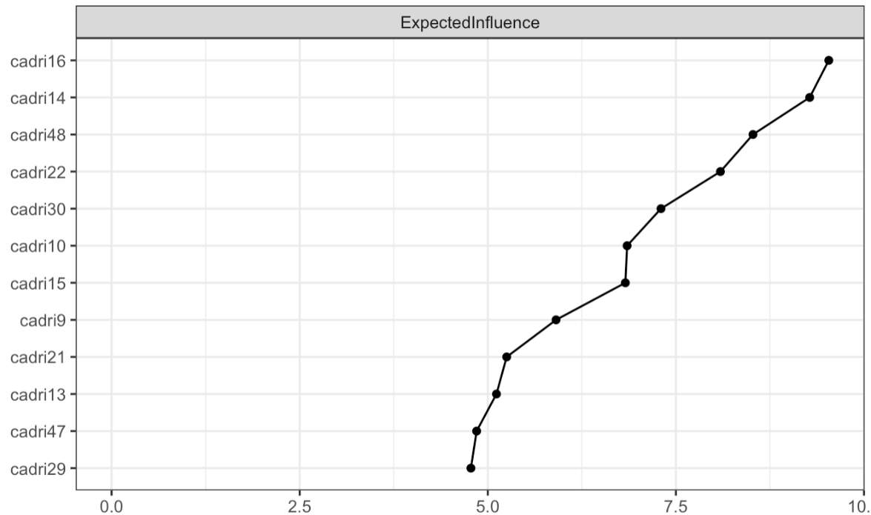

- Hispanic
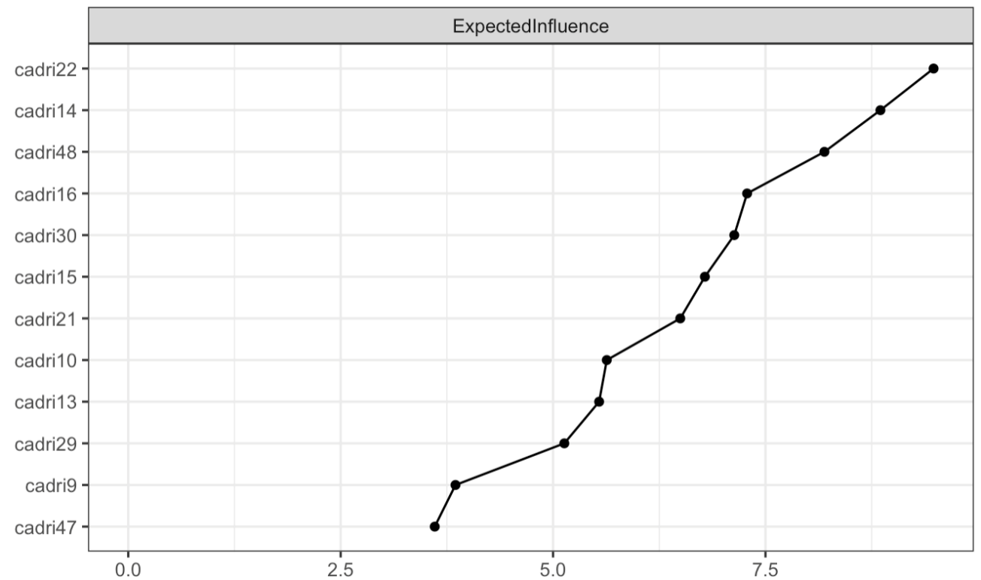
- Non-Hispanic
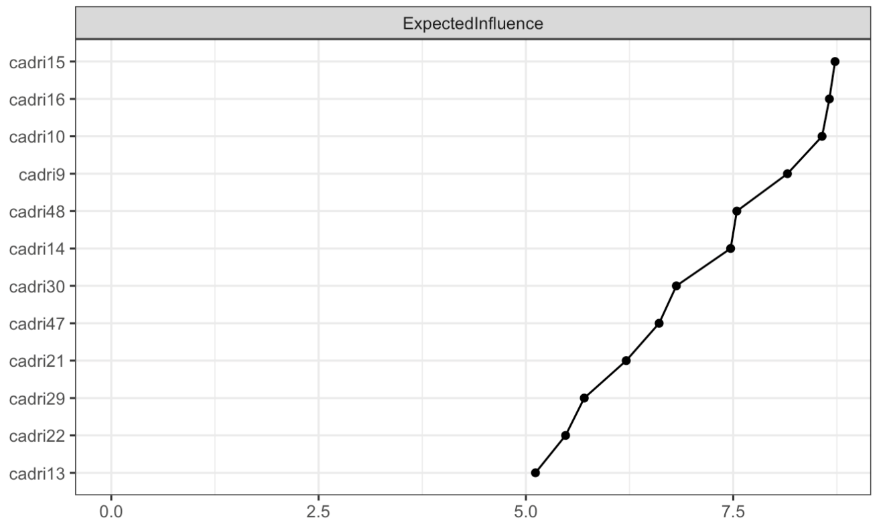

- Multiracial
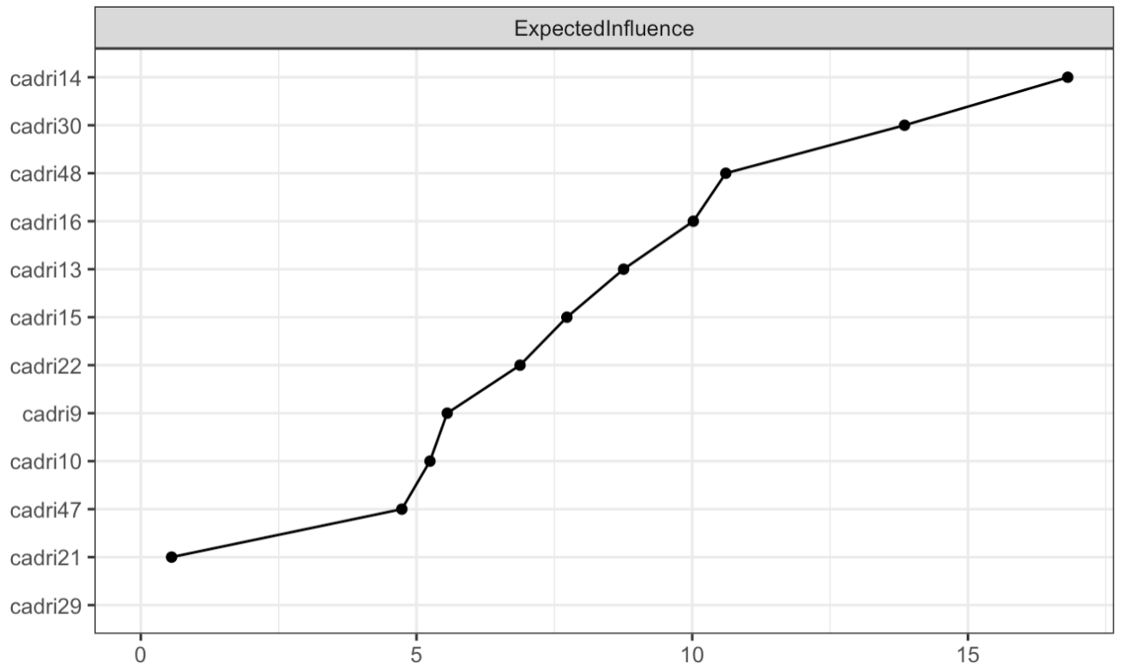
- Non-multiracial
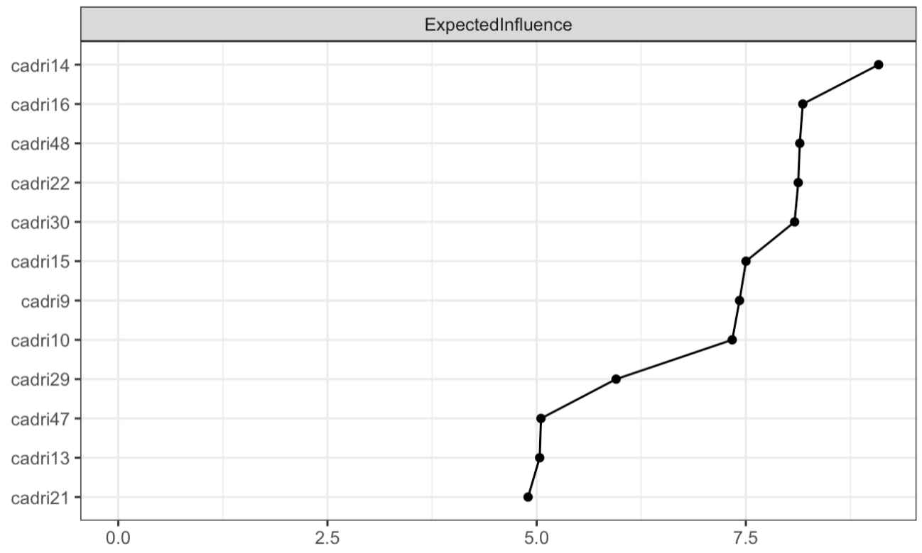

Supplemental Figure S13

Follow up Parsimonious Network Including all Variables of Interest
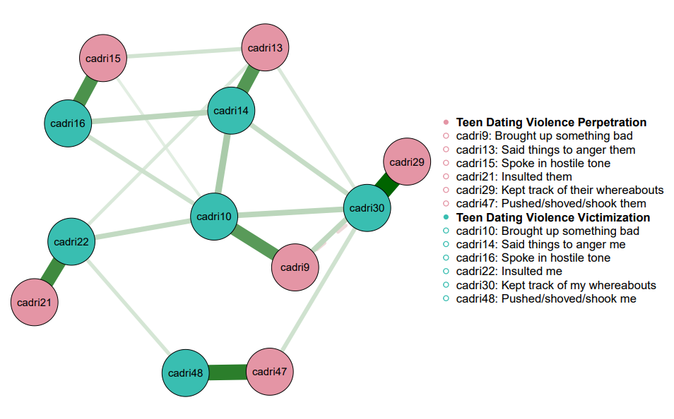

Supplemental Figure S14

Differences in Edges in Follow Up Network
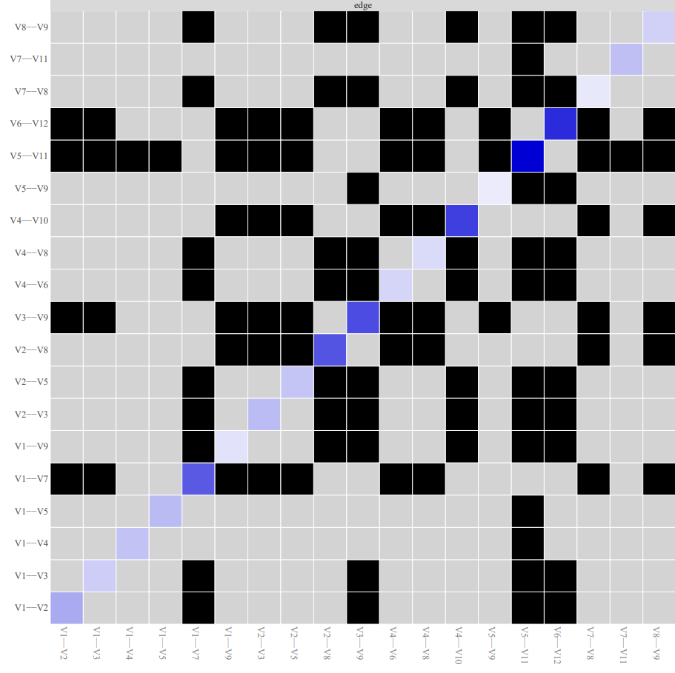

Note. Black boxes indicate edges that are different from one another.

Supplemental Table S15

Top Five Nodes with the Highest Expected Influence in the Follow Up Network
 | Expected Influence
CADRI-10: He/She brought up something bad that I had done in the past | 9.74
CADRI-30: He/She kept track of who I was with and where I was | 9.53
CADRI-14: He/She said things just to make me angry | 8.59
CADRI-22: He/She insulted me with put downs | 7.87
CADRI-16: He/She spoke to me in a hostile or mean tone of voice | 7.11
Note. CADRI = Conflict in Adolescent Dating Relationships Inventory (CADRI) to assess teen dating violence. Numbers next to the measure (e.g., CADRI-15) represent the item number in the questionnaire.

Supplemental Figure S16

Ranking of Expected Influence in Follow Up Network
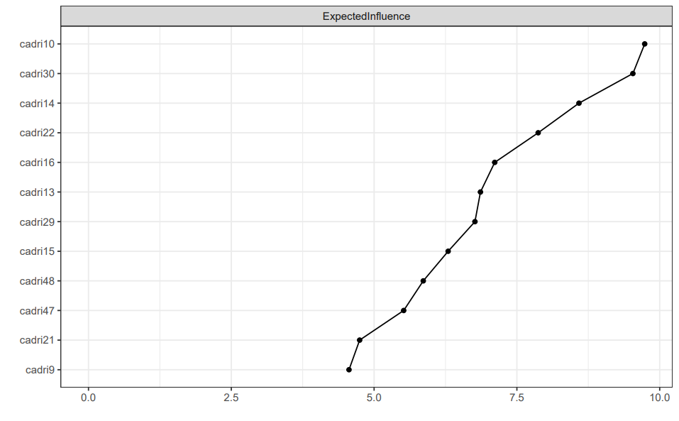

Supplemental Figure S17

Follow Up Networks for Female and Male Adolescents
- Female
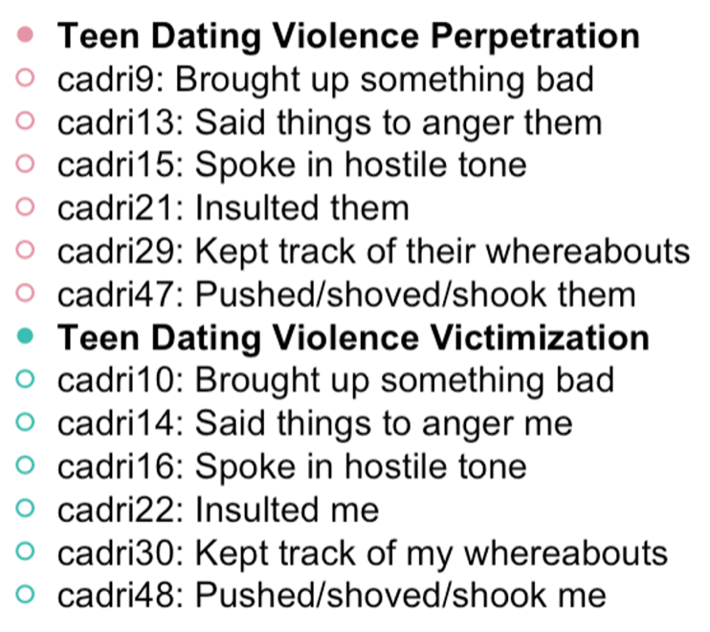
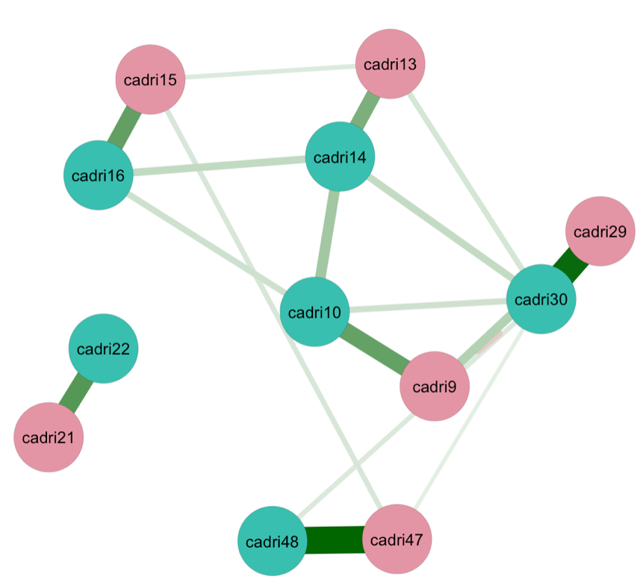
- Male
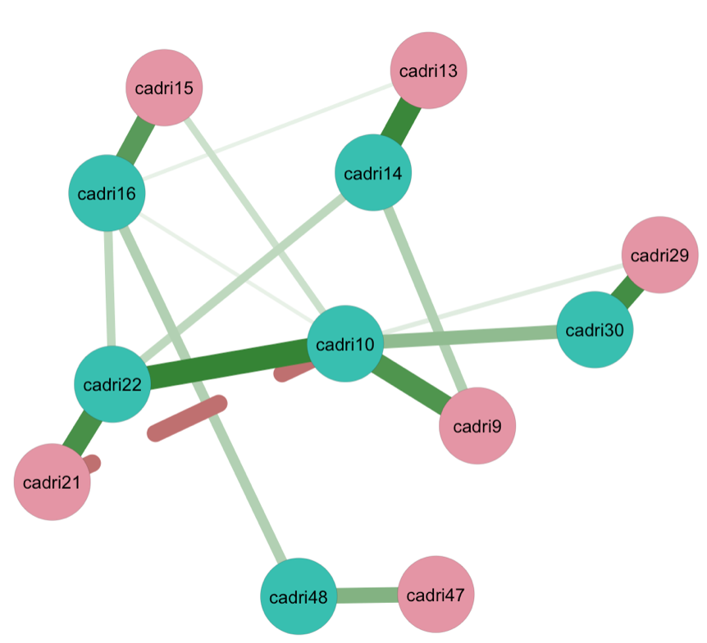

Supplemental Table S18

Top Five Highest Edge Weights in Follow Up Network of Adolescents by Gender Identity
Node 1 | Node 2 | Average Odds Ratios [95% CI]
Females
CADRI-48: He/She pushed, shoved or shook me | CADRI-47: I pushed, shoved or shook him/her | 5.66 [-4.86, 16.17]
CADRI-30: He/She kept track of who I was with and where I was | CADRI-29: I kept track of who he/she was with and where he/she was | 5.45 [-10.08, 20.98]
CADRI-22: He/She insulted me with put downs | CADRI-21: I insulted him/her with put downs | 3.78 [-4.42, 11.98]
CADRI-16: He/She spoke to me in a hostile or mean tone of voice | CADRI-15: I spoke to him/her in a hostile or mean tone of voice | 3.46 [-14.45, 21.37]
CADRI-10: He/She brought up something bad that I had done in the past | CADRI-9: I brought up something bad that he/she had done in the past | 3.42 [-7.94, 14.79]
Males
CADRI-10: He/She brought up something bad that I had done in the past | CADRI-22: He/She insulted me with put downs | 4.47 [-2.60, 11.55]
CADRI-14: He/She said things just to make me angry | CADRI-13: I said things just to make him/her angry | 4.37 [-0.26, 9.00]
CADRI-30: He/She kept track of who I was with and where I was | CADRI-29: I kept track of who he/she was with and where he/she was | 4.16 [-2.66, 10.98]
CADRI-22: He/She insulted me with put downs | CADRI-21: I insulted him/her with put downs | 4.06 [-1.53, 9.65]
CADRI-16: He/She spoke to me in a hostile or mean tone of voice | CADRI-15: I spoke to him/her in a hostile or mean tone of voice | 3.68 [-1.11, 8.47]
Note. CADRI = Conflict in Adolescent Dating Relationships Inventory (CADRI) to assess teen dating violence. The average odds ratios represent the relationship between nodes or edge strength. Numbers next to the measure (e.g., CADRI-15) represent the item number in the questionnaire.

Supplemental Figure S19

Differences in Edges in Follow Up Network by Gender Identity
- Female
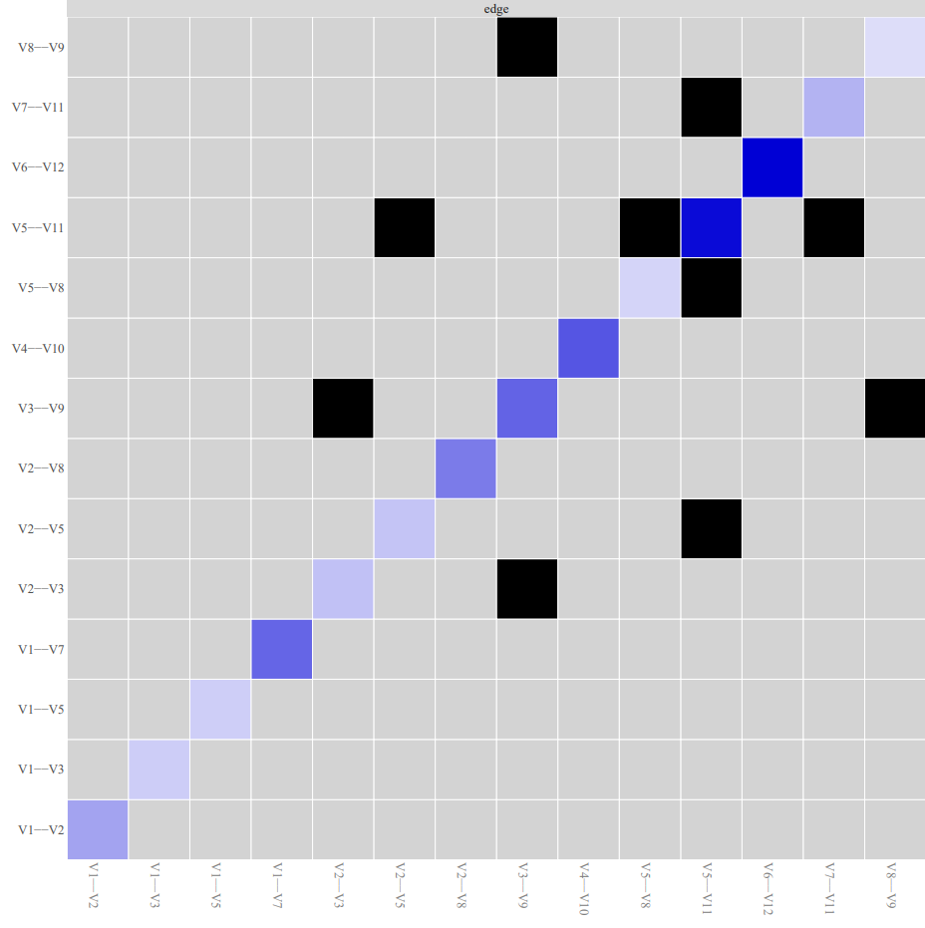

- Male
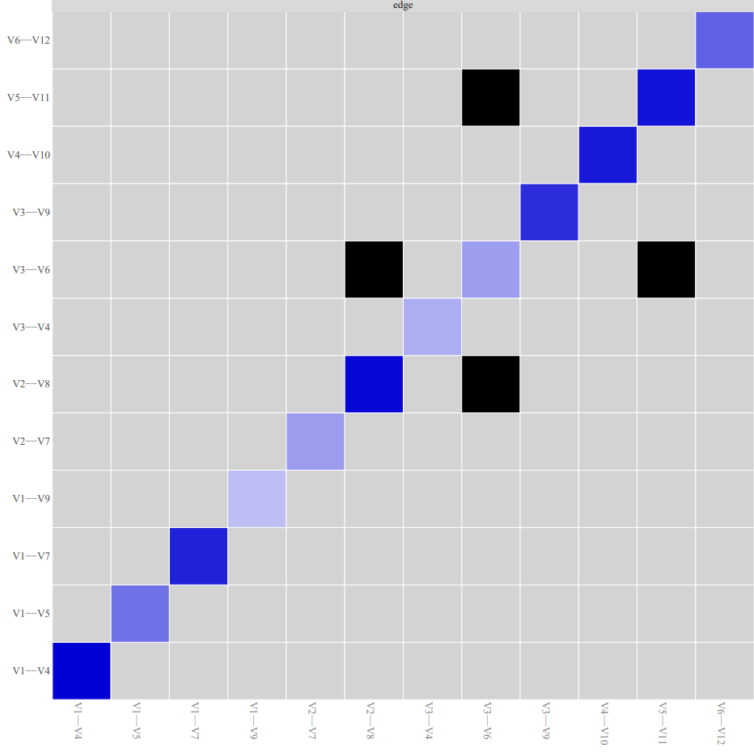
Note. Black boxes indicate edges that are different from one another.

Supplemental Table S20

Top Five Nodes at with the Highest Expected Influence in the Networks by Gender Identity at Follow Up
 | Expected Influence
Female
CADRI-30: He/She kept track of who I was with and where I was | 9.29
CADRI-10: He/She brought up something bad that I had done in the past | 8.20
CADRI-14: He/She said things just to make me angry | 7.66
CADRI-29: I kept track of who he/she was with and where he/she was | 7.14
CADRI-47: I pushed, shoved or shook him/her | 7.13
Male
CADRI-22: He/She insulted me with put downs | 11.75
CADRI-10: He/She brought up something bad that I had done in the past | 10.14
CADRI-14: He/She said things just to make me angry | 8.28
CADRI-16: He/She spoke to me in a hostile or mean tone of voice | 7.98
CADRI-30: He/She kept track of who I was with and where I was | 6.63
Note. CADRI = Conflict in Adolescent Dating Relationships Inventory (CADRI) to assess teen dating violence. Numbers next to the measure (e.g., CADRI-15) represent the item number in the questionnaire.

Supplement Figure S21
Ranking of Expected Influence in Follow Up Network by Gender Identity
- Female
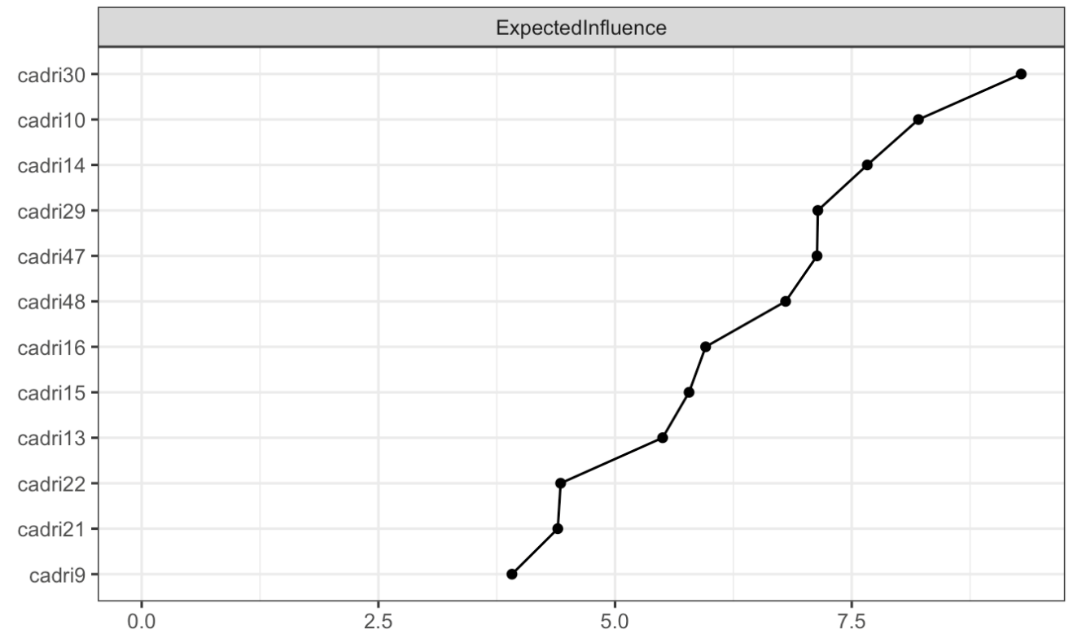
- Male
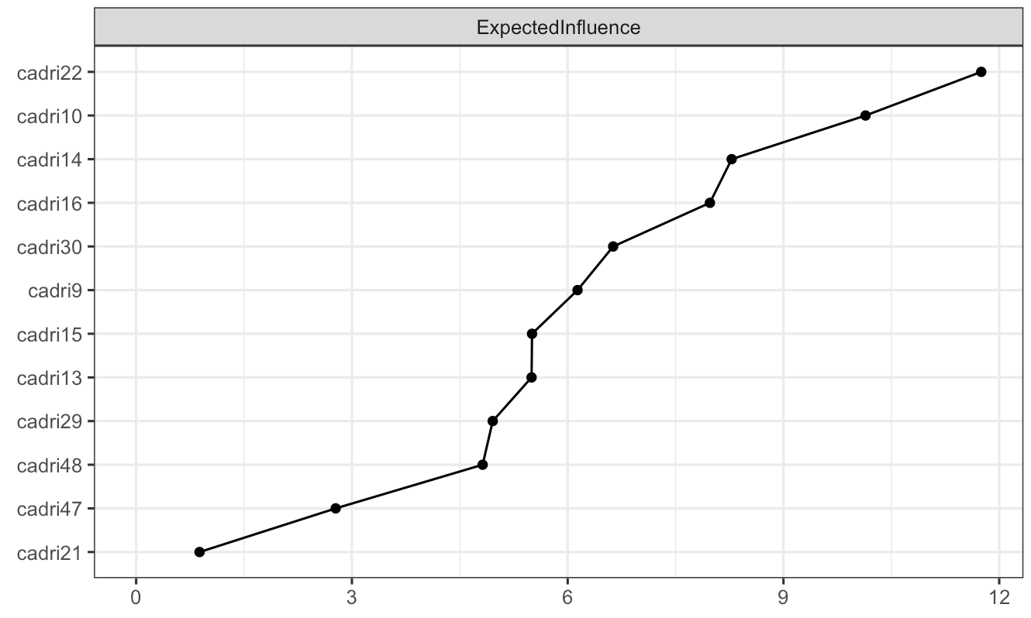

Supplemental Figure S22

Follow Up Networks by Racial/Ethnic Identity
- White
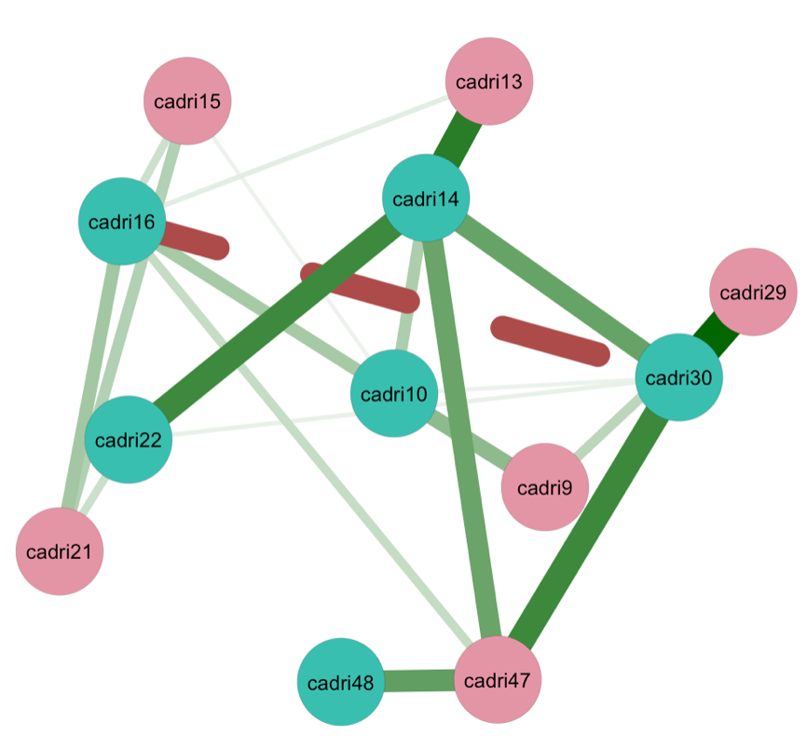
- Non-white
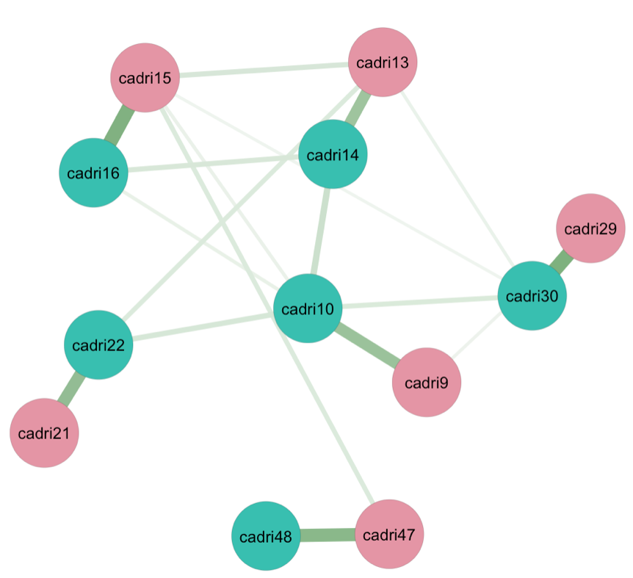
- Black
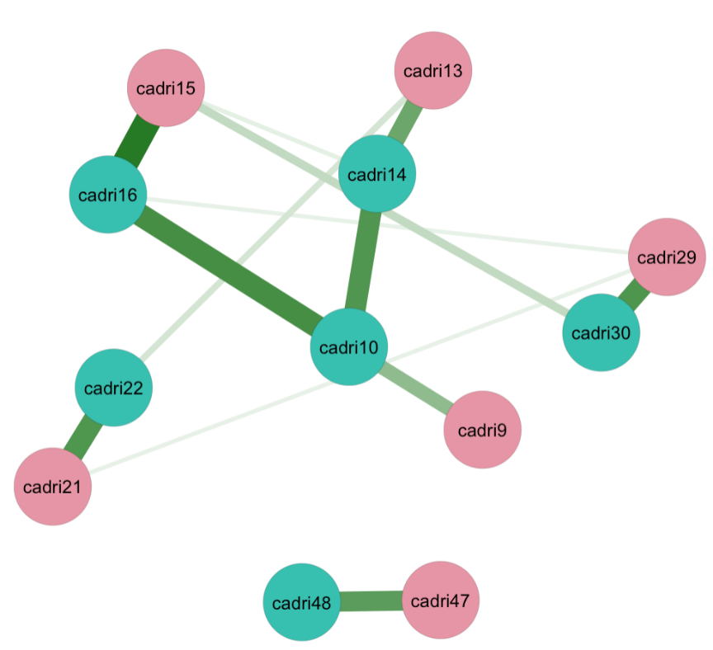
- Non-Black
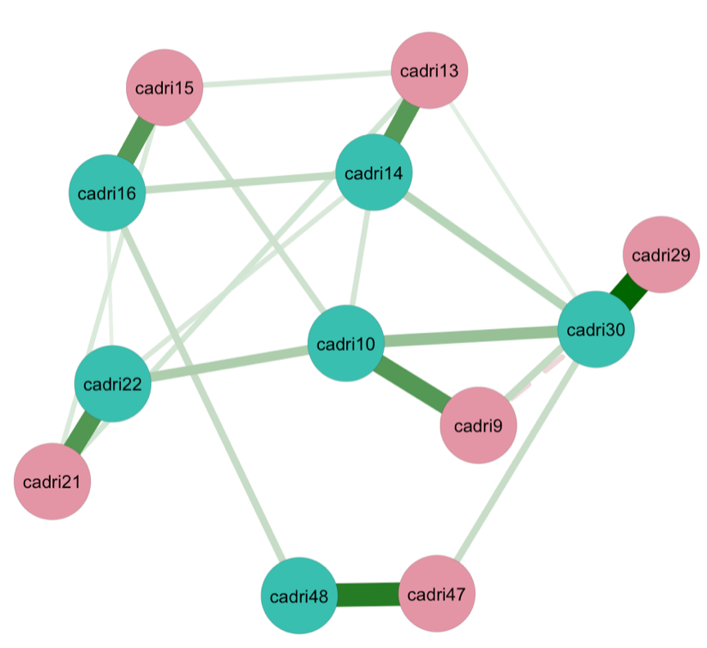

- Hispanic
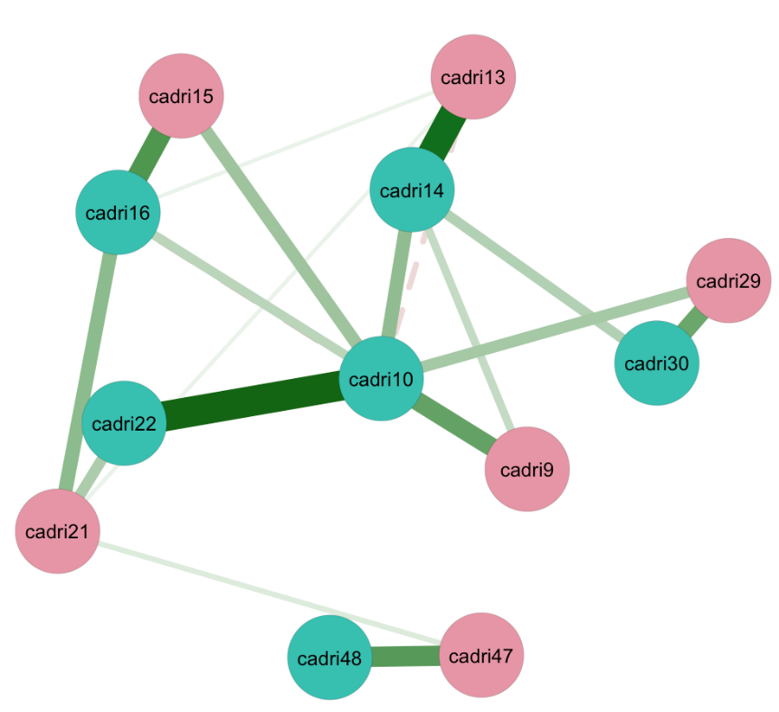
- Non-Hispanic
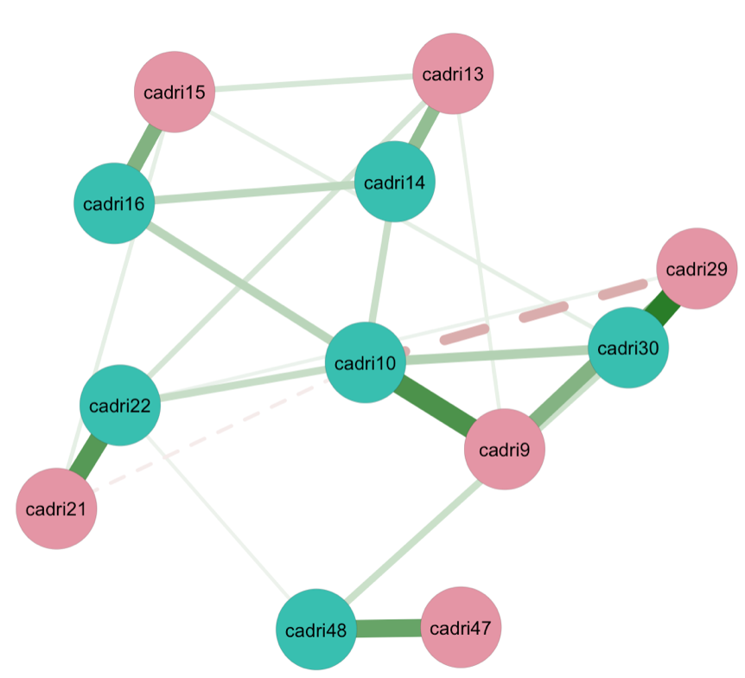

- Multiracial
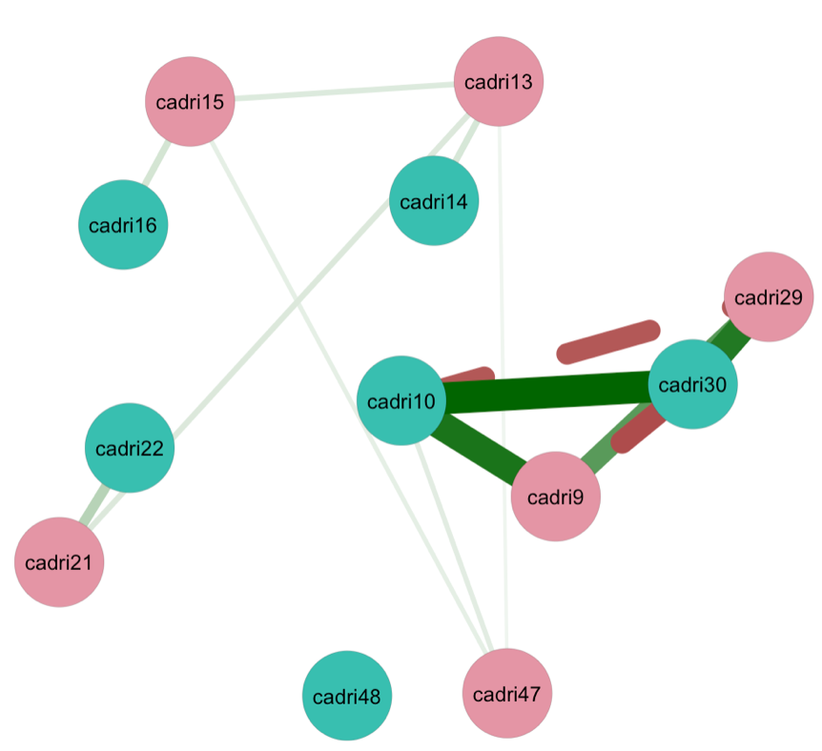
- Non-multiracial
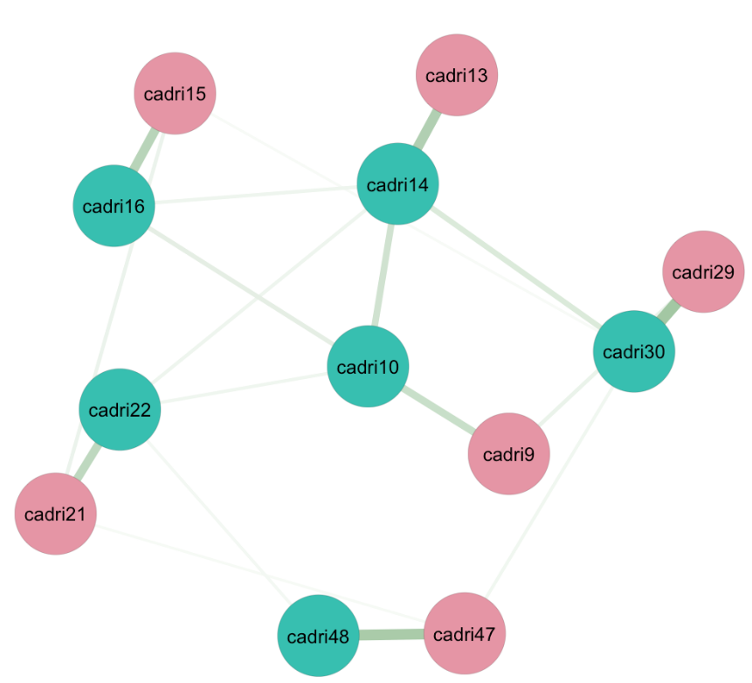

Supplemental Table S23

Top Five Edge Weights in Follow up Network by Racial/Ethnic Identity
Node 1 | Node 2 | Average Odds Ratios [95% CI]
White
CADRI-30: He/She kept track of who I was with and where I was | CADRI-29: I kept track of who he/she was with and where he/she was | 9.09 [1.58, 16.60]
CADRI-14: He/She said things just to make me angry | CADRI-13: I said things just to make him/her angry | 7.67 [0.56, 14.77]
CADRI-14: He/She said things just to make me angry | CADRI-22: He/She insulted me with put downs | 6.92 [-0.82, 14.65]
CADRI-16: He/She spoke to me in a hostile or mean tone of voice | CADRI-30: He/She kept track of who I was with and where I was | -6.41 [-9.14, -3.69]
CADRI-48: He/She pushed, shoved or shook me | CADRI-47: I pushed, shoved or shook him/her | 5.67 [-4.56, 15.89]
Non-White
CADRI-30: He/She kept track of who I was with and where I was | CADRI-29: I kept track of who he/she was with and where he/she was | 4.59 [-6.26, 15.43]
CADRI-16: He/She spoke to me in a hostile or mean tone of voice | CADRI-15: I spoke to him/her in a hostile or mean tone of voice | 4.51 [-3.90, 12.93]
CADRI-48: He/She pushed, shoved or shook me | CADRI-47: I pushed, shoved or shook him/her | 4.17 [-1.62, 9.96]
CADRI-22: He/She insulted me with put downs | CADRI-21: I insulted him/her with put downs | 3.85 [-3.31, 11.02]
CADRI-10: He/She brought up something bad that I had done in the past | CADRI-9: I brought up something bad that he/she had done in the past | 3.56 [-1.35, 8.47]
Black
CADRI-16: He/She spoke to me in a hostile or mean tone of voice | CADRI-15: I spoke to him/her in a hostile or mean tone of voice | 4.61 [-1.81, 11.03]
CADRI-10: He/She brought up something bad that I had done in the past | CADRI-16: He/She spoke to me in a hostile or mean tone of voice | 3.93 [-2.97, 10.83]
CADRI-30: He/She kept track of who I was with and where I was | CADRI-29: I kept track of who he/she was with and where he/she was | 3.73 [-4.10, 11.57]
CADRI-22: He/She insulted me with put downs | CADRI-21: I insulted him/her with put downs | 3.70 [-6.75, 14.16]
CADRI-10: He/She brought up something bad that I had done in the past | CADRI-14: He/She said things just to make me angry | 3.68 [-2.10, 9.46]
Non-Black
CADRI-30: He/She kept track of who I was with and where I was | CADRI-29: I kept track of who he/she was with and where he/she was | 5.39 [-6.40, 17.17]
CADRI-48: He/She pushed, shoved or shook me | CADRI-47: I pushed, shoved or shook him/her | 4.60 [-0.51, 9.71]
CADRI-22: He/She insulted me with put downs | CADRI-21: I insulted him/her with put downs | 3.67 [-7.21, 14.56]
CADRI-10: He/She brought up something bad that I had done in the past | CADRI-9: I brought up something bad that he/she had done in the past | 3.63 [-2.09, 9.34]
CADRI-14: He/She said things just to make me angry | CADRI-13: I said things just to make him/her angry | 3.58 [-1.15, 8.32]
Hispanic
CADRI-10: He/She brought up something bad that I had done in the past | CADRI-22: He/She insulted me with put downs | 6.85 [-2.07, 15.77]
CADRI-14: He/She said things just to make me angry | CADRI-13: I said things just to make him/her angry | 6.34 [-0.89, 13.58]
CADRI-16: He/She spoke to me in a hostile or mean tone of voice | CADRI-15: I spoke to him/her in a hostile or mean tone of voice | 4.70 [-4.41, 13.81]
CADRI-48: He/She pushed, shoved or shook me | CADRI-47: I pushed, shoved or shook him/her | 4.49 [-5.20, 14.19]
CADRI-30: He/She kept track of who I was with and where I was | CADRI-29: I kept track of who he/she was with and where he/she was | 3.99 [-9.79, 17.76]
Non-Hispanic
CADRI-30: He/She kept track of who I was with and where I was | CADRI-29: I kept track of who he/she was with and where he/she was | 5.78 [-11.48, 23.05]
CADRI-10: He/She brought up something bad that I had done in the past | CADRI-9: I brought up something bad that he/she had done in the past | 4.83 [-7.03, 16.68]
CARI-22: He/She insulted me with put downs | CADRI-21: I insulted him/her with put downs | 4.54 [-11.79, 20.87]
CADRI-48: He/She pushed, shoved or shook me | CADRI-47: I pushed, shoved or shook him/her | 4.08 [0.45, 7.71]
CADRI-16: He/She spoke to me in a hostile or mean tone of voice | CADRI-15: I spoke to him/her in a hostile or mean tone of voice | 3.38 [-2.59, 9.36]
Multiracial
CADRI-10: He/She brought up something bad that I had done in the past | CADRI-30: He/She kept track of who I was with and where I was | 14.49 [1.15, 27.82]
CADRI-10: He/She brought up something bad that I had done in the past | CADRI-9: I brought up something bad that he/she had done in the past | 13.01 [3.63, 22.38]
CADRI-30: He/She kept track of who I was with and where I was | CADRI-29: I kept track of who he/she was with and where he/she was | 12.50 [3.75, 21.25]
CADRI-30: He/She kept track of who I was with and where I was | CADRI-9: I brought up something bad that he/she had done in the past | -10.16 [-22.07, 1.75]
CADRI-10: He/She brought up something bad that I had done in the past | CADRI-29: I kept track of who he/she was with and where he/she was | -9.50 [-21.34, 2.34]
Non-Multiracial
CADRI-30: He/She kept track of who I was with and where I was | CADRI-29: I kept track of who he/she was with and where he/she was | 5.24 [-3.70, 14.19]
CADRI-48: He/She pushed, shoved or shook me | CADRI-47: I pushed, shoved or shook him/her | 4.87 [0.08, 9.66]
CADRI-14: He/She said things just to make me angry | CADRI-13: I said things just to make him/her angry | 4.44 [-2.41, 11.29]
CADRI-16: He/She spoke to me in a hostile or mean tone of voice | CADRI-15: I spoke to him/her in a hostile or mean tone of voice | 4.05 [-0.49, 8.59]
CADRI-22: He/She insulted me with put downs | CADRI-21: I insulted him/her with put downs | 3.64 [-4.57, 11.85]
Note. CADRI = Conflict in Adolescent Dating Relationships Inventory (CADRI) to assess teen dating violence. The average odds ratios represent the relationship between nodes or edge strength. Numbers next to the measure (e.g., CADRI-15) represent the item number in the questionnaire.

Supplemental Figure S24

Differences in Edges in Follow Up Network by Racial/Ethnic Identity
- White
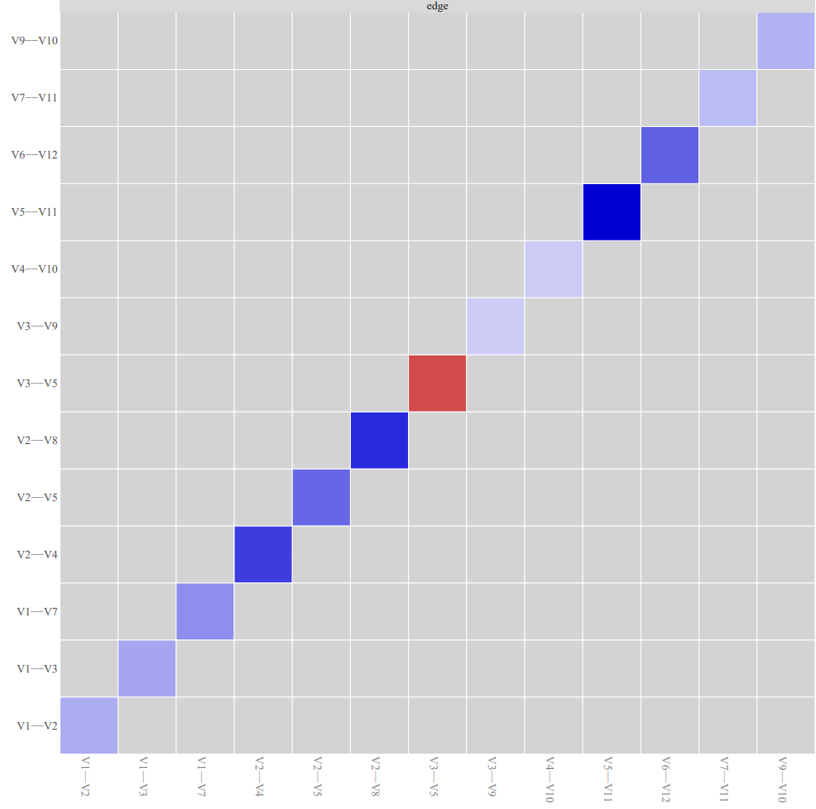

- Non-White
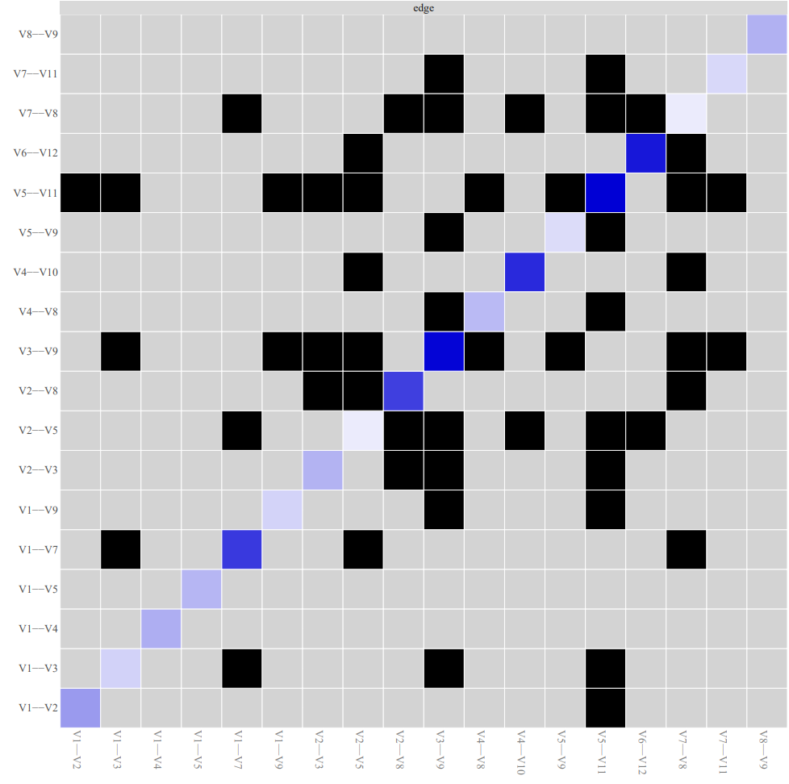

- Black
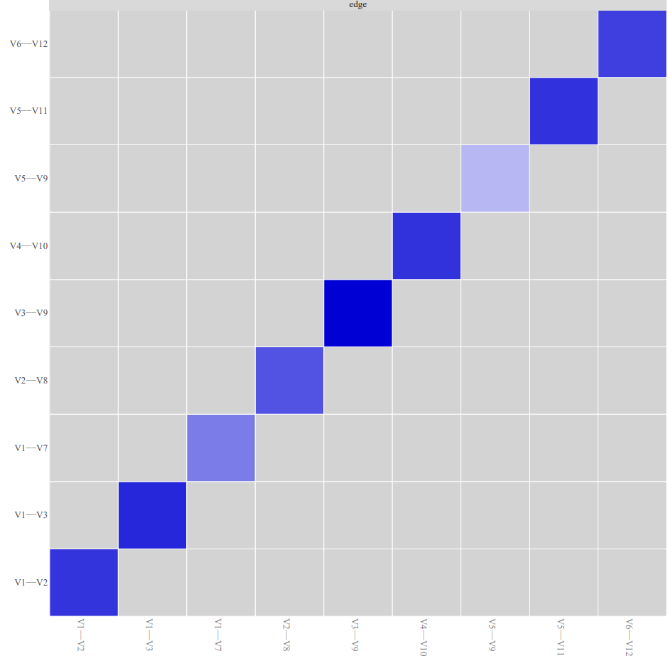

- Non-Black
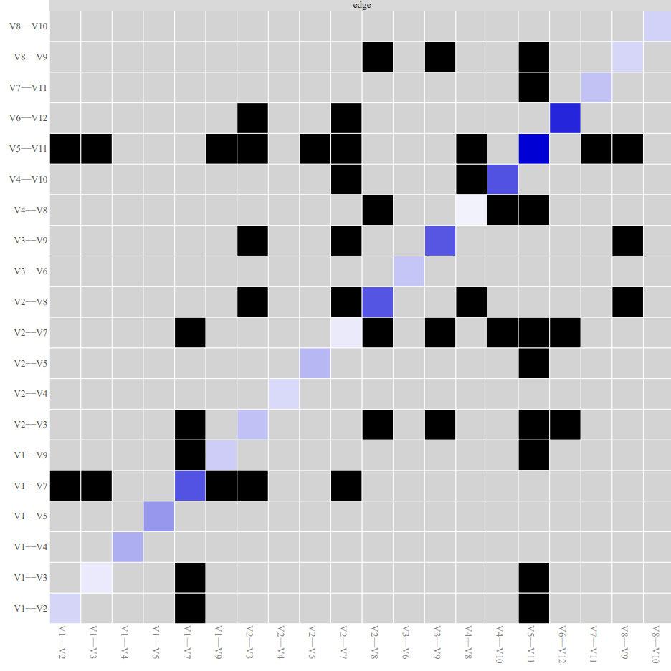

- Hispanic
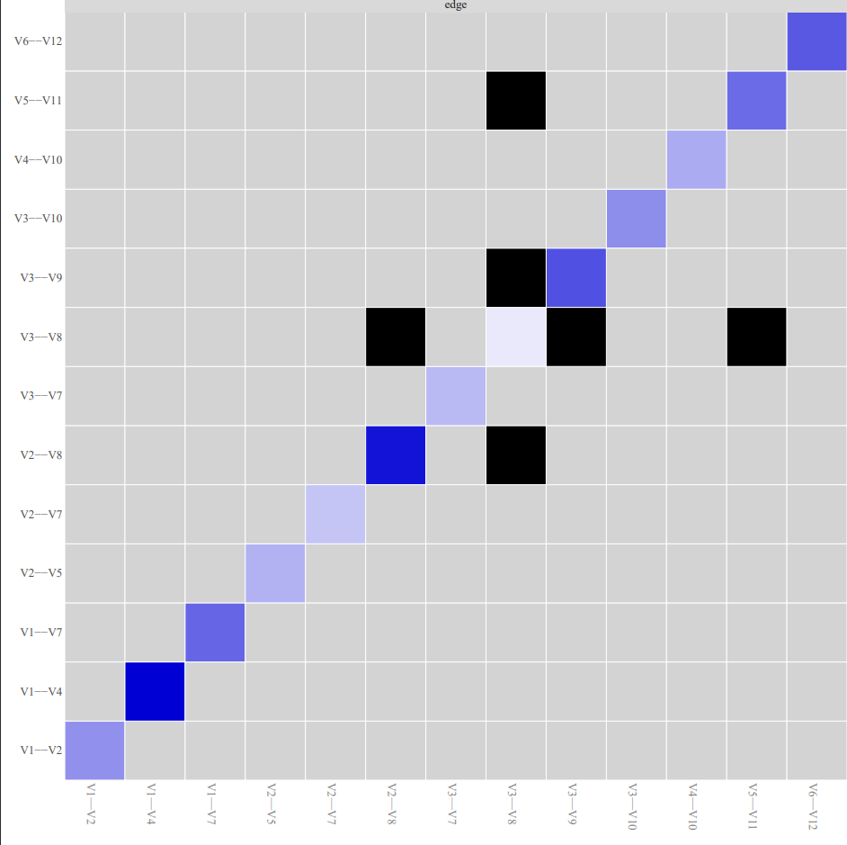

- Non-Hispanic
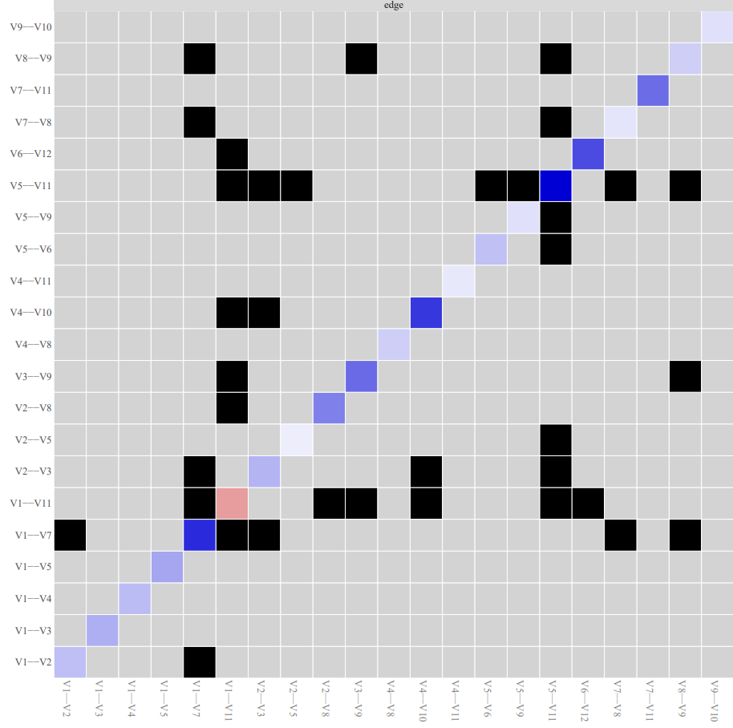

- Multiracial
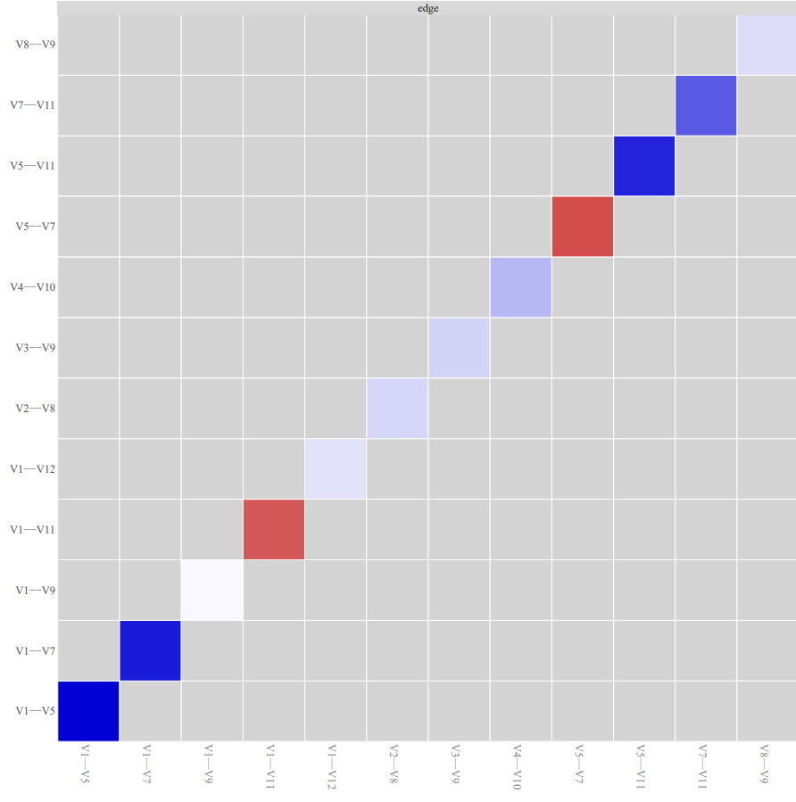

- Non-Multiracial

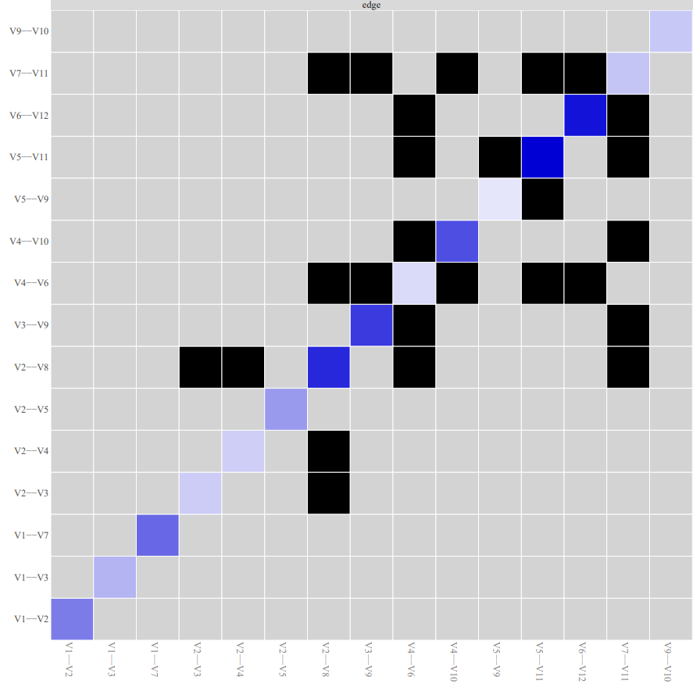
Note. Black boxes indicate edges that are different from one another.

Supplemental Table S25

Top Five Nodes with the Highest Expected Influence in Follow Up Networks by Racial/Ethnic Identity
 | Expected Influence
White
CADRI-14: He/She said things just to make me angry | 28.28
CADRI-47: I pushed, shoved or shook him/her | 19.97
CADRI-30: He/She kept track of who I was with and where I was | 16.63
CADRI-10: He/She brought up something bad that I had done in the past | 11.54
CADRI-29: I kept track of who he/she was with and where he/she was | 11.47
Non-White
CADRI-10: He/She brought up something bad that I had done in the past | 9.77
CADRI-15: I spoke to him/her in a hostile or mean tone of voice | 8.59
CADRI-30: He/She kept track of who I was with and where I was | 7.64
CADRI-13: I said things just to make him/her angry | 7.54
CADRI-22: He/She insulted me with put downs | 7.41
Black
CADRI-10: He/She brought up something bad that I had done in the past | 9.98
CADRI-16: He/She spoke to me in a hostile or mean tone of voice | 9.39
CADRI-14: He/She said things just to make me angry | 7.69
CADRI-15: I spoke to him/her in a hostile or mean tone of voice | 6.68
CADRI-30: He/She kept track of who I was with and where I was | 5.04
Non-Black
CADRI-30: He/She kept track of who I was with and where I was | 10.23
CADRI-10: He/She brought up something bad that I had done in the past | 9.94
CADRI-14: He/She said things just to make me angry | 8.54
CADRI-22: He/She insulted me with put downs | 7.33
CADRI-16: He/She spoke to me in a hostile or mean tone of voice | 7.15
Hispanic
CADRI-10: He/She brought up something bad that I had done in the past | 16.08
CADRI-14: He/She said things just to make me angry | 12.95
CADRI-22: He/She insulted me with put downs | 9.19
CADRI-16: He/She spoke to me in a hostile or mean tone of voice | 8.70
CADRI-9: I brought up something bad that he/she had done in the past | 7.60
Non-Hispanic
CADRI-30: He/She kept track of who I was with and where I was | 10.37
CADRI-10: He/She brought up something bad that I had done in the past | 9.23
CADRI-22: He/She insulted me with put downs | 8.98
CADRI-9: I brought up something bad that he/she had done in the past | 7.79
CADRI-29: I kept track of who he/she was with and where he/she was | 7.51
Multiracial
CADRI-10: He/She brought up something bad that I had done in the past | 20.06
CADRI-30: He/She kept track of who I was with and where I was | 17.07
CADRI-29: I kept track of who he/she was with and where he/she was | 12.66
CADRI-9: I brought up something bad that he/she had done in the past | 12.28
CADRI-13: I said things just to make him/her angry | 7.28
Non-Multiracial
CADRI-14: He/She said things just to make me angry | 11.67
CADRI-30: He/She kept track of who I was with and where I was | 9.31
CADRI-10: He/She brought up something bad that I had done in the past | 8.60
CADRI-16: He/She spoke to me in a hostile or mean tone of voice | 7.47
CADRI-22: He/She insulted me with put downs | 6.91
Note. CADRI = Conflict in Adolescent Dating Relationships Inventory (CADRI) to assess teen dating violence. Numbers next to the measure (e.g., CADRI-15) represent the item number in the questionnaire.

Supplemental Figure S26

Ranking of Nodes Based on Expected Influence in Follow Up Network by Racial/Ethnic Identity
- White
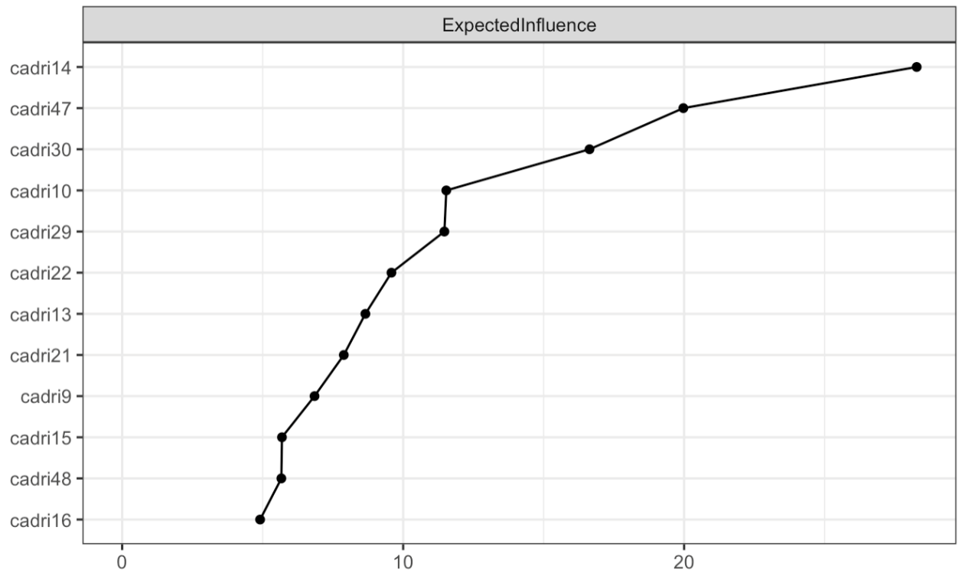
- Non-white
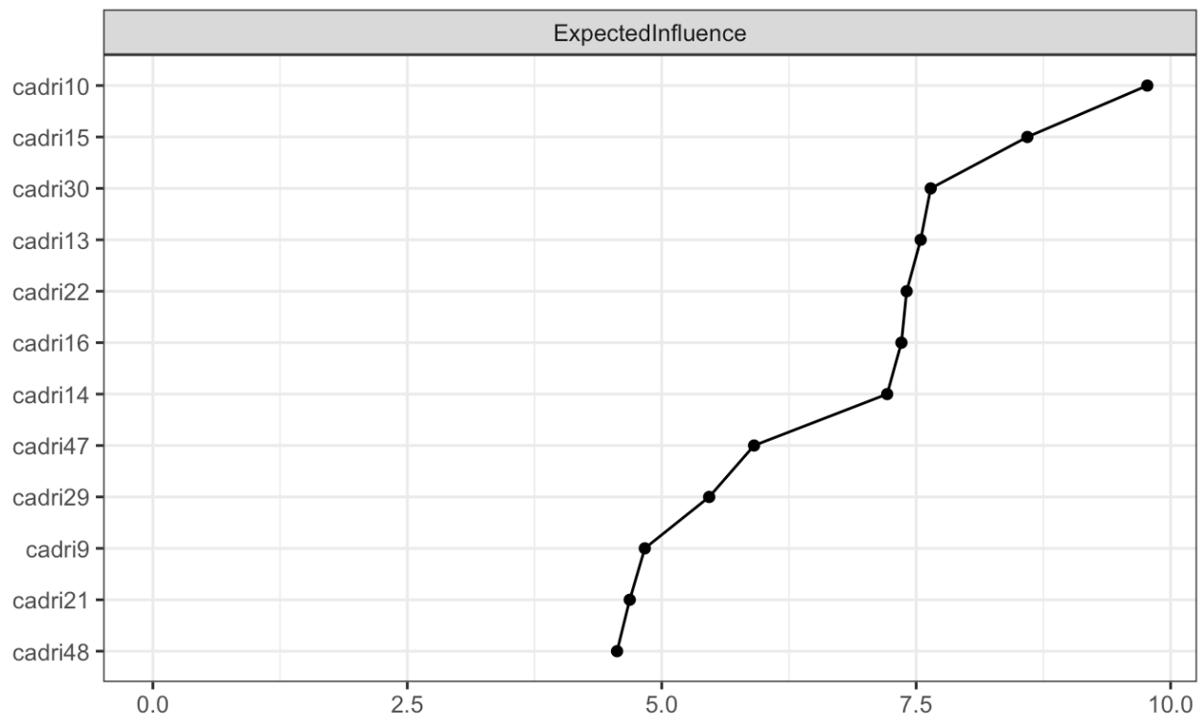

- Black
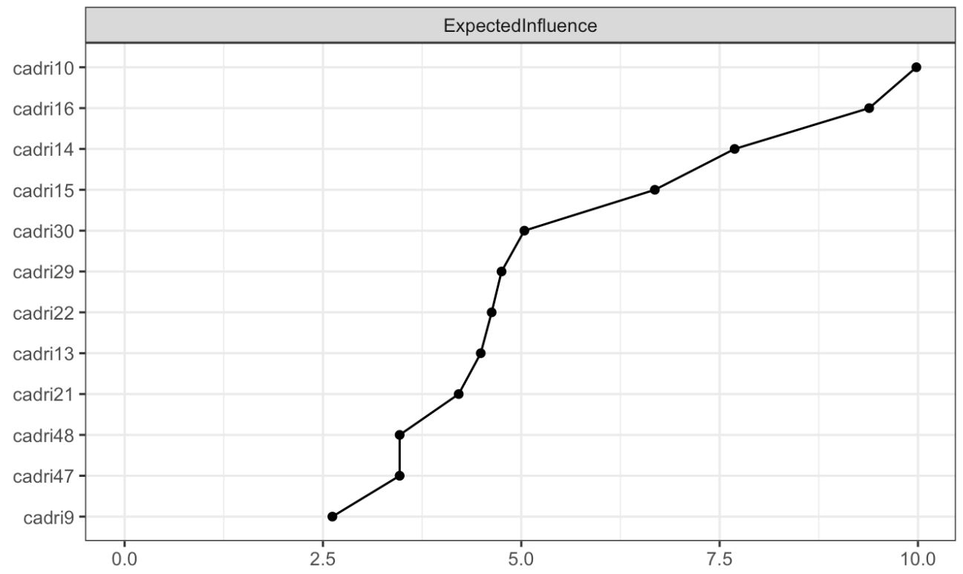
- Non-Black
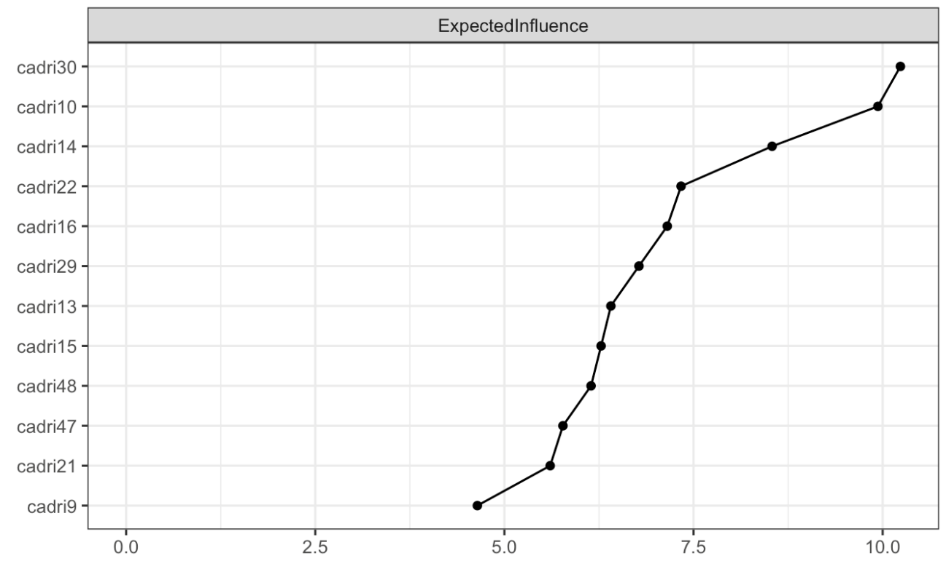

- Hispanic
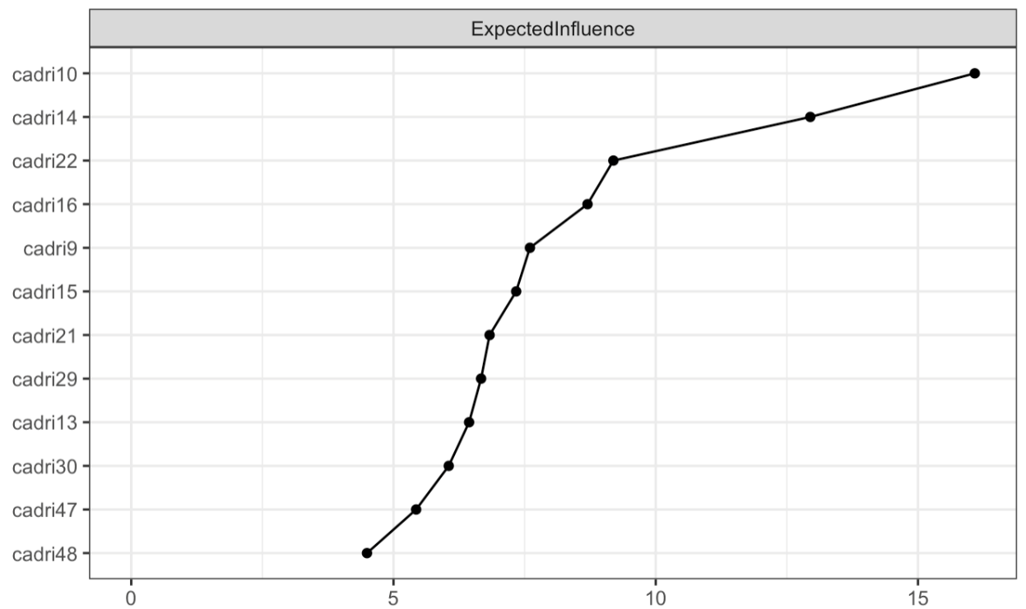
- Non-Hispanic
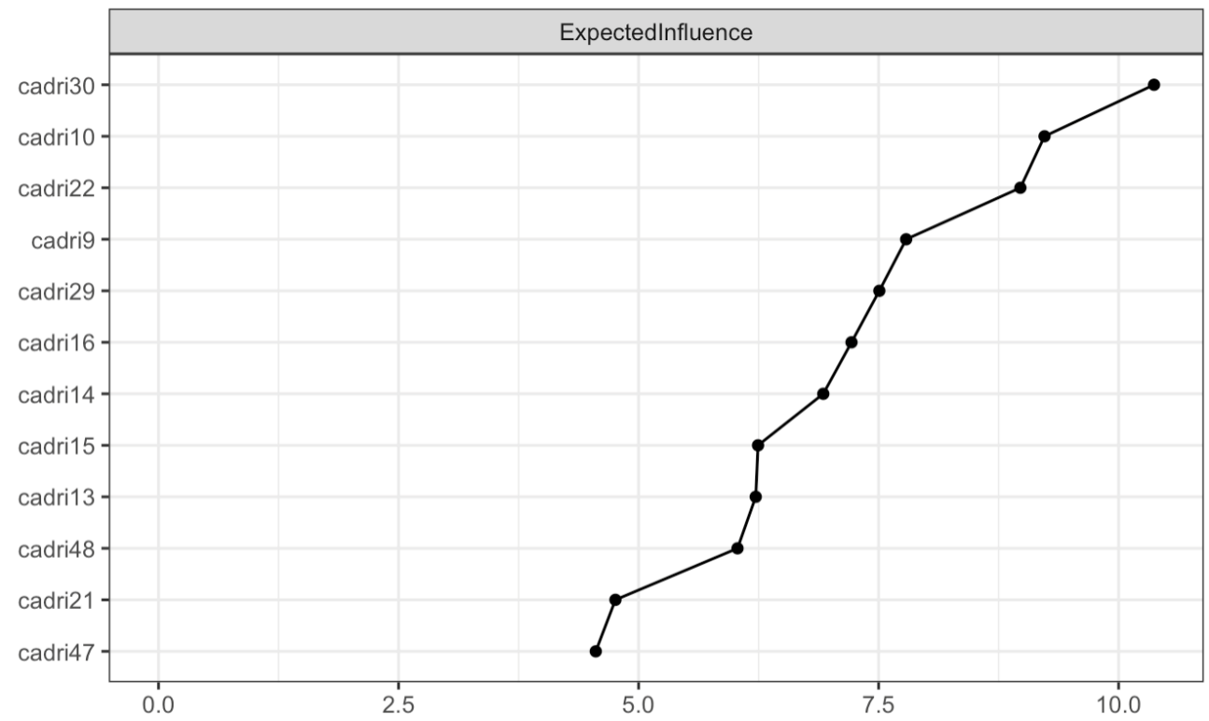

- Multiracial
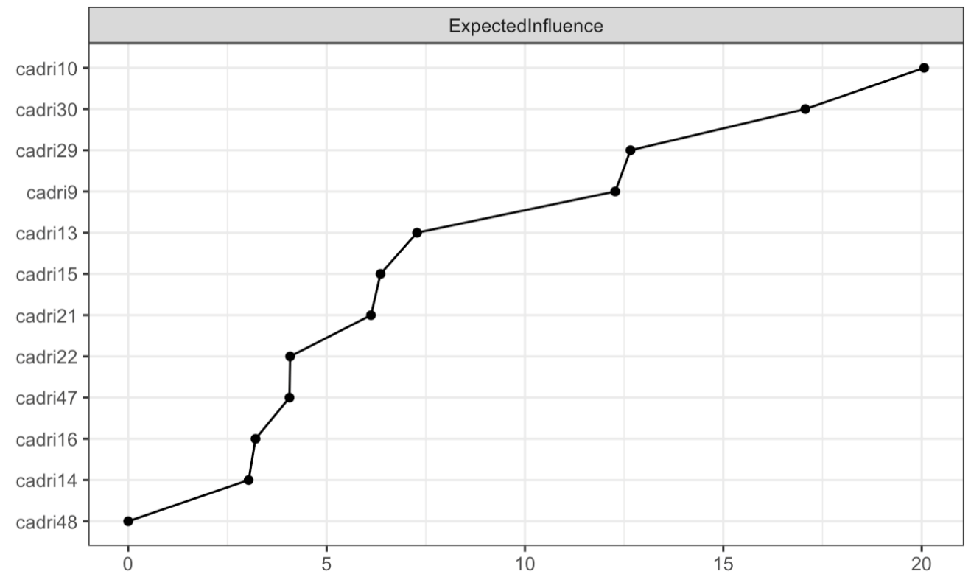
- Non-multiracial
