**Supplemental Material**

**Supplementary Figure 1**

*Diagram of Measurement Burst Study Design*

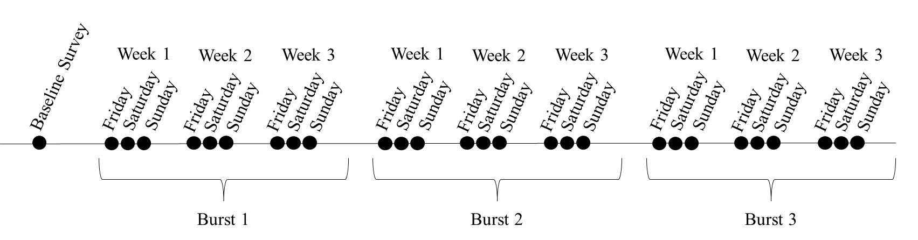

|  |  |  |
| --- | --- | --- |
| **Supplementary Table 1**  *Likely Offenders Items Designed for this Study* | | |
| 1. Did anyone at this event make efforts to be alone with you, or to draw you away from the group? | No | Yes |
| 2. To your knowledge, were there men there who you know to have, or who were showing, negative attitudes toward women (e.g., telling sexist jokes, making derogatory comments about women)? | No | Yes |
| 3. Were there men there who are known as “players”? | No | Yes |
| 4. Were you around men who were behaving in a way that was sexually aggressive toward women? | No | Yes |
|  | | |

|  |  |  |
| --- | --- | --- |
| **Supplementary Table 2**  *Capable Guardianship Items Designed for this Study* | | |
| 1. I found myself alone with someone I just met or didn’t know very well. | No | Yes |
| 2. I stayed at a party/social gathering/bar/etc. after my friends had left. | No | Yes |
| 3. I got separated from my friends. | No | Yes |
| 4. My friends were too intoxicated to be capable of helping me if I needed it. | No | Yes |
| 5. I left a bar/party/social gathering/etc. with someone I didn’t know very well. | No | Yes |
|  | | |

**Supplementary Table 3**

*Percentage of Women Endorsing Use of Each Sexual Assault Protective Behavioral Strategy (SA-PBS) Across All Going Out Events*

**Supplementary Table 4**

*Percentage of Going Out Events in Which Sexual Assault Protective Behavioral Strategies (SA-PBS) Were Endorsed*