Supplementary materials 1: Details on the literature search

The systematic search for studies on ST and PTSD was conducted in April 2024. The search included the databases PsycInfo and PubMed.

The search matrix included keywords for secondary traumatization (‘secondary traumatisation’ OR ‘secondary traumatization’ OR ‘secondary traumatic stress’ OR ‘indirect trauma’ OR ‘compassion fatigue’) AND post-traumatic stress disorder (‘post-traumatic stress disorder’ OR ‘post traumatic stress disorder’ OR ‘posttraumatic stress disorder’ OR ‘ptsd’). 'Compassion fatigue’ and ‘indirect trauma’ were included as keywords in the first block to account for the interchangeable use of terminology.

Inclusion criteria were the following:
- Published and peer-reviewed articles
- Articles written in English
- Articles available through PubMed or PsycINFO
- Studies applying a measure for PTSD consistent with either DSM-5 or ICD-11 criteria

Exclusion criteria were the following:
- Reviews, meta-analyses, book chapters, and dissertations
- Studies reporting on prevalence in populations other than work (i.e caregivers, siblings)
- Studies applying the same measure for both ST and PTSD

In total, 2994 articles were found and exported to the website covidence.org. Covidence also automatically excluded 159 duplicate articles, and 5 more duplicates were excluded manually. 3 articles were excluded because the full text was not available. In total, 2830 articles were screened, and 181 full-text articles were assessed in further detail. Of these, 174 articles were excluded, the primary reasons being that the relevant measures were not assessed, or measurement tools not consistent with DSM-5 or ICD-11 were applied. In total, 7 articles were included in the review. An overview of the selection procedure is in the flowchart below.

Figure S1: Flowchart for the literature search
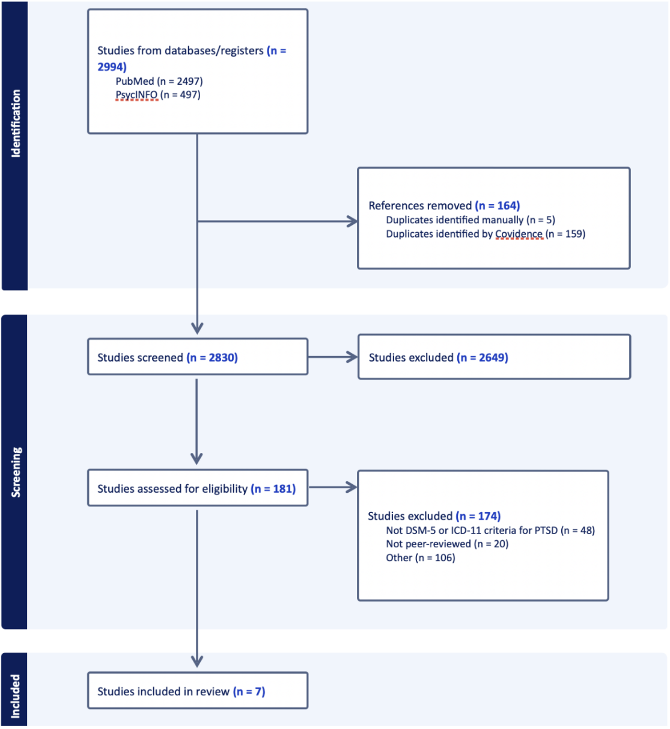

Supplementary materials 2: Symptom-level endorsement of ST and PTSD

Table S1: Symptom-level endorsement of ST and PTSD
 |  | Full sample | Prosecutors  % (n) | Municipal child protection  % (n) | ‘Barnahus’ employee  % (n) | Child forensic video interviewer  % (n)
 | ProQoL (a score of 3 or more)
I am preoccupied with more than one person I help |  | 47.6% (410) | 14.8% (38) | 67.3% (335) | 31.7% (20) | 39.5% (17)
I jump or am startled by unexpected sounds |  | 15.9% (137) | 13.6% (35) | 17.5% (87) | 20.6% (13) | 4.7% (2)
I find it difficult to separate my personal life from my life as a helper |  | 16.4% (141) | 8.9% (23) | 21.1% (105) | 15.9% (10) | 7.0% (3)
I think that I might have been affected by the traumatic stress of those I help |  | 17.2% (148) | 9.3% (24) | 19.9% (99) | 33.3% (21) | 9.3% (4)
Because of my helping, I feel “on edge” about various things |  | 24.9% (214) | 10.5% (27) | 33.5% (167) | 27.0% (17) | 7.0% (3)
I feel depressed because of the traumatic experiences of the people I help |  | 8.6% (74) | 9.7% (25) | 7.2% (36) | 17.5% (11) | 4.7% (2)
I feel as though I am experiencing the trauma of someone I have helped |  | 2.4% (21) | 2.3% (6) | 2.6% (13) | 1.6% (1) | 2.3% (1)
I avoid certain activities or situations because they remind me of frightening experiences of the people I help |  | 4.1% (35) | 5.1% (13) | 3.6% (18) | 4.8% (3) | 2.3% (1)
As a result of my helping, I have intrusive, frightening thoughts |  | 6.2% (53) | 6.2% (16) | 6.4% (32) | 6.3% (4) | 2.3% (1)
I can't recall important parts of my work with trauma victims |  | 9.5% (82) | 8.9% (23) | 10.6% (53) | 6.3% (4) | 4.7% (2)
 | ITQ (a score of 2 or more)
Having upsetting dreams that replay part of the experience or are clearly related to the experience? |  | 11.8% (102) | 9.3% (24) | 14.5% (72) | 6.3% (4) | 4.7% (2)
Having powerful images or memories that sometimes come into your mind in which you feel the experience is happening again in the here and now? |  | 7.8% (67) | 6.6% (17) | 9.2% (46) | 4.8% (3) | 2.3% (1)
Avoiding internal reminders of the experience (for example, thoughts, feelings, or physical sensations)? |  | 15.1% (130) | 13.6% (35) | 16.9% (84) | 7.9% (5) | 7.0% (3)
Avoiding external reminders of the experience (for example, people, places, conversations, objects, activities, or situations)? |  | 10.1% (87) | 7.0% (18) | 12.4% (62) | 14.3% (9) | 4.7% (2)
Being “super-alert”, watchful, or on guard? |  | 14.8% (127) | 18.7% (48) | 13.7% (68) | 7.9% (5) | 4.7% (2)
Feeling jumpy or easily startled? |  | 12% (103) | 8.6% (22) | 14.9% (74) | 11.1% (7) | 9.3% (4)

Supplementary materials 3: Findings from latent class analysis of ProQoL among prosecutors
Following the procedure described in Vang and colleagues (2022) and using endorsement rates on the ProQoL as described in table 1, a 1 through 6 class latent class analysis was conducted to identify the optimal number of latent classes required to describe underlying homogenous groups in the sample of prosecutors.
To identify the best solution, model fit was estimated using robust maximum likelihood applying all available data for model estimation (Yuan & Bentler, 2000). A total of 2,000 random sets of starting values and 1,000 final stage optimizations were used to avoid solutions based on local maxima. The relative fit of the models was compared by using parsimony corrected fit indices: Akaike Information Criterion (AIC; Akaike, 1987), Bayesian Information Criterion (BIC; Schwarz, 1978), and sample size–adjusted BIC (ssaBIC; Sclove, 1987). The model with the lowest values can generally be judged as the model with the best balance of parsimony and accuracy, provided classes are differing meaningfully and qualitatively from each other (Debowska et al., 2017). Additionally, the Lo-Mendell-Rubin adjusted likelihood ratio-test (LMRT; Lo, Mendell, & Rubin, 2001) and bootstrapped likelihood ratio-test (BSLRT, McLachlan & Peel, 2000) was used to assess whether models with additional classes constituted a significant improvement in describing the data. When a non-significant value (p > 0.05) occurs, this suggests that the model does not describe the data statistically significantly better than the previous model. Finally, entropy was assessed on model-basis as an indicator of the adequacy of the classification of individuals. Entropy range between 0 and 1, and values closer to 1 are indicative of better classification (Ramaswamy, DeSarbo, Reibstein, & Robinson, 1993).
Table S2 displays fit-statistics for the 1-through-6-class solutions, and figure S1 displays the best fitting solutions.

Table S2: Fit statistics for the LCA of symptom endorsement on ProQoL-5
 | -2LL | X2 (df) | AIC | BIC | ssaBIC | Entropy | LMRT | BSLRT
1 | -752.820 | 578.69 (999), p=1.00 | 1525.64 | 1561.13 | 1529.43 | - | - | -
2 | -667.10 | 564.15 (999), p=1.00 | 1376.20 | 1450.73 | 1384.15 | 0.829 | 171.44, p<.001 | 168.68, p<.001
3 | -656.83 | 696.93 (991), p=1.00 | 1377.65 | 1491.22 | 1389.77 | 0.846 | 20.55, p=0.504 | 20.21, p=0.512
4 | -645.87 | 492.42 (979), p=1.00 | 1377.74 | 1530.35 | 1394.02 | 0.841 | 21.92. p=0.342 | 21.56, p=0.347
5 | Nonconvergence
6 | Nonconvergence
Note: -2LL: - 2 times the loglikelihood. AIC: Akaike Information Criterion. BIC: Bayesian Information Criterion. ssaBIC: Sample-size adjusted BIC. LMRT: Lo-Mendel-Rubin adjusted LRT-test. BSLRT: Parametric bootstrapped likelihood-ratio test.

As evident from table S2, the models with 5 and 6 classes did not converge on an optimal solution. Inspecting the tendencies across the class-solutions, this is probably related to the classes above a 2-class solution representing increasingly smaller fractions of the overall sample. For the 4 to 6 class solution, classes were as low as containing n=2 individuals and were therefore rejected based on model nonconvergence and the likelihood of the additional classes representing sample specific noise. Fit-statistics converged on rejecting the one-class solution of an overall homogenous sample. Overall, fit statistics converged on supporting a 2-class solution, as this class displays the lowest BIC-score and is the only class solution that is statistically significantly better at describing the data compared to its’ predecessor as indicated by LMRT and BSLRT. Inspecting the class-solutions of class 2 and 3 as displayed in figure S2, we however opted for class 3 for the following reasons: As reported in Vang et al (2022), endorsement rates of secondary traumatization in Danish working populations is generally low, meaning that the at-risk groups in population surveys of healthy workers are expected to be small. In Vang et al. (2022), the secondary traumatization class constituted 3.8% of the sample. The smaller the groups, the less stable the solutions, and the less likely that the parsimony corrected fit statistics will indicate the solution with more classes as an improved representation of the underlying data. A case could be made that the extra class in the three-class solution in the current study also represents sample-specific noise due to the low number of participants in the secondary traumatization class. We however believe this not to be the case considering that the additional class displays higher scores on the indicators associated with higher likelihood of secondary traumatization as identified in Vang et al (2022) as well as improved entropy, indicating marginally better classification of individuals. We however deem this class to be qualitatively different from the existing two classes in a theoretically meaningful way and interpret the nonsignificant improvement of the 3-class solution over the 2-class solution as reflecting the overall low incidence of secondary traumatization among prosecutors in a sample size.
Figure S2: Profile plot of the two- and three-class solution
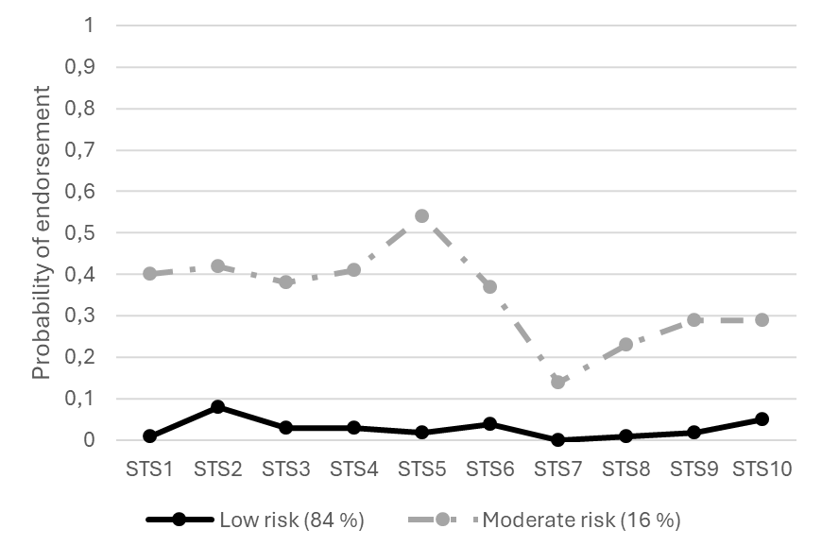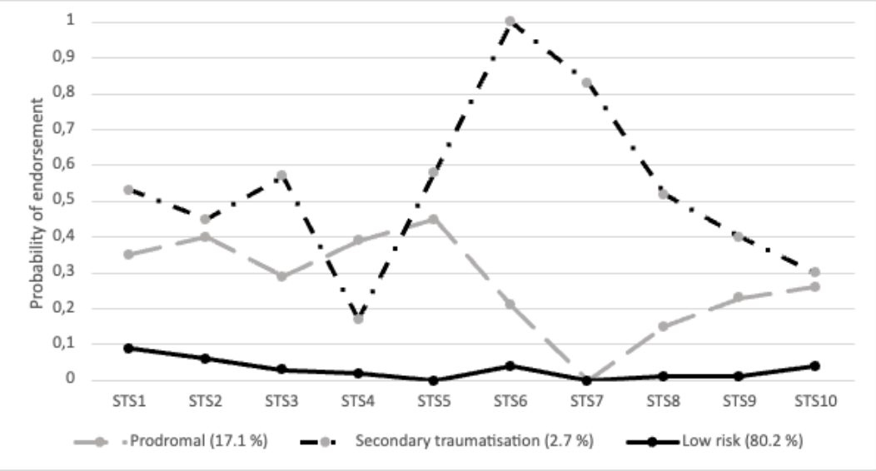
Note: Item-content: STS1: Preoccupied with more than 1 client. STS2: Startle. STS3: Difficulty separating personal/professional life. STS4: Affected by others’ traumatic stress. STS5: Tense/uneasy due to helping others. STS6: Depressed because of others’ trauma. STS7: Experiencing others’ trauma. STS8: Avoidance of reminders of others’ trauma. STS9: Intrusions of others’ trauma. STS10: Forgetting important parts of work with traumatized clients.

References for supplementary materials 3
Akaike, H. (1987). Factor analysis and AIC. In E. Parzen, K. Tanabe, & G. Kitagawa (Eds.) Selected Papers of Hirotugu Akaike (pp. 371-386). Springer.
Debowska, A., Willmott, D., Boduszek, D., & Jones, A. D. (2017). What do we know about child abuse and neglect patterns of co-occurrence? A systematic review of profiling studies and recommendations for future research. Child Abuse & Neglect, 70, 100- 111.
https://doi.org/10.1016/j.chiabu.2017.06.014
Lo, Y., Mendell, N. R., & Rubin, D. B. (2001). Testing the number of components in a normal mixture. Biometrika, 88(3), 767–778. https://doi.org/10.1093/biomet/88.3.767
Ramaswamy, V., DeSarbo, W. S., Reibstein, D. J., & Robinson, W. T. (1993). An empirical pooling approach for estimating marketing mix elasticities with PIMS data. Marketing Science, 121, 103–124. https://doi.org/10.1287/mksc.12.1.103
Schwarz, G.E. (1978). Estimating the dimension of a model. The Annals of Statistics, 6(2), 461–464.
Sclove, S. L. (1987). Application of model-selection criteria to some problems in multivariate analysis. Psychometrika, 52(3), 333-343. https://doi.org/10.1007/BF02294360
Vang, M. L., Pihl‐Thingvad, J., & Shevlin, M. (2022). Identifying child protection workers at risk for secondary traumatization: A latent class analysis of the Professional Quality of Life Scale–5. Journal of Traumatic Stress, 35(6), 1608–1619. https://doi.org/10.1002/jts.22863

Supplementary materials 4: Raw cell counts underlying the agreement analyses

Table S3: Raw cell counts underlying the agreement analysis between probable ST and probable PTSD
 | Probable ST = yes / probable PTSD = yes | Probable ST = yes / probable PTSD = no |  | Probable PTSD = yes / probable ST = no | Probable PTSD = no / probable ST = no
Full sample | 1 |  | 0 | 37 |  | 823
Prosecutors | 0 |  | 0 | 5 |  | 252
Municipal child protection | 1 |  | 0 | 29 |  | 468
‘Barnahus’ employee | 0 |  | 0 | 3 |  | 60
Child forensic video interviewers | 0 |  | 0 | 0 |  | 43

Table S4: Raw cell counts underlying the agreement analysis between probable ST (scored with the LCA method) and probable PTSD
 | Probable ST (LCA) = yes / probable PTSD = yes | Probable ST (LCA) = yes / probable PTSD = no |  | Probable PTSD = yes / probable ST (LCA) = no | Probable PTSD = no / probable ST (LCA) = no
Full sample | 10 |  | 20 | 28 |  | 803
Prosecutors | 0 |  | 7 | 5 |  | 245
Municipal child protection | 8 |  | 10 | 22 |  | 458
‘Barnahus’ employee | 2 |  | 2 | 1 |  | 58
Child forensic video interviewers | 0 |  | 1 | 0 |  | 42

