Supplementary Materials

Supplement 1: Search terms used to identify peer-reviewed literature pertaining to vicarious trauma exposure in behavioral health, victims’ advocates, and housing insecurity workforces and in consideration of synonyms for vicarious trauma exposure, workplace settings, and workforce professional titles.

Addiction workforce
(vicarious trauma*[tiab] OR secondary trauma*[tiab] OR traumatic stress [tiab] OR burnout[tiab] OR compassion fatigue[tiab] OR OR working conditions [tiab])

AND

("Substance Abuse Treatment Centers"[Mesh] OR "Substance-Related Disorders/therapy"[Mesh] OR
substance abuse*[tiab] OR substance dependenc*[tiab] OR substance use*[tiab] OR drug abuse*[tiab] OR drug dependenc*[tiab] OR addiction[tiab])

AND

("Workplace"[Mesh] OR "Workforce"[Mesh] OR "Health Personnel"[Mesh] OR "Health Occupations"[Mesh:NoExp] OR "Occupational Health"[Mesh] OR "Counselors"[Mesh] OR
counselors[tiab] OR recovery coaches[tiab] OR treatment providers[tiab] OR care provider*[tiab] OR social work* [tiab]OR work environment[tiab] OR working conditions[tiab] OR workforce[tiab] OR workplace*[tiab])

Mental health workforce
(vicarious trauma*[tiab] OR secondary trauma*[tiab] OR traumatic stress [tiab] OR burnout[tiab] OR compassion fatigue[tiab] OR working conditions [tiab])
AND
("Mental Health Services"[Mesh] OR "Mental Disorders"[Mesh] OR “Diagnosis, Dual (Psychiatry)” [MESH] OR mental health* [tiab] OR behavioral health [tiab] OR co-occurring [tiab])
AND
("Health Personnel"[Mesh] OR "Health Occupations"[Mesh:NoExp] OR "Counselors"[Mesh] OR counselor*[tiab] OR therapist* [tiab] OR psychiatri*[tiab] OR orderly[tiab] OR treatment provider*[tiab] OR care provider*[tiab] OR social work* [tiab])
AND
("Workplace"[Mesh] OR "Workforce"[Mesh] OR "Occupational Health"[Mesh] OR work environment [tiab] OR working condition*[tiab] OR workforce[tiab] OR workplace*[tiab])

Housing Insecurity Workforce
(vicarious trauma*[tiab] OR secondary trauma*[tiab] OR traumatic stress [tiab] OR burnout[tiab] OR compassion fatigue[tiab] OR working conditions [tiab])
AND

("Homeless Persons"[Mesh] OR "Emergency Shelter"[Mesh] OR “housing” [MESH] OR homeless* [tiab] OR shelter* [tiab] OR housing insecur* [tiab])
AND
("Health Personnel"[Mesh] OR "Health Occupations"[Mesh:NoExp] OR "Counselors"[Mesh] OR counselor*[tiab] OR therapist* [tiab] OR care provider*[tiab] OR social work* [tiab] or outreach work* [tiab] OR case manag*)
AND
("Workplace"[Mesh] OR "Workforce"[Mesh] OR "Occupational Health"[Mesh] OR work environment [tiab] OR working condition*[tiab] OR workforce[tiab] OR workplace*[tiab])

Victims Advocates
(burnout[tiab] OR compassion fatigue[tiab] OR vicarious trauma*[tiab] OR secondary trauma*[tiab] OR traumatic stress [tiab] OR working conditions [tiab])
AND
("Domestic Violence"[Mesh] OR "Intimate partner violence"[Mesh] OR “Sexual Trauma” [MESH] OR “Violence” [Mesh] OR “Torture” [Mesh] OR “Ethnic violence” OR “Sex Offenses” [MESH] OR “Stalking” [Mesh] OR “Child Welfare” [Mesh] OR [tiab] OR shelter* [tiab] OR crisis response* [tiab] OR domestic violence [tiab] OR intimate partner violence OR abuse OR batter* sexual assault* OR rape* OR human traffic* [tiab] OR sex traffic*[tiab] OR refugee* [tiab] OR asylum* [tiab] OR elder abuse [tiab] OR elder neglect [tiab] OR child abuse [tiab] OR child protect* [tiab] OR Stalking [tiab] OR survivor [tiab] OR victim [tiab])
AND
("Health Personnel"[Mesh] OR "Health Occupations"[Mesh:NoExp] OR "Counselors"[Mesh] OR counselor*[tiab] OR therapist* [tiab] OR care provider*[tiab] OR social work* [tiab] or outreach work* [tiab] OR case manag* OR advocate*[tiab] OR residential work* OR forensic [tiab])
AND
("Workplace"[Mesh] OR "Workforce"[Mesh] OR "Occupational Health"[Mesh] OR work environment [tiab] OR working condition*[tiab] OR workforce[tiab] OR workplace*[tiab] OR organization* [tiab] OR supervisor* [tiab] OR coworker* [tiab])

Housing Insecurity Workforce
(vicarious trauma*[tiab] OR secondary trauma*[tiab] OR traumatic stress [tiab] OR burnout[tiab] OR compassion fatigue[tiab] OR working conditions [tiab])
AND
("Homeless Persons"[Mesh] OR "Emergency Shelter"[Mesh] OR “housing” [MESH] OR homeless* [tiab] OR shelter* [tiab] OR housing insecur* [tiab])
AND
("Health Personnel"[Mesh] OR "Health Occupations"[Mesh:NoExp] OR "Counselors"[Mesh] OR counselor*[tiab] OR therapist* [tiab] OR care provider*[tiab] OR social work* [tiab] or outreach work* [tiab] OR case manag*)
AND
("Workplace"[Mesh] OR "Workforce"[Mesh] OR "Occupational Health"[Mesh] OR work environment [tiab] OR working condition*[tiab] OR workforce[tiab] OR workplace*[tiab])
Supplement 2: Cognitive interview participant characteristics (N=19)
* Participants allowed to identify with more than one racial-ethnic identity. No % calculated.
Characteristics | N (%)
Gender
Man | 7 (37)
Woman | 11 (58)
Non-binary | 1 (5)
Racial-ethnic identity*
White | 14
Black/ African American | 3
Latinx | 1
Native American/ Alaskan Native | 1
Asian | 1
Education
High school/ GED | 3 (16)
Associate’s degree/ some college | 3 (16)
Bachelor’s degree | 3 (16)
Master’s degree | 9 (47)
Doctorate | 1 (5)
Type of organization
Acute care/ Detox | 1 (5)
Residential | 5 (26)
Outpatient | 6 (32)
Drop-in/ Recovery Center | 3 (16)
Drug court | 2 (11)
Case-management organization | 2 (11)
Position
Therapist or counselor | 6 (32)
Peer specialist/ recovery coach | 4 (21)
Case manager | 3 (16)
Direct-service supervisor | 4 (21)
Outreach worker | 1 (5)
Physician | 1 (5)
Organization location
Urban | 11 (58)
Suburban | 5 (26)
Rural | 3 (16)
Geographic region
New England | 8 (42)
Mid-Atlantic | 2 (11)
South | 6 (32)
Midwest | 2 (11)
West Coast | 1 (5)
Time in current role (years)
<1 | 7 (37)
1-3 | 7 (37)
4-6 | 3 (16)
7-10 | 1 (5)
10 + | 1 (5)
Time in SUD field
<1 | 2 (11)
1-3 | 4 (21)
4-6 | 3 (16)
7-10 | 4 (21)
10 + | 6 (31)
Supplement 3: Approach to identifying suspicious and fraudulent responses
Due to increasingly high rates of survey fraud when providing participant incentives and since we did not have a delimited sampling frame, we monitored our survey responses to help ensure only real people working in the substance use field were included in our analysis. This survey was administered through Qualtrics, and at the time of data collection, we found that Qualtrics’ survey fraud detector was not dependable. We thus opted to review each survey response individually for the indicators listed below that may suggest that the response was either duplicated (i.e. a person submitted more than one response) or bot-generated. Of note, some of these indicators could be violated even when the response is not actually fraudulent. For example, somebody could complete the survey while traveling (hence why an IP address and reported geographic location did not match) or select their wrong age from the dropdown option. For this reason, we opted to conservatively remove participants that had 2 or more suspicious factors in their response based upon feedback from survey experts. Of note, the vast majority of removed responses (N=219) had 4 or more suspicious indicators while 12 responses had only 2 suspicious indicators.

Suspicious Response Indicators
- If the participant provided a response to an open-ended question, did the response make sense relative to the prompt?
- Did the IP geolocation and participant’s self-reported geographic location match?
- The survey asked the participant to report their age in two places. Did these ages match?
- Did the participant’s education, professional role, and ratio of patient-facing hours make sense when considered together?
- Was the reported number of years worked theoretically possible given their self-reported age?
- Was the amount of time the participant worked in the field greater than or equal to the amount of time they worked in their current job?
- Had the same email address been submitted before?
- What was the format of the email address? Was the email address clearly real (e.g. a .gov, .org, or .edu domain)? If a name was used in the email address, did the reported first name match the name in the email address?
- Was there an observed pattern of plausible but unlikely responses given the sample (e.g. multiple responses submitted in one day for 27 year old men, who are medical doctors, works in emergency settings, and have practiced in the field for 5 years)?

Supplement 4: Final 16-Item Vicarious Occupational Trauma Exposure (VOTE) Index
PDFs of the instrument in two different formats are available at https://hsph.harvard.edu/research/center-for-work-health-and-well-being/resources/

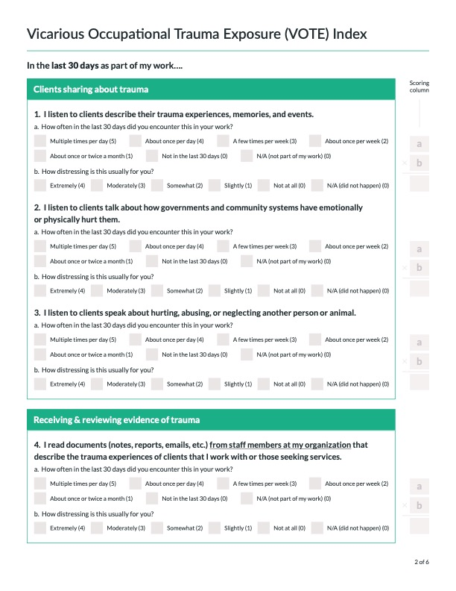

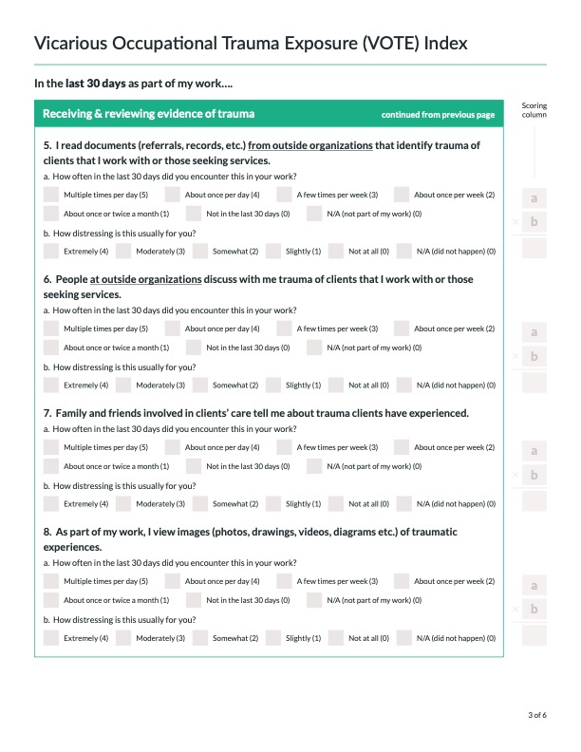

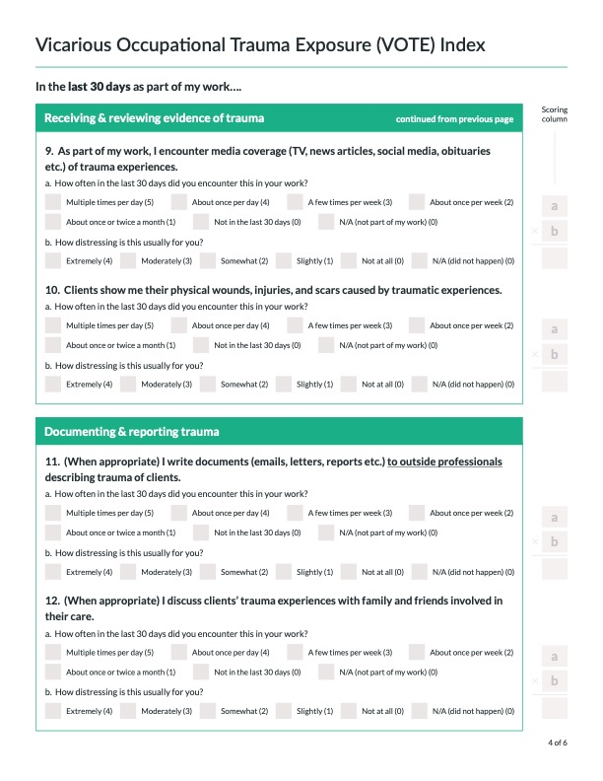

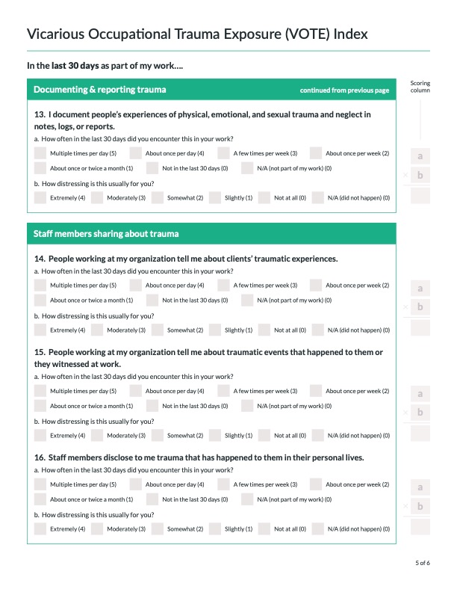

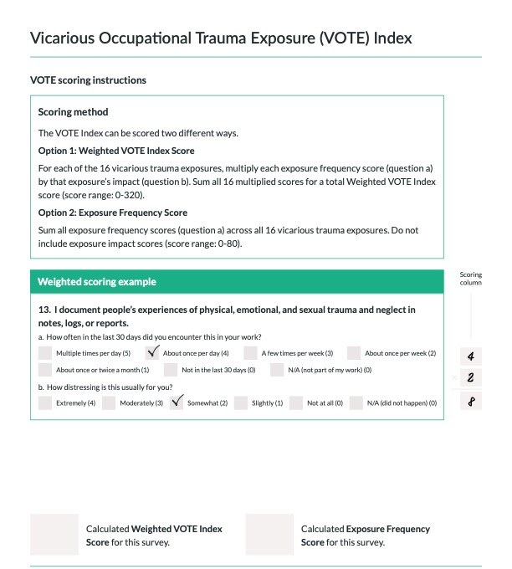

Supplement 5: Vicarious Occupational Trauma Exposure (VOTE) frequency distributions by exposure frequency scores, impact scores, and weighted frequency scores

Exposure frequency score distributions across 20 VOTE Items

Exposure impact score distributions across 20 VOTE Items

Exposure frequency score distributions weighted by exposure impact score across 20 VOTE Items

Supplement 6: Vicarious Occupational Trauma Exposure (VOTE) Index inter-item correlations by exposure frequency scores, impact scores, and weighted frequency scores

Exposure frequency scores

Exposure impact scores

Exposure frequency score weighted by exposure impact score

Supplement 7: Comparing weighted VOTE Index item mean and total scores for direct service providers and participants not providing direct services.

Domain | Item | Direct Service  (N= 1,260) | Not Direct Service  (N= 155) | P-value
Total Weighted VOTE Score |  | 67.72 | 54.17 | <0.001
Clients sharing about trauma | 1  I listened to clients describe their trauma experiences, memories, and events. | 8.13 | 5.71 | <0.001
Clients sharing about trauma | 2  I listened to clients talk about how governments and community systems have emotionally or physically hurt them. | 6.91 | 5.24 | <0.001
Clients sharing about trauma | 3  I listened to clients speak about hurting, abusing, or neglecting another person or animal. | 6.24 | 6.53 | 0.63
Receiving & reviewing evidence of trauma | 4  I read documents (notes, reports, emails, etc.) from people working at my organization that describe the trauma experiences of clients that I work with or those seeking services. | 6.11 | 6.67 | 0.25
Receiving & reviewing evidence of trauma | 5  I read documents (referrals, records, etc.) from outside organizations that identify trauma of clients that I work with or those seeking services. | 5.12 | 5.13 | 0.92
Receiving & reviewing evidence of trauma | 6  People at outside organizations discussed with me trauma of clients that I work with or those seeking services. | 4.34 | 4.26 | 0.53
Receiving & reviewing evidence of trauma | 7  Family and friends involved in clients’ care  told me about trauma clients have experienced. | 4.62 | 4.52 | 0.83
Receiving & reviewing evidence of trauma | 8  As part of my work, I viewed images (photos, drawings, videos, diagrams etc.) of traumatic experiences. | 5.45 | 4.85 | 0.54
Receiving & reviewing evidence of trauma | 9  As part of my work, I encountered media coverage (TV, news articles, social media, obituaries etc.) of trauma experiences. | 6.23 | 6.21 | 0.69
Receiving & reviewing evidence of trauma | 10  Clients showed me their physical wounds, injuries, and scars caused by traumatic experiences. | 4.88 | 4.38 | 0.71
Documenting & reporting trauma | 11  (When appropriate) I wrote documents (emails, letters, reports etc.) to outside professionals describing trauma of clients. | 3.80 | 3.32 | 0.55
Documenting & reporting trauma | 12  (When appropriate) I discussed clients’ trauma experiences with family and friends involved in their care. | 3.80 | 3.95 | 0.29
Documenting & reporting trauma | 13  I documented people’s experiences of physical, emotional, and sexual trauma or neglect in notes, logs, or reports. | 5.83 | 4.93 | 0.30
Staff members sharing about trauma | 14  People working at my organization told me about clients’ traumatic experiences. | 5.44 | 5.54 | 0.49
Staff members sharing about trauma | 15  People working at my organization told me about traumatic events that happened to them or they witnessed at work. | 4.76 | 4.63 | 0.43
Staff members sharing about trauma | 16  People working at my organization disclosed to me trauma that has happened to them in their personal lives. | 3.87 | 4.53 | 0.08

