Supplementary Materials
Table S1
Model Fit Comparisons
 | χ2 | df | TLI | CFI | RMSEA
Model A | 1248.57*** | 758 | .92 | .92 | .055
Model B | 1043.56*** | 614 | .92 | .92 | .057
Note. N = 237. Each row represents the structural model performed. TLI = Tucker-Lewis index; CFI = comparative fit index; RMSEA = root mean square error of approximation; Model A = indirect effects for phenotype invalidation, behavioral invalidation, and incongruent discrimination; Model B = indirect effects for phenotype invalidation and behavioral invalidation.
***p < .001.

Table S2
Regression Coefficients
 |  |  | 95% Confidence Interval
 | b | β | Lower |  | Upper
c1. Behavioral ~ Depression | 0.13 | 0.12 | -0.07 |  | 0.33
c4. Behavioral ~ Anxiety | 0.13 | 0.11 | -0.07 |  | 0.33
c7. Behavioral ~ Self-Esteem | -0.11 | -0.10 | -0.31 |  | 0.09
a1. Behavioral ~ Autonomy | -0.17 | -0.16 | -0.42 |  | 0.07
c2. Phenotype ~ Depression | 0.04 | 0.04 | -0.11 |  | 0.19
c5. Phenotype ~ Anxiety | -0.03 | -0.03 | -0.19 |  | 0.13
c8. Phenotype ~ Self-Esteem | -0.04 | -0.04 | -0.19 |  | 0.10
a2. Phenotype ~ Autonomy | 0.01 | 0.01 | -0.15 |  | 0.18
c3. Incongruent ~ Depression | 0.17 | 0.16 | -0.03 |  | 0.36
c6. Incongruent ~ Anxiety | 0.42*** | 0.36*** | 0.20 |  | 0.64
c9. Incongruent ~ Self-Esteem | -0.10 | -0.09 | -0.28 |  | 0.09
a3. Incongruent ~ Autonomy | -0.22 | -.21 | -0.46 |  | 0.02
b1. Autonomy ~ Depression | -0.14 | -0.14 | -0.29 |  | 0.01
b2. Autonomy ~ Anxiety | -0.19* | -0.17* | -0.35 |  | -0.03
b3. Autonomy ~ Self-Esteem | 0.24** | 0.24** | 0.08 |  | 0.40
Note. * p < .05, ** p < .01, *** p < .001

Table S3
Indirect Effects of Measurement Model 1
 |  |  | 95% Confidence Interval
 | b | β | Lower | Upper
Invalidation ~ Autonomy ~ Depression | 0.05 | 0.05 | -0.010 | 0.121
Invalidation ~ Autonomy ~ Anxiety | 0.07* | 0.06* | 0.009 | 0.142
Invalidation ~ Autonomy ~ Self-Esteem | -0.09* | -0.09* | -0.174 | -0.015
Note. * p < .05, ** p < .01, *** p < .001

Table S4
Additional Demographics: Characteristics of Participants
 | n | %
Gender
Man | 107 | 45%
Woman | 119 | 50%
Transgender | 5 | 2%
Nonbinary | 4 | 2%
Prefer not to say | 2 | 1%
Race
White Black | 97 | 41%
White Latino | 60 | 25%
White Asian | 64 | 27%
White Native | 7 | 3%
White Pacific | 2 | 1%
White MENA | 7 | 3%
Family Income
Less than $10,000 | 8 | 3%
$10,000 - $39,999 | 53 | 22%
$40,000 - $69,999 | 62 | 26%
$70,000 - $99,999 | 46 | 20%
More than $100,000 | 68 | 29%
Generational Status
1st | 1 | 1%
2nd | 104 | 44%
3rd | 42 | 18%
4th | 15 | 6%
5th | 6 | 2%
No Immigrant background | 69 | 29%
Highest Education
High School | 33 | 14%
Some College | 62 | 26%
Trade School | 6 | 3%
4-year Degree | 102 | 43%
Graduate School | 34 | 14%
Political Affiliation
Very Conservative | 7 | 3%
Conservative | 21 | 9%
Somewhat Conservative | 28 | 12%
Moderate | 60 | 25%
Somewhat Liberal | 28 | 12%
Liberal | 49 | 21%
Very Liberal | 44 | 18%

Figure S1
Full Structural Equation Model (B) with Standardized Path Coefficients and Factor Loadings Among U.S. Minority-White Biracial Individuals (N = 237)

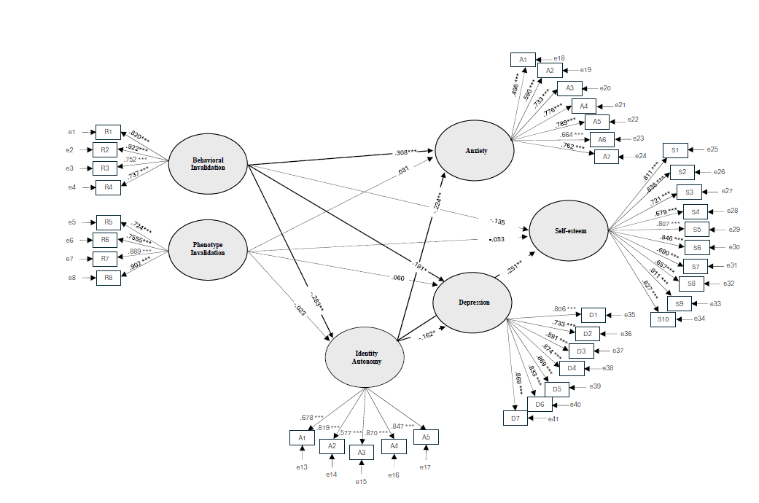

Note. * p < .05, ** p < .01, *** p < .001

Appendix
Pre-Screener
- Do you identify as a biracial or multiracial individual? Ex. Having a mixed racial background such as being part White and part Black, Asian, or Native American)
Yes
❍ No
- Are your parents of two different races? Ex: Your mom is White, and your dad is Black
❍ Yes
❍ No
- Which of the following best describes your parents' racial backgrounds?
❑ Both parents are White
❑ Both parents are from the same minority racial group
❑ One parent is White, and the other is a single minority race (e.g., Black, Asian, Native American, etc.)
❑ One Parent is White, and the other is biracial or multiracial (e.g., Black and White)
❍ Both Parents are biracial or multiracial
❍ Both parents are from different minority racial groups
❑ Other (please specify) ___
- Do you speak fluent English?
Yes
❍ No
- Do you currently live in the United States?
Yes
❍ No
- Are you between the ages of 18 and 65?
Yes
❍ No

Demographics
- How old are you? (In years) ___
- Do you speak English fluently
Yes
❍ No
- Were you born in the United States?
❍ Yes
❍ No (If no, where were you born?) ___
- Are you currently living in the United States?
Yes
❍ No
- What race is your biological father? (Check all that may apply)
❑ White/Caucasian
❑ Black/African American
❑ Hispanic/ Latino
❑ Asian
❍ American Indian or Alaska Native
❍ Native Hawaiian or Other Pacific Islander
❍ Middle Eastern/North African (MENA)
❑ Other ___
- What race is your biological mother? (Check all that may apply)
❑ White/Caucasian
❑ Black/African American
❑ Hispanic/ Latino
❑ Asian
❍ American Indian or Alaska Native
❍ Native Hawaiian or Other Pacific Islander
❍ Middle Eastern/North African (MENA)
❑ Other ___
- What is your racial identity?
- What is your ethnicity? Ex. Your racial identity is Asian, but your ethnicity is Japanese.
- What is your racial background? (Check all that may apply)
❑ White/Caucasian
❑ Black/African American
❑ Hispanic/ Latino
❑ Asian
❍ American Indian or Alaska Native
❍ Native Hawaiian or Other Pacific Islander
❍ Middle Eastern/North African (MENA)
❑ Other ___
- What does racially identifying as [INSERT Q.7 RACIAL IDENTITY] mean for you?
- You indicated that you're biracial. Do you identify more with one racial identity than the other? If so, which one? Why?
- Are your parents of two different races? Ex: Your mom is White, and your dad is Black.
❍ Yes
❍ No
- Are your parents of two different ethnicities? Ex: Your mom is Japanese, and your dad is Chinese.
❍ Yes
❍ No
- Is one of your racial backgrounds White?
❍ Yes
❍ No
- What is your minority racial background??
❑ Black/African American
❑ Hispanic/ Latino
❑ Asian
❍ American Indian or Alaska Native
❍ Native Hawaiian or Other Pacific Islander
❑ Middle Eastern/North African (MENA)
❑ Other ___
- How strongly do you identify as White?
❍ 1 Very weakly
❍ 2
❍ 3
❍ 4
❍ 5
❍ 6
❍ 7 Very strongly
❍ I don't identify as White
- How strongly do you identify as biracial
❍ 1 Very weakly
❍ 2
❍ 3
❍ 4
❍ 5
❍ 6
❍ 7 Very strongly
❍ I don't identify as biracial
- How strongly do you identify as [INSERT Q.15 MINORITY IDENTITY]?
❍ 1 Very weakly
❍ 2
❍ 3
❍ 4
❍ 5
❍ 6
❍ 7 Very strongly
❍ I don't identify as [INSERT MINORITY IDENTITY]
- Was your father born in the United States?
❍ Yes
❍ No (If no, where was he born?) ___
- Was your mother born in the United States?
❍ Yes
❍ No (If no, where was she born?) ___
- Do you speak more than one language?
❍ No
❍ Yes (If yes, what other language(s)? ___
- Are you a United States citizen?
❍ Yes
❍ No
- If you have an immigrant background, what is your generational status? (If at least one of parents is an immigrant, you are 2nd generation, if at least one of your grandparents is an immigrant, you are 3rd generation, etc.)
❍ 1st generation (I moved here myself)
❍ 2nd generation (one of my parents moved here)
❍ 3rd generation (one of my grandparents moved here)
❍ 4th generation (one of my great-grandparents moved here)
❍ 5th+ generation
❍ I do not have an immigrant background
- How would you describe your gender?
❍ Man
❍ Woman
❍ Transgender
❍ Nonbinary
❍ Prefer not to say
❍ Other___
- Are you religious?
❍ No
❍ Yes (If yes, what is your religion?) ___
- What is your current zip code? ___
- What is the highest grade or year of regular school that you have completed?
❍ No formal schooling
❍ 8th grade or less
❍ Some high school (Grades 9,10,11 & 12)
❍ High school diploma (Completed 12th grade)
❍ G.E.D.
❍ Some college or 2 year degree
❍ Technical or trade school
❍ Bachelor’s degree
❍ Graduate or professional school
- Now, please think of your household income from all sources. Include not just your own income, but also the income of everyone living with you. Include money you have from jobs and public assistance programs, as well as any other sources such as rent, interest and dividends. What was your total household income last year before taxes? If you don't know, you can give us a guess estimate. Can you indicate if it is:
❍ Less than $5,000
❍ $5,001 to $10,000
❍ $10,001 to $20,000
❍ $20,001 to $30,000
❍ $30,001 to $40,000
❍ $40,001 to $50,000
❍ $50,001 to $60,000
❍ $60,001 to $70,000
❍ $70,001 to $80,000
❍ $80,001 to $90,000
❍ $90,001 to $100,000
❍ Over 100,000
- Here is a seven-point scale on which the political views that people might hold. How would you categorize your political beliefs?
❍ Very conservative
❍ Conservative
❍ Somewhat conservative
❍ Moderate/Middle of the road
❍ Somewhat liberal
❍ Liberal
❍ Very liberal

Racial Identity Invalidation Scale (Franco & O’Brien, 2018)
- Because of the way I speak, others deny my racial group membership(s).
- I am excluded from a racial group that I feel connected to because I do not “behave” like a typical member of that racial group.
- Others think that my interests are different than those of a typical member of my racial group(s).
- When people hear my opinions, they make me feel like I do not belong in my racial group(s).
- Others would not guess the race(s) that I identify with.
- People have reacted with surprise when I tell them the race(s) that I identify with.
- My physical features (e.g., skin color, hair texture, eye shape, eye color) lead people to assume that I am not the race(s) that I perceive myself as.
- People assume I am not a member of the racial group(s) that I identify with.
- Others call me racially-derogatory words that do not apply to the racial group(s) that I identify with.
- I am discriminated against based on a race that I do not identify with.
- Others apply racial stereotypes to me that do not apply to the racial group(s) that I identify with.
- People expect me to associate with members of a racial group that I do not identify with
All items are answered using a 6-point Likert-type scale (1 = never and 6 = almost aways)

Identity Autonomy Scale (Albuja et al., 2019a)
- I feel that I have a say in how I racially identify.
- I feel that I can racially identify as I want.
- I don't feel pressured to racially identify a certain way.
- I feel that I decide how I racially identify.
- I feel free to racially identify how I want.
All items are answered using a 7-point Likert-type scale (1 = “strongly disagree” and 7 = “strongly agree”).

Rosenberg Self-Esteem Scale (Rosenberg, 2011)
- On the whole, I am satisfied with myself.
- At times I think I am no good at all. (R)
- I feel that I have a number of good qualities.
- I am able to do things as well as most other people.
- I feel I do not have much to be proud of. (R)
- I certainly feel useless at times. (R)
- I feel that I'm a person of worth, at least on an equal plane with others.
- I wish I could have more respect for myself. (R)
- All in all, I am inclined to feel that I am a failure. (R)
- I take a positive attitude toward myself.
All items are answered using a 4-point Likert scale (1 = “Strongly Disagree” and 4 = “Strongly Agree”).

Depression Anxiety Stress Scale-21 (Henry & Crawford, 2005; Lovibond & Lovibond, 2011)
- (s) I found it hard to wind down
- (a) I was aware of dryness of my mouth
- (d) I couldn’t seem to experience any positive feeling at all
- (a)I experienced breathing difficulty (e.g. excessively rapid breathing, breathlessness in the absence of physical exertion)
- (d) I found it difficult to work up the initiative to do things
- (s) I tended to over-react to situations
- (a) I experienced trembling (e.g. in the hands)
- (s) I felt that I was using a lot of nervous energy
- (a) I was worried about situations in which I might panic and make a fool of myself
- (d) I felt that I had nothing to look forward to
- (s) I found myself getting agitated
- (s) I found it difficult to relax
- (d) I felt down-hearted and blue
- (s) I was intolerant of anything that kept me from getting on with what I was doing
- (a) I felt I was close to panic
- (d) I was unable to become enthusiastic about anything
- (d) I felt I wasn’t worth much as a person
- (s) I felt that I was rather touchy
- (a) I was aware of the action of my heart in the absence of physical exertion (e.g. sense of heart rate increase, heart missing a beat)
- (a) I felt scared without any good reason
- (d) I felt that life was meaningless
All items are answered using a Likert scale (0 = “Did not apply to me at all” and 3 = “Applied to me very much or most of the time”).

