Supplemental Material A: Treatment descriptions (note that half saw the following table, while half saw the full text descriptions)
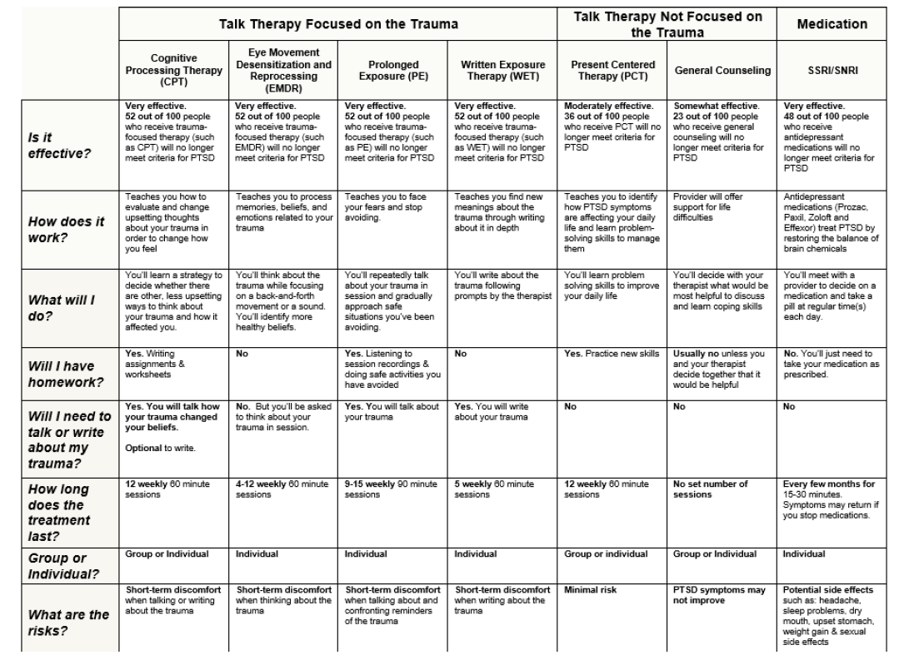
COGNITIVE PROCESSING THERAPY
Cognitive Processing Therapy (CPT) is an individual or group talk therapy for PTSD in which you will write and talk about your trauma. CPT is one of the treatments for PTSD that works very well: 52 out of 100 people who do a trauma focused treatment like CPT will no longer meet criteria for PTSD. The benefits of CPT often last long after your final session with your therapist.
How does it work?
Trauma can change the way you think. People with PTSD often believe they are to blame for what happened or have negative thoughts like “I can’t trust anyone.” CPT teaches you how to identify thoughts changed by a trauma, and then to change these upsetting thoughts.
What will I do in this treatment?
In CPT, you will complete about 12 weekly 60 minute sessions. In CPT, you’ll learn a strategy to decide whether there are more balanced ways to think about your trauma and how it affected your life. By changing your thoughts, you can change how you feel. CPT has homework: there are writing assignments and worksheets to complete between the sessions.
What are the risks?
Some people feel discomfort when talking or writing about trauma-related memories or thoughts. However, these feelings are usually short-term and people tend to feel better as they keep doing CPT.

EYE-MOVEMENT DESENSITIZATION AND REPROCESSING THERAPY (EMDR)
Eye-Movement Desensitization and Reprocessing Therapy (EMDR) is an individual talk therapy for PTSD in which you will focus your thoughts on your trauma. EMDR is one of the treatments for PTSD that works very well: 52 out of 100 people who do a trauma focused treatment like EMDR will no longer meet criteria for PTSD. The benefits of EMDR often last long after your final session with your therapist.
How does it work?
People with PTSD often have trouble making sense of what happened to them. EMDR teaches you to process memories, beliefs, and emotions related to the trauma.
What will I do in treatment?
In EMDR, you will complete 4-12 weekly 60 minute sessions. In EMDR, you will pay attention to back-and-forth movement or sound while you call to mind the trauma memory. You will identify negative beliefs associated with the trauma and work on replacing them. Over time, this can help you process your memories and feelings and change how you react to them. There is no homework between sessions.
What are the risks?
Some people feel discomfort when thinking about trauma-related memories or beliefs. However, these feelings are usually short-term and people tend to feel better as they keep doing EMDR.

PROLONGED EXPOSURE
Prolonged Exposure (PE) is an individual talk therapy for PTSD in which you will talk about your trauma. PE is one of the treatments for PTSD that works very well: 52 out of 100 people who do a trauma focused treatment like PE will no longer meet criteria for PTSD. The benefits of PE often last long after your final session with your therapist.
How does it work?
People with PTSD often try and avoid things that remind them of the trauma. They may also believe the world is a very dangerous place, or that they can’t keep themselves safe. PE teaches you to face your fears.
What will I do in this treatment?
In PE, you will complete 9-15 weekly 90 minute sessions. In PE you talk about your trauma repeatedly in session. You will also gradually approach trauma-related memories, feelings, and situations that you’ve
been avoiding. Confronting these situations can decrease your distress. PE has homework: you will listen to your session recordings and you will do safe activities that you have been avoiding.
What are the risks?
Some people feel discomfort when talking about their trauma or approaching situations that they have been avoiding. However, these feelings are usually short-term and people tend to feel better as they keep doing PE.

WRITTEN EXPOSURE THERAPY
Written Exposure Therapy (WET) is an individual talk therapy for PTSD in which you will write about your trauma. WET is one of the treatments for PTSD that works very well: 52 out of 100 people who do a trauma focused treatment like WET will no longer meet criteria for PTSD. The benefits of WET often last long after your final session with your therapist.
How does it work?
People with PTSD often try and avoid things that remind them of the trauma. Writing about the event helps you to find new meanings about the trauma through writing about it in depth.
What will I do in this treatment?
In WET, you will complete 5 weekly 60 minute sessions. In WET you will write about the trauma and how it affected you following a prompt given by your provider. You will check in with your therapist after each writing, and they will read through what you wrote. There is no homework between sessions.
What are the risks?
Some people feel discomfort when writing about trauma related memories. However, these feelings are usually short-term and people tend to feel better as they keep doing WET.

PRESENT CENTERED THERAPY
Present Centered Therapy (PCT) is an individual or group talk therapy for PTSD that does not focus on your trauma. PCT is one of the treatments for PTSD that works moderately well. 36 out of 100 people who do this treatment will no longer meet criteria for PTSD. The benefits of PCT often last long after your final session with your therapist.
How does it work?
PTSD symptoms can affect how you feel about—and cause problems in—your daily life. PCT teaches you to identify how PTSD symptoms are affecting your daily life and learn to come up with better solutions for managing your symptoms.
What will I do in treatment?
In PCT, you will complete 12 weekly 60 minute sessions. In PCT you’ll learn problem-solving skills that help you to feel more in control and to have more confidence in your ability to face problems in your daily life, including in your relationships. PCT has homework: you will be asked to use a daily diary to keep track of issues or problems that concern you between sessions.
What are the risks?
The risks are minimal.

GENERAL COUNSELING
General counseling is an individual or group talk therapy for PTSD that does not focus on your trauma. There is no set number of sessions. Although counseling can be helpful in general, it is only somewhat helpful for PTSD specifically: 23 out of 100 people who do this treatment will no longer meet criteria for PTSD.
How does it work?
People with PTSD often feel distress and want support for their problems. General counseling provides sessions with a supportive, non-judgmental therapist. You may learn more about yourself, your emotions, or healthy coping skills. You might also get support in coping with problems unrelated to your trauma which could reduce general stress.
What will I do in treatment?
Unlike other specific therapies, there is not a set expectation for what will be discussed in each session, or how many times you will meet. You may meet once a month or every other week. You can talk with your therapist about what you think may be helpful. You and your therapist will decide together what to talk about each week. In most cases there is no homework between sessions, unless you and your therapist decide together that it would be helpful.
What are the risks?
Your PTSD symptoms may not resolve since general counselling is not specifically focused on PTSD.
MEDICATIONS (SSRI/SNRI)
Specific antidepressants (Prozac, Paxil, Zoloft and Effexor) called SSRIs and SNRIs are some of the treatments for PTSD that work very well. 48 out of 100 people who take these medications will no longer meet criteria for PTSD. You will need to keep taking the medication to keep getting the benefits.
How do they work?
PTSD may be related to changes in the brain that are linked to our ability to manage stress. People with PTSD have been shown to have different amounts of certain chemicals (called neurotransmitters) in the brain than people without PTSD. SSRIs and SNRIs are believed to treat PTSD by restoring the balance of these brain chemicals.
What will I do in this treatment?
You will take a pill at regular time(s) each day. You will be seen approximately every few months for 15-30 minutes by a provider who prescribes this medication. The provider will monitor your response to medication (including side effects), and change your dose, if needed. Symptoms may return if you stop taking medication.
What are the risks?
The risks of taking SSRIs and SNRIs are side effects such as upset stomach, sweating, headache, weight changes, and sexual side effects. Some side effects are short-term, though others may last as long as you are taking the medication.

Supplemental Material B.
Figure 1.
Overall treatment preference rankings
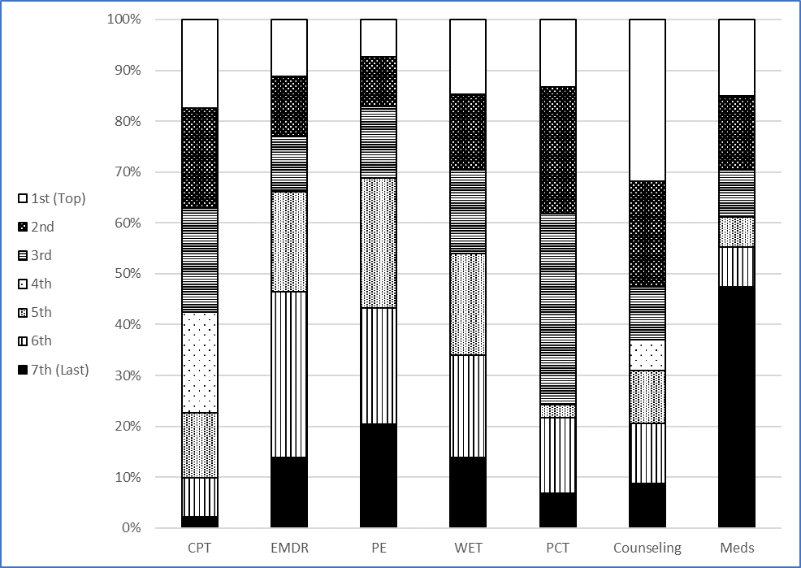

Supplemental Material C: Subcodes for reasons treatments ranked highest or lowest
Table 1. Highest ranked treatments

Codes | Number of qualitative responses | Counseling (n = 88) | CPT  (n = 71) | PCT  (n = 31) | EMDR  (n = 42) | WET  (n = 33) | PE  (n = 19) | Medications (n = 52) | Total
Codes | Subcodes
Perceived effectiveness |  |  |  |  |  |  |  |  | 50
 | Seems effective | 5 | 15 | 4 | 9 | 1 | 6 | 8
 | Logical | 1 | 2
Personal fit |  |  |  |  |  |  |  |  | 75
 | Best fit | 11 | 8 | 6 | 2 | 2 |  | 4
 | Consistent with personality | 2 | 8 |  |  | 9 | 2 | 2
 | Comfortable | 5 | 2 | 2 | 3 | 10 | 1
Good first step |  | 17 |  |  |  |  |  | 2 | 19
Content/mechanism |  |  |  |  |  |  |  |  | 89
 | Unspecified |  | 2 | 1 | 1
 | Cognitive |  | 15 |  | 1
 | Root of the problem |  | 5 |  |  | 1 | 2
 | Talk about trauma | 1 | 2
 | Skills based |  | 3
 | Wants to talk | 9 | 4 | 1 |  |  | 1
 | Biological |  |  |  | 1 |  |  | 1
 | Not talking | 2 | 1 |  | 3 | 3 |  | 6
 | Face fears |  | 1 |  |  |  | 3
 | Writing |  | 3 |  |  | 16
 | Process emotions |  | 1 |  | 1 | 3
 | Present focused | 2 | 1 | 7
Familiarity with the treatment |  |  |  |  |  |  |  |  | 64
 | Unspecified | 1 | 1
 | Received/benefited | 5 | 3 |  | 3 | 3 |  | 16
 | Received previously | 7 | 3 |  | 3 |  |  | 2
 | Heard about it | 2 | 2 |  | 6
 | Haven’t received or heard about it |  |  |  | 4
 | Similar to something else |  | 3 |  |  | 1
Easier access |  |  |  |  |  |  |  |  | 27
 | Unspecified |  |  | 1
 | Easy | 1 |  |  | 3 | 1 | 1 | 9
 | Time efficient | 1 | 2 | 1 | 3 | 1 |  | 3
 | Inexpensive
Better than alternative |  |  |  |  |  |  |  |  | 33
 | No medications | 2 | 2 |  | 2
 | Better than other | 4 | 4 | 4 | 3 |  | 4 | 3
 | True preference not offered | 2 |  | 2 | 1 | 1
Not aversive; no side effects |  |  |  |  |  |  |  |  | 8
 | Unspecified |  |  | 1
 | Not stressful | 2 |  |  |  |  |  | 1
 | No side effects |  | 2 |  | 2
Don’t have to talk about trauma |  |  | 1 |  | 2 |  |  | 2 | 5
Delivery mechanism |  |  |  |  |  |  |  |  | 13
 | Individual | 2 | 1 |  |  |  | 1
 | Group | 3 |  | 1
 | Medications helpful in combination with therapy |  |  |  |  |  |  | 5
Uncertain | Do not know | 1 |  |  | 0 |  | 1 |  | 4
 | Ambivalence |  | 1 |  |  |  | 1
Unspecified | Generic | 5 |  | 3 |  |  |  | 1 | 20
 | Unclear | 6 | 1 | 1 | 2 | 1
Survey didn’t work |  |  | 2 |  | 6 | 1 |  |  | 9
Note. CPT = Cognitive Processing Therapy. EMDR = Eye Movement Desensitization and Reprocessing. PE = Prolonged Exposure. WET = Written Exposure Therapy. The total in the right-most column represents the total number who endorsed a given overall code (and may have endorsed one or more subcodes), so it will not be the sum of all subcodes.

Table 2. Lowest ranked treatments
Codes | Number of qualitative responses | Counseling (n = 30) | CPT  (n = 9) | PCT  (n = 11) | EMDR  (n = 31) | WET  (n = 42) | PE  (n = 56) | Medications (n = 150) | Total
Codes | Subcodes
Perceived ineffectiveness |  |  |  |  |  |  |  |  | 31
 | Seems ineffective | 12 | 2 | 3 | 4 | 1 | 3 | 4
 | Illogical |  |  |  | 1 |  | 1
Lack of fit with treatment |  |  |  |  |  |  |  |  | 59
 | Poor fit | 3 |  | 1 | 4 | 5 | 6 | 3
 | Inconsistent with personality |  |  |  | 2 | 21 | 4 | 1
 | Uncomfortable |  |  | 1 | 2 | 2 | 3 | 1
Content/mechanism |  |  |  |  |  |  |  |  | 63
 | Masking the problem |  |  |  |  |  |  | 9
 | Not getting to the root of the problem | 7 |  | 1 |  |  |  | 3
 | Prefer a talking treatment |  |  |  |  | 7 |  | 3
 | Altering biology/chemistry |  |  |  |  |  |  | 7
 | Don’t prefer writing |  |  | 1 |  | 33
 | Prefer to process emotions |  |  |  |  |  |  | 1
 | Prefer a more structured treatment | 3
Familiar with the treatment (with negative associations) |  |  |  |  |  |  |  |  | 33
 | Received/did not benefit | 3 |  |  | 1 |  |  | 8
 | Received previously | 1 |  |  |  |  |  | 7
 | Heard about it |  |  | 1 |  |  |  | 3
 | Haven’t received or heard about it |  |  |  |  |  | 1
 | Already on (too many) other meds |  |  |  |  |  |  | 8
 | Similar to another treatment |  |  |  | 2
Not easy to access |  |  |  |  |  |  |  |  | 7
 | Rest of my life |  |  |  |  |  |  | 3
 | Time inefficient | 1 |  |  |  | 1 | 2
 | Cost |  |  |  |  |  |  | 1
Worse than alternatives |  |  |  |  |  |  |  |  | 68
 | Don’t want medications |  |  |  |  |  |  | 41
 | Worse than other | 1 |  | 1 | 3 |  | 4 | 14
 | True preference not offered | 1 | 1 | 1 |  |  |  | 1
Aversive (including side effects, addition) |  |  |  |  |  |  |  |  | 77
 | Unspecified |  |  |  |  |  |  | 11
 | Stressful |  |  |  | 2 | 2 | 9 | 2
 | Addiction/dependence |  |  |  |  |  |  | 8
 | Side effects |  |  |  |  |  | 1 | 46
Dislike thinking about or reliving the trauma |  |  |  | 1 |  | 3 | 19 |  | 23
Delivery mechanism |  |  |  |  |  |  |  |  | 3
 | Unspecified |  |  |  |  | 1
 | Individual | 2
 | Medications helpful in combination with therapy |  |  |  |  |  |  | 2
Uncertain | Do not know |  | 1 | 1 | 4 |  | 4 | 1 | 12
 | Ambivalence |  |  |  |  |  | 1
Unspecified | Generic | 1 | 1 | 1 | 5 | 1 | 3 | 5 | 37
 | Unclear |  | 3 | 2 | 2 | 4 | 4 | 5
Survey didn’t work |  |  | 1 | 1 | 1 |  |  |  | 3
Note. CPT = Cognitive Processing Therapy. EMDR = Eye Movement Desensitization and Reprocessing. PE = Prolonged Exposure. WET = Written Exposure Therapy. The total in the right-most column represents the total number who endorsed a given overall code (and may have endorsed one or more subcodes), so it will not be the sum of all subcodes.

