Examining the Associations between Trauma Intrusions, Emotion Regulation and Affect among European Australian and Chinese Australian Trauma Survivors using Ecological Momentary Assessment

Supplementary Material

Figure S1.
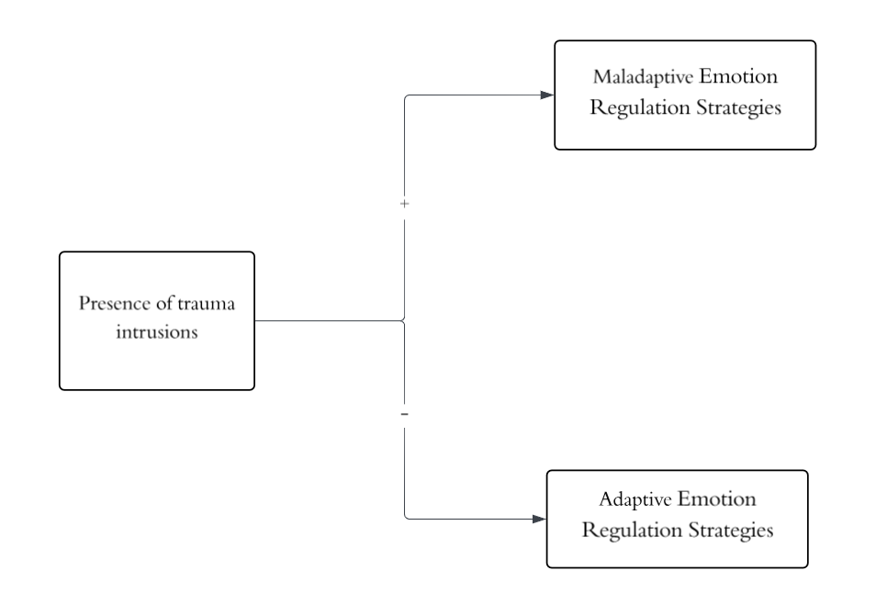
Hypothesis 1: The Associations between Trauma Intrusions and Emotion Regulation Strategies.
Note: “+” indicates a positive association and “–” indicates a negative association. In this study, maladaptive strategies included suppression, distraction, rumination, and worry; adaptive strategies included reappraisal, acceptance, problem-solving, and interpersonal regulation.
.Figure S2.

Hypothesis 2: Cultural Moderation of the Association Between Trauma Intrusions and Emotion Regulation Strategies.
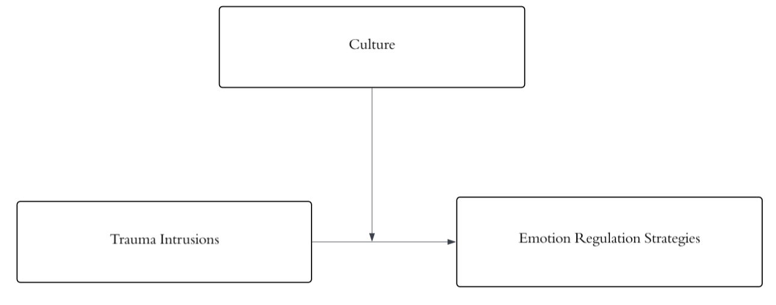
Figure S3.
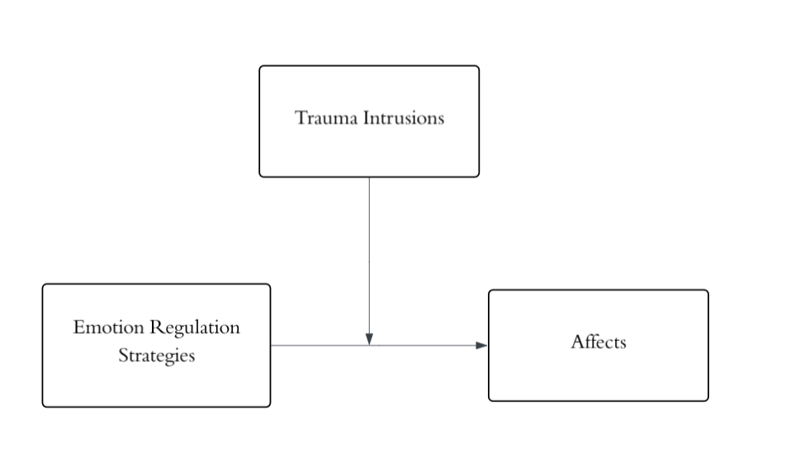
Hypothesis 3: Intrusion Moderation of the Association Between Emotion Regulation Strategies and Momentary Affect.

Figure S4.
Exploratory analyses: Culture and trauma intrusions simultaneous moderation of the association between emotion regulation strategies and momentary affect.
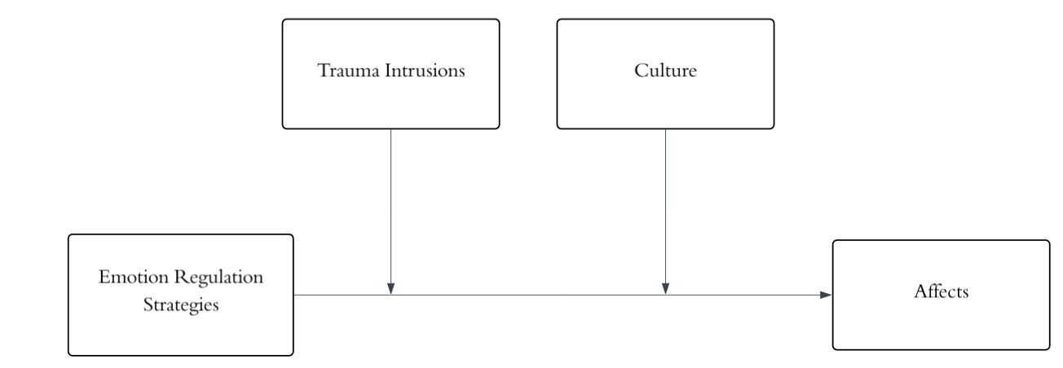
Figure S5.
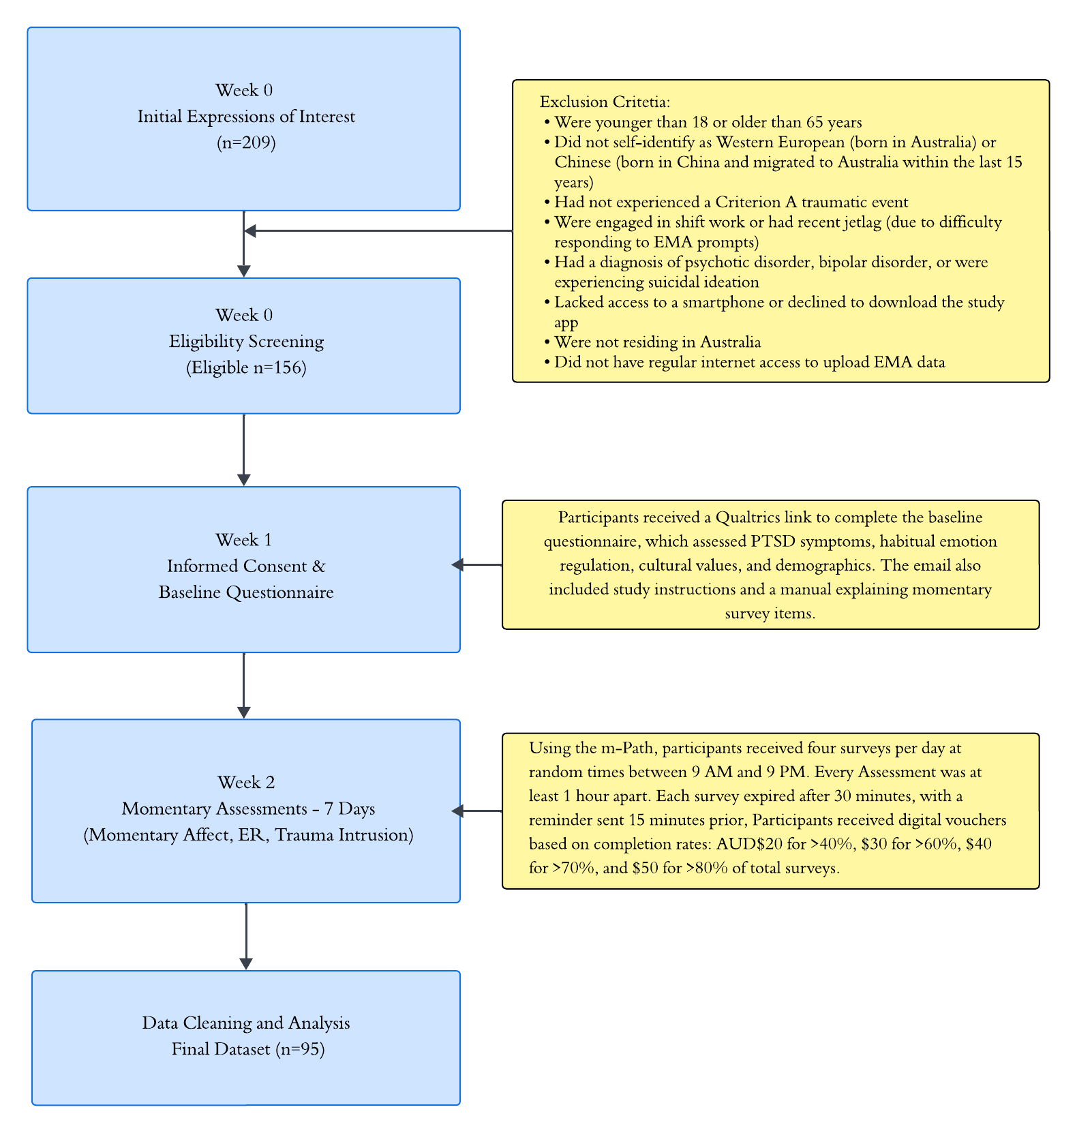
Protocol flowchart.

Table S1.
Full Model Results: Daily Emotion Regulation Strategies, Affect, and the Moderating Role of Intrusions and Culture
 |  | Positive Affect |  |  | Negative Affect
Variables | B (SE) | 95%CI | p | B (SE) | 95%CI | p
Suppression | -.27(.10) | -.46,-.08 | < .01 | .63(.13) | .37,.88 | < .001
Suppression x Intrusion | .15(.11) | -.08,.37 | .20 | .22(.15) | -.08,.52 | .16
Suppression x Intrusion x Culture | .38(.23) | -.06,.83 | .09 | -.54(.21) | -.95,-.13 | < .01
Reappraisal | .30(.09) | -.12 – .48 | < .001 | -.17(.13) | -.43,.09 | .21
Reappraisal x Intrusion | .09(.11) | -.12,.30 | .38 | -.34(.15) | -.64,-.03 | < .05
Reappraisal x Intrusion x Culture | -.48(.22) | -.91,-.06 | < .05 | .09(.20) | -.31,.48 | .67
Acceptance | .26(.09) | .05,.47 | < .01 | -.06(.14) | -.33,.20 | .64
Acceptance x Intrusion | -.23(.12) | -.47,.01 | .06 | -.03(.16) | -.34,.27 | .84
Acceptance x Intrusion x Culture | -.33(.25) | -.81,.16 | .18 | -.02(.23) | -.47,.43 | .93
Distraction | .43(.09) | .26,.60 | <.001 | -.23(.11) | -.45,-.01 | < .05
Distraction x Intrusion | .19(10) | -.01,.39 | .06 | -.19(.13) | -.44,.06 | .14
Distraction x Intrusion x Culture | -0.00 | -.40,.39 | .99 | -.11(.19) | -.48,.26 | .57
Problem Solving | .33(.11) | .11,.54 | < .01 | -.14(.13) | -.41,.12 | .28
Problem Solving x Intrusion | .19(.12) | -.05,.43 | .12 | -.18(.15) | -.47,.12 | .23
Problem Solving x Intrusion x Culture | .42(.25) | -.07,.91 | .09 | -.41(.23) | -.86,.05 | .08
Worry | -.92(.11) | -1.12,-.71 | <.001 | .95(.15) | .66,1.25 | <.001
Worry x Intrusion | -.31(.12) | -.54,-.07 | < .05 | .21(.17) | -.12,.55 | .21
Worry x Intrusion x Culture | .31(.25) | -.17,.79 | .21 | .01(.23) | -.43,.45 | .96
Interpersonal | .52(.09) | .34,.69 | <.001 | .00(.06) | -.12 – .12 | .99
Interpersonal x Intrusion | .19(.10) | -.02,.39 | .07 | -.25(.15) | -.54,.05 | .10
Interpersonal x Intrusion x Culture | -.32(.21) | -.74,.10 | .13 | .22(.20) | -.17,.61 | .27
Rumination | -.49(.10) | -.68,-.30 | <.001 | .70(.12) | .46,.95 | <.001
Rumination x Intrusion | .01(.11) | -.22,.23 | .96 | .05(.15) | -.24,.33 | .74
Rumination x Intrusion x Culture | .13(.23) | -.32,.58 | .58 | -.04(.21) | -.45,.37 | .84
Note. The European Australian group was the reference group.

Momentary Assessment Items (English & Chinese)
Affect
- At the moment I feel happy.
此刻我感到快乐。
- At the moment I feel relaxed.
此刻我感到轻松。
- At the moment I feel sad.
此刻我感到难过。
- At the moment I feel anxious.
此刻我感到焦虑。
- At the moment I feel angry.
此刻我感到愤怒。
- At the moment I feel contented.
此刻我感到满足。
Momentary Emotion Regulation Strategies
- Since the last survey, I have spoken to someone about my feelings to help me feel better.
自上次问卷以来，我向他人诉说了我的感受，来让我感到更好。
- Since the last survey I have distracted myself from my feelings (through reading, listening to music, watching TV, etc.).
自上次问卷以来，我通过（阅读、听音乐、看电视等方式）转移注意力来掩盖自己的情绪。
- Since the last survey I have told myself it is all right how I am feeling.
自上次问卷以来，我告诉了自己，我的任何感受都是合理的。
- Since the last survey I have tried to think differently about a situation in order to feel better.
自上次问卷以来，我尝试着以其他角度思考某个事情/情况，来让自己感到好一点。
- Please specify how you tried to think differently about the situation.
请简单描述你是如何用其他角度思考该事情/情况的。
- Since the last survey, I have tried to hide my feelings from others.
自上次问卷以来，我试图在他人面前隐藏我的感受。
- Since the last survey, I have worried that something bad may happen in the future.
自上次问卷以来，我有担心过未来会发生不好的事情。
- Since the last survey, I have been taking action to try to make a situation I was in better.
自上次问卷以来，我有采取行动，努力让自己所处的境况变得更好。
- Since the last survey I have gone over and over about a situation in my head without reaching a result/resolution.
自上次问卷以来，我一遍又一遍地回想了某个事情/状况，但得不出任何结论。
Intrusion and Trauma-specific Emotion Regulation Strategies
- Since the last survey, have you had any intrusive memories/thoughts about your past trauma? These could be images, sounds or thoughts about the event, but also recurring thoughts or feelings that was present during the event.
自上次问卷以来，您是否有过关于您创伤事件的记忆/想法？这些可以是关于事件的印象、声音或想法，也可以是事件期间反复出现的想法或感受。

