Supplementary File 2. (a) Themes and subthemes tree as emerged in hostage families’ accounts.
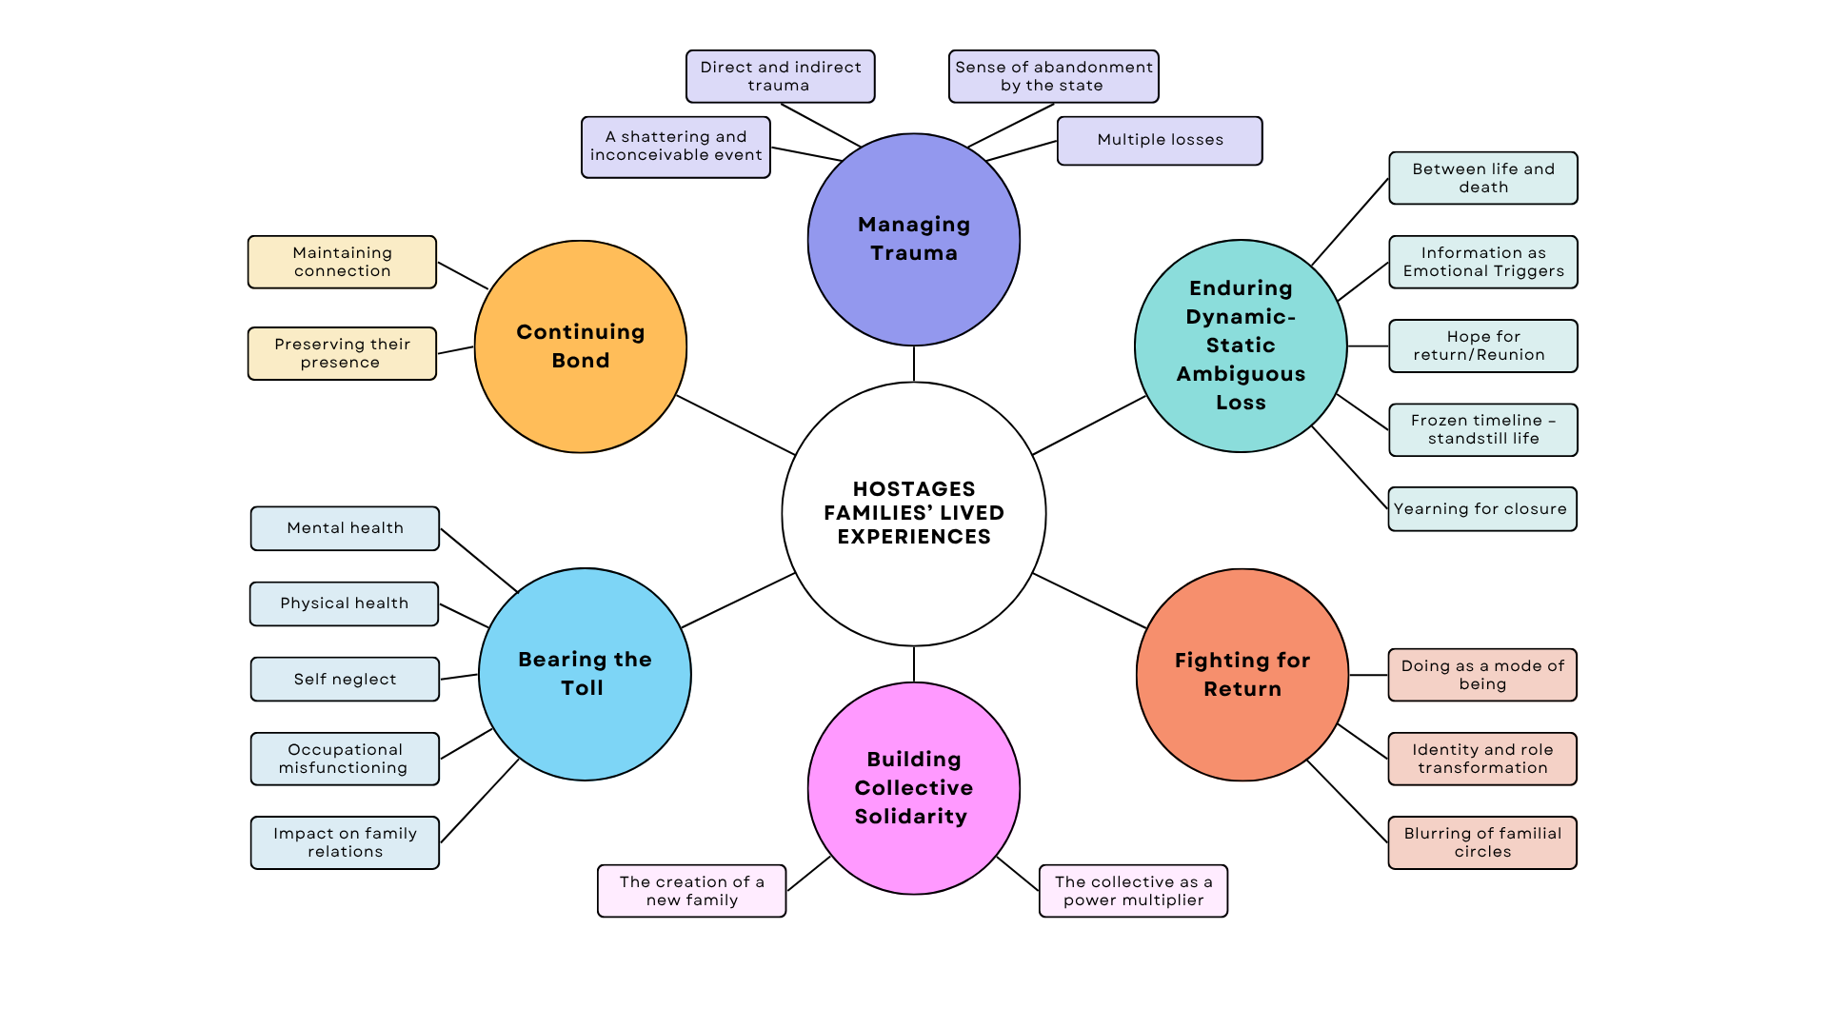
Note. Theme names are shortened for simplicity.
(b.) A summary table with descriptions linking subthemes to overarching themes and to socio-ecological levels.
Description | Sub-Theme | Theme  [and Socio-ecological level to which it is primarily connected by interviewees]
Describes the initial moments of shock and confusion on the day of the abduction of loved ones, which also marks the collective trauma of October 7. Expressions of disbelief and cognitive difficulty in processing personal trauma within the context of a powerful, extreme, and unexpected national event. | A shattering and inconceivable event | Managing private trauma within national trauma  [Socio-ecological level: National]
Illustrates the family's testimony regarding the traumatic event involving their loved ones (conversations with the person prior to the abduction, Facebook live videos, recordings) up until contact was lost and subsequently during the search. At times, this occurs while they themselves are exposed to terror as victims of the massacre (due to their place of residence). The dual and ongoing exposure, alongside sustained collective trauma, intensifies the personal trauma. | Direct and indirect trauma
Highlights the experience of vulnerability and neglect by the state on the day of the abduction. The prolonged lack of assistance from institutions responsible for civilian protection, lasting many hours and days, created a breach of trust that later extended into the kidnapping crisis itself. This illustrates the difficulty of managing private trauma without a supportive national framework. | Sense of abandonment by the state
Highlights the numerous losses experienced by families because of the collective trauma, including both those involving death and those that do not. These losses create a burden of grief and complicate the mourning process due to the ongoing focus on the trauma of the abduction of loved ones. | Multiple losses
Describes the emotional, cognitive, and practical difficulties families face in navigating the ambiguous space they are thrust into—maneuvering between life and death—and in finding an organizing framework to understand the prolonged status in which their loved one is absent but not necessarily deceased. | Between life and death | Enduring a dynamic-static ambiguous loss  [Socio-ecological level: Individual, Familial, Communal-societal, National]
Illustrates the dynamic-static ambiguous loss through frequent and fluctuating information that creates a unique psychological tension between rapid emotional shifts and sustained uncertainty. Triggers related to information about the abducted individual, the group of hostages, negotiations for release, and statements from government and state authorities activate emotional responses. | Information as emotional triggers
Emphasizes the role of hope as a resource within dynamic-static ambiguous loss. Families actively maintain positive beliefs regarding the fate and return of their loved ones, countering anxiety, uncertainty, and ongoing traumatic stress. | Hope for return/reunion
Illustrates how participants are stuck in the present moment, living day-to-day without the ability to plan due to the ambiguity surrounding the fate of their loved ones. Despite the passage of time and changing information around them, their lives have remained frozen since October 7 (the day of the abduction). | Frozen timeline – standstill life
Emphasizes the longing for clarity and closure within ambiguous loss. Family members struggle to cope with ongoing pain and uncertainty, needing closure to begin the process of recovery and healing. | Yearning for closure
Illustrates how action and advocacy in the struggle to bring back the hostages are a central part of the families’ daily existence, serving as a key tool in coping with intense emotions, helplessness, and extreme uncertainty. This ongoing activity—driven by a mix of motivations such as guilt, fear of stopping, and more—comes with costs, but is also perceived as a source of meaning and a way to discover inner strength. | Doing as a mode of being | Fighting for return  [Socio-ecological level: Individual]
Illustrates how the new status as family members of a hostage, along with active involvement in the public struggle for their loved ones’ return, reshapes identity and places the struggle at the center of life—while completely narrowing previous identities and leading to a loss of anonymity. | Identity and role transformation | Fighting for return  [Socio-ecological level: Individual]
Illustrates how the trauma of the abduction created a ripple effect, impacting various circles of closeness—both secondary and tertiary—within the family and community. These individuals mobilized and took on central roles in the struggle for return. Despite their involvement, many experience a lack of recognition on both emotional and institutional levels. | Blurring of familial circles | Fighting for return  [Socio-ecological level: Individual]
Illustrates how a shared fate led to the formation of a collective identity among families of hostages and the emergence of a new group with a common purpose. The connections formed became a source of emotional and practical support, restoring the interviewees’ faith in solidarity and mutual responsibility. | The creation of a new family | Building collective solidarity  [Socio-ecological level: communal-societal]
Illustrates how the collective strengthens the moral and public power of the families, and, in their view, enhances their visibility, presence, and influence on the public, social, and governmental systems. | The collective as a power multiplier
Presents the emotional toll and psychological symptoms resulting from the trauma of the abduction and the ongoing ambiguous loss, alongside the exhausting struggle for return—leading to significant impairment in daily functioning. | Mental health | Bearing the toll on health and functioning  [Socio-ecological level: Individual]
Presents the severe physical effects caused by the trauma and ongoing traumatic stress on the body, including significant impairment in basic functions such as eating and sleeping, increased illness, and a decline in health-related behaviors. | Physical health
Illustrates how the trauma of the abduction and its consequences lead to both conscious and unconscious neglect of health and self-care—driven by emotional overload, survivor’s guilt, and the lack of accessible and tailored healthcare services for the families. | Self-neglect
Demonstrates how absolute focus (cognitive, emotional, and practical) on the struggle leads to impaired ability to work or maintain a regular work routine. The impairment in occupational functioning creates significant financial stress, which adds to the mental and physical burden. | Occupational misfunctioning
Demonstrates how the trauma of the kidnapping and the struggle affect and alter the family dynamics, creating new challenges, triggering previous conflicts, or strengthening bonds. These tensions exacerbate the mental burden and impair overall family functioning. | Impact on family relations
Highlights the ways in which family members continue to nurture an emotional connection with their loved one in captivity, despite the physical separation. Through imagination, spiritual communication, memories, daily rituals, and public messages in the media, they strive to maintain a sense of closeness and connection. | Maintaining connection | Continuing bond with the hostage in captivity  [Socio-ecological level: Individual]
Demonstrates how families work to preserve the presence of the kidnapped family member in consciousness, both in public and private spheres, through rituals, symbols, and tangible objects. They create a sense of continuity during a period of uncertainty and waiting. | Preserving the hostage presence

