Supplemental Materials A-J
Supplemental Materials A: Consensual Qualitative Research (CQR) Steps
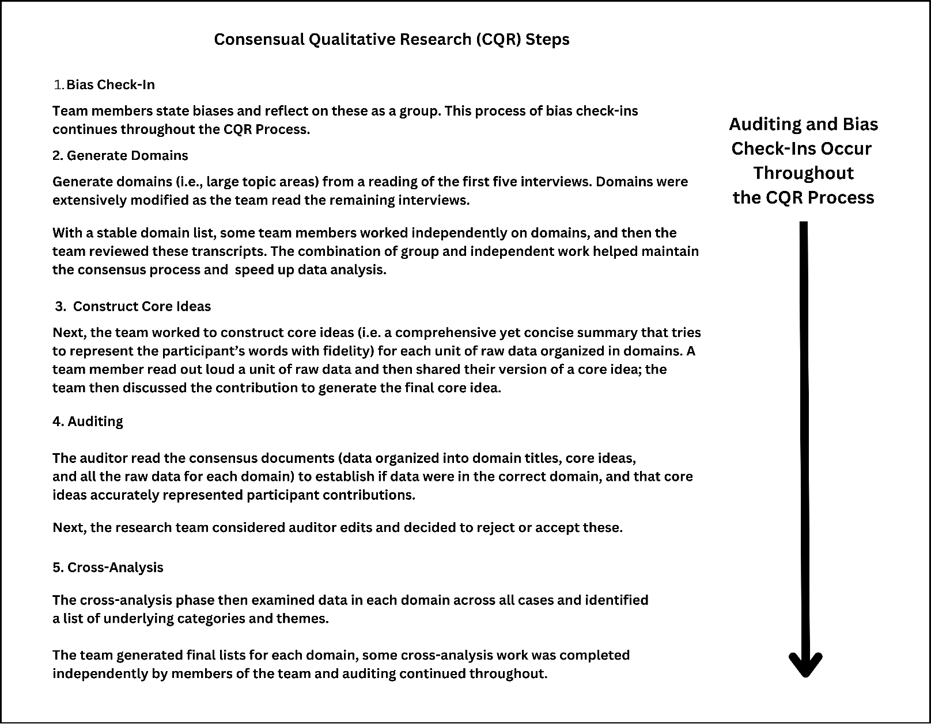

Supplemental Materials B: The HTCRH’s Participatory Action Research (PAR) Process
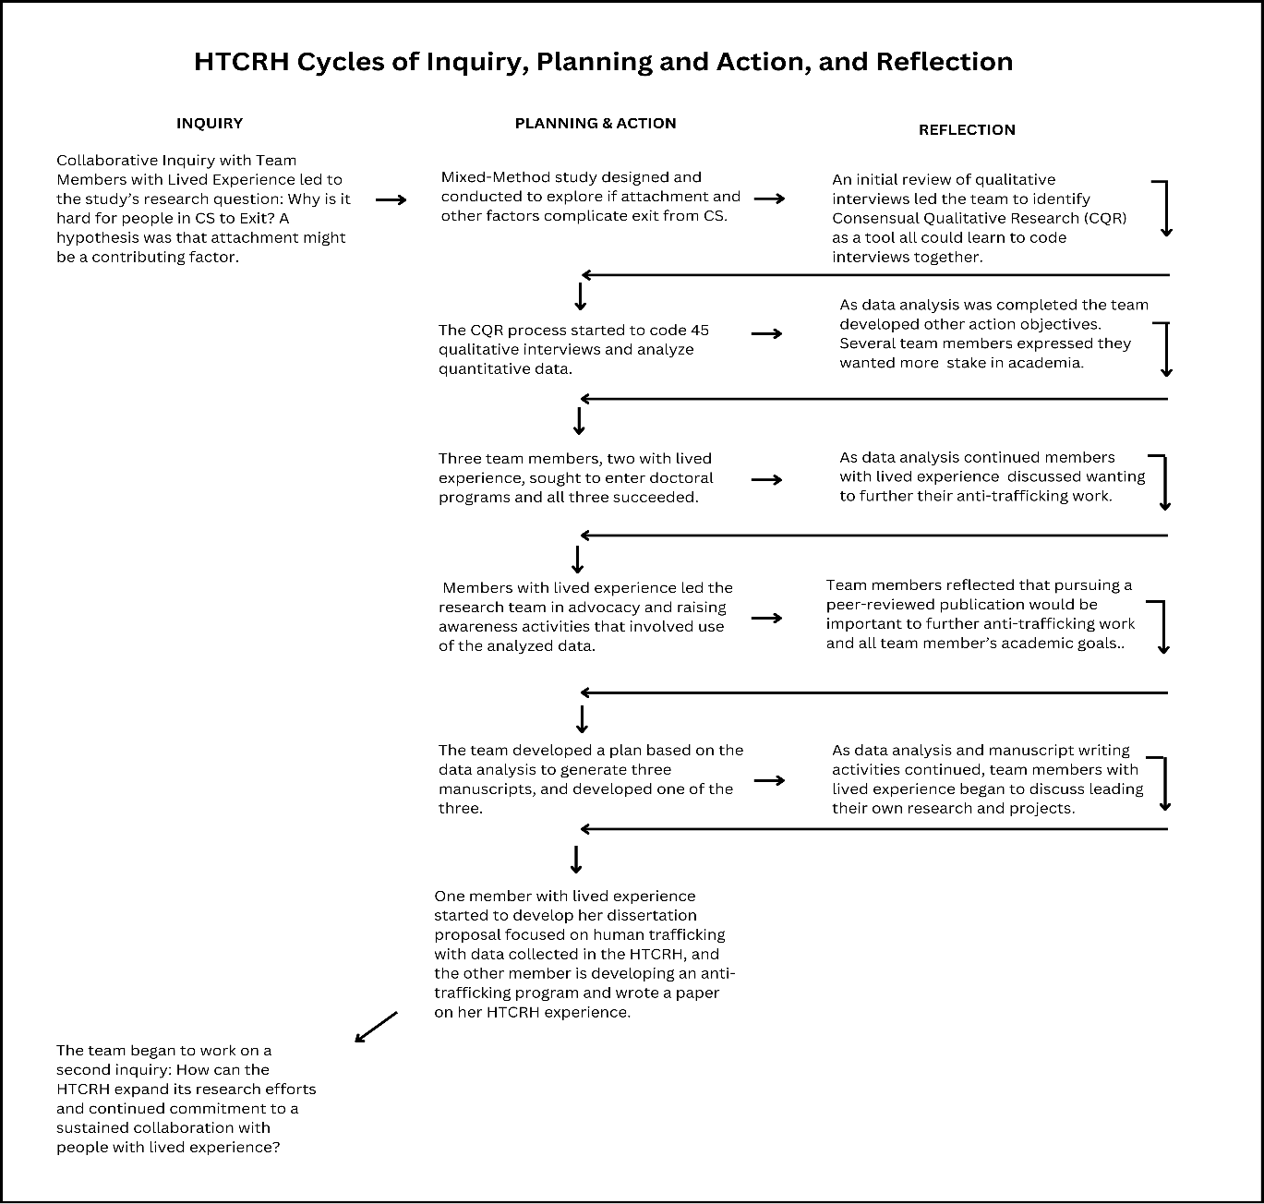

Supplemental Materials C: Description of Measures
Description of Measures
Measure | Author(s) | Description
Adult Attachment Interview (AAI) | George et al.,1985 | Includes 18 semi-structured questions that take between 30-60 minutes to complete. The AAI Identifies how early relationship patterns inform current relational functioning, both in parenting and romantic relationships. It reveals the existence of important losses and traumatic experiences that might otherwise go unreported. In contrast to self-report measures, the AAI reveals unconscious states of mind. All four research team members who administered the AAI were trained to follow the standardized interview format.
Treatment Outcome Package (TOP) | Boswell et al., 2015 | A 58-item Likert scale questionnaire used to assess a patient’s well-being by measuring and quantifying key symptom and functional domain that takes between 8-15 minutes to complete. Domains include suicide, violence, psychosis, depression, substance abuse, panic psychological symptoms of anxiety, mania, sleep, work functioning, social functioning/social conflict, sexual functioning, and quality of life. 0 is the general population average, positive scores on the Y axis represent the number of standard deviations more severe than the general population average. If the Y axis score is negative, it represents a potential strength. The TOP scales have good to excellent internal consistency reliability (alphas = .69-.93), and test-retest reliability (ICCs= .87-.94), except the Mania subscale that has a test-retest ICC of .76 and an internal consistency that has ranged between .55 in outpatient populations and .70 in long-term inpatient populations where mania is more likely.
Adverse Childhood Experiences questionnaire (ACE) | Felliti et al., 1998 | Includes 10 yes/no questions that takes about five minutes to complete. Covers ten categories of abuse, neglect, and household challenges. Respondents are given an ACE score between 0 – 10 based on how many of these 10 types of adverse experiences to which they report being exposed.
Primary Care PTSD Screen for DSM-5 (PC-PTSD5). | Prins et al., 2016 | Includes 5 yes/no items and takes about five minutes to complete. Identifies respondents with probable PTSD. It begins with an item designed to assess whether the respondent has had any exposure to traumatic events. If a respondent denies exposure, the PC-PTSD-5 is complete with a score of 0. However, if a respondent indicates that he or she has experienced a traumatic event over the course of his or her life, the respondent is instructed to respond to five additional yes/no questions about how that trauma exposure has affected him or her over the past month.
Dissociative Experiences Scale Taxon (DES-T) | Leavitt et al., 1999 | The DES-Taxon (DES-T) is an eight-item measure that takes about five minutes to complete, which is derived from the DES-II. DES-T determines whether the individual score is related to pathological dissociation (Taxon), or to more normal dissociation that likely does not indicate a dissociative disorder. The taxon is based in Items 3, 5, 7, 8, 12, 13, 22, and 27 of the DES-II. that identifies 90% of pathological cases of dissociation.
MacArthur Scale of Subjective Social Status (MacArthur SSS Scale) | Adler et al., 2000 | A single-item measure that takes one minute or less to complete created by health psychologist Nancy Adler and team (2000) that assesses a person’s perceived rank relative to others. The scale has been included in studies with groups often marginalized from research (Bullock & Limbert, 2003; Franzini & Fernandez-Esquer, 2006; Ostrove, et al., 2000).
Demographic Instrument | The Authors of this research | The researchers developed an 18-item demographic instrument to gather demographic information for this study. Questions included age, gender, sexual orientation, racial/ethnic identity, nationality, family, relationship, education, housing, mental health and substance abuse services, and income.

Supplemental Materials D: Semi-Structured Interview Prompt and Guide
Before the interview, read Chapter 6 of Seidman (2006) to understand the general guidelines for conducting it. Clarifying questions are especially important when the transitions into and out of commercial sex are unclear.
- Read the following statement to the participant in the most natural way you can, but make sure you cover all the points.
We decided to do this study because we are interested in helping providers, mentors, and peer advocates improve services for people who have had experiences in the commercial sex trade. Some people describe their experience in the commercial sex trade as being an escort, in pornography, stripping, prostitution, live cams, chat rooms, posted up online, massage parlor, bodywork, motel, brothel, mail order bride, or sugar daddy, and others also call it the way they survive(d).
We are interested in knowing about your experiences in the commercial sex trade from your perspective, starting from wherever you want to start telling your story. We are asking you to share as authentically as possible about your experience. You can ask to stop the interview or request a break anytime.
As the interviewer, my job is to focus on listening to your story because we want to give you as much space as possible to talk about your experiences in your own words and on your own terms. At times, I may appear to not respond or react much as you talk. That said, I may ask clarifying questions to make sure that I understand and follow your story. Be assured that I am listening.
- As it feels like the participant is wrapping up ask the following questions if the participant did not spontaneously cover the content:
- Attempts to Exit, If the participant does not talk about trying to exit ask:
“In our interview, you haven’t mentioned ever trying to exit the commercial sex market. To clarify, have you ever tried to exit?”
- Time Since Exit, If the participant said they did leave commercial sex but didn’t specify how long ago, ask:
“In our interview, you mentioned exiting/leaving the commercial sex. To clarify, how long ago did you exit/leave?”
- Re-Entry Thoughts
If the participant said they did leave the commercial sex, ask if s/he hasn’t already clarified:
“In our interview, you mentioned exiting/leaving the commercial sex market. Have you ever thought about going back? Please share as much as you can about your response.”
- Absence of Re-Entry Thoughts
If the participant responds to the previous question that they never thought about going back, ask:
“Do you know what keeps you from going back to the commercial sex market? Please share as much as you can about your response.”

Supplemental Materials E: Participant Demographics by Attachment Pattern
Participant Demographics by Attachment Pattern
 | All Participants | Secure (F) | Insecure-  Preoccupied (E) | Insecure-  Dismissive  (Ds) | Unresolved/  Cannot Classify (U/CC)
Characteristic | N=45 | N=9 | N=6 | N=10 | N=20
Age
18-24 | 2(4%) | 0 | 0 | 2(20%) | 0
25-34 | 13(29%) | 4(44%) | 0 | 3(30%) | 6(30%)
35-44 | 7(16%) | 2(22%) | 3(50%) | 0 | 2(10%)
45-54 | 14(31%) | 2(22%) | 2(33%) | 4(40%) | 6(30%)
55+ | 9(20%) | 1(11%) | 1(17%) | 1(10%) | 6(30%)
Age of Entry
Minor | 15(33%) | 2(22%) | 3(50%) | 4(40%) | 6(30%)
18 or Older | 30(67%) | 7(78%) | 3(50%) | 6(60%) | 14(70%)
CS Exiting Status
In | 7(15%) | 0 | 2(33%) | 2(20%) | 3(15%)
Out 1 year or less | 12(27%) | 6(67%) | 1(17%) | 2(20%) | 3(15%)
Out 2-4 years | 8(18%) | 1(11%) | 1(17%) | 2(20%) | 4(20%)
Out 5+ years | 18(40%) | 2(22%) | 2(33%) | 4(40%) | 10(50%)
Characteristic | All Participants  N=45 | Secure (F)  N=9 | Insecure-  Preoccupied (E)  N=6 | Insecure-  Dismissive  (Ds)  N=10 | Unresolved/  Cannot Classify (U/CC)  N=20
Meets TVPA Criteria
Yes | 34(76%) | 7(78%) | 5(83%) | 8(80%) | 14(70%)
No | 11(24%) | 2(22%) | 1(17%) | 2(20%) | 6(30%)
Sex
Men | 6(13%) | 0 | 2(33%) | 1(10%) | 3(15%)
Women | 38(85%) | 9(100%) | 4(67%) | 9(90%) | 16(80%)
Other | 1(2%) | 0 | 0 | 0 | 1(5%)
Race
Black or African  American | 19(42%) | 0 | 3(50%) | 4(40%) | 12(60%)
White | 22(49%) | 7(78%) | 3(50%) | 5(50%) | 7(35%)
Multi-Racial | 4(9%) | 2(22%) | 0 | 1(10%) | 1(5%)
Latin-X
Yes | 4(9%) | 0 | 1(83%) | 1(10%) | 2(10%)
Sexual Orientation
Heterosexual | 26(58%) | 6(67%) | 3(50%) | 6(60%) | 11(55%)
Homosexual/Gay/Lesbian | 5(11%) | 0 | 2(33%) | 0 | 3(15%)
Bisexual | 11(24%) | 3(33%) | 1(17%) | 3(30%) | 4(20%)
Other | 3(7%) | 0 | 0 | 1(10%) | 2(10%)

Characteristic |  | All Participants  N=45 | Secure (F)  N=9 | Insecure-  Preoccupied (E)  N=6 | Insecure-  Dismissive  (Ds)  N=10 | Unresolved/  Cannot Classify (U/CC)  N=20
Income
< $5000 |  | 13(29%) | 5(56%) | 2(33%) | 2(20%) | 4(20%)
$5000-$11,999 |  | 9(20%) | 1(11%) | 1(17%) | 5(50%) | 3(15%)
$12,000-$24,999 |  | 7(16%) | 2(22%) | 1(17%) | 1(10%) | 3(15%)
$25,000-$49,999 |  | 13(29%) | 1(11%) | 2(33%) | 1(10%) | 10(50%)
$50,000-$74,999 |  | 3(7%) | 0 | 0 | 1(10%) | 0
Children
Yes |  | 32(71%) | 8(89%) | 4(67%) | 4(40%) | 16(80%)
No |  | 13(29%) | 1(11%) | 2(33%0 | 6(60%) | 4(20%)
Relationship status
Single |  | 28(62%) | 7(78%) | 2(33%) | 6(60%) | 13(65%)
Married |  | 3(7%) | 1(11%) | 0 | 2(10%) | 1(5%)
Partnered |  | 7(15%) | 0 | 2(33%) | 2(20%) | 3(15%)
Divorced |  | 4(9%) | 1(11%) | 0 | 1(10%) | 2(10%)
Widowed |  | 3(7%) | 0 | 2(33%) | 0 | 1(5%)
Housing
Owns Home |  | 6(13%) | 1(11%) | 0 | 2(20%) | 3(15%)
Rents |  | 22(49%) | 2(22%) | 2(33%) | 6(60%) | 12(60%)
Occupies with no payment |  | 3(7%) | 0 | 2(33%) | 2(20%) | 1(5%)
Other | 14(31%) |  | 6(67%) | 2(33%) | 0 | 4(20%)

Characteristic | All  Participants  N=45 | Secure (F)  N=9 | Insecure-  Preoccupied (E)  N=6 | Insecure-  Dismissive  (Ds)  N=10 | Unresolved/  Cannot Classify (U/CC)  N=20
Employment
Full or parttime | 20(45%) | 3(33%) | 1(16.7%) | 5(50%) | 11(55%)
Raising children | 3(7%) | 1(44%) | 1(16.7%) | 1(10%) | 0
Looking | 5(11%) | 1(11%) | 1(16.7%) | 1(10%) | 2(10%)
Unemployed | 11(24%) | 4(11%) | 3(50%) | 1(10%) | 3(15%)
Disabled | 6(13%) | 0 | 0 | 2(20%) | 4(20%)
Education
No degree | 3(7%) | 0 | 0 | 0 | 2(10%)
High school | 19(42%) | 4(44%) | 3(50%) | 5(50%) | 9(45%)
Bachelor’s | 3(7%) | 0 | 3(50%) | 5(50%) | 8(40%)
Trade school or  associate | 19(42%) | 5(56%) | 0 | 0 | 0
Master’s | 1(2%) | 0 | 0 | 0 | 1(5%)

Supplemental Materials F: Outreach Flyer
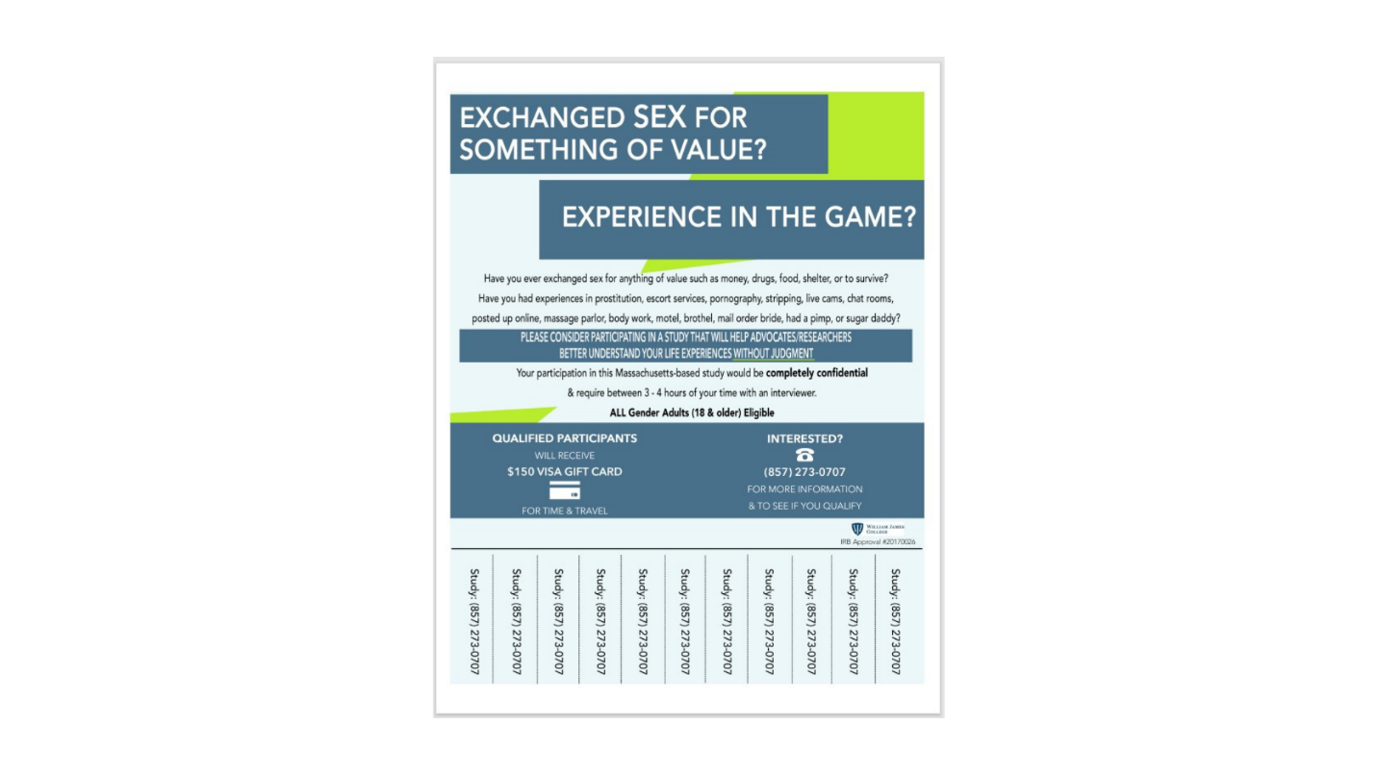
Supplemental Materials G: Interview Flow
If the potential participant consents to participate, the researcher will then complete measures and the qualitative interviews in the following order:

- Demographic Information (Form B) 10 mins __

- Adult Attachment Interview 30-60 mins __

10-15 min break (offer snacks & refreshments)

- Treatment Outcome Package (TOP) 15 mins __

- Adverse Childhood Experiences Questionnaire (ACE) 5 mins __

- Primary Care PTSD Screen for DSM 5 (PC-PTSD 5) 5 mins __

- Dissociative Experiences Scale (DES) 10 mins __

10-15 min break (offer snacks & refreshments)

- Life Course Experiences Interview (Form D) 30-60 mins __

- Daily Spiritual Experiences Scale (DSES) 10 mins __

Total Approximate Time: 3.5 hours

Supplemental Materials H: Visual Map of Qualitative Findings
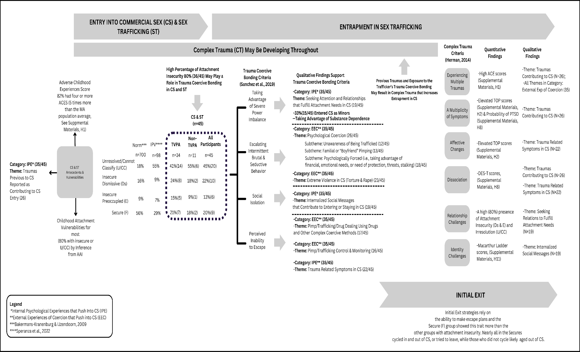

Supplemental Materials I: Quantitative Data Tables from Measures
Table I1
Adverse Childhood Experiences (ACE) Scores by Attachment Pattern and Compared to Massachusetts Population Data
 | Adverse Childhood Experiences Items
AAI Pattern | Abuse Emotional  MA  Norm  =34%* | Abuse Physical  MA Norm =23%* | Abuse  Sexual  MA Norm =10.5%* | Neglect Emotional | Neglect Physical | Parental Sep/Divorce  MA  Norm  =26% | Witnessed DV on Mother  MA  Norm  =15%* | Household Substance  Abuse  MA  Norm =26%* | Household Mental Illness  MA  Norm =19%* | Incarcerated Family Member  MA  Norm  =7%* | 4 or More ACES  MA Norm  =16%*
Secure (n=9) | 6(67%) | 6(67%) | 7(78%) | 5(56%) | 5(56%) | 9(100%) | 3(33%) | 8(89%) | 9(100%) | 4(44%) | 8(89%)
Insecure-  Preoccupied(n=6) | 5(83%) | 2(33%) | 5(83%) | 3(50%) | 6(100%) | 3(50%) | 2(33%) | 3(50%) | 5(83%) | 3(50%) | 5(83%)
Insecure-  Dismissive(n=10) | 4(40%) | 4(40%) | 5(50%) | 5(50%) | 10(100%) | 7(70%) | 3(30%) | 7(70%) | 6(60%) | 4(40%) | 7(70%)
U/CC (n=20) | 13(65%) | 14(70%) | 13(65%) | 14(70%) | 9(45%) | 16(80%) | 7(35%) | 16(80%) | 12(60%) | 7(35%) | 17(85%)
All Participants (n=45) | 28(62%) | 26(58%) | 30(67%) | 27(60%) | 14(31%) | 33(73%) | 15(33%) | 34(76%) | 32(71%) | 18(40%) | 37(82%)
*Swedo et al., 2023 (ACES for U.S. Adults by State, 2011-2020)

Table I2
Treatment Outcome Package (TOP) Scores for All Participants
TOP Scales | N | Range | Min | Max | Mean* | SD
Depression | 45 | 5.53 | -1.04 | 4.49 | 1.8516 | 1.40721
Quality of Life | 45 | 4.91 | -1.59 | 3.32 | .6209 | 1.23297
Manic Symptoms | 45 | 4.05 | -1.07 | 2.98 | .3909 | .96190
Panic | 45 | 5.88 | -.62 | 5.26 | 1.2560 | 1.57741
Psychosis | 45 | 7.73 | -.65 | 7.08 | 1.5391 | 2.05348
Substance Abuse | 45 | 13.47 | -.34 | 13.13 | 1.0987 | 2.45463
Social Comfort | 45 | 5.50 | -1.15 | 4.35 | 1.3940 | 1.41733
Sexual Functioning | 45 | 6.77 | -.80 | 5.97 | .6756 | 1.51686
Sleep | 45 | 5.69 | -1.06 | 4.63 | 1.4560 | 1.55499
Suicide | 45 | 3.44 | -.20 | 3.24 | .3411 | .73367
Violence | 45 | 9.03 | -.28 | 8.75 | .6738 | 1.85023
Workforce | 45 | 5.44 | -1.12 | 4.32 | .1078 | 1.29374

*A score of 0 represents the population mean; scores above 0 move toward psychopathology, and negative scores can be considered strengths.

Table I3
Treatment Outcome Package (TOP) Scores by Attachment Pattern
AAI Pattern TOP Items |  | Min | Max | Mean | Std.  Deviation | AAI Pattern | TOP Items | Min | Max | Mean | Std.  Deviation
Secure (F) (n=9) | Depression | -0.63 | 4.14 | 2.31 | 1.36 | Insecure/  Preoccupied (E) (n=6) | Depression | .68 | 2.63 | 1.66 | 0.78
 | Quality of Life | -0.69 | 3.06 | 0.78 | 1.25 | Insecure/  Preoccupied (E) (n=6) | Quality of Life | -0.74 | 1.96 | 0.92 | 1.00
 | Manic Symptoms | -0.68 | 1.14 | 0.28 | 0.70 | Insecure/  Preoccupied (E) (n=6) | Manic Symptoms | -0.37 | 2.36 | 0.47 | 1.05
 | Panic | -0.62 | 3.00 | 1.36 | 1.36 | Insecure/  Preoccupied (E) (n=6) | Panic | -0.62 | 2.77 | 0.92 | 1.62
 | Psychosis | -0.63 | 7.08 | 2.34 | 2.92 | Insecure/  Preoccupied (E) (n=6) | Psychosis | -0.41 | 1.66 | 0.57 | 0.88
 | Substance Abuse | -0.34 | 1.58 | 0.44 | 0.77 | Insecure/  Preoccupied (E) (n=6) | Substance Abuse | -0.34 | 6.72 | 1.05 | 2.79
 | Social Comfort | 0.83 | 3.75 | 1.86 | 0.96 | Insecure/  Preoccupied (E) (n=6) | Social Comfort | -0.44 | 1.99 | 0.95 | 0.87
 | Sexual Functioning | -0.80 | 3.89 | 0.21 | 1.58 | Insecure/  Preoccupied (E) (n=6) | Sexual Functioning | -0.80 | 3.66 | 0.30 | 1.66
 | Sleep | -0.39 | 4.63 | 1.77 | 1.59 | Insecure/  Preoccupied (E) (n=6) | Sleep | -0.72 | 3.45 | 1.27 | 1.75
 | Suicidality | -0.20 | .86 | 0.29 | 0.41 | Insecure/  Preoccupied (E) (n=6) | Suicidality | -0.20 | .025 | .026 | 0.20
 | Violence | -0.28 | 1.98 | 0.11 | 0.81 | Insecure/  Preoccupied (E) (n=6) | Violence | -0.28 | 2.77 | 0.64 | 1.44
 | Work Force | -1.12 | 2.88 | -.09 | 1.49 | Insecure/  Preoccupied (E) (n=6) | Work Force | -1.12 | 2.19 | -.008 | 1.26
Insecure/  Dismissive (Ds) (n=10) | Depression | -1.04 | 3.61 | 1.36 | 1.45 | Unresolved/Cannot Classify (UCC) (n=20) | Depression | -0.90 | 4.49 | 1.95 | 1.55
Insecure/  Dismissive (Ds) (n=10) | Quality of Life | -1.59 | 3.32 | 0.79 | 1.37 | Unresolved/Cannot Classify (UCC) (n=20) | Quality of Life | -1.32 | 3.06 | 0.38 | 1.26
Insecure/  Dismissive (Ds) (n=10) | Manic Symptoms | -0.95 | 1.57 | .057 | 0.82 | Unresolved/Cannot Classify (UCC) (n=20) | Manic Symptoms | -1.07 | 2.98 | 0.58 | 1.109
Insecure/  Dismissive (Ds) (n=10) | Panic | -0.62 | 3.77 | 0.89 | 1.55 | Unresolved/Cannot Classify (UCC) (n=20) | Panic | -0.62 | 5.26 | 1.49 | 1.73
Insecure/  Dismissive (Ds) (n=10) | Psychosis | -0.65 | 5.79 | 1.50 | 2.35 | Unresolved/Cannot Classify (UCC) (n=20) | Psychosis | -0.65 | 4.94 | 1.49 | 1.66
Insecure/  Dismissive (Ds) (n=10) | Substance Abuse | -0.34 | 13.13 | 2.16 | 4.21 | Unresolved/Cannot Classify (UCC) (n=20) | Substance Abuse | -0.34 | 4.79 | 0.88 | 1.56
Insecure/  Dismissive (Ds) (n=10) | Social Comfort | -1.15 | 4.27 | 1.04 | 1.62 | Unresolved/Cannot Classify (UCC) (n=20) | Social Comfort | -0.55 | 4.35 | 1.49 | 1.61
Insecure/  Dismissive (Ds) (n=10) | Sexual Functioning | -0.80 | 2.41 | 1.01 | 1.36 | Unresolved/Cannot Classify (UCC) (n=20) | Sexual Functioning | -0.80 | 5.97 | 0.83 | 1.71
Insecure/  Dismissive (Ds) (n=10) | Sleep | -1.06 | 3.45 | 1.10 | 1.75 | Unresolved/Cannot Classify (UCC) (n=20) | Sleep | -0.89 | 3.62 | 1.55 | 1.47
Insecure/  Dismissive (Ds) (n=10) | Suicidality | -.020 | 1.25 | 0.26 | 0.62 | Unresolved/Cannot Classify (UCC) (n=20) | Suicidality | -0.20 | 3.24 | 0.50 | .962
Insecure/  Dismissive (Ds) (n=10) | Violence | -0.28 | 2.21 | 0.32 | 1.02 | Unresolved/Cannot Classify (UCC) (n=20) | Violence | -0.28 | 8.75 | 1.11 | 2.49
Insecure/  Dismissive (Ds) (n=10) | Work Force | -1.12 | 2.22 | 0.21 | 1.20 | Unresolved/Cannot Classify (UCC) (n=20) | Work Force | -1.12 | 4.32 | 0.19 | 1.34

*A score of 0 represents the population mean; scores above 0 move toward psychopathology, and negative scores can be considered strengths.

Table I4
Analyses of Violence and Psychological Coercion by Attachment Pattern & History of Cycling by Attachment Pattern
Trafficker Perpetrated Violence and/or History of Cycling (in and Out of CS,
Psychological Coercion by Attachment Pattern trying to leave) by Attachment Pattern
AAI Pattern |  | Frequency |  | AAI Pattern |  | Frequency
Secure | Yes | 8(89% |  | Secure | Yes | 8(89%)
Secure | No | 1(11%) |  | Secure | No | 1(11%)
Secure | Total | 9 |  | Secure | Total | 9
Insecure/  Preoccupied | Yes | 2(33%) |  | Insecure/  Preoccupied | Yes | 3(50%)
Insecure/  Preoccupied | No | 4(67%) |  | Insecure/  Preoccupied | No | 3(50%)
Insecure/  Preoccupied | Total | 6 |  | Insecure/  Preoccupied | Total | 6
Insecure/  Dismissive | Yes | 8(80%) |  | Insecure/  Dismissive | Yes | 3(30%)
Insecure/  Dismissive | No | 2(20%) |  | Insecure/  Dismissive | No | 7(70%)
Insecure/  Dismissive | Total | 10 |  | Insecure/  Dismissive | Total | 10
U/CC | Yes | 15(75%) |  | U/CC | Yes | 11(55%)
U/CC | No | 5(25%) |  | U/CC | No | 9(45%)
U/CC | Total | 20 |  | U/CC | Total | 20
All Participants | Yes | 33(73%) |  | All Participants | Yes | 25(56%)
All Participants | No | 12(27%) |  | All Participants | No | 20(44%)
All Participants | Total | 45 |  | All Participants | Total | 45

Table I5
Cross Tabulation of Attachment Pattern & Age
AAI Pattern |  | Age Range
 | 18-24 |  | 25-34 | 35-44 | 45-54 | 55+ | Total
Secure | 0 |  | 4 | 2 | 2 | 1 | 9
Insecure/Preoccupied | 0 |  | 0 | 3 | 2 | 1 | 6
Insecure/Dismissive | 2 |  | 3 | 0 | 4 | 1 | 10
U/CC | 0 |  | 6 | 2 | 6 | 6 | 20
Total | 2 |  | 13 | 7 | 14 | 9 | 45

Table I6
Cross Tabulation of Attachment Pattern & Exiting Status
AAI Pattern | Exiting Status
 | In | Out for one year of less | Out for 2-4 years | Out for 5+ years | Total
Secure | 0 | 6 | 1 | 2 | 9
Insecure/Preoccupied | 2 | 1 | 1 | 2 | 6
Insecure/Dismissive | 2 | 2 | 2 | 4 | 10
U/CC | 3 | 3 | 4 | 10 | 20
Total | 7 | 12 | 8 | 18 | 45

Table I7
AAI Experiences for Secure (F) Participants
Experiences | N* | Min | Max | Mean | SD | Qualifier**
Mother Rejecting Score | 9 | 3.00 | 9.00 | 6.3889 | 2.02759 | High
Mother Neglect Score | 9 | 3.00 | 7.00 | 6.1111 | 1.45297 | High
Father Rejecting Score | 7 | 1.00 | 9.00 | 4.5714 | 3.64496 | Moderate
Father Neglect Score | 7 | 1.00 | 9.00 | 5.4286 | 2.76026 | High
Father Loving Score | 7 | 1.00 | 8.00 | 3.2857 | 2.49762 | Low
Mother Loving Score | 9 | 1.00 | 3.00 | 2.0556 | .88192 | Low
*Some scores are not available because the parent was absent
**Low (1-3); Moderate (4-5); High (6-8)

Table I8
Probable PTSD (PC-PTSD5) & Probable Pathological Dissociation (DES-T) Scores by Attachment Pattern
AAI Pattern | Probable  PTSD* | Frequency |  | AAI Pattern | Probable  Pathological  Dissociation** | Frequency
Secure (n=9) | No | 1(11%) |  | Secure (n=9) | No | 7(78%)
 | Yes | 8(89%) |  |  | Yes | 2(22%)
Insecure/Preoccupied (n=6) | No | 3(50%) |  | Insecure/Preoccupied (n=6) | No | 4(67%)
 | Yes | 3(50%) |  |  | Yes | 2(33%)
Insecure/Dismissive (n=10) | No | 6(60%) |  | Insecure/Dismissive (n=10) | No | 10(100%)
 | Yes | 4(40%) |  |  | Yes | 0
U/CC (n=20) | No | 9(45%) |  | U/CC (n=20) | No | 13(65%)
 | Yes | 11(55%) |  |  | Yes | 7(35%)
All Participants (n=45) | No | 19(42%) |  | All Participants (n=45) | No | 34(76%)
 | Yes | 26(58%) |  |  | Yes | 11(24%)
*Spottswood et al. (2017) found that civilian population median for PTSD was 11%, the special risk population median was 12.5%, and the veteran median was 24.5%.
**Maaranen et al. (2005) found that the population prevalence of pathological dissociation was 3.4% with not significant differences between genders.

Table I9
Cross Tabulation of Age & Exiting Status
Age Range | Exiting Status
 | In | Out for one year of less | Out for 2-4 years | Out for 5+ years | Total
18-24 | 1 | 1 | 0 | 0 | 2
25-34 | 3 | 5 | 3 | 2 | 13
35-44 | 2 | 3 | 1 | 1 | 7
45-54 | 1 | 3 | 4 | 6 | 14
55+ | 0 | 0 | 0 | 9 | 9
Total | 7 | 12 | 8 | 18 | 45

Table I10
Cross Tabulation of Attachment Pattern & Race
AAI Pattern | Race
 | White | Black & AA | Multi-Racial | Total | Latinx*
Secure | 7 | 0 | 2 | 9 | 0
Insecure/Preoccupied | 3 | 3 | 0 | 6 | 1
Insecure/Dismissive | 5 | 4 | 1 | 10 | 1
U/CC | 7 | 12 | 1 | 20 | 2
Total | 22 | 19 | 4 | 45 | 4
*In addition to participants responding to the Race they identified with, they answered if they identified as Latinx or not
Table I11
MacArthur Ladder Scores
 | Range | Min | Max | Mean | SD
Rung relative to the participant's standing with community | 9 | 1 | 10 | 4.89 | 2.046
Rung relative to the participant's standing in the U.S. | 9 | 1 | 10 | 4.85 | 2.449

Table I12
AAI States of Mind Scores for All Participants
States of Mind | N* | Range | Min | Max | Mean | SD | Qualifier**
Mother Idealization | 45 | 6.00 | 1.00 | 7.00 | 3.26 | 1.96 | Low
Father Idealization | 39 | 6.00 | 1.00 | 7.00 | 3.97 | 2.09 | Moderate
Mother Involving Anger | 45 | 6.00 | 1.00 | 7.00 | 2.49 | 1.68 | Low
Father Involving Anger | 39 | 6.00 | 1.00 | 7.00 | 2.18 | 1.80 | Low
Mother Derogation | 45 | 6.00 | 1.00 | 7.00 | 1.84 | 1.48 | Low
Father Derogation | 39 | 5.00 | 1.00 | 6.00 | 1.69 | 1.32 | Low
*Some scores are not available because the parent was absent
**Low (1-3); Moderate (4-5); High (6-8)

Supplemental Materials J: Demographics of Quoted Participants
Participant Pseudonym | Demographics
Allan | Latinx man, entered CS as a minor, out of CS for one year, met TVPA criteria.
Amy | Black woman, heterosexual, adult CS entry, out of CS for 10 years, met TVPA criteria.
Camila | Black woman, sexual, adult CS entry, out of CS for 8 years, met TVPA criteria.
Gelda | White woman, bisexual, adult entry, out of CS for less than a year, met TVPA criteria.
Harriet | African American woman, heterosexual, adult entry, out of CS for two years, met TVPA criteria.
Janice | White woman, heterosexual, adult CS entry, out of CS for 20 years, met TVPA criteria.
Marcia | White woman, heterosexual, adult entry, out of CS for 7 years, met TVPA criteria.
Marisol | African American woman, heterosexual, adult CS entry, out of CS for 20 years, met TVPA criteria.
Maya | Black woman, heterosexual, entered CS as a minor, out of CS for less than a year, met TVPA criteria.
Michael | African American man, homosexual, entered CS as a minor, out of CS for 1.5 years, met TVPA criteria.
Natasha | White woman, adult entry, out for 4 months, met TVPA criteria.
Stephanie | Biracial woman, heterosexual, entered CS as a minor, out of CS for 17 years, met TVPA criteria.
Tanya | Multiracial woman, heterosexual, entered as a minor, out for 2.5 years, met TVPA criteria.

