Supplementary Materials
S1. Details of Measurements
The Internet Addiction Test (IAT) was used to measure Internet use. The IAT consists of 20 items rated on a 5-point Likert scale, with scores ranging from 1 to 5. The sum of each item creates the total Internet addiction score, and the higher the total score, the more serious the degree of Internet addiction. Cronbach's alpha for this scale was .869 at T1 and .895 at T2 in the present study.
PTSD symptoms were measured with the PTSD Checklist-5 (PCL-5), which consists of 20 items and is composed of 4 dimensions: intrusive symptoms, avoidance symptoms, negative cognitive and emotional symptoms, and arousal and reactivity symptoms. Scored on a 5-point Likert scale, assigning values from 0 to 4, respondents rated each item based on their experiences over the past month, and a total PCL-5 score was obtained by summing the scores for each item. Cronbach's alpha for this scale was .869 and .878 at the two time points of the present study.
Insomnia Severity Index (ISI) was used to measure insomnia symptoms. The scale consists of 7 items on a 5-point Likert scale ranging from 0 to 4, with a total score of 28, and higher scores indicate more severe insomnia. Cronbach's alpha for this scale was .812 at both two time points of the present study.
Patient Health Questionnaire-9 (PHQ-9) was used to measure depressive symptoms, including 9 entries, using a 5-point scale, with 0-4 points as "no depression", 5-9 points as mild depression, 10-14 as "moderate depression", 15-19 as "moderately severe depression", and 20-27 as severe depression. In the present study, Cronbach's alpha was .894 and .905 for the data at T1 and T2, respectively.
S2. Network accuracy and stability
The stability estimation was conducted using the R package "bootnet", which first computed the 95% confidence intervals (CIs) of the edge weights through a nonparametric bootstrapping procedure with 1000 iterations, to estimate the accuracy of the edge weights. Then, a subset was constructed by subtracting bootstrap. If the order of centrality estimates of the network of the subset constructed by eliminating the majority of samples was highly correlated with the order of centrality of the original network, the centrality estimates can be considered to be stable. The centrality stability coefficient (CS-coefficient) is used as a specific reference index; a value of this coefficient greater than 0.5 indicates good stability, while a value greater than 0.25 indicates acceptable stability.
Finally, the Bootstrapped difference test was used to assess the differences in network properties. This test relies on a 95% CI to determine if there is a significant difference between the weights of two edges or the expected influence of two nodes.
Bootstrapped confidence intervals (CIs) around edge weights, as shown in Figure S2, indicate that the cross-lagged panel network was moderately accurate, evidenced by numerous overlaps between the bootstrapped CIs around these edge weights. The results of the subset bootstrap procedure are presented in Figure S3. The stability of bridge-EI (CS-coefficient = 0.75), in-EI (CS-coefficient = 0.75), and out-EI (CS-coefficient = 0.517) was good. Difference tests are shown in Figure S4 and Figure S5. The black boxes indicate the significant difference between edge weights or between centrality indices. The centrality indices of symptoms with the strongest expected influence were significantly stronger than the centrality indices of most other symptoms in the network.
S3. Network comparison between participants with Internet addiction
The correlation between edge lists was small (p <0.01, r = 0.19). Forty-nine edges replicated (i.e., present with the same sign) across networks of these two groups, which represented 49% of the edges in the first network and 55.1% in the other network. The CS-coefficients of the centrality indices (i.e., in-EI, out-EI, and bridge-EI) were acceptable, which means that centrality indices were stable enough to interpret the importance of symptoms in networks. In-EI between the two networks was highly correlated (r = 0.91) while the correlation of out-EI was low (r = 0.09).
The correlation of one-step bridge-EI was moderate between the two networks (ρ _{bridge-EI1} = 0.48). In the network of low IA group, insomnia severity (ISI) had the highest one-step bridge-EI scores (bridge EI1 = 1.84) whereas the one-step bridge-EI scores of psychomotor retardation (PHQ8) were the highest in high IA group (bridge EI1 = 2.06). However, the two-step bridge-EI was significantly correlated between networks (ρ _{bridge-EI2} = 0.69). In both two networks, the two-step bridge-EI scores of insomnia severity (ISI) were the highest (bridge EI2 = 2.19 in low IA group and bridge EI2 = 2.24 in high IA group).
S4. The bridge role of ISI in network without PHQ3.
Because PHQ3 is also an item about sleep, we analyzed the symptom network after removal of PHQ3 to exclude possible effects from overlap. After remove PHQ3 from the network, insomnia severity (ISI) still had the highest one-step and two-step bridge-EI and was the most influential node in the network (Figure S7).
S5. Comparison between excluded samples and samples included in the main analysis.
Before the comparison, we excluded participants who were not between 12-18 years old. The results of the comparison are shown in Table S1. Although there was a significant difference in age between the excluded and included groups at both measurement time points, the difference in means was small and we had included age as a covariate in the analysis, so possible bias was considered to have little impact. There were significant differences between the two groups on individual network node variables, but they were also small.

Table S1. Comparison between excluded samples and samples included in the main analysis.
 |  | T1 |  | T2
Variable | Included participants, mean (SD) (n =811) | Excluded participants, mean (SD) (n =836) | chi-square/t/Mann-Whitney U | Included participants, mean (SD) (n =811) | Excluded participants, mean (SD) (n =832) | chi-square/t/Mann-Whitney U
gender (male  /female) | 372/439 | 401/435 | 0.73 | 372/439 | 376/456 | 0.76
age | 14.97 (1.23) | 15.42 (1.24) | 7.53*** | 14.97 (1.23) | 15.39 (1.28) | 6.94***
PCL1 | 12.05 (4.80) | 12.06 (4.84) | 0.02 | 11.37 (4.57) | 11.34 (4.79) | -0.13
PCL2 | 4.55 (2.05) | 4.67 (2.15) | 1.17 | 4.37 (2.00) | 4.34 (2.03) | -1.38
PCL3 | 14.62 (6.06) | 14.93 (6.03) | 1.06 | 14.18 (5.88) | 14.39 (6.22) | 0.71
PCL4 | 11.79 (5.11) | 12.34 (5.41) | 2.14* | 11.38 (5.08) | 11.87 (5.88) | 1.88
ISI | 15.63 (5.98) | 15.03 (5.55) | 2.08* | 14.81 (5.66) | 15.17 (5.87) | 1.27
PHQ1 | 1.75 (0.79) | 1.78 (0.80) | 331627.50 | 1.72 (0.75) | 1.74 (0.81) | 338555.50
PHQ2 | 1.65 (0.78) | 1.70 (0.76) | 322436.50 | 1.66 (0.74) | 1.72 (0.79) | 325965.50
PHQ3 | 1.64 (0.86) | 1.72 (0.90) | 323580.50 | 1.64 (0.83) | 1.68 (0.87) | 333256.00
PHQ4 | 1.75 (0.78) | 1.77 (0.81) | 336894.50 | 1.77 (0.77) | 1.83 (0.81) | 324454.00
PHQ5 | 1.65 (0.77) | 1.76 (0.83) | 314605.00** | 1.70 (0.81) | 1.73 (0.83) | 330576.00
PHQ6 | 1.97 (0.94) | 1.98 (0.96) | 337649.50 | 1.80 (0.89) | 1.85 (0.91) | 326230.00
PHQ7 | 1.72 (0.88) | 1.77 (0.90) | 329732.00 | 1.72 (0.84) | 1.74 (0.86) | 334998.50
PHQ8 | 1.50 (0.76) | 1.55 (0.76) | 327756.50 | 1.50 (0.76) | 1.53 (0.78) | 330053.50
PHQ9 | 1.41 (0.76) | 1.50 (0.83) | 323231.00* | 1.40 (0.77) | 1.48 (0.83) | 322430.00
Note.
PCL1, Re-experiencing. PCL2, Avoidance. PCL3, Negative alterations in cognition and mood. PCL4, Hyper-arousal. ISI, Insomnia severity. PHQ1, Anhedonia. PHQ2, Sad Mood. PHQ3, Sleep. PHQ4, Energy. PHQ5, Appetite. PHQ6, Guilty. PHQ7, Concentration. PHQ8, Motor. PHQ9, Suicide. SD, standard deviation. T1, first measurement in February 2023. T2, second measurement in April 2023.

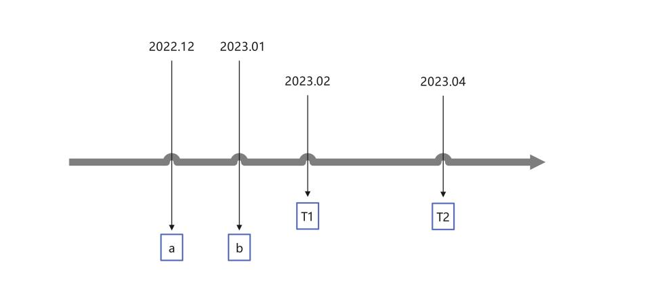
Figure S1. Overview of measurement points and Covid-19 related events.
Note:
a: China's National Health Commission Issues Announcement renamed Novel Coronavirus Pneumonia to Novel Coronavirus Infection, and had fully lifted the blockade.
b: Chinese government fully lifts infectious disease prevention, control measures taken against COVID-19. This followed the last wave of the COVID-19 pandemic in mid-to-late December.

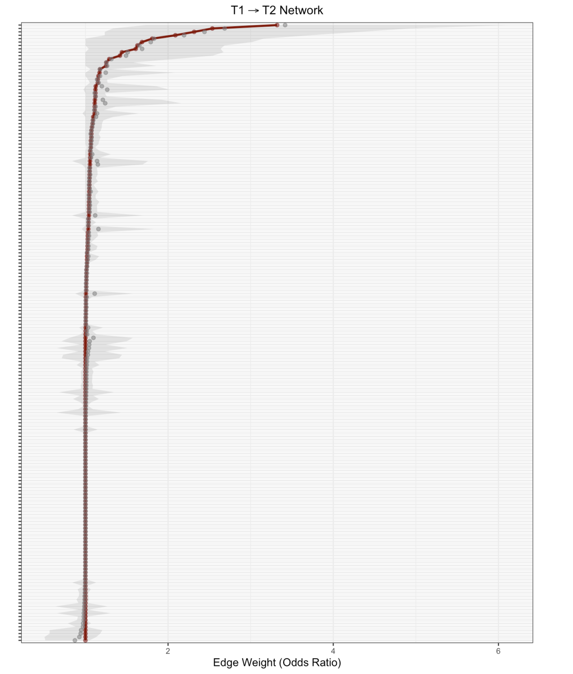
Figure S2. Bootstrapped confidence intervals (CIs) around edge weights.

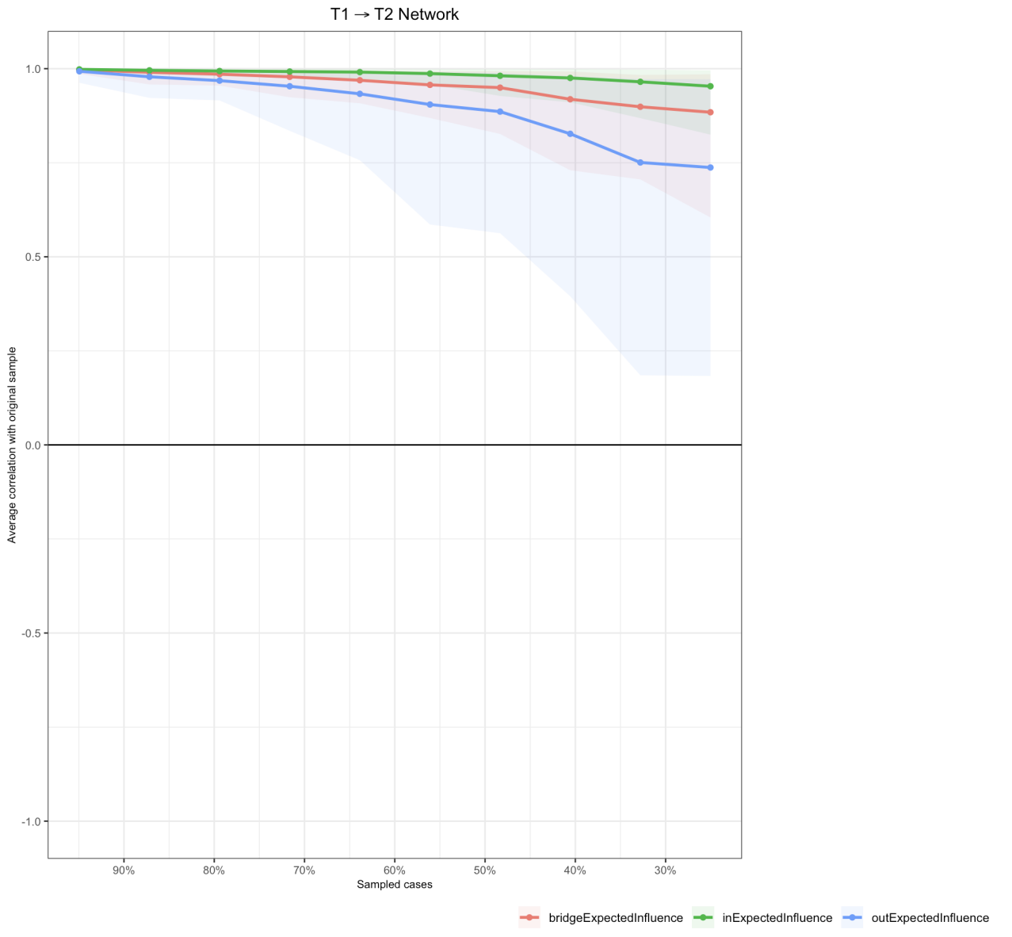
Figure S3. Stability of centrality measures for networks.

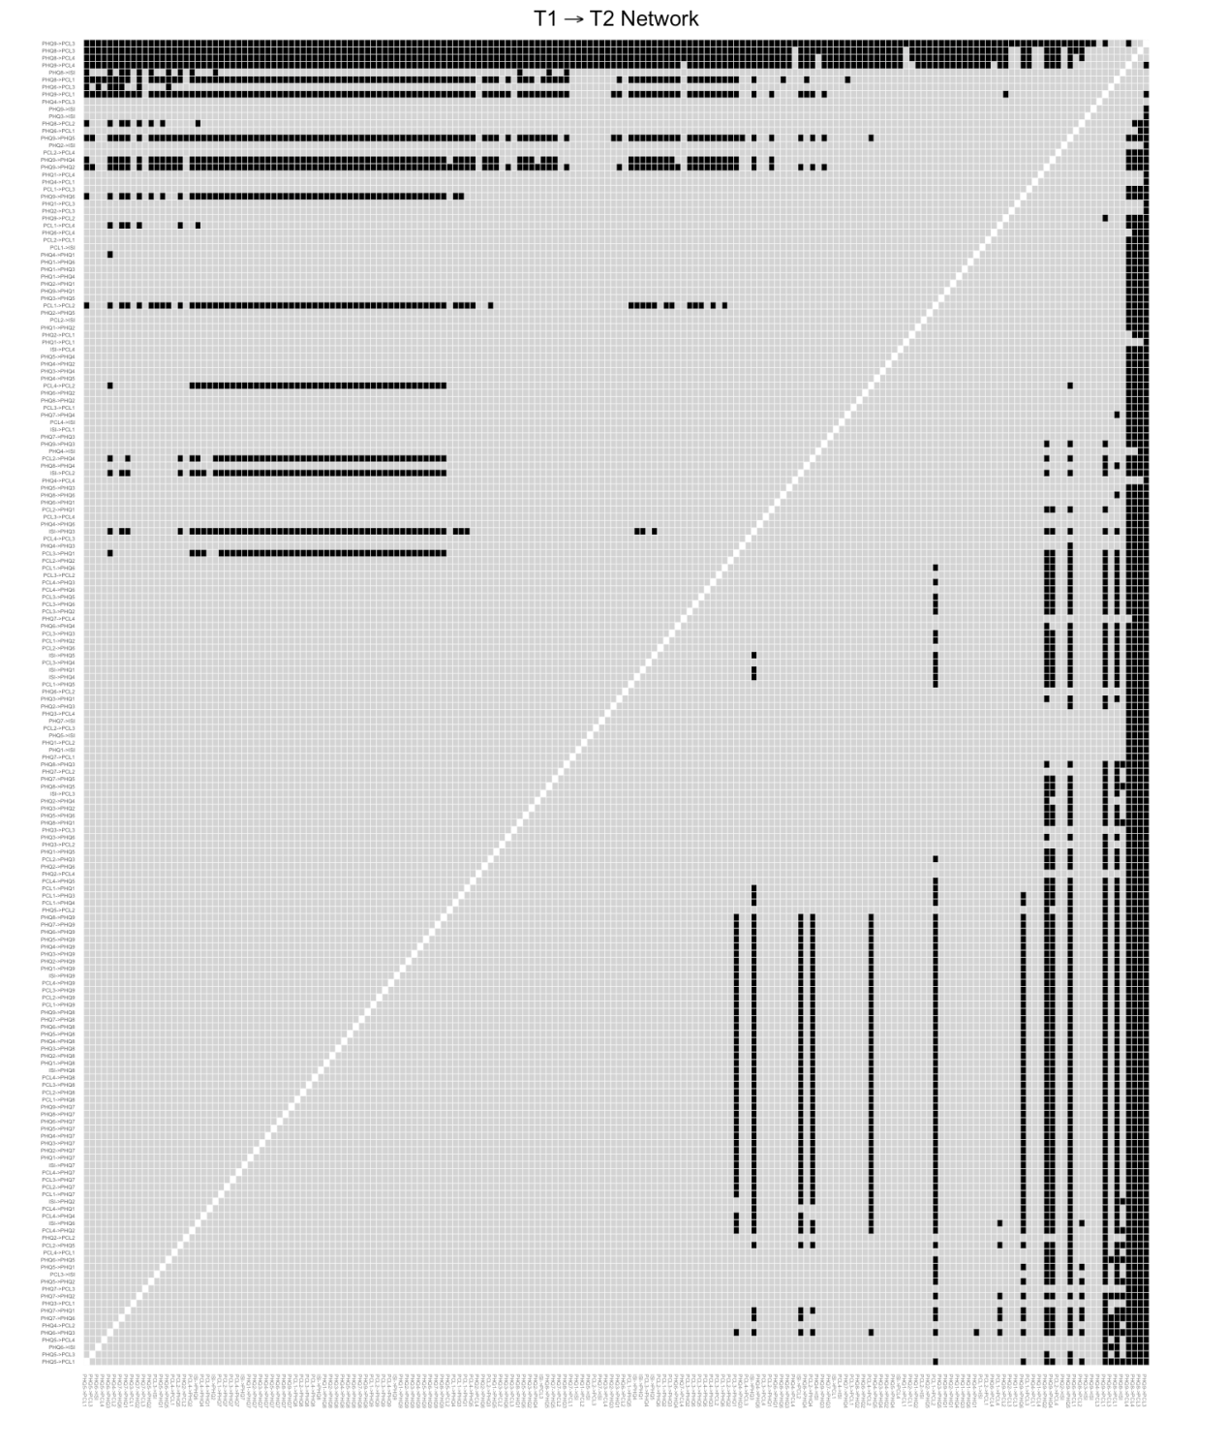
Figure S4. Bootstrapped difference tests between edge weights in the networks.

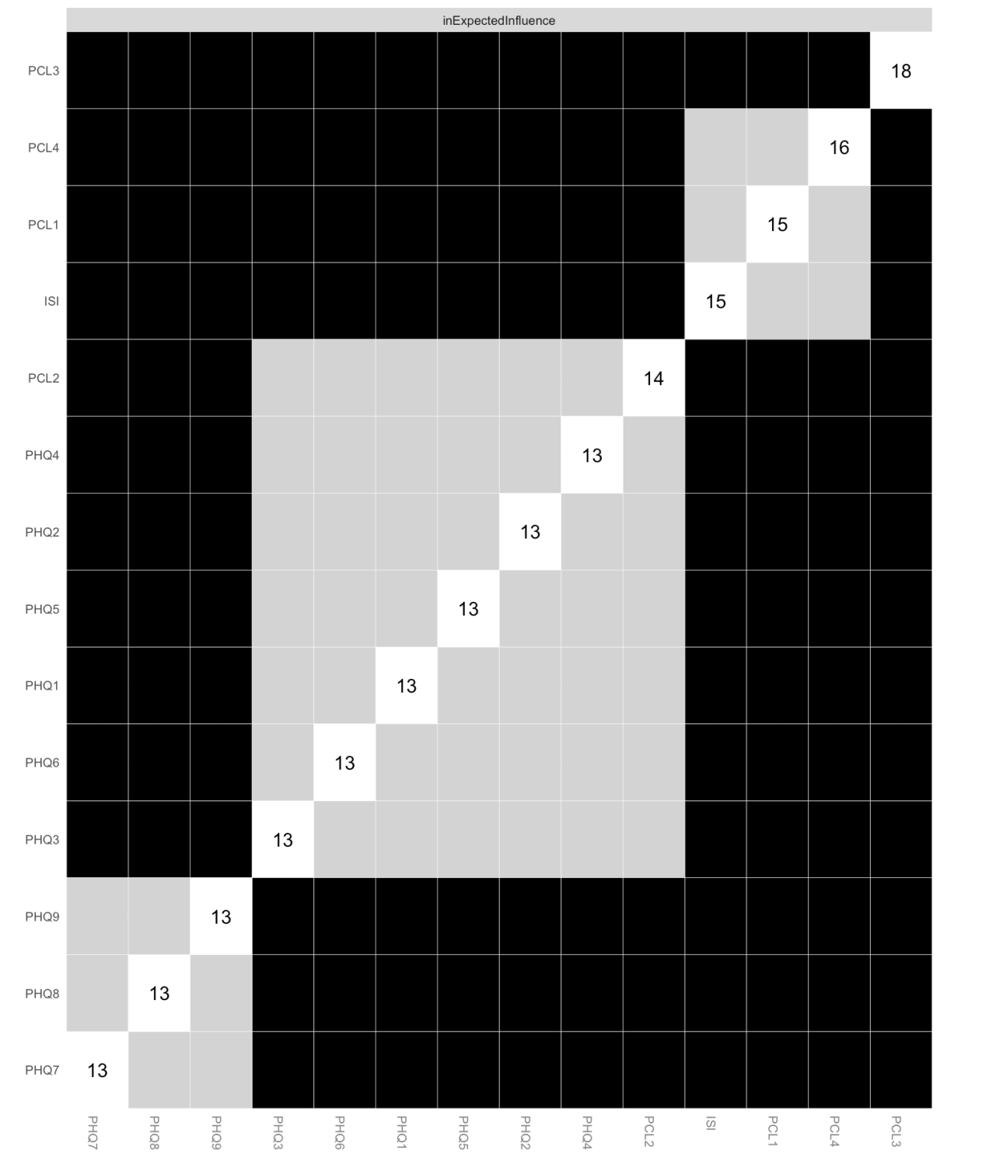
Figure S5 a. Bootstrapped difference test of in-Expected influence.

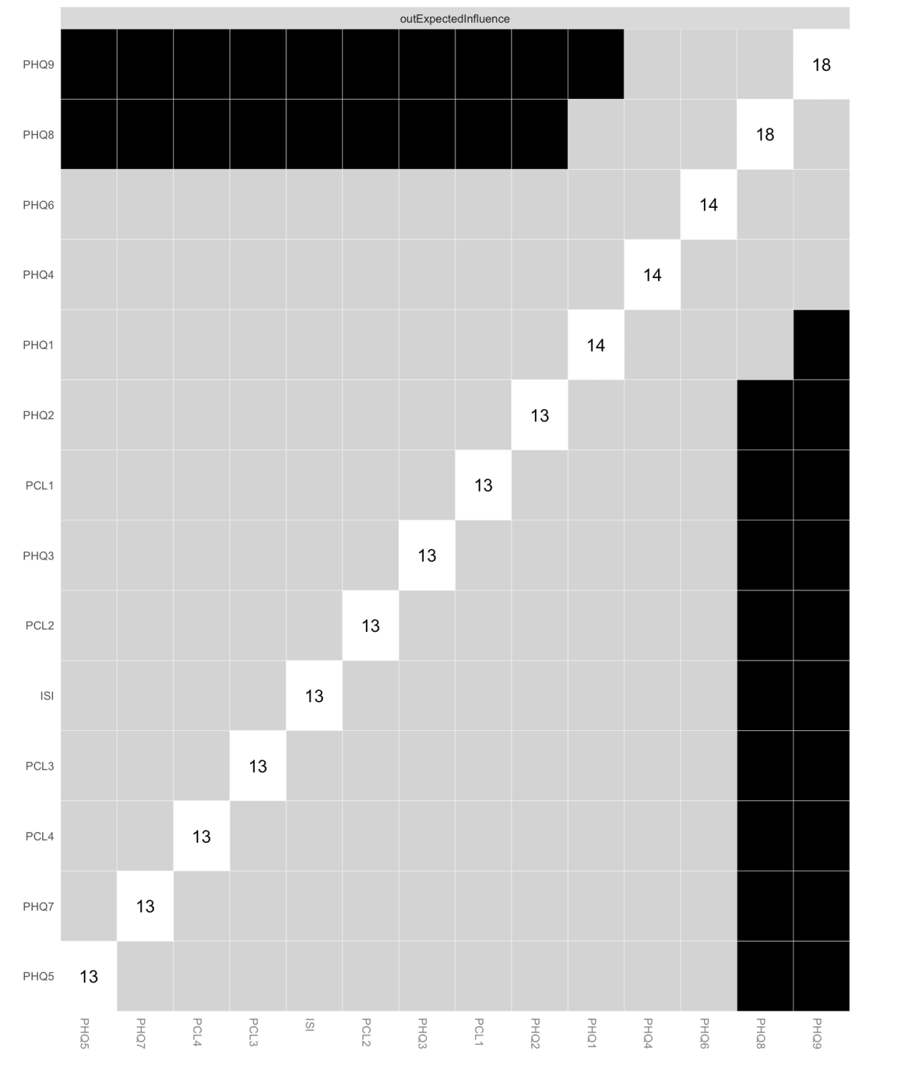
Figure S5 b. Bootstrapped difference test of out-Expected influence.

Figure S6. Network analysis in the group of low internet addicts (left) and the group of high internet addicts (right) for T1 → T2. The node from which the arrow departs is a symptom at the moment of T1 and the node to which it points is a symptom at the moment of T2. The connecting line represents the longitudinal relationship between these two symptoms. The thicker edges represent stronger relations.

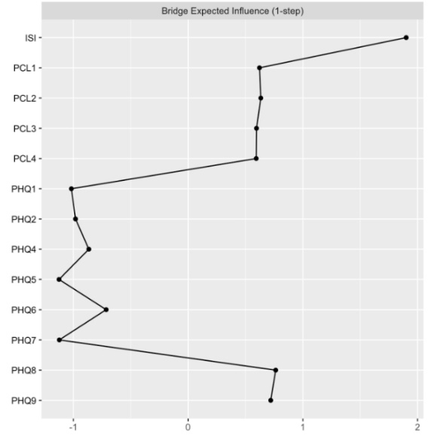
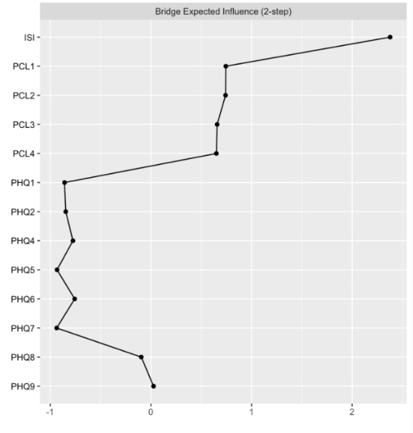
Figure S7. Bridging effects in the network without PHQ3. Larger values of the 1-step bridge expected influence indicate that a symptom has a stronger effect of directly bridging different domains of symptoms (left). Larger values of the 2-step bridge expected influence indicate that a symptom has a stronger effect of indirectly bridging different domains of symptoms (right).

