Supplementary Materials
A Randomized Controlled Trial Assists Individuals with Complex Trauma and Dissociation in Finding Solid Ground
Bethany L. Brand, Hygge J. Schielke, Karen Putnam, Nicholas A. Pierorazio, M. Shae Nester, Jerrica Robertson, Amie C. Myrick, Richard J. Loewenstein, Frank W. Putnam, Kathy Steele, Suzette Boon¹ & Ruth Lanius

Supplementary Table 1
Finding Solid Ground Topics (Schielke et al., 2022)
Module | Topics
Grounding | 1: Grounding: When, How, Why
Grounding | 2: Signs You Are Starting Get Ungrounded and Healthy Ways to Get Grounded
Grounding | 3: 101 Healthy Ways to Get Grounded
Separating Past from Present | 4: Separating Past from Present: When, How, Why
Separating Past from Present | 5: Using Imagery to Help Separate Past from Present
Separating Past from Present | 6: Separating Past from Present: Managing 90/10 Reactions
Additional Foundations | 7: More Healthy Ways to Help Yourself When You’re Feeling Too Much
Additional Foundations | 8: How to Help Yourself Heal the Impact of Trauma on the Brain
Additional Foundations | 9: Managing Crisis-Level Feelings
Additional Foundations | 10: The Importance of Self-Compassion in the Healing Process
Additional Foundations | 11: Managing Trauma-based Thoughts
Getting and Feeling Safer, Part 1 | 12: Recognizing and Planning How to Manage Challenging Situations
Getting and Feeling Safer, Part 1 | 13: Getting Healthy Needs Met Safely
Getting and Feeling Safer, Part 1 | 14: Why People Who Have Experienced Trauma Sometimes Do Unhealthy or Unsafe Things and How to Get Healthier and Safer
Getting and Feeling Safer, Part 1 | 15: The Cycle of Unhealthy Behavior and How to Break Out of It
Getting and Feeling Safer, Part 1 | 16: Understanding and Reducing Trauma-Related Reactions
Addressing Trauma-Based Thinking | 17: Shifting from Trauma-Based Thoughts to Healing-Focused Thinking
Addressing Trauma-Based Thinking | 18: Making the Decision to Get Healthier and Safer
Getting and Feeling Safer, Part 2 | 19: Working to Calm Your Alarm System
Getting and Feeling Safer, Part 2 | 20: Feeling Too Much or Too Little and Your Window of Tolerance
Getting and Feeling Safer, Part 2 | 21: Helping Yourself Recognize Signs that Your Risk of Doing Unhealthy or Unsafe Things Is Increasing
Improving Your Relationship with Emotions, Body Sensations, Aspects of Self | 22: How to Help Your Feelings Help You
 | 23: Why Naming Feelings Can be Difficult
 | 24: Naming Feelings
 | 25: Self-Understanding Through Compassion: Accepting All Your Feelings
 | 26: Safely Practicing Noticing and Naming Feelings
 | 27: Guilt, Shame, and Self-Compassion
Sticking with the Process and Building on Progress | 28: Feeling Safe Takes LOTS of Practice
Sticking with the Process and Building on Progress | 29: Let the Good Times Roll – Learning How to Allow Good Feelings and Positive Experiences
Sticking with the Process and Building on Progress | 30: You Have Learned a Lot - How to Keep Healing

Supplementary Table 2
Participants’ Countries
Country | Full Sample (n = 291) | Immediate Access (n = 149) | Waitlist (n = 142)
Australia | 22 (7.56%) | 12 (8.05%) | 10 (7.04%)
Belgium | 3 (1.03%) | 2 (1.34%) | 1 (0.70%)
Canada | 31 (10.65%) | 20 (13.42%) | 11 (7.75%)
Chile | 2 (0.69%) | 2 (1.34%) | 0 (0.00%)
Denmark | 1 (0.34%) | 0 (0.00%) | 1 (0.70%)
France | 3 (1.03%) | 2 (1.34%) | 1 (0.70%)
Germany | 3 (1.03%) | 1 (0.67%) | 2 (1.41%)
Guatemala | 1 (0.34%) | 0 (0.00%) | 1 (0.70%)
India | 3 (1.03%) | 2 (1.34%) | 1 (0.70%)
Ireland | 1 (0.34%) | 0 (0.00%) | 1 (0.70%)
Israel | 1 (0.34%) | 0 (0.00%) | 1 (0.70%)
Italy | 1 (0.34%) | 0 (0.00%) | 1 (0.70%)
Netherlands | 5 (1.72%) | 3 (2.01%) | 2 (1.41%)
New Zealand | 2 (0.69%) | 2 (1.34%) | 0 (0.00%)
Norway | 15 (5.16%) | 8 (5.37%) | 7 (4.93%)
Pakistan | 2 (0.69%) | 0 (0.00%) | 2 (1.41%)
Peru | 2 (0.69%) | 2 (1.34%) | 0 (0.00%)
Poland | 1 (0.34%) | 0 (0.00%) | 1 (0.70%)
Romania | 1 (0.34%) | 0 (0.00%) | 1 (0.70%)
Singapore | 5 (1.72%) | 2 (1.34%) | 3 (2.11%)
Sweden | 3 (1.03%) | 1 (0.67%) | 2 (1.41%)
Switzerland | 2 (0.69%) | 2 (1.34%) | 0 (0.00%)
Ukraine | 1 (0.34%) | 0 (0.00%) | 1 (0.70%)
United Kingdom | 7 (2.41%) | 3 (2.01%) | 4 (2.82%)
United States | 171 (58.76%) | 84 (56.38%) | 87 (61.27%)
Missing data | 2 (0.69%) | 2 (1.34%) | 0 (0.00%)

Supplementary Table 3
Participants’ Comorbid Clinical Diagnoses
Comorbid Diagnoses | n Endorsed | % of Sample
Depressive Episode or Depressive Disorder | 170 | 58.4%
Manic Episode or  Bipolar Disorder | 24 | 8.2%
Somatic Symptom / Somatoform Disorder | 57 | 19.6%
Substance-use Disorder | 27 | 9.3%
Schizophrenia Spectrum or other Psychotic Disorder | 5 | 1.7%
PTSD | 150 | 51.5%
Other Trauma- and  Stressor-Related Disorder | 34 | 11.7%
Anxiety Disorder | 148 | 50.9%
Cluster A Personality Disorder | 2 | 0.7%
Cluster B Personality Disorder | 52 | 17.9%
Cluster C Personality Disorder | 29 | 10.0%
Other Specified Personality Disorder or Unspecified Personality Disorder | 10 | 3.4%

Supplementary Table 4
Descriptive Statistics for Outcome Variables by Measure, Invention Group, and Time
Outcome Measure | Immediate FSG |  |  | Waitlist |  |  | Full Sample
Statistical Measure | Access Baseline | 6 Months Access | 12 Months Access | Study Entry | Access Baseline | 6 Months Access | Study Entry | 6 Months | 12 Months
DERS
M | 125.49 | 107.24 | 94.49 | 126.57 | 122.88 | 102.31 | 126.02 | 115.46 | 98.26
SD | 22.20 | 22.11 | 24.87 | 21.31 | 22.19 | 23.59 | 21.74 | 23.43 | 24.44
n | 149 | 74 | 45 | 142 | 82 | 42 | 291 | 156 | 87
PCL-5
M | 56.90 | 48.36 | 40.50 | 57.30 | 56.54 | 46.71 | 57.10 | 52.66 | 43.54
SD | 12.60 | 14.69 | 17.02 | 11.46 | 11.30 | 14.25 | 12.04 | 13.60 | 15.95
n | 149 | 73 | 44 | 142 | 81 | 42 | 291 | 154 | 86
DES-II
M | 43.98 | 38.95 | 34.66 | 44.04 | 42.91 | 38.44 | 44.01 | 41.03 | 36.53
SD | 20.39 | 20.84 | 18.60 | 20.61 | 18.52 | 19.42 | 20.46 | 19.69 | 18.99
n | 149 | 73 | 43 | 142 | 81 | 42 | 291 | 154 | 85
SCS-SF
M | 2.19 | 2.54 | 2.86 | 2.19 | 2.16 | 2.75 | 2.19 | 2.34 | 2.80
SD | 0.61 | 0.62 | 0.72 | 0.67 | 0.59 | 0.76 | 0.64 | 0.63 | 0.74
n | 149 | 71 | 42 | 142 | 81 | 42 | 291 | 152 | 84
PITQ-p
M | 47.92 | 55.18 | 61.10 | 47.55 | 47.04 | 58.18 | 47.74 | 50.85 | 59.64
SD | 13.97 | 15.68 | 18.97 | 14.44 | 14.16 | 17.64 | 14.18 | 15.39 | 18.27
n | 149 | 71 | 42 | 142 | 81 | 42 | 291 | 152 | 84
Note. DERS = Difficulties in Emotion Regulation Scale (total scores); PCL-5 = PTSD Checklist for DSM-5 (total scores); DES-II = Dissociative Experiences Scale – II (total average scores); SCS-SF = Self-Compassion Scales – Short Form (total average scores); PITQ-p = Progress in Treatment
Questionnaire – Patient Version (total average scores).

Normality and Outliers
Most symptom scales are not a perfect gaussian distribution; these outcome measures are no different. Given the underlying distributions of these scales, we initially looked at box plots to see if there were obvious outliers, followed by with Kolmogorov-Smirnov normality tests.
Distributions were examined for the outcome variables. The below combination charts illustrate the box plots and distributions. Outliers at baseline ranged between 1-8 participants. Proc Mixed is robust to small deviations in distributions. Normality testing using the Kolmogorov-Smirnov was borderline, and non-parametric distribution free analyses supported our mixed model findings for this interim report. Kolmogorov-Smirnov values provide a critical value; if the test statistic is greater than this value, normality is rejected at that level of significance. The critical values are typically around 0.05 to 0.10 and are the Lilliefors’ adjusted values as given by Dallal (1986). For these data, Kolmogorov-Smirnov values were DERS=0.07, PCL-9=0.09, DES-II=0.05, SCS-SF 0.06 and PITQ-p=0.03.

Supplementary Figure 1

Difficulties in Emotion Regulation Scale (DERS) Box Plots and Distribution Graphs by Group and Time

Note. DERSUM = summary scores for Difficulties in Emotion Regulation Scale. Group 0 = Immediate access. Time 1 (red) = Access Baseline; Time 2 (blue) = 6 months access; Time 3 (green) = 12 months access. Group 1 = Waitlist+FSG. Time 1 (red) = Study entry; Time 2 (blue) = Access Baseline; Time 3 (green) = 6 months access.

Supplementary Figure 2

PTSD Checklist for DSM-5 (PCL-5) Box Plots and Distribution Graphs by Group and Time

Note. PCLSUM = summary scores for PTSD Checklist for DSM-5. Group 0 = Immediate access. Time 1 (red) = Access Baseline; Time 2 (blue) = 6 months access; Time 3 (green) = 12 months access. Group 1 = Waitlist+FSG. Time 1 (red) = Study entry; Time 2 (blue) = Access Baseline; Time 3 (green) = 6 months access.

Supplementary Figure 3

Dissociative Experiences Scale – II (DES-II) Box Plots and Distribution Graphs by Group and Time

Note. DESMN = mean scores for Dissociative Experiences Scale – II. Group 0 = Immediate access. Time 1 (red) = Access Baseline; Time 2 (blue) = 6 months access; Time 3 (green) = 12 months access. Group 1 = Waitlist+FSG. Time 1 (red) = Study entry; Time 2 (blue) = Access Baseline; Time 3 (green) = 6 months access.

Supplementary Figure 4

Self-Compassion Scales – Short Form (SCS-SF) Box Plots and Distribution Graphs by Group and Time

SCS-SF
Note. SCMN = mean scores for Self-Compassion Scales – Short Form. Group 0 = Immediate access. Time 1 (red) = Access Baseline; Time 2 (blue) = 6 months access; Time 3 (green) = 12 months access. Group 1 = Waitlist+FSG. Time 1 (red) = Study entry; Time 2 (blue) = Access Baseline; Time 3 (green) = 6 months access.

Supplementary Figure 5

Progress in Treatment Questionnaire-Patient Version (PITQ-p) Box Plots and Distribution Graphs by Group and Time

Note. PITMN = means for Progress in Treatment Questionnaire-Patient Version. Group 0 = Immediate access. Time 1 (red) = Access Baseline; Time 2 (blue) = 6 months access; Time 3 (green) = 12 months access. Group 1 = Waitlist+FSG. Time 1 (red) = Study entry; Time 2 (blue) = Access Baseline; Time 3 (green) = 6 months access.

Supplementary Figure 6

Difficulties in Emotion Regulation Scale (DERS) Outcomes by Group over Time
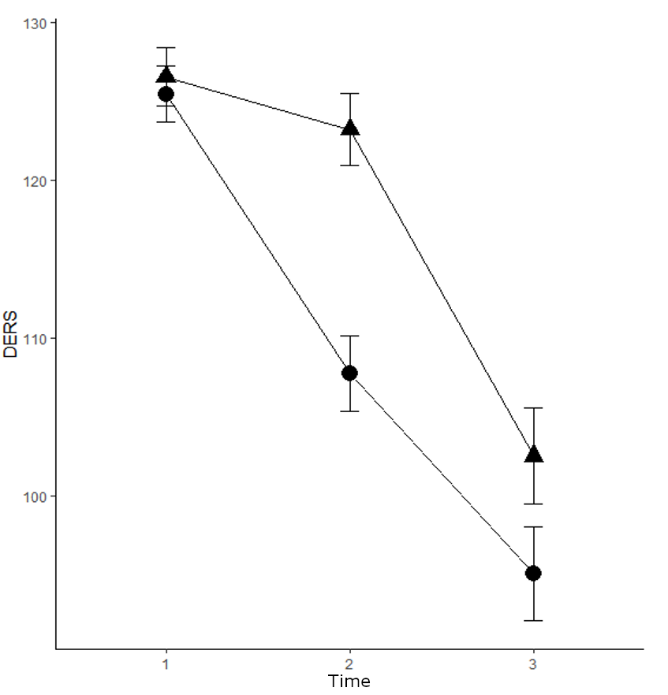
Note. Time for Immediate group (circles): Time 1 = Access Baseline; Time 2 = 6 months access; Time 3 = 12 months access. Time for Waitlist+FSG group (triangles): Time 1 = Study entry; Time 2 = Access Baseline; Time 3 = 6 months access.

Supplementary Figure 7

PTSD Checklist for DSM-5 (PCL-5) Outcomes by Group over Time

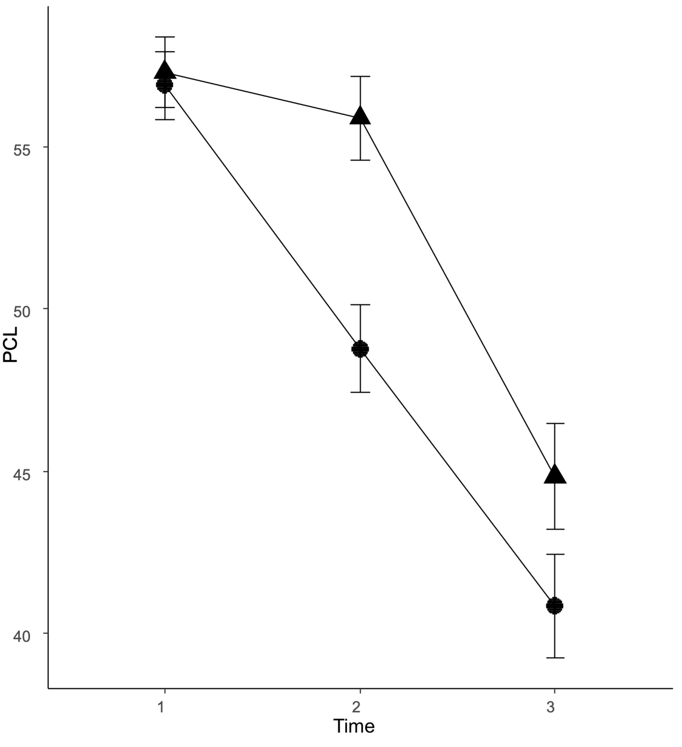
Note. Time for Immediate group (circles): Time 1 = Access Baseline; Time 2 = 6 months access; Time 3 = 12 months access. Time for Waitlist+FSG group (triangles): Time 1 = Study entry; Time 2 = Access Baseline; Time 3 = 6 months access.

Supplementary Figure 8

Self-Compassion Scales – Short Form (SCS-SF) Outcomes by Group over Time
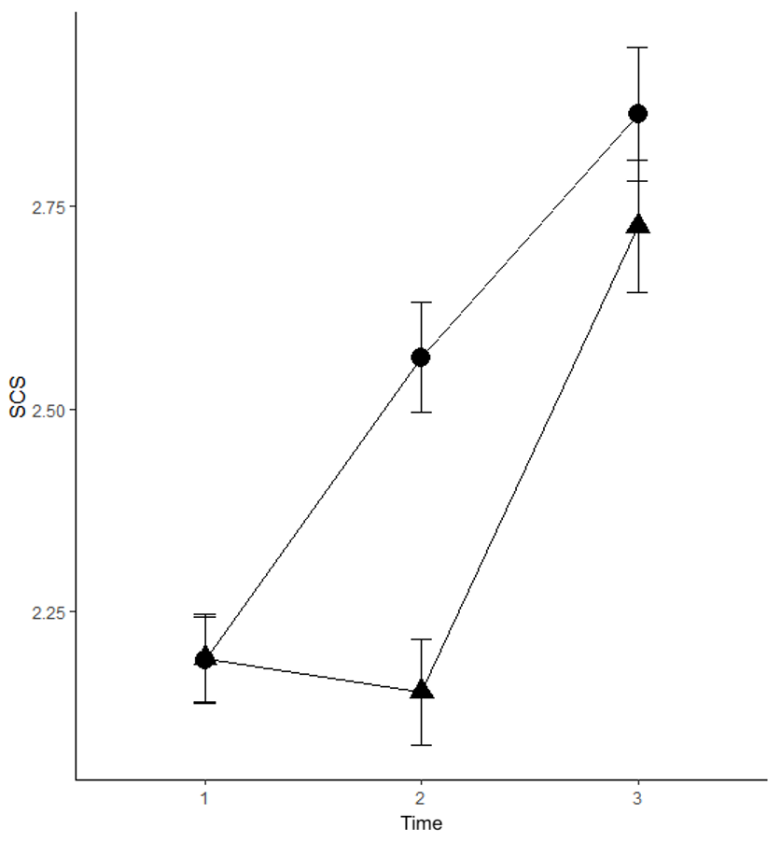
Note. Time for Immediate group (circles): Time 1 = Access Baseline; Time 2 = 6 months access; Time 3 = 12 months access. Time for Waitlist+FSG group (triangles): Time 1 = Study entry; Time 2 = Access Baseline; Time 3 = 6 months access.

Supplementary Figure 9

Progress in Treatment Questionnaire-Patient Version (PITQ-p) Outcomes by Group over Time
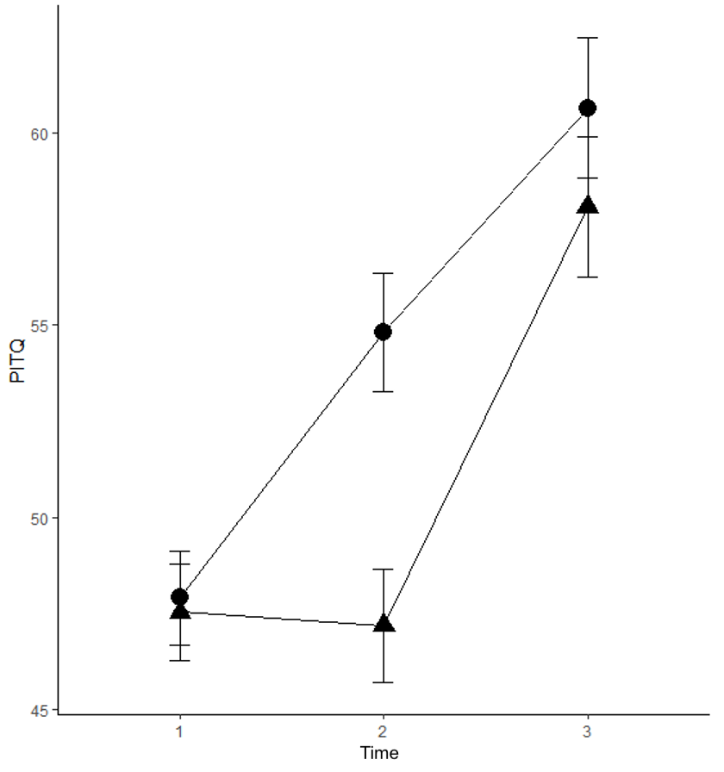
Note. Time for Immediate group (circles): Time 1 = Access Baseline; Time 2 = 6 months access; Time 3 = 12 months access. Time for Waitlist+FSG group (triangles): Time 1 = Study entry; Time 2 = Access Baseline; Time 3 = 6 months access.

Repeated Measures using SAS Proc Mixed
Mixed model repeated measure analyses were executed using SAS Proc Mixed following the procedures used by other researchers (Bell et al., 2013; Singer, 1998; Suzuki, 1999). Models were fit using difference covariance structures and the fit statistics were compared. Additionally, effects were tested using smaller dataset with non-missing data to confirm the larger N=291 sample, results available upon request. Family-wise Bonferroni error rates were by scale to control for Type 1 error.
Bonferroni Corrections
Omnibus F tests examined whether there were significant group (immediate vs waitlist access), time, and the interaction of Group*Time for our 5 outcome variables: DERS, PCL, DES-II, SCS, and PITQ-p. Given the number of comparisons, to minimize the risk of reporting Type 1 errors, Bonferroni corrections were applied to the p-values when interactions were significant, and adjusted p-values are reported in Table 2 instead of the raw unadjusted values. Bonferroni multiple test error correction p-values were <0.02. Space limitations precluded also including the unadjusted p-values to the Table; unadjusted p-values available upon request.
Because the F test for Group*Time interaction was non-significant, corrections were not applied to DES-II p-values, and the DES-II is not included in Table 2. Bonferroni corrections were also not applied to the study entry demographic variables reported in Table 1.
Effect Sizes
Effect sizes were calculated using Hedges’ g with an online program from James Uanhoro, Quantitative Research, Evaluation & Measurement program at The Ohio State University. The online calculator, references and mathematical formulas can be found at Effect Size Calculators (effect-size-calculator.herokuapp.com)
Cohen’s d and Hedges’ g differ in that Hedges’ g takes each sample size into consideration when calculating the overall effect size. It is recommended to use Hedge’s g to calculate effect size when the two sample sizes are not equal, as is the case here for the between group comparisons. When the sample sizes are equal or paired, then Hedges’ g and Cohen’s d will be the exact same value, as is the case here for the within group comparisons.
Discussion of CONSORT Figure 1
403 patients were nominated for inclusion. 62 patients did not complete a participant screen. Of the 341 participants who completed patient screens, 50 were excluded: 44 did not complete the initial survey, and 6 did not meet inclusion criteria described in the manuscript.
Of the 291 participants eligible for inclusion in the interim report, 149/291 (51.2%) were allocated to the Immediate Access group, and 142/291 (48.8%) were allocated into the Waitlist + FSG group.
At 6 months, 217/291 (74.6%) were eligible for the 6-month survey. 156/217 (71.9%) completed the 6-month survey, 74/156 (47.7%) from the Immediate Access group and 82/156 (52.6%) from the Waitlist + FSG group. 61/217 (28.1%) were eligible, but had not completed the survey at the time the interim sample was analyzed; 74/291 (25.4%) had not yet reached the 6-month timepoint.
At 12 months, 178/217 (82%) were eligible for the 12-month survey. 87/178 (48.9%) completed the 12 month survey, 45/87 (51.7%) from the Immediate Access group and 42/87 (48.3%) from the Waitlist + FSG group. 91/178 (51.1%) were eligible, but had not completed the survey at the time interim sample was analyzed; 113/217 (52.1%) had not reached the 12-month time point.
Missing data
This is a dynamic, ongoing study. This interim report involves participants currently still completing the 6-month and 1-year time points. At the time we started our interim analyses for this report, there were 291 participants that had completed the baseline assessment, 156 with 6-month data, and 87 with 1 year data. Proc Mixed can analyze this type of dynamic data including when all subjects do not have complete data across the time points. Within each scale there were little to no missing data points when calculating the sum or mean summary score. Additionally, outcome measures were examined by t-test for those participants who were not missing data for baseline vs 6-months and baseline vs 1 year and 6 months vs 1-year. These univariates pairwise comparisons of the smaller sample subset of non-missing data had the same results as reported using the full interim dataset of N=291. These results are not included here but are available upon request.
Finding Solid Ground Topics
The number of completed topics were examined between groups. Below we present the graphs of the 6-month time point of FSG access for both the Immediate and Waitlist groups and the Immediate group at 1 year in the study. The groups had an average of 12.8 topics (Immediate SD=5.2, median =13; Waitlist SD=6.2, median = 14). There was no significant difference between groups in topics completed after 6 months of FSG access in this interim sample. In the 2nd 6 months of FSG access, the same participants in the Immediate group completed an additional 8.6 topics.

Supplementary Figure 10
Number of Topics Completed by Immediate and Waitlist Group

Note. FSG = Finding Solid Ground program; TOPIC6M = number of FSG topics completed at 6 months of access to FSG; TOPICYR = number of FSG topics completed at 1 year of access to FSG.

References
Bell, B.A., Ene, M., Smiley, W.F., & Schoeneberger, J.A. (2013). A multilevel model primer using SAS. 433-2013: A Multilevel Model Primer Using SAS® PROC MIXED
Dallal G. (1986). An analytic approximation to the distribution of Lilliefors's test statistic for normality. The American Statistician, 40(4), 294-296.
Schielke, H., J., Brand, B. L., & Lanius, R. A. (2022). The Finding Solid Ground Program Workbook: Overcoming Obstacles in Trauma Recovery. Oxford University Press.
Singer, J.D. (1998). Using SAS Proc Mixed to fit multilevel models, hierarchical models and individual growth models. Journal of Educational and Behavioral Statistics, 23(4), 323-355. https://doi.org/10.3102/10769986023004323
Suzuki, S. (1999). Using PROC MIXED in Hierarchical Linear Models: Examples from two- and three-level school-effect analysis, and meta-analysis research. Midwest SAS Users Group Conference. https://Lexjansen.com.

