SUPPLEMENTAL MATERIALS

Supplementary Table 1.
Participant Demographic Information (N = 256)
Variable | n | %
Age, years
>24 | 6 | 2.3
25-34 | 66 | 25.8
35-44 | 58 | 22.7
45-54 | 55 | 21.5
56-64 | 49 | 19.1
<65 | 22 | 8.6
Registration status
Provisional ª | 40 | 15.6
General | 216 | 84.4
Area of practice endorsement ^{b}
Clinical | 105 | 41.0
Forensic | 15 | 5.9
Counselling | 14 | 5.5
Other | 13 | 5.1
Duration of clinical experience, years ^{c}
0-7 (early career) | 72 | 28.1
8-20 (middle career) | 85 | 33.2
21+ (senior career) | 59 | 23.0
State or territory of practice
Australian Capital Territory | 7 | 2.7
New South Wales | 80 | 31.3
Queensland | 48 | 18.8
South Australia | 21 | 8.2
Tasmania | 2 | 0.8
Victoria | 91 | 35.5
Western Australia | 7 | 2.7
Main area of work ^{d}
Private practice ^{e} | 160 | 62.7
Medical or primary health | 12 | 4.7
Educational | 26 | 10.2
Forensic | 10 | 3.9
Specialist mental health ^{f} | 30 | 11.8
Other ^{g} | 17 | 6.7
Note. Demographic data were missing for 24 participants.
ª In Australia, psychology trainees are awarded provisional psychologist registration after a 4-year accredited sequence of study in psychology. This precedes a minimum 2-year period of supervised practice before general registration as a psychologist can be obtained. ^{b} Psychologists can choose to complete a postgraduate qualification and supervised training focusing in one or more of nine approved areas of practice endorsement. This is optional and is not required for full general registration as a psychologist. Percentages do not sum to 100%, as some participants indicated multiple areas of endorsement, while others did not indicate any.
^{c} Excludes provisional psychologists (n = 40). ^{d} Missing data (n = 1). ^{e} The percentage of psychologists in private practice in Australia is 40.0% (Australian Health Practitioner Regulation Agency, 2020). ^{f} Includes community mental health (n = 21), clinical mental health (n = 7) and psychiatric hospital (n = 2). ^{g} Includes non-government organizations (n = 8), dual settings (n = 3) and not specified (n = 6).

Supplemental Figure 1.
Psychologists’ Confidence in Assessing and Treating Trauma Symptoms and Dissociation (N = 280)
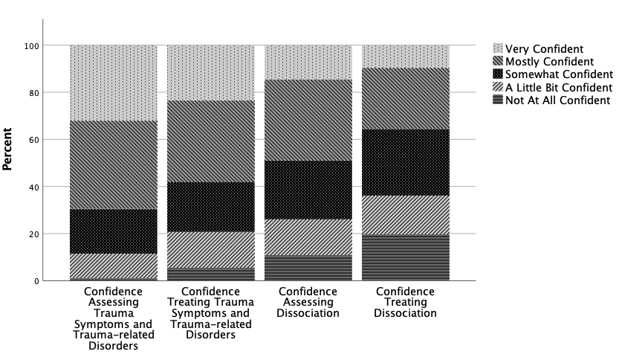
Note. Responses were missing for 2 respondents on confidence treating dissociation.

References

Australian Health Practitioner Regulation Agency. (2020). Psychologists. A snapshot as of 30 June 2020. AHPRA. https://www.ahpra.gov.au/About-Ahpra/What-We-Do/Data-access-and-research/Health-profession-demographic-snapshot-reports

