Supplemental Materials
Wu et al.: Collective Trauma
Sample Characteristics
The T1 Department of Child and Family Services (DCFS) documentations were evaluated. In the present study, among participants from our longitudinal sample (n = 63), 52 (83%) had substantiated child maltreatment (sexual abuse, physical abuse, and/or neglect) at T1 based on DCFS records and conclusion of the T1 forensic evaluation. Among a subsample of the longitudinal participants (i.e., those who have records at both T1 and T2 to permit the longitudinal analyses described below; n = 45), 34 have T1 age-at-first maltreatment data; they were on average 5 years old (SD = 3.55) when the first suspected maltreatment was reported to DCFS. Age-at-first maltreatment was not significantly correlated with T2 or T3 cumulative child abuse, T3 Covid impact, or T3 PTSD symptoms (see main text).
Ascertainment of the representativeness of the T3 longitudinal sample (n = 63), T2 longitudinal subsample (n = 45), or adults who participated in T2 but not necessarily T3 (N = 119) against the T1 group of children (N = 458) who qualified for the present study revealed no significant differences in: T1 age, t(456)s ≤ 1.93, ps ≥ .054; ethnicity (Black vs. other), t(456)s ≤ .43, ps ≥ .667; and the number of T1 types of substantiated maltreatment (range: 0-3), t(450)s ≤ 1.00, ps ≥ .320. However, the T2 sample contained a higher proportion of females, t(456)s ≥ 2.32, ps ≤ .021. Thus, the longitudinal participants were largely representative of the T1 sample.
T3 PC-PTSD-5 Modifications
To better determine different types of trauma, three modifications were made to the T3 PC-PTSD-5 measure:
a) Participants in the present study were allowed to indicate “yes” or “no” for each of the trauma items instead of responding to one single question about presence or absence of exposure to any of the trauma items;
b) The item “a physical or sexual assault or abuse” was separated out into four different items (“child sexual abuse/child sexual assault,” “child physical abuse/child physical assault,” “sexual assault as an adult,” and “physical assault as an adult”);
c) Three items were added (“having a loved one die from Covid-19”, “other” where participants could describe other types of trauma not specified in the checklist, and “I have not experienced a traumatic event.”).
Longitudinal Measures and Analyses
Additional analyses were conducted with the longitudinal subsample to (a) lend further support to the significant cross-sectional relations found in the main text, and (b) rule out potential confounds.
Measures
The following measures were administered only to participants in the longitudinal sample as part of the larger study:
T1 Memory for Sentences (MFS). The MFS test from the 4th edition Stanford–Binet Intelligence Scale assessed participants’ T1 verbal short-term memory. It is a standardized measure for children ages 2 years and older. Sentences of various lengths were read; participants, as children, repeated the sentences after hearing each one. Higher scale scores indicate better short-term memory and verbal intelligence (test–retest reliability = .89; Sattler, 1988).
T2 Child Abuse Questions. These questions are taken from the victimization questionnaire in Quas et al. (2005) to measure self-disclosed child abuse histories. Questions assess the presence or absence of child sexual abuse (“As a child or teenager, before you turned 18, did you ever experience a sexual offense or were alleged to have experienced a sexual offense”) and physical abuse (“As a child or teenager, before you turned 18, did you ever experience physical abuse or was it ever suspected that you experienced physical abuse”). The total number of self-reported child abuse types indexes T2 cumulative child abuse (range: 0-2). Questions were proceeded by the following normalization and definitional instructions:
- For child sexual abuse, “This set of questions concerns childhood sexual experiences. About 1/4th of all girls in America and about 1/9th of all boys report having experienced sexual abuse growing up, so if you experienced it, you are not alone. These offenses include: sexual touching, someone exposing himself or herself to you, oral sex, and/or attempted or experienced vaginal or anal sex. These acts could have been committed by a family member or a nonfamily member. These offenses also include sexual acts you agreed to, as long as you were under 18 years of age and the other person was 4 or more years older than you. These offenses do not include sex play or sexual relations with someone who was about the same age as you or younger.”
- For child physical abuse, “The next questions concern physical abuse that you experienced as a child or adolescent (before you turned 18). These offenses include a parent or a caretaker, including step parents, foster parents or grandparents, ever hitting you with a fist or object; slapping, shoving, kicking, or biting you; or physically assaulting you, that is, beating you up, which includes assault with an object, such as a wooden board, knife, or even a gun. Please include ‘whoopings’ or spankings that leave black and blue marks or worse.”
T2 Childhood Trauma Questionnaire (CTQ). CTQ consists of 28 maltreatment experiences. Ratings (5-point scale from 1 = never true to 5 = very often true) yielded 5 sub-scores measuring the severity of sexual abuse, physical abuse, emotional abuse, physical neglect, and emotional neglect. Due to the focus of our study on child sexual and physical abuse, we computed an average of the sexual and physical abuse CTQ sub-scores to index T2 Child Sexual or Physical Abuse (CSPA) CTQ. Higher scores indicate more severe sexual and/or physical abuse. Psychometric properties for CTQ are excellent (α = .97; Bernstein et al., 1994). In our sample, CTQ α = .95 for all items, and α = .93 for only the sexual and physical abuse items.
T2 Trauma Symptom Checklist (TSC). TSC is a 40-item questionnaire that measures adult trauma symptoms (Elliott & Briere, 1992). Symptoms span six domains: dissociation, anxiety, depression, sex abuse trauma index, sleep disturbances, and sexual problems. On a 4-point scale (0 = never to 3 = very often), participants rate how often they experienced each symptom in the last 2 months. Higher total scores indicate more trauma symptoms. TSC has good psychometric properties across traumatized and non-traumatized multi-race samples (e.g., α’s average .89 to .91; Briere, 1996). In our sample, TSC yielded α = .93.
T2 Controlled Oral Word Association Test (COWAT). COWAT is a verbal fluency test that assesses adults’ ability to produce as many words as possible beginning with designated letters in a 60-second period (Benton & Hamsher, 1978). Higher COWAT scores indicate greater verbal fluency and are correlated with higher intelligence (Crawford et al., 1998). Test-retest reliability is .84 (Ross et al., 2007).
Longitudinal Analyses
Analyses were performed using measures from the main text and those reported above. Correlations and summary statistics of key T2 and T3 variables in the present study are displayed in Table S1. In the following section, a multiple linear regression was first performed to examine whether T2 cumulative child abuse, similar to T3 cumulative child abuse (see main text), would be associated with more negative T3 Covid impact. A second regression was conducted to test whether T2 CSPA CTQ (child abuse severity score), rather than T3 Covid impact, would predict more PTSD symptoms at T3. Finally, additional regressions revealed that both T2 and T3 cumulative child abuse remained significant predictors of T3 PTSD symptoms when T2 TSC (trauma symptoms score) was controlled. Power analyses using G*Power for the longitudinal regression analyses revealed that the size of our longitudinal subsample (n = 45) permitted over 80% power to detect a medium-to-large effect size of f² = .27.
Cumulative Child Abuse as a Longitudinal Predictor. Because both T3 cumulative child abuse and T3 Covid impact were derived from self-report at the same time point, it is possible that at T3, participants who were more negatively impacted by Covid had a greater tendency to report trauma experiences, hence contributing to a positive relation between cumulative child abuse and negative Covid impact. To address this concern, we focused on the subsample of longitudinal participants who also participated in both T1 and T2 data collection; participants in this group had been involved in a child maltreatment investigation at T1 and would not have had any Covid impact at T2. The main regression (see main text) was reconducted with a T2 measure of cumulative child abuse as the predictor of T3 Covid impact and controlling for potential effect of T3 friend and family Covid diagnoses. Model 1 consists of T3 friend and family Covid diagnoses. T2 cumulative child abuse was added into Model 2, followed by T3 perceived discrimination in Model 3.
Results indicated that cumulative child abuse was again a unique predictor of T3 Covid impact, β = .37, t(40) = 2.44, p = .019; Model 2: F(2, 40) = 3.25, p = .049, R² = .14, ΔR² = .13, replicating findings from the main text. Adults who reported more types of child abuse at T2 reported more negative impact of Covid at T3. T3 perceived discrimination was not significant in Model 3, β = .07, t(39) = .42, p = .677, likely due to loss of sufficient statistical power, but the trend remained the same as the pattern in the main text.
Child Abuse Severity as a Longitudinal Predictor. We also aimed to test the possibility that abuse severity, compared to pandemic impact, would be a stronger predictor of PTSD symptoms for adults with high levels of cumulative childhood abuse. Because the longitudinal participants from our study reported significantly more types of child abuse than the community sample, we performed an additional regression using our longitudinal subsample to examine whether at relatively high levels of cumulative child abuse, T2 child abuse severity, instead of T3 Covid impact, would predict T3 PTSD symptoms. T3 PTSD symptoms served as the dependent variable. T2 CSPA CTQ was entered into Model 1, followed by T3 Covid impact in Model 2.
T2 CSPA CTQ emerged as a unique predictor in Model 1, F(1, 41) = 28.46, p < .001, R² = .41. Higher CSPA CTQ scores at T2 were associated with elevated PTSD symptomatology at T3, β = .64, t(41) = 5.34, p < .001. T3 Covid impact was not significant, β = .23, t(40) = 1.93, p = .061; Model 3, F(2, 40) = 17.04, p < .001, R² = .46; ΔR² = .05, p = .061. Thus, T2 abuse severity scores, but not T3 Covid impact, predicted more PTSD symptoms during the pandemic. Results supported main text findings regarding a lack of association between T3 Covid impact and T3 PTSD symptoms in adults who experienced a relatively high number of child abuse types.
Potential Confounder: Pre-Pandemic Trauma Symptoms and Verbal Abilities. Participants who have experienced more types of childhood abuse may have reported more PTSD symptoms during the pandemic due to higher levels of pre-pandemic trauma symptoms. Therefore, additional regressions were conducted controlling for T2 TSC. T3 PTSD symptoms was the dependent variable. T2 TSC was entered into Model 1, followed by T2 cumulative child abuse in Model 2. Finally, T3 Covid impact was added into Model 3. The regression was also repeated with T3 cumulative child abuse replacing T2 cumulative child abuse in Model 2.
Based on the regression, more trauma symptoms at T2 were associated with more PTSD symptoms at T3, β = .58, t(41) = 4.58, p < .001; Model 1, F(1, 41) = 20.93, p < .001, R² = .34. Of importance, controlling for T2 TSC, both T2 cumulative child abuse, β = .54, t(40) = 4.21, p < .001; Model 2, F(2, 40) = 23.61, p < .001, R² = .54; ΔR² = .20, p < .001, and T3 cumulative child abuse, β = .60, t(40) = 5.78, p < .001; Model 2, F(2, 40) = 35.32, p < .001, R² = .64; ΔR² = .30, p < .001, still emerged as significant predictors of T3 PTSD symptoms. More cumulative child abuse predicted a higher proportion of PTSD symptoms during the pandemic.
There are also potential concerns that participants who disclosed more types of child abuse may have reported more negative Covid impact and higher levels of T3 PTSD symptoms due to a general tendency to talk more. Thus, we considered participants’ T1 and T2 verbal abilities (i.e., T1 MFS and T2 COWAT scores). T1 MFS and T2 COWAT did not significantly correlate with cumulative abuse measures, T3 Covid impact, or T3 PTSD, -.22 ≤ rs ≤ .20, ps ≥ .154, suggesting that verbal abilities did not explain findings from the main text.
Structural Equation Modeling with Full Information Maximum Likelihood Estimation
Because of limited sample size of the longitudinal subsample, we used Structural Equation Modeling (SEM) with Full Information Maximum Likelihood (FIML) estimation to test whether result of the T2 cumulative child abuse variable remained with our larger T2 sample (i.e., adults who participated in T2 but not necessarily T3; N = 119). All SEM analyses were performed using the R package Lavaan (Rosseel, 2012). Power analyses using the Shiny app pwrSEM (Wang & Rhemtulla, 2021) indicated that the sample size permitted over 80% power to detect a medium effect size of β = .30.
We entered the same regression predictors (T3 friend and family Covid diagnoses, T2 cumulative child abuse, and T3 perceived discrimination) into the first SEM model; T3 Covid impact was the dependent variable. The same result emerged: Participants who reported more types of childhood abuse at T2 perceived significantly more negative impact of the pandemic at T3, β = .34, p = .024.
Similarly, we used SEM with FIML estimation to test whether with our larger T2 sample (N = 119), T2 CSPA CTQ (i.e., abuse severity) would be a unique predictor of T3 PTSD symptoms. We entered the same regression predictors (T2 CSPA CTQ and T3 Covid impact) into the second SEM model; T3 PTSD symptoms was the dependent variable. The model yielded the same result: Higher T2 CSPA scores predicted more T3 PTSD symptoms, β = .61, p < .001.
Regression Assumptions
Breusch-Pagan test (Breusch & Pagan, 1979) was not significant for all regressions reported in the main text, ps ≥ .067, and those reported below, ps ≥ .058, suggesting no violation of the homoscedasticity assumption. We also visually inspected the normal quantile-quantile (Q-Q) plots (Figure S1) and confirmed that the residuals were sufficiently normally distributed. Note that statistical tests for normality were not used, because they tend to be overly conservative, and regressions with large sample sizes (e.g., number of observations per estimated parameters > 10) are generally robust against small deviations from normality (e.g., Ghasemi & Zahediasl, 2012; Schmidt & Finan, 2018). There were no influential outliers (Cook’s distances < .23).
For the community sample, we employed some word-of-mouth recruiting, which has been recommended as a complementary recruitment strategy when challenging circumstances (e.g., conflicts, mistrust) arise within the research environments and/or the target participants belong to marginalized groups (e.g., Cohen & Arieli, 2011). Such recruitment was necessary in our study in a limited number of cases to ensure matching, especially since the study was conducted during the pandemic when recruitment options were limited. Matching was deemed to outweigh the small amount of “snowballing” that was necessary to use.

References
Benton, A. L., & Hamsher, K. (1978). Multilingual aphasia examination. AJA Associates.
Bernstein, D. P., Fink, L., Handelsman, L., Foote, J., Lovejoy, M., Wenzel, K., Sapareto, E., & Ruggiero, J. (1994). Initial reliability and validity of a new retrospective measure of child abuse and neglect. The American Journal of Psychiatry, 151, 1132-1136.
Breusch, T. S., & Pagan, A. R. (1979). A simple test for heteroscedasticity and random coefficient variation. Econometrica: Journal of the Econometric Society, 47, 1287-1294.
Briere, J. (1996). Psychometric review of the Trauma Symptom Checklist-40. In B. H. Stamm (Ed.). Measurement of stress, trauma, and adaptation (pp. 373–377). Sidran Press.
Cohen, N., & Arieli, T. (2011). Field research in conflict environments: Methodological challenges and snowball sampling. Journal of Peace Research, 48, 423-435.
Crawford, J. R., Venneri, A., & O'Carroll, R. E. (1998). Neuropsychological assessment of the elderly. Comprehensive Clinical Psychology, 7, 133-169.
Elliott, D. M., & Briere, J. (1992). Sexual abuse trauma among professional women: Validating the Trauma Symptom Checklist-40 (TSC-40). Child Abuse & Neglect, 16, 391–398.
Ghasemi, A., & Zahediasl, S. (2012). Normality tests for statistical analysis: A guide for non-statisticians. International Journal of Endocrinology and Metabolism, 10, 486-489.
Quas, J. A., Goodman, G. S., Ghetti, S., Alexander, K.W., Edelstein, R., Redlich, A. D., Cordon, I. M., & Jones, D. P. H. (2005). Childhood sexual assault victims: Long-term outcomes after testifying in criminal court. Monographs of the Society for Research in Child Development (Vol. 280). Wiley.
Ross, T. P., Clahoun, E., Cox, T., Wenner, C., Kono, W., & Pleasant, M. (2007). The reliability and validity of qualitative scores for the Controlled Oral Word Association Test. Archives in Clinical Neuropsychology, 22, 475-488.
Rosseel, Y. (2012). “Lavaan: An R Package for Structural Equation Modeling.” Journal of Statistical Software, 48, 1-36.
Sattler, J. M. (1988). Assessment of children (3rd ed.). Lewis Publisher.
Schmidt, A. F., & Finan, C. (2018). Linear regression and the normality assumption. Journal of Clinical Epidemiology, 98, 146-151.
Wang, Y. A., & Rhemtulla, M. (2021). Power analysis for parameter estimation in structural equation modeling: A discussion and tutorial. Advances in Methods and Practices in Psychological Science, 4, 1-17.
Table S1
Means (SDs) and Correlations of Study Variables
Measure | M (SD) | 1 | 2 | 3 | 4 | 5 | 6 | 7 | 8 | 9 | 10 | 11 | 12
1. T3 Age in Years | 33.81 (7.46) | -
2. T3 Genderª | 0.65 (0.48) | .10 | -
3. T3 Ethnicity^{b} | 0.60 (0.49) | -.19* | .02 | -
4. T2 Cumulative Child Abuse | 1.18 (0.83) | -.13 | .05 | -.12 | -
5. T2 CSPA CTQ | 11.22 (6.20) | .11 | .05 | -.12 | .69*** | -
6. T2 TSC | 20.60 (16.79) | -.30* | .03 | -.07 | .58*** | .49*** | -
7. T3 Group^{c} | 0.47 (0.50) | -.11 | .06 | .09 | - | - | - | -
8. T3 Covid Impact | 3.35 (1.39) | -.08 | -.06 | -.10 | .36* | .10 | .31* | .07 | -
9. T3 Cumulative Child Abuse | 0.58 (0.82) | -.10 | .23** | -.14 | .62*** | .58*** | .40** | .44*** | .31*** | -
10. T3 PTSD Symptoms | 0.43 (0.41) | -.02 | .08 | .05 | .70*** | .64*** | .58*** | .16 | .28** | .54*** | -
11. T3 EDS | 12.31 (10.34) | -.06 | -.05 | .00 | .23 | .21 | .27 | -.04 | .31*** | .20* | .38*** | -
12. T3 Own Covid Diagnoses | 0.33 (0.78) | -.03 | .09 | -.06 | -.14 | -.18 | -.01 | -.10 | .13 | -.06 | .04 | .13 | -
13. T3 FF Covid Diagnoses | 3.03 (3.74) | .02 | .09 | -.10 | .21 | .21 | .27 | .04 | .26** | .13 | .16 | .08 | .25**
Note. Ns = 129 to 135, except n = 45 for T2 Cumulative Child Abuse, T2 CSPA CTQ, and T2 TSC. CSPA CTQ = Child abuse severity score. TSC = Trauma symptoms score. PTSD Symptoms = Proportion of PTSD symptoms. EDS = Everyday Discrimination Scale scores. Own Covid Diagnoses = Whether participants themselves have been diagnosed with Covid and severity of symptoms. FF Covid Diagnoses = The number of family members and friends diagnosed with Covid.
ªGender: male = 0; female = 1. ^{b}Ethnicity: other = 0; Black = 1. ^{c}T3 Group: community sample = 0; longitudinal sample = 1.
*p < .05. **p < .01. ***p < .001.
Figure S1
Time 3 (T3): 2020-2021
Longitudinal Sample (N = 63) + Comparison Sample (N = 72)
[Matched on age, race, education, and income]
Completed an online survey about trauma, perceived everyday discrimination, and Coivid-19 experiences
Normal Q-Q Plots
(a) Main Text Regression Predicting T3 Covid Impact:
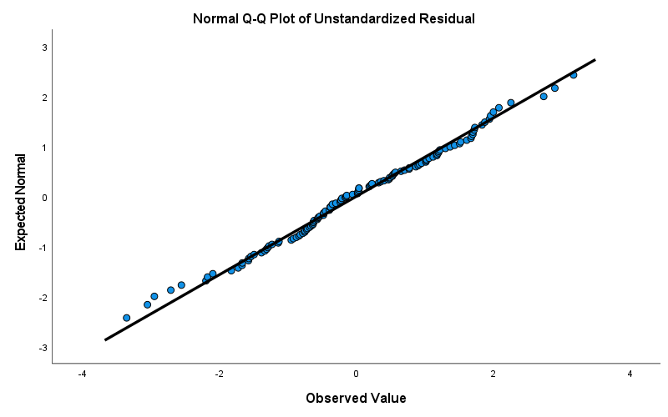
(b) Main Text Regression Predicting T3 PTSD Symptoms:
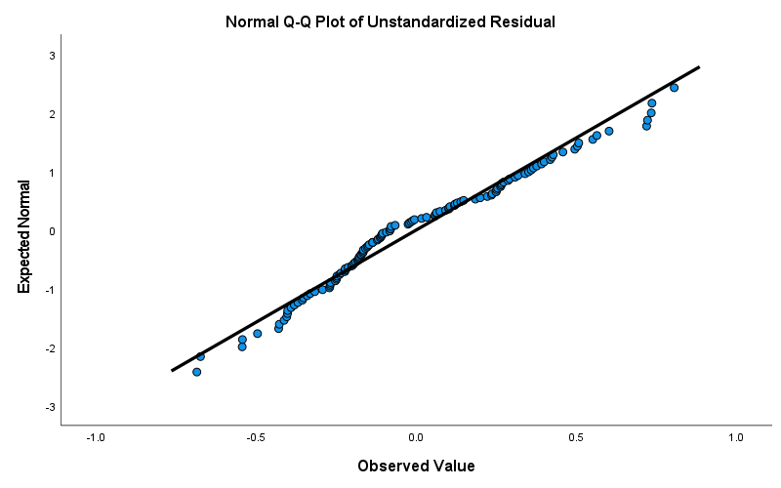
(c) Longitudinal Regression Predicting T3 Covid Impact:
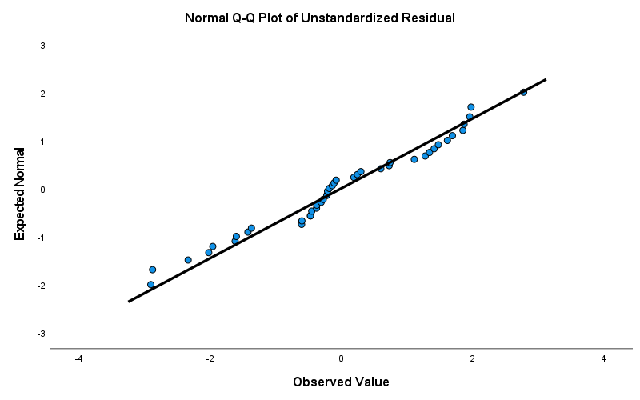
(d) Longitudinal Regression Predicting T3 PTSD Symptoms (CSPA CTQ as a Predictor):
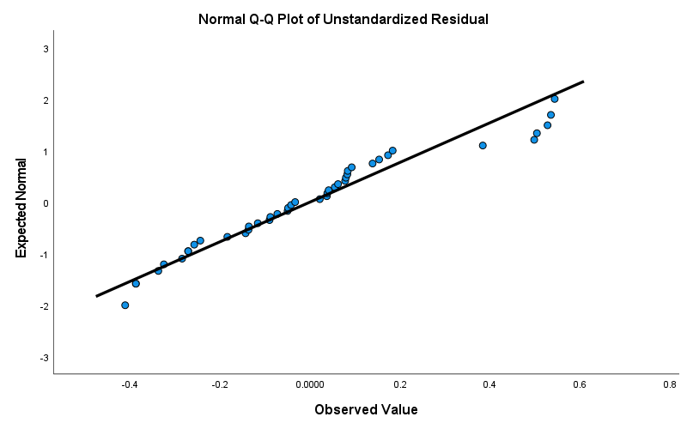
(e) Longitudinal Regression Predicting T3 PTSD Symptoms, Controlling for T2 PTSD Symptoms (T2 Cumulative Child Abuse as a Predictor):
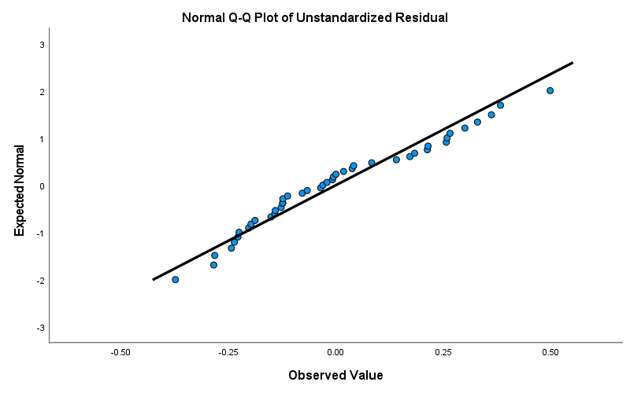
(f) Longitudinal Regression Predicting T3 PTSD Symptoms Controlling for T2 PTSD Symptoms (T3 Cumulative Child Abuse as a Predictor):
