Supplementary Table 1
Sociodemographic characteristics of the sample (N = 1,092).
 | N | %
Sex
Male | 533 | 48.8%
Female | 559 | 51.2%
Age
18-24 | 118 | 10.8%
25-34 | 208 | 29.9%
35-44 | 231 | 51.0%
45-54 | 174 | 15.9%
55-64 | 218 | 20.0%
65+ | 143 | 13.1%
Ethnicity
Irish | 826 | 75.6%
Non-Irish | 266 | 24.4%
Urbanicity
Rural, suburb, town | 780 | 71.4%
City | 312 | 28.6%
Education
No post-secondary education | 306 | 28.0%
Post-secondary education | 786 | 72.0%
Religion
Atheist or Agnostic | 236 | 21.6%
Theist | 770 | 70.6%
Other | 86 | 7.9%
Relationship status
In a committed relationship | 188 | 17.2%
Married | 548 | 50.2%
Single | 261 | 23.9%
Separated/divorced | 74 | 6.8%
Widowed | 21 | 1.9%
Living alone
No | 920 | 84.2%
Yes | 172 | 15.8%
Do you have children?
No | 430 | 39.4%
Yes | 662 | 60.6%
Employment status
Currently unemployed | 286 | 26.2%
Currently employed | 806 | 73.8%
Income level
€0 – 20,000 | 367 | 33.6%
€20,000 – 29,999 | 211 | 19.3%
€30,000 – 39,999 | 216 | 19.8%
€40,000 – 49,999 | 133 | 12.2%
€50,000 or more | 165 | 15.1%

Supplementary Figure 1
Latent class profile for female and male survivors of IPV
Females
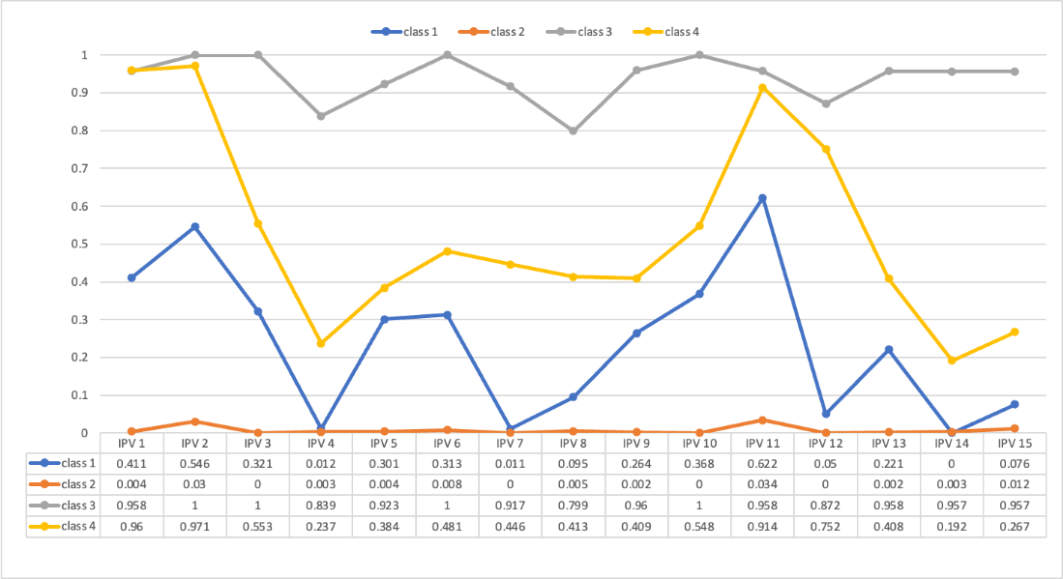
Males
