Supplemental Material

Perceived Safey Items
My neighborhood is well lit at night
I see and speak to other people when I am walking in my neighborhood
There is a high crime rate in my neighborhood
The crime rate in my neighborhood makes it unsafe to go on walks during the day
The crime rate in my neighborhood makes it unsafe to go on walks at night
Walkers and bikers on the streets in my neighborhood can be easily seen by people in their homes
Table S1. Perceived safety items
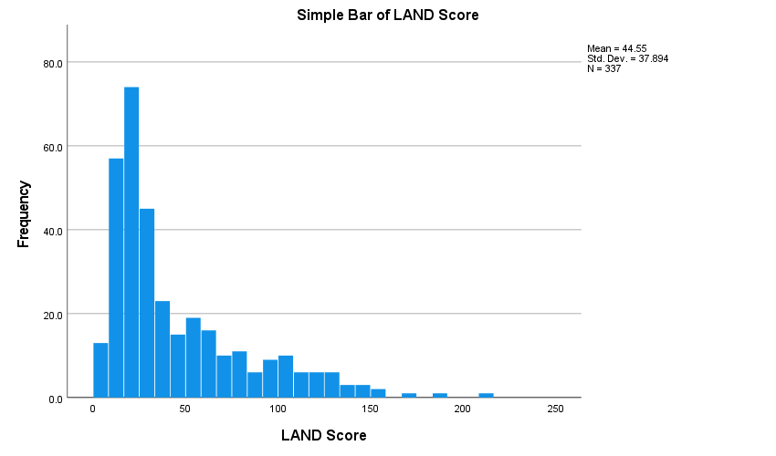

Figure S1. Histogram of the LAND physical neighborhood disorder score

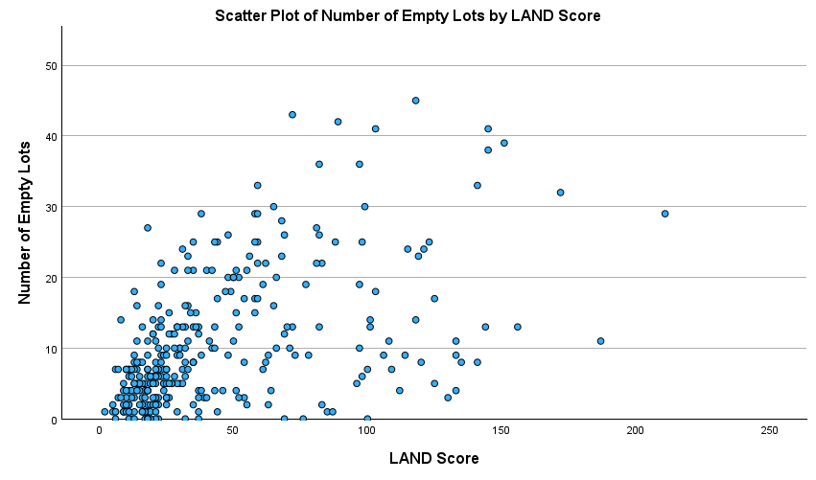

Figure S2. Scatterplot between number of empty lots and LAND score

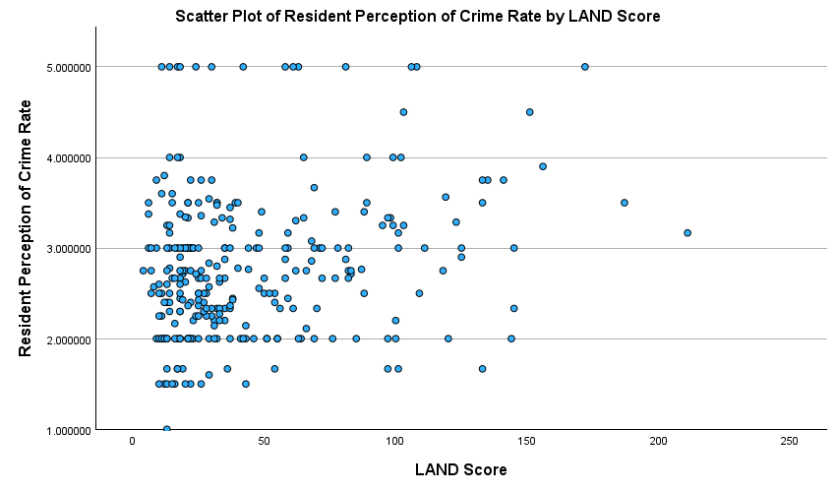

Figure S3. Scatterplot of LAND score and resident perceived crime rate

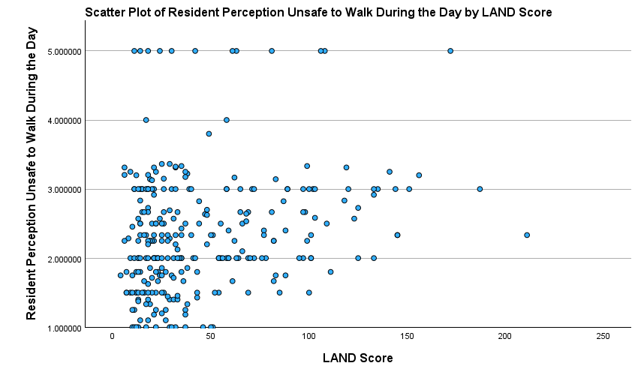

Figure S4. Scatterplot of LAND score and resident perception of unsafe to walk during the day

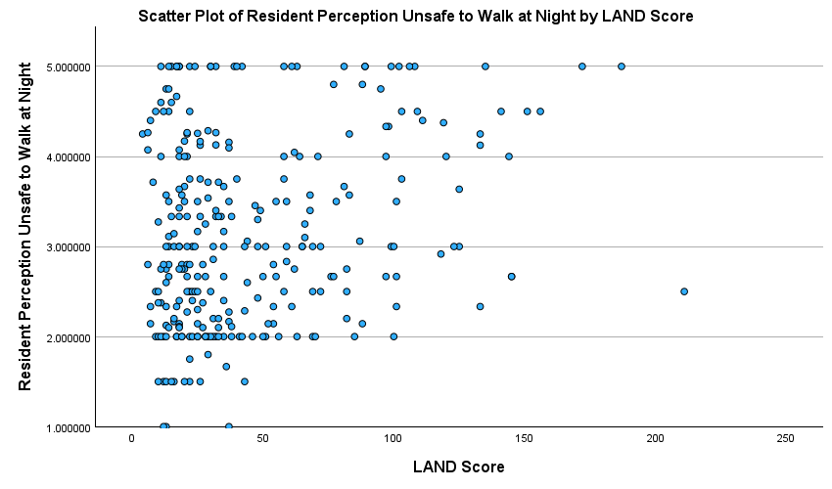

Figure S5. Scatterplot of LAND score and resident perception of unsafe to walk at night

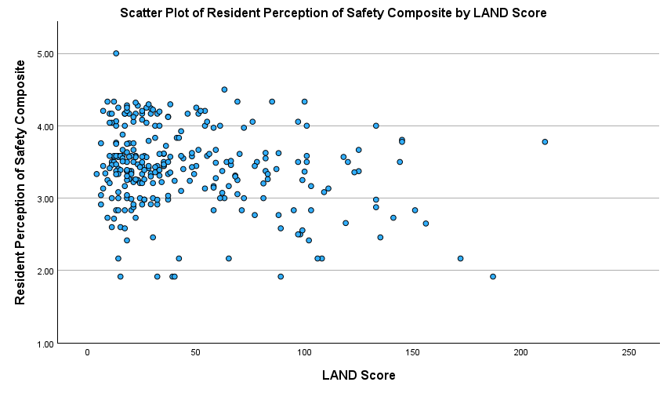

Figure S6. Scatterplot of LAND score and resident perception of safety average composite

Neighborhood Disorder Coding Form

Start of Block: Street Segment

Q1.1 Please refer to the coding manual for how to answer specific questions.

Q1.2 Coder NetID
-Selected from dropdown menu. Menu BLINDED for review.

Q1.3 Road ID (Add a .1 if you are coding the odd number block face, and .2 if you are coding the even number block face)
________________________________________________________________

Q1.4 Road Name
________________________________________________________________

Q1.5 Can you code this side of the street? (e.g., its not a highway)
- Yes (1)
- No (2)

Skip To: Q1.7 If Can you code this side of the street? (e.g., its not a highway) = Yes

Q1.6 If no, please describe (e.g., highway).
________________________________________________________________
________________________________________________________________
________________________________________________________________
________________________________________________________________
________________________________________________________________

Skip To: End of Survey If Condition: If no, please describe (e.g... Is Displayed. Skip To: End of Survey.

Q1.7 What is the street's resolution quality? (i.e., number of clicks to blurry image)
________________________________________________________________

Q1.8 What is the date (mm/yyyy) of image capture for the street you are currently coding?
________________________________________________________________

Q1.9 Is historical data present?
- Yes (1)
- No (2)

Skip To: Q1.12 If Is historical data present? = No

Q1.10 What is the first (the oldest) available year (yyyy)?
________________________________________________________________

Q1.11 What is the last (most recent) available year (yyyy)?
________________________________________________________________

Q1.12 Latitude of the first lot coded on this street
________________________________________________________________

Q1.13 Longitude of the first lot coded on this street
________________________________________________________________

Q1.14 Are there more than 35 lots on this block face? (Note: If there are more than 35 lots, stop coding and contact BLINDED for review)
▼ Yes (54) ... No (55)

Skip To: End of Survey If Are there more than 35 lots on this block face? (Note: If there are more than 35 lots, stop codin... = Yes
End of Block: Street Segment

Start of Block: Lot 1

Q2.1 Below you will complete questions regarding the first lot you are coding on this street.

Q2.2 What type of lot?
- Residential (1)
- Commercial (2)
- Recreational (3)
- Empty lot (e.g., no buildings, and not recreational) (4)
- Other (5)

Display This Question:
If What type of lot? = Other

Q2.3 Please describe (e.g., church, urban farm).
________________________________________________________________
________________________________________________________________
________________________________________________________________
________________________________________________________________
________________________________________________________________

Q2.4 Is 75% or more of the image obstructed?
- Yes (1)
- No (2)

Skip To: Q2.9 If Is 75% or more of the image obstructed? = Yes

Q2.5 Is there litter present?
- None to a little litter (about 0 to 5 pieces) (1)
- Some litter (about 6 to 20 pieces) (2)
- A lot of litter (over 20 pieces) (3)

Q2.6 How maintained is the lot?
- No to little deterioration (about 0 to 5 years with no maintenance) (1)
- Some deterioration (about 10 years with no maintenance) (2)
- A lot of deterioration (about 20 years with no maintenance) (3)

Q2.7 Is the lot vacant or abandoned?
- Yes (1)
- No (2)

Q2.8 Is there graffiti present?
- No graffiti (0 graffiti tags) (1)
- Some graffiti (1 to 3 graffiti tags) (2)
- A lot of graffiti (4 or more graffiti tags) (3)

Q2.9 Do you want to code another lot on this street?
- Yes (1)
- No (2)

End of Block: Lot 1

Start of Block: Lot 2

Q3.1 Below you will complete questions regarding the second lot you are coding on this street.

Q3.2 What type of lot?
- Residential (1)
- Commercial (2)
- Recreational (3)
- Empty lot (e.g., no buildings, and not recreational) (4)
- Other (5)

Display This Question:
If What type of lot? = Other

Q3.3 Please describe (e.g., church, urban farm).
________________________________________________________________
________________________________________________________________
________________________________________________________________
________________________________________________________________
________________________________________________________________

Q3.4 Is 75% or more of the image obstructed?
- Yes (1)
- No (2)

Skip To: Q3.9 If Is 75% or more of the image obstructed? = Yes

Q3.5 Is there litter present?
- None to a little litter (about 0 to 5 pieces) (1)
- Some litter (about 6 to 20 pieces) (2)
- A lot of litter (over 20 pieces) (3)

Q3.6 How maintained is the lot?
- No to little deterioration (about 0 to 5 years with no maintenance) (1)
- Some deterioration (about 10 years with no maintenance) (2)
- A lot of deterioration (over 20 years with no maintenance) (3)

Q3.7 Is the lot vacant or abandoned?
- Yes (1)
- No (2)

Q3.8 Is there graffiti present?
- No graffiti (0 graffiti tags) (1)
- Some graffiti (1 to 3 graffiti tags) (2)
- A lot of graffiti (4 or more graffiti tags) (3)

Q3.9 Do you want to code another lot on this street?
- Yes (1)
- No (2)

End of Block: Lot 2

Start of Block: Lot 3

Q4.1 Below you will complete questions regarding the third lot you are coding on this street.

Q4.2 What type of lot?
- Residential (1)
- Commercial (2)
- Recreational (3)
- Empty lot (e.g., no buildings, and not recreational) (4)
- Other (5)

Display This Question:
If What type of lot? = Other

Q4.3 Please describe (e.g., church, urban farm).
________________________________________________________________
________________________________________________________________
________________________________________________________________
________________________________________________________________
________________________________________________________________

Q4.4 Is 75% or more of the image obstructed?
- Yes (1)
- No (2)

Skip To: Q4.9 If Is 75% or more of the image obstructed? = Yes

Q4.5 Is there litter present?
- None to a little litter (about 0 to 5 pieces) (1)
- Some litter (about 6 to 20 pieces) (2)
- A lot of litter (over 20 pieces) (3)

Q4.6 How maintained is the lot?
- No to little deterioration (about 0 to 5 years with no maintenance) (1)
- Some deterioration (about 10 years with no maintenance) (2)
- A lot of deterioration (over 20 years with no maintenance) (3)

Q4.7 Is the lot vacant or abandoned?
- Yes (1)
- No (2)

Q4.8 Is there graffiti present?
- No graffiti (0 graffiti tags) (1)
- Some graffiti (1 to 3 graffiti tags) (2)
- A lot of graffiti (4 or more graffiti tags) (3)

Q4.9 Do you want to code another lot on this street?
- Yes (1)
- No (2)

End of Block: Lot 3

Start of Block: Lot 4

Q5.1 Below you will complete questions regarding the fourth lot you are coding on this street.

Q5.2 What type of lot?
- Residential (1)
- Commercial (2)
- Recreational (3)
- Empty lot (e.g., no buildings, and not recreational) (4)
- Other (5)

Display This Question:
If What type of lot? = Other

Q5.3 Please describe (e.g., church, urban farm).
________________________________________________________________
________________________________________________________________
________________________________________________________________
________________________________________________________________
________________________________________________________________

Q5.4 Is 75% or more of the image obstructed?
- Yes (1)
- No (2)

Skip To: Q5.9 If Is 75% or more of the image obstructed? = Yes

Q5.5 Is there litter present?
- None to a little litter (about 0 to 5 pieces) (1)
- Some litter (about 6 to 20 pieces) (2)
- A lot of litter (over 20 pieces) (3)

Q5.6 How maintained is the lot?
- No to little deterioration (about 0 to 5 years with no maintenance) (1)
- Some deterioration (about 10 years with no maintenance) (2)
- A lot of deterioration (over 20 years with no maintenance) (3)

Q5.7 Is the lot vacant or abandoned?
- Yes (1)
- No (2)

Q5.8 Is there graffiti present?
- No graffiti (0 graffiti tags) (1)
- Some graffiti (1 to 3 graffiti tags) (2)
- A lot of graffiti (4 or more graffiti tags) (3)

Q5.9 Do you want to code another lot on this street?
- Yes (1)
- No (2)

End of Block: Lot 4

Start of Block: Lot 5

Q6.1 Below you will complete questions regarding the fifth lot you are coding on this street.

Q6.2 What type of lot?
- Residential (1)
- Commercial (2)
- Recreational (3)
- Empty lot (e.g., no buildings, and not recreational) (4)
- Other (5)

Display This Question:
If What type of lot? = Other

Q6.3 Please describe (e.g., church, urban farm).
________________________________________________________________
________________________________________________________________
________________________________________________________________
________________________________________________________________
________________________________________________________________

Q6.4 Is 75% or more of the image obstructed?
- Yes (1)
- No (2)

Skip To: Q6.9 If Is 75% or more of the image obstructed? = Yes

Q6.5 Is there litter present?
- None to a little litter (about 0 to 5 pieces) (1)
- Some litter (about 6 to 20 pieces) (2)
- A lot of litter (over 20 pieces) (3)

Q6.6 How maintained is the lot?
- No to little deterioration (about 0 to 5 years with no maintenance) (1)
- Some deterioration (about 10 years with no maintenance) (2)
- A lot of deterioration (over 20 years with no maintenance) (3)

Q6.7 Is the lot vacant or abandoned?
- Yes (1)
- No (2)

Q6.8 Is there graffiti present?
- No graffiti (0 graffiti tags) (1)
- Some graffiti (1 to 3 graffiti tags) (2)
- A lot of graffiti (4 or more graffiti tags) (3)

Q6.9 Do you want to code another lot on this street?
- Yes (1)
- No (2)

End of Block: Lot 5

Start of Block: Lot 6

Q7.1 Below you will complete questions regarding the sixth lot you are coding on this street.

Q7.2 What type of lot?
- Residential (1)
- Commercial (2)
- Recreational (3)
- Empty lot (e.g., no buildings, and not recreational) (4)
- Other (5)

Display This Question:
If What type of lot? = Other

Q7.3 Please describe (e.g., church, urban farm).
________________________________________________________________
________________________________________________________________
________________________________________________________________
________________________________________________________________
________________________________________________________________

Q7.4 Is 75% or more of the image obstructed?
- Yes (1)
- No (2)

Skip To: Q7.9 If Is 75% or more of the image obstructed? = Yes

Q7.5 Is there litter present?
- None to a little litter (about 0 to 5 pieces) (1)
- Some litter (about 6 to 20 pieces) (2)
- A lot of litter (over 20 pieces) (3)

Q7.6 How maintained is the lot?
- No to little deterioration (about 0 to 5 years with no maintenance) (1)
- Some deterioration (about 10 years with no maintenance) (2)
- A lot of deterioration (over 20 years with no maintenance) (3)

Q7.7 Is the lot vacant or abandoned?
- Yes (1)
- No (2)

Q7.8 Is there graffiti present?
- No graffiti (0 graffiti tags) (1)
- Some graffiti (1 to 3 graffiti tags) (2)
- A lot of graffiti (4 or more graffiti tags) (3)

Q7.9 Do you want to code another lot on this street?
- Yes (1)
- No (2)

End of Block: Lot 6

Start of Block: Lot 7

Q8.1 Below you will complete questions regarding the seventh lot you are coding on this street.

Q8.2 What type of lot?
- Residential (1)
- Commercial (2)
- Recreational (3)
- Empty lot (e.g., no buildings, and not recreational) (4)
- Other (5)

Display This Question:
If What type of lot? = Other

Q8.3 Please describe (e.g., church, urban farm).
________________________________________________________________
________________________________________________________________
________________________________________________________________
________________________________________________________________
________________________________________________________________

Q8.4 Is 75% or more of the image obstructed?
- Yes (1)
- No (2)

Skip To: Q8.9 If Is 75% or more of the image obstructed? = Yes

Q8.5 Is there litter present?
- None to a little litter (about 0 to 5 pieces) (1)
- Some litter (about 6 to 20 pieces) (2)
- A lot of litter (over 20 pieces) (3)

Q8.6 How maintained is the lot?
- No to little deterioration (about 0 - 5 years with no maintenance) (1)
- Some deterioration (about 10 years with no maintenance) (2)
- A lot of deterioration (over 20 years with no maintenance) (3)

Q8.7 Is the lot vacant or abandoned?
- Yes (1)
- No (2)

Q8.8 Is there graffiti present?
- No graffiti (0 graffiti tags) (1)
- Some graffiti (1 to 3 graffiti tags) (2)
- A lot of graffiti (4 or more graffiti tags) (3)

Q8.9 Do you want to code another lot on this street?
- Yes (1)
- No (2)

End of Block: Lot 7

Start of Block: Lot 8

Q9.1 Below you will complete questions regarding the eighth lot you are coding on this street.

Q9.2 What type of lot?
- Residential (1)
- Commercial (2)
- Recreational (3)
- Empty lot (e.g., no buildings, and not recreational) (4)
- Other (5)

Display This Question:
If What type of lot? = Other

Q9.3 Please describe (e.g., church, urban farm).
________________________________________________________________
________________________________________________________________
________________________________________________________________
________________________________________________________________
________________________________________________________________

Q9.4 Is 75% or more of the image obstructed?
- Yes (1)
- No (2)

Skip To: Q9.9 If Is 75% or more of the image obstructed? = Yes

Q9.5 Is there litter present?
- None to a little litter (about 0 to 5 pieces) (1)
- Some litter (about 6 to 20 pieces) (2)
- A lot of litter (over 20 pieces) (3)

Q9.6 How maintained is the lot?
- No to little deterioration (about 0 to 5 years with no maintenance) (1)
- Some deterioration (about 10 years with no maintenance) (2)
- A lot of deterioration (over 20 years with no maintenance) (3)

Q9.7 Is the lot vacant or abandoned?
- Yes (1)
- No (2)

Q9.8 Is there graffiti present?
- No graffiti (0 graffiti tags) (1)
- Some graffiti (1 to 3 graffiti tags) (2)
- A lot of graffiti (4 or more graffiti tags) (3)

Q9.9 Do you want to code another lot on this street?
- Yes (1)
- No (2)

End of Block: Lot 8

Start of Block: Lot 9

Q10.1 Below you will complete questions regarding the ninth lot you are coding on this street.

Q10.2 What type of lot?
- Residential (1)
- Commercial (2)
- Recreational (3)
- Empty lot (e.g., no buildings, and not recreational) (4)
- Other (5)

Display This Question:
If What type of lot? = Other

Q10.3 Please describe (e.g., church, urban farm).
________________________________________________________________
________________________________________________________________
________________________________________________________________
________________________________________________________________
________________________________________________________________

Q10.4 Is 75% or more of the image obstructed?
- Yes (1)
- No (2)

Skip To: Q10.9 If Is 75% or more of the image obstructed? = Yes

Q10.5 Is there litter present?
- None to a little litter (about 0 to 5 pieces) (1)
- Some litter (about 6 to 20 pieces) (2)
- A lot of litter (over 20 pieces) (3)

Q10.6 How maintained is the lot?
- No to little deterioration (about 0 to 5 years with no maintenance) (1)
- Some deterioration (about 10 years with no maintenance) (2)
- A lot of deterioration (over 20 years with no maintenance) (3)

Q10.7 Is the lot vacant or abandoned?
- Yes (1)
- No (2)

Q10.8 Is there graffiti present?
- No graffiti (0 graffiti tags) (1)
- Some graffiti (1 to 3 graffiti tags) (2)
- A lot of graffiti (4 or more graffiti tags) (3)

Q10.9 Do you want to code another lot on this street?
- Yes (1)
- No (2)

End of Block: Lot 9

Start of Block: Lot 10

Q11.1 Below you will complete questions regarding the tenth lot you are coding on this street.

Q11.2 What type of lot?
- Residential (1)
- Commercial (2)
- Recreational (3)
- Empty lot (e.g., no buildings, and not recreational) (4)
- Other (5)

Display This Question:
If What type of lot? = Other

Q11.3 Please describe (e.g., church, urban farm).
________________________________________________________________
________________________________________________________________
________________________________________________________________
________________________________________________________________
________________________________________________________________

Q11.4 Is 75% or more of the image obstructed?
- Yes (1)
- No (2)

Skip To: Q11.9 If Is 75% or more of the image obstructed? = Yes

Q11.5 Is there litter present?
- None to a little litter (about 0 to 5 pieces) (1)
- Some litter (about 6 to 20 pieces) (2)
- A lot of litter (over 20 pieces) (3)

Q11.6 How maintained is the lot?
- No to little deterioration (about 0 to 5 years with no maintenance) (1)
- Some deterioration (about 10 years with no maintenance) (2)
- A lot of deterioration (over 20 years with no maintenance) (3)

Q11.7 Is the lot vacant or abandoned?
- Yes (1)
- No (2)

Q11.8 Is there graffiti present?
- No graffiti (0 graffiti tags) (1)
- Some graffiti (1 to 3 graffiti tags) (2)
- A lot of graffiti (4 or more graffiti tags) (3)

Q11.9 Do you want to code another lot on this street?
- Yes (1)
- No (2)

End of Block: Lot 10

Start of Block: Lot 11

Q12.1 Below you will complete questions regarding the eleventh lot you are coding on this street.

Q12.2 What type of lot?
- Residential (1)
- Commercial (2)
- Recreational (3)
- Empty lot (e.g., no buildings, and not recreational) (4)
- Other (5)

Display This Question:
If What type of lot? = Other

Q12.3 Please describe (e.g., church, urban farm).
________________________________________________________________
________________________________________________________________
________________________________________________________________
________________________________________________________________
________________________________________________________________

Q12.4 Is 75% or more of the image obstructed?
- Yes (1)
- No (2)

Skip To: Q12.9 If Is 75% or more of the image obstructed? = Yes

Q12.5 Is there litter present?
- None to a little litter (about 0 to 5 pieces) (1)
- Some litter (about 6 to 20 pieces) (2)
- A lot of litter (over 20 pieces) (3)

Q12.6 How maintained is the lot?
- No to little deterioration (about 0 to 5 years with no maintenance) (1)
- Some deterioration (about 10 years with no maintenance) (2)
- A lot of deterioration (over 20 years with no maintenance) (3)

Q12.7 Is the lot vacant or abandoned?
- Yes (1)
- No (2)

Q12.8 Is there graffiti present?
- No graffiti (0 graffiti tags) (1)
- Some graffiti (1 to 3 graffiti tags) (2)
- A lot of graffiti (4 or more graffiti tags) (3)

Q12.9 Do you want to code another lot on this street?
- Yes (1)
- No (2)

End of Block: Lot 11

Start of Block: Lot 12

Q13.1 Below you will complete questions regarding the twelfth lot you are coding on this street.

Q13.2 What type of lot?
- Residential (1)
- Commercial (2)
- Recreational (3)
- Empty lot (e.g., no buildings, and not recreational) (4)
- Other (5)

Display This Question:
If What type of lot? = Other

Q13.3 Please describe (e.g., church, urban farm).
________________________________________________________________
________________________________________________________________
________________________________________________________________
________________________________________________________________
________________________________________________________________

Q13.4 Is 75% or more of the image obstructed?
- Yes (1)
- No (2)

Skip To: Q13.9 If Is 75% or more of the image obstructed? = Yes

Q13.5 Is there litter present?
- None to a little litter (about 0 to 5 pieces) (1)
- Some litter (about 6 to 20 pieces) (2)
- A lot of litter (over 20 pieces) (3)

Q13.6 How maintained is the lot?
- No to little deterioration (about 0 to 5 years with no maintenance) (1)
- Some deterioration (about 10 years with no maintenance) (2)
- A lot of deterioration (over 20 years with no maintenance) (3)

Q13.7 Is the lot vacant or abandoned?
- Yes (1)
- No (2)

Q13.8 Is there graffiti present?
- No graffiti (0 graffiti tags) (1)
- Some graffiti (1 to 3 graffiti tags) (2)
- A lot of graffiti (4 or more graffiti tags) (3)

Q13.9 Do you want to code another lot on this street?
- Yes (1)
- No (2)

End of Block: Lot 12

Start of Block: Lot 13

Q14.1 Below you will complete questions regarding the thirteenth lot you are coding on this street.

Q14.2 What type of lot?
- Residential (1)
- Commercial (2)
- Recreational (3)
- Empty lot (e.g., no buildings, and not recreational) (4)
- Other (5)

Display This Question:
If What type of lot? = Other

Q14.3 Please describe (e.g., church, urban farm).
________________________________________________________________
________________________________________________________________
________________________________________________________________
________________________________________________________________
________________________________________________________________

Q14.4 Is 75% or more of the image obstructed?
- Yes (1)
- No (2)

Skip To: Q14.9 If Is 75% or more of the image obstructed? = Yes

Q14.5 Is there litter present?
- None to a little litter (about 0 to 5 pieces) (1)
- Some litter (about 6 to 20 pieces) (2)
- A lot of litter (over 20 pieces) (3)

Q14.6 How maintained is the lot?
- No to little deterioration (about 0 to 5 years with no maintenance) (1)
- Some deterioration (about 10 years with no maintenance) (2)
- A lot of deterioration (over 20 years with no maintenance) (3)

Q14.7 Is the lot vacant or abandoned?
- Yes (1)
- No (2)

Q14.8 Is there graffiti present?
- No graffiti (0 graffiti tags) (1)
- Some graffiti (1 to 3 graffiti tags) (2)
- A lot of graffiti (4 or more graffiti tags) (3)

Q14.9 Do you want to code another lot on this street?
- Yes (1)
- No (2)

End of Block: Lot 13

Start of Block: Lot 14

Q15.1 Below you will complete questions regarding the fourteenth lot you are coding on this street.

Q15.2 What type of lot?
- Residential (1)
- Commercial (2)
- Recreational (3)
- Empty lot (e.g., no buildings, and not recreational) (4)
- Other (5)

Display This Question:
If What type of lot? = Other

Q15.3 Please describe (e.g., church, urban farm).
________________________________________________________________
________________________________________________________________
________________________________________________________________
________________________________________________________________
________________________________________________________________

Q15.4 Is 75% or more of the image obstructed?
- Yes (1)
- No (2)

Skip To: Q15.9 If Is 75% or more of the image obstructed? = Yes

Q15.5 Is there litter present?
- None to a little litter (about 0 to 5 pieces) (1)
- Some litter (about 6 to 20 pieces) (2)
- A lot of litter (over 20 pieces) (3)

Q15.6 How maintained is the lot?
- No to little deterioration (about 0 to 5 years with no maintenance) (1)
- Some deterioration (about 10 years with no maintenance) (2)
- A lot of deterioration (over 20 years with no maintenance) (3)

Q15.7 Is the lot vacant or abandoned?
- Yes (1)
- No (2)

Q15.8 Is there graffiti present?
- No graffiti (0 graffiti tags) (1)
- Some graffiti (1 to 3 graffiti tags) (2)
- A lot of graffiti (4 or more graffiti tags) (3)

Q15.9 Do you want to code another lot on this street?
- Yes (1)
- No (2)

End of Block: Lot 14

Start of Block: Lot 15

Q16.1 Below you will complete questions regarding the fifteenth lot you are coding on this street.

Q16.2 What type of lot?
- Residential (1)
- Commercial (2)
- Recreational (3)
- Empty lot (e.g., no buildings, and not recreational) (4)
- Other (5)

Display This Question:
If What type of lot? = Other

Q16.3 Please describe (e.g., church, urban farm).
________________________________________________________________
________________________________________________________________
________________________________________________________________
________________________________________________________________
________________________________________________________________

Q16.4 Is 75% or more of the image obstructed?
- Yes (1)
- No (2)

Skip To: Q16.9 If Is 75% or more of the image obstructed? = Yes

Q16.5 Is there litter present?
- None to a little litter (about 0 to 5 pieces) (1)
- Some litter (about 6 to 20 pieces) (2)
- A lot of litter (over 20 pieces) (3)

Q16.6 How maintained is the lot?
- No to little deterioration (about 0 to 5 years with no maintenance) (1)
- Some deterioration (about 10 years with no maintenance) (2)
- A lot of deterioration (over 20 years with no maintenance) (3)

Q16.7 Is the lot vacant or abandoned?
- Yes (1)
- No (2)

Q16.8 Is there graffiti present?
- No graffiti (0 graffiti tags) (1)
- Some graffiti (1 to 3 graffiti tags) (2)
- A lot of graffiti (4 or more graffiti tags) (3)

Q16.9 Do you want to code another lot on this street?
- Yes (1)
- No (2)

End of Block: Lot 15

Start of Block: Lot 16

Q17.1 Below you will complete questions regarding the sixteenth lot you are coding on this street.

Q17.2 What type of lot?
- Residential (1)
- Commercial (2)
- Recreational (3)
- Empty lot (e.g., no buildings, and not recreational) (4)
- Other (5)

Display This Question:
If What type of lot? = Other

Q17.3 Please describe (e.g., church, urban farm).
________________________________________________________________
________________________________________________________________
________________________________________________________________
________________________________________________________________
________________________________________________________________

Q17.4 Is 75% or more of the image obstructed?
- Yes (1)
- No (2)

Skip To: Q17.9 If Is 75% or more of the image obstructed? = Yes

Q17.5 Is there litter present?
- None to a little litter (about 0 to 5 pieces) (1)
- Some litter (about 6 to 20 pieces) (2)
- A lot of litter (over 20 pieces) (3)

Q17.6 How maintained is the lot?
- No to little deterioration (about 0 to 5 years with no maintenance) (1)
- Some deterioration (about 10 years with no maintenance) (2)
- A lot of deterioration (over 20 years with no maintenance) (3)

Q17.7 Is the lot vacant or abandoned?
- Yes (1)
- No (2)

Q17.8 Is there graffiti present?
- No graffiti (0 graffiti tags) (1)
- Some graffiti (1 to 3 graffiti tags) (2)
- A lot of graffiti (4 or more graffiti tags) (3)

Q17.9 Do you want to code another lot on this street?
- Yes (1)
- No (2)

End of Block: Lot 16

Start of Block: Lot 17

Q18.1 Below you will complete questions regarding the seventeenth lot you are coding on this street.

Q18.2 What type of lot?
- Residential (1)
- Commercial (2)
- Recreational (3)
- Empty lot (e.g., no buildings, and not recreational) (4)
- Other (5)

Display This Question:
If What type of lot? = Other

Q18.3
Please describe (e.g., church, urban farm).
________________________________________________________________
________________________________________________________________
________________________________________________________________
________________________________________________________________
________________________________________________________________

Q18.4 Is 75% or more of the image obstructed?
- Yes (1)
- No (2)

Skip To: Q18.9 If Is 75% or more of the image obstructed? = Yes

Q18.5 Is there litter present?
- None to a little litter (about 0 to 5 pieces) (1)
- Some litter ( about 6 to 20 pieces) (2)
- A lot of litter (over 20 pieces) (3)

Q18.6 How maintained is the lot?
- No to little deterioration (about 0 to 5 years with no maintenance) (1)
- Some deterioration (about 10 years with no maintenance) (2)
- A lot of deterioration (over 20 years with no maintenance) (3)

Q18.7 Is the lot vacant or abandoned?
- Yes (1)
- No (2)

Q18.8 Is there graffiti present?
- No graffiti (0 graffiti tags) (1)
- Some graffiti (1 to 3 graffiti tags) (2)
- A lot of graffiti (4 or more graffiti tags) (3)

Q18.9 Do you want to code another lot on this street?
- Yes (1)
- No (2)

End of Block: Lot 17

Start of Block: Lot 18

Q19.1 Below you will complete questions regarding the eighteenth lot you are coding on this street.

Q19.2 What type of lot?
- Residential (1)
- Commercial (2)
- Recreational (3)
- Empty lot (e.g., no buildings, and not recreational) (4)
- Other (5)

Display This Question:
If What type of lot? = Other

Q19.3 Please describe (e.g., church, urban farm).
________________________________________________________________
________________________________________________________________
________________________________________________________________
________________________________________________________________
________________________________________________________________

Q19.4 Is 75% or more of the image obstructed?
- Yes (1)
- No (2)

Skip To: Q19.9 If Is 75% or more of the image obstructed? = Yes

Q19.5 Is there litter present?
- None to a little litter (about 0 to 5 pieces) (1)
- Some litter (about 6 to 20 pieces) (2)
- A lot of litter (over 20 pieces) (3)

Q19.6 How maintained is the lot?
- No to little deterioration (about 0 to 5 years with no maintenance) (1)
- Some deterioration (about 10 years with no maintenance) (2)
- A lot of deterioration (over 20 years with no maintenance) (3)

Q19.7 Is the lot vacant or abandoned?
- Yes (1)
- No (2)

Q19.8 Is there graffiti present?
- No graffiti (0 graffiti tags) (1)
- Some graffiti (1 to 3 graffiti tags) (2)
- A lot of graffiti (4 or more graffiti tags) (3)

Q19.9 Do you want to code another lot on this street?
- Yes (1)
- No (2)

End of Block: Lot 18

Start of Block: Lot 19

Q20.1 Below you will complete questions regarding the nineteenth lot you are coding on this street.

Q20.2 What type of lot?
- Residential (1)
- Commercial (2)
- Recreational (3)
- Empty lot (e.g., no buildings, and not recreational) (4)
- Other (5)

Display This Question:
If What type of lot? = Other

Q20.3 Please describe (e.g., church, urban farm)
________________________________________________________________
________________________________________________________________
________________________________________________________________
________________________________________________________________
________________________________________________________________

Q20.4 Is 75% or more of the image obstructed?
- Yes (1)
- No (2)

Skip To: Q20.9 If Is 75% or more of the image obstructed? = Yes

Q20.5 Is there litter present?
- None to a little litter (about 0 to 5 pieces) (1)
- Some litter (about 6 to 20 pieces) (2)
- A lot of litter (over 20 pieces) (3)

Q20.6 How maintained is the lot?
- No to little deterioration (about 0 to 5 years with no maintenance) (1)
- Some deterioration (about 10 years with no maintenance) (2)
- A lot of deterioration (over 20 years with no maintenance) (3)

Q20.7 Is the lot vacant or abandoned?
- Yes (1)
- No (2)

Q20.8 Is there graffiti present?
- No graffiti (0 graffiti tags) (1)
- Some graffiti (1 to 3 graffiti tags) (2)
- A lot of graffiti (4 or more graffiti tags) (3)

Q20.9 Do you want to code another lot on this street?
- Yes (1)
- No (2)

End of Block: Lot 19

Start of Block: Lot 20

Q21.1 Below you will complete questions regarding the twentieth lot you are coding on this street.

Q21.2 What type of lot?
- Residential (1)
- Commercial (2)
- Recreational (3)
- Empty lot (e.g., no buildings, and not recreational) (4)
- Other (5)

Display This Question:
If What type of lot? = Other

Q21.3 Please describe (e.g., church, urban farm)
________________________________________________________________
________________________________________________________________
________________________________________________________________
________________________________________________________________
________________________________________________________________

Q21.4 Is 75% or more of the image obstructed?
- Yes (1)
- No (2)

Skip To: Q21.9 If Is 75% or more of the image obstructed? = Yes

Q21.5 Is there litter present?
- None to a little litter (about 0 to 5 pieces) (1)
- Some litter (about 6 to 20 pieces) (2)
- A lot of litter (over 20 pieces) (3)

Q21.6 How maintained is the lot?
- No to little deterioration (about 0 to 5 years with no maintenance) (1)
- Some deterioration (about 10 years with no maintenance) (2)
- A lot of deterioration (over 20 years with no maintenance) (3)

Q21.7 Is the lot vacant or abandoned?
- Yes (1)
- No (2)

Q21.8 Is there graffiti present?
- No graffiti (0 graffiti tags) (1)
- Some graffiti (1 to 3 graffiti tags) (2)
- A lot of graffiti (4 or more graffiti tags) (3)

Q21.9 Do you want to code another lot on this street?
- Yes (1)
- No (2)

End of Block: Lot 20

Start of Block: Lot 21

Q22.1 Below you will complete questions regarding the twenty-first lot you are coding on this street.

Q22.2 What type of lot?
- Residential (1)
- Commercial (2)
- Recreational (3)
- Empty lot (e.g., no buildings, and not recreational) (4)
- Other (5)

Display This Question:
If What type of lot? = Other

Q22.3 Please describe (e.g., church, urban farm)
________________________________________________________________
________________________________________________________________
________________________________________________________________
________________________________________________________________
________________________________________________________________

Q22.4 Is 75% or more of the image obstructed?
- Yes (1)
- No (2)

Skip To: Q22.9 If Is 75% or more of the image obstructed? = Yes

Q22.5 Is there litter present?
- None to a little litter (about 0 to 5 pieces) (1)
- Some litter (about 6 to 20 pieces) (2)
- A lot of litter (over 20 pieces) (3)

Q22.6 How maintained is the lot?
- No to little deterioration (about 0 to 5 years with no maintenance) (1)
- Some deterioration (about 10 years with no maintenance) (2)
- A lot of deterioration (over 20 years with no maintenance) (3)

Q22.7 Is the lot vacant or abandoned?
- Yes (1)
- No (2)

Q22.8 Is there graffiti present?
- No graffiti (0 graffiti tags) (1)
- Some graffiti (1 to 3 graffiti tags) (2)
- A lot of graffiti (4 or more graffiti tags) (3)

Q22.9 Do you want to code another lot on this street?
- Yes (1)
- No (2)

End of Block: Lot 21

Start of Block: Lot 22

Q23.1 Below you will complete questions regarding the twenty-second lot you are coding on this street.

Q23.2 What type of lot?
- Residential (1)
- Commercial (2)
- Recreational (3)
- Empty lot (e.g., no buildings, and not recreational) (4)
- Other (5)

Display This Question:
If What type of lot? = Other

Q23.3 Please describe (e.g., church, urban farm)
________________________________________________________________
________________________________________________________________
________________________________________________________________
________________________________________________________________
________________________________________________________________

Q23.4 Is 75% or more of the image obstructed?
- Yes (1)
- No (2)

Skip To: Q23.9 If Is 75% or more of the image obstructed? = Yes

Q23.5 Is there litter present?
- None to a little litter (about 0 to 5 pieces) (1)
- Some litter (about 6 to 20 pieces) (2)
- A lot of litter (over 20 pieces) (3)

Q23.6 How maintained is the lot?
- No to little deterioration (about 0 to 5 years with no maintenance) (1)
- Some deterioration (about 10 years with no maintenance) (2)
- A lot of deterioration (over 20 years with no maintenance) (3)

Q23.7 Is the lot vacant or abandoned?
- Yes (1)
- No (2)

Q23.8 Is there graffiti present?
- No graffiti (0 graffiti tags) (1)
- Some graffiti (1 to 3 graffiti tags) (2)
- A lot of graffiti (4 or more graffiti tags) (3)

Q23.9 Do you want to code another lot on this street?
- Yes (1)
- No (2)

End of Block: Lot 22

Start of Block: Lot 23

Q24.1 Below you will complete questions regarding the twenty-third lot you are coding on this street.

Q24.2 What type of lot?
- Residential (1)
- Commercial (2)
- Recreational (3)
- Empty lot (e.g., no buildings, and not recreational) (4)
- Other (5)

Display This Question:
If What type of lot? = Other

Q24.3 Please describe (e.g., church, urban farm)
________________________________________________________________
________________________________________________________________
________________________________________________________________
________________________________________________________________
________________________________________________________________

Q24.4 Is 75% or more of the image obstructed?
- Yes (1)
- No (2)

Skip To: Q24.9 If Is 75% or more of the image obstructed? = Yes

Q24.5 Is there litter present?
- None to a little litter (about 0 to 5 pieces) (1)
- Some litter (about 6 to 20 pieces) (2)
- A lot of litter (over 20 pieces) (3)

Q24.6 How maintained is the lot?
- No to little deterioration (about 0 to 5 years with no maintenance) (1)
- Some deterioration (about 10 years with no maintenance) (2)
- A lot of deterioration (over 20 years with no maintenance) (3)

Q24.7 Is the lot vacant or abandoned?
- Yes (1)
- No (2)

Q24.8 Is there graffiti present?
- No graffiti (0 graffiti tags) (1)
- Some graffiti (1 to 3 graffiti tags) (2)
- A lot of graffiti (4 or more graffiti tags) (3)

Q24.9 Do you want to code another lot on this street?
- Yes (1)
- No (2)

End of Block: Lot 23

Start of Block: Lot 24

Q25.1 Below you will complete questions regarding the twenty-fourth lot you are coding on this street.

Q25.2 What type of lot?
- Residential (1)
- Commercial (2)
- Recreational (3)
- Empty lot (e.g., no buildings, and not recreational) (4)
- Other (5)

Display This Question:
If What type of lot? = Other

Q25.3 Please describe (e.g., church, urban farm)
________________________________________________________________
________________________________________________________________
________________________________________________________________
________________________________________________________________
________________________________________________________________

Q25.4 Is 75% or more of the image obstructed?
- Yes (1)
- No (2)

Skip To: Q25.9 If Is 75% or more of the image obstructed? = Yes

Q25.5 Is there litter present?
- None to a little litter (about 0 to 5 pieces) (1)
- Some litter (about 6 to 20 pieces) (2)
- A lot of litter (over 20 pieces) (3)

Q25.6 How maintained is the lot?
- No to little deterioration (about 0 to 5 years with no maintenance) (1)
- Some deterioration (about 10 years with no maintenance) (2)
- A lot of deterioration (over 20 years with no maintenance) (3)

Q25.7 Is the lot vacant or abandoned?
- Yes (1)
- No (2)

Q25.8 Is there graffiti present?
- No graffiti (0 graffiti tags) (1)
- Some graffiti (1 to 3 graffiti tags) (2)
- A lot of graffiti (4 or more graffiti tags) (3)

Q25.9 Do you want to code another lot on this street?
- Yes (1)
- No (2)

End of Block: Lot 24

Start of Block: Lot 25

Q26.1 Below you will complete questions regarding the twenty-fifth lot you are coding on this street.

Q26.2 What type of lot?
- Residential (1)
- Commercial (2)
- Recreational (3)
- Empty lot (e.g., no buildings, and not recreational) (4)
- Other (5)

Display This Question:
If What type of lot? = Other

Q26.3 Please describe (e.g., church, urban farm)
________________________________________________________________
________________________________________________________________
________________________________________________________________
________________________________________________________________
________________________________________________________________

Q26.4 Is 75% or more of the image obstructed?
- Yes (1)
- No (2)

Skip To: Q26.9 If Is 75% or more of the image obstructed? = Yes

Q26.5 Is there litter present?
- None to a little litter (about 1 to 5 pieces) (1)
- Some litter (about 6 to 20 pieces) (2)
- A lot of litter (over 20 pieces) (3)

Q26.6 How maintained is the lot?
- No to little deterioration (about 0 to 5 years with no maintenance) (1)
- Some deterioration (about 10 years with no maintenance) (2)
- A lot of deterioration (over 20 years with no maintenance) (3)

Q26.7 Is the lot vacant or abandoned?
- Yes (1)
- No (2)

Q26.8 Is there graffiti present?
- No graffiti (0 graffiti tags) (1)
- Some graffiti (1 to 3 graffiti tags) (2)
- A lot of graffiti (4 or more graffiti tags) (3)

Q26.9 Do you want to code another lot on this street?
- Yes (1)
- No (2)

End of Block: Lot 25

Start of Block: Lot 26

Q27.1 Below you will complete questions regarding the twenty-sixth lot you are coding on this street.

Q27.2 What type of lot?
- Residential (1)
- Commercial (2)
- Recreational (3)
- Empty lot (e.g., no buildings, and not recreational) (4)
- Other (5)

Display This Question:
If What type of lot? = Other

Q27.3 Please describe (e.g., church, urban farm)
________________________________________________________________
________________________________________________________________
________________________________________________________________
________________________________________________________________
________________________________________________________________

Q27.4 Is 75% or more of the image obstructed?
- Yes (1)
- No (2)

Skip To: Q27.9 If Is 75% or more of the image obstructed? = Yes

Q27.5 Is there litter present?
- None to a little litter (about 0 to 5 pieces) (1)
- Some litter (about 6 to 20 pieces) (2)
- A lot of litter (over 20 pieces) (3)

Q27.6 How maintained is the lot?
- No to little deterioration (about 0 to 5 years with no maintenance) (1)
- Some deterioration (about 10 years with no maintenance) (2)
- A lot of deterioration (over 20 years with no maintenance) (3)

Q27.7 Is the lot vacant or abandoned?
- Yes (1)
- No (2)

Q27.8 Is there graffiti present?
- No graffiti (0 graffiti tags) (1)
- Some graffiti (1 to 3 graffiti tags) (2)
- A lot of graffiti (4 or more graffiti tags) (3)

Q27.9 Do you want to code another lot on this street?
- Yes (1)
- No (2)

End of Block: Lot 26

Start of Block: Lot 27

Q28.1 Below you will complete questions regarding the twenty-seventh lot you are coding on this street.

Q28.2 What type of lot?
- Residential (1)
- Commercial (2)
- Recreational (3)
- Empty lot (e.g., no buildings, and not recreational) (4)
- Other (5)

Display This Question:
If What type of lot? = Other

Q28.3 Please describe (e.g., church, urban farm)
________________________________________________________________
________________________________________________________________
________________________________________________________________
________________________________________________________________
________________________________________________________________

Q28.4 Is 75% or more of the image obstructed?
- Yes (1)
- No (2)

Skip To: Q28.9 If Is 75% or more of the image obstructed? = Yes

Q28.5 Is there litter present?
- None to a little litter (about 0 to 5 pieces) (1)
- Some litter (about 6 to 20 pieces) (2)
- A lot of litter (over 20 pieces) (3)

Q28.6 How maintained is the lot?
- No to little deterioration (about 0 to 5 years with no maintenance) (1)
- Some deterioration (about 10 years with no maintenance) (2)
- A lot of deterioration (over 20 years with no maintenance) (3)

Q28.7 Is the lot vacant or abandoned?
- Yes (1)
- No (2)

Q28.8 Is there graffiti present?
- No graffiti (0 graffiti tags) (1)
- Some graffiti (1 to 3 graffiti tags) (2)
- A lot of graffiti (4 or more graffiti tags) (3)

Q28.9 Do you want to code another lot on this street?
- Yes (1)
- No (2)

End of Block: Lot 27

Start of Block: Lot 28

Q29.1 Below you will complete questions regarding the twenty-eighth lot you are coding on this street.

Q29.2 What type of lot?
- Residential (1)
- Commercial (2)
- Recreational (3)
- Empty lot (e.g., no buildings, and not recreational) (4)
- Other (5)

Display This Question:
If What type of lot? = Other

Q29.3 Please describe (e.g., church, urban farm)
________________________________________________________________
________________________________________________________________
________________________________________________________________
________________________________________________________________
________________________________________________________________

Q29.4 Is 75% or more of the image obstructed?
- Yes (1)
- No (2)

Skip To: Q29.9 If Is 75% or more of the image obstructed? = Yes

Q29.5 Is there litter present?
- None to a little litter (about 0 to 5 pieces) (1)
- Some litter (about 6 to 20 pieces) (2)
- A lot of litter (over 20 pieces) (3)

Q29.6 How maintained is the lot?
- No to little deterioration (about 0 to 5 years with no maintenance) (1)
- Some deterioration (about 10 years with no maintenance) (2)
- A lot of deterioration (over 20 years with no maintenance) (3)

Q29.7 Is the lot vacant or abandoned?
- Yes (1)
- No (2)

Q29.8 Is there graffiti present?
- No graffiti (0 graffiti tags) (1)
- Some graffiti (1 to 3 graffiti tags) (2)
- A lot of graffiti (4 or more graffiti tags) (3)

Q29.9 Do you want to code another lot on this street?
- Yes (1)
- No (2)

End of Block: Lot 28

Start of Block: Lot 29

Q30.1 Below you will complete questions regarding the twenty-ninth lot you are coding on this street.

Q30.2 What type of lot?
- Residential (1)
- Commercial (2)
- Recreational (3)
- Empty lot (e.g., no buildings, and not recreational) (4)
- Other (5)

Display This Question:
If What type of lot? = Other

Q30.3 Please describe (e.g., church, urban farm)
________________________________________________________________
________________________________________________________________
________________________________________________________________
________________________________________________________________
________________________________________________________________

Q30.4 Is 75% or more of the image obstructed?
- Yes (1)
- No (2)

Skip To: Q30.9 If Is 75% or more of the image obstructed? = Yes

Q30.5 Is there litter present?
- None to a little litter (about 0 to 5 pieces) (1)
- Some litter (about 6 to 20 pieces) (2)
- A lot of litter (over 20 pieces) (3)

Q30.6 How maintained is the lot?
- No to little deterioration (about 0 to 5 years with no maintenance) (1)
- Some deterioration (about 10 years with no maintenance) (2)
- A lot of deterioration (over 20 years with no maintenance) (3)

Q30.7 Is the lot vacant or abandoned?
- Yes (1)
- No (2)

Q30.8 Is there graffiti present?
- No graffiti (0 graffiti tags) (1)
- Some graffiti (1 to 3 graffiti tags) (2)
- A lot of graffiti (4 or more graffiti tags) (3)

Q30.9 Do you want to code another lot on this street?
- Yes (1)
- No (2)

End of Block: Lot 29

Start of Block: Lot 30

Q31.1 Below you will complete questions regarding the thirtieth lot you are coding on this street.

Q31.2 What type of lot?
- Residential (1)
- Commercial (2)
- Recreational (3)
- Empty lot (e.g., no buildings, and not recreational) (4)
- Other (5)

Display This Question:
If What type of lot? = Other

Q31.3 Please describe (e.g., church, urban farm)
________________________________________________________________
________________________________________________________________
________________________________________________________________
________________________________________________________________
________________________________________________________________

Q31.4 Is 75% or more of the image obstructed?
- Yes (1)
- No (2)

Skip To: Q31.9 If Is 75% or more of the image obstructed? = Yes

Q31.5 Is there litter present?
- None to a little litter (about 0 to 5 pieces) (1)
- Some litter (about 6 to 20 pieces) (2)
- A lot of litter (over 20 pieces) (3)

Q31.6 How maintained is the lot?
- No to little deterioration (about 0 to 5 years with no maintenance) (1)
- Some deterioration (about 10 years with no maintenance) (2)
- A lot of deterioration (over 20 years with no maintenance) (3)

Q31.7 Is the lot vacant or abandoned?
- Yes (1)
- No (2)

Q31.8 Is there graffiti present?
- No graffiti (0 graffiti tags) (1)
- Some graffiti (1 to 3 graffiti tags) (2)
- A lot of graffiti (4 or more graffiti tags) (3)

Q31.9 Do you want to code another lot on this street?
- Yes (1)
- No (2)

End of Block: Lot 30

Start of Block: Lot 31

Q32.1 Below you will complete questions regarding the thirty-first lot you are coding on this street.

Q32.2 What type of lot?
- Residential (1)
- Commercial (2)
- Recreational (3)
- Empty lot (e.g., no buildings, and not recreational) (4)
- Other (5)

Display This Question:
If What type of lot? = Other

Q32.3 Please describe (e.g., church, urban farm)
________________________________________________________________
________________________________________________________________
________________________________________________________________
________________________________________________________________
________________________________________________________________

Q32.4 Is 75% or more of the image obstructed?
- Yes (1)
- No (2)

Skip To: Q32.9 If Is 75% or more of the image obstructed? = Yes

Q32.5 Is there litter present?
- None to a little litter (about 0 to 5 pieces) (1)
- Some litter (about 6 to 20 pieces) (2)
- A lot of litter (over 20 pieces) (3)

Q32.6 How maintained is the lot?
- No to little deterioration (about 0 to 5 years with no maintenance) (1)
- Some deterioration (about 10 years with no maintenance) (2)
- A lot of deterioration (over 20 years with no maintenance) (3)

Q32.7 Is the lot vacant or abandoned?
- Yes (1)
- No (2)

Q32.8 Is there graffiti present?
- No graffiti (0 graffiti tags) (1)
- Some graffiti (1 to 3 graffiti tags) (2)
- A lot of graffiti (4 or more graffiti tags) (3)

Q32.9 Do you want to code another lot on this street?
- Yes (1)
- No (2)

End of Block: Lot 31

Start of Block: Lot 32

Q33.1 Below you will complete questions regarding the thirty-second lot you are coding on this street.

Q33.2 What type of lot?
- Residential (1)
- Commercial (2)
- Recreational (3)
- Empty lot (e.g., no buildings, and not recreational) (4)
- Other (5)

Display This Question:
If What type of lot? = Other

Q33.3 Please describe (e.g., church, urban farm)
________________________________________________________________
________________________________________________________________
________________________________________________________________
________________________________________________________________
________________________________________________________________

Q33.4 Is 75% or more of the image obstructed?
- Yes (1)
- No (2)

Skip To: Q33.9 If Is 75% or more of the image obstructed? = Yes

Q33.5 Is there litter present?
- None to a little litter (about 0 to 5 pieces) (1)
- Some litter (about 6 to 20 pieces) (2)
- A lot of litter (over 20 pieces) (3)

Q33.6 How maintained is the lot?
- No to little deterioration (about 0 to 5 years with no maintenance) (1)
- Some deterioration (about 10 years with no maintenance) (2)
- A lot of deterioration (over 20 years with no maintenance) (3)

Q33.7 Is the lot vacant or abandoned?
- Yes (1)
- No (2)

Q33.8 Is there graffiti present?
- No graffiti (0 graffiti tags) (1)
- Some graffiti (1 to 3 graffiti tags) (2)
- A lot of graffiti (4 or more graffiti tags) (3)

Q33.9 Do you want to code another lot on this street?
- Yes (1)
- No (2)

End of Block: Lot 32

Start of Block: Lot 33

Q34.1 Below you will complete questions regarding the thirty-third lot you are coding on this street.

Q34.2 What type of lot?
- Residential (1)
- Commercial (2)
- Recreational (3)
- Empty lot (e.g., no buildings, and not recreational) (4)
- Other (5)

Display This Question:
If What type of lot? = Other

Q34.3 Please describe (e.g., church, urban farm)
________________________________________________________________
________________________________________________________________
________________________________________________________________
________________________________________________________________
________________________________________________________________

Q34.4 Is 75% or more of the image obstructed?
- Yes (1)
- No (2)

Skip To: Q34.9 If Is 75% or more of the image obstructed? = Yes

Q34.5 Is there litter present?
- None to a little litter (about 0 to 5 pieces) (1)
- Some litter (about 6 to 20 pieces) (2)
- A lot of litter (over 20 pieces) (3)

Q34.6 How maintained is the lot?
- No to little deterioration (about 0 to 5 years with no maintenance) (1)
- Some wear and tear (about 10 years with no maintenance) (2)
- A lot of wear and tear (over 20 years with no maintenance) (3)

Q34.7 Is the lot vacant or abandoned?
- Yes (1)
- No (2)

Q34.8 Is there graffiti present?
- No graffiti (0 graffiti tags) (1)
- Some graffiti (1 to 3 graffiti tags) (2)
- A lot of graffiti (4 or more graffiti tags) (3)

Q34.9 Do you want to code another lot on this street?
- Yes (1)
- No (2)

End of Block: Lot 33

Start of Block: Lot 34

Q35.1 Below you will complete questions regarding the thirty-fourth lot you are coding on this street.

Q35.2 What type of lot?
- Residential (1)
- Commercial (2)
- Recreational (3)
- Empty lot (e.g., no buildings, and not recreational) (4)
- Other (5)

Display This Question:
If What type of lot? = Other

Q35.3 Please describe (e.g., church, urban farm)
________________________________________________________________
________________________________________________________________
________________________________________________________________
________________________________________________________________
________________________________________________________________

Q35.4 Is 75% or more of the image obstructed?
- Yes (1)
- No (2)

Skip To: Q35.9 If Is 75% or more of the image obstructed? = Yes

Q35.5 Is there litter present?
- None to a little litter (about 0 to 5 pieces) (1)
- Some litter (about 6 to 20 pieces) (2)
- A lot of litter (over 20 pieces) (3)

Q35.6 How maintained is the lot?
- No to little deterioration (about 0 to 5 years with no maintenance) (1)
- Some deterioration (about 10 years with no maintenance) (2)
- A lot of deterioration (over 20 years with no maintenance) (3)

Q35.7 Is the lot vacant or abandoned?
- Yes (1)
- No (2)

Q35.8 Is there graffiti present?
- No graffiti (0 graffiti tags) (1)
- Some graffiti (1 to 3 graffiti tags) (2)
- A lot of graffiti (4 or more graffiti tags) (3)

Q35.9 Do you want to code another lot on this street?
- Yes (1)
- No (2)

End of Block: Lot 34

Start of Block: Lot 35

Q36.1 Below you will complete questions regarding the thirty-fifth lot you are coding on this street.

Q36.2 What type of lot?
- Residential (1)
- Commercial (2)
- Recreational (3)
- Empty lot (e.g., no buildings, and not recreational) (4)
- Other (5)

Display This Question:
If What type of lot? = Other

Q36.3 Please describe (e.g., church, urban farm)
________________________________________________________________
________________________________________________________________
________________________________________________________________
________________________________________________________________
________________________________________________________________

Q36.4 Is 75% or more of the image obstructed?
- Yes (1)
- No (2)

Skip To: Q36.9 If Is 75% or more of the image obstructed? = Yes

Q36.5 Is there litter present?
- None to a little litter (about 0 to 5 pieces) (1)
- Some litter (about 6 to 20 pieces) (2)
- A lot of litter (over 20 pieces) (3)

Q36.6 How maintained is the lot?
- No to little deterioration (about 0 to 5 years with no maintenance) (1)
- Some deterioration (about 10 years with no maintenance) (2)
- A lot of deterioration (over 20 years with no maintenance) (3)

Q36.7 Is the lot vacant or abandoned?
- Yes (1)
- No (2)

Q36.8 Is there graffiti present?
- No graffiti (0 graffiti tags) (1)
- Some graffiti (1 to 3 graffiti tags) (2)
- A lot of graffiti (4 or more graffiti tags) (3)

Q36.9 Do you want to code another lot on this street?
- Yes (1)
- No (2)

End of Block: Lot 35

Start of Block: Closing Questions

Q37.1 Latitude of the last lot coded on this street
________________________________________________________________

Q37.2 Longitude of the last lot coded on this street
________________________________________________________________

Q332 Additional Notes
________________________________________________________________
________________________________________________________________
________________________________________________________________
________________________________________________________________
________________________________________________________________

End of Block: Closing Questions

