Supplemental Material S1
Figure S1
Extended Framework of Multilingual Functional Health Literacy Skills
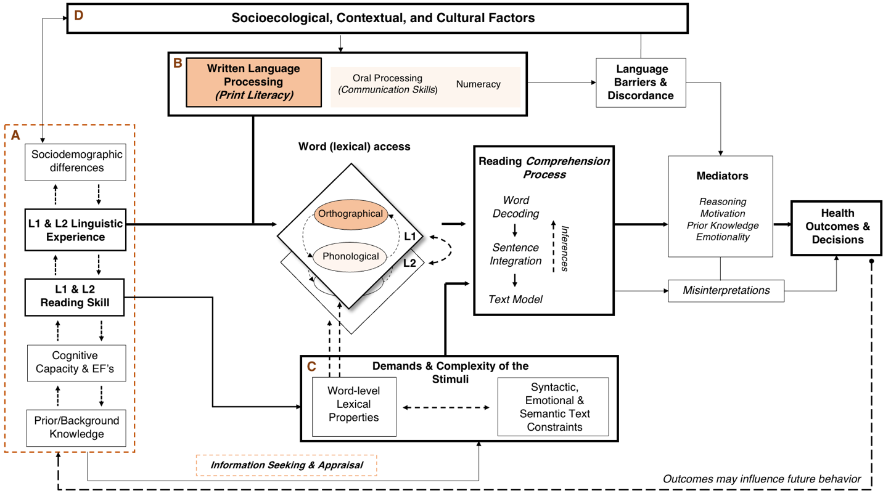
Note. The figure outlines an illustrative visualization for some of our proposed extensions to the original Health Literacy Skills Framework model outlined in Squiers et al. (2012). In our adaptation each letter-labelled panel (i.e., A, B, C, and D) outlines four essential components proposed to encompass a multilingual model of health literacy skills, as applied to written texts. Taken together, the four components dynamically influence the processing and comprehension of health information. The sociodemographic, linguistic, and cognitive individual differences (Panel A) would interact with the socio-ecological context (Panel D) to influence the development of functional literacy skills (Panel B). Readers’ skill and proficiency then interacts with the linguistic complexity of texts (Panel C), affecting how individuals process information in their L1 and L2. During reading, the interaction between the L1 and L2 language systems (influenced by language experience and task demands) affects the processing of information of words (Panel C). Finally, information is integrated to be employed in the decision-making process, mediated by the interaction between individual differences and the socio-ecological context.

