SUPPLEMENTARY MATERIAL
VR DEVELOPMENT AND SCENES

Scenario Content
Connected Spaces was designed as a serious VR game for Meta Quest 2 with integrated spatial audio. The experience comprised two scenes depicting cross-generational ethnic discrimination:

Scene 1: A father and daughter from one of four ethnic groups (Hausa, Igbo, Niger Delta, Yoruba) suffer discrimination from close friends and neighbours, with verbal abuse escalating to violence.

Scene 2: The daughter, now living with an uncle in another city, experiences ethnic discrimination from schoolmates during a “cultural day” celebration. The scene is set in a bathroom with mirrors, a deliberate design choice to enhance presence and body ownership illusion, particularly in the Embody condition.

Each VR mode (Embody, Observe, Role Model, Embody+Observe) had four ethnic variants, yielding 16 possible experiences. Content was piloted for emotional intensity to minimise potential harm while maintaining ecological validity.

Technical Development Pipeline
The final experience was built in Unity3D for Meta Quest 2. Our development approach prioritized ecological validity and authenticity:

- Character modeling: We photographed real individuals as reference and modeled photorealistic characters in Blender (creation and bone rigging). Clothing was created in Clo 3D and Marvelous Designer, modeled after actual school uniforms worn by participants.

- Environment design: School buildings, interiors, buses and other environments were modeled after real locations in Lagos to maximise ecological validity.

- Voice acting: All dialogue was recorded with real Nigerian adolescents and adults, matching character ages and roles, to ensure authentic accents and emotional delivery. Recording was done using professional Shure microphones and edited with Audacity.

- Motion capture: Body animations were captured using Rokoko and Xsens motion capture suits, then refined in Reallusion 3DXchange and iClone 7/8. Facial animations were captured using iPhone TrueDepth camera with iClone plugins, preserving authentic human expressions.

Realism Decisions and Uncappy Valley Considerations
We deliberately chose photorealism over stylized aesthetics, reasoning that ecological validity was paramount for discrimination scenarios targeting participants’ real-world attitudes toward specific ethnic groups. Rather than mitigating Uncanny Valley through stylization, we addressed it through authenticity: motion-captured animations from real people, voice acting by real Nigerian adolescents and adults, and environment modeled on actual locations participants would recognise. This approach aimed to minimise the artificial “tells” that trigger Uncanny Valley discomfort while maximizing the scenarios’ relevance to participants’ lived experiences.

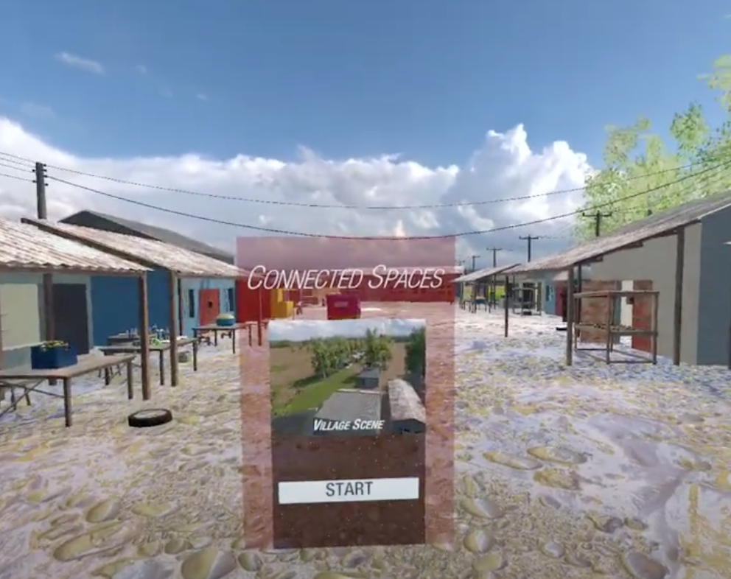
Opening Scene of the VR Ethnic Discrimination Experience: Connected Spaces

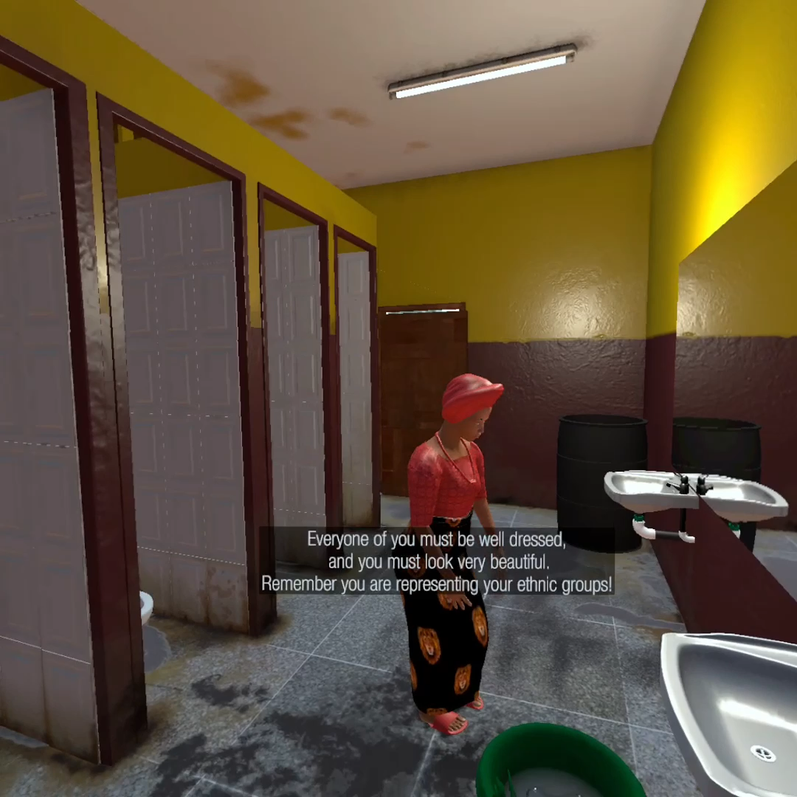
Bathroom Scene (Igbo version): venue of ethnic discrimination

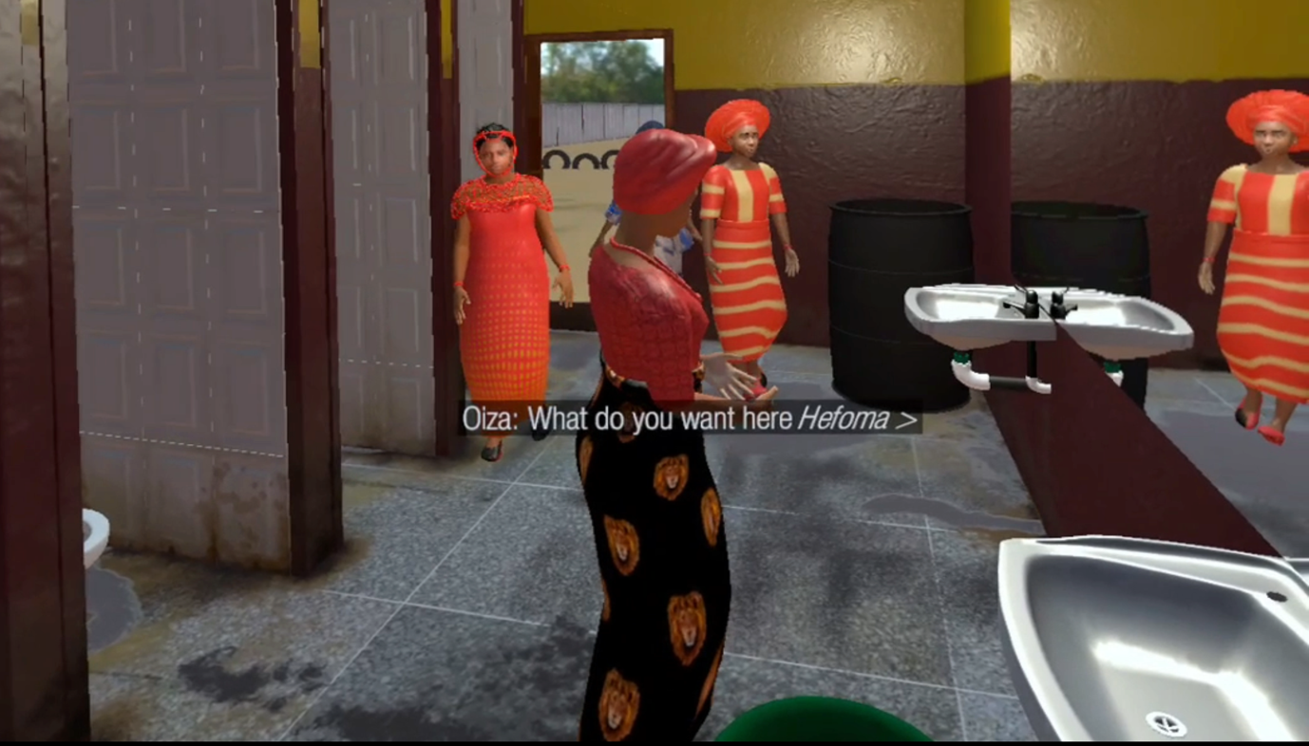
Bathroom Scene (Igbo version): The start of the ethnic discrimination. Mirror is on the right

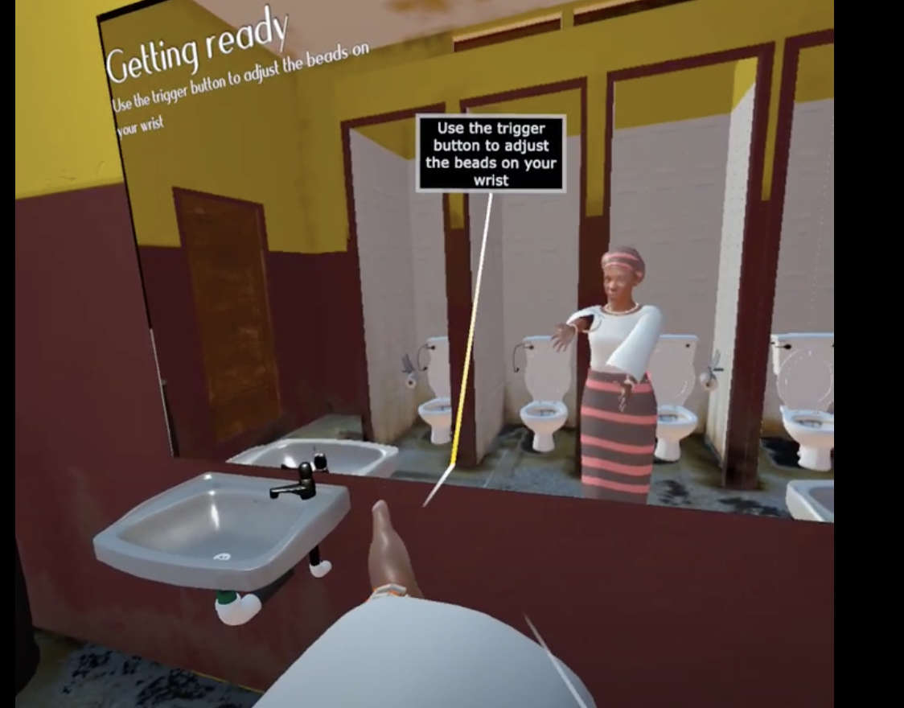
Bathroom Scene (Yoruba version)

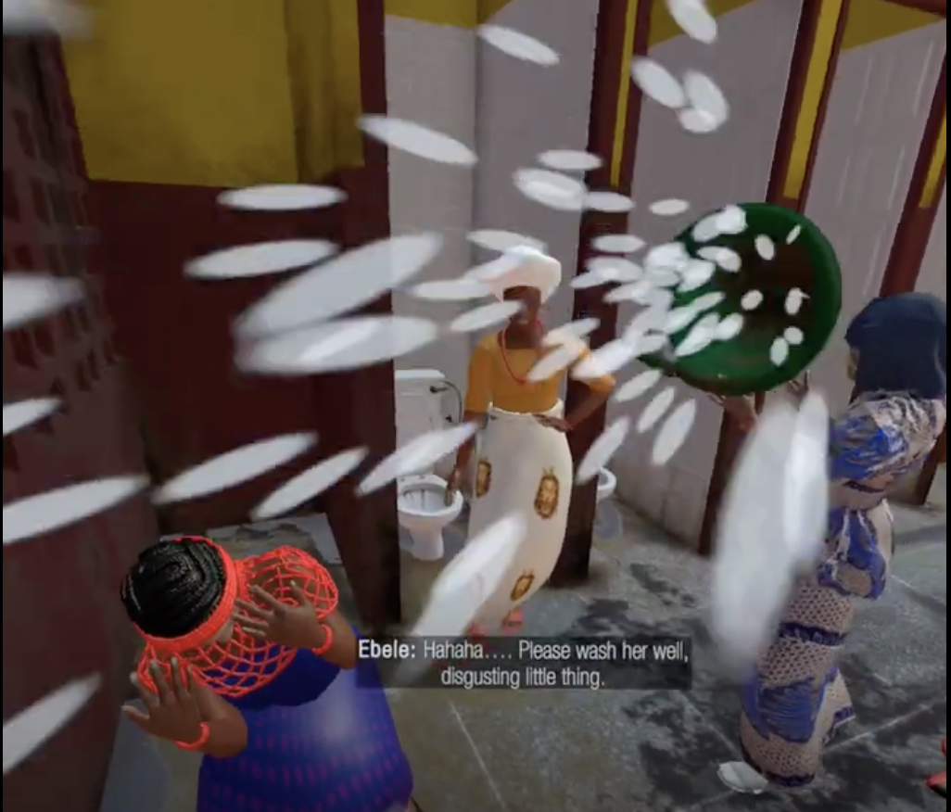
Bathroom Scene (Niger Delta version): Her classmates pour dirty water on her colorful cultural attire

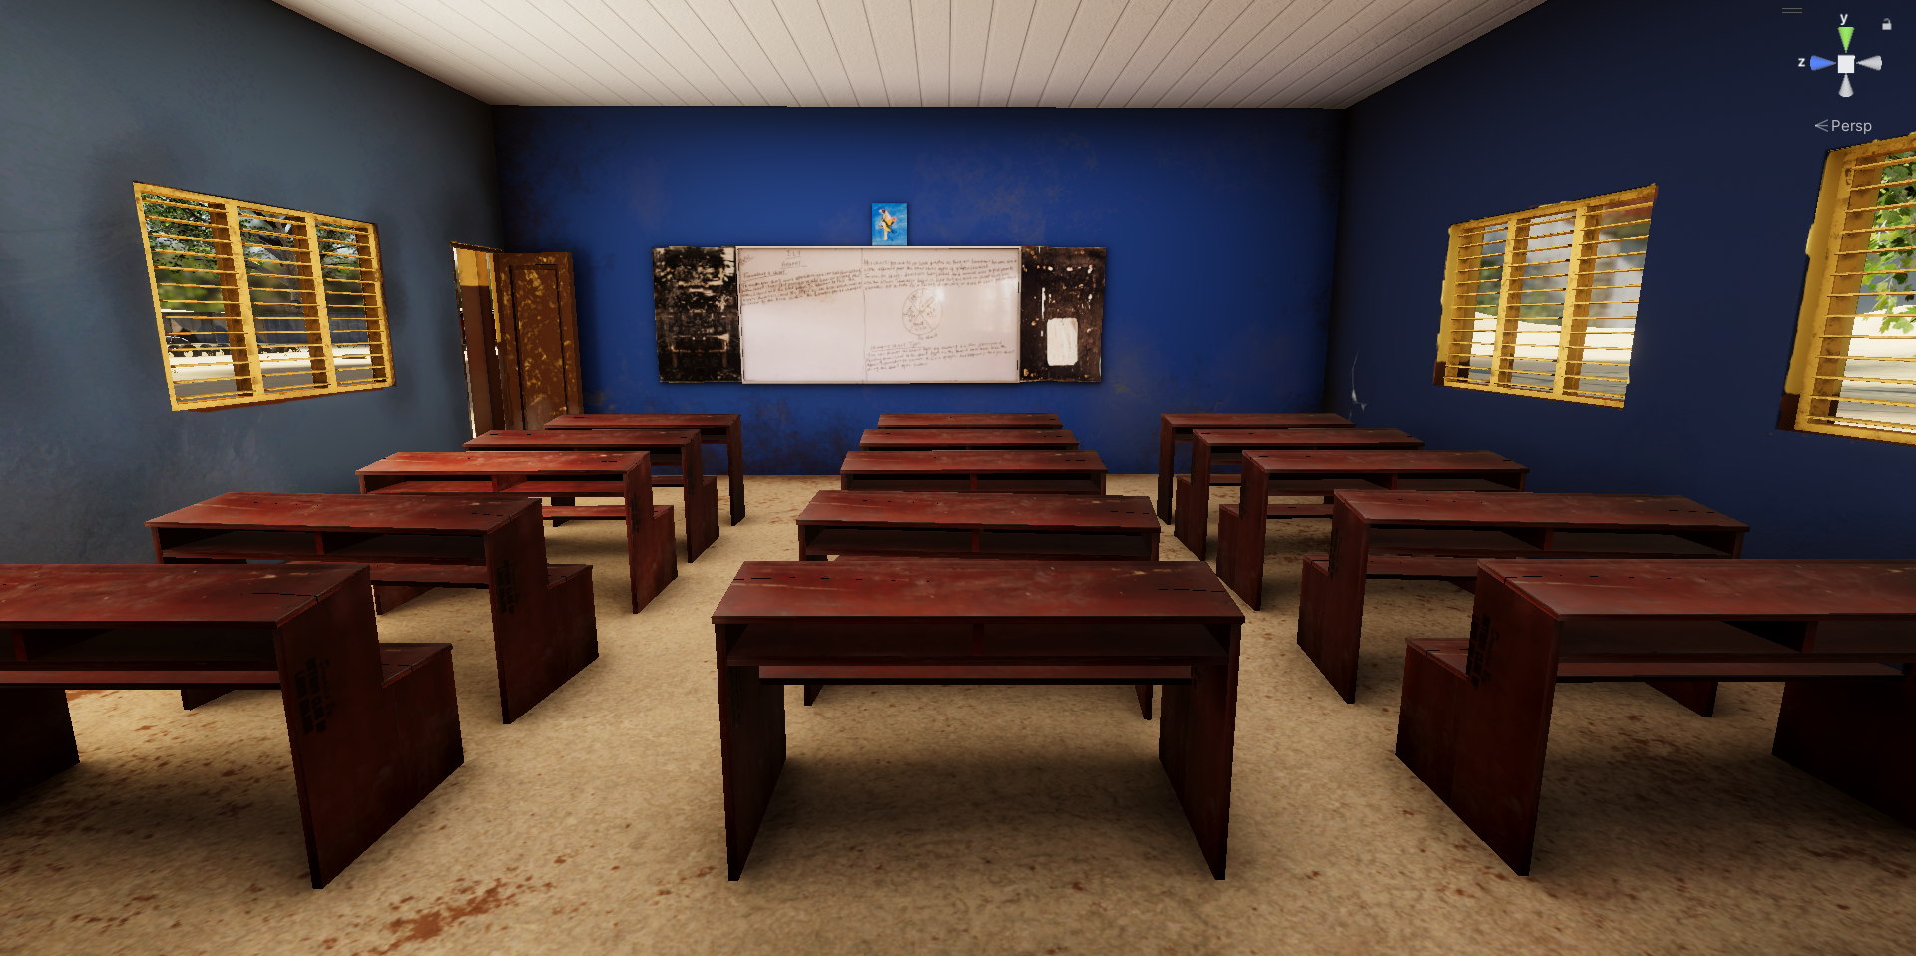
Classroom Scene
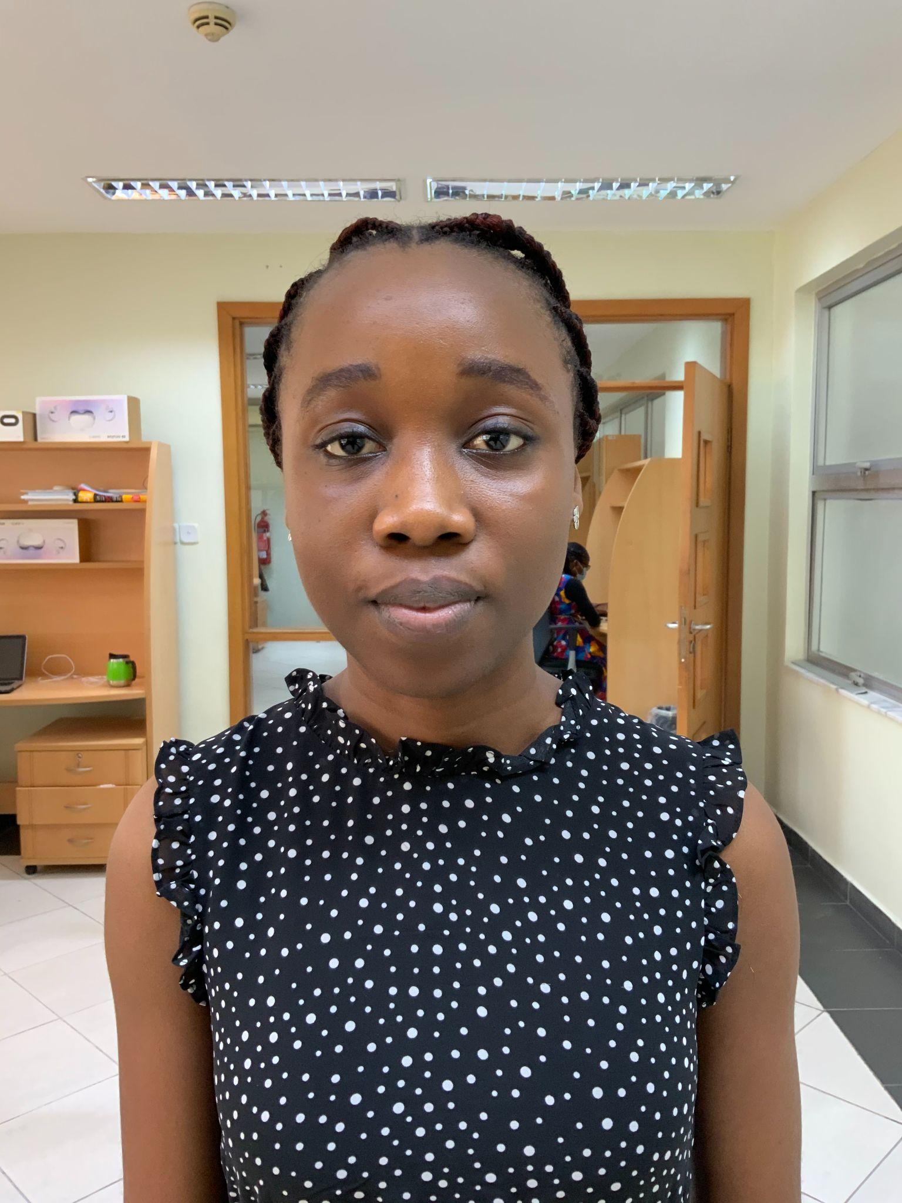
Character Model 1
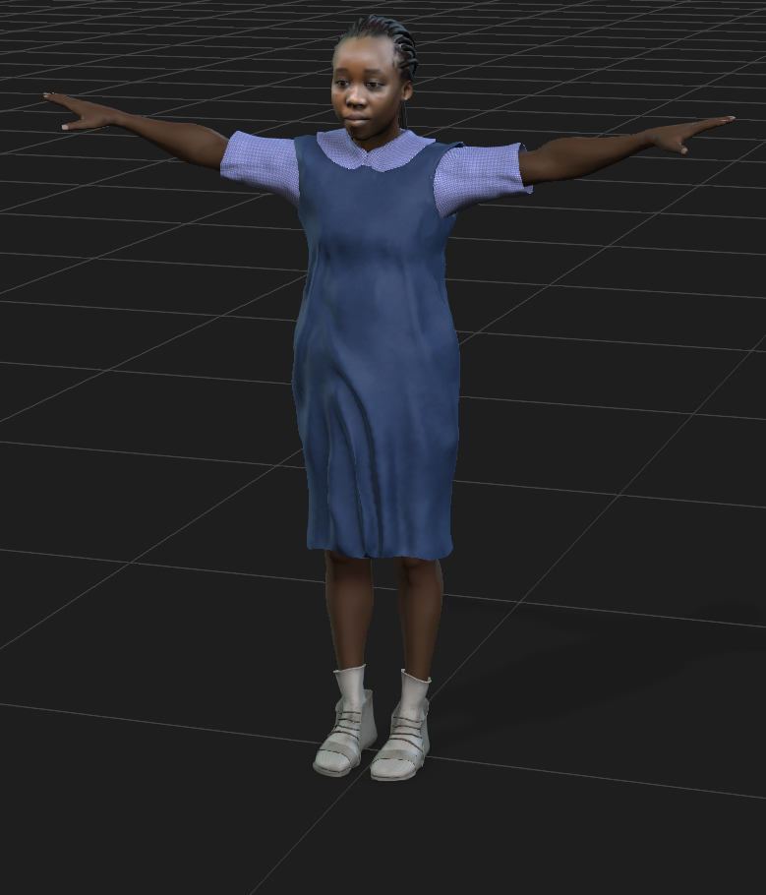
VR Avatar based on Character Model 1

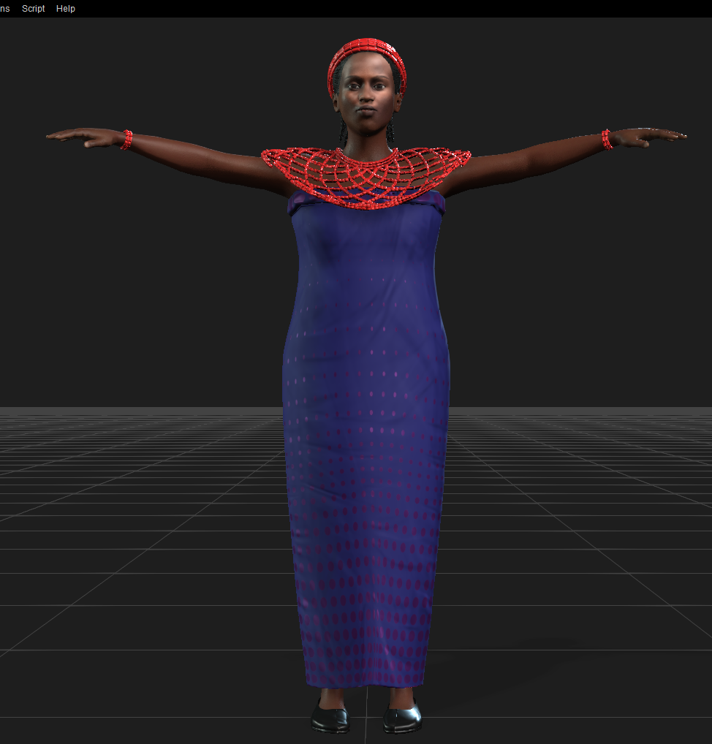
VR Avatar in T-pose: Niger Delta Cultural Attire

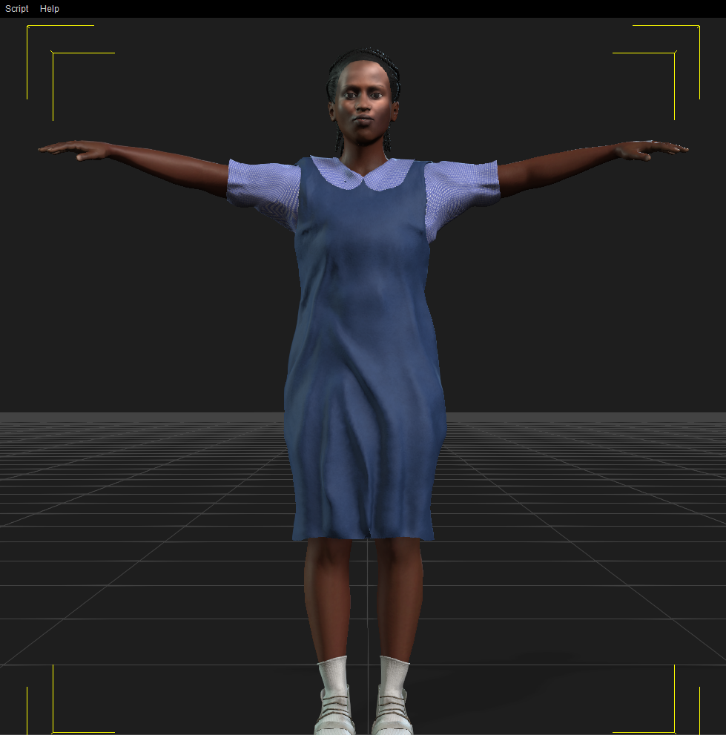
VR Avatar in T-pose: School Uniform

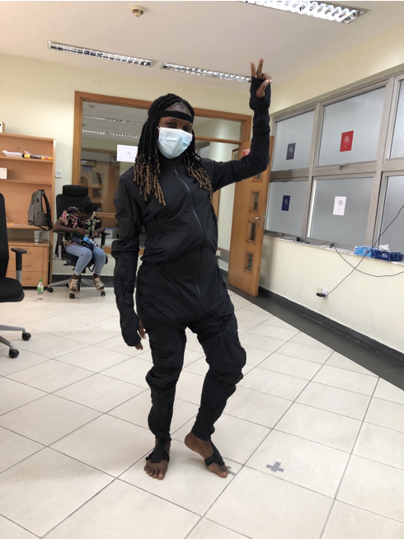
Lab Research Assistant doing Motion Capture for Animation with Rokoko Mocap suit

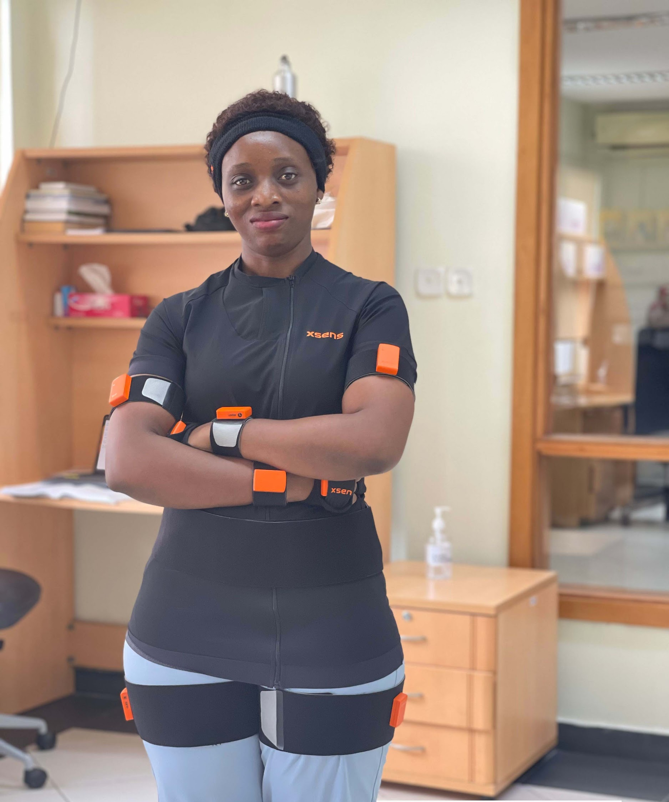
Lab Research Assistant doing Motion Capture for Animation with Xsens Mocap suit

Realism Decisions and Uncanny Valley Considerations
We deliberately chose photorealism over stylized aesthetics, reasoning that ecological validity was paramount for discrimination scenarios targeting participants’ real-world attitudes toward specific ethnic groups. Rather than mitigating Uncanny Valley through stylization, we addressed it through authenticity: motion-captured animations from real people, voice acting by real Nigerian adolescents and adults, and environment modeled on actual locations participants would recognise. This approach aimed to minimise the artificial “tells” that trigger Uncanny Valley discomfort while maximizing the scenarios’ relevance to participants’ lived experiences.

