Supplementary Materials
Table of Contents
Supplementary Table 1: Activity Categories
Supplementary Table 2: Time-Use Descriptives by Cluster
Supplementary Figure 1: Clustering Quality Metrics
Supplementary Figure 2: Elbow Plots
Supplementary Text 1: Robustness Check
Supplementary Text 2: Identifying the Optimal Number of Clusters
Supplementary Text 3: Pairwise Comparisons Between Clusters on Weekends

Supplementary Table 1
Activity Categories
Categories | Activities
Sleep | sleeping and resting
Personal Care | personal care, eating and drinking
Housework | unpaid work; cooking, cleaning, and shopping for the household; fixing things around the house, fixing bike, gardening
Caretaking | looking after brothers, sisters, other children in the household; looking after parent or other adult in the household (medical or personal  care); looking after animals
Work | paid work
Commuting | travel by bus, taxi, tube, plane; travel by car, van
Mandatory School | in class, school breaks, detention, homework
School-related Activities | school clubs
Physical Activity | cycling; individual ball games and training; jogging,  running, walking, hiking; team ball games and training; swimming and  other water sports; other exercise and sports, dancing, keeping fit, skiing,  gymnastics; travel by physically active means
Volunteering | n.a.
Religious Activities | n.a.
Active Leisure | attending live sporting events; cinema, theatre, performance, gig, etc.; exhibition, museum, library, other cultural events; shopping (including window shopping, hanging out at shopping centre); speaking, socializing face-to-face; hobbies, arts and crafts, musical activities, writing stories, poetry, etc.; reading (not for school)
Screen Time | speaking on the phone; playing electronic games and apps; answering emails, instant messaging, texting; browsing and updating social networking sites; general Internet browsing, programming; listening to music, ratio, iPod, other audio content; watch TV, DVDs, downloaded videos
Passive Leisure | did nothing, just relaxing, bored, waiting
Other | n.a.
Note. The Activities column denotes all specific activities that participants could select from when reporting their time use, and the Categories column indicates the broader column for which those activities have been grouped under.

Supplementary Table 2
Time-Use Descriptives by Cluster
 | Weekday |  |  |  | Weekend
 | (1) Early Risers and Varied Activities |  | (2) Late Sleepers and Screen Time Users |  | (1) Early Risers and Varied Activities |  | (2) Late Sleepers and Active Leisure |  | (3) Late Sleepers and Screen Time Users |  | (4) Minimal Sleepers and Other Activities
Activity | M | SD | M | SD | M | SD | M | SD | M | SD | M | SD
Sleep | 8.91 | 1.25 | 8.29 | 2.78 | 10.90 | 2.24 | 10.21 | 1.83 | 10.05 | 2.06 | 6.12 | 2.32
Mandatory School | 6.81 | 1.35 | 6.25 | 2.97 | 3.45 | 2.14 | 3.60 | 2.18 | 9.19 | 2.58 | 4.18 | 3.87
Personal Care | 1.98 | 1.01 | 1.78 | 1.75 | 2.30 | 1.28 | 2.06 | 1.12 | 1.80 | 1.06 | 4.49 | 4.84
Screen Time | 1.91 | 1.33 | 4.90 | 2.22 | 1.78 | 2.17 | 0.75 | 1.23 | 0.49 | 0.82 | 0.79 | 1.64
Other Active Leisure | 1.18 | 1.53 | 0.46 | 0.86 | 1.21 | 1.36 | 4.77 | 2.67 | 0.67 | 0.98 | 1.46 | 2.23
Physical Activity | 1.16 | 1.21 | 0.83 | 0.93 | 1.13 | 2.19 | 0.34 | 0.69 | 0.28 | 0.64 | 0.48 | 0.99
Commuting | 0.73 | 0.89 | 0.52 | 0.70 | 0.90 | 1.68 | 0.48 | 0.99 | 0.50 | 1.08 | 4.22 | 3.71
Other | 0.52 | 1.08 | 0.47 | 1.24 | 0.63 | 1.15 | 0.66 | 0.99 | 0.26 | 0.60 | 0.30 | 0.75
Other Passive Leisure | 0.32 | 0.81 | 0.18 | 0.61 | 0.55 | 1.23 | 0.27 | 0.62 | 0.31 | 0.65 | 1.11 | 3.58
Housework | 0.18 | 0.62 | 0.10 | 0.34 | 0.40 | 0.92 | 0.66 | 1.80 | 0.24 | 0.64 | 0.46 | 1.24
Caretaking | 0.11 | 0.38 | 0.11 | 0.65 | 0.31 | 1.42 | 0.04 | 0.30 | 0.05 | 0.28 | 0.08 | 0.40
School Activities | 0.10 | 0.39 | 0.04 | 0.21 | 0.27 | 0.83 | 0.11 | 0.36 | 0.12 | 0.55 | 0.25 | 0.99
Work | 0.05 | 0.37 | 0.05 | 0.27 | 0.15 | 0.64 | 0.03 | 0.20 | 0.03 | 0.22 | 0.02 | 0.17
Religious Activities | 0.03 | 0.24 | 0.01 | 0.11 | 0.03 | 0.43 | 0.02 | 0.27 | 0.00 | 0.10 | 0.03 | 0.24
Volunteering | 0.01 | 0.12 | 0.02 | 0.41 | 0.00 | 0.05 | 0.01 | 0.12 | 0.00 | 0.00 | 0.00 | 0.00

Supplementary Figure 1
Clustering Quality Metrics
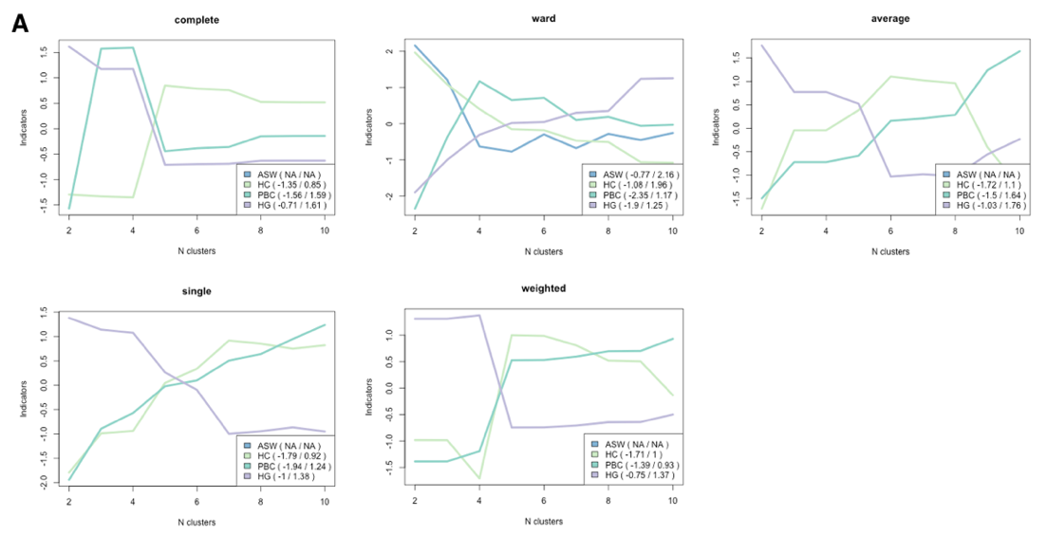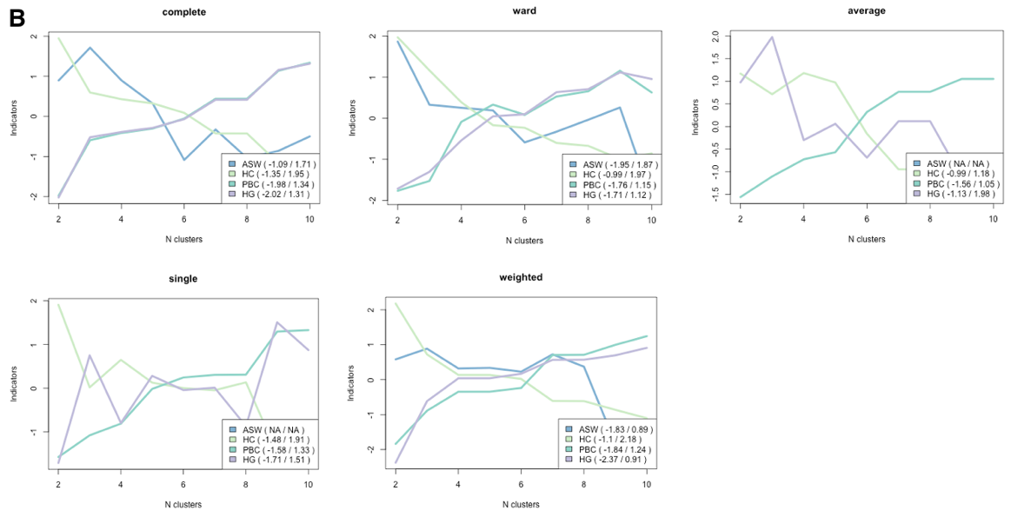
Note. Panel A depicts results for weekdays, and Panel B depicts results for weekends. Average Silhouette Width = ASW, Hubert’s Coefficient = HC, Point Biserial Correlation = PBC, and Hubert’s Gamma = HG.

Supplementary Figure 2
Elbow Plots
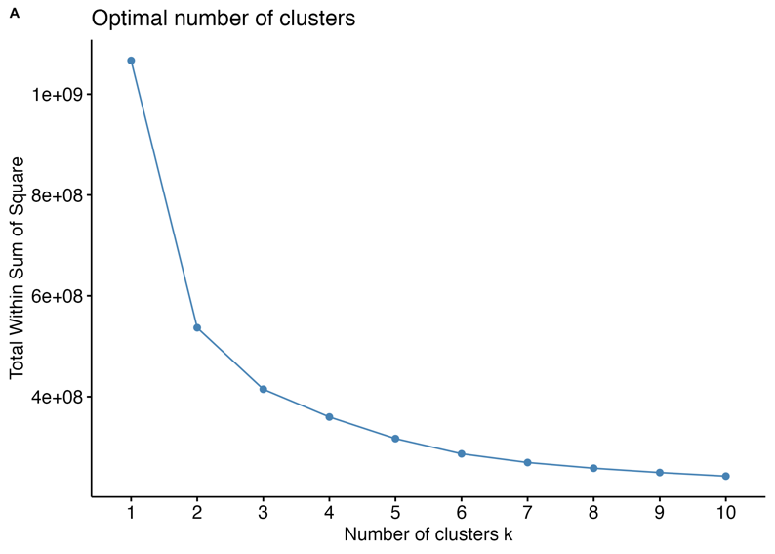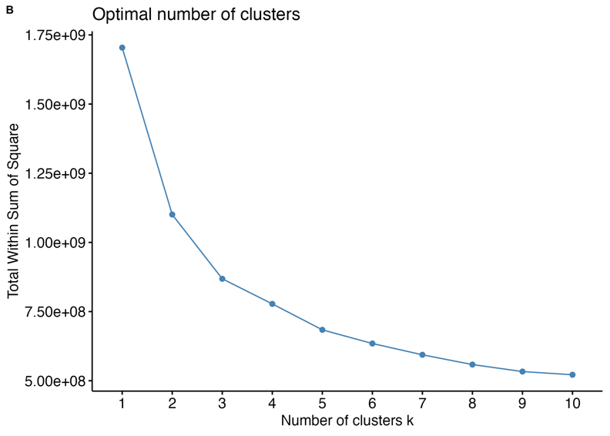
Note. This figure depicts the optimal number of clusters using elbow plots on weekdays in Panel A and weekends in Panel B.

Supplementary Text 1
Robustness Check
We also conducted a robustness check to examine whether the results were consistent when including participants with missingness. In other words, we retained participants who had missing data for activity slots to see whether this comprised a sizable group and produced substantially different results.
Overall, we found largely consistent results. When evaluating various fit metrics and examining sample sizes, a two-cluster solution was optimal on weekdays (n = 2,134), and a four-cluster solution was optimal on weekends (n = 2,416).
In the robustness check analyses for weekdays, we observed fewer significant effects, but in general, the (2) Late Sleepers and Screen Time Users group had poorer outcomes than the (1) Early Risers and Varied Activities group. Outcomes that were consistently implicated between the analyses were life satisfaction and self-esteem.
In the robustness check analyses for weekends, we again found that the (3) Late Sleepers and Screen Time Users group experienced poorer outcomes than the (1) Early Risers and Varied Activities and (2) Late Sleepers and Active Leisure groups. However, one key difference from the analyses in the main text was that in the robustness check analyses, the (3) Late Sleepers and Screen Time Users group at times reported worse outcomes than the (4) Minimal Sleepers and Other Activities group, including for mental well-being, self-esteem, peer problems, and frequency of seeing friends outside of school. Still, the (4) Minimal Sleepers and Other Activities group reported poorer performance on a vocabulary task than the (3) Late Sleepers and Screen Time Users group.

Supplementary Text 2
Identifying the Optimal Number of Clusters
This study employed cluster analysis, an exploratory and data-driven method. Several approaches informed by objective clustering quality metrics and theory were used to identify the optimal number of clusters. In terms of clustering quality metrics, we pre-registered using four metrics: Average Silhouette Width (ASW), Hubert’s Coefficient (HC), Point Biserial Correlation (PBC) and Hubert’s Gamma (HG). ASW assesses how well an object matches others in its own cluster compared to others in neighboring clusters. HC assesses the difference between the observed clustering solution and the best possible solution. PBC and HG measure the extent to which the distances can be reproduced. The optimal number of clusters is indicated by high values of ASW, PBC, and HG and a low HC value.
In addition, prior work has used elbow plots to determine the optimal number of clusters. Elbow plots depict the number of clusters on the x-axis and the total within sum of squares on the y-axis. The optimal number of clusters is determined based on where the “elbow” or curve occurs. See Supplementary Figure 2 for the elbow plots on weekdays (Panel A) and weekends (Panel B).
We used the Ward clustering algorithm as pre-registered but also considered other clustering algorithms, including the complete, average, simple, and weighted clustering algorithms.
We initially allowed for up to 20 clusters to be identified based on past research (Purol et al., 2021). However, we observed that obtaining an extensive number of clusters was not feasible for interpretation and analysis given the sample size. We therefore opted to reduce the number of clusters that could be identified to 10 potential clusters.

Supplementary Text 3
Pairwise Comparisons Between Clusters on Weekends
We conducted pairwise comparisons between all four clusters on weekends, and the results can be accessed in the Open Science Framework.
We tested whether demographic factors predicted cluster membership; see the file path: 2_data_analysis/2_weekends/results/demographics
We also tested whether cluster membership was associated with well-being outcomes; see the file path: 2_data_analysis/2_weekends/results/main_regression

