A Supplementary Material

A.1 Coding Scheme
Dimension | Categories | Sub-category | Definition
Cognitive | Lack Of Knowledge |  | P. states lack of knowledge or Insecurity about what algorithms are.
 | Automated Process |  | P. has a general understanding of what algorithms are doing (e.g., automated analyzing process, repeated steps, automatically produces output from input).
 | Level Of Specificity | Unspecific/  Specific/  Not Applicable | Unspecific understanding: describes algorithms on a superficial level with little details or naming of specific functions and applications.  Specific understanding: detailed and concrete description, naming of such as field of application, platform specifics, examples of algorithmic functions.
 | Function | Problem solving | Algorithms solve problems.
 |  | Recommendation | Algorithms recommend content and are responsible for the order in which content is presented.
 |  | Advertisement | Algorithm are used for advertisement.
 | Awareness External Entity |  | P. are aware that algorithms are employed by platform providers, software firms, advertisers etc.  They are programmed by programmers.
 | Data Collection |  | Algorithms collect data.
 | Field Of Application | Social Media | Algorithms are used on social media platforms.
 |  | News | Algorithms can be responsible for the news recommended to users.
 |  | General Internet | Algorithms are employed all over the internet.
 |  | Search Engines | Search engines employ algorithms.
 |  | Computer | P. associates computer (program/science/use) with algorithms.
 |  | Mobile Apps | Mobile apps employ algorithms.
 | Attributed Intelligence |  | P. projects intelligence on algorithm (e.g., learning, knowledge, Artificial intelligence).
Affective | Valence | Positive | P. shows positive feelings towards algorithm. They are described as useful, practical, constructive etc.
 |  | Negative | P. shows negative feelings towards algorithm. They are described as exploiting, reductive, stereotype enforcing etc.
 |  | Ethical | Participants show ethical considerations.
 | Anthropomorphism |  | P. describes algorithms as human-like and projects human-like actions on them (e.g., think, act, look)
Behavioral | Awareness Human- Algorithm Interaction |  | P. is aware of the interaction between human and algorithms, this relationship does not have to be reciprocal.
 | Agency | Active | P. expresses agency in influencing algorithms.
 |  | passive | P. experiences no agency in influencing algorithms.
Note: Participant’s (P.) answers are coded along this scheme. All categories were coded as either present or absent, except for “level of specificity”.

A.2 Inter-Rater reliability:
Category | Inter-Rater Reliability
Lack Of Knowledge | .98
Automated Process | .88
Specific | .65
Problem Solving | .95
Recommendation | .75
Advertisement | .84
External Entity | .96
Data Collection | .73
Social Media | .81
News | 1.0
Search Engine | .91
General Internet | .51
Computer | .88
Mobile App | .66
Awareness Intelligence | .71
Positive Affect | .82
Negative Affect | .59
Ethical Consideration | .5
Anthropomorphism | .63
Interaction Human Algorithm | .72
Active Agency | .59
Passive Agency | .63

A.3 Affect-Based Associations:

Dimension | Category | Sub-Category | Overall | Germany | U.S. | χ² | d
Affective | Valence | Positive | 0.04 | 0.04 | 0.05 | 0.19 | .02
 |  | Negative | 0.04 | 0.04 | 0.03 | 1.12 | .05
Notes. Frequencies in percent; Effect size of comparison: Cohen’s d; p < 0.05 (*), p < 0.01 (**), p < 0.001 (***); for level of specificity frequency of sub-categories cannot be compared, as the category is coded three-dimensional.

A.4 Word frequency for different categories:
 | Germany | US
Ads | 126 | 174
Data | 131 | 268
Math | 56 | 98
Program | 108 | 256
Task | 18 | 63
Solution | 107 | 66
Recommendation | 6 | 57
Sorting | 7 | 53
Pattern | 50 | 79
Personalization | 43 | 60
Preferences | 16 | 170
Recipe/Instruction | 9 | 18
Note. Word frequency for inductive categories. Hereby related terms were counted as the same category (e.g., math, mathematical)

A.5 Word Clouds
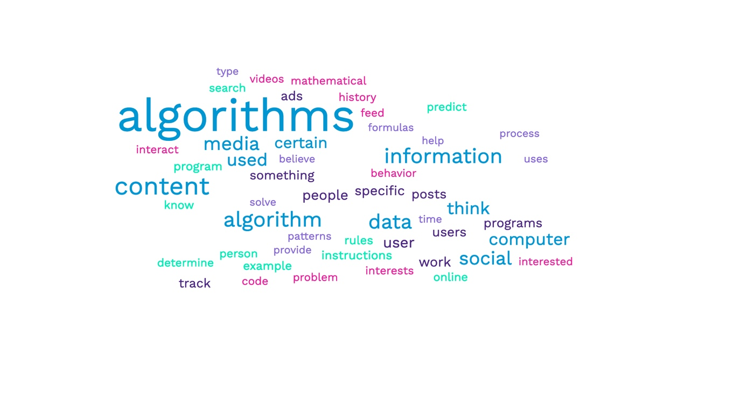
Note. Word cloud of all combined answers of the American sample.
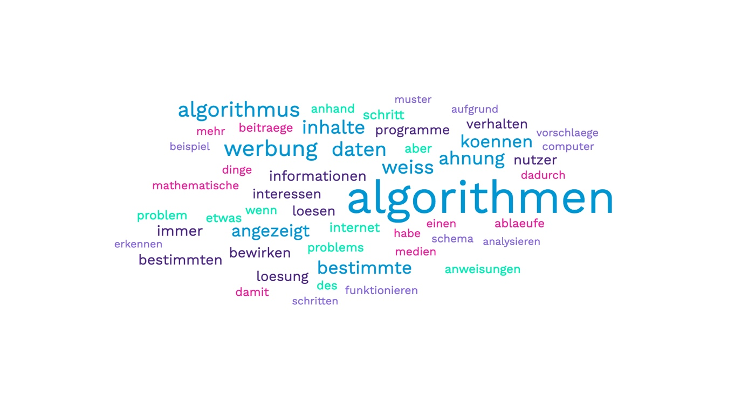
Note. Word cloud of all combined answers of the German sample.

