Anxiety Talking: Does Anxiety Predict Sharing Information about COVID-19?
Supplementary Online Materials

Ori Cantwell¹ and Kostadin Kushlev²
¹Department of Psychology, Wesleyan University
²Department of Psychology, Georgetown University

Author Note
Ori Cantwell – https://orcid.org/0000-0003-4632-3211
Kostadin Kushlev – https://orcid.org/0000-0003-1025-3258
We have no known conflict of interest to disclose.
Correspondence concerning this article should be addressed to Ori Cantwell, Wesleyan University, WesBox 90844, 45 Wyllys Avenue, Middletown, CT 06459. Email: ocantwell@wesleyan.edu
All the survey methodology, questionnaires, and dataset access information can be found on this paper’s project page on the Open Science Framework, https://osf.io/6425d/.

Does Anxiety Predict Social Distancing Intentions?
We wanted to see how participants’ anxiety related to social distancing, which was not assessed in the April 2020 survey data that contained data on information sharing—the main focus of our research. The panel’s comfort with doing various errands and social activities was assessed, however, in the American Trends Panel March 2020 survey. We used this measure of discomfort with social contact as an approximate indicator of social distancing. For consistency with the main manuscript, we only included participants who also completed the April 2020 survey. We found that March anxiety indeed predicted March social distancing, r = .29, 95%CI[0.27; 0.31], p < 0.001. March anxiety still predicted March social distancing (β = .26, p < .001) after controlling for other March well-being measures (see Table S4).
Participants. Participants were a nationally representative sample of non-institutionalized adults residing in the United States (originally N = 11,537). We made an a priori decision to exclude all observations with missing answers for any of our variables, and all participants who did not also complete the April 2020 survey. Thus, we analyzed data from a final N = 8,161 participants who also completed the American Trends Panel April 2020 survey. In this subsample for March 2020, 46.6% of participants were male, 89.4% lived in an urban area, 66.7% had an annual family income over $50,000, and 32.2% considered themselves politically liberal or very liberal.
The sample was 70.6% White (non-Hispanic), 16.4% Hispanic, 7.3% Black (non-Hispanic), and 5.8% other. Like the April sample, the sample for this dataset overrepresented White participants, who make up 60.1% of the population, and underrepresented Black and Hispanic participants, who make up 13.4% and 18.5% of the population, respectively (U.S. Census Bureau, 2019). For this reason, these findings also may be more generalizable to White populations than Black and Hispanic populations.
Panel participants were recruited through three random-digit-dial surveys and two national address-based random sample surveys, conducted by the American Trends Panel. Survey responses were recorded between March 19th and March 24th, 2020. All participants received post-paid incentives ranging from $5 to $20.
Measures. To measure social distancing, we created a five-item index of variables with binary responses (0-Uncomfortable doing this, 1-Comfortable doing this). Participants reported their comfort with visiting friends, going to a restaurant, attending a crowded party, going to the grocery store, and going to a polling place to vote (alpha = 0.71). Emotion variables were all measured with the same items as in the April 2020 survey. Participants reported how often (0-Rarely or none of the time to 3-Most or all of the time) they felt nervous, anxious, or on edge (“Anxious”), depressed (“Depressed”), lonely (“Lonely”), hopeful (“Hopeful”), had trouble sleeping (“Bad Sleep”), or experienced a physical response such as nausea, headaches, or a fast heartbeat when thinking about COVID-19 (“Psychosomatic Anxiety”).
More information about the methodology is available at https://osf.io/6425d/?view_only=015b906a691e4c9c9ce57a5b4e72d857.

Supplementary Tables

Table S1. In April 2020, getting news about the COVID-19 pandemic from the White House predicts lower anxiety, even after controlling for all other news sources, including news consumption on social media.
Predictor |  | b |  | SE |  | β |  | t |  | p
(Intercept) |  | 1.108 |  | 0.010 |  | 0.000 |  |  | 109.386 |  | < .001
International News |  | 0.026 |  | 0.016 |  | 0.020 |  |  | 1.685 |  | 0.092
National News |  | 0.060 |  | 0.019 |  | 0.038 |  |  | 3.221 |  | 0.001
Local News |  | 0.023 |  | 0.017 |  | 0.016 |  |  | 1.362 |  | 0.173
News from White House |  | -0.147 |  | 0.014 |  | -0.118 |  |  | -10.711 |  | < .001
News from Biden Campaign |  | 0.039 |  | 0.024 |  | 0.019 |  |  | 1.670 |  | 0.095
News from State Officials |  | 0.023 |  | 0.017 |  | 0.015 |  |  | 1.264 |  | 0.206
News from Health Officials |  | 0.100 |  | 0.019 |  | 0.063 |  |  | 5.335 |  | < .001
News from Friends/Family |  | 0.077 |  | 0.018 |  | 0.049 |  |  | 4.336 |  | < .001
News Listservs |  | -0.039 |  | 0.020 |  | -0.023 |  |  | -1.991 |  | 0.046
News Forums |  | 0.007 |  | 0.019 |  | 0.005 |  |  | 0.398 |  | 0.691
Passive Social Media News |  | 0.139 |  | 0.011 |  | 0.153 |  |  | 13.225 |  | < .001

Table S2. Anxiety still predicts interactive, but not active, information sharing when controlling for news from social media (in addition to other negative emotions, news consumption, and demographics).
 | Interactive Info Sharing |  |  |  |  | Active Info Sharing (Social Media)
Predictors | b | SE | β | t | p | b | SE | Odds Ratio | Z | p
(Intercept) | 2.568 | 0.013 | 0.000 | 197.03 | < .001 | -3.590 | 0.231 | 0.028 | -15.53 | < .001
Anxious | 0.111 | 0.011 | 0.131 | 9.698 | <.001 | 0.050 | 0.038 | 1.052 | 1.314 | 0.189
Depressed | 0.000 | 0.014 | 0.000 | -0.058 | 0.954 | 0.007 | 0.045 | 1.008 | 0.166 | 0.868
Lonely | 0.015 | 0.011 | 0.016 | 1.310 | 0.190 | 0.036 | 0.038 | 1.037 | 0.952 | 0.341
Hopeful | -0.009 | 0.009 | -0.010 | -1.002 | 0.316 | 0.011 | 0.031 | 1.011 | 0.369 | 0.713
Bad Sleep | 0.005 | 0.009 | 0.006 | 0.512 | 0.609 | 0.002 | 0.030 | 1.002 | 0.057 | 0.954
Psychosomatic Anxiety | 0.044 | 0.016 | 0.029 | 2.714 | 0.007 | 0.181 | 0.050 | 1.199 | 2.587 | <.001
International News | 0.051 | 0.012 | 0.046 | 4.267 | <.001 | 0.116 | 0.041 | 1.123 | 2.805 | 0.005
National News | 0.138 | 0.015 | 0.102 | 9.357 | <.001 | -0.041 | 0.051 | 0.960 | -0.804 | 0.421
Local News | 0.005 | 0.013 | 0.004 | 0.392 | 0.695 | -0.153 | 0.046 | 0.858 | -3.366 | <.001
News from White House | 0.061 | 0.012 | 0.058 | 5.110 | <.001 | -0.056 | 0.041 | 0.946 | -1.357 | 0.175
News from Biden Campaign | 0.029 | 0.019 | 0.017 | 1.546 | 0.122 | 0.046 | 0.060 | 1.047 | 0.762 | 0.446
News from State Officials | 0.058 | 0.013 | 0.047 | 4.382 | <.001 | 0.055 | 0.040 | 1.057 | 1.230 | 0.219
News from Health Officials | 0.079 | 0.014 | 0.059 | 5.471 | <.001 | 0.205 | 0.051 | 1.227 | 4.025 | <.001
News from Friends/Family | 0.154 | 0.014 | 0.117 | 11.23 | <.001 | -0.187 | 0.047 | 0.829 | -4.019 | <.001
News Listservs | 0.005 | 0.015 | 0.003 | 0.310 | 0.756 | 0.017 | 0.050 | 1.018 | 0.351 | 0.725
News Forums | 0.028 | 0.014 | 0.022 | 1.986 | 0.047 | 0.140 | 0.045 | 1.150 | 3.129 | 0.002
News from Social Media | 0.092 | 0.008 | 0.119 | 10.84 | <.001 | 1.151 | 0.033 | 3.160 | 35.34 | <.001
Urban (v. Rural) | 0.058 | 0.027 | 0.021 | 2.143 | 0.032 | -0.185 | 0.091 | 0.831 | -2.042 | 0.041
Male (v. Female) | -0.064 | 0.017 | -0.038 | -3.709 | <.001 | -0.080 | 0.059 | 0.923 | -1.363 | 0.173
Age | -0.015 | 0.010 | -0.017 | -1.557 | 0.120 | 0.180 | 0.033 | 1.198 | 5.534 | <.001
Education | 0.030 | 0.007 | 0.052 | 4.624 | <.001 | -0.004 | 0.022 | 0.996 | -0.173 | 0.862
Political Ideology | 0.036 | 0.010 | 0.046 | 3.672 | <.001 | 0.032 | 0.033 | 1.032 | 0.958 | 0.338
Religiosity | -0.003 | 0.005 | -0.006 | -0.589 | 0.556 | 0.005 | 0.019 | 1.005 | 0.287 | 0.774
Family Income | 0.031 | 0.004 | 0.084 | 7.367 | <.001 | -0.007 | 0.014 | 0.993 | -0.510 | 0.610
Race/Ethnicity (v. Black non-Hispanic)
White non-Hispanic | -0.202 | 0.033 | -0.239 | -6.070 | <.001 | 0.064 | 0.111 | 1.066 | 0.572 | 0.567
Hispanic | -0.171 | 0.037 | -0.202 | -4.655 | <.001 | 0.057 | 0.120 | 1.059 | 0.477 | 0.633
Other | -0.231 | 0.046 | -0.273 | -4.982 | <.001 | -0.031 | 0.154 | 0.970 | -0.198 | 0.843

Note. Urban location was coded from county-level FIPS codes (0–Non-Metropolitan; 1–Metropolitan,). Political ideology was self-reported on a scale from 0–Very conservative to 4–Very liberal). We found no evidence of multicollinearity between predictors (see Table S3). See Figure S1 for further diagnostics.

Table S3. Collinearity statistics between predictors of information sharing in Table 2.
 |  | Variance Inflation Factor |  | Tolerance
Anxious |  | 1.39 |  | 0.718
Depressed |  | 1.50 |  | 0.666
Lonely |  | 1.27 |  | 0.788
Hopeful |  | 1.06 |  | 0.946
Bad Sleep |  | 1.16 |  | 0.862
Psychosomatic Anxiety |  | 1.13 |  | 0.887
International News |  | 1.11 |  | 0.904
National News |  | 1.12 |  | 0.889
Local News |  | 1.11 |  | 0.901
News from White House |  | 1.18 |  | 0.848
News from Biden Campaign |  | 1.12 |  | 0.890
News from State Officials |  | 1.11 |  | 0.899
News from Health Officials |  | 1.11 |  | 0.897
News from Friends/Family |  | 1.08 |  | 0.925
News Listservs |  | 1.11 |  | 0.904
News Forums |  | 1.11 |  | 0.904
News from Social Media |  | 1.11 |  | 0.904
Urban |  | 1.03 |  | 0.974
Male |  | 1.04 |  | 0.959
Age |  | 1.14 |  | 0.880
Education |  | 1.16 |  | 0.859
Liberalness |  | 1.29 |  | 0.778
Religiosity |  | 1.12 |  | 0.894
Income |  | 1.17 |  | 0.855
Race/Ethnicity |  | 1.06 |  | 0.947

Table S4. Anxiety predicts social distancing intentions in March 2020 even after controlling for related measures.
Predictor |  | b |  | SE |  | β |  | t |  |  | p
(Intercept) |  | 0.652 |  | 0.003 |  | 0.000 |  |  |  | 212.62 |  |  | < .001
Anxious |  | 0.072 |  | 0.004 |  | 0.259 |  |  |  | 19.30 |  |  | < .001
Depressed |  | -0.018 |  | 0.005 |  | -0.056 |  |  |  | -3.73 |  |  | < .001
Lonely |  | -0.007 |  | 0.004 |  | -0.021 |  |  |  | -1.65 |  |  | 0.098
Hopeful |  | -0.021 |  | 0.003 |  | -0.071 |  |  |  | -6.36 |  |  | < .001
Bad Sleep |  | 0.010 |  | 0.003 |  | 0.036 |  |  |  | 3.00 |  |  | 0.003
Psychosomatic Anxiety |  | 0.046 |  | 0.006 |  | 0.096 |  |  |  | 8.28 |  |  | < .001

Supplementary Figures

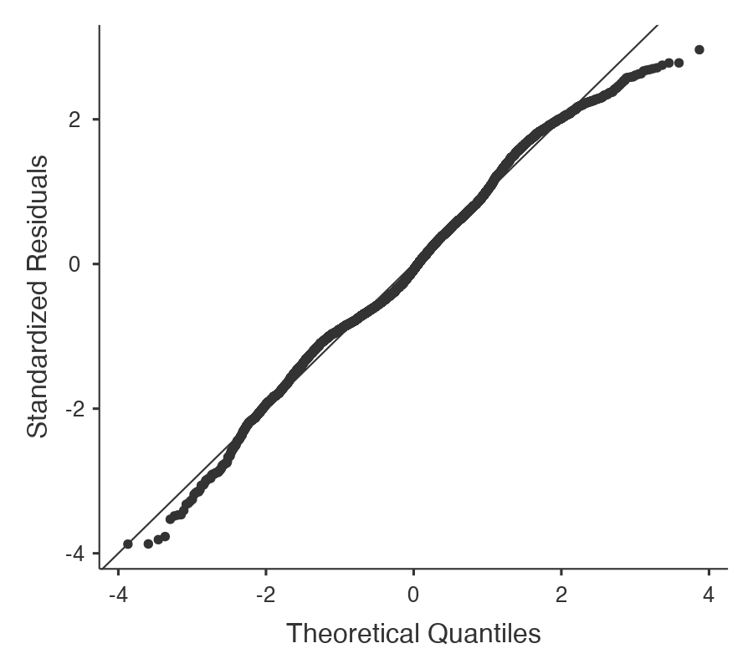
Figure S1. Q-Q plot for interactive information sharing regressed onto anxiety, other emotions, news consumption, and demographics (see Table 2 for details). The standardized residuals do not deviate from the diagonal, suggesting that the assumption for normality of residuals is not violated.

