Supplemental Materials
Figure S1
Standardized Regression Coefficients for the Relationship Between Active Instagram Use and User Self-Esteem as Mediated by Intensity of Instagram Use
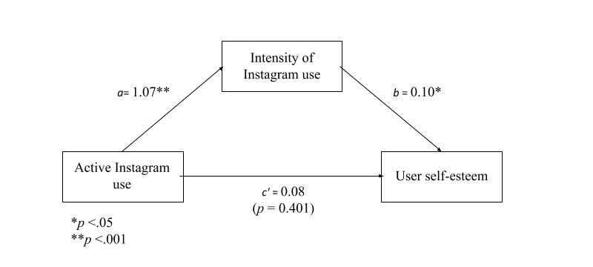
Figure S2
Standardized Regression Coefficients for the Relationship Between Active Instagram Use and User Well-Being as Mediated by Intensity of Instagram Use
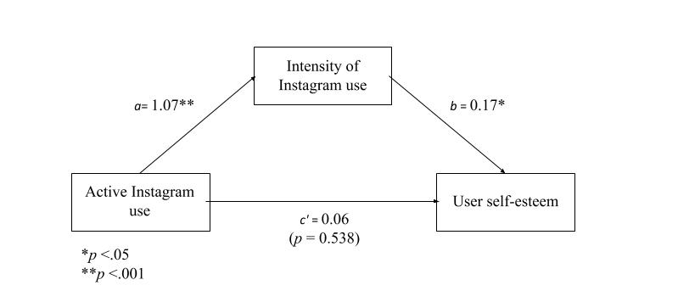
User Well-Being

Measures
Passive and Active Use Measure (PAUM)
How frequently do you perform the following activities when you are on Instagram? (Note: Choosing “Very Frequently” means that about 100% of the time that you log on to Instagram, you perform that activity).
- 1 – Never (0%)
- 2 – Rarely (25%)
- 3 – Sometimes (50%)
- 4 – Somewhat frequently (75%)
- 5 – Very frequently (100%)

- Posting photos to your profile
- Commenting on other users’ photos
- Sending direct messages to other users
- Checking to see what someone else is up to
- Viewing photos
- Viewing videos
- Tagging other users in videos
- Browsing the newsfeed passively (without liking or commenting on anything)
- Browsing the newsfeed actively (liking and commenting on other users’ posts)
- Looking through my friends’ posts

Items should be presented to respondents in randomized order.
Scoring: Items are summed.
Active: 1, 2, 3, 7, 9
Passive: 4, 5, 6, 8, 10

Instagram Intensity
The Instagram Intensity scale is used to measure Instagram usage beyond simple measures of frequency and duration, incorporating emotional connectedness to the site and its integration into individuals’ daily activities.

Scale Items
- Instagram is part of my everyday activity
- I am proud to tell people I'm on Instagram
- Instagram has become part of my daily routine
- I feel out of touch when I haven't logged onto Instagram for a while
- I feel I am part of the Instagram community
- I would be sorry if Instagram shut down
- Approximately how many TOTAL Instagram followers do you have? *
- In the past week, on average, approximately how much time PER DAY have you spent actively using Instagram?**

Response categories range from 1 = strongly disagree to 5 = strongly agree, unless otherwise noted.
*Can be asked as an open-ended (as in Ellison et al., 2007) or closed-ended question. If asked as an open-ended question, Total Instagram followers must transformed by taking the log before averaging across items to create the scale due to differing item scale ranges. If asked as a closed ended question, a ten point ordinal scale may be used (e.g. 10 or less, 11–50, 51–100, 101–150, 151–200, 201–250, 251–300, 301–400, more than 400). You may wish to adjust these response categories depending on your population, etc.
**Can be asked as an open-ended or closed-ended question. If asked as an open-ended question, Instagram minutes should be measured by having participants fill in the amount of time they spend on Instagram. Then the item should then be transformed by taking the log before averaging across items to create the scale due to differing item scale ranges. If asked as a close ended question an ordinal scale may be used (e.g. 1= 0-14min, 2=15-29 min, etc). Again, response categories may differ based on population means.

Computing the Scale
The Instagram Intensity score is computed by calculating the mean of all of the items in the scale.

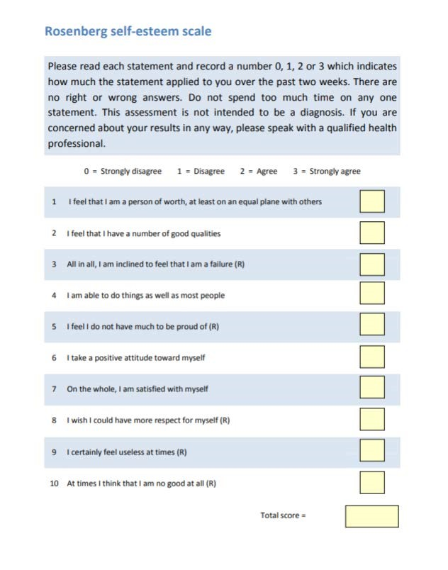

Satisfaction With Life Scale
Below are five statements that you may agree or disagree with. Using the 1 - 7 scale below, indicate your agreement with each item by placing the appropriate number on the line preceding that item. Please be open and honest in your responding.
- 7 - Strongly agree
- 6 - Agree
- 5 - Slightly agree
- 4 - Neither agree nor disagree
- 3 - Slightly disagree
- 2 - Disagree
- 1 - Strongly disagree
____ In most ways my life is close to my ideal.
____ The conditions of my life are excellent.
____ I am satisfied with my life.
____ So far I have gotten the important things I want in life.
____ If I could live my life over, I would change almost nothing.

- 31 - 35 Extremely satisfied
- 26 - 30 Satisfied
- 21 - 25 Slightly satisfied
- 20 - Neutral
- 15 - 19 Slightly dissatisfied
- 10 - 14 Dissatisfied
- 5 - 9 Extremely dissatisfied

