Supplementary Materials - Study 1 Measures and Procedures

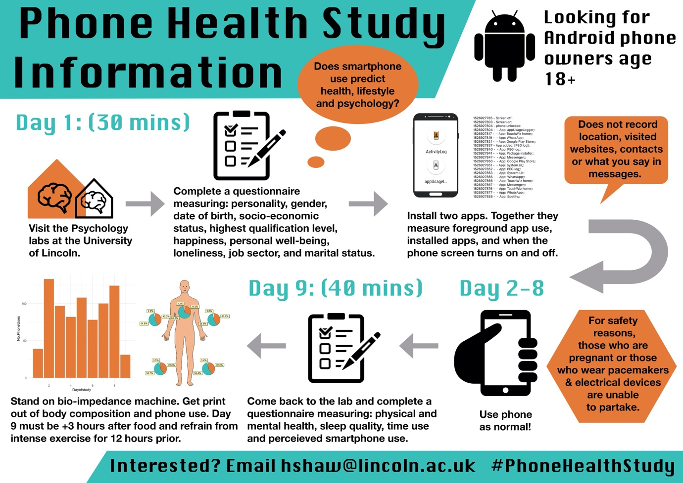

Figure S.1. Study infographic used to advertise the project. Describes the itinerary of the study and what measures were collected across which days.

Application Use

App usage logger worked in a similar way to activity logger, but, had an additional response when the screen was turned on and off. When the screen was turned on a function would repeat every 200 milliseconds. The function would query a database (UsageStats, 2019) generated by Android and independent of the application. This database stored a record of what applications were being used for the past two years on an Android device. The query would only question what application was running in the foreground for the past second. If this was the first time the function had ran since the screen was turned on or identified a different application from the previous time the function ran, then the name of the application would be documented in the internal memory along with a UNIX timestamp. However, repetitively running this function would be require extensive amounts of processing power and therefore to save battery the app would stop calling this function while the phone screen was off. App usage logger would also document meta-data including installed apps, the deletion and installation of applications across the week, and smartphone unlocking. Source code for both apps are available to download (Shaw et al., 2018).

Personality

The 60-item HEXACO was used to analyse a user’s personality across six domain level traits; honesty-humility, emotionality, extraversion, agreeableness, conscientiousness and openness-to-experience (see chapter 3 for a detailed description of each trait) (Ashton & Lee, 2009). Only single factors were examined rather than facet-level personality scores as these have previously shown to have higher predictive performance when predicting personality from phone logs (Stachl et al., 2017). For each trait, ten questions were answered concerning how much a participant agreed or disagreed with a statement about themselves. Answers were recorded on a five-point likert-style scale, whereby five = ‘strongly agree’ and one = ‘strongly disagree’. Reliability analysis showed that all trait scales had good internal reliability, apart from honestly-humility (α = 0.65) and openness-to-experience (α = .78) which fell below the .8 threshold.

Demographic Information

Self-report questions were used to measure gender, date of birth, marital status, highest qualification and job sector. Gender was measured through the selection of six options on a multiple-choice question: ‘Female’, ‘Male’, ‘Transgender’, ‘Gender Variant/Non-Conforming’, ‘Not Listed (please specify)’, and ‘Prefer Not to Say’. Participants selected one of five options for marital status: ‘Single’, ‘Married/Civil Partnership’, ‘Widowed’, ‘Divorced’, and ‘Separated’. Job sectors were taken from the UK Prospects websites and included 24 categories ranging from accounting to transport and logistics (Prospects, 2019). Highest qualification was measured through a multiple-choice question containing each of the eight UK levels with examples of what qualifications constitute to each level (UK-Government, 2019).

The MacArthur Ladder of Subjective Social Status was used to measure a person’s perceived social economic status in society (Adler, Epel, Castellazzo, & Ickovics, 2000). In this scale, participants viewed a picture of a ten-step ladder. The instructions were: “There are 10 steps on this ladder. At the top of the ladder are the people who are the best off, those who have the most money, most education, and best jobs. At the bottom are the people who are the worst off, those who have the least money, least education, and worst jobs or no job. On the multiple-choice options below, please select a step which best represents where you stand on this ladder”. Like chapter three, this was used instead of collecting details about pay or household income.

Happiness

Happiness was measured using the Oxford Happiness Questionnaire (Hills & Argyle, 2002). Participants were asked to indicate how much they agreed or disagreed with 29 statements about happiness on a six-point Likert scale, whereby 1 = “Strongly Disagree” and 6 = “Strongly Agree”. Example questions included “I laugh a lot” and “I often experience joy and elation”. Higher scores indicated greater amounts of happiness.

Loneliness

The UCLA loneliness scale (Russell, Peplau, & Cutrona, 1980) was used to measure lonesomeness and consisted of 20 questions such as “I feel left out” and “There are people I can turn to”. Participants responded how often they felt a particular way on a 4-point Likert scale, whereby 1 = “Never” and 4 = “Often”. Higher scores indicated greater levels of loneliness.

Personal Wellbeing

The Personal Wellbeing Index included eight questions which indicated how satisfied a person was with several life factors, such as: standard of living, health, life achievement, personal relationships, safety, community, future security, and religion (International Wellbeing Group, 2013). Questions were asked on a 11-point Likert scale whereby 0 = “no satisfaction at all” and 10 = “completely satisfied”. Higher total scores indicated higher overall wellbeing.

Somatic Symptoms

The PHQ-15 (Kroenke, Spitzer, & Williams, 2002) consisted of 15 questions relating to somatic symptoms such as stomach pain, back pain, menstrual cramps, and headaches. Participants were asked “Over the last two weeks, how much have you been bothered by any of the following problems” and responded on a three-point scale whereby 0 = “not bothered at all’ and 2 = “bothered a lot’. Scores of 5, 10 and 15 are cut of points for low, medium and high somatic symptom severity.

Ocular and Musculoskeletal Symptoms

Ocular symptoms were measured by adapting the PHQ-15 to seven new ocular symptoms including vision blurring, eye redness, visual disturbance, secretion, inflammation, lacrimation, and eye dryness. Similarly, musculoskeletal symptoms were measured by adapting the PHQ-15 to six new symptoms including pain in the neck, spine, shoulders, hands, wrists, and fingers.

Sleep Quality

The Pittsburgh Sleep Quality Index measured sleep quality and disturbances by reflecting over the past month (Buysee, Reynolds III, Monk, Berman, & Kupfer, 1988). 19 items were used to generate several component scores such as: subjective sleep quality, sleep latency, sleep duration, habitual sleep efficiency, sleep disturbances, use of sleeping medication, and daytime dis-functioning. These were used to calculate a global score, which has shown to have a diagnostic sensitivity of 89.6% and a specificity of 86.5% when distinguishing good to poor sleepers (Buysee et al., 1988). Higher scores indicate lower sleep quality.

