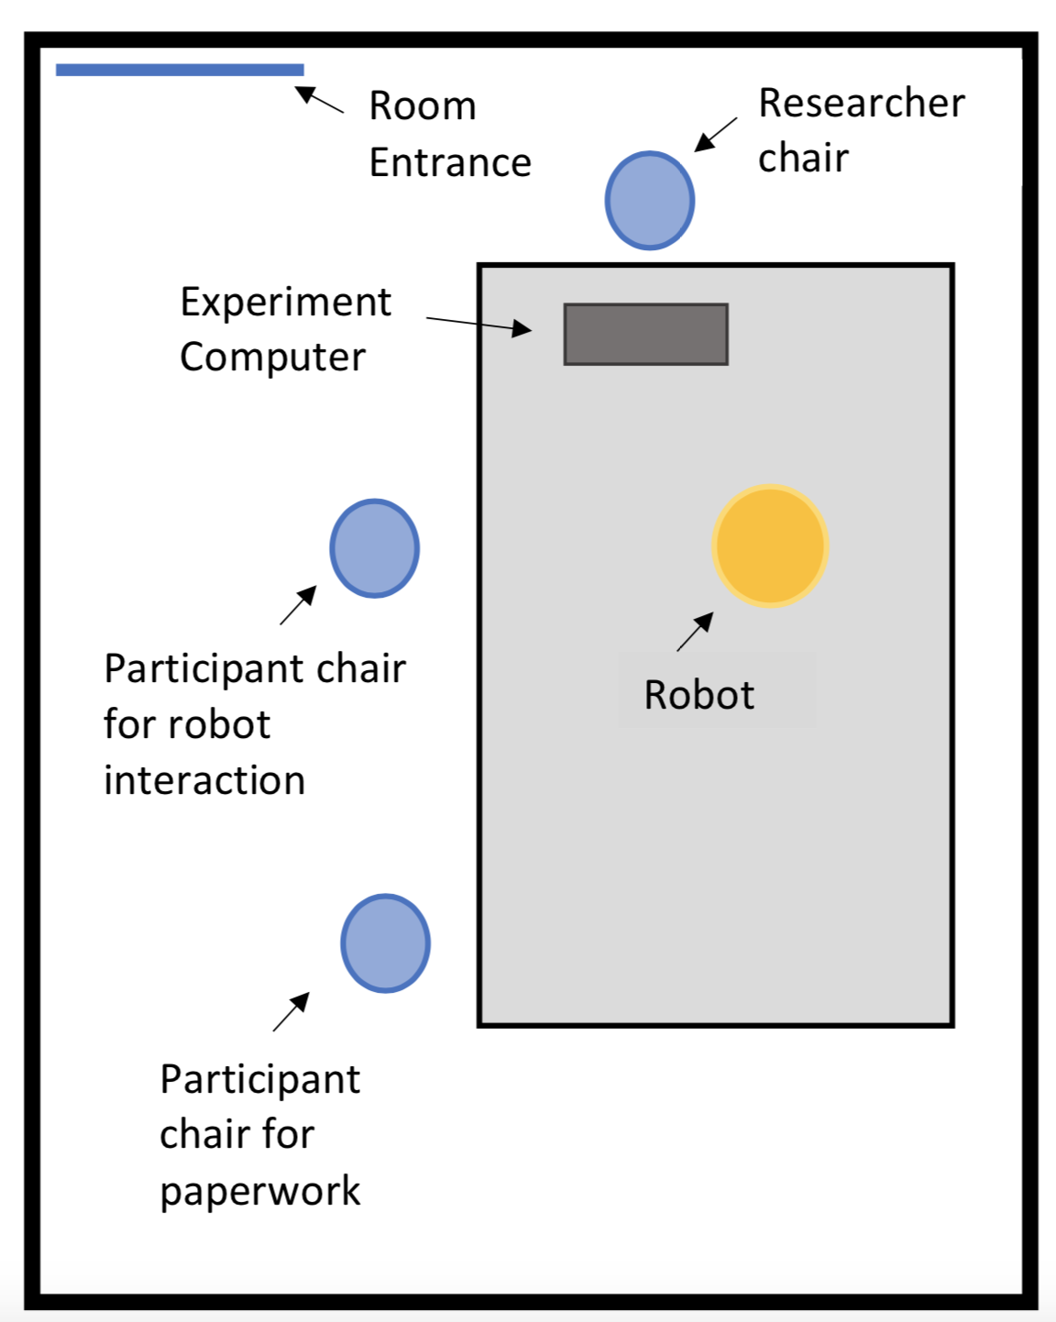

Figure S1. Experimental room set-up

