Symphony of Influence: Dark Tetrad Traits and Classical Music Preference as Predictors of Stress and Cognitive Performance

Supplementary Online Materials
Exclusion Criteria
To ensure participant safety and meet the experimental requirements, we excluded individuals diagnosed with musicogenic epilepsy, severe hearing loss, heart conditions, red-green color blindness, anxiety, dyslexia, or dyscalculia. Additionally, participants using anxiety medication, antidepressants, or sleep tranquilizers were not included.
Methodological Updates from Doumas et al. (2018) and Gomes Arrulo et al. (2021)
Doumas et al. (2018) developed a stress-inducing mathematical paradigm, resulting in subjective stress, accuracy and calculation time as outcomes on four tasks. Then Gomes Arrulo et al. (2021) adapted their paradigm to explore the interaction between dark personality traits and music preferences in relation to stress and cognitive performance, addressing a significant gap in understanding the adaptive aspects of these traits when combined with behavioral strategies. We took inspiration from their paradigm and adapted it further to create methodological improvements. We incorporated a targeted measure of mathematical anxiety in the survey, as Gomes Arrulo et al. (2021) in their future directions. This was particularly relevant to the cognitive performance tasks that required participants to solve mathematical equations under time and social pressure. This addition offered a more nuanced assessment of anxiety in relation to the demands of mathematical tasks. Furthermore, while Gomes Arrulo et al. (2021) relied solely on subjective stress reports, we integrated a physiological measure of stress, specifically heart rate, to enhance the validity and reliability of our stress assessment (Föhr et al., 2015).
Another limitation of the Gomes Arrulo et al. (2021) study was the use of the Short Dark Triad (SD3) measure, which as aforementioned, has been critiqued for its unidimensional treatment of dark traits, item overlap between Machiavellianism and psychopathy, and its overemphasis on the grandiose aspects of narcissism (Papageorgiou et al., 2019; Truhan et al., 2021). This overlap may have obscured important associations, as Gomes Arrulo et al. (2021) found an unexpected lack of significant relationships between psychopathy and stress or performance outcomes. Therefore, we adopted a multidimensional approach to dark traits and expanded our assessment to include the Dark Tetrad model (Welsh et al., 2024), providing a more comprehensive exploration of how different facets of dark personality relate to stress and performance.
In terms of experimental conditions, Gomes Arrulo et al. (2021) used three auditory conditions: hip-hop/rap music, classical/relaxing music, and silence. We adapted our study to include self-selected music or a radio documentary. In the self-selected music condition, the experimenter played the participant’s favourite artist through Apple Music, based on the artist the participant had specified in their survey. Evidence suggests that silence as a control condition may lead to discomfort, and is overused in stress research (Fancourt et al., 2014). Therefore, rather than silence we had a neutral auditory stimulus—a radio podcast—following Groarke and Hogan’s (2019) recommendation for an active control condition. Those in the radio condition participants listened to the BBC Radio documentary “Life on Earth and Beyond” by David Attenborough on Apple Podcasts. Additionally, we shortened the post-task waiting period to 10 minutes, as research shows this interval is sufficient for affect habituation following a baseline assessment, optimizing the design for both efficiency and participant comfort (Groarke & Hogan, 2019). We also allowed participants to select their own music, as self-selected music has been shown to more effectively regulate stress and elicit positive emotional responses compared to experimenter-selected music (Burns et al., 2002). These condition adjustments sought to improve the ecological validity of our current experiment to better reflect real-world music usage and ambient background noise common in academic and workplace settings.
Power Analyses
Gomes Arrulo et al. (2021) conducted a power analysis using G*Power 3, which indicated that a minimum sample of 69 participants (23 per condition) was required to achieve a power of 0.9, f(U) = 0.50, and α = .05 for analyses of variance. Given that the experimental paradigm was modified to include only two conditions, this suggested that a minimum of 46 participants would suffice for the statistical power required in the current study. Additionally, based on our priori power analysis for multiple linear regressions and moderations, based on the same significance and effect thresholds, we aimed to recruit at least 76 participants, which was the sample size achieved by Gomes Arrulo et al. (2021) to explore direct and indirect effects . Ultimately, data from 90 participants were collected.
Descriptions of Survey Instruments
The Five-Factor Narcissism Inventory – Super-Short Form (FFNI-SSF), Five-Factor Machiavellianism Inventory – Super-Short Form (FFMI-SSF), and Elemental Psychopathy Assessment – Super-Short Form (EPA-SSF) assess narcissism, Machiavellianism, and psychopathy using Five-Factor Model (FFM) trait expressions. The Five-Factor Model Antagonistic Triad Measure (FFM-ATM; Rose et al., 2023a & 2023b) reorganizes items from these instruments into four broad FFM-based dimensions—Antagonism, Agency, Impulsivity, and Emotional Stability—allowing these constructs to be examined either as traditional dark-triad traits or as integrated FFM-derived components. In this study, both scoring approaches were employed to maintain consistency with the existing dark-triad literature while also capturing the more conceptually precise, trait-level structure provided by the FFM-ATM, thereby offering a richer and more theoretically grounded interpretation of antagonistic personality features. Examples of subscales, items and reliabilities are provided below.
Agentic Narcissism: This captures the dominant, assertive, self‐confident, outgoing, leadership‐oriented aspects of grandiose narcissism. Example item (from the FFM-ATM/FFNI-SSF): “I am comfortable taking on positions of authority.” The reliability for the subscale at development was α = .52-.71 across samples. Narcissistic Antagonism: This subscale represents the disagreeable, exploitative, manipulative, entitled, arrogant core of narcissism. Example item (from the FFM-ATM/FFNI-SSF): “I deserve special treatment.” The reliability for the subscale at development was α = .68 -.77across samples. Narcissistic Neuroticism: This reflects the vulnerable side: insecurity, shame, sensitivity to criticism, hypersensitivity, self-doubt, reactive anger. Example item (from the FFM-ATM/FFNI-SSF): “I feel ashamed when people judge me.” The reliability for the subscale at development was α = .75 -.80 across samples.
Machiavellian Agency: Reflects assertiveness, ambition, leadership orientation, self‐directedness in the service of Machiavellian goals (i.e., being agentic in using others). Example item (from the FFM-ATM/FFMI-SSF): “I work hard to pursue my goals”. The reliability for the subscale at development was α = .56. Machiavellian Antagonism: Reflects manipulativeness, exploitation, cynical interpersonal strategies; aspects of Machiavellianism that involve disagreeableness and exploitative tendencies. Example item (from the FFM-ATM/FFMI-SSF): “Being honest all of the time won’t lead to success”. The reliability for the subscale at development was α = .62. Machiavellian Planning: Reflects strategic foresight, cautiousness, planning. Example item (from the FFM-ATM/FFMI-SSF): “"Act first, think later," describes me well” (reversed item). The reliability for the subscale at development was α = .73-.77 across samples.
Psychopathic Antagonism: Reflects the callous‐manipulative, deceitful, exploitative core of psychopathy (low agreeableness). Example item (from the FFM-ATM/EPA-SSF): “I have more important things to worry about than other people’s feelings.” Psychopathic Stability: This facet refers to low neuroticism (i.e., being unemotional, unflappable, emotionally shallow). Example item (from the FFM-ATM/EPA-SSF): “I’m not easily flustered.” Psychopathic Disinhibition: Reflects rashness, impulsivity, thrill‐seeking, lack of constraint. Example item (from the FFM-ATM/EPA-SSF): “I like doing things that are risky or dangerous.” The internal consistencies of the subscales have been considered adequate (ω=0.56 to 70; Van Til et al., 2024).
Antagonism: This scale reflects a tendency toward disagreeableness, manipulativeness, entitlement, exploitiveness, coldness toward others, and general interpersonal antagonism. For example, one item from the FFM-ATM is: “I’m willing to exploit others to further my own goals”. The reliability for the subscale at development was α = .86. Emotional Stability: This is the tendency toward low neuroticism (i.e., being calm, not easily upset, not worried), or conversely, low emotional instability. Higher scores reflect greater emotional stability (i.e., less anxiety, guilt, self-doubt). Example item: “I remain cool, calm, and collected when things get stressful”. The reliability for the subscale at development was α = .86. Impulsivity: This reflects a tendency toward rash, spontaneous action without sufficient forethought, thrill-seeking, lack of planning or perseverance. For example: “I tend to jump right into things without thinking very far ahead”. The reliability for the subscale at development was α = .78. Agency: This dimension captures assertiveness, ambition, leadership, goal‐directedness, confidence, and taking initiative. Example item: “I often emerge as the leader in a group”. The reliability for the subscale at development was α = .70.
The Comprehensive Assessment of Sadistic Tendences 12 item (CAST-12) is a brief measure of sadistic personality, developed by Buckels et al. (2023). Direct Physical Sadism reflects the enjoyment of personally inflicting physical pain or harm, with example items such as “I enjoy physically hurting people”. The reliability for the subscale at development was α = .79. Vicarious Sadism captures pleasure derived from observing others in pain or distress, with representative items like “I sometimes replay my favorite scenes from gory slasher films”. The reliability for the subscale at development was α = .80. Direct Verbal Sadism represents the tendency to humiliate, insult, or mock others, as illustrated by items such as “I enjoy making jokes at the expense of others”. The reliability for the subscale at development was α = .77.
The state stress subscale from the Depression Anxiety Stress Scales (DASS-21) was developed by Lovibond and Lovibond (1995.) An example item from this scale is “I found it hard to wind down.” An example item from the 11-item Math Anxiety Scale for Teachers (Hart & Ganley, 2019) is “I feel nervous when I have to solve math problems in front of others.” Classical music preference was captured using the 14-item Short Test of Music Preferences–Revised (STOMP-R; Rentfrow & Gosling, 2003). An example item from the classical music subscale is: “I enjoy listening to classical music.” Frequency of music use was assessed using the Music Use Questionnaire (MUSE; Chin & Rickard, 2012). An example item from the questionnaire is: “How often do you listen to music each day? (in hours)” The Adaptive Functions of Music Listening (AFML) scale (Groarke & Hogan, 2018) was administered, specifically the stress and cognition subscales. Example items include: Stress subscale: “I listen to music to help me relax when I’m stressed.” Cognition subscale: “Listening to music helps me concentrate and think clearly.”
The Experimental Script
Instructions for Experimental Arithmetic Tasks
Practice Trial
Experimenter 1: “In the following task, you will see several addition problems appearing on the screen.
Your task will be to decide whether the sum is correct or incorrect.
If the sum is correct, please press the Y button for ‘Yes’.
If the sum is incorrect, please press the N button for ‘No’.
You will see 6 practice problems first.
Please press the space bar to proceed.”
Tasks 1 & 4
Experimenter 1: “In the following task, you will see several addition problems appearing on the screen.
Your task will be to decide whether the sum is correct or incorrect.
If the sum is correct, please press the Y button for ‘Yes’.
If the sum is incorrect, please press the N button for ‘No’.
Please press the space bar to proceed.”
Tasks 2 & 3
Experimenter 1: “Your task will be exactly the same as before.
You will have to decide whether the sum is correct or incorrect.
If the sum is correct, please press the Y button for ‘Yes’.
If the sum is incorrect, please press the N button for ‘No’.
While you are doing this task, you will see a bar at the bottom of the screen. The bar will show how much time you have spent on the task, and how much time you have left to complete it.
There will also be a line showing the average time that other participants took when they solved these problems. At first the bar will be green, but once you reach the average completion time, it will turn red.
If you have any questions about the task, please ask now.”
Social Evaluative Threat
After the completion of Task 2 (arithmetic and time pressure) Experimenter 1 will begin to set up Task 3 when Experimenter 2 will call them out to come and discuss an issue with them. Experimenter 1 will excuse themselves, “I’m sorry, could you just excuse me for a moment?” leaving the participant in the small lab to go and have this conversation in the main lab.
Both experimenters review and discuss the data collected.
Experimenter 2: “See this is what concerned me.”
Experimenter 1: “Yes, I see. Hmm, this isn’t very good.”
Both experimenters will return to the small lab.
Experimenter 2: "Apologies, but the data collected isn't quite accurate. The bar turns from green to red when your response time exceeds the average participant's, indicating a slower performance. Could we give it another try? Please aim to respond more quickly to keep the bar green and stay on track."
Proceed to set up Task 3 and provide instructions. Both experimenters are present in the room and observing the participant whilst they complete Task 3.
Auditory Stimuli (After Task 3 and before Task 4)
Experimenter 2: “Thank you for giving that another go”.
Experimenter 1: “We will now give you a short break, during this wait period....
Active Control Condition “Please listen to the radio documentary being played through this speaker. Please do not distract yourself with anything (e.g. phone). Is this level of sound comfortable for you? (adjust speaker if required).
Self-Selected Music Condition “Please listen to some self-selected music as indicated in your survey. It will be played through this speaker. Please do not distract yourself with anything (e.g. phone). Is this level of sound comfortable for you? (adjust if required).
Both experimenters leave the room for 15 minutes. Experimenter 1 then returns to run Task 4.
During all tasks Experimenter 1 will monitor the participant to be ready to engage in the Distress Protocol (Appendix H).

Table S1
Dark Tetrad Facet Correlations
Dark Tetrad Facet Correlations |  | 1 | 2 | 3 | 4 | 5 | 6 | 7 | 8 | 9 | 10 | 11 | 12
1 | Psychopathic Antagonism | X
2 | Psychopathic Stability | -.22* | X
3 | Psychopathic Disinhibition | .49*** | -.20 | X
4 | Narcissistic Antagonism | .71*** | -.06 | .64*** | X
5 | Narcissistic Neuroticism | .05 | -.50*** | .19 | .13 | X
6 | Narcissistic Extraversion | .11 | .20 | .42*** | .45*** | .08 | X
7 | Machiavellian Antagonism | .51*** | .06 | .44*** | .51*** | -.18 | .37*** | X
8 | Machiavellian Agency | -.29** | .70*** | -.09 | -.04 | -.38*** | .27* | .18 | X
9 | Machiavellian Planning | -.24* | .27* | -.50*** | -.24 | -.30** | -.17 | -.005 | .34** | X
10 | Sadism Verbal | .29** | -.03 | .47*** | .50*** | .01 | .43*** | .58*** | .08 | -.15 | X
11 | Sadism Physical | .40*** | -.005 | .53*** | .57*** | .05 | .35*** | .51*** | .15 | -.09 | .50*** | X
12 | Sadism Vicarious | .42*** | .02 | .26* | .25* | -.12 | .42*** | .50*** | .06 | -.03 | .38*** | .36*** | X
Note: Table presents significant correlations where *** = p <.001. Dark Tetrad facets from The Five-Factor Model Antagonistic Triad Measure (FFM-ATM; Rose et al., 2023a) and the Comprehensive Assessment of Sadistic Tendencies (CAST-12; Buckels, 2023).
Table S2
Dark Facet and Outcome Correlations
 | State Stress | Math Anxiety | Subjective Stress | Physiological Stress | Accuracy | Calculation time | AFML Stress | AFML Cognition
Psychopathic Antagonism | .25** | .11 | .19 | .14 | -.01 | -.16 | -.07 | .08
Psychopathic Stability | -.40*** | -.31*** | -.30** | -.09 | .26* | -.26* | -.07 | -.15
Psychopathic Disinhibition | .19 | -.01 | -.04 | .12 | .004 | -.11 | .22** | .06
Narcissistic Antagonism | .27* | .01 | .12 | .21 | -.03 | -.14 | .002 | .01
Narcissistic Neuroticism | .37* | .07 | .10 | -.06 | -.05 | .05 | .24** | .24**
Narcissistic Extraversion | .18 | -.17 | -.07 | .08 | .21** | -.22** | .26** | .03
Machiavellian Antagonism | .02 | -.20 | .11 | .20 | .07 | -.25** | -.22 | -.06
Machiavellian Agency | -.28* | -.42*** | -.27* | -.05 | .22* | -.27** | -.22** | -.10
Machiavellian Planning | -.15 | -.02 | .09 | .01 | .009 | -.09 | -.38*** | -.27***
Sadism Verbal | .06 | -.20 | -.12 | .22* | .16 | -.24** | .002 | .03
Sadism Physical | .16 | -.10 | -.03 | .16 | .03 | -.10 | -.12 | -.15
Sadism Vicarious | .04 | -.14 | .02 | .17 | .14 | -.13 | -.05 | -.10
Note: Table presents significant correlations where * = p <.05, ** p <.01, *** = p <.001 Dark Tetrad facets from The Five-Factor Model Antagonistic Triad Measure (FFM-ATM; Rose et al., 2023a) and the Comprehensive Assessment of Sadistic Tendencies (CAST-12; Buckels, 2023).

Histograms and the Kolmogorov-Smirnov tests
A series of one-sample Kolmogorov-Smirnov tests were conducted to assess whether the distributions of subjective stress, physiological stress, accuracy, and calculation time deviated significantly from normality. The tests for subjective stress, physiological stress, and calculation time were not significant, indicating that these distributions did not differ significantly from normal. This confirmed that these dependent variables met the assumption of normality required for the application of ANOVA. Additionally, the Monte Carlo method provided further confirmation, with the lower bounds of the 99% confidence intervals for the test statistics indicating no significant deviations from normal. However, the Kolmogorov-Smirnov test for mean accuracy did show a deviation from normality (d = 0.16, p = .024). Upon further inspection of task-by-task accuracy, it was observed that baseline accuracy in Task 1 did not deviate significantly from normality. For subsequent tasks, while some deviations approached the critical threshold (p < .05), these deviations were not unexpected given the added pressures in the context of the specific task conditions, which were anticipated to introduce variability in performance. Field (2024) suggests that ANOVA is fairly resilient to violations of normality, particularly when the sample size is large enough (which is the case in this study, based on the G*Power analyses outlined in the methods). Given the robustness of ANOVA to minor deviations from normality and the consistency of the results across the other outcome variables (subjective stress, physiological stress, and calculation time), we proceeded with ANOVAs for all four experimental outcome variables.
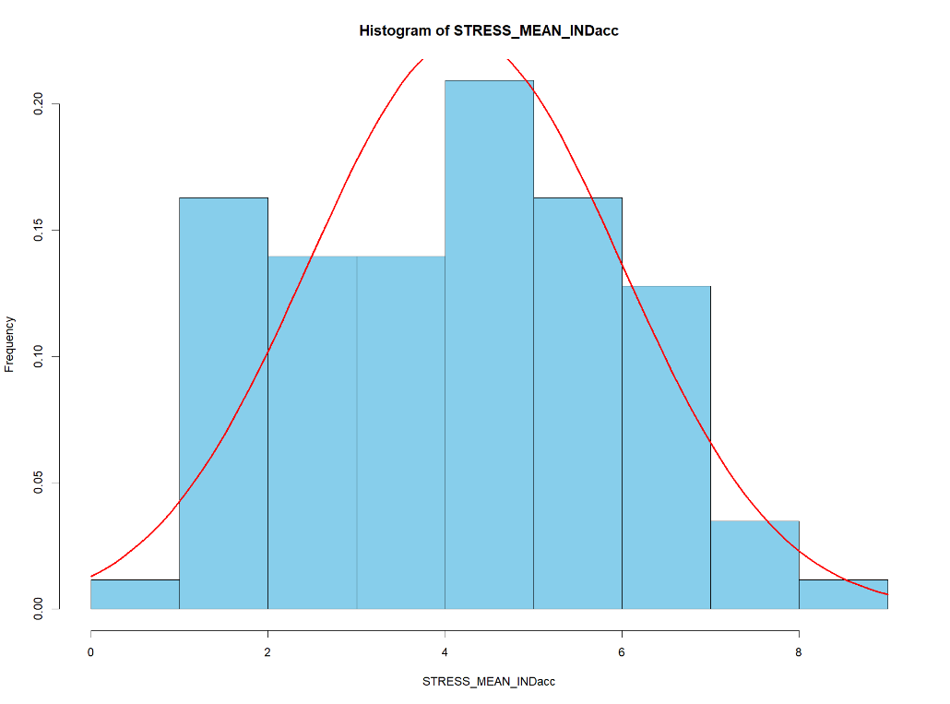
Figure S1. Histogram of Mean Subjective Stress (accounting for individual differences by taking later task scores from Task 1).
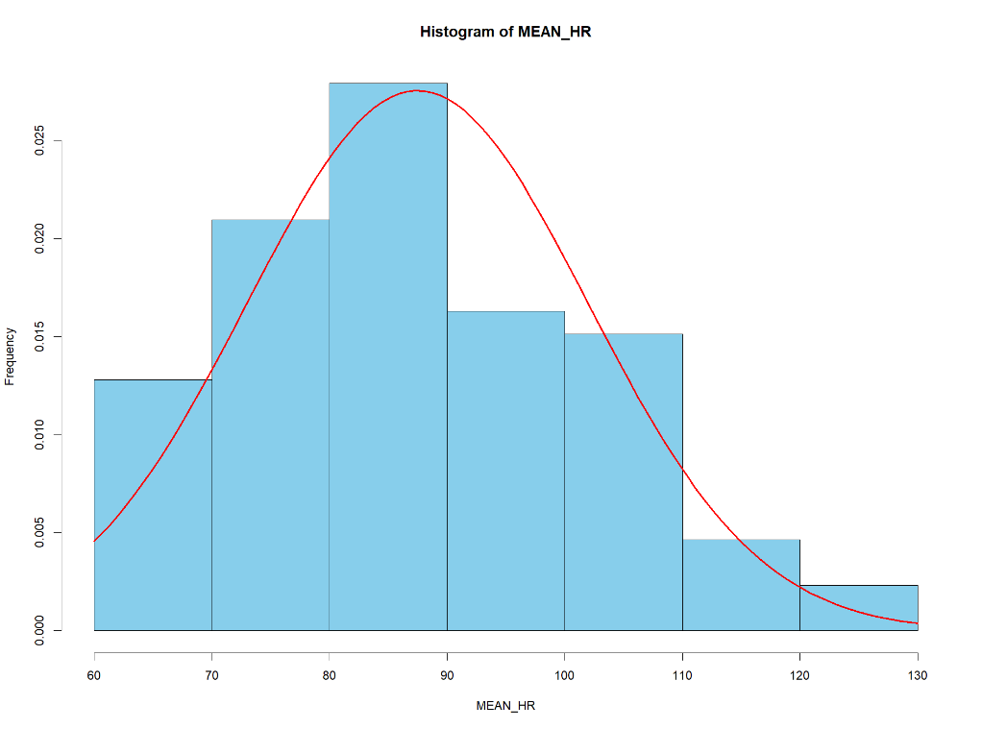
Figure S2. Histogram of Mean Physiological Stress.
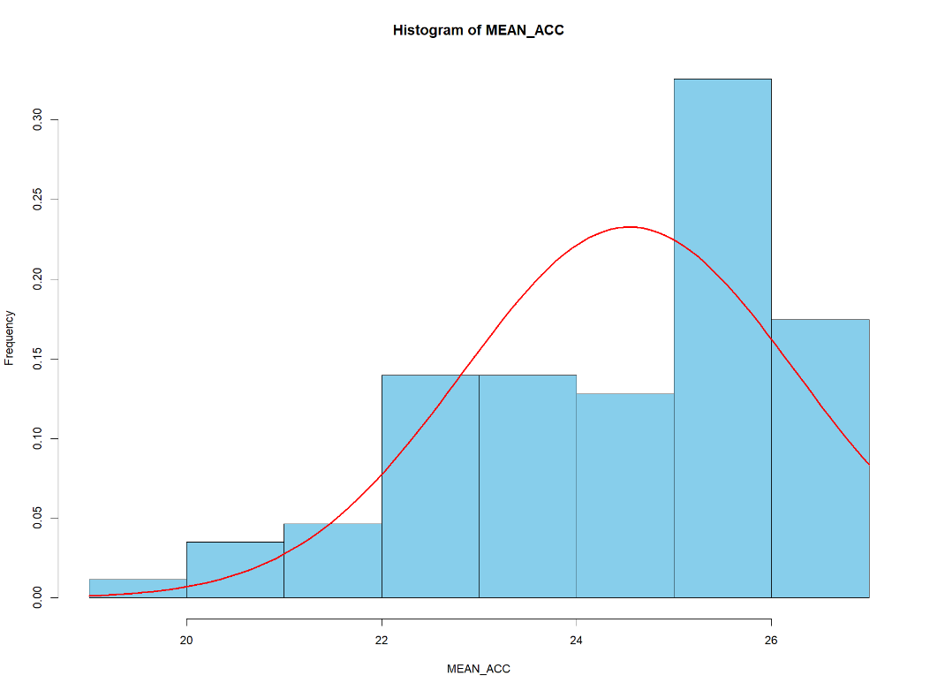
Figure S3. Histogram of Mean Task Accuracy.
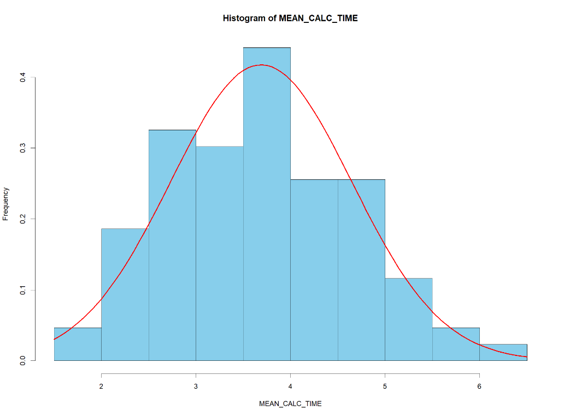
Figure S4. Histogram of Mean Task Calculation Time.

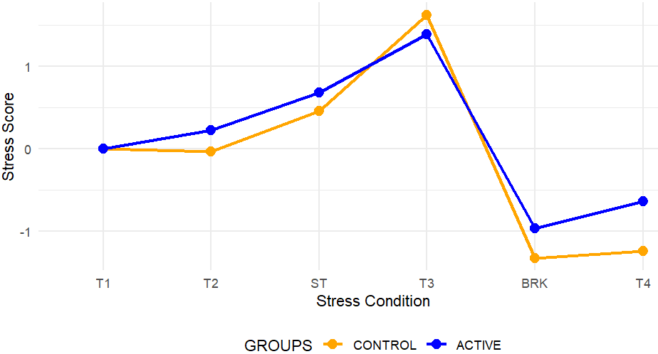
Figure S5. Visualization of Subjective Stress by Group Across the Paradigm.

Regressions
Among the regressions there are a mixture of significant and non-significant models. We choose to interpret both. While a non-significant overall model (F-test) suggests that as a collective the predictors do not account for a reliable amount of variance in the outcome. Yet, the individual predictor test examines unique effects while holding the others constant. Thus, a predictor may still appear significant within a model that is non-significant overall if the remaining predictors add little explanatory value or introduce noise. Further, multicollinearity can also weaken the joint explanatory power of the predictors, lowering the F-statistic while leaving a single predictor’s unique effect detectable. Thus, individual predictor significance reflects unique variance explained, whereas overall model significance reflects shared variance. Therefore, significant predictors in a non-significant model are not contradictory and are valuable to interpret (Field, 2024).
Dark Facets and State Stress
A multiple linear regression was conducted to examine whether agentic narcissism, narcissistic neuroticism, and narcissistic antagonism predicted state stress scores. The overall model was statistically significant, F(3, 82) = 6.45, p < .001, and explained 19.1% of the variance in stress (R² = .19, Adjusted R² = .16). The standard error of the estimate was 0.66. Narcissistic neuroticism was a significant positive predictor of stress, B = 0.25, SE = 0.07, β = .34, p = .001, 95% CI [0.10, 0.39]. Narcissistic antagonism showed a trend-level association, B = 0.26, SE = 0.15, β = .20, p = .073, 95% CI [–0.03, 0.55], but did not reach statistical significance. Agentic narcissism was not a significant predictor of stress, B = 0.05, SE = 0.09, β = .06, p = .600, 95% CI [–0.13, 0.23].
A multiple linear regression was conducted to examine whether psychopathic disinhibition, psychopathic stability, and psychopathic antagonism predicted state stress. The overall model was statistically significant, F(3, 82) = 6.24, p < .001, and explained 18.6% of the variance in stress (R² = .19, Adjusted R² = .16). The standard error of the estimate was 0.66. Psychopathic stability was a significant negative predictor of state stress, B = –0.32, SE = 0.09, β = –.35, p < .001, 95% CI [–0.50, –0.13], indicating higher stability was associated with lower state stress. Psychopathic antagonism was not a significant predictor, B = 0.19, SE = 0.16, β = .14, p = .239, 95% CI [–0.13, 0.51]. Psychopathic disinhibition was also non-significant, B = 0.07, SE = 0.12, β = .06, p = .582, 95% CI [–0.17, 0.31].
A multiple linear regression was conducted to examine whether Machiavellian planning, antagonism, and agency predicted state stress. The overall model approached significance, F(3, 82) = 2.50, p = .065, and explained 8.4% of the variance in state stress (R² = .08, Adjusted R² = .05). The standard error of the estimate was 0.71. Machiavellian agency was a significant negative predictor of stress, B = –0.29, SE = 0.12, β = –.27, p = .021, 95% CI [–0.54, –0.05], indicating that higher agency was associated with lower state stress. Machiavellian antagonism was not significant, B = 0.08, SE = 0.12, β = .07, p = .515, 95% CI [–0.16, 0.32]. Machiavellian planning was also not significant, B = –0.05, SE = 0.11, β = –.06, p = .621, 95% CI [–0.27, 0.16].
A multiple linear regression was conducted to examine whether vicarious sadism, direct physical sadism, and direct verbal sadism predicted state stress scores. The overall model was not statistically significant, F(3, 82) = 0.78, p = .507, and explained 2.8% of the variance in stress (R² = .03, Adjusted R² = –.01). The standard error of the estimate was 0.73. None of the sadism variables significantly predicted state stress. Direct verbal sadism was not a significant predictor, B = –0.02, SE = 0.10, β = –.02, p = .858, 95% CI [–0.22, 0.18]. Direct physical sadism was also a non-significant predictor, B = 0.27, SE = 0.19, β = .18, p = .160, 95% CI [–0.11, 0.64]. Vicarious sadism was not a significant predictor of stress, B = –0.02, SE = 0.10, β = –.02, p = .873, 95% CI [–0.21, 0.18].
Dark Facets and Math Anxiety
A multiple linear regression was conducted to test whether agentic narcissism, narcissistic neuroticism, and narcissistic antagonism predicted math anxiety. The overall regression model was not statistically significant, F(3, 82) = 1.25, p = .298, and explained 4.4% of the variance in math anxiety (R² = .04, Adjusted R² = .01). The standard error of the estimate was 1.18. None of the predictors significantly predicted math anxiety. Narcissistic neuroticism was not a significant predictor, B = 0.09, SE = 0.13, β = .07, p = .505, 95% CI [–0.17, 0.35]. Narcissistic antagonism was also a non-significant predictor, B = 0.22, SE = 0.26, β = .10, p = .406, 95% CI [–0.30, 0.73]. Agentic narcissism showed a trend toward a negative association with math anxiety, B = –0.29, SE = 0.16, β = –.22, p = .071, 95% CI [–0.61, 0.03], but did not reach significance.
A multiple linear regression was conducted to examine whether psychopathic disinhibition, psychopathic stability, and psychopathic antagonism predicted math anxiety. The overall model was statistically significant, F(3, 82) = 3.42, p = .021, and explained 11.1% of the variance in math anxiety (R² = .11, Adjusted R² = .08). The standard error of the estimate was 1.14. Psychopathic stability was a significant negative predictor of math anxiety, B = –0.46, SE = 0.16, β = –.32, p = .004, 95% CI [–0.78, –0.15], indicating higher stability was associated with lower math anxiety. Psychopathic antagonism was not a significant predictor, B = 0.22, SE = 0.27, β = .10, p = .422, 95% CI [–0.32, 0.76]. Psychopathic disinhibition was also non-significant, B = –0.21, SE = 0.21, β = –.12, p = .317, 95% CI [–0.62, 0.20].
A multiple linear regression was conducted to examine whether Machiavellian planning, antagonism, and agency predicted math anxiety. The overall model was statistically significant, F(3, 82) = 7.05, p < .001, and explained 20.5% of the variance in math anxiety (R² = .21, Adjusted R² = .18). The standard error of the estimate was 1.08. Machiavellian agency was a significant negative predictor of math anxiety, B = –0.78, SE = 0.19, β = –.44, p < .001, 95% CI [–1.16, –0.40], indicating higher agency was associated with lower math anxiety. Machiavellian planning was not significant, B = 0.21, SE = 0.17, β = .13, p = .216, 95% CI [–0.12, 0.54], nor was Machiavellian antagonism, B = –0.22, SE = 0.19, β = –.12, p = .232, 95% CI [–0.59, 0.15].
A multiple linear regression was run to examine whether vicarious sadism, direct physical sadism, and direct verbal sadism predicted levels of math anxiety. The overall model was not statistically significant, F(3, 82) = 1.30, p = .279, and explained 4.5% of the variance in math anxiety (R² = .05, Adjusted R² = .01). The standard error of the estimate was 1.18. None of the sadism variables significantly predicted math anxiety scores. Direct verbal sadism was not a significant predictor, B = –0.23, SE = 0.17, β = –.18, p = .168, 95% CI [–0.56, 0.10]. Direct physical sadism was also not a significant predictor, B = 0.05, SE = 0.31, β = .02, p = .862, 95% CI [–0.56, 0.66]. Vicarious sadism was not significantly associated with math anxiety, B = –0.11, SE = 0.16, β = –.08, p = .486, 95% CI [–0.44, 0.21].
Dark Facets and Subjective Stress
A multiple linear regression was conducted to examine whether agentic narcissism, narcissistic neuroticism, and narcissistic antagonism predicted individual mean subjective stress. The overall regression model was not statistically significant, F(3, 82) = 1.22, p = .307, and explained 4.3% of the variance (R² = .04, Adjusted R² = .01). The standard error of the estimate was 1.76. None of the predictors significantly predicted subjective stress. Narcissistic neuroticism was not a significant predictor, B = 0.15, SE = 0.19, β = .09, p = .427, 95% CI [–0.23, 0.54]. Narcissistic antagonism was also a non-significant predictor, B = 0.59, SE = 0.39, β = .19, p = .132, 95% CI [–0.18, 1.35]. Agentic narcissism was not a significant predictor, B = –0.32, SE = 0.24, β = –.16, p = .186, 95% CI [–0.79, 0.16].
A multiple linear regression was conducted to examine whether psychopathic disinhibition, psychopathic stability, and psychopathic antagonism predicted subjective stress. The overall model was statistically significant, F(3, 82) = 4.31, p = .007, and explained 13.6% of the variance in subjective stress (R² = .14, Adjusted R² = .10). The standard error of the estimate was 1.67. Psychopathic stability was a significant negative predictor of subjective stress, B = –0.62, SE = 0.23, β = –.29, p = .009, 95% CI [–1.08, –0.16], indicating higher stability was associated with lower subjective stress. Psychopathic antagonism showed a trend-level positive association, B = 0.77, SE = 0.40, β = .23, p = .059, 95% CI [–0.03, 1.56], but did not achieve significance. Psychopathic disinhibition was not a significant predictor, B = –0.53, SE = 0.31, β = –.20, p = .088, 95% CI [–1.13, 0.08].
A multiple linear regression was conducted to examine whether Machiavellian planning, antagonism, and agency predicted stress subjective stress. The overall model was statistically significant, F(3, 82) = 4.70, p = .004, and explained 14.7% of the variance in subjective stress (R² = .15, Adjusted R² = .12). The standard error of the estimate was 1.66. Machiavellian agency was a significant negative predictor of subjective stress, B = –1.02, SE = 0.29, β = –.38, p < .001, 95% CI [–1.60, –0.43], indicating that higher agency was associated with lower stress. Machiavellian planning was a significant positive predictor, B = 0.53, SE = 0.26, β = .22, p = .043, 95% CI [0.02, 1.03], suggesting higher planning was associated with higher subjective stress. Machiavellian antagonism was not statistically significant, B = 0.51, SE = 0.29, β = .19, p = .079, 95% CI [–0.06, 1.07].
A multiple linear regression was conducted to examine whether vicarious sadism, direct physical sadism, and direct verbal sadism predicted subjective stress. The overall model was not statistically significant, F(3, 82) = 0.58, p = .633, and explained 2.1% of the variance in stress mean accuracy (R² = .02, Adjusted R² = –.02). The standard error of the estimate was 1.78. None of the sadism variables significantly predicted subjective stress. Direct verbal sadism was not a significant predictor, B = –0.31, SE = 0.25, β = –.16, p = .218, 95% CI [–0.80, 0.19]. Direct physical sadism was also non-significant, B = 0.09, SE = 0.46, β = .02, p = .851, 95% CI [–0.83, 1.00]. Vicarious sadism was not a significant predictor, B = 0.15, SE = 0.24, β = .08, p = .538, 95% CI [–0.33, 0.64].
Dark Facets and Physiological Stress
A multiple linear regression was conducted to examine whether narcissistic antagonism, narcissistic neuroticism, and agentic narcissism predicted mean physiological stress. The overall model was not statistically significant, F(3, 82) = 1.48, p = .226, explaining 5.1% of the variance in heart rate (R² = .051, Adjusted R² = .017). The standard error of the estimate was 14.37. None of the predictors significantly predicted mean heart rate. Narcissistic antagonism was not significant, B = 5.89, SE = 3.14, β = .23, p = .065, 95% CI [–0.36, 12.14]. Narcissistic neuroticism was not a significant predictor, B = –1.30, SE = 1.58, β = –.09, p = .412, 95% CI [–4.43, 1.84], nor was agentic extraversion, B = –0.24, SE = 1.94, β = –.02, p = .900, 95% CI [–4.10, 3.61].
A multiple linear regression was conducted to examine whether psychopathic disinhibition, psychopathic stability, and psychopathic antagonism predicted mean physiological stress. The overall model was not statistically significant, F(3, 82) = 0.67, p = .573, and explained 2.4% of the variance in mean physiological stress (R² = .02, Adjusted R² = –.01). The standard error of the estimate was 14.58. None of the psychopathy dimensions significantly predicted mean physiological stress. Psychopathic antagonism was not significant, B = 2.89, SE = 3.49, β = .11, p = .410, 95% CI [–4.05, 9.83]. Psychopathic stability was not significant, B = –0.94, SE = 2.01, β = –.05, p = .640, 95% CI [–4.95, 3.06]. Psychopathic disinhibition was also non-significant, B = 0.97, SE = 2.66, β = .05, p = .716, 95% CI [–4.31, 6.25].
A multiple linear regression was conducted to examine whether Machiavellian planning, antagonism, and agency predicted mean physiological stress The overall model was not statistically significant, F(3, 82) = 1.43, p = .239, and explained 5.0% of the variance in physiological stress (R² = .05, Adjusted R² = .02). The standard error of the estimate was 14.38. Machiavellian antagonism was a significant positive predictor of physiological stress, B = 4.94, SE = 2.47, β = .22, p = .048, 95% CI [0.03, 9.85], indicating that higher antagonism was associated with higher physiological stress. Machiavellian agency was not significant, B = –2.31, SE = 2.54, β = –.11, p = .364, 95% CI [–7.36, 2.73], nor was Machiavellian planning, B = 0.91, SE = 2.22, β = .05, p = .684, 95% CI [–3.50, 5.31].
A multiple linear regression was conducted to examine whether vicarious sadism, direct physical sadism, and direct verbal sadism predicted physiological stress. The overall model was not statistically significant, F(3, 82) = 1.71, p = .172, and explained 5.9% of the variance in mean physiological stress (R² = .06, Adjusted R² = .02). The standard error of the estimate was 14.31. None of the sadism variables significantly predicted mean physiological stress. Direct verbal sadism was not a significant predictor, B = 2.51, SE = 2.00, β = .16, p = .212, 95% CI [–1.46, 6.48]. Direct physical sadism was also non-significant, B = 1.42, SE = 3.71, β = .05, p = .702, 95% CI [–5.95, 8.79]. Vicarious sadism was not a significant predictor of physiological stress, B = 1.52, SE = 1.96, β = .09, p = .441, 95% CI [–2.38, 5.42].
Dark Facets and Accuracy
A multiple linear regression was conducted to examine whether agentic narcissism, narcissistic neuroticism, and narcissistic antagonism predicted mean accuracy scores. The overall model was not statistically significant, F(3, 82) = 2.02, p = .117, and explained 6.9% of the variance in mean accuracy (R² = .07, Adjusted R² = .04). The standard error of the estimate was 1.68. Agentic narcissism was not a significant predictor of mean accuracy, B = 0.55, SE = 0.23, β = .29, p = .019, 95% CI [0.09, 1.00], when the adjusted Bonferroni-adjusted threshold of p<.012 was considered. Narcissistic neuroticism was not a significant predictor, B = –0.10, SE = 0.19, β = –.06, p = .587, 95% CI [–0.47, 0.27]. Narcissistic antagonism was also a non-significant predictor, B = –0.46, SE = 0.37, β = –.15, p = .216, 95% CI [–1.19, 0.27].
A multiple linear regression was conducted to examine whether psychopathic disinhibition, psychopathic stability, and psychopathic antagonism predicted mean accuracy. The overall model was not statistically significant, F(3, 82) = 2.13, p = .103, and explained 7.2% of the variance in mean accuracy (R² = .07, Adjusted R² = .04). The standard error of the estimate was 1.68. Psychopathic stability was not a significant positive predictor of mean accuracy, B = 0.59, SE = 0.23, β = .28, p = .014, 95% CI [0.12, 1.05]. Psychopathic antagonism was not a significant predictor, B = 0.09, SE = 0.40, β = .03, p = .832, 95% CI [–0.72, 0.89]. Psychopathic disinhibition was also non-significant, B = 0.11, SE = 0.31, β = .05, p = .713, 95% CI [–0.50, 0.72].
A multiple linear regression was conducted to examine whether Machiavellian planning, antagonism, and agency predicted mean accuracy. The overall model was not statistically significant, F(3, 82) = 1.59, p = .198, and explained 5.5% of the variance in mean accuracy (R² = .055, Adjusted R² = .02). The standard error of the estimate was 1.70. Machiavellian agency was not a significant positive predictor, B = 0.63, SE = 0.30, β = .24, p = .040, 95% CI [0.03, 1.22]. Machiavellian antagonism was not significant, B = 0.06, SE = 0.29, β = .02, p = .841, 95% CI [–0.52, 0.64], nor was Machiavellian planning, B = –0.17, SE = 0.26, β = –.07, p = .524, 95% CI [–0.69, 0.35].
A multiple linear regression was conducted to examine whether vicarious sadism, direct physical sadism, and direct verbal sadism predicted mean accuracy scores. The overall model was not statistically significant, F(3, 82) = 1.09, p = .358, and explained 3.8% of the variance in mean accuracy (R² = .04, Adjusted R² = .003). The standard error of the estimate was 1.71. None of the sadism variables significantly predicted mean accuracy. Direct verbal sadism was not a significant predictor, B = 0.29, SE = 0.24, β = .16, p = .223, 95% CI [–0.18, 0.77]. Direct physical sadism was also not significant, B = –0.30, SE = 0.44, β = –.09, p = .500, 95% CI [–1.18, 0.58]. Vicarious sadism was not a significant predictor, B = 0.22, SE = 0.24, β = .11, p = .345, 95% CI [–0.24, 0.69].
Dark Facets and Calculation Time
A multiple linear regression was conducted to examine whether agentic narcissism, narcissistic neuroticism, and narcissistic antagonism predicted mean calculation time. The overall model was not statistically significant, F(3, 82) = 1.57, p = .202, and explained 5.4% of the variance in calculation time (R² = .05, Adjusted R² = .02). The standard error of the estimate was 0.95. None of the predictors significantly predicted mean calculation time. Narcissistic neuroticism was not a significant predictor, B = 0.07, SE = 0.10, β = .08, p = .476, 95% CI [–0.13, 0.28]. Narcissistic antagonism also did not significantly predict calculation time, B = –0.10, SE = 0.21, β = –.06, p = .631, 95% CI [–0.51, 0.31]. Agentic narcissism did not reach significance, B = –0.21, SE = 0.13, β = –.20, p = .106, 95% CI [–0.46, 0.05].
A multiple linear regression was conducted to examine whether psychopathic disinhibition, psychopathic stability, and psychopathic antagonism predicted mean calculation time. The overall model was statistically significant, F(3, 82) = 3.76, p = .014, and explained 12.1% of the variance in calculation time (R² = .12, Adjusted R² = .09). The standard error of the estimate was 0.91. Psychopathic stability was a significant negative predictor of calculation time, B = –0.38, SE = 0.13, β = –.32, p = .004, 95% CI [–0.63, –0.13], indicating higher stability was associated with faster calculation times. Psychopathic antagonism was not significant, B = –0.34, SE = 0.22, β = –.19, p = .125, 95% CI [–0.77, 0.10]. Psychopathic disinhibition was also non-significant, B = –0.12, SE = 0.17, β = –.08, p = .486, 95% CI [–0.45, 0.21].
A multiple linear regression was conducted to examine whether Machiavellian planning, antagonism, and agency predicted mean calculation time. The overall model was statistically significant, F(3, 82) = 3.59, p = .017, explaining 11.6% of the variance in calculation time (R² = .116, Adjusted R² = .084). The standard error of the estimate was 0.91. Machiavellian agency significantly predicted lower calculation time, B = –0.33, SE = 0.16, β = –.23, p = .045, 95% CI [–0.65, –0.01], indicating that higher agency was associated with faster calculation performance. Machiavellian antagonism approached significance for predicting lower calculation time, B = –0.31, SE = 0.16, β = –.21, p = .052, 95% CI [–0.62, 0.002]. Machiavellian planning was not a significant predictor, B = –0.02, SE = 0.14, β = –.01, p = .909, 95% CI [–0.30, 0.26].
A multiple linear regression was conducted to examine whether vicarious sadism, direct physical sadism, and direct verbal sadism predicted mean calculation time. The overall model was not statistically significant, F(3, 82) = 1.73, p = .168, and explained 5.9% of the variance in calculation time (R² = .06, Adjusted R² = .03). The standard error of the estimate was 0.94. None of the sadism variables significantly predicted mean calculation time. Direct verbal sadism showed a trend toward a negative association, B = –0.25, SE = 0.13, β = –.24, p = .066, 95% CI [–0.51, 0.02], but did not reach significance. Direct physical sadism was not significant, B = 0.08, SE = 0.24, β = .04, p = .749, 95% CI [–0.41, 0.56]. Vicarious sadism was also not a significant predictor, B = –0.06, SE = 0.13, β = –.05, p = .657, 95% CI [–0.32, 0.20].

Table S3
Mean Experimental Outcomes by Dichotomized Dark Facets
DARK FACET | GROUP | N | SUBJECTIVE STRESS | PHYSIOLOGICAL STRESS | ACCURACY | CALCULATION TIME
Psychopathic Antagonism | High | 35 | 4.46 | 89.5 | 24.8 | 3.46
Psychopathic Antagonism | Low | 51 | 4.07 | 86.1 | 24.4 | 3.84
Psychopathic Invulnerability | High | 40 | 3.70 | 86.9 | 24.9 | 3.46
Psychopathic Invulnerability | Low | 46 | 4.68 | 88.0 | 24.2 | 3.89
Psychopathic Disinhibition | High | 49 | 4.20 | 88.6 | 24.5 | 3.64
Psychopathic Disinhibition | Low | 37 | 4.26 | 86.1 | 24.6 | 3.76
Narcissistic Antagonism | High | 43 | 4.41 | 91.6 | 24.6 | 3.53
Narcissistic Antagonism | Low | 43 | 4.04 | 83.4 | 24.5 | 3.85
Narcissistic Neuroticism | High | 36 | 4.20 | 86.7 | 24.6 | 3.66
Narcissistic Neuroticism | Low | 50 | 4.24 | 88.1 | 24.5 | 3.71
Narcissistic Extraversion | High | 30 | 4.15 | 89.5 | 24.7 | 3.56
Narcissistic Extraversion | Low | 56 | 4.27 | 86.4 | 24.5 | 3.76
Machiavellian Antagonism | High | 41 | 4.45 | 90.7 | 24.6 | 3.50
Machiavellian Antagonism | Low | 45 | 4.02 | 84.6 | 24.5 | 3.86
Machiavellian Agency | High | 51 | 3.87 | 86.9 | 24.9 | 3.47
Machiavellian Agency | Low | 35 | 4.74 | 88.4 | 24.0 | 4.01
Machiavellian Planning | High | 41 | 4.38 | 87.6 | 24.5 | 3.60
Machiavellian Planning | Low | 45 | 4.09 | 87.4 | 24.5 | 3.77
Sadism Verbal | High | 43 | 4.03 | 90.1 | 24.8 | 3.42
Sadism Verbal | Low | 43 | 4.42 | 84.9 | 24.3 | 3.96
Sadism Physical | High | 37 | 3.89 | 88.0 | 24.5 | 3.56
Sadism Physical | Low | 49 | 4.48 | 87.1 | 24.5 | 3.79
Sadism Vicarious | High | 67 | 4.11 | 89.1 | 24.7 | 3.65
Sadism Vicarious | Low | 19 | 4.64 | 81.8 | 24.0 | 3.84
Note: Dark Tetrad facets from The Five-Factor Model Antagonistic Triad Measure (FFM-ATM; Rose et al., 2023a) and the Comprehensive Assessment of Sadistic Tendencies (CAST-12; Buckels, 2023).

Table S4
Mean Experimental Outcomes by Auditory Condition

GROUP | N | SUBJECTIVE STRESS | PHYSIOLOGICAL STRESS | ACCURACY | CALCULATION TIME
ACTIVE | 45 | 4.01 | 86.1 | 24.5 | 3.74
CONTROL | 41 | 4.46 | 89.0 | 24.6 | 3.64

Table S5
Descriptives of Alternative Arrangement of the FFM-ATM Items
N = 86 Likert Scales Ranged 1-5 |  | 1 | 2 | 3 | 4 | Mean | SD | Skew | Kurtosis | ω
1 | Antagonism | X |  |  |  | 1.99 | 0.52 | 0.62 | -0.11 | .79
2 | Emotional Stability | r = .15 | X |  |  | 2.81 | 0.74 | 0.21 | -0.53 | .80
3 | Impulsivity | r = .24* | r=-.19 | X |  | 2.40 | 0.64 | 0.31 | -0.98 | .56
4 | Agency | r = .30** | r = .33** | r-.13 | X | 3.61 | 0.66 | -0.17 | -0.60 | .67

Note: SD = Standard Deviation. ω = McDonald’s Omega. r = Pearson Correlations. Dark Tetrad facets were assessed using The Five-Factor Model Antagonistic Triad Measure (FFM-ATM; Rose et al., 2023a). * = p<.05, **=p<.01, ***=p<.001
Table S6
FFM-ATM Dimension Correlations with Survey and Experimental Outcomes
 | State Stress | Math Anxiety | Subjective Stress | Physiological Stress | Accuracy | Calculation time | AFML Stress | AFML Cognition
Antagonism | .11 | -.11 | .11 | .16 | .07 | -.23* | -.19 | -.06
Emotional Stability | -.49*** | -.39*** | -.29** | -.02 | .24* | -.24* | -.24* | -.22*
Impulsivity | .15 | -.07 | -.10 | -.01 | .004 | .02 | .34** | .19
Agency | .06 | -.20 | -.14 | .02 | .22* | -.24* | .17 | -.05
Note: Dark Tetrad facets were assessed using The Five-Factor Model Antagonistic Triad Measure (FFM-ATM; Rose et al., 2023a). * = p<.05, **=p<.01, ***=p<.001
Table S7
Mean Experimental Outcomes by Dichotomized FFM-ATM Facets
FFM-ATM | GROUP | N | SUBJECTIVE STRESS | PHYSIOLOGICAL STRESS | ACCURACY | CALCULATION TIME
Antagonism | High | 46 | 4.34 | 88.6 | 24.7 | 3.38
Antagonism | Low | 40 | 4.10 | 86.2 | 24.2 | 4.05
Emotional Stability | High | 42 | 3.88 | 86.7 | 24.9 | 3.49
Emotional Stability | Low | 44 | 4.56 | 88.2 | 24.2 | 3.88
Impulsivity | High | 66 | 4.10 | 88.1 | 24.7 | 3.64
Impulsivity | Low | 20 | 4.64 | 85.6 | 24.0 | 3.85
Agency | High | 14 | 2.90 | 85.7 | 25.2 | 3.12
Agency | Low | 72 | 4.48 | 87.8 | 24.4 | 3.80
Note: Dark Tetrad facets were assessed using The Five-Factor Model Antagonistic Triad Measure (FFM-ATM; Rose et al., 2023a).

Alternative Explorations: Group Differences and Regressions
Four one-way ANOVAs of subjective stress revealed significant group differences (low vs high) using the FFM-ATM dimensions. Yet, there were no group by task interactive effects suggesting that while the high and low groups differ in their overall performance, this difference is not dependent on the specific task being performed. Thus, the ranking or relative stress and performance outcomes are stable across tasks, with no task-specific moderating effects on the group differences for agency, impulsivity, emotional stability or antagonism.
A multiple linear regression was conducted to examine whether agency, impulsivity, antagonism, and emotional stability predicted state stress. The overall model was statistically significant, F(4, 81) = 9.44, p < .001, explaining 31.8% of the variance in stress (R² = .32, Adjusted R² = .28). The standard error of the estimate was 0.61. Regarding individual predictors, emotional stability was a strong negative predictor of stress, B = –0.58, SE = 0.10, β = –.59, p < .001, 95% CI [–0.77, –0.38], while agency positively predicted stress, B = 0.23, SE = 0.11, β = .214, p = .039, 95% CI [0.01, 0.45]. Impulsivity and antagonism were not significant predictors (Impulsivity: B = –0.03, p = .804; Antagonism: B = 0.20, p = .15).
A multiple linear regression was conducted to examine whether agency, impulsivity, antagonism, and emotional stability predicted math anxiety scores. The overall model was statistically significant, F(4, 81) = 4.23, p = .004, explaining 17.3% of the variance in maths anxiety (R² = .17, Adjusted R² = .13). The standard error of the estimate was 1.11. Among the predictors, only emotional stability significantly predicted math anxiety, with higher emotional stability associated with lower anxiety, B = –0.64, SE = 0.18, β = –.40, p < .001, 95% CI [–0.99, –0.28]. Agency, impulsivity, and antagonism did not significantly predict math anxiety (Agency: B = –0.09, p = .67; Impulsivity: B = –0.27, p = .19; Antagonism: B = 0.009, p = .97).
A multiple linear regression was conducted to examine whether agency, impulsivity, antagonism, and emotional stability predicted subjective stress levels. The overall model was statistically significant, F(4, 81) = 3.69, p = .008, explaining 15.4% of the variance in subjective stress (R² = .15, Adjusted R² = .11). The standard error of the estimate was 1.66. Among the predictors, antagonism and emotional stability significantly predicted stress. Higher antagonism was associated with higher stress, B = 0.79, SE = 0.38, β = .23, p = .040, 95% CI [0.04, 1.54], while higher emotional stability predicted lower stress, B = –0.82, SE = 0.27, β = –.34, p = .003, 95% CI [–1.35, –0.28]. Impulsivity showed a trend toward predicting lower stress but was not significant (B = –0.58, p = .06), and agency did not significantly predict stress (B = –0.17, p = .57).
A multiple linear regression was conducted to examine whether agency, impulsivity, antagonism, and emotional stability predicted mean physiological stress. The overall model was not statistically significant, F(4, 81) = 0.63, p = .64, explaining 3.0% of the variance in mean heart rate (R² = .03, Adjusted R² = –.02). The standard error of the estimate was 14.62. None of the predictors significantly contributed to the model (Antagonism: B = 5.11, SE = 3.32, β = .18, p = .13, 95% CI [–1.47, 11.71]; Emotional stability: B = –1.15, p = .63; Impulsivity: B = –1.35, p = .61; Agency: B = –0.10, p = .97).
A multiple linear regression was conducted to examine whether agency, impulsivity, antagonism, and emotional stability predicted mean accuracy. The overall model was not statistically significant, F(4, 81) = 1.79, p = .139, explaining 8.1% of the variance in mean accuracy (R² = .08, Adjusted R² = .04). The standard error of the estimate was 1.684. None of the predictors significantly contributed to the model. Emotional stability (B = 0.46, SE = 0.27, β = .20, p = .094, 95% CI [–0.08, 0.10]), antagonism (B = –0.03, p = .95), impulsivity (B = 0.07, p = .83), and agency (B = 0.39, p = .20) were non-significant predictors.
A multiple linear regression was conducted to examine whether agency, impulsivity, antagonism, and emotional stability predicted mean calculation time. The overall model was statistically significant, F(4, 81) = 2.59, p = .043, explaining 11.3% of the variance in mean calculation time (R² = .11, Adjusted R² = .07). The standard error of the estimate was 0.92. None of the individual predictors reached statistical significance (Antagonism: B = –0.33, SE = 0.21, β = –.18, p = .12, 95% CI [–0.75, 0.08]; Emotional stability: B = –0.19, SE = 0.15, β = –.15, p = .196, 95% CI [–0.49, 0.10]; Impulsivity: B = 0.08, SE = 0.17, β = .06, p = .63, 95% CI [–0.25, 0.41]; Agency: B = –0.21, SE = 0.17, β = –.15, p = .22, 95% CI [–0.54, 0.12]).

References
Burns, J. L., Labbé, E., Arke, B., Capeless, K., Cooksey, B., Steadman, A., & Gonzales, C. (2002). The effects of different types of music on perceived and physiological measures of stress. Journal of Music Therapy, 39(2), 101–116. https://doi.org/10.1093/jmt/39.2.101
Fancourt, D., Ockelford, A., & Belai, A. (2014). The psychoneuroimmunological effects of music: A systematic review and a new model. Brain, Behavior, and Immunity, 36, 15–26. https://doi.org/10.1016/j.bbi.2013.10.014
Field, A. P. (2024). Discovering statistics using IBM SPSS statistics (6th ed.). SAGE Publications.
Van Til, K., Miller, J. D., & Lynam, D. R. (2024). Exploring the structure of fearlessness using self-report measures. Journal of Personality. https://doi.org/10.1111/jopy.12851

