Online Supplemental Material

Figure S1

Intervention Flow Diagram
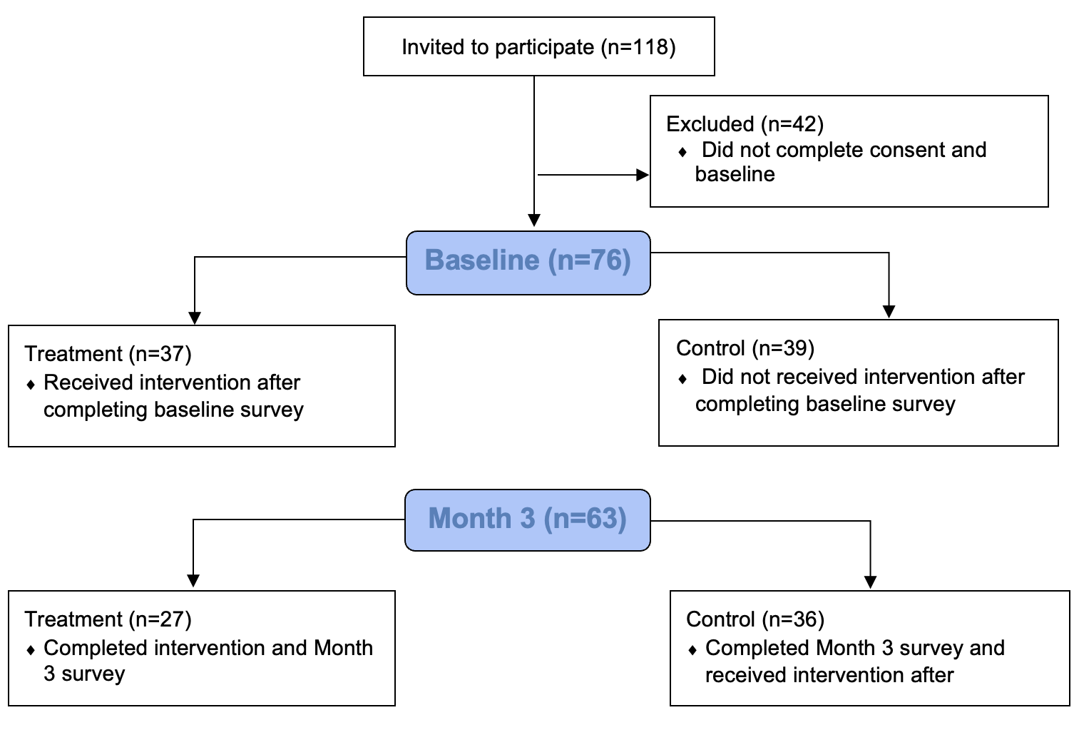

Figure S2

Intervention Timeline
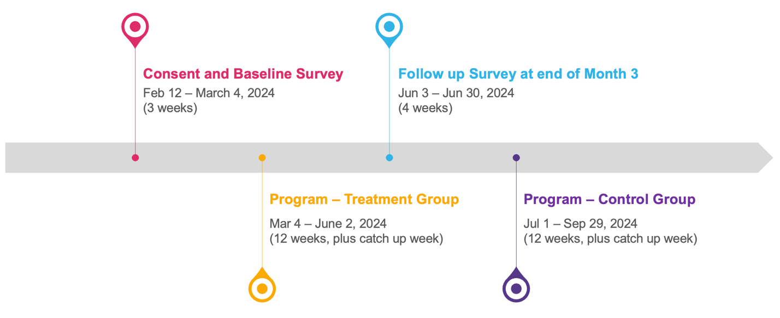

Figure S3

Principal Investigators Introductory Note for Program



Table S1

Dollars and Zen Monthly Topics and Weekly Activities

Month 1 Topics and Activities
Week 1: | Setting SMART goals information  Participants were introduced to the concept of SMART goals and to the concrete steps to determine how much to save each week to meet a financial SMART goal
Week 2: | Setting SMART goals tool  Participants were guided through setting SMART short-, medium-, and long-term financial goals and through entering information into a tool that calculates the amount they need to save each month to reach those goals
Week 3: | Money beliefs information and techniques  Participants were provided cognitive-behavioral information that helped them understand how their beliefs about money could cause stress and unhealthy financial behaviors; participants were guided through a tool that helped them identify their negative beliefs about money that they want to change and adaptive beliefs about money that they want to adopt
Week 4: | Questions to reflect on knowledge gained and actions taken
Month 2 Topics and Activities
Week 1: | Paying bills information  Participants were provided concrete tips and rationales on how to prioritize which bills to pay first and concrete tips on dealing with creditors and collection agencies
Week 2: | Paying bills tool  Participants were provided a worksheet on which they can put estimates of each monthly bill in the housing, job, insurance, and other obligations domains; this worksheet then directed them to mark the priority of each of the bills based on the risks involved with not paying that bill
Week 3: | Financial stress management plan information and techniques  Participants were introduced to the benefits of having a financial stress management plan and the specific elements of a financial stress management plan, including identifying potential areas of financial stress and ways to prevent them in advance, identifying things that are under their control, identifying sources of support in advance, and engaging in ways to calm their mind so that they can think clearly; participants were guided through creating a specific plan that addresses all of the plan elements they learned about
Week 4: | Questions to reflect on knowledge gained and actions taken
Month 3 Topics and Activities
Week 1: | Dealing with debt information and tool  Participants were provided concrete tips on paying down debt, alternatives to short-term loans, and use of debt settlement services; participants were guided through a tool that helped them note the interest rates and priorities involved with each debt as well as keep track of the minimum payment due and balance of each debt
Week 2: | Creating a savings plan information and tool  Participants were provided the most compelling reasons for saving and given concrete ways to save; participants were guided through a tool that helped them set a savings goal and brainstorm concrete ways that they could cut costs and save
Week 3: | Reducing financial stress information and techniques  Participants were provided information on and walked through specific techniques that could help them relax, release negative emotions during stress, and reimagine a better financial future for themselves; example activities they were guided through included deep breathing, expressive writing, and positive visualization
Week 4: | Questions to reflect on knowledge gained and actions taken

Table S2

Cronbach’s Alphas for Scales Used as Primary Outcomes

 | All | Baseline | Follow-up | English | Spanish
Financial Capability Scale | 0.64 | 0.67 | 0.61 | 0.58 | 0.66
Financial Self-Efficacy Scale | 0.81 | 0.81 | 0.81 | 0.88 | 0.74
Pittsburgh Sleep Quality Index | 0.75 | 0.71 | 0.79 | 0.76 | 0.69
Financial Stress Effects | 0.91 | 0.92 | 0.90 | 0.92 | 0.91

Table S3

Baseline Demographic Characteristics by Completers and Non-Completers Samples

 | Non-Completer | Completers | Diff.(2)-(3)
 | mean | mean | b | p
Women | 46% | 82% | -36% | 0.01
Hispanic | 92% | 95% | -3% | 0.67
Age | 54.67 | 43.59 | 11.07 | 0.01
Sites
Site 1 – BGCM | 46% | 37% | 10% | 0.52
Site 2 – MCLE | 38% | 16% | 23% | 0.06
Site 4 – MYM/ECC | 15% | 46% | -31% | 0.04
Site 3 – Other | 0% | 2% | -2% | 0.65
Educational Attainment
No elementary graduate | 54% | 23% | 31% | 0.02
Elementary graduate | 0% | 26% | -26% | 0.04
High school graduate | 38% | 39% | 0% | 0.99
College graduate | 8% | 13% | -5% | 0.6
Born in the United States | 17% | 24% | -7% | 0.59
Spanish Language | 92% | 77% | 15% | 0.22
Couple household | 69% | 46% | 23% | 0.13
Members in household | 3.08 | 4.03 | -0.95 | 0.12
Minors in household | 1.75 | 3.00 | -1.25 | 0.24
Home ownership/rent | 182% | 189% | -7% | 0.51
Own | 18% | 11% | 7% | 0.51
Rent | 82% | 89% | -7% | 0.51
Employment situation | 150% | 164% | -14% | 0.61
Working | 75% | 63% | 12% | 0.42
Unemployed | 0% | 10% | -10% | 0.25
Outside labor force | 25% | 27% | -2% | 0.88
Hours worked p/week | 21.11 | 27.38 | -6.27 | 0.23
Income Groups
< $34,999 | 62% | 78% | -16% | 0.22
$35,000 to $59,999 | 38% | 8% | 31% | 0
$60,000 to $99,999 | 0% | 10% | -10% | 0.25
>$99,999 | 0% | 5% | -5% | 0.43
Bank account in household | 54% | 73% | -19% | 0.18
Bank account, self | 38% | 70% | -31% | 0.03
N. | 13 | 63 | 76
Note. BGCM denotes Boys and Girls Club of Malibu, MCLE denotes Malibu Community Labor Exchange, MYM/ECC denotes Mind Your Money/Eastmont Community Center. Diff. denotes Difference. N. denotes number of observations in each group.

Table S4

Bivariate Correlation Matrix Between Primary Dependent Variables at Baseline and at 3 Months

 | Baseline |  |  |  | 3 Months
 | 1 | 2 | 3 | 4 | 1 | 2 | 3 | 4
1 Financial Capability Scale
2 Financial Self-Efficacy Scale | .27* |  |  |  | .14
3 Financial Stress Indicator | -.18 | -.36** |  |  | -.26* | -.51***
4 Financial Stress Effects | -.15 | -.37** | .63*** |  | -.18 | -.31* | .58***
5 Pittsburgh Sleep Quality Index | -.15 | -.28* | .46*** | .49*** | -.34** | -.20 | .26* | .24
Note. * p < .05. ** p<0.01. *** p<0.001.

Table S5

Difference-In-Difference Regression Estimates for Intention To Treat Approach for Secondary Outcomes

 | (1) |  | (2) |  | (3) |  | (4) |  | (5)
Dependent Variables | Track Income  Expenses |  | Reduce  Debt |  | Emergency Savings |  | Retirement  Savings |  | Financial Plan
Panel A: Financial Behaviors
Post_Intervention | 0.12 |  | 0.10 |  | -0.17 |  | -0.13 |  | 0.15
 | (0.15) |  | (0.17) |  | (0.15) |  | (0.10) |  | (0.12)
Treatment X Post_Intervention | 0.51 |  | 1.10*** |  | 0.72** |  | 0.60*** |  | 0.45**
 | (0.32) |  | (0.32) |  | (0.31) |  | (0.22) |  | (0.22)
Number of observations (N) | 129 |  | 122 |  | 129 |  | 127 |  | 137
Number of participants | 68 |  | 67 |  | 69 |  | 67 |  | 71
Model R-squared | 0.11 |  | 0.27 |  | 0.10 |  | 0.15 |  | 0.17
 | (1) |  | (2) |  | (3) |  | (4) |  | (5)
Dependent Variable | Cognitive Restructuring |  | Relaxation |  | Expressive Writing |  | Stress Management Plan |  | Positive Visualization
Panel B: Financial Stress Management
Post_Intervention | -0.18 |  | -0.02 |  | -0.10 |  | -0.07 |  | 0.14
 | (0.12) |  | (0.19) |  | (0.16) |  | (0.16) |  | (0.16)
Treatment X Post_Intervention | 0.73** |  | 0.58 |  | 0.331 |  | 0.70** |  | 0.63*
 | (0.30) |  | (0.43) |  | (0.30) |  | (0.27) |  | (0.36)
Number of observations (N) | 126 |  | 129 |  | 145 |  | 141 |  | 128
Number of participants | 69 |  | 70 |  | 75 |  | 74 |  | 68
Model R-squared | 0.13 |  | 0.05 |  | 0.02 |  | 0.11 |  | 0.14
Note. Robust standard errors in parentheses. *** p<0.01, ** p<0.05, * p<0.1. We estimate the Difference-in-Difference model including individual fixed effects and clustering standard errors at the individual level. N denotes number of observations included in each regression estimation. Here we exclude those participants who are already practicing the financial behavior and/or financial stress management activity given that they cannot show a change after intervention.

Table S6

Difference-In-Difference Regression Estimates for Treatment On the Treated Approach for Primary Outcomes

 | (1) | (2) | (3) | (4) | (5)
Dependent Variable | FCS | FSES | FSI | PSQI | FSE
Post_Intervention | -0.10 | -0.68 | 0.05 | -0.32 | -1.17
 | (0.21) | (0.73) | (0.15) | (0.56) | (1.03)
Treatment X Post_Intervention | 1.07** | 1.78* | -0.55** | -0.67 | -0.11
 | (0.46) | (0.91) | (0.22) | (0.82) | (1.52)
Number of observations (N) | 122 | 119 | 122 | 109 | 120
Number of participants | 61 | 61 | 61 | 58 | 61
R-squared | 0.14 | 0.06 | 0.13 | 0.05 | 0.05
Note. Robust standard errors in parentheses. *** p<0.01, ** p<0.05, * p<0.1. We weight by gender, education, income, and bank account ownership. We estimate the Difference-in-Difference model including individual fixed effects and clustering standard errors at the individual level. N denotes number of observations included in each regression estimation. FCS denotes Financial Capability Scale, FSES denotes Financial Self-Efficacy Scale, FSI denotes Financial Stress Indicator, PSQI denotes Pittsburgh Sleep Quality Index and FSE denotes Financial Stress Effects.

Table S7

Difference-In-Difference Regression Estimates for Treatment On the Treated Approach for Secondary Outcomes

 | (1) | (2) |  | (3) |  | (4) |  | (5)
Dependent Variables | Track Income  Expenses | Reduce  Debt |  | Emergency Savings |  | Retirement  Savings |  | Financial Plan
Panel A: Financial Behavior
Post_Intervention | 0.09 | 0.21 |  | -0.13 |  | -0.13 |  | 0.16
 | (0.21) | (0.29) |  | (0.24) |  | (0.13) |  | (0.14)
Treatment X Post_Intervention | 0.54 | 1.06*** |  | 0.64* |  | 0.58** |  | 0.46**
 | (0.33) | (0.39) |  | (0.37) |  | (0.23) |  | (0.22)
Number of observations (N) | 99 | 94 |  | 105 |  | 103 |  | 109
Number of participants | 69 | 70 |  | 75 |  | 74 |  | 68
R-squared | 0.12 | 0.29 |  | 0.07 |  | 0.14 |  | 0.19
 | (1) | (2) |  | (3) |  | (4) |  | (5)
Dependent Variable | Cognitive Restructuring | Relaxation |  | Expressive Writing |  | Stress Management Plan |  | Positive Visualization
Panel B: Financial Stress Management
Post_Intervention | -0.34** | -0.10 |  | -0.06 |  | -0.08 |  | 0.19
 | (0.15) | (0.30) |  | (0.23) |  | (0.22) |  | (0.22)
Treatment X Post_Intervention | 0.94*** | 0.72 |  | 0.26 |  | 0.74** |  | 0.63*
 | (0.31) | (0.47) |  | (0.33) |  | (0.30) |  | (0.38)
Number of observations (N) | 103 | 107 |  | 117 |  | 115 |  | 105
Number of participants | 57 | 58 |  | 61 |  | 61 |  | 56
R-squared | 0.20 | 0.06 |  | 0.01 |  | 0.12 |  | 0.15
Note. Robust standard errors in parentheses. *** p<0.01, ** p<0.05, * p<0.1. We estimate the Difference-in-Difference model including individual fixed effects and clustering standard errors at the individual level. N denotes number of observations included in each regression estimation. Here we exclude those participants who are already practicing the financial behavior and/or financial stress management activity given that they cannot show a change after intervention.
We weight by gender, education, income, site, and bank account ownership.

Table S8

Usefulness and Familiarity with Financial Capability and Financial Stress Management Topics

 | Month 1 | Month 2 | Month 3
Panel A: Financial Capability Related Material
From the choices below, how would you rate the usefulness of information covered in this month
1 Not at all useful | 5 (9%) | 2 (4%) | 4 (8%)
2 Slightly useful | 6 (11%) | 6 (12%) | 4 (8%)
3 Moderately useful | 16 (29%) | 11 (22%) | 16 (33%)
4 Extremely useful | 29 (52%) | 31 (62%) | 24 (50%)
From the choices below, how would you rate your familiarity with the information covered in this month
1 Not at all familiar | 8 (14%) | 3 (6%) | 4 (8%)
2 Slightly familiar | 18 (32%) | 14 (28%) | 14 (30%)
3 Moderately Familiar | 17 (30%) | 22 (44%) | 20 (42%)
4 Very familiar | 13 (23%) | 11 (22%) | 9 (19%)
Panel B: Financial Stress Management Related Material
From the choices below, how would you rate the usefulness of information covered in this month
1 Not at all useful | 5 (9%) | 1 (2%) | 1 (2%)
2 Slightly useful | 4 (7%) | 10 (20%) | 10 (21%)
3 Moderately useful | 15 (27%) | 12 (24%) | 15 (31%)
4 Extremely useful | 32 (57%) | 27 (54%) | 22 (46%)
From the choices below, how would you rate your familiarity with the information covered in this month
1 Not at all familiar | 9 (16%) | 8 (16%) | 10 (21%)
2 Slightly familiar | 19 (34%) | 11 (22%) | 7 (15%)
3 Moderately Familiar | 15 (27%) | 27 (54%) | 24 (51%)
4 Very familiar | 13 (23%) | 4 (8%) | 6 (13%)
Note. Percentages might add to more or less than 100 due to rounding up decimals.

Table S9

Data Collected in week 4 Each Month about Levels of Financial Stress, Recommended Actions and Use of Audio Files

 | Month 1 | Month 2 | Month 3
From the choices below, did participating in activities lower financial stress?
1 Not at all | 4 (7%) | 3 (6%) | 1 (2%)
2 Very little | 8 (14%) | 8 (16%) | 12 (26%)
3 Moderately | 27 (48%) | 27 (54%) | 17 (36%)
4 Extremely | 17 (30%) | 12 (24%) | 17 (36%)
Participants took a recommended action related to program material
Yes | 48 (86%) | 43 (86%) | 35 (74%)
No | 8 (14%) | 7 (14%) | 12 (26%)
Note. Percentages might add to more or less than 100 due to rounding up decimals. Questions about whether participating in activities lower financial stress and whether participants took recommended actions were self-reported. Data on participant clicking on audio version was collected in our platform

Table S10

Total Number of Participants and Percentages from Total that Completed Activities

 | Treatment |  | Control
Activity | Total | % | Total | % | Diff. T-C,  % points
Baseline survey | 37 |  | 39
Follow-up Survey | 27 | 73% | 36 | 92% | -19%
Month 1 - Week 1 | 35 | 95% | 26 | 72% | 23%
Month 1 - Week 2 | 34 | 92% | 21 | 58% | 34%
Month 1 - Week 3 | 33 | 89% | 19 | 53% | 36%
Month 1 - Week 4 | 33 | 89% | 19 | 53% | 36%
Month 2 - Week 1 | 33 | 89% | 18 | 50% | 39%
Month 2 - Week 2 | 32 | 86% | 18 | 50% | 36%
Month 2 - Week 3 | 30 | 81% | 18 | 50% | 31%
Month 2 - Week 4 | 30 | 81% | 17 | 47% | 34%
Month 3 - Week 1 – information | 30 | 81% | 17 | 47% | 34%
Month 3 - Week 1 - Tool | 30 | 81% | 16 | 44% | 37%
Month 3 - Week 2 - information | 29 | 78% | 16 | 44% | 34%
Month 3 - Week 2 - Tool | 28 | 76% | 15 | 42% | 34%
Month 3 - Week 3 | 27 | 73% | 15 | 42% | 31%
Month 3 - Week 4 | 27 | 73% | 15 | 42% | 31%

Study Flow Description
We had in our sample 37 and 39 participants in treatment and control groups, respectively. We show in column denoted as “Total” the number of participants that completed a specific weekly activity. Percentages in the column denoted as “%” are calculated out of the total number of participants in treatment and control groups (37 and 39 respectively). Differences expressed as percentage points show in the column denoted as “Diff. T-C, % points” are estimated by subtracting the completion percentage rates between treatment and control groups. Treatment group completed first the baseline survey, were invited to complete program activities in the first three months, and a follow up survey right at the end of the program. Control group completed first the baseline survey and the follow up survey at the same time as the treatment group. Control group participants who completed the follow survey were invited to complete program activities. Participants were given the flexibility to complete program activities at their own pace during the month, where they will be drop off from program if they did not complete program activities by the monthly deadline, which was set after one extra week. We conducted follow up phone calls among participants in treatment group that did not complete all activities by the end of the month. We did not conduct follow up phone calls among control group participants.

Table S11

Percentage of Participants that Clicked on the Audio File in the First Page and that Spent More than 3 Minutes on the Weekly Activity

 | MONTH 1 | MONTH 2 | MONTH 3
Week 1 - audio click | 44% | 49% | 51%
Week 1 - spent more than 3 min | 75% | 60% | 75%
Week 2 - audio click | 47% | 53% | 49%
Week 2 - spent more than 3 min | 95% | 87% | 67%
Week 3 - audio click | 46% | 2% | 38%
Week 3 - spent more than 3 min | 70% | 100% | 98%
Week 4 - audio click | 45% | 42% | 44%
Week 4 - spent more than 3 min | 64% | 73% | 67%
Note. We estimate the percentage of participants that clicked in the audio file for the first page of the weekly activity and those who spent more than 3 minutes completing the weekly activity. We calculate this using available data from participants collected in our platform.

Table S12

Participants Responses About Their Financial Behavior*

Budgeting and Planning
"I organized expenses and income to be able to save in a smarter way and write down debts to keep them in mind and pay them off, apart from that the breathing exercises were useful to relax"
"I planned my 3 GOALS in a table to have them visible and thus it is more committing to follow the process. At the same time more motivating to be seeing how I am moving forward with my purpose. And making electronic transactions to make it easier."

Expense Management and Conscious Spending
"First I started to pay the smallest debt, then buy only the indispensable and get rid of the unnecessary expenses to have a better economic solvency. Also practice the relaxation exercises."
"I put into practice not spending money on something that I can prepare in my house. And be more positive about the money."

Debt Management and Debt Repayment
"I made plans to pay off my debt so I can begin saving."
"This month I focused on how to deal with debt and how to reimagine and release. I don’t think my family and I are at a place to save yet"

Bill and Payment Management
"I looked over my bills, and put the most important ones first, and so on. I have to not stress as much, like I have."
"The action I took was to prioritize payments, which one is the most important and which others are not so much, for example paying the rent on time because otherwise I could be evicted and that would cause me more problems and therefore more stress."

Income Management and Saving
"I have a savings account now. Managed not to spend it due to staying calm doing some breathing exercises it helps to think twice. Dealing with debt a day at a time starting out with small payments little by little caught up, eventually."
"I made a budget of my expenses and income, I set savings goals and I met them, and I am getting closer to my short-term goals"

Note. *We underline here parts of statements that also relate to financial stress management techniques. We translated to English when necessary and made edits to correct for grammar and typos.

Table S13

Participants Responses About Their Financial Stress*

Stress Reduction and Relaxation
"Try to look for information that helps me calm down and understand what [sic] There are things that are out of my control but there are little things that I can do to stay calm and practice prayer, to believe that God will never abandon me."
Practicing Positivity and Mindfulness
"I am trying to write down how I feel and why and this is helping me to stop thinking about it. I wrote it down and read it out loud and now I am understanding why I am angry and trying to see what I can do"
Planning and Collaboration
"Prioritized the bills that needed to be paid at each pay period and requested an extension where possible. Focused on managing my financial stress by create a plan, anticipating challenges and communicating my needs with my partner to get support."

Note. *We underline here parts of statements that also relate to financial management techniques. We translated to English when necessary and made edits to correct for grammar and typos.

