Supplemental Material A
Table SA-1
Sociodemographic Characteristics of Participants
Baseline characteristics | Total Sample  (N = 176) | Control  (n = 106) | Intervention  (n = 70) | p-value ª
Gender |  |  |  | .82
Male | 39 (22.2%) | 25 (23.6%) | 14 (20.0%)
Female | 134 (76.1%) | 79 (74.5%) | 55 (78.6%)
Different identity | 3 (1.7%) | 2 (1.9%) | 1 (1.4%)
Age | 37.28 (15.81) | 37.09 (16.66) | 37.57 (14.54) | .85
Marital status |  |  |  | .70
Never married | 53 (30.1%) | 34 (32.7%) | 19 (27.1%)
Married | 70 (39.8%) | 38 (36.5%) | 32 (45.7%)
De facto | 13 (7.4%) | 7 (6.7%) | 6 (8.6%)
Separated/Divorced | 16 (9.1%) | 11 (10.6%) | 5 (7.1%)
Widowed | 2 (1.1%) | 2 (1.9%) | 0 (0.0%)
Civil partnership | 4 (2.3%) | 3 (2.9%) | 1 (1.4%)
In a relationship but not  living together | 26.(9.1%) | 9 (8.7%) | 7 (10.0%)
Missing | 2 (1.1%) | 2 (1.89%) | 0 (0.0%)
Children ^{b} | 81 (46%) | 46 (43.4%) | 35 (50.0%) | .39
Highest educational level |  |  |  | .93
Some high school | 11 (6.3%) | 8 (7.5%0 | 3 (4.3%)
High school degree or  equivalent | 96 (54.5%) | 57 (53.8%) | 39 (55.7%)
Bachelor’s degree | 33 (18.8%) | 20 (18.9%) | 13 (18.6%)
Postgraduate degree | 28 (15.9%) | 16 (15.1%) | 12 (17.1%)
PhD or higher level | 8 (4.5%) | 5 (4.7%) | 3 (4.3%)
Employment |  |  |  | .78
Unemployed/home  duties | 29 (16.5%) | 17 (16.0%) | 12 (17.4%)
Casual / Part-time work | 54 (30.7%) | 30 (28.3%) | 24 (34.8%)
Full-time work | 41 (23.3%) | 28 (26.4%) | 13 (18.8%)
Studying only | 22 (12.5%) | 14 (13.2%) | 8 (11.6%)
Working and studying | 29 (16.5%) | 17 (16.0%) | 12 (17.4%)
Missing | 1 (0.6%) | 0 (0.0%) | 1 (1.4%)
Household income (weekly) |  |  |  | .17
Nil income | 8 (4.5%) | 4 (3.8%) | 4 (5.9%)
$1–$199 | 9 (5.1%) | 8 (7.6%) | 1 (1.5%)
$200–$299 | 7 (4.0%) | 3 (2.9%) | 4 (5.9%)
$300–$399 | 12 (6.8%) | 8 (7.6%) | 4 (5.9%)
$400–$599 | 19 (10.8%) | 15 (14.3%) | 4 (5.9%)
$600–$799 | 16 (9.1%) | 9 (8.6%) | 7 (10.3%)
$800–$999 | 13 (7.4%) | 8 (7.6%) | 5 (7.4%)
$1,000–$1,249 | 13 (7.4%) | 10 (9.5%) | 3 (4.4%)
$1,250–$1,499 | 13 (7.4%) | 5 (4.8%) | 8 (11.8%)
$1,500–$1,999 | 19 (10.8%) | 10 (9.5%) | 9 (13.2%)
$2,000–$2,499 | 18 (10.2%) | 12 (11.4%) | 6 (8.8%)
$2,500–$2,999 | 3 (1.7%) | 2 (1.9%) | 1 (1.5%)
$3,000–$3,499 | 7 (4.0%) | 2 (1.9%) | 5 (7.4%)
$3,500–$3,999 | 6 (3.4%) | 5 (4.8%) | 1 (1.5%)
$4,000–$4,999 | 8 (4.5%) | 4 (3.8%) | 4 (5.9%)
$5,000 or more | 2 (1.1%) | 0 (0.0%) | 2 (2.9%)
Missing | 3 (1.7%) | 1 (0.9%) | 2 (2.8%)
ESOL ^{b} | 23 (13.1%) | 14 (13.2%) | 9 (12.9%) | .95
Imagery ability^{c} | 3.76 (0.61) | 3.70 (0.60) | 3.84 (0.62) | .15
Perceived distress^{d} | 21.25 (6.84) | 21.89 (6.73) | 20.29 (6.95) | .13
Note. ESOL = English to Speakers of Other Languages; indicates participants whose first language is not English. Perceived stress was measured using the Perceived Stress Scale (PSS-10; Cohen & Williamson, 1988).
ª Statistical analyses were conducted to test differences in demographical characteristics between the intervention and control group. Independent samples t-tests were used for continuous data, and chi-square tests were used for categorical data.
^{b} Reflects the number and percentage of participants answering “yes” to this question.
^{c} PSS-10 (Cohen & Williamson, 1988)
^{d} International Personality Item Pool factor V (intellect and imagination) of Goldberg’s Big-Five Factor Markers (Goldberg, 1992, 1999)

Supplemental Material B
Figure SB-1
Overview of Study Design and Randomisation Procedure
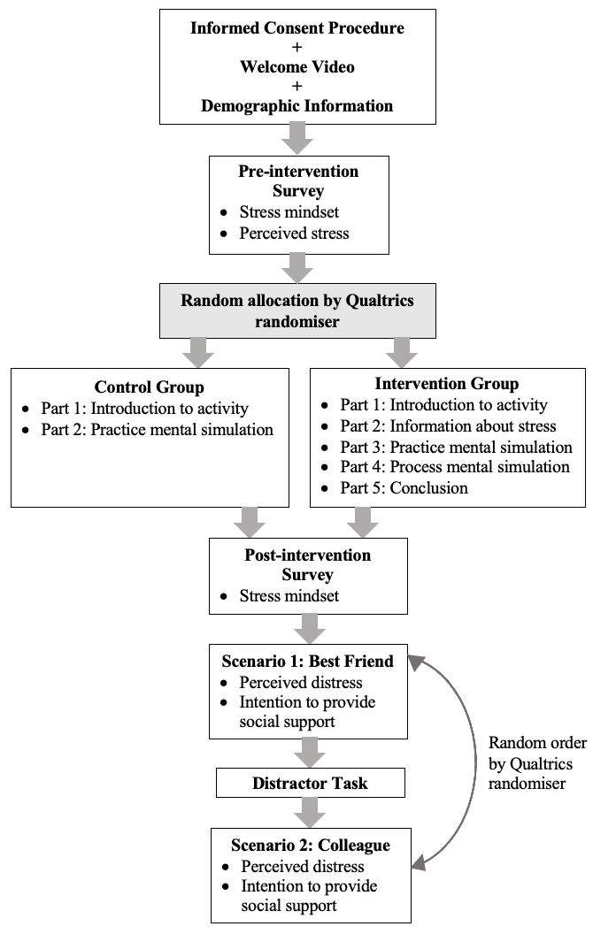

Supplemental Material C
Table SC-1
Item Wording for Study Measures
Variable | Measure | Items | Scale/Scoring
Stress mindset | SCMM (Keech et al., 2018) | You are unable to use stress to enhance your performance and productivity*  Stress can be used as a way to get the most out of your life  Stress can be used to enhance your health and vitality  Stress must be reduced or avoided to get the most out of life*  You can use stress to boost your performance and productivity  Stress will impair your health and vitality*  Stress can be used to enhance your performance and productivity  You can use stress to stimulate your health and vitality  Stress can be used to enhance your learning and growth  The effect of stress on you is negative*  You are unable to use stress to enhance your learning and growth*  You are unable to use stress to enhance your health and vitality*  Stress will impair your learning and growth*  Stress will impair your performance and productivity*  You can use stress to facilitate your learning and growth | 1 = strongly disagree,  6 = strongly agree  Scale calculated: mean
Perception of others’ stress | Distress thermometer - adapted (Roth et al., 1998) | In reference to each hypothetical scenario, participants answered the question, “Imagining the scenario you just read, how much distress do you think your friend (or colleague) has been experiencing in the past week including today?”.  Participants were also presented with a colour graphic representation of the distress thermometer. | 0 = no distress  10 = extreme distress
Intention to provide social support | Provision of social support - adapted (Jetten et al., 2011; Steffens et al., 2016) | I would be likely to help them with their tasks  I would be likely to provide emotional support to them  I would be likely to listen to them if they need to talk  I would be likely to make them feel cared for | 1 = strongly disagree,  7 = strongly agree  Scale calculated: mean
* = Reverse-coded item

Supplemental Material D
Table SD-1
Hypothetical Scenarios: Stressor Description, Wording, and Scoring
Text Reference | Scenario 1 (Best friend) | Scenario 2 (Colleague) | SRRS Score
Relationship statement | Alex has been your best friend for more than 10 years and is someone you know very well and spend time with on a regular basis. | Jamie is a colleague from work who you have known for 2 months and occasionally have small talk with over lunch. | -
Stressor 1  Taking on a mortgage | Alex has recently bought a house and taken out a substantial home loan, and told you that they will be moving in 2 weeks | Although you don’t know Jamie very well, at a recent lunch, Jamie shared with you that they have just purchased a home and taken out a large mortgage | 31
Stressor 2  Change in residence | Alex is now packing and dealing with logistics for the move with little support, while also working full-time. | The move will take place in a couple of weeks, which means that Jamie is spending much of their evenings and weekends packing and organising things with minimal help. | 20
Stressor 3  Troubles with the boss | Yesterday, Alex told you that they have been called into a serious work meeting due to workplace issues, and has mentioned to you that there have been some troubles with their manager. | On top of this, Jamie also told you that there have been some issues with their boss, who has called them into a serious meeting | 23
Stressor 4  Revision of personal  habits | Besides this, you are aware that Alex recently made a firm commitment to participate in a running group that meets daily after work because Alex’s doctor advised that they need to engage in more regular exercise. | In addition, you find out that Jamie has recently committed to participating in a rowing club that meets every weekday before work based on advice from their GP to increase daily physical activity. | 25
Note. SRRS = Social Readjustment Rating Scale (Holmes & Rahe, 1967). Life stressors and scores are derived from the SRRS, with a total score of 99 points in each scenario. A cumulative life stressor score of 150-299 over a 2-year period indicates a high level of stress and a 50% chance of experiencing a major health breakdown in the near future (the next 2 years).

Supplemental Material E
Table SE-1
Means and Standard Deviations for Dependent Variables
Test variable | Control Group | Intervention Group
Stress mindset
Pre-intervention | 3.19 (0.89) | 3.31 (0.83)
Post-intervention | 3.18 (0.96) | 3.96 (0.91)
Perception of others’ stress
Best friend | 7.46 (1.35) | 7.46 (1.57)
Colleague | 7.24 (1.43) | 7.06 (1.61)
Intention to provide social support
Best friend | 6.16 (0.89) | 6.21 (1.08)
Colleague | 5.42 (1.23) | 5.37 (1.28)

