Supplementary Material:
Table 1:
Correlation Table
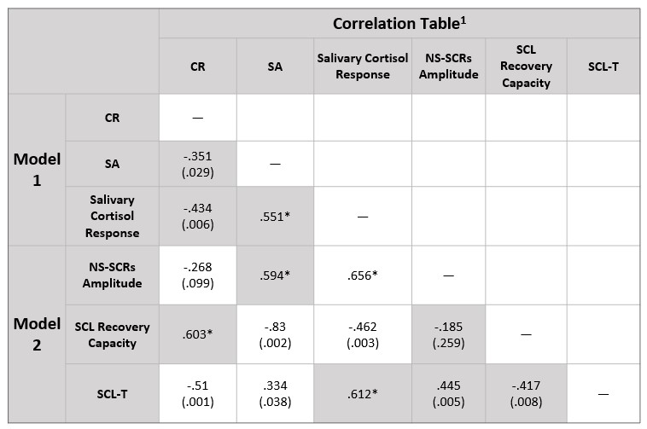
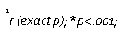

Note:
Pearson correlation, N= 39; CR: Cognitive reserve; SA: State-Anxiety; Salivary Cortisol Response: the differential adrenocortical response. This consists of the difference between S0 and S1 (S1-S0), in order to know the increase of cortisol in response to the stressor; NS-SCRs Amplitude: the mean amplitude of non-specific skin conductance responses; SCL Recovery Capacity: the average conductance level recovery response after a peak; SCL-T: the skin conductance level trend.

