Supplemental Materials A

Community Assessment of Psychic Experiences (CAPE)

1. Do you ever feel as if people seem to drop hints about you or say things with a double meaning?

(please tick)

Never Sometimes Often Nearly always

2. Do you ever feel as if things in newspapers or on TV shows were written especially for you?

(please tick)

Never Sometimes Often Nearly always

3. Do you ever feel as if some people are not what they seem to be?

(please tick)

Never Sometimes Often Nearly always

4. Do you ever feel as if you are being persecuted in some way?

(please tick)

Never Sometimes Often Nearly always

5. Do you ever feel as if there is a conspiracy against you?

(please tick)

Never Sometimes Often Nearly always

6. Do you ever feel that people look at you oddly because of your appearance?

(please tick)

Never Sometimes Often Nearly always

7. Do you ever feel as if the thoughts are being taken away from you?

(please tick)

Never Sometimes Often Nearly always

8. Have your thoughts ever been so vivid that you were worried other people would hear them?

(please tick)

Never Sometimes Often Nearly always

9. Do you ever hear your own thoughts being echoed back to you?

(please tick)

Never Sometimes Often Nearly always

10. Do you ever hear voices when you are alone?

(please tick)

Never Sometimes Often Nearly always

11. Do you ever hear voices talking to each other when you are alone?

(please tick)

Never Sometimes Often Nearly always

12. Do you ever feel as if a double has taken the place of a family member, friend or acquaintance?

(please tick)

Never Sometimes Often Nearly always

13. Do you ever see objects, people or animals that other people cannot see?

(please tick)

Never Sometimes Often Nearly always

14. Do you ever feel as if the thoughts in your head are not your own?

(please tick)

Never Sometimes Often Nearly always

Supplemental Materials B

Trauma History Screen (THS)

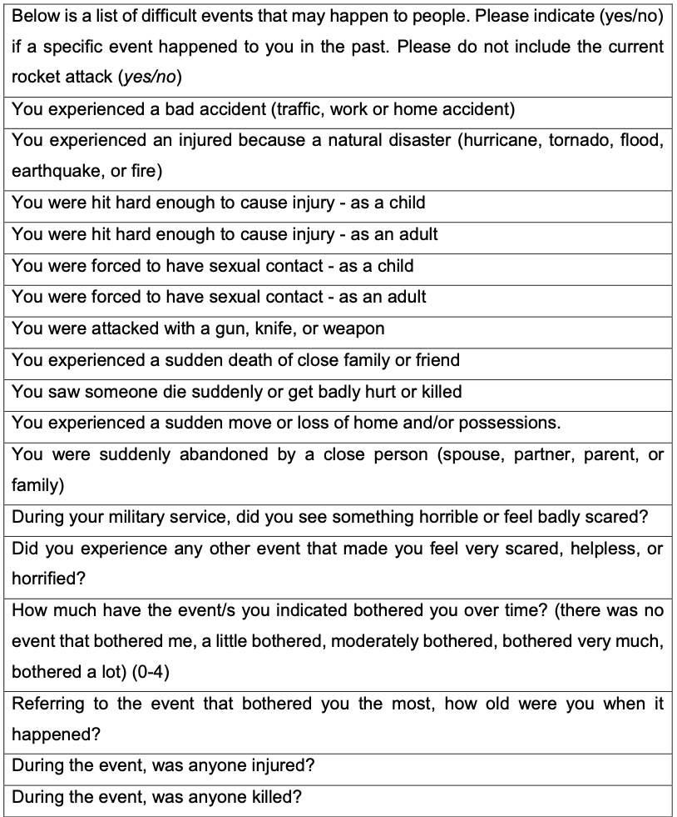

Supplemental Materials C

Multilevel Linear Regression Models and Assumption Tests

Supplementary Table 1
Multilevel Linear Regression Model Estimates for the Effects of Siren Exposure and Time on PE during Conflict
 | Model 2 |  |  |  | CAPE model
Variables | β | 95% CI | p |  | β |  | 95% CI | p
Siren | 0.19 | [0.07, 0.30] | 0.002 |  |  | 0.16 | [0.05, 0.27] | 0.004
Time | -0.01 | [-0.02, 0.00] | 0.152 |  |  | -0.01 | [-0.02, 0.01] | 0.221
CAPE score | - | - | - |  |  | 0.20 | [0.12, 0.29] | <0.001

Supplementary Table 2
Shapiro-Wilk Test of Normality
 | W | p-value
Model | 0.83 | <0.001

Note. The Shapiro-Wilk test of normality is significant which suggests that the model residuals do not conform to the assumption of being normally distributed.

Supplementary Figure 1
QQ-Plot
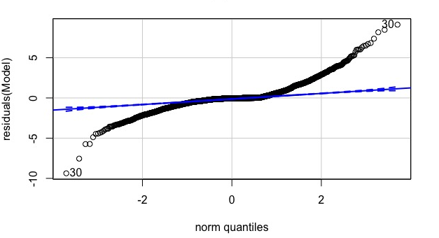
Note. The Q-Q plot does not look normal which suggests that the model residuals do not conform to the assumption of being normally distributed.

Supplementary Figure 2
Residual vs. Fitted Plot
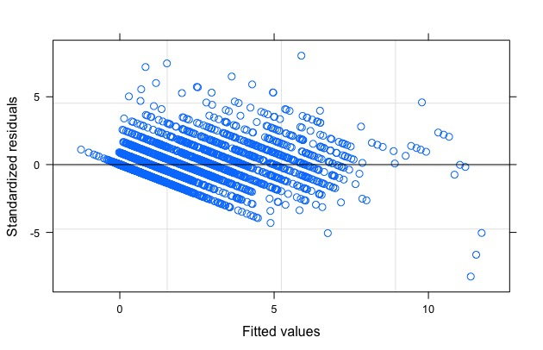

Note. There is a pattern to the residuals plotted against fitted values which suggests that the variance of the residuals is non-constant, or “heteroscedastic”.
Supplemental Materials D
Missing Data
To detect any potential biases arising from the missing data, we performed a multilevel regression analysis to assess whether any sample characteristics predicted the number of completed experience sampling assessments. Participants who reported to be average in terms of financial status completed 9.47 more assessments than those who were below average (95% CI 5.50– 13.46; p<0.001). Moreover, a positive association was found between PE at baseline and the number of valid assessments. More specifically, for every unit increase in CAPE score, the number of completed assessments increased with 0.24 (95% CI 0.14– 0.33; p<0.001). This provided strong evidence that financial status and PE at baseline were associated with the number of completed experience sampling assessments.
There was no evidence of any relationship between participants’ age and the number of completed assessments (p=0.419), nor between gender and the number of completed assessments (p=0.102). In addition, there was no evidence of an association between the number of completed assessments and the number of types of traumatic events which participants had experienced before the conflict started (p=.308).
These analyses suggested that the data were not missing completely at random (MCAR) since financial status and PE at baseline were associated with the number of completed experience sampling responses. Consequently, we made an assumption that the data were missing at random (MAR), implying that whether the data were missing or not was related to the values of the observed data (Sterne et al., 2009). We therefore considered an observed case analysis to be valid by adjusting for the covariates that made the MAR assumption plausible.
Supplemental Materials E
Multilevel Logistic Regression Models
Supplementary Table 3
Fit Indices for Multilevel Logistic Regression Models Predicting PE during Conflict
 | Model 1 | Model 2 | Model 3
Predictors | Siren exposure | Siren exposure and time | Siren exposure, time, and interaction of siren exposure × time
AIC | 3205 | 3197 | 3196
BIC | 3244 | 3242 | 3248
Note. Lower AIC and BIC values indicate better model fit which suggests that Model 2 is the best fitting model.

Supplementary Table 4
Stratified Analyses for Low-Trauma and High-Trauma Groups
 | Low trauma (< 2 THS score) |  |  |  | High trauma (≥ 2 THS score)
 | OR | 95% CI | p |  | OR |  | 95% CI | p
Siren | 1.14 | [0.77, 1.68] | 0.509 | 1.32 |  | [0.89, 1.97] |  | 0.173
Time | 0.94 | [0.91, 0.98] | 0.002 | 0.96 |  | [0.93, 1.00] |  | 0.062

Note. The effect of siren exposure on PE did not change depending on whether participants belonged to the low-trauma versus high-trauma group.

Supplementary Table 5
Model Estimates for the Effects of Siren Exposure and Time on PE during Conflict (N=112)
 | Model 2
Variables | OR | 95% CI | p
Siren | 1.37 | [1.07, 1.74] | 0.012
Time | 0.96 | [0.93, 0.98] | <0.001
Note. There were only minor differences in the odds ratios (OR), confidence intervals (CI), and p-values compared to the analyses with participants who had completed at least 20 experience sampling assessments (N=97).

Supplementary Table 6
Model Estimates for the Effects of Siren Exposure and Time on PE Moderated by THS Score (N=112)
 | THS model with interaction
Variables | OR | 95% CI | p
Siren | 1.38 | [1.08, 1.76] | 0.010
Time | 0.96 | [0.93, 0.98] | <0.001
THS score | 1.47 | [0.93, 2.31] | 0.099
Siren × THSª | 1.02 | [0.86, 1.21] | 0.824
Note. There were only minor differences in the odds ratios (OR), confidence intervals (CI), and p-values compared to the analyses with participants who had completed at least 20 experience sampling assessments (N=97).

