Supplementary Material 2
Additional Exploratory Analyses
We examined the correlation between the delta of psychological variables (i.e., derived from the Feeling Scale, Felt Arousal Scale, Borg Scale, and Attentional Scale; rated from 5 min to 20 min) and the delta of O₂Hb (Min 0–5 to Min 15–20) in two hemispheres using R Studio (v. v2024.12.1+563). Results indicated that only the correlation between attentional focus and O₂Hb in the right hemisphere was significant (r = 0.231, p = 0.032; see Table 1 and Figure 1).

Table 1. The Pearson correlation between psychological variables and PFC activation
 | ΔFS | ΔFAS | ΔBS | ΔAS
ΔO₂Hb: Left | -0.138 | -0.022 | 0.162 | 0.114
ΔO₂Hb: Right | 0.004 | -0.015 | 0.023 | 0.231*
Note: FS = Feeling Scale, FAS = Felt Arousal Scale, BS = Borg Scale, AS = Attentional Scale.
*p <0.05.

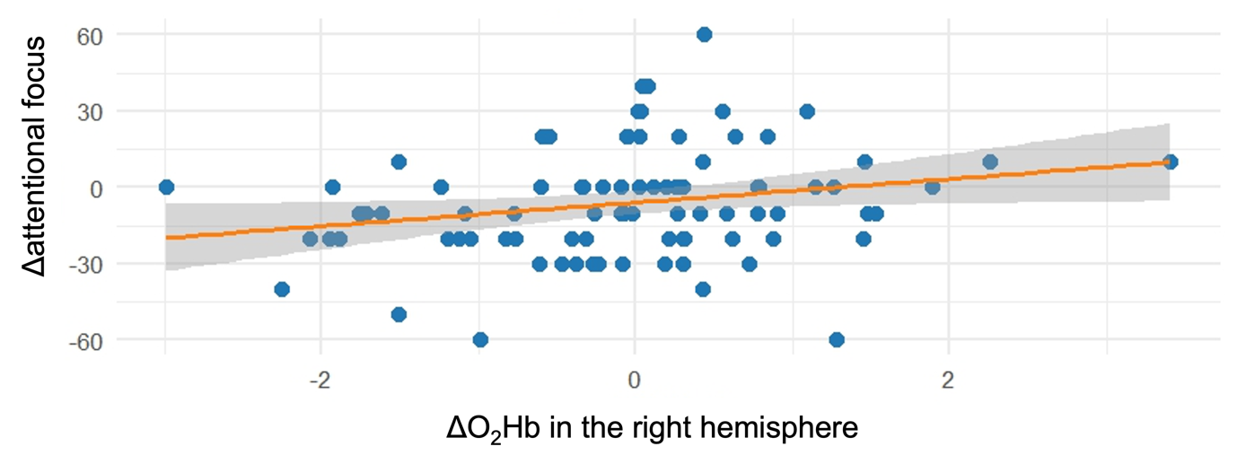
Figure 1. Correlation between ΔO₂Hb and Δ attentional focus

