Supplementary Material 1

Table 1. Descriptive statistics for affective responses across conditions
Variable | Time | Subthreshold priming |  | Suprathreshold priming |  | Control
 |  | M | SD | M | SD | M | SD
Affective valence | 5min | 2.552 | 1.502 | 2.517 | 1.745 | 2.552 | 1.454
 | 10min | 2.690 | 1.734 | 2.793 | 1.677 | 2.724 | 1.709
 | 15min | 3.034 | 1.679 | 2.966 | 1.880 | 2.759 | 1.958
 | 20min | 3.034 | 2.026 | 3.000 | 1.982 | 2.828 | 1.929
Arousal | 5min | 3.621 | 1.115 | 3.862 | 1.156 | 3.828 | 0.966
 | 10min | 4.276 | 1.099 | 4.448 | 0.910 | 4.517 | 1.056
 | 15min | 4.724 | 0.882 | 4.759 | 0.951 | 5.103 | 0.939
 | 20min | 4.862 | 0.990 | 5.103 | 0.900 | 4.966 | 0.981

Table 2. LMEM summaries for affective responses, fixed and random effects estimates, and model fit indices
Predictor | Affective valence |  |  |  | Arousal
 | b | SE | t | p | b | SE | t | p
(Intercept) | 2.187 | 0.315 | 6.940 | < 0.001 | 3.573 | 0.202 | 17.686 | < 0.001
Baseline (Covariate) | 0.235 | 0.048 | 4.902 | < 0.001 | 0.027 | 0.048 | 0.568 | 0.570
Condition [Suprathreshold priming] | -0.059 | 0.231 | -0.254 | 0.800 | 0.228 | 0.161 | 1.422 | 0.156
Condition [No priming] | -0.187 | 0.235 | -0.795 | 0.427 | 0.190 | 0.162 | 1.176 | 0.240
Time [10min] | 0.138 | 0.231 | 0.596 | 0.552 | 0.655 | 0.159 | 4.123 | < 0.001
Time [15min] | 0.483 | 0.231 | 2.086 | 0.038 | 1.103 | 0.159 | 6.945 | < 0.001
Time [20min] | 0.483 | 0.231 | 2.086 | 0.038 | 1.241 | 0.159 | 7.813 | < 0.001
Condition [Suprathreshold priming] × Time [10min] | 0.138 | 0.327 | 0.421 | 0.674 | -0.069 | 0.225 | -0.307 | 0.759
Condition [No priming] × Time [10min] | 0.034 | 0.327 | 0.105 | 0.916 | 0.034 | 0.225 | 0.153 | 0.878
Condition [Suprathreshold priming] × Time [15min] | -0.034 | 0.327 | -0.105 | 0.916 | -0.207 | 0.225 | -0.921 | 0.358
Condition [No priming] × Time [15min] | -0.276 | 0.327 | -0.843 | 0.400 | 0.172 | 0.225 | 0.767 | 0.444
Condition [Suprathreshold priming] × Time [20min] | 0.000 | 0.327 | 0.000 | 1.000 | 0.000 | 0.225 | 0.000 | 1.000
Condition [No priming] × Time [20min] | -0.207 | 0.327 | -0.632 | 0.528 | -0.103 | 0.225 | -0.460 | 0.646
Random Effects
σ² | 0.777 |  |  |  | 0.366
τ₀₀ | 1.942 _{ID} |  |  |  | 0.615 _{ID}
Model Fit
AIC | 1038.406 |  |  |  | 774.984
BIC | 1096.189 |  |  |  | 832.767
ICC | 0.714 |  |  |  | 0.627
Marginal R² / Conditional R² | 0.051 / 0.729 |  |  |  | 0.197 / 0.700
Note. All models were estimated based on 29 participants and 348 observations. The reference level for condition was subthreshold priming, and for time was 5 min. b = unstandardized regression coefficient; SE = standard error; σ² = residual variance; τ₀₀ = random intercept variance; ICC = intraclass correlation coefficient; AIC = Akaike information criterion; BIC = Bayesian information criterion.

Table 3. Descriptive statistics for PFC activation across conditions
Variable | Time | Subthreshold priming |  |  |  | Suprathreshold priming |  |  |  | Control
 |  | Right |  | Left |  | Right |  | Left |  | Right |  | Left
 |  | M | SD | M | SD | M | SD | M | SD | M | SD | M | SD
O₂Hb | 5min | 0.172 | 1.282 | -0.119 | 1.340 | 0.119 | 1.218 | 0.396 | 1.262 | 0.001 | 1.311 | -0.065 | 1.577
 | 10min | 0.523 | 1.366 | 0.131 | 1.498 | -0.316 | 1.619 | 0.076 | 1.269 | -0.419 | 1.612 | -0.820 | 1.552
 | 15min | 0.417 | 1.226 | 0.213 | 1.166 | -0.227 | 1.590 | 0.034 | 0.947 | -0.494 | 1.507 | -0.571 | 1.405
 | 20min | 0.228 | 1.119 | -0.231 | 1.257 | -0.177 | 1.138 | 0.064 | 1.195 | 0.016 | 1.391 | -0.544 | 1.207
HHb | 5min | -0.103 | 0.769 | 0.072 | 0.804 | -0.071 | 0.731 | -0.238 | 0.757 | -0.001 | 0.786 | 0.039 | 0.946
 | 10min | -0.314 | 0.820 | -0.079 | 0.899 | 0.189 | 0.972 | -0.045 | 0.761 | 0.251 | 0.967 | 0.492 | 0.931
 | 15min | -0.250 | 0.736 | -0.128 | 0.700 | 0.136 | 0.954 | -0.020 | 0.569 | 0.296 | 0.905 | 0.343 | 0.843
 | 20min | -0.137 | 0.672 | 0.139 | 0.755 | 0.107 | 0.683 | -0.038 | 0.717 | -0.010 | 0.835 | 0.327 | 0.724

Table 4. LMEM summaries for PFC activation, fixed and random effects estimates, and model fit indices
Predictor | O₂Hb |  |  |  | HHb
 | b | SE | t | p | b | SE | t | p
(Intercept) | 0.172 | 0.250 | 0.689 | 0.491 | -0.103 | 0.150 | -0.689 | 0.491
Condition [Suprathreshold priming] | -0.054 | 0.327 | -0.165 | 0.869 | 0.032 | 0.196 | 0.165 | 0.869
Condition [No priming] | -0.172 | 0.327 | -0.525 | 0.600 | 0.103 | 0.196 | 0.525 | 0.600
Time [10min] | 0.351 | 0.327 | 1.073 | 0.283 | -0.211 | 0.196 | -1.074 | 0.283
Time [15min] | 0.245 | 0.327 | 0.749 | 0.454 | -0.147 | 0.196 | -0.750 | 0.454
Time [20min] | 0.056 | 0.327 | 0.170 | 0.865 | -0.034 | 0.196 | -0.171 | 0.864
Hemisphere [Left] | -0.292 | 0.327 | -0.893 | 0.372 | 0.175 | 0.196 | 0.892 | 0.373
Condition [Suprathreshold priming] × Time [10min] | -0.785 | 0.462 | -1.698 | 0.090 | 0.471 | 0.277 | 1.698 | 0.090
Condition [No priming] × Time [10min] | -0.770 | 0.462 | -1.666 | 0.096 | 0.462 | 0.277 | 1.667 | 0.096
Condition [Suprathreshold priming] × Time [15min] | -0.590 | 0.462 | -1.276 | 0.202 | 0.354 | 0.277 | 1.277 | 0.202
Condition [No priming] × Time [15min] | -0.740 | 0.462 | -1.600 | 0.110 | 0.444 | 0.277 | 1.600 | 0.110
Condition [Suprathreshold priming] × Time [20min] | -0.352 | 0.462 | -0.760 | 0.447 | 0.211 | 0.277 | 0.761 | 0.447
Condition [No priming] × Time [20min] | -0.040 | 0.462 | -0.087 | 0.931 | 0.024 | 0.277 | 0.087 | 0.931
Condition [Suprathreshold priming] × Hemisphere [Left] | 0.569 | 0.462 | 1.232 | 0.219 | -0.341 | 0.277 | -1.231 | 0.219
Condition [No priming] × Hemisphere [Left] | 0.226 | 0.462 | 0.488 | 0.625 | -0.135 | 0.277 | -0.488 | 0.625
Time [10min] × Hemisphere [Left] | -0.100 | 0.462 | -0.217 | 0.829 | 0.060 | 0.277 | 0.217 | 0.828
Time [15min] × Hemisphere [Left] | 0.088 | 0.462 | 0.190 | 0.849 | -0.053 | 0.277 | -0.190 | 0.850
Time [20min] × Hemisphere [Left] | -0.167 | 0.462 | -0.362 | 0.717 | 0.101 | 0.277 | 0.363 | 0.717
Condition [Suprathreshold priming] × Time [10min] × Hemisphere [Left] | 0.214 | 0.654 | 0.327 | 0.744 | -0.128 | 0.392 | -0.328 | 0.743
Condition [No priming] × Time [10min] × Hemisphere [Left] | -0.235 | 0.654 | -0.359 | 0.719 | 0.141 | 0.392 | 0.359 | 0.720
Condition [Suprathreshold priming] × Time [15min] × Hemisphere [Left] | -0.105 | 0.654 | -0.161 | 0.872 | 0.063 | 0.392 | 0.161 | 0.872
Condition [No priming] × Time [15min] × Hemisphere [Left] | -0.099 | 0.654 | -0.151 | 0.880 | 0.059 | 0.392 | 0.151 | 0.880
Condition [Suprathreshold priming] × Time [20min] × Hemisphere [Left] | 0.131 | 0.654 | 0.201 | 0.841 | -0.079 | 0.392 | -0.202 | 0.840
Condition [No priming] × Time [20min] × Hemisphere [Left] | -0.327 | 0.654 | -0.500 | 0.617 | 0.196 | 0.392 | 0.500 | 0.617
Random Effects
σ² | 1.549 |  |  |  | 0.558
τ₀₀ | 0.265 _{ID} |  |  |  | 0.096 _{ID}
Model Fit
AIC | 2379.726 |  |  |  | 1693.221
BIC | 2497.905 |  |  |  | 1811.400
ICC | 0.146 |  |  |  | 0.146
Marginal R² / Conditional R² | 0.057 / 0.195 |  |  |  | 0.057 / 0.195
Note. All models were estimated based on 29 participants and 696 observations. The reference level for condition was subthreshold priming, for time was 5 min, and for hemisphere was right. b = unstandardized regression coefficient; SE = standard error; σ² = residual variance; τ₀₀ = random intercept variance; ICC = intraclass correlation coefficient; AIC = Akaike information criterion; BIC = Bayesian information criterion.

Table 5. Descriptive statistics for manipulation check variables across conditions
Variable | Time | Subthreshold priming |  | Suprathreshold priming |  | Control
 |  | M | SD | M | SD | M | SD
Attentional focus | 5min | 47.241 | 19.438 | 47.241 | 18.302 | 46.897 | 15.143
 | 10min | 44.828 | 17.448 | 45.517 | 18.045 | 41.207 | 16.885
 | 15min | 40.690 | 16.242 | 43.103 | 19.292 | 39.310 | 19.073
 | 20min | 40.000 | 16.475 | 40.000 | 19.457 | 42.759 | 19.982
Perceived exertion | 5min | 10.310 | 1.775 | 9.931 | 1.889 | 10.448 | 1.502
 | 10min | 11.207 | 1.989 | 11.000 | 2.018 | 11.310 | 1.650
 | 15min | 11.552 | 2.148 | 11.621 | 2.194 | 11.586 | 1.803
 | 20min | 11.862 | 2.263 | 12.138 | 2.117 | 11.897 | 1.933
State mindfulness | – | 3.984 | 0.381 | 4.000 | 0.519 | 3.696 | 0.406
Theta/Alpha means | – | 1.197 | 0.444 | 1.208 | 0.389 | 1.207 | 0.446
Word judgment accuracy | – | 0.974 | 0.034 | 0.945 | 0.175 | – | –

Table 6. LMEM summaries for perceptual responses, fixed and random effects estimates, and model fit indices
Predictor | Attentional focus |  |  |  | Perceived exertion
 | b | SE | t | p | b | SE | t | p
(Intercept) | 47.241 | 3.350 | 14.100 | < 0.001 | 10.310 | 0.363 | 28.438 | < 0.001
Baseline (Covariate)
Condition [Suprathreshold priming] | 0.000 | 3.382 | 0.000 | 1.000 | -0.379 | 0.306 | -1.241 | 0.216
Condition [No priming] | -0.345 | 3.382 | -0.102 | 0.919 | 0.138 | 0.306 | 0.451 | 0.652
Time [10min] | -2.414 | 3.382 | -0.714 | 0.476 | 0.897 | 0.306 | 2.932 | 0.004
Time [15min] | -6.552 | 3.382 | -1.937 | 0.054 | 1.241 | 0.306 | 4.060 | < 0.001
Time [20min] | -7.241 | 3.382 | -2.141 | 0.033 | 1.552 | 0.306 | 5.075 | < 0.001
Condition [Suprathreshold priming] × Time [10min] | 0.690 | 4.782 | 0.144 | 0.885 | 0.172 | 0.432 | 0.399 | 0.690
Condition [No priming] × Time [10min] | -3.276 | 4.782 | -0.685 | 0.494 | -0.034 | 0.432 | -0.080 | 0.936
Condition [Suprathreshold priming] × Time [15min] | 2.414 | 4.782 | 0.505 | 0.614 | 0.448 | 0.432 | 1.037 | 0.301
Condition [No priming] × Time [15min] | -1.034 | 4.782 | -0.216 | 0.829 | -0.103 | 0.432 | -0.239 | 0.811
Condition [Suprathreshold priming] × Time [20min] | 0.000 | 4.782 | 0.000 | 1.000 | 0.655 | 0.432 | 1.515 | 0.131
Condition [No priming] × Time [20min] | 3.103 | 4.782 | 0.649 | 0.517 | -0.103 | 0.432 | -0.239 | 0.811
Random Effects
σ² | 165.808 |  |  |  | 1.356
τ₀₀ | 159.715 _{ID} |  |  |  | 2.456 _{ID}
Model Fit
AIC | 2810.026 |  |  |  | 1211.652
BIC | 2863.957 |  |  |  | 1265.583
ICC | 0.491 |  |  |  | 0.644
Marginal R² / Conditional R² | 0.025 / 0.503 |  |  |  | 0.103 / 0.681
Note. All models were estimated based on 29 participants and 348 observations. The reference level for condition was subthreshold priming, and for time was 5 min. b = unstandardized regression coefficient; SE = standard error; σ² = residual variance; τ₀₀ = random intercept variance; ICC = intraclass correlation coefficient; AIC = Akaike information criterion; BIC = Bayesian information criterion.

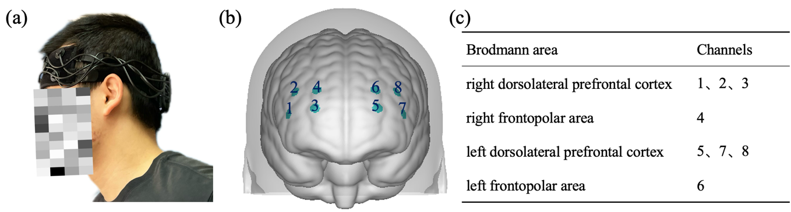Figure 1. The fNIRS system used in the study: (a) equipment set-up during exercise; (b) channel distribution; (c) the corresponding Brodmann area of channels.

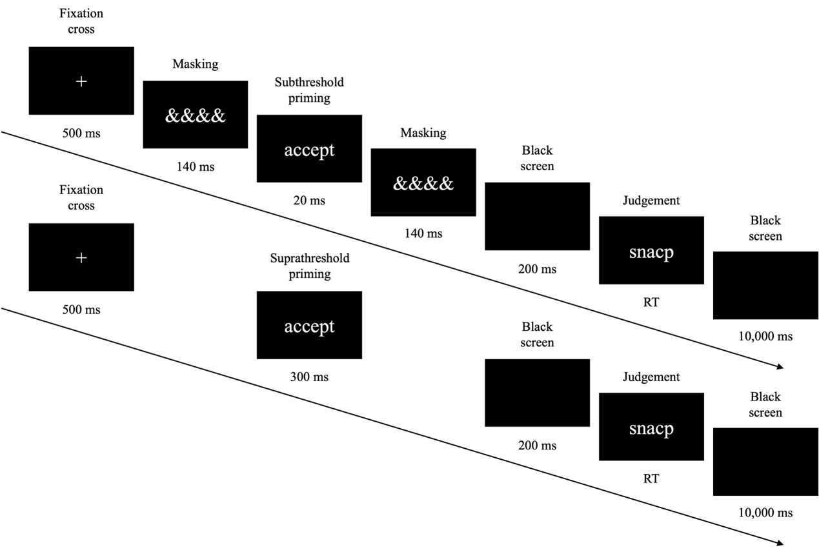
Figure 2. The priming procedure. The figure shows a single trial for the subthreshold (top) and suprathreshold (bottom) conditions, with timings in milliseconds (ms). Participants were required to complete 108 trials (8 practice, 100 experimental) during the exercise protocol.

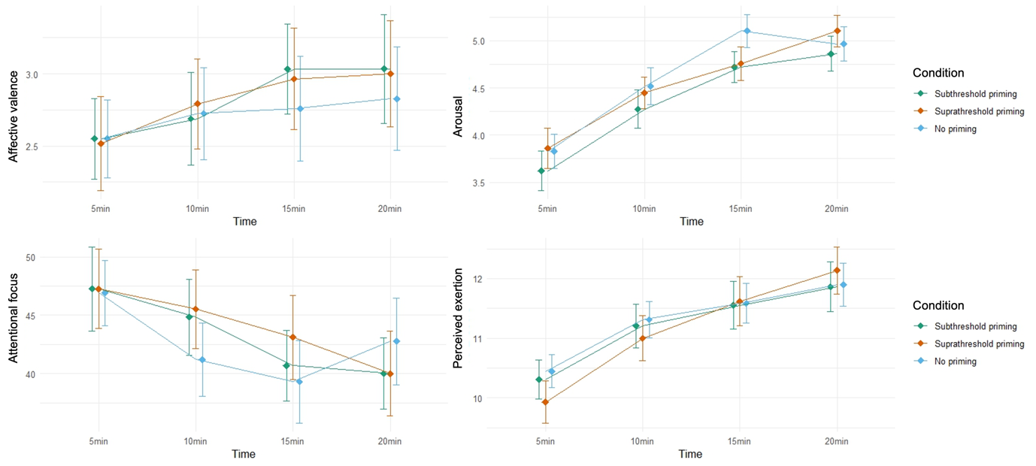
Figure 3. M (± SE) for affective valence, arousal, perceived exertion, and attentional focus across conditions through the exercise bout.

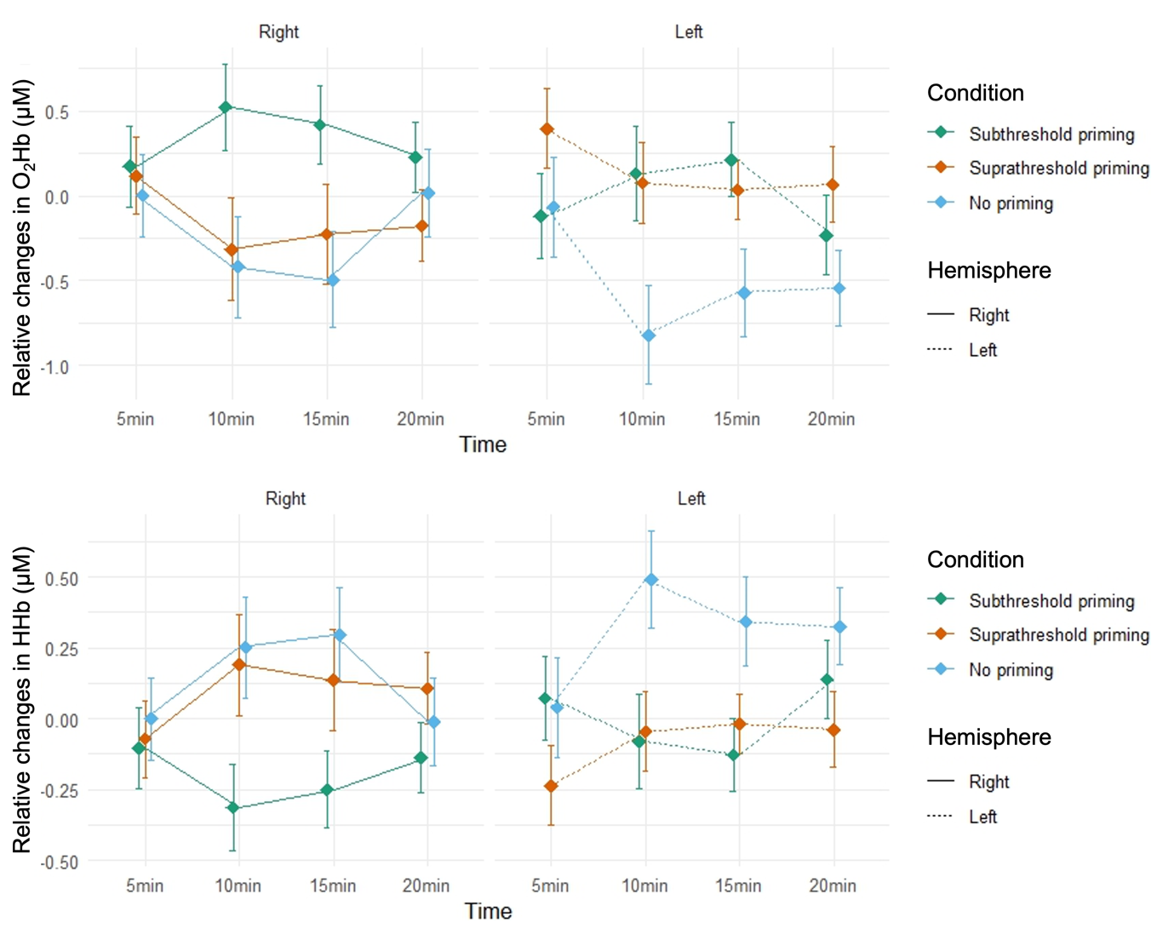
Figure 4. M (± SE) for oxygenated hemoglobin (O₂Hb) and deoxyhemoglobin (HHb) across conditions throughout the exercise bout.

