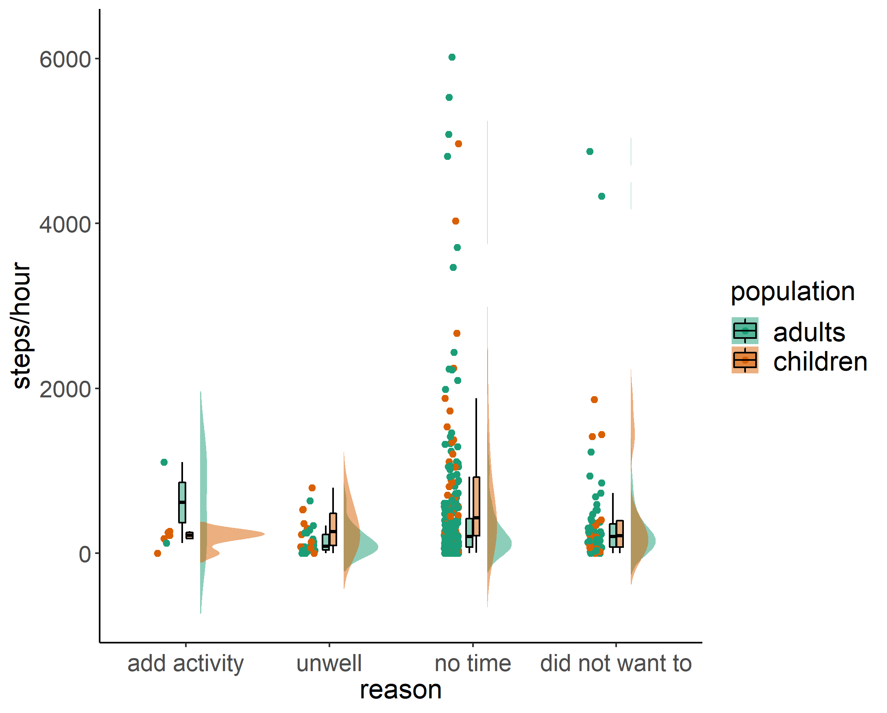
Supplement Figure 1
Descriptive steps in the hour after the just-in-time trigger has been answered (raincloud plots) for all adults (green) and children (red) listed by the reason for the previous inactive period (i.e. have been active but did not wear the sensor (add activity), did not feel well (unwell), had no time (no time), and did not want to be active (did not want to) for all those trigger which were answered within 60 minutes.

