Supplemental Materials: Supporting Implementation Fidelity

Detailed Procedures

Sampling Procedure

During the 2014 to 2024 decade, we piloted (21 teachers, 5 schools), refined (27 teachers, 10 schools), and conducted a cluster-randomized controlled trial of our teacher-trained, teacher-led Pathways model, randomizing 123 schools to treatment (62 schools) or delayed treatment (61 schools). Of these 138 schools, we trained teachers in 122 schools (15 in the pilot and refinement phases, 107 in the randomized trial phase). 16 schools (3 treatment, 13 delayed treatment) did not complete training. School closures during the COVID-19 pandemic meant that two years elapsed after random assignment to delayed treatment before the district allowed training. As a result, eight schools did not take up the opportunity for training. After the end of the COVID-19 pandemic, five additional delayed treatment schools did not take up the opportunity for training when asked again a year after their initial consent. Three treatment schools did not complete training, sometimes due to not having eighth-grade teachers in place for the summer training.
Detailed Recruitment Procedure
Eligibility requirements included that the school was sufficiently staffed to deliver Pathways to all students and to ensure adequate treatment contrast (not currently implementing curricula or programming with core messages that overlapped with Pathways content). For pilot and development schools, we identified schools proximal to the training site. For randomized trials, we systematically recruited schools. For pilot schools, a research team member shared an overview of the project via email with the district and principal, met virtually with a principal or assistant principal, and met with the school’s 8th-grade teachers and counselors in that order. Each time, giving an overview of the program, supporting research, and required data collection activities. The participating teachers and counselors then signed electronic consent forms. For development schools, a member of the research team met onsite with principals, teachers, and counselors. Teachers and counselors signed consent forms at the summer training. For randomized trial schools, the research team mailed a box to principals containing a travel coffee mug imprinted with the project logo and website, and a brief overview of the Pathways program and research requirements. A research team member met with interested principals virtually or by phone to discuss the opportunity in greater detail and assess eligibility. Then they met with all 8th-grade teachers at the school, onsite or virtually, to provide an overview, answer any questions, and have teachers and counselors complete consent forms.
As noted in the body of the paper, to participate, a school leader had to meet with a research team member to learn about Pathways, what participation involved (e.g., teacher training, data collection, video recordings of each session), and select a delivery method (e.g., all 8th-grade teachers deliver during advisory, or all students receive Pathways in a subject class). Teachers could only consent after meeting with a research team member to learn about the program, training, support calls, and data collection procedures. To be certified to deliver Pathways, teachers had to attend and actively participate each day of training.
During the development phase, teachers signed consent forms at summer training. During the pilot phase, they did so at or shortly after the initial meeting with the research team. During the randomized trial, teachers signed consent forms before their school was randomly assigned to a condition. Participating schools were only included in the lottery if they had enough 8th-grade teachers to implement Pathways with all 8th-grade students. If teachers who signed the consent form were no longer at the school by the time training occurred, the new teachers who replaced them signed consent forms before training started.

The process was slightly more involved for the delayed-treatment schools as their training occurred a year after randomization. Moreover, COVID-19 created an exception to the one-year delay between randomization and training for 21 schools whose randomization to delayed treatment occurred in the fall before the COVID-19 pandemic; those schools were offered training two years later. A research team member followed up in March of the following school year with delayed treatment schools to determine if the principal wanted to proceed and have teachers receive Pathways summer training. If so, all teachers were asked to sign or re-sign a consent form on arrival at the summer training.

Detailed Data Collection Procedure

Teachers and students filled out questionnaires and teachers recorded video, all without compensation. As noted in the body of the paper, regarding fidelity, our predicted variable, we collected video recordings from implementing teachers and feedback from students provided via an online feedback survey during their regular Pathways class period at the end of the Pathways program. The procedure for video recording varied such that in earlier years, project staff visited schools, set up video recording equipment, and recorded Pathways implementation. As Pathways scaled, project staff provided the video recording equipment (GoPro camera and tripod), and teachers set it up themselves, returning their videos to the research team on SD cards. We calculated fidelity scores even if some session videos were missing or not codable (e.g., filmed in time-lapse mode) as long as at least three sessions spanning more than half of Pathways could be coded.

We collected our teacher-level predictors from teachers. The 27 pilot and development phase teachers provided feedback (not linked to them) in an anonymous semi-structured interview with members of our research team not involved in the training or support calls one to three months after they completed delivering Pathways to their classrooms. We used it to revise the manual instructions, support materials, and training. We switched to three teacher-level surveys in the 2019-20 school year. Two surveys assessed training engagement operationalized as teacher beliefs about the implications of the active ingredients of Pathways to teaching before (T0) and after training (T1). A third survey assessed teacher engagement with preparing sessions and delivery aids in a post-implementation survey about a month after they completed delivering Pathways to their classrooms. Starting in the 2019-20 school year, we coded the timestamps to obtain information about whether teachers were using the manualized guide to quality delivery.

School-level predictors came from administrative and public data hosted on official State government websites. Public data sources are linked and detailed below in the Public Data Retrieval Links section. We coded school urbanicity following the National Center for Education Statistics (2021). We used public sources to obtain school climate scores and percentage of Math and English Language proficient, and mostly administrative data (n = 77 schools, public sources n = 15 schools) for student body features (ELL, FRPL, racial-ethnic composition).
Five-Component Fidelity
Reliability
The reliability for each component of fidelity during the first three implementation years is reported in Oyserman et al., 2021. The overall process was consistent across the years of implementation; each year of implementation, the Pathways program was delivered as 12 sessions twice a week. As a result of implementation support feedback, we developed a smaller module version so that the 12 sessions could be delivered in smaller standardized chunks four times a week over the same 6-week period. We report alpha reliability for each component after the first three years of implementation, to avoid redundancy with Oyserman et al., 2021. We detail the process for the 12 session twice weekly delivery as only 14% of classrooms delivered with the smaller module chunks version. We limited calculation to classrooms that used the odd-even coding scheme (n=164) as including the six additional classrooms that coded all sessions would produce what would seem like missing data in the calculation.
All five fidelity components were reliable. Dosage (α=.77) reliability was obtained by treating each session-level percentages of tasks attempted score as an item (excluding Initiation, Duration, and Pacing as these components of dosage are classroom-level rather than session-level and are calculated from video time stamps rather than observational coding). Adherence (α = .83) reliability score was obtained by treating each session-level adherence percentage score as an item. Student Responsiveness (α = .79) reliability was obtained by treating each session-level student responsiveness percentage score as an item. Quality (α = .75) reliability was obtained by treating each of the components of quality (Message Persuasiveness, Classroom Quality, and Student Ratings of Quality) as an item. Fidelity of Receipt (α = .92) reliability was obtained using student-level data from students in the n=164 classrooms who took the 11-item student fidelity of receipt measure in the feedback survey.
Component Calculation
Next, we describe how each component was coded from video time stamps, video rater scores, and student feedback survey responses. Table 2 in the main text provides an overview of the five components of fidelity, which are equally weighted in the overall fidelity score. As an example of the coding, Figure S1 shows the checklist for Session 2 of the intervention; the first column is what was counted for task attempted; the second column is what was counted for adherence percentage; the third column is what was counted for student behaviors of student responsiveness. The top and bottom panels of Figure S2 show select parts of the quality and take-home point coding rubrics for Session 2.

Figure S1
Checklist Rubric for Session 2 Fidelity Coding
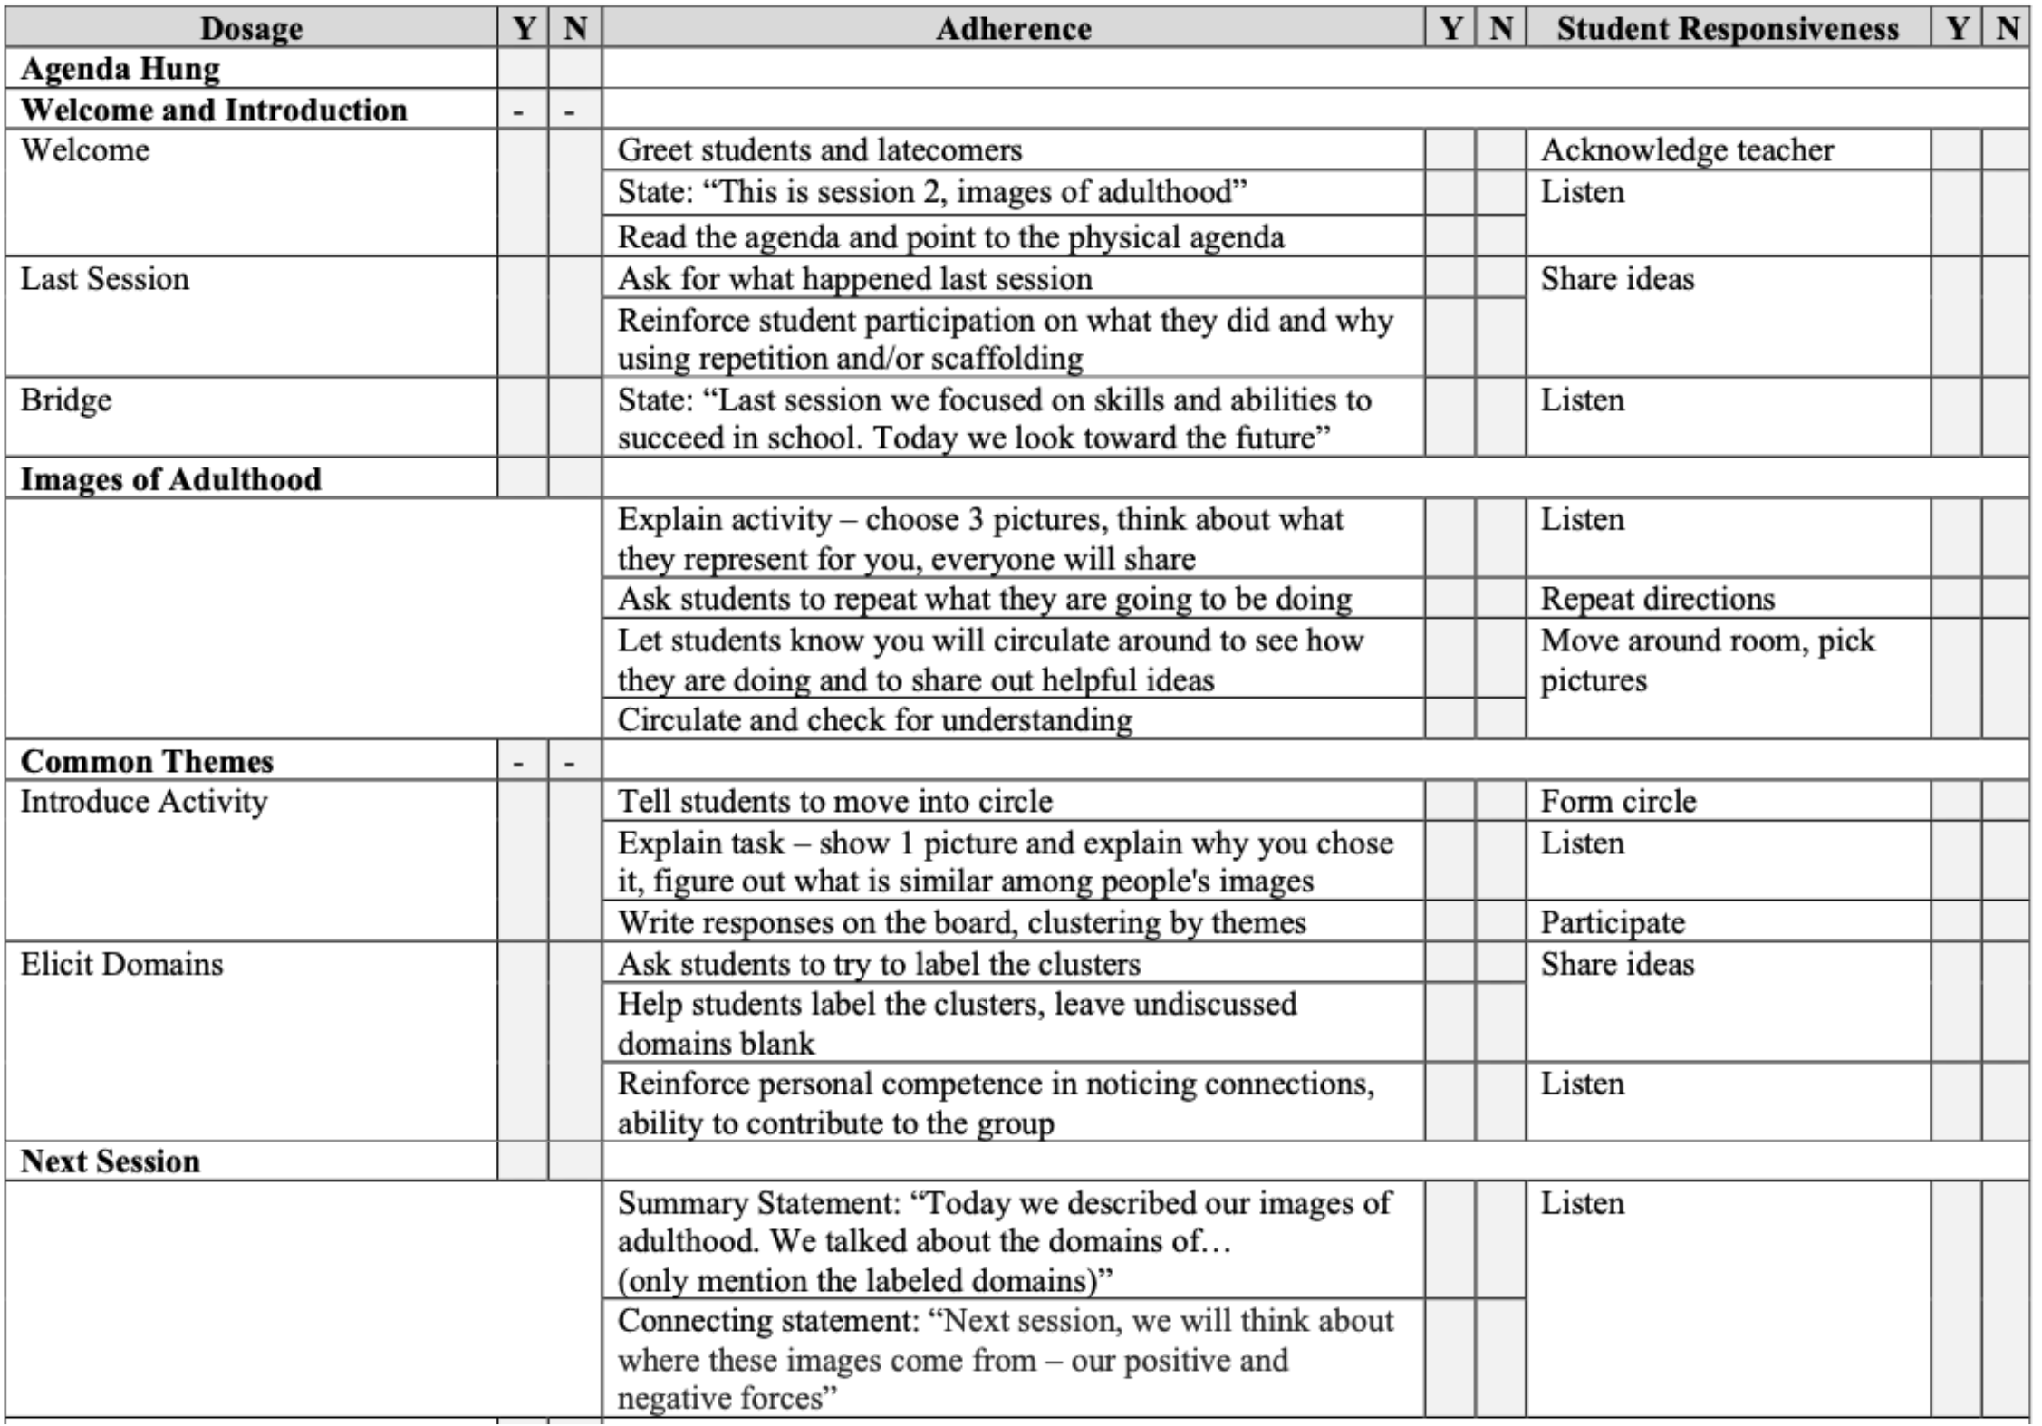

Figure S2
Select Parts of Quality Rubric (Top Panel) and Take-Home Point Rubric (Bottom Panel) for Session 2 Fidelity Coding

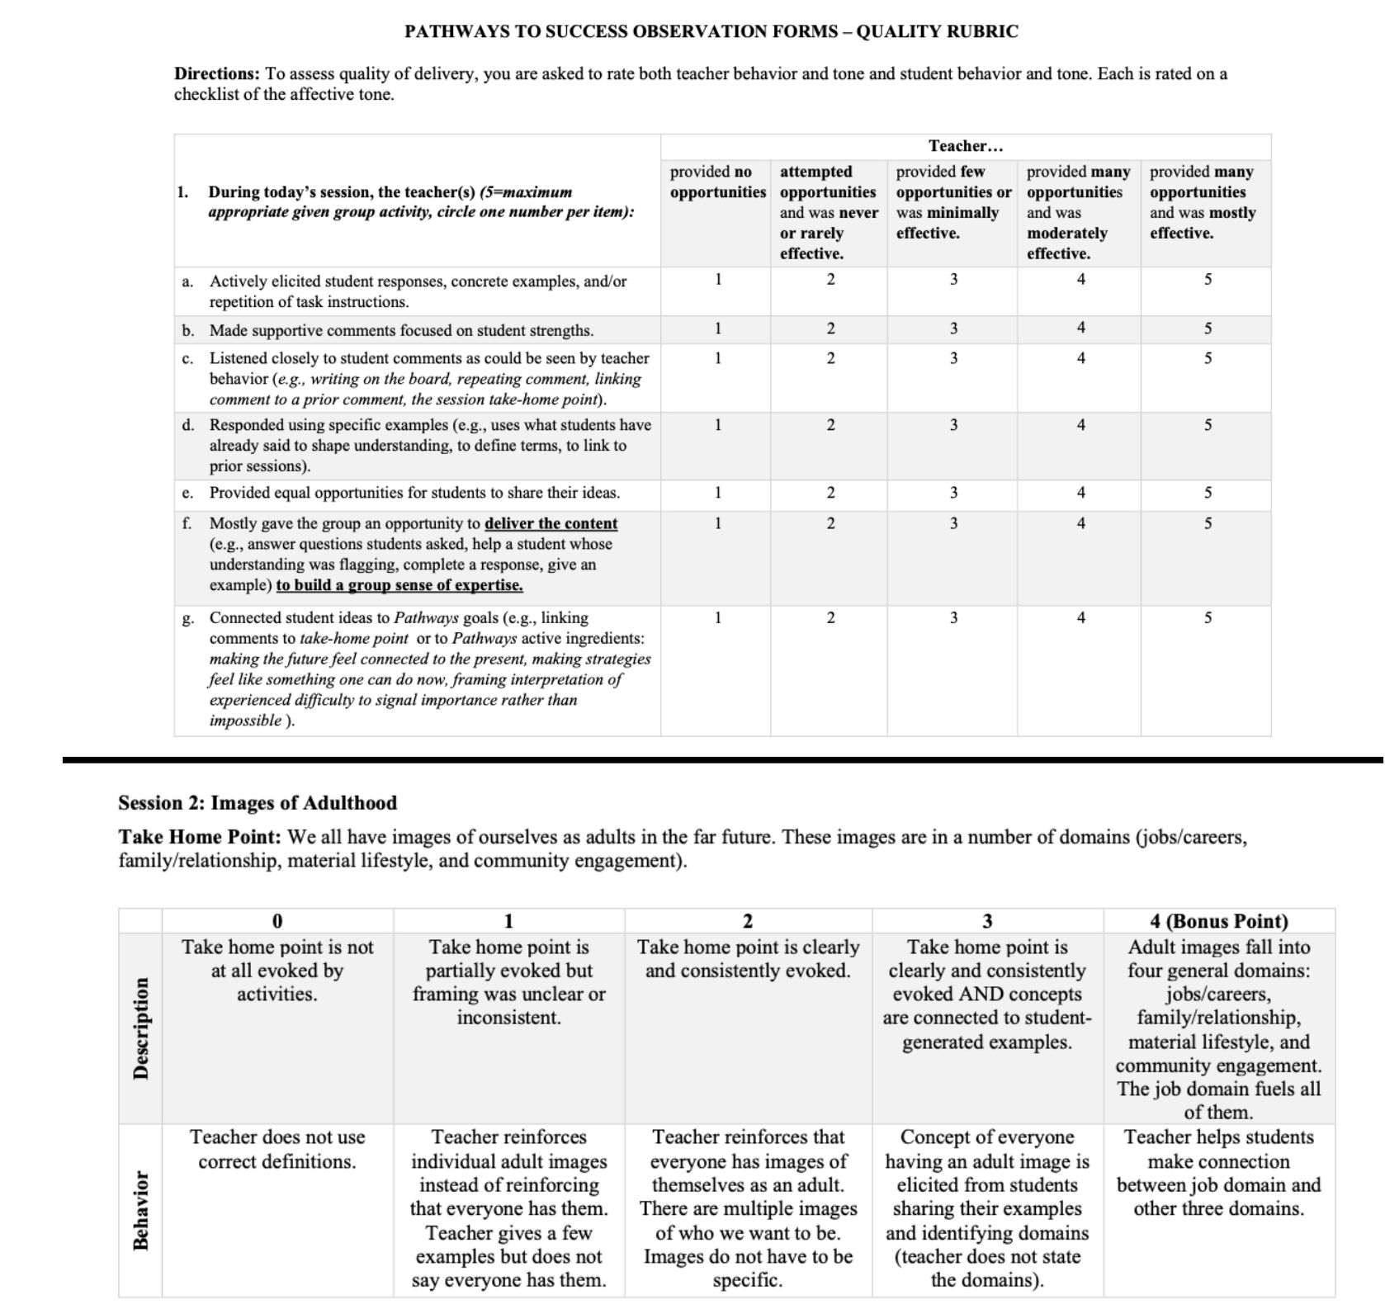

Dosage has four components—Initiation, Pacing/Spacing, Duration, and Task-Attempted Percentage—and is calculated at the classroom-level as the unweighted average of these components.
Initiation is an indicator of the extent to which implementation started on time. Each school has a scheduled Pathways start date based on the school start date. Pathways implementation typically begins in the first week of school but can vary based on consent requirements for video recording. If session 1 was implemented within 6 days from the intended start date, the classroom score for initiation is “2”. If implementation started 7 or more days after the scheduled date but within 14 days, the classroom score for initiation is “1”. If Pathways did not begin until more than two weeks after the scheduled start date, the classroom score for initiation is “0”.
Pacing/spacing for a session indicates whether the implementation of the session occurred as planned such that each session occurred at least one day after the prior session, and no more than 4 days passed between each session and the prior session. If a session met this criterion, it was scored “1”; otherwise, it was scored as “0”.
Duration indicates whether Pathways sessions were completed within the intended timeframe of twice a week for 6 weeks, allowing for minor deviations due to school holidays and assembly days. If implementation was completed within 8 weeks, the classroom score for duration is “1”; otherwise, it was scored as “0”.
Task-attempted percentage was calculated as the number of tasks attempted in a session divided by the number of tasks possible to have attempted for that session. To obtain this number, the rater watched the video recording of each session and used a checklist set to the specific session to mark with a check if the task occurred or not. The number of tasks in each session varied from 7 to 16. The classroom-level score is calculated as the average of all session-level task attempt percentages.

Adherence measures how closely the teacher followed the session activities in implementing Pathways. At the classroom level, it is calculated as the average of session-level adherence scores. At the session level, it is calculated as the number of activities completed in a session divided by the number of intended activities for that session, calculated as a percentage. It is coded by raters using a checklist of 18 to 52 activities (depending on the session). Each activity had to occur in the intended sequence to be coded as an occurrence.

Student responsiveness measures the extent to which students engage with Pathways. It has two components obtained from video ratings—Student Behavior and Student Engagement—and is calculated as the unweighted average of these components.
Student behavior is calculated for each session as a percentage of activities students engaged in as a function of how many there were, ranging from 16 to 34 across sessions. Coders code each behavior as it occurs in the session.
Student engagement is calculated for each session as the average of the rater scores on the following 8 items: used each other’s names, listened to each other, engaged in session activities, shared ideas with each other, asked questions, used higher-order thinking skills, reflected about their thinking and/or experiences, and had a negative affective tone (negatively valenced item reverse-coded, 1=never, 5=always.

Quality has 3 components—Message Persuasiveness, Classroom Quality, and Student Ratings of Quality—and is calculated as the unweighted average of these components.
Message persuasiveness is calculated at the session level as the unweighted average of 3 observer-rated items—fluency, take-home point, and student-led delivery—each first computed as a percentage score. The classroom-level message persuasiveness score is calculated as the average of session-level message persuasiveness percentages. Fluency is the degree to which the teacher creates a fluid Pathways experience through clear and consistent communication to students, authentic mastery of the material (knows and believes it), and effective eliciting of student interest, 0=message feels untrue to 2=message feels like it must be true. Take-home point is the degree to which the teacher clearly evokes the key take home point of each session, 0= the take-home point was evoked at all during the session to 3= the teacher communicated the take home point and reinforced it using student ideas. Student-led delivery is the degree to which the teacher effectively uses student content to deliver key session ideas. Scores range from 1=teacher provided the concepts to 7=the teacher seamlessly wove the Pathways concepts from student content, eliciting student ideas and helping them develop a sense of expertise.
Classroom quality was initially (e.g., Oyserman et al., 2006) coded using the rubric detailed next. However, as published in Horowitz et al., 2018, in the first three years of the current decade of teacher-led Pathways, we used the CLASS-S version of quality. We returned to our original method of coding classroom quality because the CLASS-S is privately owned and hence not something that we can share, making policy application and scalability of fidelity coding problematic. Starting with the fourth year of the project, we coded quality at the session level as the unweighted average of 2 subscales from the engagement rubric: instructional support and emotional support. The overall classroom quality score was calculated as the average of session-level classroom quality percentages. All items are rated by an observer on a scale of 1 to 5. Instructional support 12 items: 7 items were rated from 1=provided no opportunities to 5=provided many opportunities and was mostly effective (e.g., the teacher demonstrated supportive behaviors during Pathways implementation by actively eliciting student responses, making supportive comments, listening closely to students, responding using specific examples, providing equal opportunities for sharing, giving students space to deliver content, and connecting student ideas to Pathways goals); 5 items were rated 1=never to 5= always (e.g., referring to students by name, avoiding negative comments or tone, keeping the group focused on the session topic, and effectively evoking Pathways rules of student behavior). Emotional support 7 items were rated from 1=strongly disagree to 5= strongly agree (e.g., the teacher set a supportive classroom tone by being enthusiastic, warm, clear, knowledgeable, supportive, accepting, and sincere during Pathways implementation). Each scale was averaged, and averages were converted to percentages before averaging again to create a mean classroom quality score.
Student-rated quality is from the student feedback survey and includes student-reported experience of the classroom environment during Pathways with the classroom-level as unweighted average of four components—peer climate, classroom support, teacher climate, and teacher sensitivity. We used a 50% rule of thumb, coding a students’ scale as missing if they missed more than half of the items. Student-rated peer climate 5 items were rated from 1=strongly disagree to 5=strongly agree (students in my classroom were warm, enthusiastic, supportive, knowledgeable, and sincere during Pathways activities). If a student skipped more than 2 items, their score was set to missing; otherwise, we calculated each student’s rating as a percentage score. The classroom-level score is calculated as the average of all student percentages in the classroom. Student-rated classroom support 6 items were rated from 1=strongly disagree to 5=strongly agree (I felt comfortable, supported, emotionally safe, and connected during Pathways activities. If a student skipped more than 3 items, their score was set to missing; otherwise, we calculated each student’s rating as a percentage. The classroom-level score is calculated as the average of all student percentages in the classroom. Student-rated teacher climate 5 items were rated from 1=strongly disagree to 5=strongly agree (My Pathways teacher was warm, enthusiastic, supportive, knowledgeable, and sincere during Pathways activities). If a student skipped more than 2 items, their score was set to missing; otherwise, we calculated each student’s rating as a percentage score. The classroom-level score is calculated as the average of all student percentages in the classroom. Student-rated teacher sensitivity 7 items: 6 items were rated from 1=not at all to 5=a lot (During Pathways, my teacher understood our problems, listened to our comments, did not negatively criticize our ideas, used specific examples, gave students a chance to participate, gave students a chance to answer questions other students raised) and one item was rated from 1=strongly disagree to 5=strongly agree (My Pathways teacher was clear). If a student skipped more than 3 items, their score was set to missing; otherwise, we calculated each student’s rating as a percentage score. The classroom-level score is calculated as the average of all student percentages in the classroom.

Fidelity of receipt is the extent to which students reported experiencing the active ingredients of Pathways; their confidence that they can do the things they practiced and anticipate and overcome future difficulties. All items are rated by the student on a scale of 1 to 5. If a student skipped more than five of the 11 items on the survey, their score was set to missing; otherwise we calculated each student’s score by transforming the scale from 1-5 to 0-4 (by subtracting 1), calculating the mean score across the items, and dividing by 4 to create the percentage. The classroom-level score is calculated as the average of all student percentages in the classroom.

The components are distinct. As Table S1 reveals, the five components of fidelity, though correlated, are distinct, each contributing unique variance to the overall score.

Table S1
Correlations Among the Five Classroom-level Components of Fidelity
Components of Fidelity | Correlation
 | 1 | 2 | 3 | 4 | 5
1. Dosage | -- | 0.38 | 0.30 | 0.24 | -0.03
2. Adherence | <.001 | -- | 0.80 | 0.60 | 0.12
3. Student Responsiveness | <.001 | <.001 | -- | 0.84 | 0.28
4. Quality | <.001 | <.001 | <.001 | -- | 0.47
5. Fidelity of Receipt | .692 | .051 | <.001 | <.001 | --
Note. Top triangle correlations, bottom triangle p-values n=251 classrooms except for the fidelity of receipt correlations (n=249) due to two classrooms not administering the student feedback survey.

Additional Analyses
Table S2
Correlations Among Teacher Engagement Variables at Three Points: During Pathways Training, While Preparing to Deliver Sessions, and While Delivering Sessions
Measure | Correlations
Describing Engagement with Underlying Training Concepts
 | 1 | 2 | 3 | 4 | 5 | 6
1. T0 Difficulty-as-Importance | -- | .28 | -.05 | -.11 | .17 | .04
2. T1 Difficulty-as-Importance | <.001 | -- | -.06 | -.22 | .08 | .12
3. T0 Difficulty-as-Impossibility | .507 | .443 | -- | .47 | -.14 | -.02
4. T1 Difficulty-as-Impossibility | .150 | .004 | <.001 | -- | .04 | -.07
5. T0 Possible Identities | .055 | .369 | .115 | .676 | -- | .38
6. T1 Possible Identities | .617 | .183 | .809 | .442 | <.001 | --
Describing Engaged Preparation
 | 1 | 2 | 3 | 4 | 5 | 6
1. Used the Manual | -- | .16 | .06 | .02 | -.03 | .12
2. Used the Website | .048 | -- | .44 | .27 | .24 | .18
3. Used Video Resources | .445 | < .001 | -- | .23 | .15 | .23
4. Attended Weekly Support Calls | .772 | .001 | .004 | -- | .83 | .03
5. Admin Record of Call Attendance | .739 | .003 | .064 | < .001 | -- | .01
6. Time Prepping | .146 | .031 | .006 | .693 | .891 | --
Describing Engaged Delivery
 | 1 | 2 | 3
1. Used the PowerPoint | -- | -.03 | -.01
2. On-Time Session Delivery | .748 | -- | -.80
3. Too-Fast Session Delivery | .894 | <.001 | --
Note: Correlations are in the top triangle and p-values are in the bottom triangle. Training engagement measures were collected before training (T0) and immediately after training (T1) and describe engagement with underlying Pathways concepts. The preparation and delivery engagement variables were collected from teachers after Pathways delivery and describe use of the implementation supports.

Table S3
Teacher-Level Engagement During Training, Preparation, and Delivery: Descriptive Statistics
Engagement Measures | n | Mean | SD | Mean 95% CI | ICC | ICC 95% CI
During Training
T0 Difficulty-as-Importance | 172 | 3.55 | 1.07 | 3.39. 3.71 | .15 | -.05, .35
T1 Difficulty-as-Importance | 172 | 5.01 | 1.26 | 4.83, 5.20 | .21 | .01, .40
T0 Difficulty-as-Impossibility | 172 | 2.08 | 0.91 | 1.94, 2.21 | -.10 | -.29, .11
T1 Difficulty-as-Impossibility | 172 | 1.57 | 0.84 | 1.44, 1.69 | .07 | -.13, .27
T0 Possible Identities | 125 | 5.21 | 0.88 | 5.05, 5.36 | .13 | -.09, .35
T1 Possible Identities | 134 | 5.68 | 0.63 | 5.57, 5.78 | -.28 | -.44, -.08
During Preparation
Used the Manual | 150 | 3.83 | 0.50 | 3.75, 3.91 | -.47 | -.60, -.31
Used the Website | 150 | 3.11 | 0.89 | 2.96, 3.25 | -.02 | -.22, .20
Used Video Resources | 150 | 2.33 | 0.99 | 2.17, 2.49 | .26 | .05, .45
Attended Support Calls | 150 | 3.44 | 0.81 | 3.31, 3.57 | .40 | .20, .57
Admin Recorded Attendance | 198 | 4.92 | 1.63 | 4.70, 5.15 | .38 | .21, .54
Time Prepping | 149 | 2.60 | 0.80 | 2.47, 2.73 | -.12 | -.31, .10
During Delivery
Used the PowerPoint | 150 | 3.46 | 0.78 | 3.33, 3.59 | .15 | -.07, .35
On-time Session Delivery | 171 | 77% | 20% | 74.31, 80.40 | .36 | .17, .53
Too-fast Session Delivery | 171 | 17% | 20% | 13.84, 19.69 | .44 | .26, .59
Note: Ns vary given differences in data sources, and because the possible identities measure was developed later. SD = standard deviation, CI = confidence interval, ICC = intraclass correlation –the proportion of between-school to total variance. Negative values imply unreliable estimates of near-zero true values. Measures are self-reports, except support call attendance (administrative records), and on-time and too-fast session delivery (video-based).

Predicting Teacher-Level Fidelity from Teacher Training Engagement
Beliefs changed as a result of training. However, only one of the six belief measures, baseline difficulty-as-importance (T0 difficulty-as-importance b=-1.88, t=-2.73, p=.007) yielded a significant prediction of fidelity of delivery (T0 difficulty-as-impossibility b=0.27, t= 0.33, p=.739; T0 possible identities b=0.81, t=0.94, p=.349; T1 difficulty-as-importance b=0.61, t=1.10, p=.276; T1 difficulty-as-impossibility b=-0.21, t=-0.24, p=.808; T1 possible identities b=-0.76, t=-0.67, p=.507).

Figure S3
Average Fidelity (Mean and 95% CI) by Training Type After Start of COVID-19 Pandemic
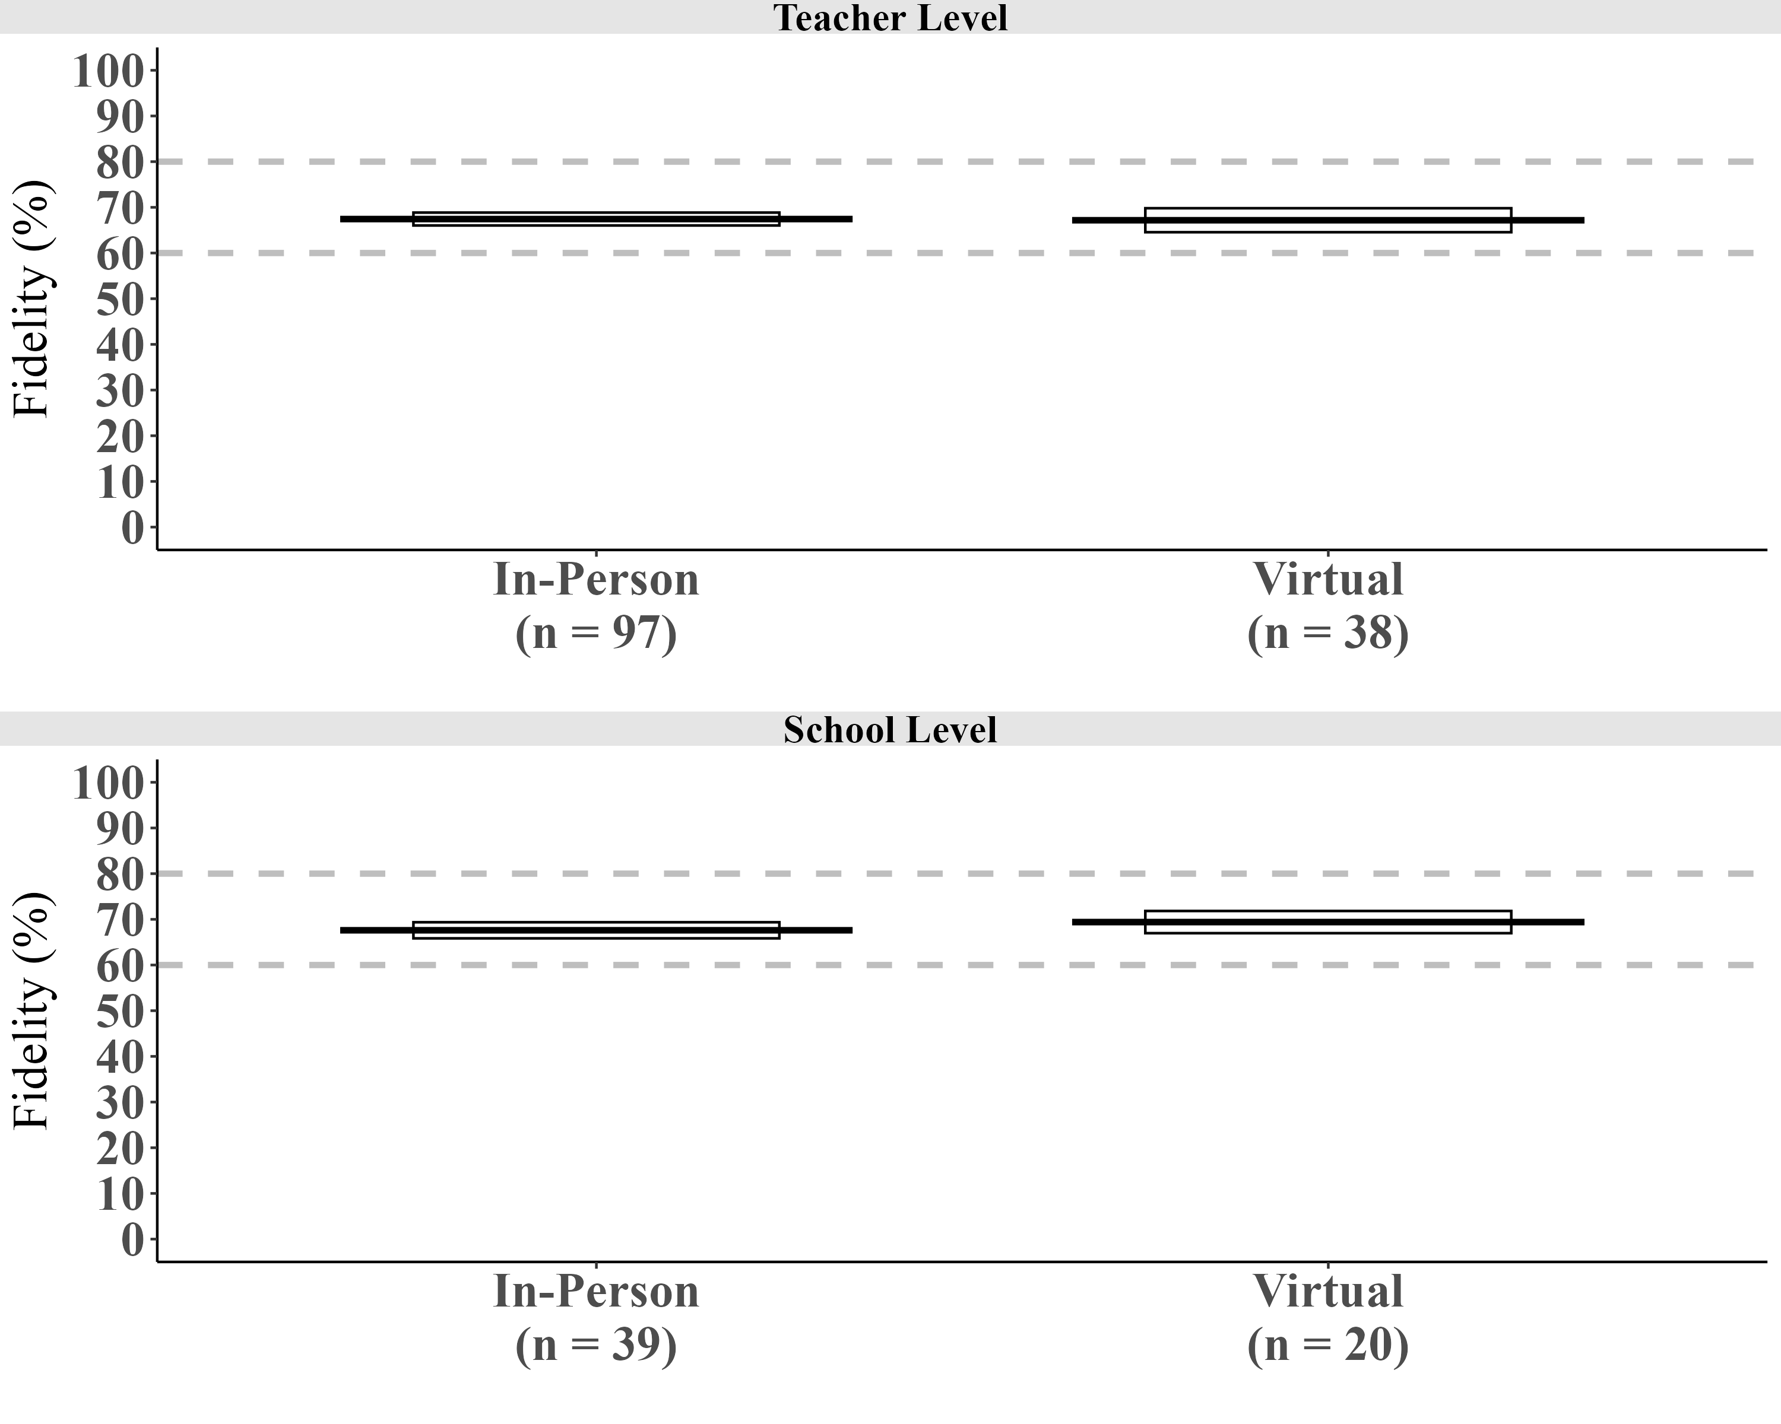Note. Line segments represent means. Boxes represent the 95% confidence interval around the mean. Teacher-level: in-person M=67.44%, CI [66.03%, 68.85%], virtual M=67.18% CI [64.55%, 69.81%]. School-level: in-person M=67.60% CI [65.84%, 69.36%], virtual M=69.40% CI [66.97%, 71.83%].

Table S4
Correlations Among School-Level Features
Measure | Correlations
Features of Student Bodies
 | 1 | 2 | 3 | 4 | 5 | 6 | 7 | 8
1. %ELL | -- | 0.32 | -0.24 | -0.20 | -0.34 | -0.40 | 0.80 | -0.08
2. %FRPL | .002 | -- | -0.64 | -0.55 | 0.49 | -0.79 | 0.22 | -0.43
3. %ELA Proficient | .021 | <.001 | -- | 0.93 | -0.53 | 0.67 | -0.08 | 0.38
4. %Math Proficient | .060 | <.001 | <.001 | -- | -0.44 | 0.57 | -0.10 | 0.33
5. %Black | .001 | <.001 | <.001 | <.001 | -- | -0.61 | -0.57 | -0.30
6.%White | <.001 | <.001 | <.001 | <.001 | <.001 | -- | -0.28 | 0.32
7. %Hispanic | <.001 | .031 | .424 | .356 | <.001 | .007 | -- | -0.11
8. %Another Race | .462 | <.001 | <.001 | .001 | .003 | .002 | .297 | --
Features of Teacher & Student Experience
1. School Climate | -- | .09
2. School Mean Class Size | .396 | --

Table S5
Teacher-Level and School-Level Average Fidelity Scores (%) by Census Location
Urbanicity | Teacher | School | % Teacher-Level Fidelity |  |  | % School-Level Fidelity
 | n | n | M | SD | Range | M | SD | Range
City | 112 | 59 | 71.30 | 6.66 | 49.79-89.42 | 70.72 | 6.60 | 49.79-82.30
Suburban | 11 | 2 | 71.51 | 7.95 | 61.48-81.49 | 67.28 | 7.21 | 62.19-72.38
Town | 37 | 8 | 65.63 | 7.67 | 53.38-83.17 | 65.92 | 6.89 | 58.58-78.72
Rural | 43 | 23 | 67.52 | 8.72 | 43.76-79.95 | 69.76 | 6.24 | 55.34-79.86
Note. Urbanicity = School census location, SD = standard deviation.

Table S6
Multiple Linear Regression Predicting School-Level Fidelity in Schools with More Than One Teacher (n = 44)
Predictors | b | SE | t | p
Intercept | 54.04 | 3.15 | 17.15 | < .001
School Climate | 0.12 | 0.04 | 2.97 | .005
Urbanicity | 1.63 | 0.60 | 2.72 | .010
%Math Proficient | 0.10 | 0.05 | 1.95 | .059
Note. b = unstandardized regression coefficient; SE = standard error.

Summative Regression: Teacher-Level Effects After Accounting for School-Level Effects
Our summative regression equation included the significant teacher-level and school-level predictors of teacher-level fidelity and revealed consistency, implying that features at both levels matter. Thus, controlling for urbanicity, school climate, and % math proficient (the school-level predictors), the teacher-level predictor of too-fast delivery remained a significant predictor of less fidelity (b=-9.92, t=-3.71, p<.001) and the reverse, the school-level predictors remained significant predictors controlling for too-fast delivery (urbanicity b=1.15, t=2.78, p=.006; school climate b=0.09, t=3.09, p=.002; %math proficient b=0.16, t = 4.35, p<.001).

Teacher-Level Measures

Teacher Training Engagement

Response scales range 1 = strongly disagree to 6 = strongly agree.
T0 and T1 Difficulty-as-Impossibility
- "Cut your losses." If something feels very difficult to teach, it may be better to focus on something else.
- When teaching a class feels difficult, that material may be impossible for students to understand.
- Your gut tells you that if material feels difficult for your students, it is probably impossible for them to ever really understand.
- When a concept is difficult for my students to grasp, the material may not be for them.
T0 and T1 Difficulty-as-Importance
- If my students find something difficult to learn, it often signals that it is important for them - “No pain, no gain.”
- When a concept is difficult for my students to grasp, it likely means that it is important for them to learn.
- When teaching a class feels difficult, that class may be important for students to understand.
- When teaching a concept feels difficult, that concept is often worth your attention.
T0 and T1 Possible Identities
- Students who think about who they will become as an adult do better in school.
- Students who take action now to get to their future self do better in school.
- Students who believe that their effort in school now will matter for their future self do better in school.
- Students who see school as the path toward their future self do better in school.

Teacher Preparation and Delivery Aids
Unless otherwise noted, response scale: 1 = I did not use, 2 = some sessions, 3 = most sessions, and 4 = all sessions.
Manual Usage: Overall, how frequently did you use the Pathways implementation manual to prepare for a Pathways session?

Website Usage: Overall, how frequently did you use the Pathways website to prepare for a Pathways session?

Video Resources Usage: Overall, how frequently did you use the Pathways video resources to prepare for a Pathways session?

Pathways PowerPoint Usage: Overall, how frequently did you use the Pathways PowerPoint presentation when implementing Pathways sessions
Teacher-Recalled Support Call Attendance: How often did you attend the weekly check-in meetings? 1 = I attended fewer than 2 check-in meetings, 2 = I attended 2 or 3 check-in meetings, 3 = I attended 4 or 5 check-in meetings, 4 = I attended all 6 check-in meetings.
Estimated Time Prepping
On average, how much time did you spend preparing (e.g., including time spent reviewing the Pathways implementation manual, the website, and/or watching video resources) to implement each session?
Closed Response Version (Starting AY 2019, Ending AY 2021): (1=15 mins or less, 2=between 15 - 30 mins, 3=between 30 -60 mins, 4=more than 60 minutes)
Slider Response Version (Starting AY 2022): Use the slider to indicate the number of minutes (0 minutes to 120 minutes).

Fidelity Calculation

We calculated classroom-level fidelity with the five factors (dosage, adherence, responsiveness, quality, and receipt) recommended in the literature. We calculated Dosage, Adherence, and Responsiveness based on rater-coded checklists of the video recordings of each Pathways session in each classroom. We calculated Quality based on three components, two rater-coded checklist scores from the video recordings, and one from the student-rated checklist responses from the student feedback survey obtained immediately following Pathways. We calculated Fidelity of Receipt from the student feedback survey. The basic rubrics for each of these aspects of coding are provided in Oyserman (2015).

Training Raters and Interrater Reliability
The coding protocol for data collected in 2014, the first year of the current project, is published in Horowitz et al., 2018 on pages 13 to 20; this same protocol was used in years two and three (see Oyserman et al., 2021). Years 1 to 3 of implementation included pilot and development phases. After this time, we trained two cadres of raters, one a set of student raters and another a set of raters who already had experience with observational coding who were employed by the American Institutes of Research. This reduced the chance that coders had region or place-based biases. Raters at each site were trained and supervised by at least one member of the research team. Before any coding began, raters participated in a two-day training led by members of the research team. This training ensured raters understood the structure of each Pathways session and how to use the coding rubrics. Raters completed checklists of observed behavior as well as summative codes for each video recording they observed. The checklist was of activities or behaviors as they occurred; the two summative sets of items are detailed below. Raters had to meet a minimum of 80% agreement with at least one other rater on each of these for each session before they could independently code any video recordings of that session. On average, this initial alignment took two videos after initial training. Double coding of data collected in the first three years of implementation is detailed in Horowitz et al. (2018) and Oyserman et al., 2021. In subsequent years, the volume of coding increased. To minimize slippage in reliability, raters also had to double-code a new video with another rater every five to six sessions and reach 80% agreement on all three rubrics again. On average, across all years of implementation, 11.32% of video recordings were double-coded.
Interrater reliability was calculated differently depending on the type of item on the rubric. For binary response items (e.g., the yes/no items on the adherence/dosage checklist), raters had to have exact matches on 80% of items. For Likert-style response items (e.g., the 1 to 5 rated items on the quality rubric), raters had to select ratings within one point of each other. So, agreement could be an exact match (e.g., both raters selected 3) or a near match (e.g., one rater selected 3 and the other selected 4 or 2; one rater selected 1 and the other selected 2).

Missing Data Procedures
We addressed missing student survey and video data in our fidelity calculations as follows. First, regarding missing data from the student feedback survey for a classroom, we followed a three-step process. If the teacher delivered to more than one classroom, we imputed the missing data from average student feedback survey scores based on all other classroom(s) in which the teacher delivered Pathways. If the teacher did not deliver Pathways to more than one classroom, but there were other classrooms in the school, we imputed the missing data from school-level student feedback survey scores. If the school had only one 8th grade classroom, as was the case for two of the schools in our sample, we did not impute student data and instead computed fidelity from only video data. Second, regarding missing video recordings for a classroom, as reported by Oyserman and colleagues (2021), overall fidelity was calculated as the unweighted average of the 12 Pathways sessions for the first three years of the project.
Teachers videotaped each session. The research team randomly assigned each classroom to an odd-numbered or even-numbered coding scheme. Missing data was not an issue in the early years of the project. During those years, project staff went to school to collect video. After the COVID-19 pandemic, this was not possible and a rule for handling missing data was necessary.
We analyzed Year 1 to Year 3 fidelity results, finding that it would be sufficient to compute the average fidelity score from half of the sessions as long as sessions were spread across the full program, with the optimum match between the 6-session average and the 12-session average being when all even-numbered or odd-numbered sessions were coded. Hence, starting in the fourth year of Pathways delivery, we followed that rule. The exception to this rule was that we fully coded sessions to verify that odd-even coding was sufficient whenever we started a new phase of the design. Thus we checked again after the first cohort of delayed treatment schools, again finding that fidelity scores did not significantly differ from each other whether derived from coding only odd sessions, only even sessions, or all sessions (even vs odd coding: t(18) = 0.12, p = .905, 95% CI [−0.01, 0.01], Mean difference = 0.00; all vs even coding: t(18) = 0.00, p = .998, 95% CI [−0.01, 0.01], Mean difference = 0.00; all vs odd coding: t(18) = 0.11, p = .910, 95% CI [−0.01, 0.01], Mean difference = 0.00. We also checked our full coding against odd or even session coding among the small group of teachers who delivered Pathways sessions using an alternative version of the manual that allowed sessions to be delivered in smaller chunks to accommodate shorter daily delivery time. This accommodation was developed as part of implementation support. Here fidelity scores did differ significantly, but the mean difference was not practically meaningful as evidenced by extremely small (negligible) Hedge’s g-average effect size values (even vs odd coding: t(24) = -2.85, p = .009, 95% CI [-0.03, -0.00], Mean difference = -0.02, Hedge’s g-average = -0.14; all vs even coding: t(24) = 2.83, p = .009, 95% CI [0.00, 0.01], Mean difference = 0.01, Hedge’s g-average = 0.07; all vs odd coding: t(24) = -2.83, p = .009, 95% CI [-0.01, -0.00], Mean difference = -0.01, Hedge’s g-average = -0.07). In the current manuscript, we use the all-session coded fidelity score but do not recommend that all sessions need to be coded in future use of the scoring rubric. Altogether, the total number of odd-even coded schools was 63, and the number of fully coded schools was 29. To adhere to the principal of coding the full delivery, our decision rule was to include a classroom if we could code at least half of the planned sessions across the full Pathways program; hence we coded fidelity if we had three or more video across the Pathways sessions. If not, we assumed that we had insufficient information to code for fidelity.

Open Access Data

We share two anonymized data files (https://osf.io/bhmfd/overview). One file contains teacher-level data; each teacher ID begins with a T and includes a three-digit random number. To protect the privacy of schools with only one teacher, we cannot share a data file that links teachers to schools. Where multiple data points were collected, labels with the prefix T0 indicate a variable measured before attending the teacher training, and T1 indicates a variable measured after completing the teacher training but before delivering the intervention. The second file is the school-level data file. School IDs begin with an S and include a three-digit random number. To protect the privacy of schools, we cannot share a data file that links student information or public information to schools. Hence, the school-level data file includes only School ID, school-level fidelity scores, and urbanicity. Below are the links we used to obtain the publicly available school-level information for our analyses.

Public Data Retrieval Links

School-Level Student Body Features (%Race-Ethnicity, %ELL, %FRPL)
Colorado Schools
https://www.cde.state.co.us/district-school-dashboard
Data pulled by selecting district and school, and then printing the page as a PDF and selecting variables:
- % FRL Eligible
- % Multilingual Learners
https://www.cde.state.co.us/schoolview/explore/welcome
Data were retrieved by selecting the school from the drop-down menu, navigating to the student enrollment information, and then printing the page as a PDF and selecting the variables below. The count (#) of students identifying as a certain race-ethnicity was always reported separately for female and male students. We summed the values together. Percentages were not reported for race-ethnicity identification. Hence, we calculated percentages by dividing the # of students in each racial-ethnic group by the # Students Enrolled variable.
- # Students Enrolled (School)
- # American Indian or Alaskan Native Female / Male
- # Asian Female / Male
- # Black or African American Female / Male
- # Hispanic or Latino Female / Male
- # Native Hawaiian/ Pacific Islander Female / Male
- # Two or more races Female / Male
- # White Female / Male
Indiana Schools
https://www.in.gov/doe/it/data-center-and-reports/
Data were pulled by downloading the public datasets for “School Enrollment by Ethnicity and Free/Reduced Price Meal Status” and “School Enrollment by Special Education and English Language Learners (ELL)” and selecting the variables below. Percentages were not reported for race-ethnicity identification or FRPL status. Hence, we calculated percentages by dividing the # of students in each group by the # Total Enrollment variable.
- # Total Enrollment
- # Free/Reduced Price Meals
- # American Indian
- # Asian
- # Black
- # Hispanic
- # Multiracial
- # Native Hawaiian or Other Pacific Islander
- # White
- ELL %
Illinois Schools
https://www.isbe.net/pages/illinois-state-report-card-data.aspx
Data pulled by downloading the “Report Card Public Data Set” files and selecting variables:
- % Student Enrollment - White
- % Student Enrollment - Black or African American
- % Student Enrollment - Hispanic or Latino
- % Student Enrollment - Asian
- % Student Enrollment - Native Hawaiian or Other Pacific Islander
- % Student Enrollment - American Indian or Alaska Native
- % Student Enrollment - Two or More Races
- % Student Enrollment - EL
- % Student Enrollment - Low Income
Nevada Schools
https://nevadareportcard.nv.gov/di/main/demoprof2015fwd
Data were extracted by selecting the appropriate year and schools and then exporting the files and selecting the variables below. When percentages (%) of students identifying as a certain race-ethnicity were not reported, we calculated the percentage by dividing the count (#) of students in that racial-ethnic group by the # Student Enrollment variable.
- # Student Enrollment
- % White (or # instead of % and then calculate percentage)
- % Black (or # instead of % and then calculate percentage)
- % Hispanic (or # instead of % and then calculate percentage)
- % Asian (or # instead of % and then calculate percentage)
- % Pacific Islander (or # instead of % and then calculate percentage)
- % Am In/AK Native (or # instead of % and then calculate percentage)
- % Two or More Races (or # instead of % and then calculate percentage)
- % English Learners (or # instead of % and then calculate percentage)
- % Free or Reduced-Price Lunch (or # instead of % and then calculate percentage)

School Climate Data
Colorado Schools
Scores are derived from teacher surveys: https://www.cde.state.co.us/tlcc
Indiana Schools
Climate surveys were not administered in Indiana.
Illinois Schools
Scores are derived from student and teacher surveys: https://www.isbe.net/Pages/5Essentials-Survey.aspx
Nevada Schools
Scores are derived from teacher and student surveys: https://nevadaschoolclimate.org/Reports
Staff surveys were missing in 21 of the 31 schools we worked with in Nevada, so most of our Nevada climate data are student-based.

