Endorsement of Traditional Confucianism and Depressive Symptoms Among Chinese LGB Individuals: The Role of Proximal Processes and Outness
Supplemental Materials

1 Results Testing Hypotheses by Gender
Table 1 presents descriptive statistics by gender. For gay and bisexual men, Confucianism endorsement, three proximal processes, and depressive symptoms were significantly positively correlated, supporting H1. For lesbian and bisexual women, however, the association between Confucianism endorsement and depressive symptoms was non-significant, which rendered it unnecessary to test the further hypotheses in lesbian and bisexual women.
Figure 1 demonstrates the results testing the hypothesized path model in gay and bisexual men. The model reached good fit: χ²(18) = 62.038, p < .001, CFI = .95, TLI = .90, RMSEA = .07, 90% CI = [.05, .08], SRMR = .05. Similar to the results reported in the manuscript, the model revealed no direct effect of Confucianism endorsement on depressive symptoms, and Confucianism endorsement and depressive symptoms were significantly associated with three proximal processes. R² values for observed variables were all statistically significant. The model explained a 4.7% variance in perceived stigma, a 42.2% variance in internalized homophobia, a 22.7% variance in rejection sensitivity, and a 21.0% variance in depressive symptoms. As Table 2 presents, three proximal processes fully mediated the association between Confucianism endorsement and depressive symptoms, supporting H2. Figure 2 shows that outness significantly interacted with Confucianism endorsement in predicting three proximal processes. Figures 3a, 3b, and 3c illustrate that Confucianism endorsement had a stronger association with proximal processes for the high level of outness than those with middle and low levels of outness. Table 3 shows that the indexes of moderated meditation via three proximal processes were significant, supporting H3b.
2 Results Testing Hypotheses by Sexual Orientation
Table 4 presents descriptive statistics by sexual orientation. For both lesbian/gay and bisexual individuals, Confucianism endorsement, three proximal processes, and depressive symptoms were positively correlated, supporting H1.
2.1 Results Testing Path Models in Lesbian/Gay Individuals
Figure 3 demonstrates the results testing the hypothesized path model in lesbian/gay individuals. The model showed good fit: χ²(15) = 51.554, p < .001, CFI = .96, TLI = .90, RMSEA = .06, 90% CI = [.05, .08], SRMR = .04. Similarly, the model revealed no direct effect of Confucianism endorsement on depressive symptoms, and Confucianism endorsement and depressive symptoms were significantly associated with three proximal processes. R² values for observed variables were all statistically significant. The model explained a 6.8% variance in perceived stigma, a 49.0% variance in internalized homophobia, a 20.3% variance in rejection sensitivity, and a 15.5% variance in depressive symptoms. Table 5 demonstrates that three proximal processes fully mediated the association between Confucianism endorsement and depressive symptoms, supporting H2. Figure 4 shows that outness did not significantly interact with Confucianism endorsement in predicting three proximal processes, rejecting H3b.
2.2 Results Testing Path Models in Bisexual Individuals
Figure 5 demonstrates the results testing the hypothesized path model in bisexual individuals. The model showed good fit: χ²(15) = 31.375, p < .001, CFI = .98, TLI = .94, RMSEA = .05, 90% CI = [.03, .08], SRMR = .03. The model revealed no direct effect of Confucianism endorsement on depressive symptoms. Confucianism endorsement was significantly associated with three proximal processes. Depressive symptoms could be significantly predicted by perceived stigma and rejection sensitivity, but not by internalized homophobia. R² values for observed variables were statistically significant. The model explained a 14.8% variance in perceived stigma, a 49.9% variance in internalized homophobia, a 29.6% variance in rejection sensitivity, and a 19.7% variance in depressive symptoms. Table 6 demonstrates that rejection sensitivity fully mediated the association between Confucianism endorsement and depressive symptoms, while the mediating effects of perceived stigma and internalized homophobia were not significant, partly supporting H2. Figure 6 shows that outness significantly interacted with Confucianism endorsement in predicting internalized homophobia and rejection sensitivity but not for predicting perceived stigma. Figures 7a and 7b illustrate that Confucianism endorsement had a stronger association with internalized homophobia and rejection sensitivity for the high level of outness compared to those with middle and low levels of outness. Table 7 shows that only the index of moderated meditation via rejection sensitivity was significant, partly supporting H3b.

Results by Gender
Table 1. Correlations among key variables by gender.
 | 1 | 2 | 3 | 4 | 5 | 6 | M | SD
1. Confucianism | – | .215*** | .560*** | .265*** | -.034 | .075 | 1.97 | .35
2. Perceived stigma | .217*** | – | .356*** | .334*** | -.021 | .195*** | 2.42 | .78
3. Internalized homophobia | .649*** | .406** | – | .371*** | -.190*** | .130** | 1.65 | .72
4. Rejection sensitivity | .476*** | .385*** | .468*** | – | -.142** | .249*** | 2.78 | .99
5. Outness | .148*** | -.027 | .064 | .118** | – | .065 | 2.85 | .91
6. Depressive symptoms | .244*** | .265*** | .342*** | .346*** | .207*** | – | 1.22 | .84
M | 2.29 | 2.79 | 2.52 | 3.48 | 2.61 | 1.26
SD | .52 | .75 | .99 | 1.05 | 0.87 | .77
Note. Bivariate correlations for lesbian and bisexual women (n = 429) are placed above, and bivariate correlations for gay and bisexual men (n = 570) are presented below the diagonal. Means and SDs for lesbian and bisexual women are presented in the vertical columns, as means and SDs for gay and bisexual men are presented in the horizontal rows. **p < .01, ***p < .001

Table 2. Indirect path analysis among gay and bisexual men.
Indirect path | β | SE | 95% CI
Confucianism→PS→Depressive symptoms | .04** | .02 | [.01, .07]
Confucianism→IH→Depressive symptoms | .17** | .06 | [.06, .28]
Confucianism→RS→Depressive symptoms | .15*** | .04 | [.08, .22]
Note. Reported effects were all standardized. **p < .01, ***p < .001.

Table 3. Conditional indirect effects of Confucianism endorsement on depressive symptoms via proximal processes at different levels of outness among gay and bisexual men.
Outness | Effect | SE | 95% CI
Confucianism→PS→Depressive symptoms
Low (–1 SD) | .01 | .01 | [-.006, .033]
Mean | .02 | .01 | [.005, .042]
High (+1 SD) | .03 | .01 | [.008, .058]
Index of moderated mediation | .01 | .01 | [.001, .025]
Confucianism→IH→Depressive symptoms
Low (–1 SD) | .08 | .03 | [.028, .139]
Mean | .09 | .03 | [.033, .153]
High (+1 SD) | .10 | .03 | [.037, .170]
Index of moderated mediation | .01 | .01 | [.001, .026]
Confucianism→RS→Depressive symptoms
Low (–1 SD) | .07 | .02 | [.034, .119]
Mean | .09 | .02 | [.044, .128]
High (+1 SD) | .10 | .02 | [.052, .144]
Index of moderated mediation | .01 | .01 | [.000, .027]
Note. Reported effects were all standardized.

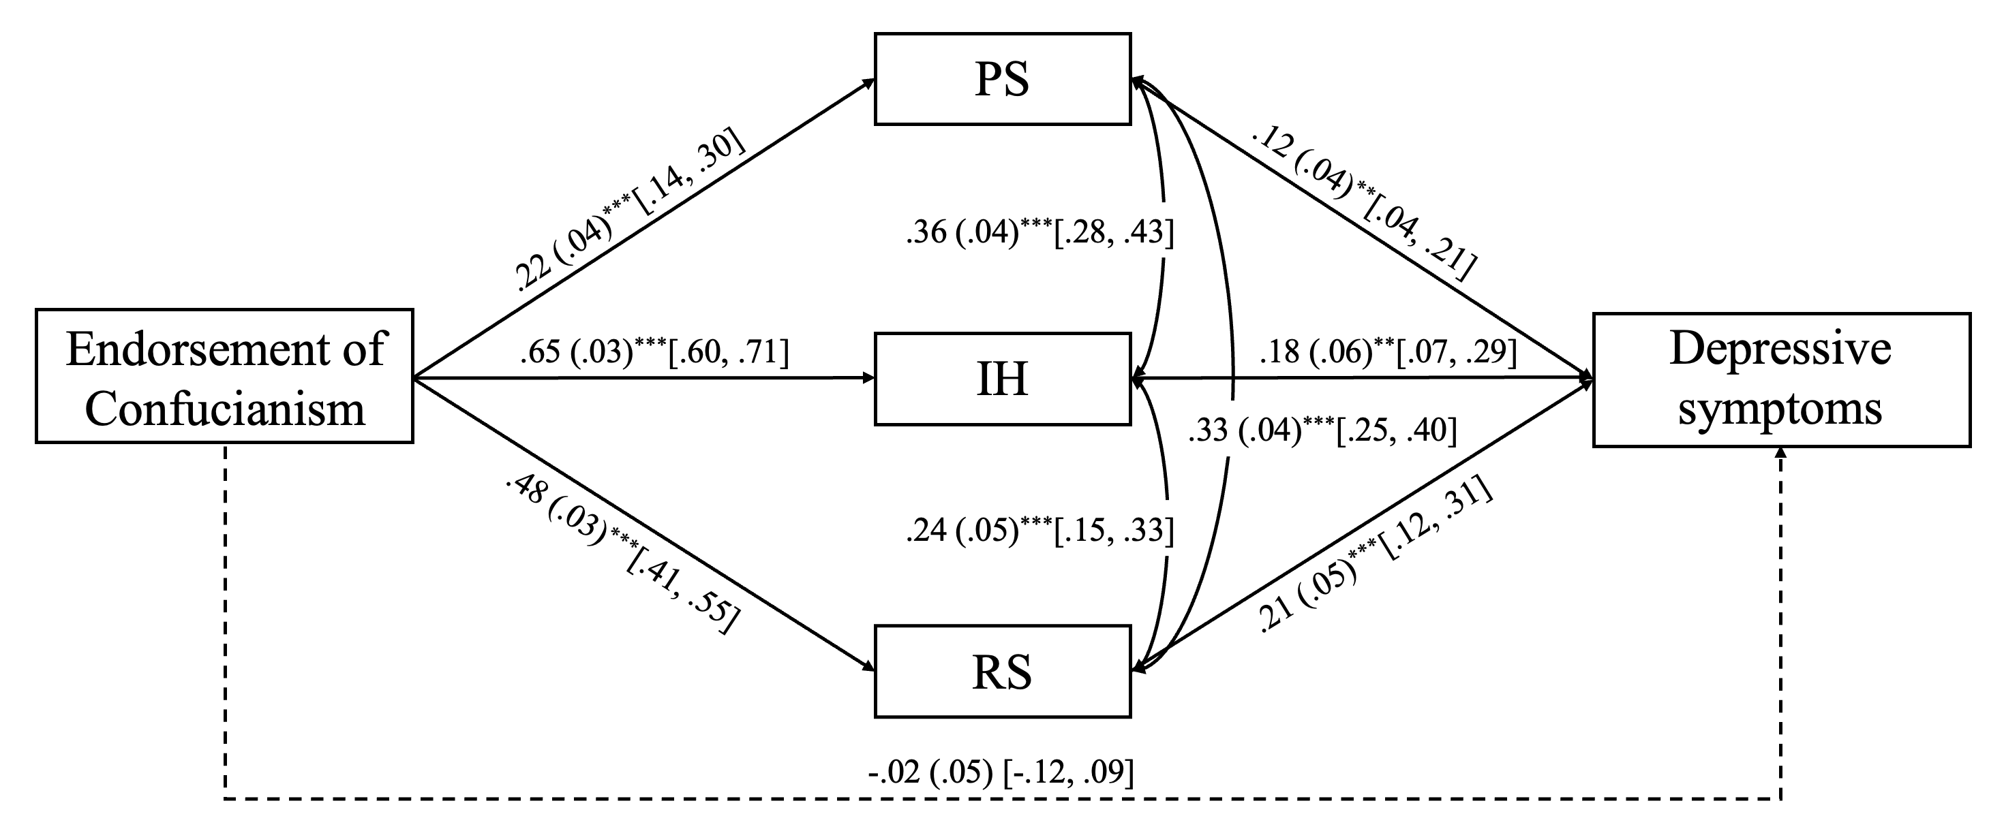
Figure 1. The path model for gay and bisexual men. Age, education, occupation, annual income, location, and sexual orientation were included as covariates. **p < .01, ***p < .001.

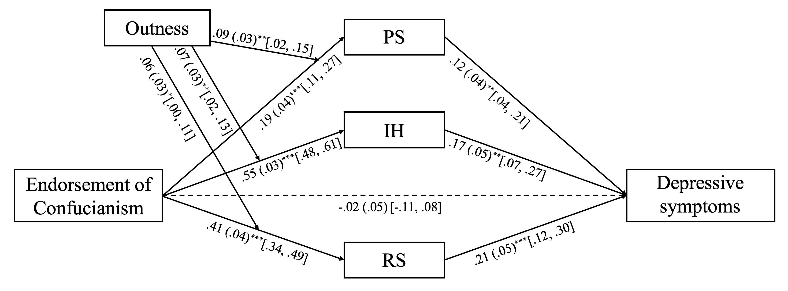
Figure 2. The moderated mediation model for gay and bisexual men. Age, education, occupation, annual income, location, and sexual orientation were included as covariates. *p < .05, **p < .01, ***p < .001.

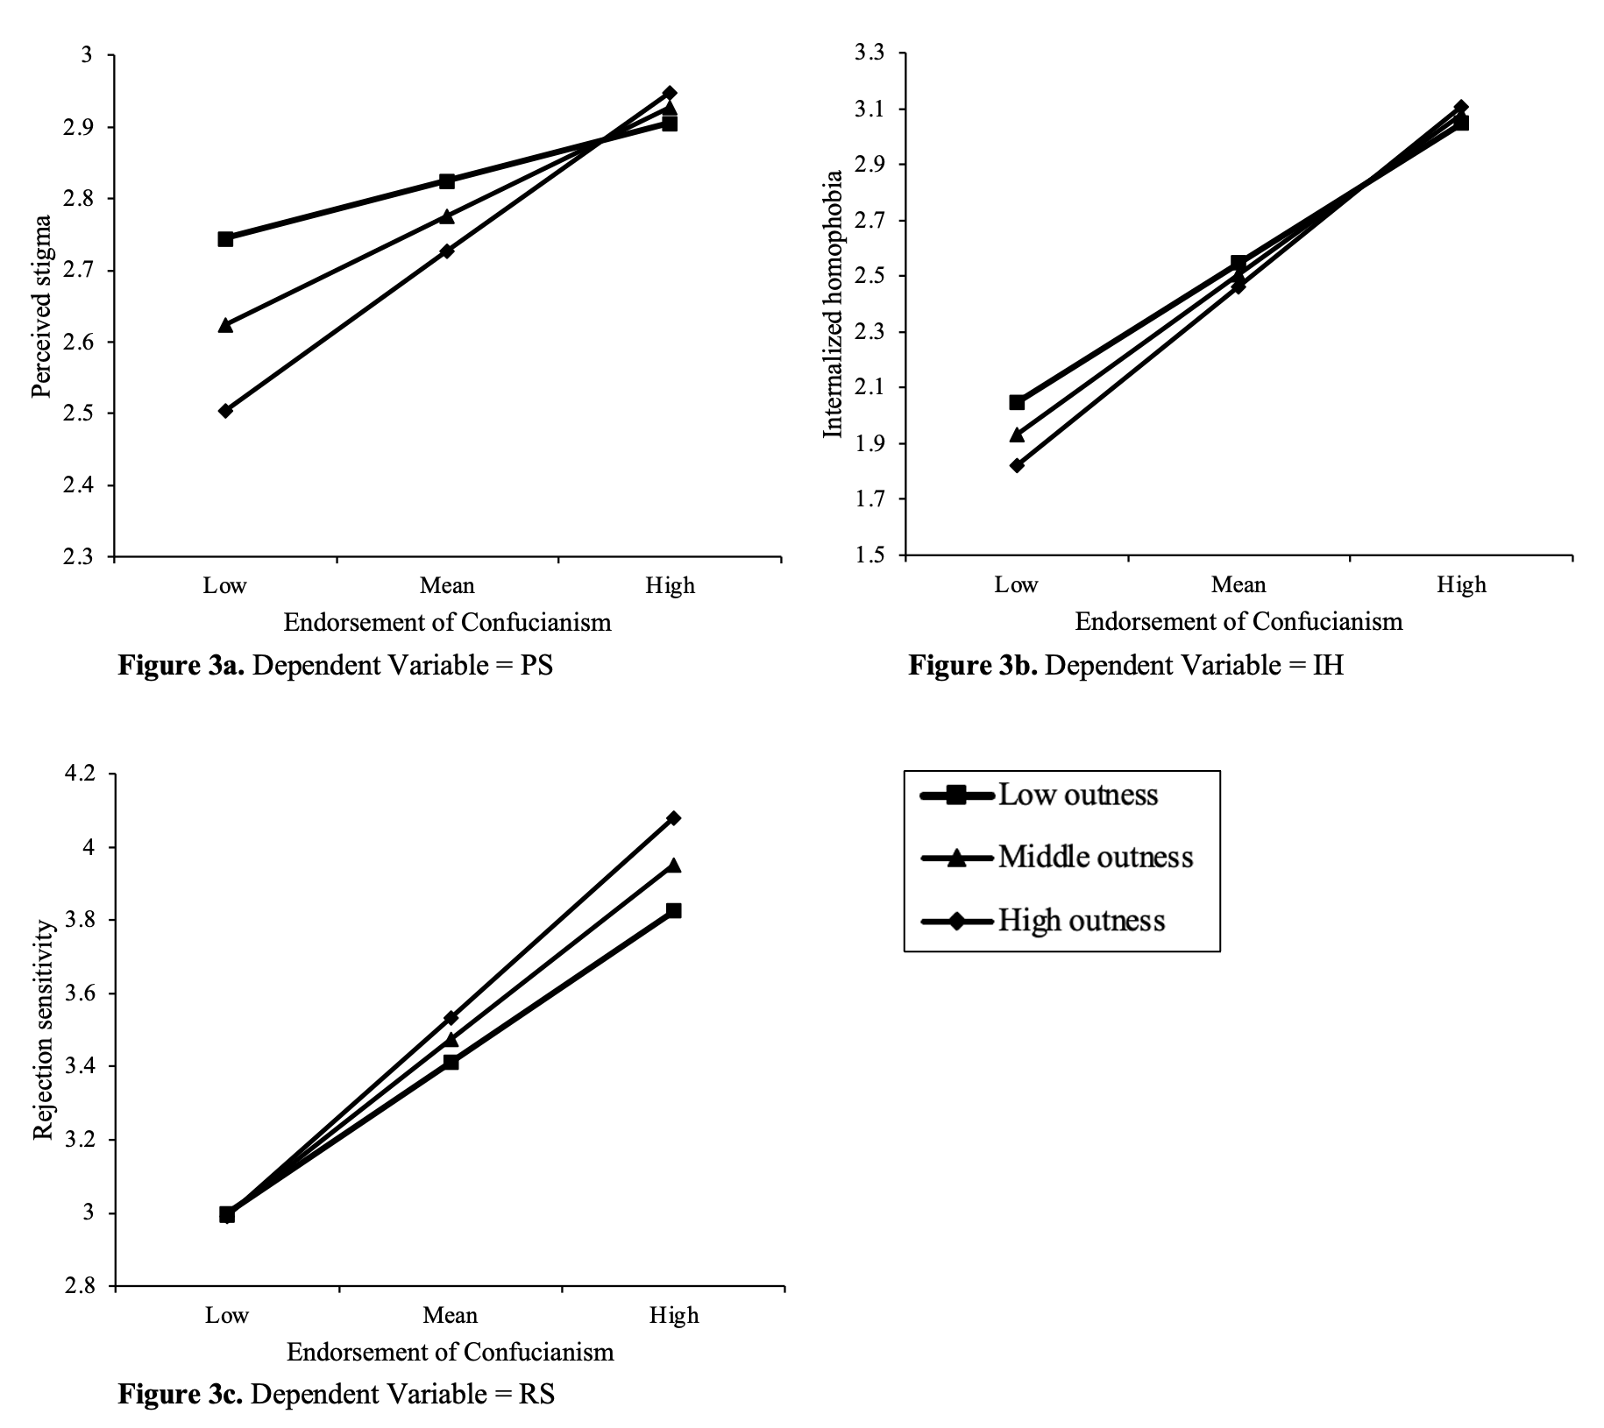
Figure 3. Interaction between Confucianism endorsement and outness on proximal processes for gay and bisexual men.

Results by Sexual Orientation
Table 4. Correlations among key variables by sexual orientation.
 | 1 | 2 | 3 | 4 | 5 | 6 | M | SD
1. Confucianism | – | .369*** | .672*** | .525*** | .194*** | .255*** | 2.26 | .50
2. Perceived stigma | .198*** | – | .525*** | .430*** | -.014 | .240*** | 2.66 | .78
3. Internalized homophobia | .653*** | .381** | – | .553*** | .028 | .263** | 2.45 | 1.03
4. Rejection sensitivity | .401*** | .394*** | .448*** | – | .165** | .318*** | 3.38 | 1.08
5. Outness | -.043 | -.074 | -.119** | -.141*** | – | .233*** | 2.58 | .90
6. Depressive symptoms | .109** | .225*** | .211*** | .268*** | .097* | – | 1.32 | .76
M | 2.08 | 2.61 | 1.95 | 3.05 | 2.79 | 1.19
SD | .46 | .79 | .90 | 1.07 | .88 | .82
Note. Bivariate correlations for bisexual individuals (n = 392) are placed above, and bivariate correlations for lesbian/gay individuals (n = 607) are presented below the diagonal. Means and SDs for bisexual individuals are presented in the vertical columns, as means and SDs for lesbian/gay individuals are presented in the horizontal rows. **p < .01, ***p < .001

Table 5. Indirect path analysis among lesbian/gay individuals.
Indirect path | β | SE | 95% CI
Confucianism→PS→Depressive symptoms | .02* | .01 | [.00, .03]
Confucianism→IH→Depressive symptoms | .10** | .03 | [.03, .16]
Confucianism→RS→Depressive symptoms | .07*** | .02 | [.04, .11]
Note. Reported effects were all standardized. **p < .01, ***p < .001.

Table 6. Indirect path analysis in bisexual individuals.
Indirect path | β | SE | 95% CI
Confucianism→PS→Depressive symptoms | .04 | .02 | [-.00, .08]
Confucianism→IH→Depressive symptoms | .07 | .05 | [-.02, .15]
Confucianism→RS→Depressive symptoms | .10** | .03 | [.04, .16]
Note. Reported effects were all standardized. **p < .01, ***p < .001.

Table 7. Conditional indirect effects of Confucianism endorsement on depressive symptoms via proximal processes at different levels of outness in bisexual individuals.
Outness | Effect | SE | 95% CI
Confucianism→IH→Depressive symptoms
Low (–1 SD) | .05 | .04 | [-.020, .122]
Mean | .06 | .04 | [-.022, .134]
High (+1 SD) | .07 | .04 | [-.024, .147]
Index of moderated mediation | .01 | .01 | [-.002, .019]
Confucianism→RS→Depressive symptoms
Low (–1 SD) | .06 | .03 | [.017, .122]
Mean | .08 | .03 | [.025, .132]
High (+1 SD) | .09 | .03 | [.032, .147]
Index of moderated mediation | .01 | .01 | [.001, .030]
Note. Reported effects were all standardized.
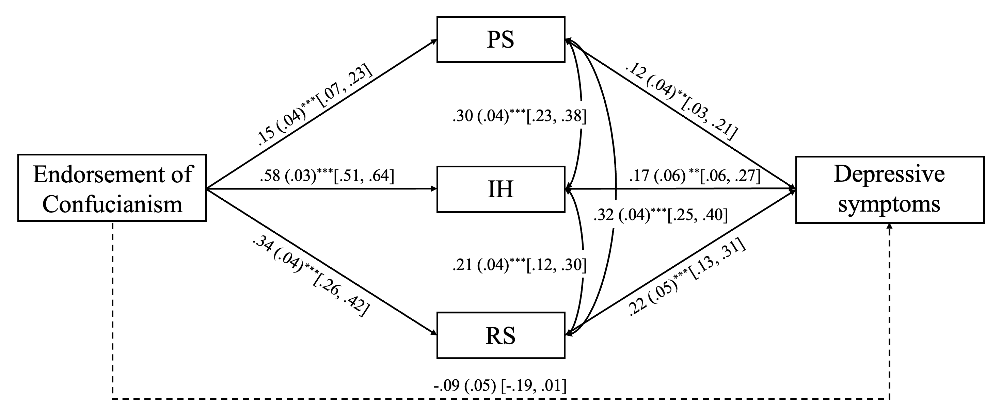
Figure 3. The path model for lesbian/gay individuals. Age, gender, education, occupation, annual income, and location were included as covariates. **p < .01, ***p < .001.

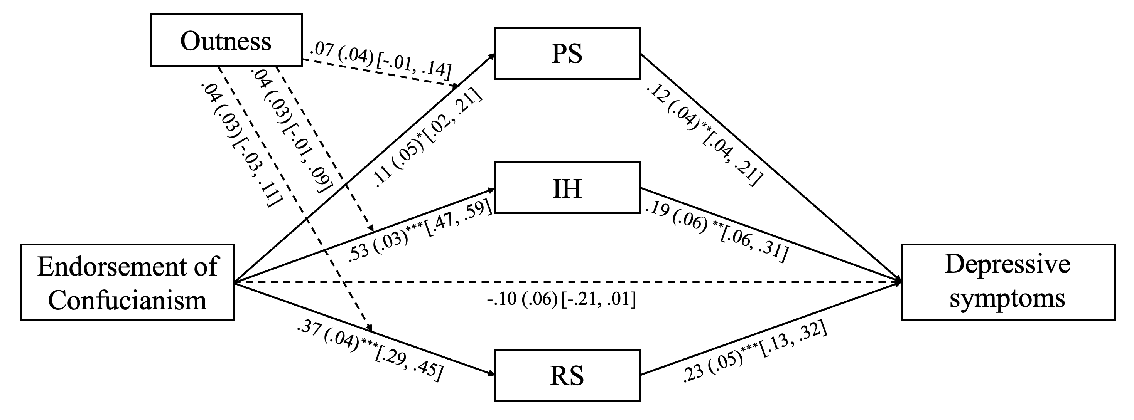
Figure 4. The moderated mediation model for lesbian/gay individuals. Age, gender, education, occupation, annual income, and location were included as covariates. *p < .05, **p < .01, ***p < .001.

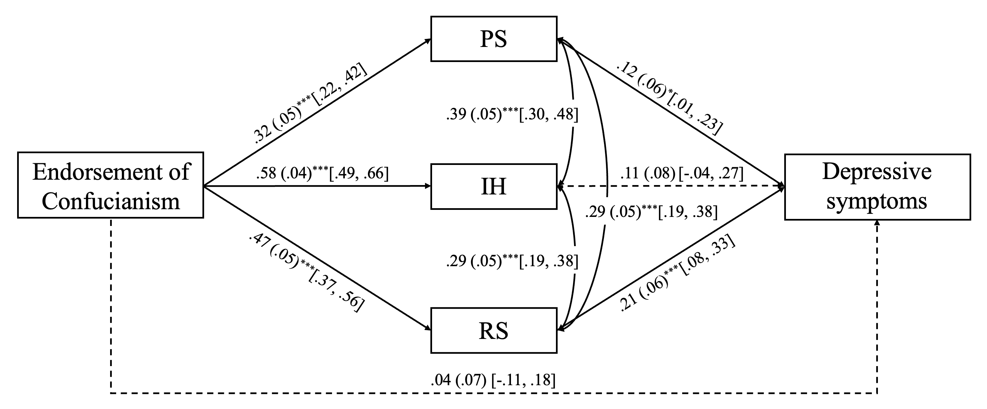
Figure 5. The path model for bisexual individuals. Age, gender, education, occupation, annual income, and location were included as covariates. **p < .01, ***p < .001.

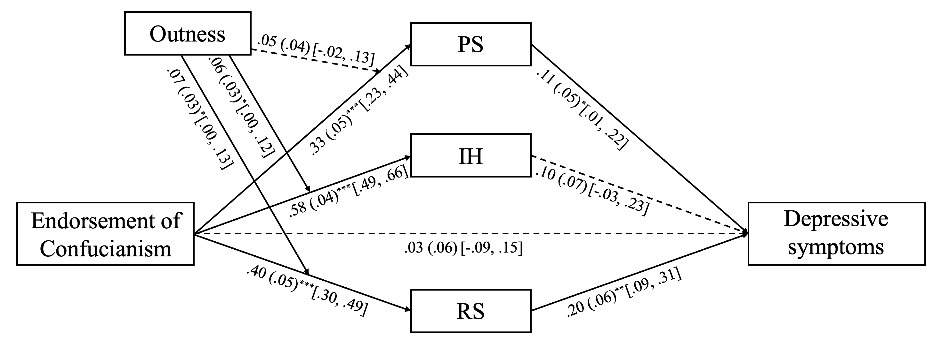
Figure 6. The moderated mediation model for bisexual individuals. Age, gender, education, occupation, annual income, and location were included as covariates. *p < .05, **p < .01, ***p < .001.
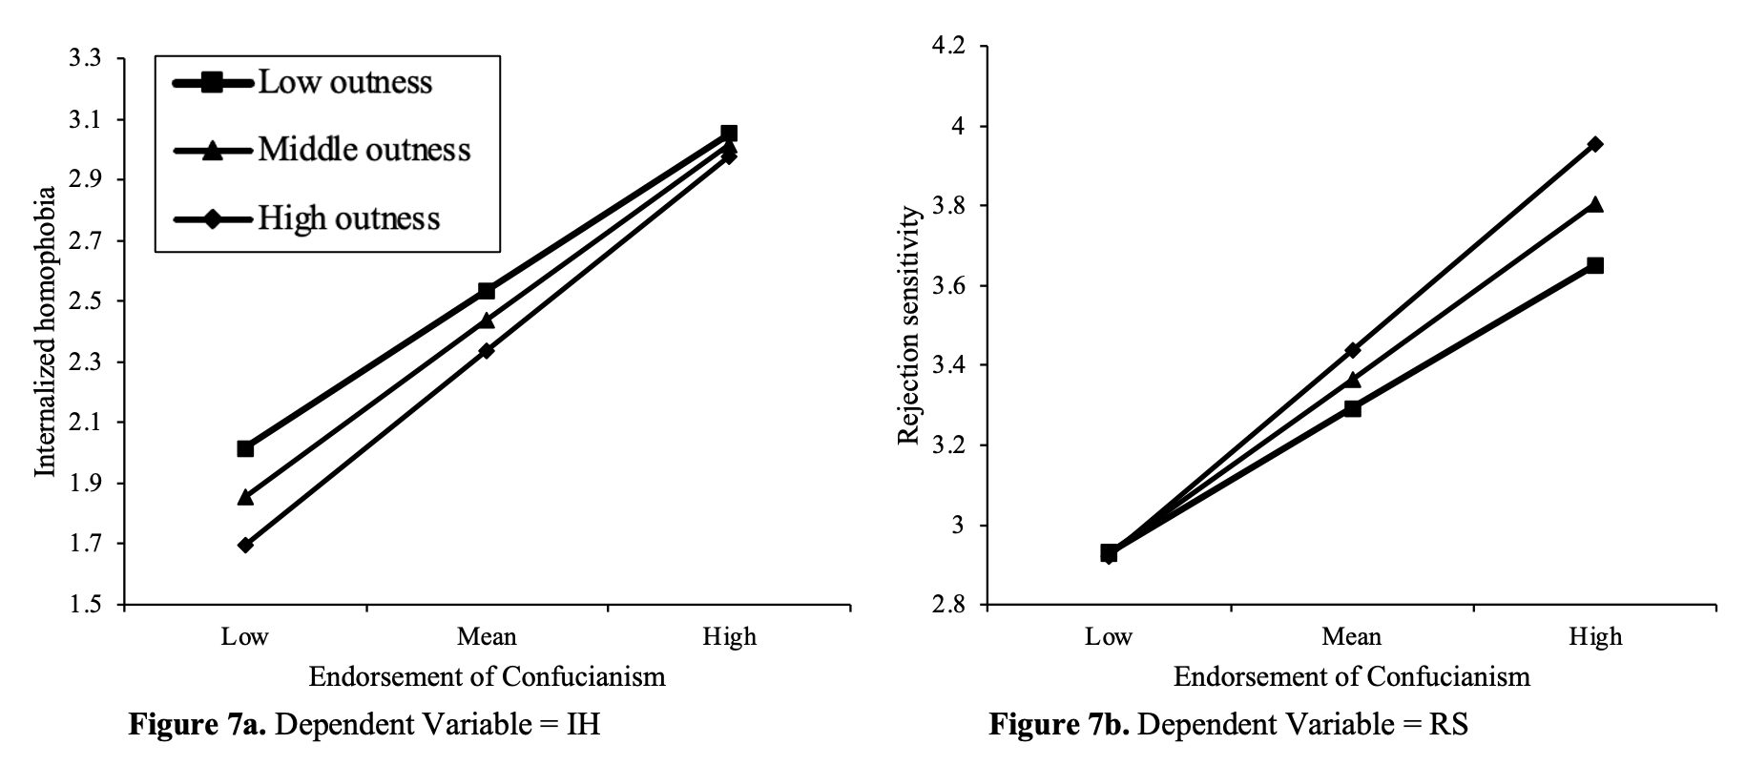
Figure 7. Interaction between Confucianism endorsement and outness on proximal processes in bisexual individuals.

