Supplementary Analyses
The Hypothesised Structural Model Including Covariates
On exploratory grounds, we re-examined the hypothesised model presented in the main text (Figure 3) with the inclusion of several demographic covariates: age, LGBTQ+ identity sub-groups that were responded to on the centrality measures, ethnic identity, relationship status, and recruitment source. The primary reason for this supplementary analysis was to test the robustness of the model and to ascertain if the inclusion of the covariates influenced model fit, or the direction or magnitude of pathway coefficients. Age was included as a continuous variable and all other covariates were simplified by dichotomising them prior to inclusion in the model. As the sample of LGBTQ+ individuals in this study were quite diverse in their LGBTQ+ identity orientations (see Table 1 in the main text), we aggregated them into six commonly reported LGBTQ+ identity groups (e.g., see Hill et al., 2020), and then used these individual groups as dichotomous variables within analyses. As such:
- LGBTQ+ identities that were individually embedded within identity centrality constructs were collapsed to represent those who endorsed the centrality of their gay identity (cisgender gay men; n = 258), lesbian identity (cisgender lesbian women; n = 144), bisexual identity (cisgender bisexual individuals; n = 193), other sexual identity (cisgender individuals with other sexual identities; n = 134), trans (binary) identity (transgender individuals with binary gender identities; n = 163), or non-binary identity (non-binary, gender-fluid, and agender individuals; n = 168). Then, each of these sub-groups were dummy-coded with those endorsing the centrality of their gay identity being the reference groups for analyses.
- Ethnicity was re-coded such that lower scores (0) correspond to White individuals (n = 876), and higher scores (1) represent those reporting other (or multiple) ethnicities (n = 164).
- Relationship status was re-coded to reflect those who were single (coded as 0; n = 519) and those in a relationship (coded as 1; n = 541), regardless of relationship type.
- Recruitment source was coded such that low scores (0) correspond with recruitment via social media platforms (n = 848) and high scores (1) refer to those recruited via Prolific (n = 212).
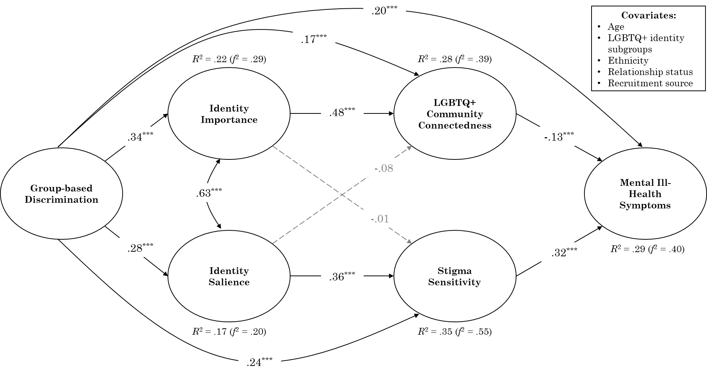
All covariates were included in the model as exogenous observed variables predicting all five endogenous latent variables (i.e., identity importance, identity salience, LGBTQ+ community connectedness, stigma sensitivity, and mental ill-health symptoms). Model results are presented in Figure S1.
Figure S1
Standardised Path Coefficients for the Structural Equation Model on the Relationship Between Discrimination and Mental Ill-Health Including Demographic Covariates
Notes. *p < .05, **p < .01, ***p < .001. Dashed arrows represent non-significant pathways (p > .05). Effect size estimates (R² and Cohen’s f²) reported alongside each endogenous variable for interpretation.

The model presented with the inclusion of the covariates showed acceptable fit to the data, χ²(581) = 1954.43, p < .001, CFI = .93, RMSEA [90% CI] = .048 [.045, .050], SRMR = .05. As shown in Figure S1, the hypothesised pathways between all latent variables are in the same directions, and show similar magnitudes, to the model without covariates presented in the main text (Figure 3). In this case however, they show these relationships above and beyond what is accounted for by the demographic covariates. Of note, some covariates also significantly related to the hypothesised variables. Age was negatively related to mental ill-health symptoms (β = -.16, p < .001), community connectedness (β = -.12, p < .001), and stigma sensitivity (β = -.31, p < .001), but was found to be unrelated to both identity importance (β = .06, p = .098) and identity salience (β = -.03, p = .448). For each of the central LGBTQ+ identity sub-groups: (a) the lesbian (compared to gay) identity group was associated with less identity salience (β = -.09, p = .014), but was found to be unrelated to other endogenous variables (all ps > .254), (b) the bisexual (compared to gay) sub-group was positively associated with mental ill-health (β = .12, p = .002), negatively associated with stigma sensitivity (β = -.09, p = .030), identity importance (β = -.20, p < .001), and identity salience (β = -.20, p < .001), but was found to be unrelated to community connectedness (β = .03, p = .412), (c) the other (compared to gay) sexual identity sub-group held a similar pattern of findings to that of the bisexual identity group such that it was positively associated with mental ill-health (β = .10, p = .005), negatively associated with stigma sensitivity (β = -.12, p = .001), identity importance (β = -.10, p = .010), and identity salience (β = -.10, p = .009), but was found to be unrelated to community connectedness (β = .03, p = .402), (d) the trans binary (compared to gay) sub-group was positively associated with both community connectedness (β = .08, p = .022) and stigma sensitivity (β = .09, p = .014), but found to be unrelated to all other endogenous variables (all ps > .069), and (e) the non-binary (compared to gay) sub-group was positively associated with both mental ill-health (β = .18, p < .001) and community connectedness (β = .15, p < .001), negatively associated with identity salience (β = -.12, p = .003), but found to be unrelated to the other endogenous variables (all ps > .263).
Ethnic identity was found to be unrelated to all of the endogenous variables in the model (all p’s > .062). For associations with relationship status, those in a relationship (compared to those who are single) were associated with significantly less mental ill-health symptoms (β = -.06, p = .034) and identity salience (β = -.07, p = .027). However, relationship status was found to be unrelated to all other endogenous variables (all ps > .135). Finally, participants who were recruited via prolific (compared with social media recruitment) were associated with less identity importance (β = -.18, p < .001) and less identity salience (β = -.17, p < .001). Source of participant recruitment was found to be unrelated to all other endogenous variables (all ps > .257).
In brief, the inclusion of covariates in this model did not change the fit of the model (i.e., models with and without covariates both had acceptable fit indices), the direction of associations, and the magnitudes of the standardized pathway coefficients, compared to the model without covariates in the main text (Figure 3). This provides support for the robustness of this model, whilst also providing preliminary evidence that the differences in these model constructs that can be accounted for by demographic factors do not appear to impede on the overall model results. We encourage future researchers to examine the replicability of this model among other diverse groups and sub-groups.

