Supplemental Materials
Simplified explanation of AI
In this study, we employ an AI technique called supervised machine learning to develop a predictive model. Figure S1 presents a simplified example using cat versus dog classification. Initially, a dataset is divided into a training set (80%) and a testing set (20%). The model is trained on the labeled training set, where features such as ear shape, tail length, and presence of whiskers are associated with respective labels (“cat” or “dog”). During training, the model learns to identify patterns in these features to distinguish between classes. After training, the model's performance is evaluated on a blinded testing set. Predictions are compared to true labels, and this feedback informs potential refinements.
In this study, we apply this machine learning approach to predict suicidality based on social media data. Instead of physical traits, the model is trained on features such as textual content, images, and behavioral patterns, enabling it to differentiate between users with and without indicators of suicidality.

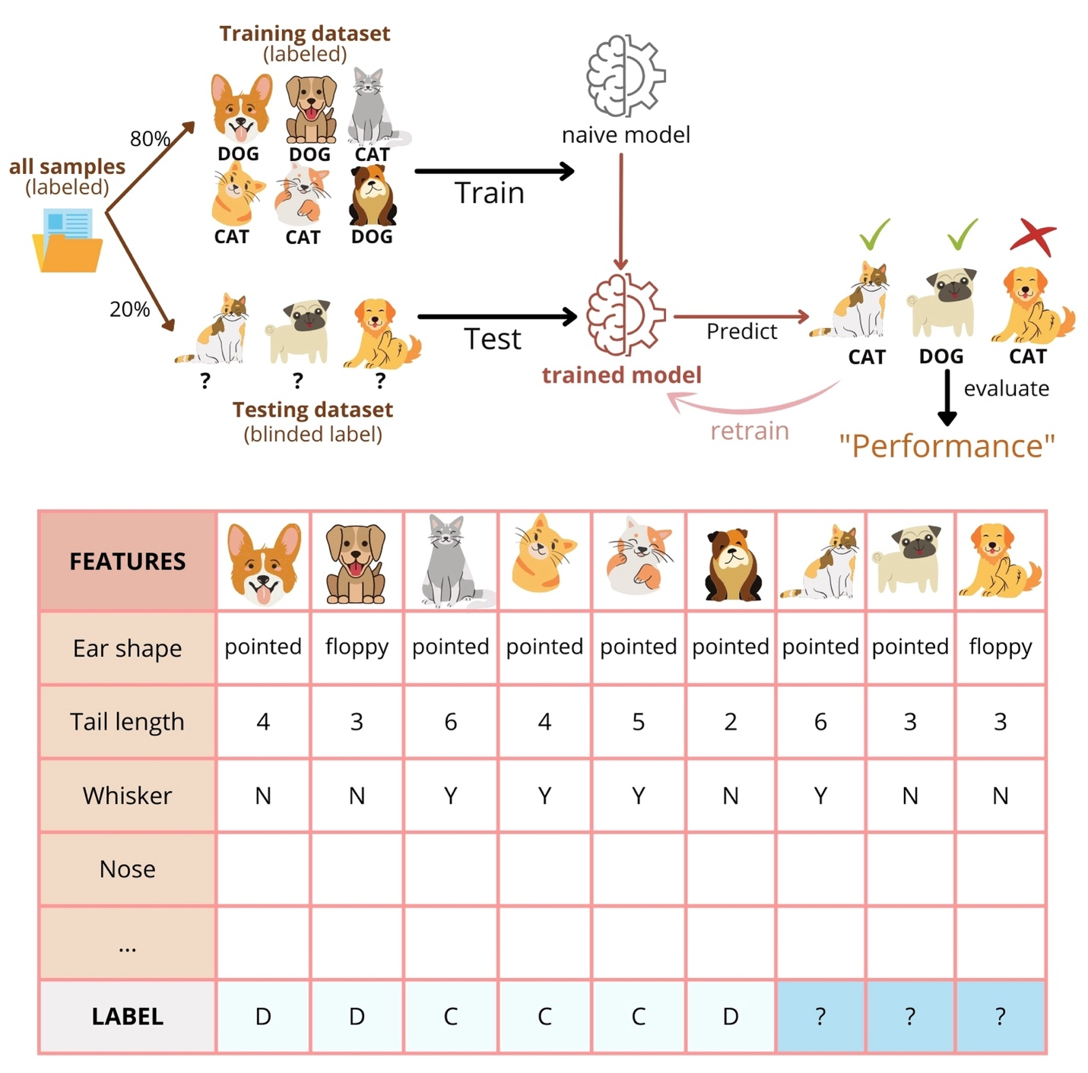

Figure S1 illustrates a supervised machine learning workflow for binary classification, using the example of distinguishing between cats and dogs.

Supplemental Methods 1
Image analysis
We used the OpenCV library (Bradski & Kaehler, 2008) to compute a value for each component in HSV (Hue-Saturation-Value) and RGB (Red-Green-Blue) color spaces.
We used Google Cloud Vision API to perform the following tasks:
1) Label detection was used to provide generalized labels for an image with a confidence score.
2) Object detection was used to detect multiple objects in an image with a confidence score.
3) Face and emotion detection was used to detect multiple faces within an image along with emotion state (joy, sorrow, anger, surprise) with 1-5 likelihood ratings which means very unlikely, unlikely, possible, likely, and very likely, respectively.
4) Explicit content detection (Safe Search) was used to detect five following categories of explicit content within an image with 1-5 likelihood ratings similar to face and emotion detection:
- Adult content may contain elements such as nudity, pornographic images or cartoons, or sexual activities.
- Spoof content involves modifications to an image's canonical version to make it appear humorous or offensive.
- Medical content includes images related to medical conditions or procedures.
- Violent content may depict death, serious harm, or injury to individuals or groups of individuals.
- Racy content may include (but is not limited to) skimpy or sheer clothing, strategically covered nudity, lewd or provocative poses, or close-ups of sensitive body areas.
5) Text detection was used to identify text in images, including both typed text (e.g., in a PDF) and handwritten text (e.g., in tattoos or graffiti), using an artificial intelligence method known as Optical Character Recognition (OCR). OCR extracts text from images and converts it into editable formats.
From tasks 1) and 2), we obtained multiple labels and objects for each photo. In total, we identified 729 unique labels and 115 unique objects. These were categorized into the following groups: nature, art, connection, activity, light, leisure, mood, body, fashion, and people, before being fed into our AI modeling. 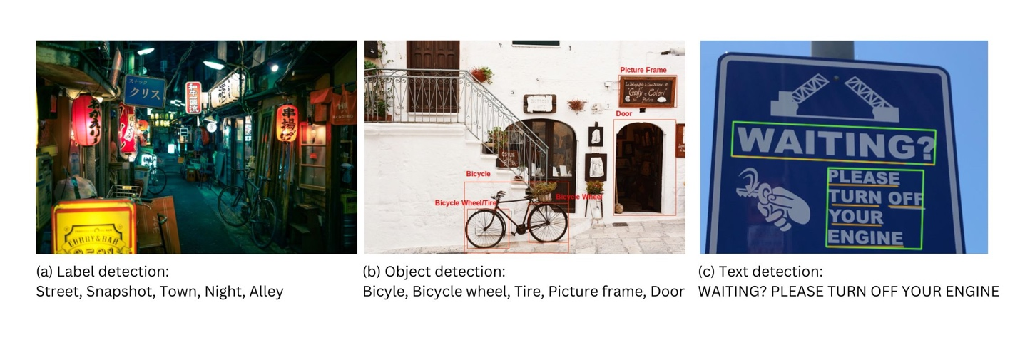Figure S2 shows examples of label, object, and text detection from Google Cloud Vision API.
Portions of Figure S2 are reproduced from work shared by Google and used according to the terms described in the Creative Commons 4.0 Attribution License. The images were originally sourced from:
- Image of an empty pathway (Alex Knight, Unsplash, https://unsplash.com/photos/wfwUpfVqrKU)
- Black bicycle near handrails at daytime (Bogdan Dada, Unsplash, https://unsplash.com/photos/J9cBJjlpYKU)
Text analysis
Natural Language Toolkit (NLTK) (Bird et al., 2009) was used to preprocess text by cleaning the text, removing URL, parsing to sentences and words, and stemming from root words. Then, we counted the frequency of emojis and some specific word groups, including first-person pronouns and death-related words.
We performed sentiment analysis using VADER (Valence Aware Dictionary and sEntiment Reasoner), supported by NLTK. It analyses text and returns a positivity score, negativity score, and neutral score ranging from 0 to 1, and a compound score between -1 and +1 (Hutto & Gilbert, 2014).
The NRCLex Project of the Python Package Index (PyPI) (Bailey, 2019), based on the National Research Council Canada (NRC) affect lexicon (Mohammad & Turney, 2013), was used to analyze text and return frequency of words associated with each emotion among eight basic emotions (anger, fear, anticipation, trust, surprise, sadness, joy, and disgust).
Supplemental Methods 2
Data analysis – Performance of image and text analysis of open-source AI tools
For label, object, and text detection from an image, three raters agreed or disagreed (0,1) with each item. Fleiss kappa was used to determine inter-rater agreement among them. If there was non-agreement among them, Cohen’s kappa between any two of the raters was then conducted to find where the difference was. Three raters gave ratings (1-5) to each item for facial emotion and explicit content detection from an image, so the Kendall Coefficient of Concordance W was used to determine the correlation among three sets of ratings. If there was non-agreement among them, Kendall Tau between any two of the raters was then conducted to find where the difference was. For NLP, two experts were asked to agree or disagree with the analysis made by AI, so the items that each rater agreed to each other were counted to calculate the percent agreement.

Table S1
Performance of image analysis by Google Cloud Vision API on 25 random images from our dataset
Content |  | Statistics
Label detection ª |  | κ = 0.22 (p < 0.001) *
Object detection ª |  | κ = 0.34 (p < 0.001) *
Text detection (OCR) ª |  | κ = 0.43 (p < 0.001) *
Face and emotion detection ^{b} | Joy | W = 0.96 (p < 0.001) *
Face and emotion detection ^{b} | Anger | W = 0.92 (p < 0.001) *
Face and emotion detection ^{b} | Surprise | W = 0.91 (p < 0.001) *
Face and emotion detection ^{b} | Sorrow | W = 0.89 (p < 0.001) *
Explicit content detection ^{b} | Adult | W = 0.43 (p = 0.153)
Explicit content detection ^{b} | Medical | W = 1.00 (p < 0.001) *
Explicit content detection ^{b} | Spoof | W = 0.78 (p < 0.001) *
Explicit content detection ^{b} | Violence | W = 0.75 (p < 0.001) *
Explicit content detection ^{b} | Racy | W = 0.89 (p < 0.001) *

Note.
ª For label and object detection, agreement among three raters (two experts and AI) was shown in the Fleiss’ Kappa Statistics (κ) with p-value.
^{b} For face and emotion detection and explicit content detection, agreement among three raters (two experts and AI) was shown in Kendall coefficient of concordance W with p-value.
* p-value < 0.05

Table S2
Performance of sentiment analysis by NLTK and emotion analysis by NRCLex on 25 random captions from our dataset
Raters |  | Percent agreement
 |  | Sentiment analysis | Emotion analysis
Agreement between two experts | Agree | 24/25 (96%) | 18/25 (72%)
Agreement between two experts | Disagree | 1/25 (4%) | 7/25 (28%)
Agreement between experts and AI | Agree | 22/25 (88%) | 15/25 (60%)
Agreement between experts and AI | Partially agree | 1/25 (4%) | 7/25 (28%)
Agreement between experts and AI | Disagree | 2/25 (8%) | 3/25 (12%)

Table S3
Statistics of categorical variables using frequency with percentage and chi-square test
Variables | N (%) |  |  | Chi-square  (p-value)
Variables | Total (N = 142) | No SI (N = 109) | SI (N = 33) | Chi-square  (p-value)
Description ª  - No description  - Negative description  - Neutral description  - Positive description | 13 (9.2%)  7 (4.9%)  96 (67.6%)  26 (18.3%) | 12 (11.0%)  2 (1.8%)  76 (69.7%)  19 (17.4%) | 1 (3.0%)  5 (15.2%)  20 (60.6%)  7 (21.2%) | 11.383 (0.016) *
Followers (upper outlier) ª | 7 (4.9%) | 4 (3.7%) | 3 (9.1%) | 1.588 (0.353)
Posts (upper outlier) ª | 2 (1.4%) | 0 (0.0%) | 2 (6.1%) | 6.700 (0.053)
Variables for participant with  posts ^{b} | N (%) |  |  | Chi-square  (p-value)
Variables for participant with  posts ^{b} | Total (N = 67) | No SI (N = 50) | SI (N = 17) | Chi-square  (p-value)
Any post with art (yes/no) ª | 14 (20.9%) | 6 (12.0%) | 8 (47.1%) | 9.434 (0.005) *
Any post with connection (yes/no) | 30 (44.8%) | 23 (46.0%) | 7 (41.2%) | 0.119 (0.730)
Any post with activity (yes/no) | 24 (35.8%) | 21 (42.0%) | 3 (17.6%) | 3.273 (0.070)
Note.
ª We use Fisher’s Exact test for these features since there were more than 20% of cells having expected count less than 5.
^{b} These features used the dataset from 67 participants who have any post on their Instagram profiles.
* p-value < 0.05

Table S4 Statistics of numerical variables using median with interquartile range and Mann-Whitney U test
Variables | Median (IQR) |  |  | U  (p-value)
Variables | Total (N = 142) | No SI (N = 109) | SI (N = 33) | U  (p-value)
User features
- Profile features
Description sentiment score | 0.0 (0.0, 0.0) | 0.0 (0.0, 0.0) | 0.0 (0.0, 0.0) | 1649 (0.331)
Following | 664.5 (403.8, 971.5) | 685.0 (411.0, 962.5) | 607.0 (356.5, 1057.5) | 1748 (0.807)
Followers | 672.0 (342.3, 1093.8) | 701.0 (372.5, 1120.0) | 622.0 (287.5, 877.5) | 1563 (0.225)
Posts | 0.0 (0.0, 2.0) | 0.0 (0.0, 2.0) | 1.0 (0.0, 2.5) | 1663 (0.476)
Variables for participants with posts ª | Median (IQR) |  |  | U  (p-value)
Variables for participants with posts ª | Total (N = 67) | No SI (N = 50) | SI (N = 17) | U  (p-value)
- Behavior features
Comments | 6.0 (2.0, 14.0) | 8.0 (2.8, 15.5) | 3.0 (0.0, 10.0) | 321 (0.132)
Likes | 58.0 (0.0, 143.5) | 67.4 (0.0, 144.8) | 19.0 (0.0, 135.5) | 374 (0.458)
People tagged | 1.0 (0.0, 2.8) | 1.1 (0.0, 2.9) | 0.5 (0.0, 2.5) | 382 (0.519)
Posts with tag | 1.0 (0.0, 2.0) | 1.0 (0.0, 2.0) | 1.0 (0.0, 1.0) | 352 (0.265)
Posts during night time | 0.0 (0.0, 0.0) | 0.0 (0.0, 0.0) | 0.0 (0.0, 0.0) | 380 (0.340)
Image posts | 0.0 (0.0, 20.0) | 0.0 (0.0, 21.3) | 0.0 (0.0, 15.3) | 422 (0.950)
Video posts | 0.0 (0.0, 0.0) | 0.0 (0.0, 0.0) | 0.0 (0.0, 0.0) | 419 (0.860)
Posts with multiple contents | 100.0 (50.0, 100.0) | 100.0 (50.0, 100.0) | 100.0 (62.5, 100.0) | 419 (0.920)
Image features
- Color spaces
Hue | 55.0 (45.1, 68.4) | 57.7 (50.0, 69.4) | 48.2 (41.0, 55.8) | 281 (0.038)*
Saturation | 84.8 (71.6, 99.2) | 85.4 (71.8, 99.4) | 80.6 (63.7, 101.1) | 384 (0.555)
Value | 139.9 (127.6, 150.2) | 140.0 (126.9, 152.3) | 139.1 (129.6, 147.6) | 413 (0.863)
Red | 117.4 (106.0, 133.7) | 114.1 (103.8, 130.4) | 124.6 (115.9, 141.0) | 274 (0.030)*
Green | 116.8 (106.6, 126.7) | 117.2 (106.4, 128.0) | 115.9 (106.2, 121.9) | 412 (0.851)
Blue | 108.5 (96.3, 124.5) | 112.4 (97.6, 126.9) | 107.0 (93.0, 112.5) | 351 (0.286)
- Label and object detection
Nature (all) | 60.0 (28.6, 88.9) | 73.2 (32.5, 91.7) | 43.8 (6.7, 55.0) | 255 (0.014)*
Natural landscape | 25.0 (0.0, 50.0) | 27.6 (0.0, 50.0) | 20.0 (0.0, 43.1) | 375 (0.460)
Plant | 20.0 (0.0, 50.0) | 20.0 (1.5, 51.4) | 11.1 (0.0, 31.3) | 331 (0.169)
Water | 0.0 (0.0, 12.5) | 0.0 (0.0, 12.8) | 0.0 (0.0, 5.0) | 334 (0.141)
Beach | 0.0 (0.0, 16.7) | 0.0 (0.0, 21.3) | 0.0 (0.0, 6.7) | 336 (0.156)
Sky | 38.9 (11.1, 68.8) | 50.0 (21.1, 75.0) | 24.1 (0.0, 40.0) | 275 (0.029)*
Art | 0.0 (0.0, 0.0) | 0.0 (0.0, 0.0) | 0.0 (0.0, 0.0) | 283 (0.002)*
Light | 11.1 (0.0, 20.6) | 11.1 (0.0, 25.0) | 7.1 (0.0, 16.3) | 355 (0.297)
Leisure | 11.1 (0.0, 28.6) | 14.6 (0.0, 28.9) | 0.0 (0.0, 24.7) | 331 (0.161)
Mood | 41.7 (0.0, 62.5) | 42.7 (0.0, 66.7) | 39.4 (6.7, 53.9) | 403 (0.749)
Body | 23.8 (0.0, 40.6) | 14.3 (0.0, 33.3) | 33.3 (16.7, 51.5) | 244 (0.008)*
Fashion | 0.0 (0.0, 5.0) | 0.0 (0.0, 0.0) | 10.0 (0.0, 37.5) | 256 (0.003)*
People | 5.5 (1.5, 9.0) | 5.3 (2.3, 9.4) | 6.3 (1.3, 8.3) | 416 (0.891)
- Face and emotion detection
Face | 4.5 (1.0, 8.0) | 4.5 (1.3, 8.0) | 6.0 (1.0, 7.5) | 425 (0.994)
Joy | 3.0 (1.4, 4.0) | 3.0 (1.4, 4.0) | 2.6 (1.1, 3.8) | 364 (0.383)
- Explicit content detection (Safe Search)
Explicit content (overall) | 1.5 (1.3, 1.8) | 1.5 (1.2, 1.7) | 1.7 (1.4, 1.9) | 309 (0.093)
Adult content | 1.4 (1.1, 1.8) | 1.4 (1.0, 1.7) | 1.4 (1.2, 1.8) | 350 (0.275)
Medical content | 1.3 (1.1, 1.5) | 1.3 (1.0, 1.5) | 1.3 (1.2, 1.7) | 369 (0.414)
Spoof content | 1.3 (1.0, 1.5) | 1.2 (1.0, 1.4) | 1.4 (1.2, 1.6) | 285 (0.042)*
Violent content | 1.1 (1.0, 1.3) | 1.1 (1.0, 1.2) | 1.3 (1.0, 1.5) | 307 (0.085)
Racy content | 2.2 (1.4, 2.9) | 2.0 (1.4, 2.8) | 2.5 (1.9, 3.0) | 322 (0.135)
- Text detection (OCR)
Text in image | 0.0 (0.0, 0.03) | 0.0 (0.0, 0.0) | 0.0 (0.0, 0.1) | 328.5 (0.069)
Text features
- Frequency of certain words
Emojis | 0.5 (0.0, 1.0) | 0.6 (0.0, 1.5) | 0.0 (0.0, 0.8) | 323 (0.124)
First-person pronouns | 0.0 (0.0, 2.0) | 0.0 (0.0, 2.0) | 1.0 (0.0, 3.5) | 355 (0.274)
Death related words | 0.0 (0.0, 0.0) | 0.0 (0.0, 0.0) | 0.0 (0.0, 0.0) | 400 (0.086)
- Emotion analysis
Fear | 0.0 (0.0, 0.1) | 0.0 (0.0, 0.1) | 0.0 (0.0, 0.1) | 411 (0.769)
Anger | 0.0 (0.0, 0.0) | 0.0 (0.0, 0.0) | 0.0 (0.0, 0.0) | 375 (0.311)
Anticipate | 0.0 (0.0, 0.2) | 0.0 (0.0, 0.2) | 0.0 (0.0, 0.2) | 423 (0.974)
Trust | 0.0 (0.0, 0.1) | 0.0 (0.0, 0.1) | 0.0 (0.0, 0.1) | 397 (0.642)
Surprise | 0.0 (0.0, 0.0) | 0.0 (0.0, 0.0) | 0.0 (0.0, 0.0) | 393 (0.490)
Sadness | 0.0 (0.0, 0.0) | 0.0 (0.0, 0.0) | 0.0 (0.0, 0.0) | 386 (0.401)
Disgust | 0.0 (0.0, 0.0) | 0.0 (0.0, 0.0) | 0.0 (0.0, 0.0) | 415 (0.776)
Joy | 0.0 (0.0, 0.2) | 0.0 (0.0, 0.2) | 0.0 (0.0, 0.2) | 405 (0.752)
- Sentiment analysis
Compound sentiment score | 0.0 (0.0, 0.3) | 0.1 (0.0, 0.3) | 0.0 (0.0, 0.3) | 399 (0.697)
% of negative posts | 0.0 (0.0, 0.0) | 0.0 (0.0, 3.1) | 0.0 (0.0, 4.1) | 419 (0.920)
% of neutral posts | 50.0 (0.0, 100.0) | 50.0 (0.0, 100.0) | 40.0 (0.0, 100.0) | 393 (0.643)
% of positive posts | 25.0 (0.0, 75.0) | 22.5 (0.0, 100.0) | 27.8 (0.0, 67.5) | 411 (0.833)
Negative sentiment score | 0.0 (0.0, 0.1) | 0.0 (0.0, 0.1) | 0.0 (0.0, 0.1) | 419 (0.900)
Neutral sentiment score | 0.7 (0.6, 0.9) | 0.7 (0.6, 0.9) | 0.7 (0.6, 1.0) | 399 (0.698)
Positive sentiment score | 0.1 (0.0, 0.3) | 0.1 (0.0, 0.3) | 0.1 (0.0, 0.3) | 420 (0.933)
Abbreviation. SI = suicidal ideation
Note.
ª 54 variables shared the same dataset from 67 participants who have any post on their Instagram profile, thus used the same adjusted alpha from Bonferroni correction at 0.0009.
* p-value meets only the criteria of p < 0.05 for each test considered individually but doesn’t meet Bonferroni criterion for statistical significance

Table S5
Statistics of variables using backward multivariate binary logistic regression
Variables | Odd ratios | 95% CI | p-value
Hue | 0.982 | (0.940, 1.025) | 0.410
Red | 1.021 | (0.995, 1.047) | 0.114
Sky | 0.120 | (0.006, 2.620) | 0.178
Art | 0.010 | (0.000, 353.024) | 0.389
Any post with art (yes/no) | 36.740 | (3.572, 377.946) | 0.002 **
Body | 26.597 | (0.999, 708.392) | 0.050
Fashion | 6.247 | (0.283, 139.252) | 0.246
Spoof content | 2.591 | (0.237, 28.356) | 0.435
Description (indicator = Neutral description) |  |  | 0.015 *
No description | 0.285 | (0.030, 2.731) | 0.277
Negative description | 15.534 | (2.487, 97.022) | 0.003 **
Positive description | 1.646 | (0.486, 5.575) | 0.424
Note. * p-value < 0.05, ** p-value < 0.01

Supplemental References
Bailey, M. M. (2019). NRCLex. Retrieved from https://pypi.org/project/NRCLex/
Bird, S., Klein, E., & Loper, E. (2009). Natural language processing with Python: analyzing text with the natural language toolkit: " O'Reilly Media, Inc.".
Bradski, G., & Kaehler, A. (2008). Learning OpenCV: Computer vision with the OpenCV library: " O'Reilly Media, Inc.".
Hutto, C., & Gilbert, E. (2014). Vader: A parsimonious rule-based model for sentiment analysis of social media text. Paper presented at the Proceedings of the international AAAI conference on web and social media.
Mohammad, S. M., & Turney, P. D. (2013). Crowdsourcing a word–emotion association lexicon. Computational intelligence, 29(3), 436-465.

