Detailed Participants’ Demographic Information
Variable | n | %
Age
17 or younger | - | -
18-20 | 116 | 40.56
21-30 | 97 | 33.92
31-40 | 40 | 13.99
41-50 | 19 | 6.64
51-60 | 8 | 2.80
61 or older | 6 | 2.10
Gender
Male | 82 | 28.67
Female | 202 | 70.63
Non-binary / Third gender | 2 | 0.70
Prefer not to say | - | -
Others | - | -
Ethnicity
African | 28 | 9.79
Black / African American | 2 | 0.70
Black / British | 7 | 2.45
Caribbean | 1 | 0.35
East Asian | 2 | 0.70
European | 181 | 63.29
Latino/Hispanic | 1 | 0.35
Māori | - | -
Middle Eastern | 2 | 0.70
Mixed | 7 | 2.45
Native American or Alaskan Native | - | -
Pacific Islander | - | -
Romani / Travelers | - | -
South Asian | 13 | 4.55
Southeast Asian | 6 | 2.10
White / Sephardic Jew | 33 | 11.54
White Mexican | - | -
Others / Unknown | 3 | 1.05

Path diagram for the three-factor structure of the OMS-HC-15 scores, showing standardised coefficients.
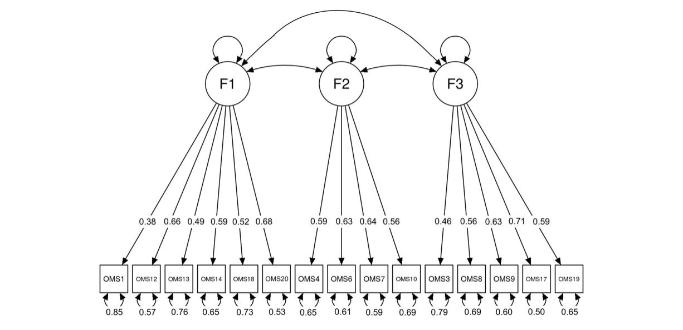
Note. F1 = Attitude; F2 = Disclosure and Help-Seeking; F3 = Social Distance.

