Supplemental Material B
For
“Talking the talk, not walking the walk: The co-evolution of overconfidence and loss aversion”
In Kruger and Dunning (1999), subjects took tests of humor, grammar, and logic. After answering, but before receiving feedback, they estimated how many questions they had answered correctly. When expected performance is regressed on actual performance, the resulting pattern—often labelled the Dunning–Kruger effect—shows that overconfidence is largest among the least able: low performers tend to overestimate their ability, while high performers tend to underestimate theirs. The central issue is whether this pattern reflects heterogeneous metacognition or is instead a statistical artefact.
We focus on two statistical concerns. First is measurement error in test performance, which serves only as a noisy proxy for latent ability. Systematic sources of error include poor test design (e.g., overly complex phrasing or insufficient time limits), while random error arises from inattention, misreading questions, or guessing. In this context, regressing expected performance on measured performance leads to attenuation bias in the slope (and a correspondingly inflated intercept), mechanically generating a Dunning–Kruger–like pattern. Measurement error in cognitive tests is well-documented: Fawns-Ritchie and Deary (2020) find only moderate test–retest reliability in UK Biobank data (mean $r=0.55$, range $=0.40-0.89$), and grammar tasks can perform worse (Tabatabaei & Dehghani, 2012, $r=0.39$). Prior work has argued that such unreliability can explain much of the Dunning–Kruger pattern (Ackerman et al., 2002; Burson et al., 2006; Ehrlinger et al., 2008; Feld et al., 2017; Gignac & Zajenkowski, 2019a; Krueger & Mueller, 2002).
Figure B1 replicates this analysis drawing on data from Jansen et al. (2021). We regress expected performance, $b$, on actual performance, $a$, and plot the predicted relationship at different assumed reliability levels, $r$, in actual performance. After correcting the estimated OLS coefficient for measurement error, the adjusted slope approaches unity as $r$ decreases. With no measurement error ($r=1$), higher performance is associated with smaller gaps between expectation and reality, $b-a$, consistent with the classic Dunning–Kruger effect. As reliability declines (e.g., $r=0.5$), the corrected slope estimates approach unity, but the qualitative pattern persists.

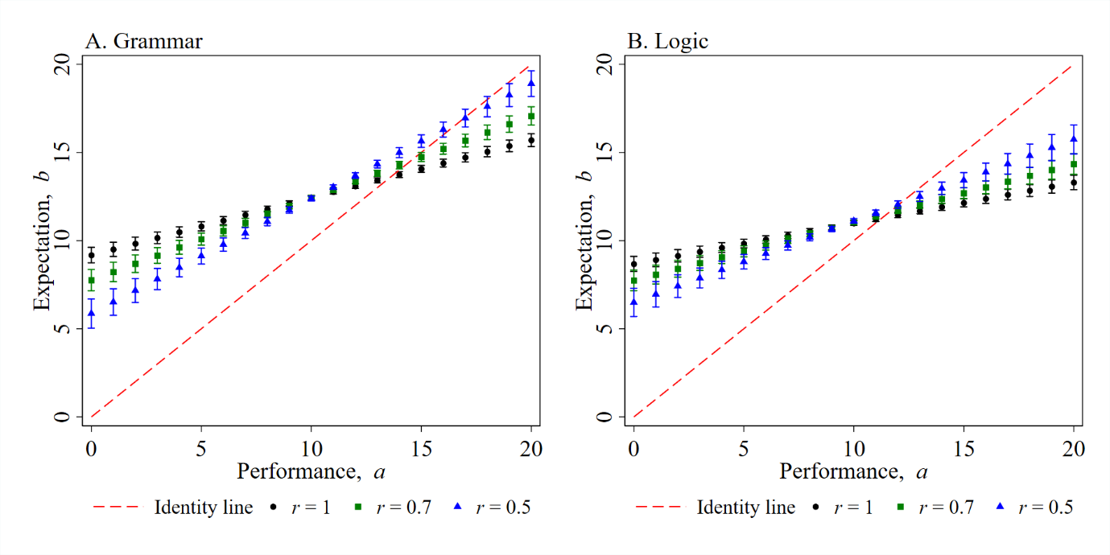
Fig. B1. Summarizing expected performance on Grammar and Logic tests as a function of actual performance. We report this predicted relationship for different levels of reliability, $r$, in performance.
Note. Error bars are 95% confidence intervals.

Second, and often overlooked in the social sciences, OLS (ordinary least squares) regression produces two distinct lines when data are scattered (i.e., when $r<1$). The regression of $y$-on-$x$ minimizes squared vertical errors, while $x$-on-$y$ minimizes squared horizontal errors. Consequently, the two lines differ, sometimes substantially, from what a visual inspection of the scatterplot might suggest. Both regressions “pull” predictions toward the mean of the dependent variable: the $y$-on-$x$ line produces a slope that is too shallow (with intercept too high), while the $x$-on-$y$ line produces a slope that is too steep (with intercept too low) when plotted with $y$ on the vertical axis (Campbell & Kenny, 1999). This inherent directionality of OLS regression naturally generates a regression-to-the-mean pattern that can mimic the so-called Dunning–Kruger effect—low performers appear overconfident and high performers underconfident—even if all deviations are purely statistical noise.

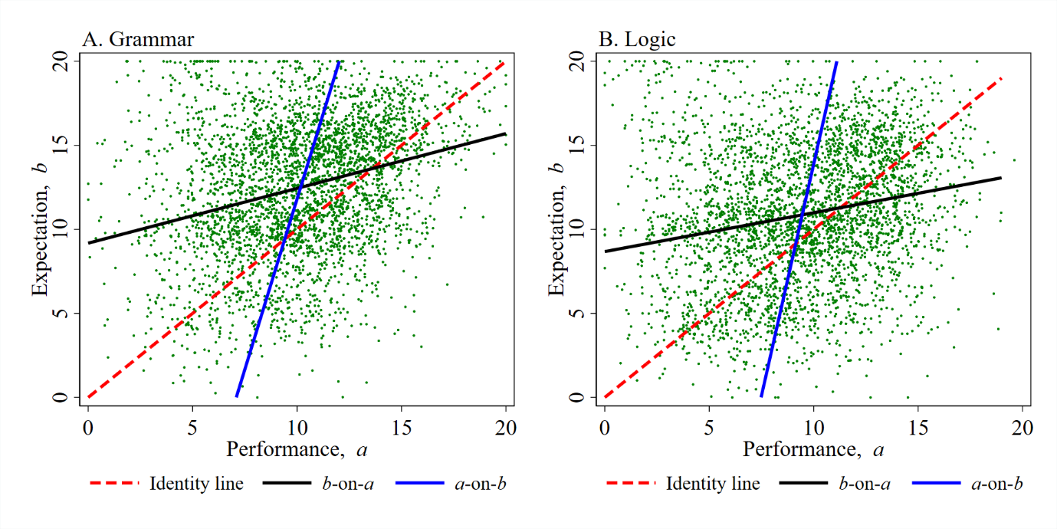
Fig. B2. Expected and actual performance on the Grammar and Logic tests, shown both as performance-on-expectations and expectations-on-performance regressions, with consistent axes for comparison.
Note. For the scatterplot we create random, spherical noise around data points so that data points are not plotted on top of each other.

One approach to determine a single equation regardless of the direction of the regression is to use scale‐independent symmetric regression (Kane, 2021; Taagepera, 2008). To illustrate the symmetric regression, consider the predictions derived from two standard OLS regressions, one for expected performance on actual performance,$b$-on-$a$, and another for actual performance on expected performance, $a$-on-$b$:
$b=α+ca$ (1)
$a=α'+c'b$ (2)
In Figure B2, we plot the predictions provided in (1) and (2) again drawing on data from Jansen et al. (2021), but where (2) is rearranged so it is relative to the same axis as in (1), that is, $c^{''}=1/c'$. Figure B2 illustrates the bounds of the range of linear regression possibilities, what is next is to determine the most likely possibility. The scale-independent symmetric regression assumes that there is as much legitimacy in (1) as in (2), and under this assumption can be calculated as follows:
$b=\left[B-CA\right]+Ca$ (3)
where, $B$ and $A$ are the sample means of $b_{i}$ and $a_{i}$, respectively, and $C$ is the slope of the symmetric regression line, which is given as $C=c^{''}|R|$, where $R^{2}=cc'$. In the case of the grammar (logic) test data, this yields a scale-independent symmetric regression line which is approximately equal to
$b=0.80+1.15a$ ($b=0.19+1.13$a) (4)
These symmetric regression lines are illustrated in Figure B3 along with the scattered data. This approach provides support that overconfidence is observed at all levels of performance, and that overconfidence is increasing in performance, the opposite of the Dunning-Kruger effect. Indeed, both of these lines seem consistent with eyeballing the scatterplot.
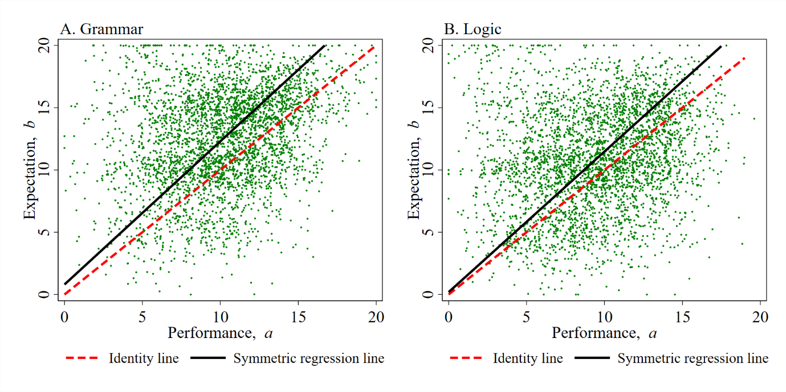
Fig. B3. The symmetric regression line between expected and actual performance on the Grammar and Logic tests.
Note. For the scatterplot we create random, spherical noise around data points so that data points are not plotted on top of each other.

To conclude, if $b$-on-$a$ is as legitimate as $a$-on-$b$, the “best estimate” is that the most competent are the most overconfident. However, performance, $a$, includes two sorts of measurement error: systematic errors and random errors, whilst the issue in expectations, $b$, is random error. Indeed, Jonsson and Allwood (2003) report that expectations about performance have a higher test–retest reliability than the accuracy of those expectations. Given this differential measurement error, the slope coefficient in Equation (4) is likely biased downward, whereas the intercept is biased upward. These results are consistent with accumulating evidence, whereby accounting for different errors being minimised and the additional problem of measurement error has the potential to qualitatively change theoretical conclusions (Hedge et al., 2018; Vadillo et al., 2022).

Open Practices Statement
The data that support these findings are from Jansen et al. (2021), publicly available on the Open Science Framework: https://osf.io/er9ms/. The complete analysis script to replicate the results is openly available in the Open Science Framework at https://osf.io/vpxqg (Dawson, 2026). This study was not preregistered.

References
Ackerman, P. L., Beier, M. E., & Bowen, K. R. (2002). What we really know about our abilities and our knowledge. Personality and Individual Differences, 33(4), 587-605.
Burson, K. A., Larrick, R. P., & Klayman, J. (2006). Skilled or unskilled, but still unaware of it: How perceptions of difficulty drive miscalibration in relative comparisons. Journal of Personality and Social Psychology, 90(1), 60-77.
Campbell, D. T., & Kenny, D. A. (1999). A primer on regression artifacts. Guilford Press.
Dawson, C. (2026, May 6). Talking the talk, not walking the walk: The co-evolution of overconfidence and loss aversion. https://osf.io/vpxqg
Ehrlinger, J., Johnson, K., Banner, M., Dunning, D., & Kruger, J. (2008). Why the unskilled are unaware: Further explorations of (absent) self-insight among the incompetent. Organizational Behavior and Human Decision Processes, 105(1), 98-121.
Fawns-Ritchie, C., & Deary, I. J. (2020). Reliability and validity of the UK Biobank cognitive tests. PloS one, 15(4), e0231627.
Feld, J., Sauermann, J., & De Grip, A. (2017). Estimating the relationship between skill and overconfidence. Journal of Behavioral and Experimental Economics, 68, 18-24.
Gignac, G. E., & Zajenkowski, M. (2019a). The Dunning-Kruger effect is (mostly) a statistical artifact: Valid approaches to testing for real metacognitive deficits. Intelligence, 75, 101405.
Gignac, G. E., & Zajenkowski, M. (2019b). People tend to overestimate their romantic partner's intelligence even more than their own. Intelligence, 73, 41-51.
Hedge, C., Powell, G., & Sumner, P. (2018). The reliability paradox: Why robust cognitive tasks do not produce reliable individual differences. Behavior Research Methods, 50, 1166-1186.
Jansen, R. A., Rafferty, A. N., & Griffiths, T. L. (2021). A rational model of the Dunning–Kruger effect supports insensitivity to evidence in low performers. Nature Human Behaviour, 5(6), 756-763.
Jonsson, A. C., & Allwood, C. M. (2003). Stability and variability in the realism of confidence judgments over time, content domain, and gender. Personality and Individual Differences, 34(4), 559-574.
Kane, M. T. (2021). Symmetric Least Squares Estimates of Functional Relationships. ETS Research Report Series, 2021(1), 1-14.
Kirkegaard, E. O. W., & Gerritsen, A. (2021). Looking for evidence of the Dunning-Kruger effect: an analysis of 2400 online test takers. OpenPsych. https://doi.org/10.26775/op.2021.08.29
Kruger, J., & Dunning, D. (1999). Unskilled and unaware of it: how difficulties in recognizing one's own incompetence lead to inflated self-assessments. Journal of Personality and Social Psychology, 77(6), 1121-1134.
Krueger, J., & Mueller, R. A. (2002). Unskilled, unaware, or both? The better-than-average heuristic and statistical regression predict errors in estimates of own performance. Journal of Personality and Social Psychology, 82(2), 180–188.
Taagepera, R, (2008). Why We Should Shift to Symmetric Regression'. In R. Taagepera, Making Social Sciences More Scientific: The Need for Predictive Models (Chapter 12, pp. 154-175). Oxford Academic.
Tabatabaei, O., & Dehghani, M. (2012). Assessing the reliability of grammaticality judgment tests. Procedia-Social and Behavioral Sciences, 31, 173-182.
Vadillo, M. A., Malejka, S., Lee, D. Y., Dienes, Z., & Shanks, D. R. (2022). Raising awareness about measurement error in research on unconscious mental processes. Psychonomic Bulletin & Review, 29(1), 21-43.

Reduced major axis (RMA) regression which minimizes the sum of the horizontal and vertical data points from the fitted regression line, is an analogous approach, and produces consistent results.
While Jansen et al. (2021) represents the largest dataset of its kind, we additionally selected two further datasets at random to replicate the analysis. To address concerns that the findings might be sample-specific or driven by particular design features, we reanalysed: (1) Gignac and Zajenkowski (2019b) and (2) Kirkegaard and Gerritsen (2021). The results provide further evidence consistent with the necessary conditions of the signaling model and the Jansen et al. (2021) dataset.

