Supplementary Materials 1
Alternative versions to implement the frequency-based memory
There are different ways to implement the frequency-based memory, λ, into the ε-α model. In our ε-α-λ model, we directly integrated the feedback information and choice (in)frequency into the same Q-values or reward expectancies. However, it is also possible that human or non-human animals kept separate representations of those instead.
Therefore, we fitted alternative implementations of the unchosen value-bias that separate the frequency-based memory from the Q-values and the Rescorla-Wagner update rule. In these variations, we always keep the update rule for chosen actions as in the original ε-α-λ model (which we refer to as M$λ1$ in this model comparison to indicate that we are comparing models that implement λ in different ways):
$$Q_{t}\left(a,c\right)= Q_{t-1}\left(a,c\right)+ α\left(r_{t-1}-Q_{t-1}\left(a,c\right)\right)$$
However, we kept the effect of the unchosen value-bias, $λ$, separate from these Q-values, by creating frequency values F, and then weighing the Q-values and F-values in the $ε$-greedy decision rule:
$$Decision at trial t: \left\{\begin{aligned}\underset{a}{argmax}\left\{Q_{t-1}\left(a\right)+wF_{t-1}\left(a\right)\right\} \\ random action\end{aligned}\right.\begin{matrix}with P= \\ with P=\end{matrix} \begin{matrix}1-ε \\ ε\end{matrix}$$
where w represents a free parameter. We tested several implementations of these F-values, and compared the model fits to our original model. A first alternative, referred to as M$λ$2 computes the F-values by adding $λ$ to the F-values of unchosen actions. Mathematically, we formulate it as:
$$F_{2,t}\left(a,u\right)= F_{2, t-1}\left(a,u\right)+ λ_{2}$$
In a third version, M$λ$3, F-values are computed with a Rescorla-Wagner style update rule, with $λ$ as the learning rate, and unchosen actions automatically receive a reward of 1, while the chosen action receives a reward of 0:
$$F_{3, t}\left(a,u\right)= F_{3, t-1}\left(a,u\right)+ λ_{3}(1-F_{3, t-1}\left(a,u\right))$$
$$F_{3,t}\left(a,c\right)= F_{3, t-1}\left(a,c\right)+ λ_{3}(0-F_{3, t-1}\left(a,c\right))$$
The last 2 versions, M$λ$4.1 and M$λ$4.2, are the same as version M$λ$2, but with a fixed $λ$, where M$λ$4.1 has a positive $λ$ (1/K, where K is the total amount of choice options), and M$λ$4.2 has a negative $λ$ (-1/K). This way, the number of free parameters was similar to M$λ1$, while we could still evaluate the degree of using frequency-based memory through the interpretation of w.
We fitted these 4 models to the animal data, and compared their model fit to our original model ε-α-λ model (M$λ1$) based on lowest BIC value. The results can be seen in Figure S.1. The original model, ε-α-λ (M$λ1$), provides the best fit for all species.
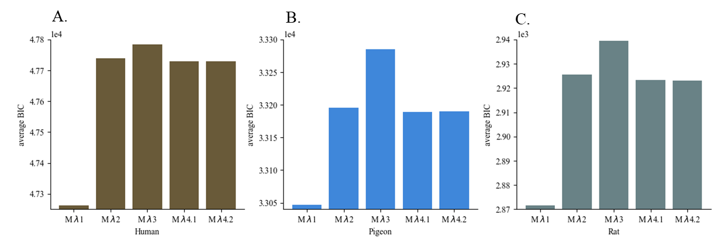
Figure S.1: Model fits of alternative models to implement a frequency-based memory in the Rescorla-Wagner models on human (A), pigeon (B) and rat (C) behavioral data. The original model ε-α-λ (M$λ1$) gives the best model fit, based on the lowest BIC value.

Supplementary Materials 2
Trajectories of Q-values with λ component at its max
We have plotted the Q-values from the 8-choice adversarial environment for two sets of parameter combinations. We simulated the adversarial environment for many trials (5000), and plotted the variation in Q-values of the last 50 trials. In these simulations, we always put λ at its maximum value.
In Figure S.2A, we look at an extreme case where α = 1, ε = 0 and λ = 0.125 (maximum). In this case, the model will always choose the highest valued option, there is no random choice because ε = 0. From the plot, the highest valued option iterates over trials between all options, and Q-values stay within the 0-1 range. This means that in this case, we have a model that can systematically switch between all the options, with no need for random exploration based on ε. The result is systematic variability. This is the idea behind the frequency-based memory, i.e., a mechanism that results in a more systematic form of variability, i.e., variability without an underlying stochastic process.
When stochastic choices are added by increasing ε to 0.3 (Figure S.2B), we can notice two main things. First, actions can be repeated more. The sequence is less systematic than in the previous, extreme case because there is 30% more random choice. Second, the Q-values can get larger than 1, but this is not considered a problem, as it is the relative values of the Q-values that matter in the model (Sutton & Barto, 2020).
In a traditional RW model, Q-values are interpreted as moving toward the long term expected reward. The unchosen value-bias, λ, acts in the same direction as this goal where infrequency leads to more reward in an adversarial environment and infrequency also leads to higher Q-values in the model. Still, the λ mechanism is designed to bias action values based on choice history (and infrequency of occurrence) and we do not regard the Q-values in this model as pure value estimates as in the traditional RW interpretation. Instead, the Q-values are interpreted as a combined signal representing both experienced outcomes and frequency-based biases.
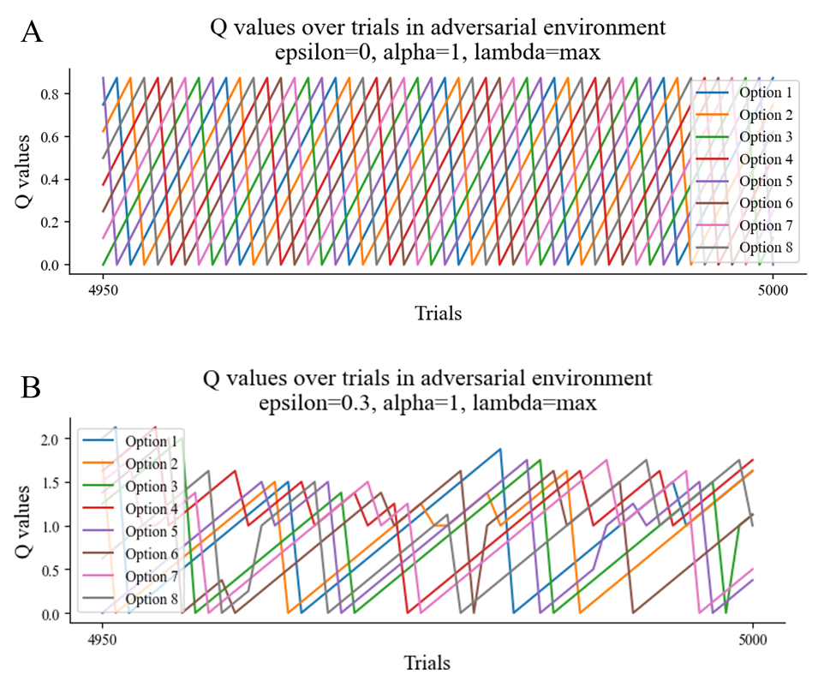
Figure S.2: Q-value trajectories for 8 choice options in an adversarial environment for 2 parameter settings. A) Extreme case where ε = 0, α = 1 and λ = 0.125 (maximum value). This situation creates systematic variability without needing random choice via ε-greedy. It shows the main idea behind the frequency-based mechanism. B) ε is increased to 0.3, where α is still equal to 1 and λ equal to its maximum value. The situation shows a less systematic form of variability with respect to panel A, because of the random choices. Q-values move outside the [0, 1] interval, but represent a combined signal of long term expected reward and choice history.

Supplementary Materials 3
Model recovery of alternative memory-based mechanisms for adaptive variability
Figure S.3 shows the model recovery on a group level for the models presented in Table 2 of the main text. For each model, 500 datasets of 800 trials were simulated and then fit on all 8 models. Best model fit (on a group level) was evaluated by determining the lowest average BIC value. This recovery shows that on a group level (with group size 15) the correct model can be identified based on lowest average BIC values.
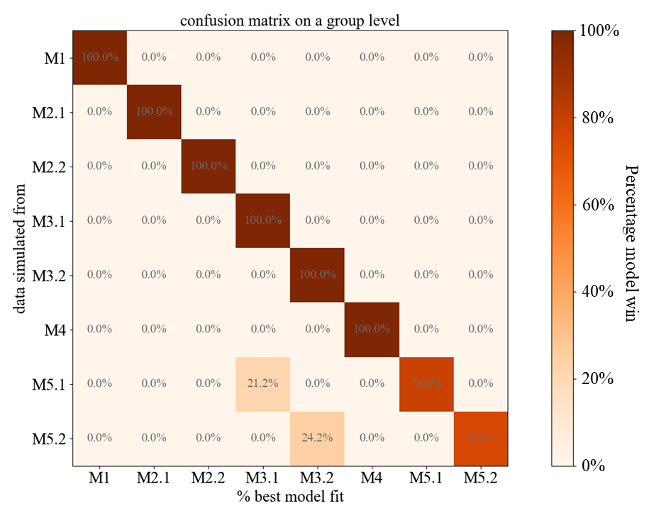
Figure S.3: 500 datasets of 800 trials were simulated with all 8 models from Table 2 in the main text. These datasets were then fit on all the 8 models using negative loglikelihood minimization. Best model fit on a group level was determined with the lowest average BIC value. The figure gives the probability that the correct model results in the best model fit, given that the data was simulated from that model.

Supplementary materials 4
Correlations between estimated parameters
There were no correlations between any of the simulated estimated parameters (all Spearman and Pearson correlations both lie in the interval [-0.03, 0.02]), ensuring that there were no artificial interdependencies introduced by our estimation procedure.
Figure S.4 shows the correlations between the parameter values fitted to the animal data. However, we should be careful in interpreting these results, since the number of estimations for humans was 18 (6 subjects x 3 conditions), for pigeons 15 (5 subjects x 3 conditions) and for rats 20. In the case of humans and pigeons, these datasets were also not independent as they consisted of only 6 and 5 subjects, who each did 3 sessions. Therefore, these correlations should only be considered as exploratory analyses, rather than inferential tests. We found that for humans, only the Spearman correlation between learning rate and the unchosen value-bias was negatively correlated (Spearman correlation = 0.60, p-value = 0.008). Other relations between parameters were not significant. For pigeons, we similarly observed a significant negative correlation between learning rate and unchosen value-bias (Pearson correlation = -0.54, p-value = 0.04 and Spearman correlation = -0.52, p-value=0.048). For rats, however, we found a significant negative correlation between epsilon and learning rate (Pearson correlation = -0.65, p-value < .01 and Spearman correlation = -0.76, p-value < .01).
Although we should be careful in interpreting these correlations, given the very small sample size and dependence between estimations, it suggests that, for humans and pigeons, learning rate and the unchosen value-bias may partly trade-off with each other across species and/or sessions. Also, while humans seemed to rely more on the unchosen value-bias, pigeons relied more on learning rate. In rats, we observed a negative correlation between epsilon and learning rate, similar to how decision noise and learning rate parameters often trade off against each other in reinforcement learning models more generally (Gershman, 2016). Together, these results suggest that while there are multiple mechanisms (governed by different parameters) to achieve variability, these mechanisms can both co-exist or trade-off with each other. Future studies should investigate whether these trade-offs are systematic across and within different species.
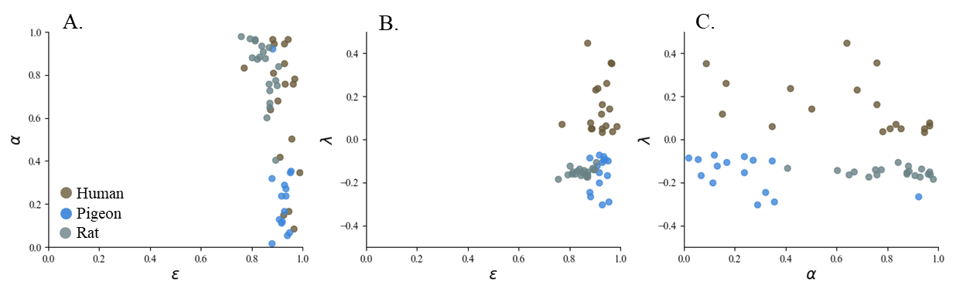
Figure S.4: Correlations between estimated parameter values for humans (brown), pigeons (blue) and rats (grey). Panel A shows the relation between stochasticity (ε) and learning rate (α). Panel B shows the relation between stochasticity (ε) and the unchosen value-bias (λ). Panel C shows the relation between learning rate (α) and the unchosen value-bias (λ).

