Supplementary Materials
Table of Contents
- SMA1: Information about Controversies
- SMA2: Factor Analysis
- SMA3: Within-domain Variation in Paths
- SMA4: Nested Model Comparisons for Main Study
- SMA5: Further Data on Predicting Persistence from PPM
- SMA6: Social Judgments
- SMA7: Trial Order Comparison and Poll Trust
- SMB1: Overview of Supplementary Studies
- SMB2: Supplementary Study 1
- SMB3: Supplementary Study 2
- SMB4: Supplementary Study 3
- SMB5: Supplementary Study 4
- SMC1: Replicating the Main Study Results
SMA1: Information about Controversies
In this section, we first provide a list of topics covered by Pew Research, a major polling agency (Supplementary Figure A0.1), and describe an online resource we developed to facilitate the exploration of our stimulus set. Next, we provide a table of the controversies used in our study with information about the public distribution of opinion and the polls the issues are taken from (Supplementary Table A1). We also provide a table reporting basic statistics about participants’ responses to these controversies (Supplementary Table A2).

Supplementary Figure A0.1

A List of the Set of Topics Covered by Pew Research



Note. Our four domains (morality, politics, science, and religion) cover a large set of issues studied by polling agencies such as Pew Research. List available at: https://www.pewresearch.org/topics-condensed/

The Controversy Explorer (available in our OSF repository) contains a searchable database of all issues used in the study, as well as visualizations that use large language model (LLM) embeddings and dimensionality reduction techniques to represent the structure of the stimuli. Both the table and the visualizations allow filtering of issues by key criteria (e.g., extent of disagreement and domain), and allow readers to easily visit the public opinion polls that each stimulus is drawn from (see Supplementary Figure A0). Beyond facilitating interpretability, the LLM embeddings show that our intuitive categorization of issues into domains is reflected in the semantic content of the issues (i.e., issues that belong to the same domain naturally cluster together when projected to a lower-dimensional space).

Supplementary Figure A0

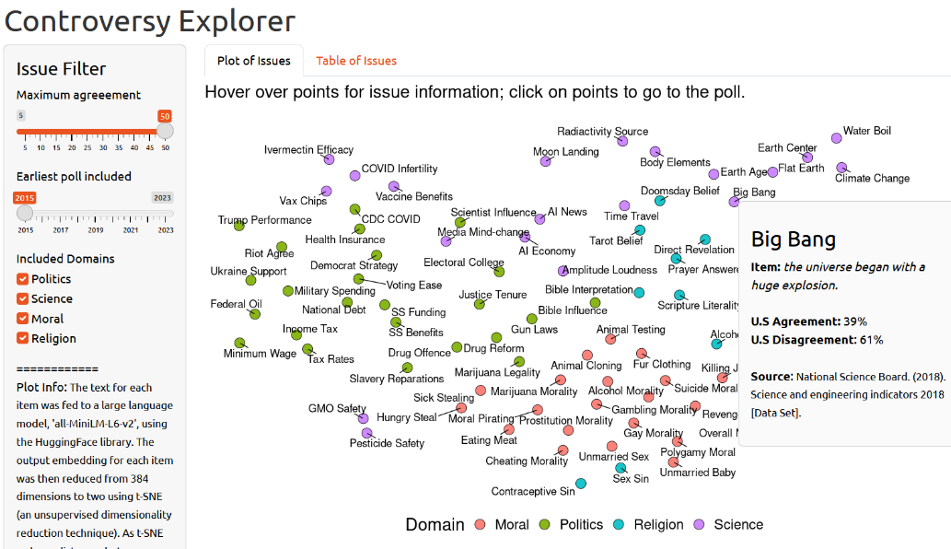
A Screenshot of the Controversy Explorer
Note. Hovering over each issue displays information related to that controversy used in the study, and clicking on the issues takes users to the polls. The controversies are colored by domain, and positioned using a lower-dimensional projection of the controversies’ semantic embeddings from a large language model.

Supplementary Table A1
A Table of the Issues, and Public Opinion Statistics on those Issues, used in Study 1
Domain | Issue | Item | Dis. Level | Ag. | Dis. | Citation
Moral | Alcohol Morality | in general, drinking alcohol is not morally acceptable | high | 12 | 86 | Gallup Organization. (2020). The Gallup poll [Data Set].
Moral | Eating Meat | eating meat is always immoral | high | 7 | 79 | YouGov. (2022). YouGov survey: morality [Data Set].
Moral | Revenge Morality | it is always morally acceptable to take revenge from someone who has deliberately wronged you | high | 8 | 79 | YouGov. (2022). YouGov survey: morality [Data Set].
Moral | Cheating Morality | cheating in a relationship is never immoral | high | 9 | 82 | YouGov. (2022). YouGov survey: morality [Data Set].
Moral | Hungry Steal | it is always acceptable for someone to steal food if they cannot afford it | high | 10 | 78 | YouGov. (2022). YouGov survey: morality [Data Set].
Moral | Moral Taint | people who have done very bad things in their life (for example, a terrible crime) can never be genuinely good people | high | 11 | 75 | YouGov. (2022). YouGov survey: morality [Data Set].
Moral | Killing Justification | killing a person can never be justified | high | 14 | 78 | YouGov. (2022). YouGov survey: morality [Data Set].
Moral | Moral Universalism | moral values are fundamentally the same everywhere | high | 15 | 75 | YouGov. (2022). YouGov survey: morality [Data Set].
Moral | Fur Clothing | in general, buying or wearing clothing made of animal fur is morally wrong | low | 37 | 60 | Gallup Organization. (2022). The Gallup poll [Data Set].
Moral | Death Penalty | in general, the death penalty is morally wrong | low | 38 | 55 | Gallup Organization. (2022). The Gallup poll [Data Set].
Moral | Animal Testing | it is never morally acceptable to test products on animals before using them on humans | low | 36 | 49 | YouGov. (2022). YouGov survey: morality [Data Set].
Moral | Sick Stealing | it is never morally acceptable for someone to steal medication if they cannot afford it | low | 37 | 59 | YouGov. (2022). YouGov survey: morality [Data Set].
Moral | Rich Morality | in general, rich people are less moral than poor people | low | 37 | 48 | YouGov. (2022). YouGov survey: morality [Data Set].
Moral | Moral Pirating | downloading pirated media from the internet is always immoral | low | 38 | 44 | YouGov. (2022). YouGov survey: morality [Data Set].
Moral | Prostitution Morality | paying for sex is always immoral | low | 43 | 42 | YouGov. (2022). YouGov survey: morality [Data Set].
Moral | Animal Cloning | it is morally acceptable to clone animals | low | 38 | 58 | Gallup Organization. (2022). Cloning [Data Set].
Moral | Marijuana Morality | in general, smoking marijuana is not morally acceptable | medium | 28 | 70 | Gallup Organization. (2020). The Gallup poll [Data Set].
Moral | Overall Morality | the state of moral values in the country as a whole is getting better | medium | 18 | 78 | Gallup Organization. (2022). The Gallup poll [Data Set].
Moral | Suicide Morality | in general, suicide is morally acceptable | medium | 22 | 72 | Gallup Organization. (2022). The Gallup poll [Data Set].
Moral | Gambling Morality | in general, gambling is morally wrong | medium | 25 | 71 | Gallup Organization. (2022). The Gallup poll [Data Set].
Moral | Gay Morality | in general, gay or lesbian relations are morally wrong | medium | 25 | 71 | Gallup Organization. (2022). The Gallup poll [Data Set].
Moral | Unmarried Sex | sex between an unmarried man and woman is generally immoral | medium | 23 | 76 | Gallup Organization. (2022). Marriage [Data Set].
Moral | Polygamy Moral | a married person having more than one spouse at the same time is morally acceptable | medium | 23 | 75 | Gallup Organization. (2022). Marriage [Data Set].
Moral | Unmarried Baby | it is not moral to have a baby outside of marriage | medium | 28 | 70 | Gallup Organization. (2022). Marriage [Data Set].
Politics | Trump Performance | Donald Trump will go down in history as an outstanding president | high | 15 | 85 | Abt Associates (2021). Washington Post-ABC news poll [Data Set].
Politics | Riot Agree | I support the actions of people who stormed the U.S. Capitol | high | 8 | 89 | Abt Associates (2021). Washington Post-ABC news poll [Data Set].
Politics | National Debt | the national debt is not a problem at all | high | 4 | 95 | Beacon Research & Shaw & Company Research. (2023). Fox News poll [Data Set].
Politics | SS Funding | the funding of Social Security is not a problem at all | high | 11 | 87 | Beacon Research & Shaw & Company Research. (2023). Fox News poll [Data Set].
Politics | SS Benefits | Social Security benefits for some future retirees should be reduced | high | 16 | 82 | Beacon Research & Shaw & Company Research. (2023). Fox News poll [Data Set].
Politics | Minimum Wage | The federal minimum wage is about right | high | 13 | 81 | YouGov. (2022). YouGov Survey: the minimum wage [Data Set].
Politics | Gun Laws | gun laws should be less strict than they are today | high | 14 | 85 | Pew Research Center. (2021). Key facts about Americans and guns [Data Set].
Politics | CDC COVID | public health officials (e.g., at CDC) have done an excellent job of responding to COVID | high | 13 | 87 | Pew Research Center. (2022). Pew American trends panel poll [Dataset].
Politics | Drug Offence | sentences of people incarcerated for drugs should not be commuted or reduced | low | 39 | 61 | Bully Pulpit Interactive. (2021). Poll results on American attitudes toward war on drugs [Data Set].
Politics | Voting Ease | the government should make it easier for people to vote | low | 40 | 52 | YouGov. (2022). YouGov survey: Issue Positions and Importance [Data Set].
Politics | Democrat Strategy | the Democratic Party has a clear plan for dealing with the problems facing the country | low | 35 | 65 | Beacon Research & Shaw & Company Research. (2022). Fox News poll [Data Set].
Politics | Federal Oil | the U.S should get more oil from its federal lands | low | 41 | 36 | YouGov. (2023). YouGov survey: the Willow project [Data Set].
Politics | Military Spending | the U.S is spending too much on immigration | low | 35 | 65 | Gallup Organization. (2023). Military and national defense [Data Set].
Politics | Health Insurance | health coverage is a responsibility of the government | low | 40 | 57 | Gallup Organization. (2022). Healthcare system [Data Set].
Politics | Tax Rates | tax rates on household incomes over $400,000 should not be raised | low | 37 | 61 | Pew Research Center. (2023). The pope is concerned about climate change. how do U.S. Catholics feel about it? [Data Set].
Politics | Bible Influence | the Bible should have no influence on laws in the US | low | 36 | 64 | Pew Research Center. (2022). Pew American trends panel poll [Dataset].
Politics | Drug Reform | it is not important to reform the country's drug laws | medium | 18 | 82 | Bully Pulpit Interactive. (2021). Poll results on American attitudes toward war on drugs [Data Set].
Politics | Income Tax | income tax rates for all Americans should be increased | medium | 17 | 80 | Beacon Research & Shaw & Company Research. (2023). Fox News poll [Data Set].
Politics | Justice Tenure | Supreme Court justices should be limited to 18-year terms | medium | 30 | 66 | Beacon Research & Shaw & Company Research. (2022). Fox News poll [Data Set].
Politics | Marijuana Legality | the use of marijuana should be illegal | medium | 32 | 68 | Gallup Organization. (2021). Illegal drugs [Data Set].
Politics | Slavery Reparations | descendants of people enslaved in the U.S. should be repaid in some way | medium | 30 | 68 | Pew Research Center. (2022). 77% of Black Americans 'compared with 18% of White Americans ' support reparations for descendants of enslaved people [Data Set].
Politics | Scientist Influence | scientists have too much influence in public policy debates | medium | 19 | 81 | Pew Research Center. (2022). Pew American trends panel poll [Dataset].
Politics | Ukraine Support | the US is providing too much support to Ukraine | medium | 20 | 80 | Pew Research Center. (2022). Pew American trends panel poll [Dataset].
Politics | Electoral College | presidential elections should be decided based on the electoral college, not the popular vote | medium | 30 | 65 | PRRI. (2022). PRRI American values survey [Dataset].
Religion | Dead Harm | people who have died can harm the living | high | 18 | 82 | Pew Research Center (2023). Spritiruality among Americans [Data Set].
Religion | Tarot Belief | tarot-card readings divine information about the future | high | 15 | 85 | YouGov. (2022). Most Americans Hold Some New Age Beliefs. [Dataset]
Religion | Immaterial Spirit | people only have a physical body, and no soul or spirit | high | 17 | 83 | Pew Research Center (2023). Spritiruality among Americans [Data Set].
Religion | Contraceptive Sin | using contraceptives is sinful | high | 10 | 63 | Pew Research Center. (2015). U.S. Catholics open to non-traditional families [Data Set].
Religion | Residence Sin | living in a house larger than needed is sinful | high | 11 | 64 | Pew Research Center. (2015). U.S. Catholics open to non-traditional families [Data Set].
Religion | Alcohol Sin | drinking alcohol is sinful | high | 15 | 58 | Pew Research Center. (2015). U.S. Catholics open to non-traditional families [Data Set].
Religion | God Gender | God is both male and female | high | 10 | 71 | Harris Interactive (2013). Religious belief poll [Data Set].
Religion | Holy America | God intended America to be a new promised land for European Christians | high | 10 | 83 | PRRI. (2022). PRRI American values survey [Dataset].
Religion | Bible Interpretation | the Bible was not written for each person to interpret as he or she chooses | low | 40 | 51 | LifeWay Research. (2016). The state of American theology study 2016 [Data Set].
Religion | Ghost Communication | people who have died can communicate with the living | low | 42 | 58 | Pew Research Center (2023). Spritiruality among Americans [Data Set].
Religion | Nature Spirits | parts of nature, like mountains, rivers, or trees, have spirits | low | 48 | 52 | Pew Research Center (2023). Spritiruality among Americans [Data Set].
Religion | Sex Sin | sex outside of traditional marriage is not a sin | low | 43 | 49 | LifeWay Research. (2016). The state of American theology study 2016 [Data Set].
Religion | Devil Belief | the devil does not exist | low | 46 | 54 | IPSOS. (2023). Global religion 2023: Religious beliefs across the world: A 26-country advisor survey [Data Set].
Religion | God Control | God observes but does not control what happens on Earth | low | 37 | 63 | Harris Interactive (2013). Americans' belief in God, miracles and heaven declines [Data Set].
Religion | Hell Belief | Hell does not exist | low | 36 | 62 | Pew Research Center. (2021). Pew Research Center's American trends panel poll [Dataset].
Religion | Doomsday Belief | we are living in the end times | low | 39 | 58 | Pew Research Center. (2022). Pew American trends panel poll [Dataset].
Religion | Small Sin | even the smallest sin deserves eternal damnation | medium | 19 | 78 | LifeWay Research. (2016). The state of American theology study 2016 [Data Set].
Religion | God Belief | God does not exist | medium | 19 | 81 | Gallup Organization. (2022). Belief in God in U.S. dips to 81%, a new low [Data Set].
Religion | Existential Reason | not everything in life necessarily happens for a reason | medium | 32 | 68 | Pew Research Center. (2021). Few Americans blame God or say faith has been shaken amid pandemic, other tragedies [Data Set].
Religion | Witchcraft Belief | witches or spells exist | medium | 21 | 79 | IPSOS. (2021). IPSOS understanding society: wave 24 [Dataset].
Religion | God Influence | God or a higher power directly influences everything that occurs in the world | medium | 21 | 78 | Pew Research Center. (2021). Pew Research Center's American trends panel poll [Dataset].
Religion | Direct Revelation | it is impossible to receive a direct revelation from a higher power | medium | 29 | 67 | Pew Research Center. (2021). Pew Research Center's American trends panel poll [Dataset].
Religion | Prayer Answered | it is impossible to get a definite answer to a specific prayer request | medium | 31 | 67 | Pew Research Center. (2021). Pew Research Center's American trends panel poll [Dataset].
Religion | Scripture Literality | holy scripture is the word of God and should be taken literally, word for word | medium | 22 | 76 | Pew Research Center. (2022). Pew American trends panel poll [Dataset].
Science | Scientific Method | the scientific method identifies unchanging core principles and truths | high | 15 | 85 | Pew Research Center (2019). Pew Research Center's American Trends Panel Poll 42. [Dataset]
Science | Flat Earth | the Earth is flat, not round | high | 10 | 90 | Hamilton, L. (2022). Polar Environment and Science (POLES 2021) [Data Set].
Science | Moon Landing | NASA astronauts did not really land on the Moon | high | 12 | 88 | Hamilton, L. (2022). Polar Environment and Science (POLES 2021) [Data Set].
Science | COVID Infertility | COVID-19 vaccines have been shown to cause infertility | high | 8 | 92 | Kaiser Family Fondation. (2023). The COVID-19 pandemic: insights from three years of KFF polling [Data Set].
Science | Ivermectin Efficacy | Ivermectin is a safe and effective treatment for COVID-19 | high | 14 | 86 | Kaiser Family Fondation. (2023). The COVID-19 pandemic: insights from three years of KFF polling [Data Set].
Science | Earth Center | the center of the Earth is not very hot | high | 15 | 85 | National Science Board. (2018). Science and engineering indicators 2018 [Data Set].
Science | Antibiotic Bacterial | antibiotics are not effective against bacterial infections | high | 10 | 90 | Hart Research Associates And Public Opinion Strategies. (2012). Americans' knowledge of and attitudes toward antibiotic resistance: A report of findings from a national survey and two focus groups [Data Set].
Science | Media Mind-change | social media is very effective at changing people's minds about political issues | high | 16 | 83 | Pew Research Center. (2022). Spring 2022 global attitudes survey [Dataset].
Science | Time Travel | humans will someday be able to travel through time | low | 39 | 56 | SSRS. (2021). CBS News poll [Data Set].
Science | Body Elements | the elements in the human body are made of stardust from stars millions of years ago | low | 37 | 58 | The Marist Poll. (2021). Cleveland Museum of Natural History survey [Data Set].
Science | Big Bang | the universe began with a huge explosion | low | 39 | 61 | National Science Board. (2018). Science and engineering indicators 2018 [Data Set].
Science | GMO Safety | it is safe to eat genetically modified foods | low | 37 | 63 | Pew Research Center. (2015). Public and scientists' views on science and society [Data Set].
Science | Water Boil | water boils at lower temperatures at higher altitudes | low | 34 | 66 | Pew Research Center. (2015). A look at what the public knows and does not know about science [Data Set].
Science | Amplitude Loudness | amplitude or height determines loudness in a sound wave | low | 35 | 65 | Pew Research Center. (2015). A look at what the public knows and does not know about science [Data Set].
Science | Antibiotic Viral | antibiotics are not at all effective against viral infections | low | 42 | 58 | Hart Research Associates And Public Opinion Strategies. (2012). Americans' knowledge of and attitudes toward antibiotic resistance: A report of findings from a national survey and two focus groups [Data Set].
Science | Specie Documentation | scientists have not documented most of the species on Earth | low | 46 | 51 | Hart Research Associates And Public Opinion Strategies. (2012). Americans' knowledge of and attitudes toward antibiotic resistance: A report of findings from a national survey and two focus groups [Data Set].
Science | Earth Age | the Earth is not billions of years old | medium | 25 | 75 | Hamilton, L. (2022). Polar Environment and Science (POLES 2021) [Data Set].
Science | Vaccine Benefits | vaccines have mostly not been a benefit to human health | medium | 31 | 69 | Hamilton, L. (2022). Polar Environment and Science (POLES 2021) [Data Set].
Science | Radiactivity Source | not all radioactivity is man-made | medium | 30 | 70 | National Science Board. (2018). Science and engineering indicators 2018 [Data Set].
Science | Pesticide Safety | it is safe to eat foods grown with pesticides | medium | 28 | 72 | Pew Research Center. (2015). Public and scientists' views on science and society [Data Set].
Science | Climate Change | the earth is getting warmer mostly due to natural patterns | medium | 24 | 76 | Pew Research Center. (2023). The pope is concerned about climate change. how do U.S. Catholics feel about it? [Data Set].
Science | Solar Rotation | it takes one day for the Earth to go around the Sun | medium | 18 | 75 | Hart Research Associates And Public Opinion Strategies. (2012). Americans' knowledge of and attitudes toward antibiotic resistance: A report of findings from a national survey and two focus groups [Data Set].
Science | AI Economy | having machines with the ability to think for themselves will help the economy | medium | 19 | 73 | Monmouth University Polling Institute. (2023). Monmouth University poll [Dataset].
Science | AI News | there will never be a time when entire news articles will be written by artificial intelligence | medium | 24 | 72 | Monmouth University Polling Institute. (2023). Monmouth University poll [Dataset].
Note. Ag. Indicates agreement with the items in the public opinion poll cited on the rightmost column, Dis. indicates disagreement with the item; Dis. Level groups the disagreements into high, medium, and low amounts of disagreement; Issue indicates labels we generated as pointers to the text in the item. Links to all items are available on the Controversy Explorer on our OSF repository, as well as in the Materials section of the repository. Note that the wording for some items was reversed (e.g., if an item read ‘S is True’ with 65% agreement in the original poll, we sometimes used ‘S is False’ with 65% disagreement instead).

Supplementary Table A2
A Table of the Issues, and Public Opinion Statistics on those Issues, used in the Main Study
Domain | Issue | Level | # Responses | Estimated Disagreement | Actual Disagreement | Prediction Error
Moral | Animal Cloning | low | 29 | 62 | 45.1 | -16.9
Moral | Death Penalty | low | 29 | 62 | 50 | -12
Moral | Rich Morality | low | 26 | 63 | 43.7 | -19.3
Moral | Fur Clothing | low | 20 | 63 | 45.1 | -17.9
Moral | Moral Pirating | low | 15 | 62 | 38.9 | -23.1
Moral | Prostitution Morality | low | 12 | 57 | 36.2 | -20.8
Moral | Sick Stealing | low | 11 | 63 | 42.7 | -20.3
Moral | Animal Testing | low | 23 | 64 | 38.9 | -25.1
Moral | Polygamy Moral | medium | 21 | 77 | 66 | -11
Moral | Gambling Morality | medium | 18 | 75 | 63.2 | -11.8
Moral | Unmarried Baby | medium | 15 | 72 | 54.7 | -17.3
Moral | Suicide Morality | medium | 32 | 78 | 66.5 | -11.5
Moral | Gay Morality | medium | 13 | 75 | 57 | -18
Moral | Unmarried Sex | medium | 3 | 77 | 62 | -15
Moral | Overall Morality | medium | 20 | 82 | 51.4 | -30.6
Moral | Marijuana Morality | medium | 11 | 72 | 50.6 | -21.4
Moral | Revenge Morality | high | 4 | 92 | 41.2 | -50.8
Moral | Hungry Steal | high | 45 | 90 | 52.8 | -37.2
Moral | Moral Universalism | high | 25 | 85 | 35.1 | -49.9
Moral | Killing Justification | high | 29 | 86 | 30 | -56
Moral | Moral Taint | high | 17 | 89 | 41 | -48
Moral | Alcohol Morality | high | 4 | 88 | 63.8 | -24.2
Moral | Cheating Morality | high | 4 | 91 | 64 | -27
Moral | Eating Meat | high | 4 | 93 | 80.8 | -12.2
Politics | Voting Ease | low | 30 | 60 | 37.4 | -22.6
Politics | Drug Offence | low | 12 | 61 | 41.4 | -19.6
Politics | Bible Influence | low | 54 | 64 | 43.3 | -20.7
Politics | Health Insurance | low | 45 | 60 | 40.5 | -19.5
Politics | Military Spending | low | 19 | 65 | 34.2 | -30.8
Politics | Federal Oil | low | 12 | 59 | 46.2 | -12.8
Politics | Tax Rates | low | 3 | 63 | 80.3 | 17.3
Politics | Democrat Strategy | low | 1 | 65 | 37 | -28
Politics | Slavery Reparations | medium | 34 | 70 | 64.1 | -5.9
Politics | Marijuana Legality | medium | 13 | 68 | 56.5 | -11.5
Politics | Justice Tenure | medium | 66 | 70 | 42.7 | -27.3
Politics | Electoral College | medium | 10 | 70 | 53.9 | -16.1
Politics | Ukraine Support | medium | 36 | 80 | 38.6 | -41.4
Politics | Drug Reform | medium | 5 | 82 | 61.4 | -20.6
Politics | Scientist Influence | medium | 4 | 81 | 63.2 | -17.8
Politics | Income Tax | medium | 3 | 83 | 72.7 | -10.3
Politics | CDC COVID | high | 56 | 87 | 44.6 | -42.4
Politics | Trump Performance | high | 19 | 85 | 37.5 | -47.5
Politics | SS Funding | high | 11 | 89 | 42.9 | -46.1
Politics | Gun Laws | high | 14 | 86 | 48.8 | -37.2
Politics | National Debt | high | 5 | 96 | 56.6 | -39.4
Politics | Minimum Wage | high | 13 | 87 | 51.6 | -35.4
Politics | SS Benefits | high | 6 | 84 | 63.5 | -20.5
Politics | Riot Agree | high | 2 | 92 | 67.5 | -24.5
Religion | Nature Spirits | low | 9 | 52 | 81.2 | 29.2
Religion | Sex Sin | low | 66 | 57 | 37 | -20
Religion | Hell Belief | low | 32 | 64 | 60.7 | -3.3
Religion | Devil Belief | low | 28 | 54 | 62.8 | 8.8
Religion | Ghost Communication | low | 22 | 58 | 49 | -9
Religion | God Control | low | 11 | 63 | 55 | -8
Religion | Doomsday Belief | low | 14 | 61 | 53.2 | -7.8
Religion | Bible Interpretation | low | 21 | 60 | 51 | -9
Religion | Existential Reason | medium | 87 | 68 | 40.4 | -27.6
Religion | God Belief | medium | 20 | 81 | 73.4 | -7.6
Religion | Prayer Answered | medium | 16 | 69 | 43.3 | -25.7
Religion | Direct Revelation | medium | 17 | 71 | 52 | -19
Religion | God Influence | medium | 29 | 79 | 40.2 | -38.8
Religion | Witchcraft Belief | medium | 17 | 79 | 57.2 | -21.8
Religion | Small Sin | medium | 4 | 81 | 49.5 | -31.5
Religion | Scripture Literality | medium | 10 | 78 | 47.4 | -30.6
Religion | Immaterial Spirit | high | 45 | 83 | 70.3 | -12.7
Religion | Residence Sin | high | 13 | 89 | 66.7 | -22.3
Religion | Tarot Belief | high | 15 | 85 | 69.8 | -15.2
Religion | Alcohol Sin | high | 14 | 85 | 59.7 | -25.3
Religion | Holy America | high | 5 | 90 | 43.2 | -46.8
Religion | God Gender | high | 30 | 90 | 68.3 | -21.7
Religion | Dead Harm | high | 12 | 82 | 59.2 | -22.8
Religion | Contraceptive Sin | high | 6 | 90 | 65.2 | -24.8
Science | Big Bang | low | 29 | 61 | 36.3 | -24.7
Science | GMO Safety | low | 31 | 63 | 47.1 | -15.9
Science | Amplitude Loudness | low | 16 | 65 | 41.4 | -23.6
Science | Water Boil | low | 28 | 66 | 32.4 | -33.6
Science | Body Elements | low | 14 | 63 | 59 | -4
Science | Antibiotic Viral | low | 35 | 58 | 34.7 | -23.3
Science | Specie Documentation | low | 28 | 54 | 36.3 | -17.7
Science | Time Travel | low | 3 | 61 | 70.3 | 9.3
Science | Solar Rotation | medium | 16 | 82 | 23.9 | -58.1
Science | AI News | medium | 10 | 76 | 51.5 | -24.5
Science | Radiactivity Source | medium | 75 | 70 | 37.9 | -32.1
Science | AI Economy | medium | 27 | 81 | 61.1 | -19.9
Science | Pesticide Safety | medium | 26 | 72 | 43.7 | -28.3
Science | Climate Change | medium | 12 | 76 | 51.5 | -24.5
Science | Vaccine Benefits | medium | 2 | 69 | 86.5 | 17.5
Science | Earth Age | medium | 5 | 75 | 58.8 | -16.2
Science | Media Mind-change | high | 75 | 84 | 34.5 | -49.5
Science | Moon Landing | high | 7 | 88 | 53.7 | -34.3
Science | Scientific Method | high | 49 | 85 | 40.3 | -44.7
Science | Ivermectin Efficacy | high | 9 | 86 | 51.6 | -34.4
Science | COVID Infertility | high | 3 | 92 | 52.3 | -39.7
Science | Earth Center | high | 3 | 85 | 33.7 | -51.3
Science | Antibiotic Bacterial | high | 2 | 90 | 30 | -60
Note. Table shows the number of participants who indicated agreeing with each item (‘# Responses’), the actual public disagreement with them on the issue, their estimate of disagreement, and the average prediction error for each issue in our set.

SMA2: Factor Analysis
In keeping with recent recommendations (Jackson et al., 2009), we investigated whether our data were statistically appropriate for factor analysis. A Bartlett’s test of sphericity suggests that there is sufficient significant correlation in the data for factor analysis (χ² (15) = 3981.9, p < .001, and the Kaiser, Meyer, Olkin (KMO) overall measure of sampling adequacy suggests the data seem appropriate for factor analysis (KMO = 0.69; see Supplementary Figure A1).

Supplementary Figure A1

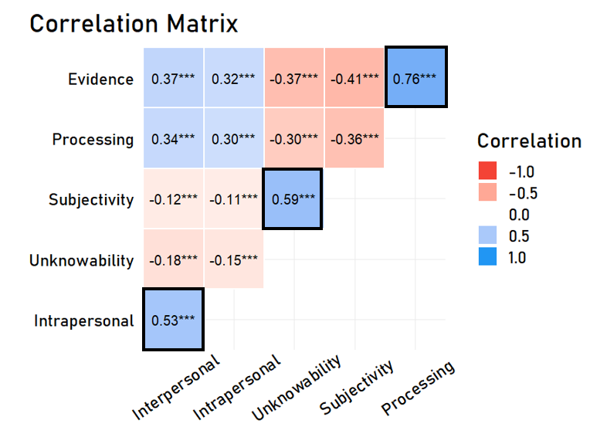
The Paths to Persistence Items Show Adequate Correlations
Note. The correlation matrix shows that there is sufficient correlation across items to warrant factor analysis. The bolded squares indicate the correlations between items that are expected to load onto the same factor. *** indicates p < .001.

We conducted a confirmatory factor analysis using the lavaan package in R, with the raw scores from the six items as the input, without constraining factors to be orthogonal, and using a Maximum Likelihood estimation procedure. We assessed the resulting model first using commonly accepted indices of fit: the Comparative Fit Index (CFI) of the resulting model was 0.995 (standard for a good fit > .95), the Tucker-Lewis Index (TLI) was 0.987 (standard for a good fit > .95), and the Root Mean Square Error of Approximation (RMSEA) was .042 (standard for a good fit < .06).
We also analyzed the quality of the fit without relying on standard baselines, as they have well-known limitations (Xia & Yang, 2019), first by fitting an exploratory, unconstrained factor analysis to see if it also resulted in a three-factor solution (it did; see Supplementary Figure A2).
Supplementary Figure A2

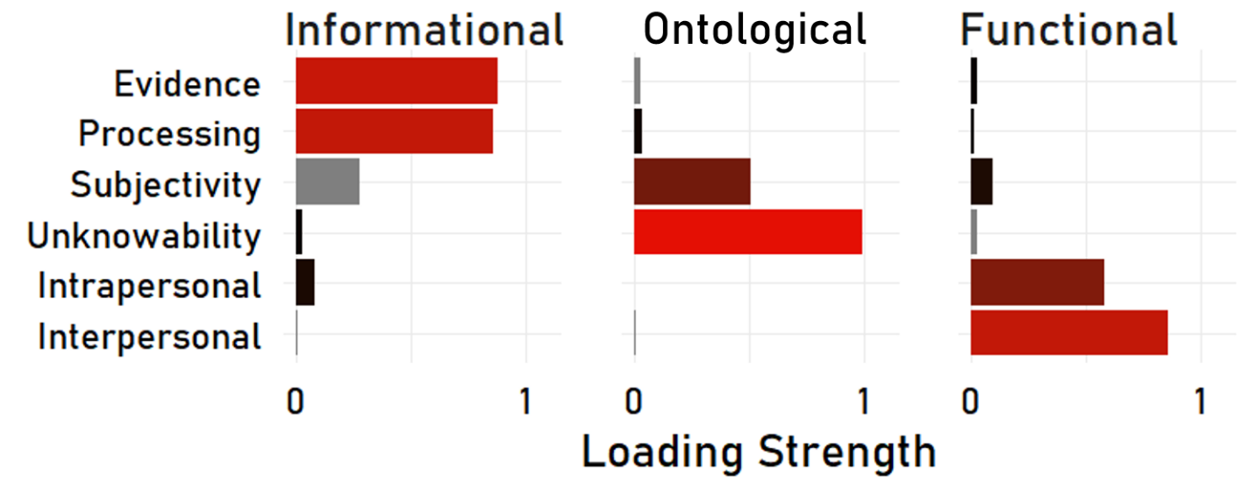
Factor Loadings from an Exploratory Factor Analysis
Note. The factor loadings on the x-axis indicate the presence of a three-factor structure. The three latent factors (oblimin rotation) accounted for 67% of the total variance of the original data (27%, 22%, and 18% respectively).

We also compared the relative fit of the best two-factor solution to that of a three-factor solution. Comparing the Akaike Information Criterion (AIC) and Bayesian Information Criterion (BIC) of the resulting models shows that the three-factor solution fits the data better than the best possible exclusive two-factor solution (AIC₃ = 43692.5 vs. AIC₂= 44116.1; lower values indicate better complexity-penalized fit). We thus concluded that our six items can be reliably clustered to three.
SMA3: Within-domain Variation in Paths
Supplementary Figure A3

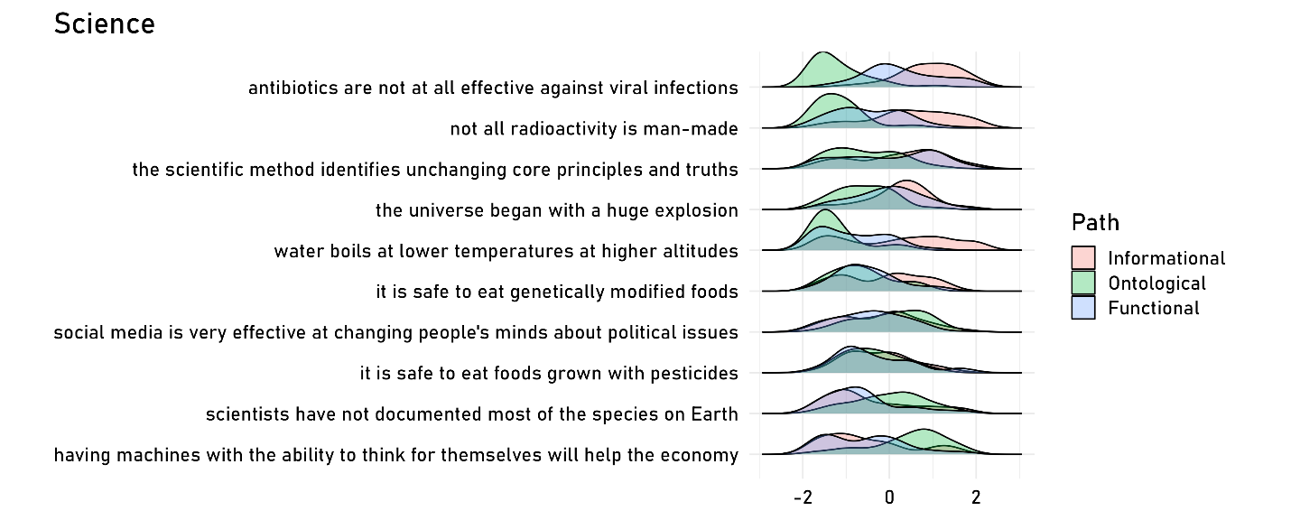
Within-domain variation for Scientific Issues in Paths
Note. Figure shows scaled density plots demonstrating variation for scientific controversies with at least 20 responses.

Supplementary Figure A4

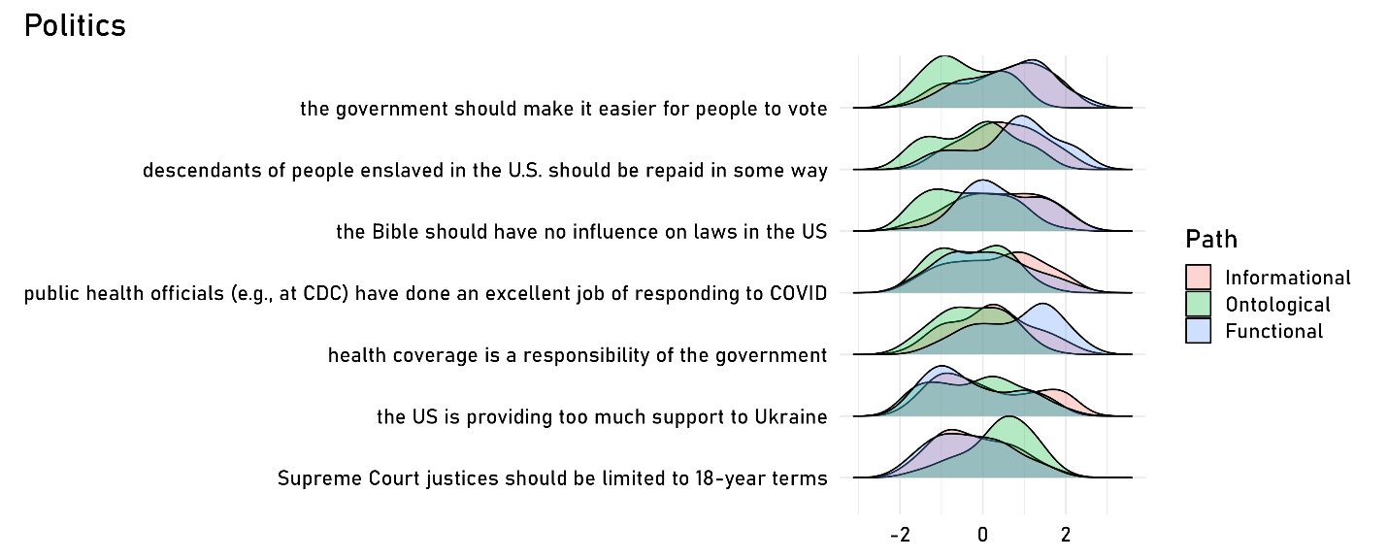
Within-domain variation for Political Issues in Paths
Note. Figure shows scaled density plots demonstrating variation for political controversies with at least 20 responses.

Supplementary Figure A5

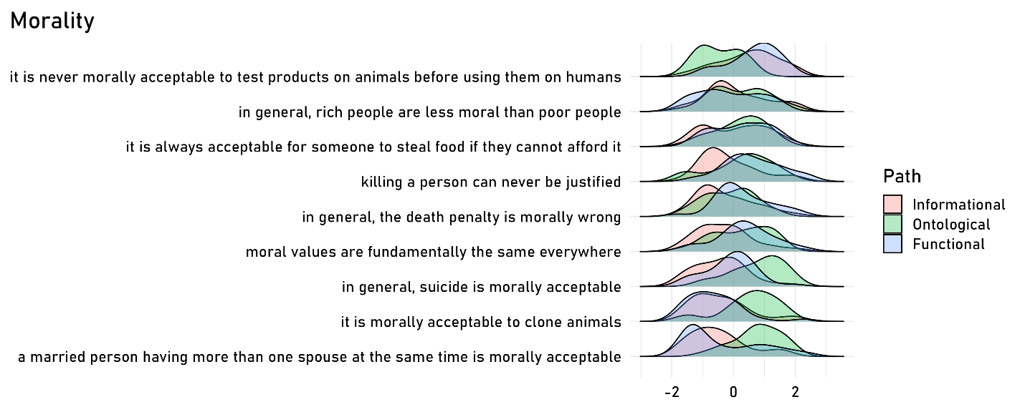
Within-domain variation for Moral Issues in Paths
Note. Figure shows scaled density plots demonstrating variation for moral controversies with at least 20 responses.

Supplementary Figure A6

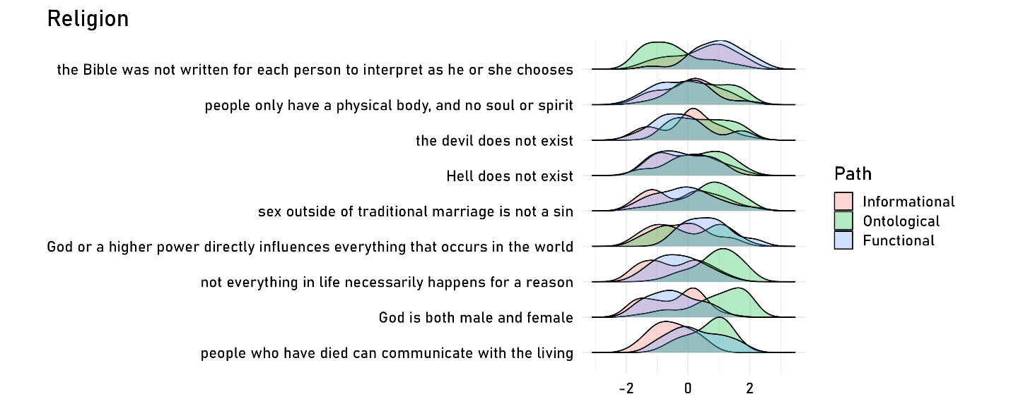
Within-domain variation for Religious Issues in Paths
Note. Figure shows scaled density plots demonstrating variation for religious controversies with at least 20 responses.

SMA4: Model Comparisons for Main Study
Supplementary Figure A7

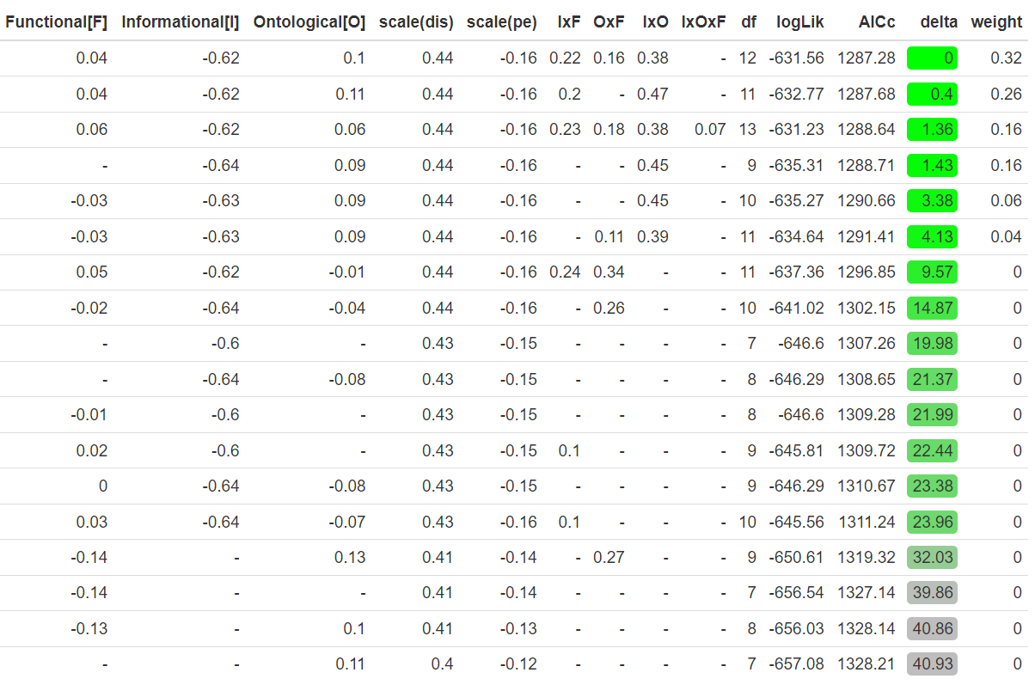
AIC Comparisons of Model Performance in Predicting Persistence for Questioning
Note. AICc denotes the bias-corrected AIC score, where lower values indicate better fit; delta shows the difference between the best performing model (at top) and all other models. Columns on the left show the estimated weights for the predictors in the nested regressions; if a regression does not include a predictor, its absence is indicated by ‘-’. Finally, logLik corresponds to the log likelihood of the data given the model, and is a measure of pure fit (that does not penalize complexity).

Supplementary Figure A8

AIC Comparisons of Model Performance in Predicting Persistence for Binarized View Change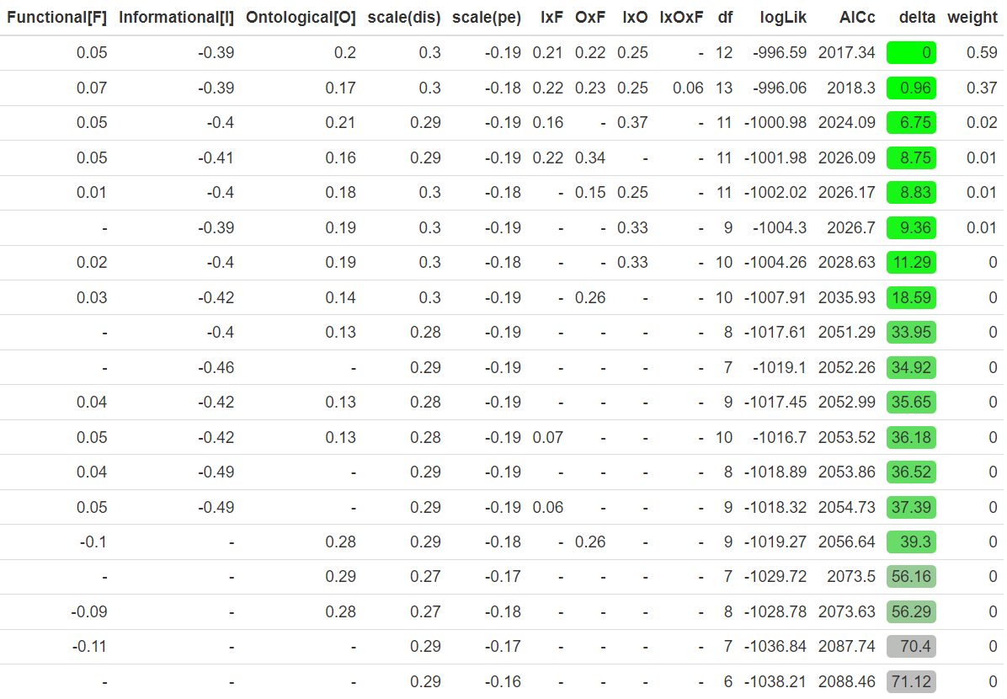Note. AICc denotes the bias-corrected AIC score, where lower values indicate better fit; delta shows the difference between the best performing model (at top) and all other models. Columns on the left show the estimated weights for the predictors in the nested regressions; if a regression does not include a predictor, its absence is indicated by ‘-’. Finally, logLik corresponds to the log likelihood of the data given the model, and is a measure of pure fit (that does not penalize complexity).

Supplementary Figure A9
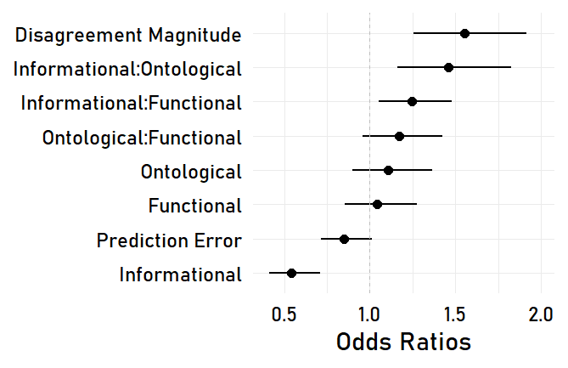
Coefficient Estimates for the Best Fitting Model for View Questioning
Note. Error bars show 95% confidence intervals.
Supplementary Figure A10
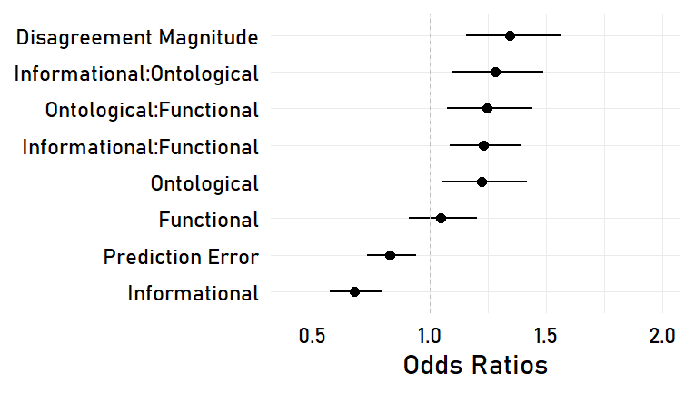
Coefficient Estimates for the Best Fitting Model for View Change
Note. Error bars show 95% confidence intervals

SMA5: Further Data on Predicting Persistence from PPM
Here we provide additional visualizations of the relationship between view questioning and persistence. Note that Figures A10 plots heatmaps showing pairwise interactions—faceting by the third variable reduces the number of observations in each cell to an extent that the plot becomes misleading. Figure A11 plots view questioning across binarized paths. Figure A12 and A13 replicate key plots with view change.
Supplementary Figure A10
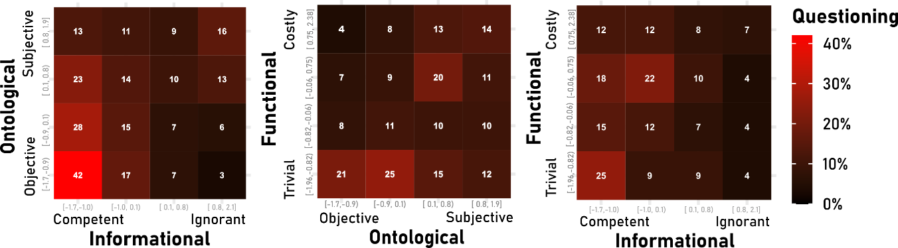
Average View Questioning in our Data Across Pairwise Combinations of Factors
Note. Heatmaps display average persistence rates across the three pairwise combinations of the paths in our data. For this figure and several that follow, the labels at scale endpoints are presented to facilitate the interpretation of effects; they were not presented as such to participants (in particular, note that the objective-subjective labels reflects the composite created from items reflecting both ontological considerations, subjectivity and unknowability).

Supplementary Figure A11
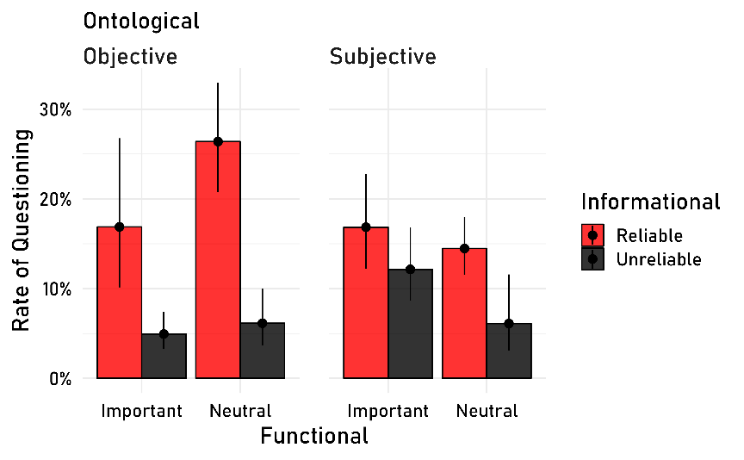
View Questioning Across Mean-split Binarized PPM
Note. Error bars show 95% Wilson confidence intervals.
Supplementary Figure A12
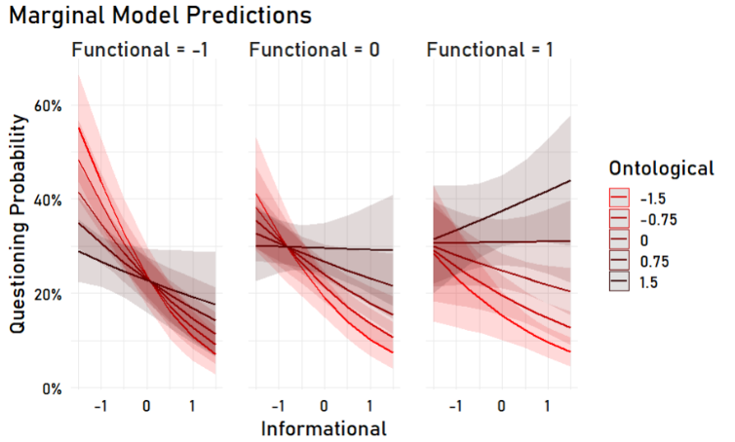
Coefficient Estimates for the Best Fitting Model for View Change
Note. Shaded areas 95% confidence intervals. We replicate in this model the same trends as in the view questioning model, with one exception: here, we see a clear, positive trend such that there is a positive effect of unreliability for important issues (functional = 1) that are subjective. It is difficult to provide a theoretically motivated explanation for this trend; it may be a positive response bias, as participants who respond positively to each question respond faster (e.g., ~65% of participants who accept all paths (factor score > 0.5) respond in less than 10 seconds to the questioning measure, whereas ~44% of participants who accept functional and ontological but not informational do).
SMA6: Social Judgments
Our main study featured four social measures, which we examined in the context of the interacting effects of the PPM—this creates a complex space of potential effects. We provide a qualitative explanation of some of the important trends below, plot the effects in all their complexity in Supplementary Figure A14, and show a regression table for each social measure in Supplementary Figure A15.

Participants were highly receptive to conversations about objective and important issues—even when disagreeing others were seen as epistemically inferior—but increasing subjectivity dramatically lowered receptivity. Receptiveness to friendship with disagreeing others showed a similar pattern, except that it was not influenced by ontological considerations at all. Support of free speech about unimportant issues showed the opposite pattern: The more subjective the disagreement, the more inclined participants were to support disagreeing others’ self-expression—but only if they were perceived as intelligent. Perceptions of how disagreements could be best resolved, on the other hand, were highly sensitive to functional and ontological considerations: The more objective an issue, the more experts were seen as the best way to resolve disagreements—but this pattern held exclusively for trivial issues.

Supplementary Figure A13

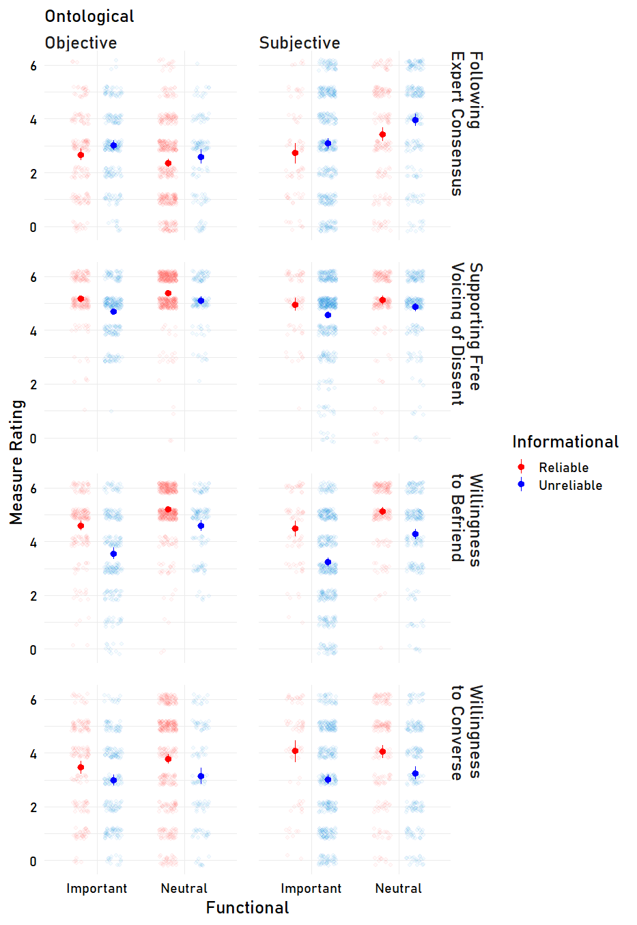
Social Consequences of Paths to Persisence

Note. The figure plots the mean ratings (and 95% confidence interval) for the social measures (labels on the right of each row) as a function of each binarized path.
Supplementary Figure A14

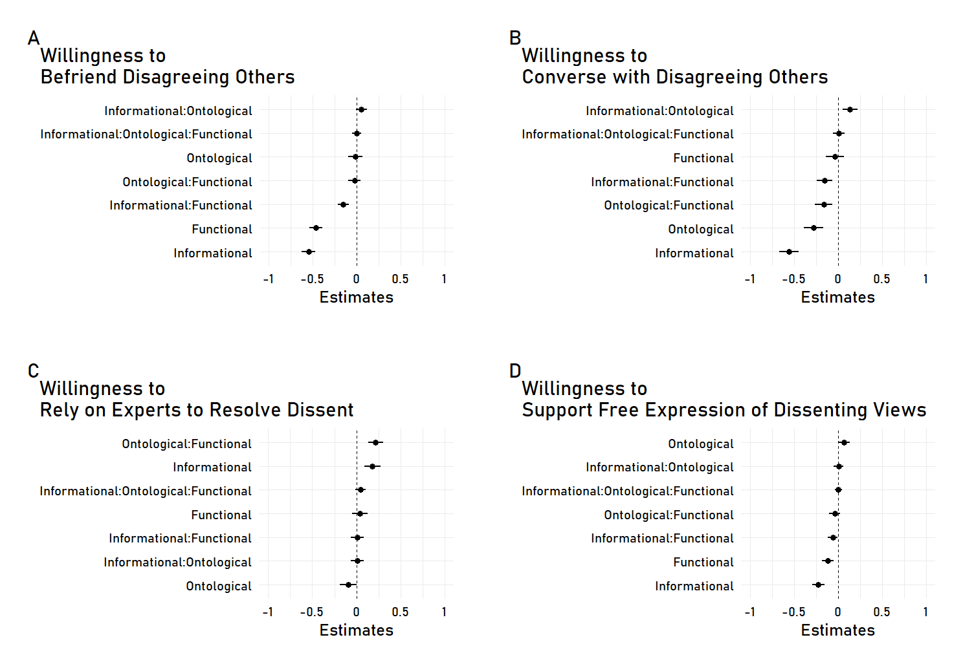
Regressions Predicting Social Outcomes from PPM in Linear Mixed-effects Regressions

Note. Plots show coefficient estimates from regressions with 95% confidence intervals. All regressions included domain-clustered random intercepts for issues, as regressions with random slopes did not converge. These regressions show that the visual trends in the prior figure are statistically significant.

SMA7: Trial Order Comparison and Trust of Polls

In this section, we first report the influence of trial order, and then trust of polls, in explaining variation in persistence.

Given that participants responded to multiple, similar trials, it is possible that they exhibited perseverative responding, whereby they provide responses similar to those they provided previously (or provide simple responses). To test this possibility, we examined whether rates of persistence changed across the trials, as we had access to the (randomized) order in which participants encountered different issues. We found that rates of persistence, belief change, and prediction errors were stable. A three-sample test for equality of proportions was conducted for view questioning. The results indicated no statistically significant difference among the proportions, χ² (2, N = 1951) = 1.78, p = .410. The proportion of questioning was .13 for participants’ first responses, .12 for their second responses, and .11 for their third responses. We conducted the same test with our belief change measure and found the same pattern: The results indicated no statistically significant difference among the proportions, χ² (2, N = 1951) = 2.53, p = .282. The proportion of belief change was .26 for participants’ first responses, .23 for their second responses, and .26 for their third responses. We also did not find substantial differences in average prediction error in perceptions of disagreement across trials (mean errors were 27%, 25%, 24% respectively; t-tests of these comparisons do not suggest significant differences, p > .05). We also looked at our paths to persistence items, and did not find notable differences in the proportion of participants whose factor scores suggested agreement with the paths, all p > .05; see our OSF repository for a script that includes these analyses).
For trust of polls, participants were asked to indicate their agreement with the following likert-type question using a 7-point scale: “I believe that the professional public opinion polls cited in this study accurately reflect Americans' beliefs about issues.” Responses to this question suggest that mistrust of survey data accounted for a marginally significant and small portion of the variation in persistence: on average, 14.2% of participants who indicated trusting our polls (>4 response to the likert scale above) questioned their views, whereas 10.7% of those who reported some level of distrust questioned their views—and this ~3% difference was significant (p = .02). There was also a small, 4% difference in average view change in the same direction, with 26.9% of poll trusters questioning, and 23.1% of poll doubters questioning (p = .06). Finally, confidence change showed the same pattern, with a 5.6% differential in confidence change due to poll trust (p = .003). Taken together, these results suggest that trust of polls influences persistence, but does not explain the overwhelming tendency to persist that we see in our data.

SMB1: Overview of Supplementary Studies
Here, we present four additional pre-registered studies that address questions beyond those we targeted in our main study (all pre-registrations, materials, analysis scripts, and data are available in our open-access repository at https://osf.io/389as). Below, we list these questions, and describe the studies that address them.
The first question is whether people’s qualitative, free-form responses to disagreement are captured by the considerations highlighted in the PPM. In Supplementary Study 1 (SE1), we elicited open-ended responses to disagreement concerning one of four controversial statements from the same four domains. We examined whether participants tended to persist in their views, and we documented the sorts of explanations they generated. In particular, we investigated the extent to which they offered explanations for persistence that could be classified as informational, ontological, functional, or computational, and whether any other meaningful categories of response emerge.
The second question is whether the structure of participants’ responses to a broad set of close-ended items mirrors the structure of the PPM. In Supplementary Study 2 (SE2), we used the same stimuli from SE1 in a closed-ended design. Beyond investigating the structure of participants’ responses to a broader set of close-ended items, we investigated cross-domain variation in participants’ responses, and examined asymmetries in participants who accepted vs. rejected most paths to persistence.
The third question is how participants’ responses to controversy change when they reflect on public opinion statistics on these controversies—as opposed to their own estimates of societal disagreement (as examined in SE1 and SE2)—as reasons to question their views. In Supplementary Study 3 (SE3), we expanded on and replicated the findings of SE2 by investigating whether providing participants with actual public opinion statistics on controversies made them less likely to persist in their initial beliefs.
The fourth question is what the distribution of people’s responses to dissent are, beyond persistence (as opposed to view questioning or change). As outlined in the introduction, there are four possible responses to dissent: persistence, conciliation, suspension, and polarization. In Supplementary Study 4, we investigated the distribution of participants’ responses across these alternatives through a discrete measure, in a study that is structurally largely identical to our main study in the manuscript.
Importantly, the measures we used throughout these studies evolved over time, as we triangulated close-ended items that were internally reliable. Therefore, these studies do not serve as a direct replication of the findings of our main study—they rather provide evidence for the four relevant questions noted above, and they offer some evidence that our central conclusions are robust to minor variations in item wording or measurement.

SMB2: Supplementary Study 1
In SE1, we presented participants with controversial statements from the same four domains as our primary study. Each participant received one of four statements from a given domain and indicated whether they agreed or disagreed with the statement. Participants then estimated the societal distribution of opinion regarding that statement, and finally explained whether the disagreement regarding the issue made them question their own views. Two independent coders then classified participants’ open-ended explanations in accordance with the Paths to Persistence Model.

Methods
Participants
Participants were 356 adults (164 men, 188 women, 4 other, mean age = 33) recruited on Prolific in exchange for monetary compensation ($0.50 for a 4-minute study). Participation across all studies was restricted to users currently residing in the United States with an approval rating ≥ 98% on at least 100 tasks. Repeat participation within and across studies and pilots was restricted using the Prolific platform. No participants were excluded from our analyses. This study’s design and hypotheses were preregistered; see https://aspredicted.org/ZWH_55D/.
Materials and Procedure
Participants were first assigned to one of 16 statements across four domains (see Supplementary Table 1B).

Supplementary Table 1B
Statements used in Supplementary Studies 1 and 2
Morality | Politics | Religion | Science
Having a baby outside of marriage is immoral. | Upper-income people in the US pay too much in taxes. | Holy scripture is the literal word of God. | Human activity is a major contributor to climate change.
Eating meat is immoral. | Gun laws in the US are not strict enough. | Humans have souls. | Power lines do not cause cancer.
Doctor-assisted suicide is immoral. | The federal government has too much power. | All animals have souls. | Genetically modified crops are safe for human consumption.
Testing products on animals is immoral. | The US has too much immigration. | There is an afterlife. | Vaccines do not cause autism.
Note. Statements were chosen to be highly controversial in the US, and are largely overlapping with items used in the main study.

On the first screen, participants indicated their own opinions about their assigned statement by responding to the question “Do you personally agree that [statement]?” with ‘Yes,’ ‘No,’ or ‘I have not made up my mind about this claim.’ Afterwards, they rated how confident they were in their responses on a five-point scale from ‘Very Confident’ to ‘Not at all Confident.’
Participants next estimated the distribution of opinions in the US regarding the statement. They were asked to drag three sliders, all initialized at zero, to indicate a population percentage for three groups: the percentage of the US population that agrees with the claim, disagrees with the claim, and has not made up their mind yet. The three estimates were required to sum to 100. Participants then encountered our key prompt and measure:

In the previous question, you indicated that [N]% of people in the US share your view about whether [statement]. This means that [100-N]% of people in the US do not share your view.
Does the fact that [100-N]% of people in the US do not share your view about whether [statement] make you question your own view? Why or why not? Please carefully explain your thoughts in a few sentences.
There are no right or wrong answers to this question, we are simply interested in what you think.

After providing a response in a text box, participants answered demographic questions (age, sex, educational background, level of religiosity, political affiliation) and received debriefing information.

Results

Opinion Measures
For our data to speak to persistence, participants needed to both have opinions about our issues and perceive them as being controversial. Confirming the former, the vast majority (82.6%) of our participants agreed or disagreed with our controversial statements. The remaining 17.4% reported not having made up their minds, with religious controversies eliciting the most (23.3%) and moral controversies the least (13.8%) suspension of judgment (see Supplementary Figure 1B).
Supplementary Figure 1B

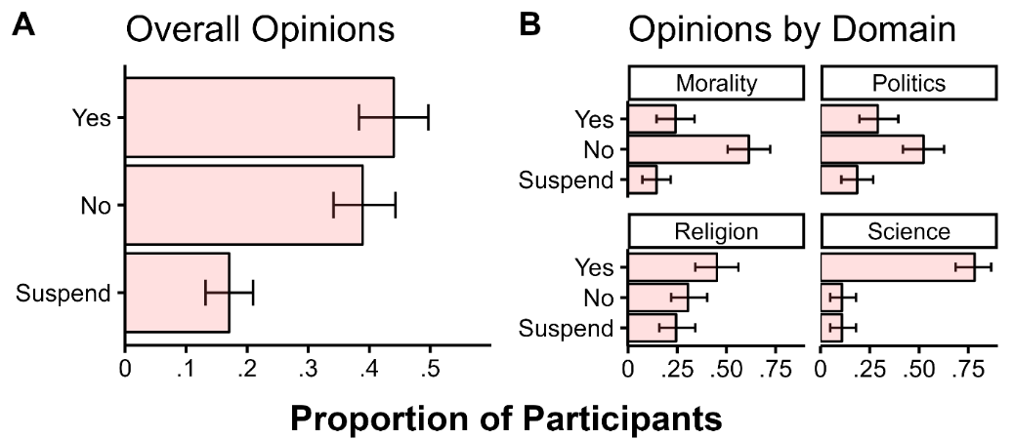
Distribution of Participants’ Opinions from Study 1
Note. Facet A shows the distribution of participants’ opinions across all statements used in SE1, Facet B shows opinions broken down by domain. Overall, participants were roughly equally likely to agree or disagree with the statements, and not very likely to have not made up their minds initially (labelled ‘suspend’)—though with substantial cross-domain variation. Error bars show bootstrapped 95% confidence intervals.

To accurately examine persistence, we restrict all subsequent analyses to data from the 83% of participants (N = 294) who indicated having opinions about the controversies. Overall, these participants were quite confident in their controversial beliefs (85.7% report being ‘very’ or ‘moderately’ confident; see Supplementary Figure 2B), though the beliefs they endorsed differed across the sample (overall proportions of agreement and disagreement with the statements were ~50%, with substantial domain variation—most participants agreed with our science items and disagreed with our morality items).

Supplementary Figure 2B

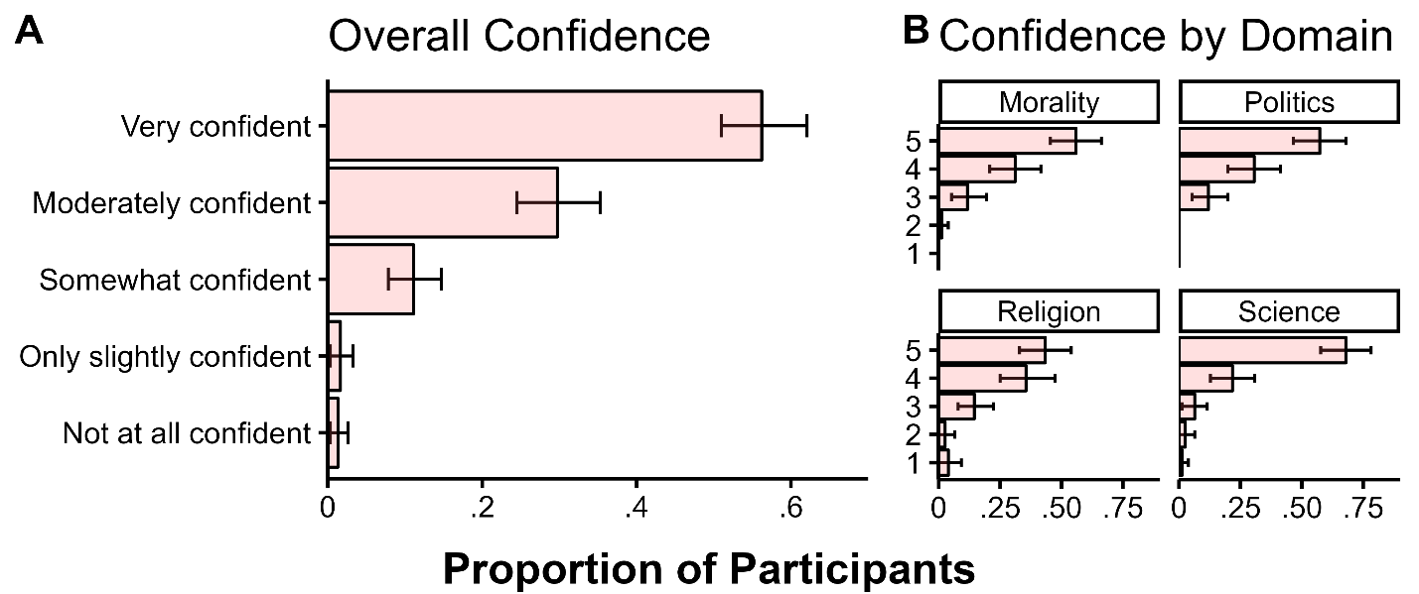
Distribution of Participants’ Confidence in their Opinion from Study 1
Note. Facet A shows the distribution of participants’ confidence in their opinions across all statements used in SE1, Facet B shows the same judgments broken down by domain as Likert scores. Error bars show bootstrapped 95% confidence intervals.

It is also worth noting that participants who suspended judgment differed in some respects from those who initially did not: those who suspended tended to hold their stance with lower confidence (OR = 0.50, 95% CI [0.37, 0.66], p < .01) and they were slightly more likely to be politically conservative (OR = 1.35, 95% CI [1.04, 1.74], p < .05).
Perceived Consensus & Persistence
We next investigated whether our issues were perceived to be controversial. On average, participants thought that half of Americans shared their views (M = 51.2%, SD = 21.1), that a third had the opposite view (M = 32.9%, SD = 19.6), and that a sixth had suspended judgment (M = 15.9%, SD = 11.2), with the most perceived disagreement for politics, and the least for science (see Supplementary Figure 3B). There was much cross-participant variance in perceived disagreement, with a quarter of participants perceiving a substantial majority (71.2%) of Americans as disagreeing with them, and a quarter perceiving a substantial majority (64.0%) as agreeing with them.

Supplementary Figure 3B

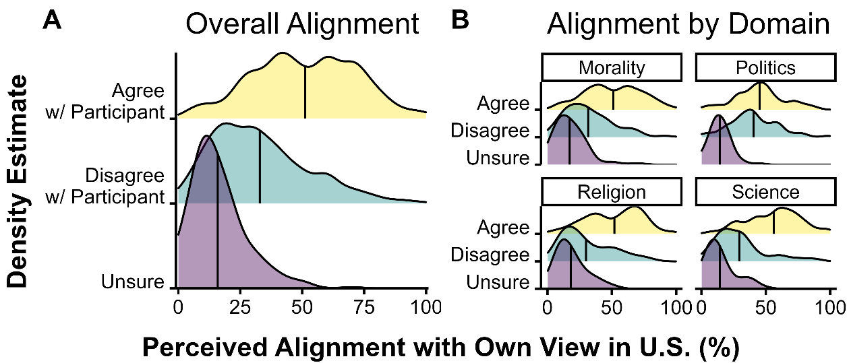
Distribution of Perceived Population Alignment with Participant Opinion from Study 1
Note. Facet A shows the distribution of perceived alignment with participants’ own view collapsing across domains, and Facet B shows the breakdown by domain. Shaded areas show density plots, and the lines on the densities show the mean estimate.

Having confirmed that participants had strong opinions about our issues and perceived them to be controversial (in the sense that they perceived non-trivial amounts of dissent in the population), we investigated our first hypothesis: that people typically persist in these beliefs despite societal disagreement (as a reminder, we examined participants’ open-ended responses to the following question: “Does the fact that [100-N]% of people in the US do not share your view about whether [statement] make you question your own view? Why or why not? Please carefully explain your thoughts in a few sentences.”)
The vast majority of opinionated participants (94.2%) indicated not questioning their views after reflecting on the fact that large portions of the population disagree with them (95% CI [90.7, 96.5]; test that proportion was observed by chance: χ2 (1, 294) = 228.2, p < .001). This proportion was consistent across domains and ranged from 89.9% for religion to 96.1% for morality. Moreover, an exploratory logistic regression shows that the extent of perceived disagreement did not predict the likelihood of questioning one’s view, b = 0.017, 95% CI [-0.006, 0.042], z(293) = 1.38, p = .165—potentially as a consequence of participants reflecting on relatively small amounts of perceived disagreement, or as a consequence of reflecting on their own estimates (issues that we addressed through the designs of SE4 and the main study). Given the rarity of view questioning in this dataset (N = 17), we cannot effectively compare participants who persisted with those who questioned their views. Our subsequent analyses for this study therefore focus on the explanations generated by the 94% of opinionated participants who persisted (N = 277).
Explanation coding
To analyze explanations for persistence, we had two independent coders code all open-ended explanations for the presence of our four pre-defined categories as well as new categories that were identified from the responses themselves. The pre-defined categories included: appeal to informational factors (such as asymmetries in evidence or processing of evidence), appeal to ontological factors (objectivity, knowability), appeal to functional factors (intra- and inter-personal consequences of holding beliefs), and computational factors (e.g., denying the presence or significance of disagreement; see Supplementary Table 2B)
The coders also included the following categories: ‘Unclear,’ which included responses that were blank, uninformative, or irrelevant (i.e., did not address the prompt); ‘opinion,’ which captured claims such as ‘everyone is entitled to their opinions’ (which are plausibly ontological but underspecified); and ‘other,’ which covered anything sensible not easily categorizable using the rubric. Interrater reliability on the initial five codes (collapsing ‘unclear,’ ‘opinion,’ and ‘other’) suggested substantial agreement between our raters, κ = .61, 95% CI [.53, .69] (see Landis & Koch, 1977). To reach our final coding categories, the coders discussed discrepancies in their coding (fewer than 5% of judgments) and revised their assignments in light of this discussion.
Explanations for Persistence
Of the pre-defined categories, the most common type of explanation was the informational, followed by ontological, computational, and functional. Supplementary Table 2B lists all codes, their prevalence in the dataset, examples from actual participant responses, and explanations.

Cross-domain Variation
Our data also supported the hypothesis that explanations for persistence differ across domains. We conducted mixed- and fixed-effects logistic regression analyses, predicting the classification of our main categories from domain, with nested random intercepts for statements (where models converged). These analyses revealed that informational explanations were more likely to be used to justify persistence in science, whereas ontological explanations were more likely to be used for religion (see Supplementary Figure 4B). These results are robust to the inclusion of perceived agreement, and inclusion of participants who initially indicated being unsure.

Table 2B
Coding Categories and Sample Responses from Study 1
Main Code | Ratio | Example  Participant Response |  | Explanation  of Example
Informational | 29.2% |  | “I honestly think that people believing this are unintelligent. There's no evidence of this at all (…)” | Appeals to asymmetries in competence and evidence to justify persistence.
Ontological | 6.8% |  | “I don't think this is something that can be proved or disproved by living people. This is just a personal choice.” | The unknowability of the claim justifies subjectivity and hence persistence.
Functional | 2.5% |  | “(…) people are inclined to believe in it because the thought of no longer existing is scary. It scares me too.” | The intrapersonal cost of changing one’s view about the issue justifies persistence.
Computational | 5.4% |  | “To be honest I think there are many pro and cons.” | The participant finds the question to be complex, which contributes to their persistence.
Opinion | 14.4% |  | “Everyone is allowed their own opinion and can do what they want (…).” | These responses suggest subjectivity, but not explicitly.
Unclear | 35.7% |  | “It does not change my view at all.” | It is difficult to interpret these responses clearly.
Uncodable | 8.6% |  | “(…) I have faith that God is real and those that don't - don't affect me. | These are difficult to cluster with each other or other items.
Note. Ratio refers to the percentage of responses from participants who persisted that were classified as belonging to that main code by both coders post discussion. The codes were used mostly exclusively (4.7% of responses fit multiple codes).

Supplementary Figure 4B
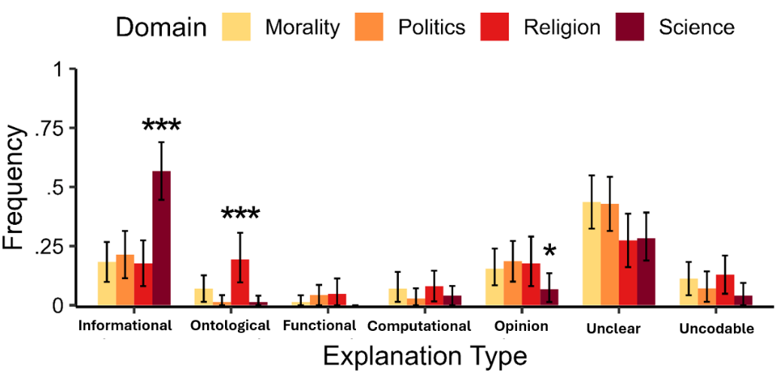
Explanations of Persistence Across Domains in Supplementary Study 1
Note. Bars show the proportion of responses classified as instances of each explanation type at the domain level (i.e., the frequencies for each domain across explanations sum to 1); error bars show bootstrapped 95% confidence intervals. * indicates p <.05 and *** indicates p <.001 for deviation-coded domain contrasts in logistic regressions.

Discussion
The results of SE1 support the capacity for the Paths to Persistence Model to account for people’s qualitative, open-ended explanations for why they persist in their beliefs amid dissent: Participants’ responses systematically aligned with the informational and ontological paths, sometimes demonstrated functional and computational characteristics, and their explanations did not suggest any coherent alternative paths. Moreover, the use of these paths shows systematic variation across domains, with informational explanations most common overall and especially for science, and ontological explanations most common for religion (echoing the results of our main study). It is worth noting that our coding scheme was particularly conservative when it came to ontological explanations, as the ‘opinion’ category captured claims that could be plausibly interpreted as appeals to subjectivity (e.g., “No it does not make me question my choice because everyone has their opinions and feelings”). Treating opinion responses as ontological would increase the proportion of ontological responses to 20%, close to the proportion of informational responses. Doing so also conserves the domain variation observed with the stricter criteria, supporting the idea that underspecified appeals to opinions in fact reflect ontological commitments.
A potentially worrisome feature of our data is the non-negligible proportions of responses that were either uncodable or unclear. While we take the “uncodable” category to primarily reflect low participant effort (recall that no participants were excluded), the “unclear” category is potentially more informative. Most often, such “explanations” simply lacked explanatory content, and instead stated persistence in some form, or were too vague to classify. Such responses could reflect the limitations of our methodology, which relies on participants’ ability to explicitly reflect on and report reasons to persist in their belief. To the extent such persistence was driven by non-conscious factors, we might expect participants to experience something like explanatory “dumbfounding,” finding themselves in possession of a judgment they were unable to adequately justify (Haidt, 2001). For the same reason, we expect our method to underestimate the actual influence of functional and computational factors (see, e.g., Wilson et al., 1989; Wilson & Brekke, 1994).
A final observation is that participants rarely offered more than one path to persistence (< 5% of responses). This is consistent with the hypothesis that a single path to persistence is sufficient to support belief persistence, but could also reflect the difficulty of generating and communicating accurate explanations of the internal drivers of one’s judgments with limited time. This in part motivates our use of close-ended items in the rest of our studies, which are more likely to capture drivers of persistence that participants might not generate explicitly (for instance, people may rarely choose ‘agree’ on an item that could suggest that they are biased, but the variation on the negative to neutral half of the scale might be informative)—and which is more conducive to parallel evaluations of multiple paths.

SMB3: Supplementary Study 2
In SE2, we developed a closed-ended analogue of our first study. Instead of answering an open-ended question about their reactions to disagreement, participants provided ratings for eleven Likert-type items that corresponded to the pre-defined coding categories used in the prior study. We were interested in whether their responses to this broad set of items recovered the structure of the PPM. Moreover, by having participants rate items corresponding to factors that were infrequently generated in Supplementary Study 1 (such as functional and computational), we can also gain greater insight into whether all factors of the Paths to Persistence Model capture variation in judgments.

Methods
Participants
Participants were 354 adults (153 men, 196 women, 4 other, 1 unidentified, mean age = 34) recruited as in Supplementary Study 1. An additional two participants were excluded for failing a pre-registered attention check (explained below). Given that participants generated sufficiently rich and diverse open-ended explanations to yield robust conclusions in Supplementary Study 1 (and that we did not have a priori expectations with regards to how our closed-ended items would cluster together), we adopted the same sample size for this study. This study’s design and hypotheses were preregistered; see https://aspredicted.org/VJ1_HYR.
Materials and Procedure
Participants were assigned to one of 16 statements from Study 1, and shown the same personal opinion, confidence, and societal opinion distribution measures. The content of the studies diverged after this point. Instead of an open-ended question, participants first gave a binary (yes / no) response to the following question: “Does the fact that (100 – N) % of people in the US do not share your view about whether X make you question your own view?” After responding to this question, participants answered 11 Likert-type agreement items, from Strongly Disagree (1) to Strongly Agree (7), in random order. For all items, participants rated how much they agreed with each statement as an explanation for why the disagreement did or did not make them question their own views. These eleven items are shown in Table 3B below, with labels that indicate the corresponding coding categories from Study 1.

Supplementary Table 3B
Closed-ended Items Used in Supplementary Study 2
Persistence Path | Subpath | Close-ended Items
Informational | Evidence Quality | People who disagree with me about Y have evidence that is less good than my own.
Informational | Evidence Quantity | People who disagree with me about Y have less evidence about this issue than I do.
Informational | Competence | People who disagree with me about Y are not as good as I am at evaluating this issue.
Informational | Bias | People who disagree with me about Y are more biased than I am on this issue.
Ontological | Difficulty | Knowing what to believe about Y is very difficult.
Ontological | Subjective | Whether Y is more a matter of opinion than fact; there are no right or wrong answers about it.
Ontological | Unknowable | People will never know whether Y; it is an issue that is fundamentally unknowable.
Functional | Inter-  personal | (…) changing my view could damage my relationships with important people in my life.
Functional | Intra-  personal | (…) changing my view would threaten who I am as a person.
Computational | Awareness | I have deeply considered why people disagree about whether Y.
Computational | Majority | People disagreeing about Y does not matter to me, given that enough people actually agree with me.
Note. Table shows closed-ended analogues of coding categories from Study 1. Measures for questioners are abridged where they follow directly from the measures for persisters. Functional items are abridged—in the study, they were preceded by “It’s important to [maintain my view / be open to changing my mind] about whether Y because (…).” Questioners were shown the items with different wording across some, but not all measures, and are omitted here because this inconsistency makes their interpretation difficult, and because our pre-registered analyses did not incorporate questioner’s responses. Although the difficulty item is related to unknowability (an ontological consideration), it could also reflect computational considerations; the item was modified in later studies to eliminate this ambiguity.

Finally, participants answered an attention check, followed by the same demographic questions used in Supplementary Study 1. The attention check was a multiple-choice question that asked: “Which of the following best describes what this survey is about?” There were eight obvious lures (‘elementary physics,’ ‘car preferences,’ etc.), and the correct answer was ‘people’s opinions.’

Results

Perceived Consensus & Persistence
As in SE1, we first confirmed that our issues were perceived to be controversial (they were: across all participants, the percentage of perceived agreement with one’s position in the population was nearly half, at 50.6%), and that our participants had opinions about the issues (they did: 44.6% agreed, 38.4% disagreed, and only 16.9% were unsure). As before, we excluded participants who suspended judgment from analyses of persistence; in accordance with prior results, an exploratory logistic regression shows that the main predictor of suspension was lower confidence. We also verified that participants tended to persist with the closed-ended opinion measure (they did, with 87.8% persisting, 95% CI = [83.3, 91.1], test that the proportion was observed by chance: χ2 (1, 294) = 166.13, p < .001). As in Supplementary Study 1, these proportions were fairly consistent across domains, with perceived agreement with one’s position ranging from 61% in science to 40% for politics, and persistence from 82% for science to 93% for politics. The distributions for stated beliefs, confidence, and population beliefs were consistent with those observed in SE1 (these results are available in our OSF repository).

Factor Analysis of Persistence Explanations
To reduce the dimensionality of our 11-item measure of explanations for persistence, and as pre-registered, we conducted the following factor analysis (in accordance with recent recommendations; Jackson, Gillaspy, & Purc-Stephenson, 2009). The analysis was based on data from the 258 participants who reported having an opinion and who persisted despite reflecting on disagreement.
We first verified the suitability of our data for factor analysis in accordance with recommendations (see Henson & Roberts, 2006) by ensuring that our data were normally distributed. Quantile-quantile plots comparing the empirical and normal distributions indicated no substantial deviations from normality. We then ensured that our data in fact showed patterns of correlation through a Bartlett’s test, which revealed significant correlation, χ² (55) = 830.21, p < .001, and we computed the KMO Measure of Sampling Adequacy, finding an overall MSA = .80, which indicates strong factorability. We finally implemented a factor analysis with a minimal residual factoring method and an oblique rotation. We determined the number of factors to include by conducting a parallel analysis, which suggested a three- or four-factor solution (see Supplementary Figure 5B for a scree plot).

Supplementary Figure 5B

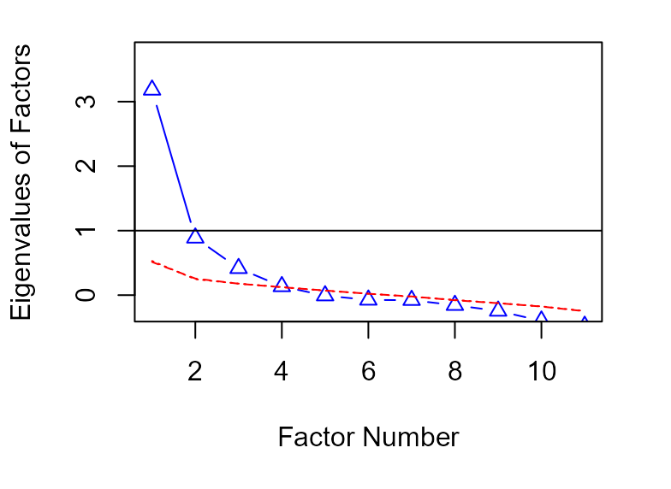
Scree Plot for Factor Analysis from Study 2
Note. Figure shows scree plot of factor analysis. The blue line shows the actual eigenvalues obtained from the factor analysis, with factors ordered by their relative importance in accounting for variation in the data. The red dashed line shows the expected eigenvalues for randomly simulated data. The point at which the simulated and actual eigenvalues intersect is taken to be the point at which additional factors stop providing more information (and typically corresponds to a qualitative flattening of the slope between subsequent eigenvalues). For this plot, this point occurs between three and four factors, with the fourth factor failing to contribute much information.
The four-factor solution explained 51% of total variance in ratings, and the four factors respectively accounted for 22%, 14%, 12%, and 3% of variation in the data. Importantly, the factor loadings were exactly in line with our a priori expectations (see Supplementary Figure 6B). This four-factor model achieved excellent fit (TLI = 1.01, RMSEA = 0, 90%CI [0, .051]; typical cutoff values indicating good fit are TLI ≥ .95 and RMSEA ≤ .06), as did the three-factor model (TLI = .96, RMSEA = .05), as the fourth factor did not capture much variance in the data.

Supplementary Figure 6B
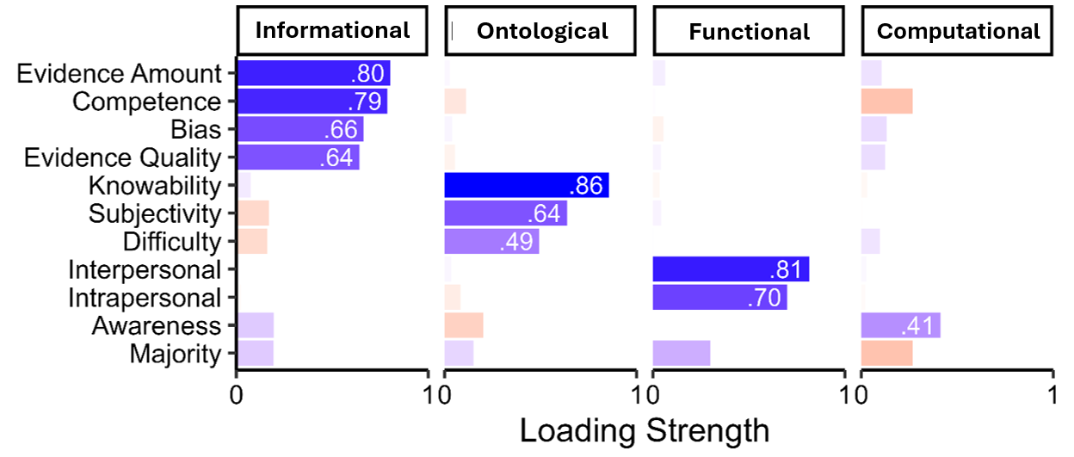
Factor Loadings of Responses to Closed-ended Items from Study 2
Note. Factor loadings greater than .35 are shown in white text (the recommended threshold at our sample size; Hair et al., 1998). Blue indicates positive loadings, and red negative. The pattern of factor loadings for each factor accords with the structure of the PPM.

Cross-domain Variation
Having reduced the dimensionality of our data, we proceeded to investigate whether we replicated the domain-dependence observed in Supplementary Study 1. To do so, we first extracted factor scores from the four-factor solution (using Thurstone’s method, though the results presented below also hold for the Bartlett method among others; Grice, 2001). We then conducted separate one-way ANOVAs with domain as the independent variable for each of our factors. This analysis revealed significant domain variation for all four factor scores (informational: F(3, 254) = 11.44, p <.001, ontological: F(3,305) = 20.36, p < .001, functional: F(3, 254) = 2.94, p < .05, computational: F(3, 254) = 3.71, p < .05; see Supplementary Figure 7B). In particular, and as predicted, we found that the informational factor was utilized more frequently for scientific controversies than the average (M = 0.53; t(58) = 4.52, p <.001), and that the ontological factor was more common for religious controversies than the average (M = 0.41; t(61) = 3.72, p <.001). We also observed effects that we had no predictions for. The informational factor was dispreferred for moral controversies (M = -0.33; t(69) = -3.52, p <.001). The ontological was preferred for moral controversies (M = 0.28, t(69) = 3.17, p =.002) and dispreferred for scientific controversies (M = -0.62, t(58) = -6.01, p < .001). Finally, the functional path was weakly dispreferred for religious controversies (M = -0.26, t(61) = -2.56, p = .013) and computational path weakly preferred for political controversies (M = 0.19, t(66) = 2.48, p =.016).

Supplementary Figure 7B
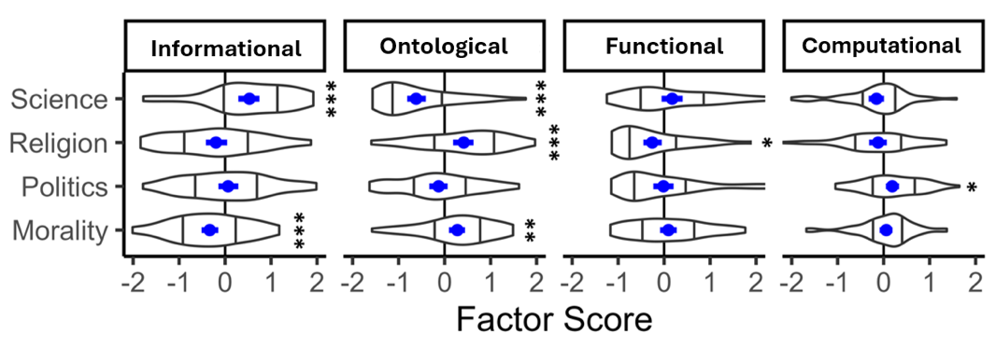
Cross-domain Variation in Factor Scores
Note. The blue point displays the mean, error bars show bootstrapped 95% confidence intervals, and the violin plots depict smoothed densities, with bars indicating the first and third quantiles. * denotes p <.05, ** denotes p <.01, *** denotes p <.001.

Discussion
The results of this study show that the structure of participants’ responses to a broader set of 11 close-ended items mirrors the structure of the PPM. As in SE1, we find that participants overwhelmingly reported sustaining their beliefs in the face of societal disagreement, and doing so in a domain-dependent manner. Importantly, we find that responses to items ostensibly measuring the computational path do not capture meaningful variance in participants’ responses.
These analyses also provide finer-grained insight into the mechanisms of persistence than open-ended responses provide. For instance, the factor loadings we obtained suggest that amount of evidence and competence may be more characteristic of informational persistence (above perceptions of bias and evidential quality), whereas knowability may be a more characteristic component of ontological persistence (above subjectivity).
Though this study offers finer-grained insight into the mechanisms of persistence, it is plausible that the high prevalence of persistence observed in both SE1 and SE 2 reflects a feature of the task: while participants were prompted to reflect on the percentage of other people in the U.S. who disagree with their own view (as derived from their own estimates of the societal distribution of opinion), they did not receive novel evidence of disagreement. This potential shortcoming is addressed in Supplementary Study 3 (as well as in our main study).

SMB4: Supplementary Study 3
In our prior studies, participants were asked whether their own estimates of societal disagreement made them question their views, and we found that they overwhelmingly persisted. However, it is possible that their persistence did not result from the factors suggested by the PPM—instead, participants may have persisted because they were asked to reflect on their own estimates, which they may have already “priced-in” to their beliefs. If they had been presented with novel evidence of disagreement instead, they may have questioned their views. More generally, it is plausible that the divergence between perceived and actual disagreement in the population moderates the likelihood of persistence (in line with past work showing that belief change scales with prediction error; Vlasceanu et al., 2020).
To investigate this possibility, we conducted a conceptual replication of SE2 in which we provided participants with actual statistics on controversies obtained from recent public opinion polls conducted by major polling organizations. This allowed us to assess the rates of persistence when participants encounter novel evidence of disagreement, and moreover to investigate whether prediction error, as well as endorsing particular paths to persistence, predicts persistence.

Methods
Participants
Participants were 399 adults (188 men, 201 women, 7 other, 3 unidentified, mean age = 37) recruited as in Supplementary Studies 1 and 2. An additional two participants were excluded for completing the study in an unrealistic amount of time (< 1 minute, as pre-registered). We based the sample size on our prior two studies. This study’s design and hypotheses were pre-registered; see https://aspredicted.org/T55_53Q.
Materials and Procedure
Participants were assigned to one of 12 statements from the same domains used in Supplementary Studies 1 and 2, though some of the statements used were changed due to the unavailability of recent public opinion polls (see Supplementary Table 4).

Supplementary Table 4

Stimuli Used in SE3
Domain | Prompt / Public Opinion Measure | Ag. | Dis. | Source
Morality | Sex between teenagers is morally wrong. | 46 | 48 | (Gallup, 2022)
Morality | Doctor-assisted suicide is morally wrong. | 54 | 43 | (Gallup, 2022)
Morality | Medical testing on animals is morally wrong. | 43 | 52 | (Gallup, 2022)
Politics | Gun laws in the U.S. are not strict enough. | 52 | 46 | (Gallup, 2021)
Politics | Right-wing extremism is a major problem in the U.S. | 52 | 48 | (Pew, 2021)
Politics | Upper-income people in the US pay too little in taxes. | 58 | 38 | (Pew , 2019)
Religion | Those who do not believe in God can go to heaven. | 53 | 44 | (Pew, 2021)
Religion | Suffering in the world is not a punishment of God. | 50 | 48 | (Pew, 2021)
Religion | God hears people’s prayers and intervenes on their behalf. | 42 | 58 | (Gallup, 2022)
Science | Human activity contributes a great deal to climate change. | 49 | 51 | (Pew, 2019)
Science | Genetically modified crops are no worse than non-GM crops for one’s health. | 48 | 51 | (Pew, 2019)
Science | Nuclear power plants are generally safe. | 49 | 47 | (Gallup, 2019)
Note. Statements were chosen to be highly controversial in the US. Ag. indicates agreement with the measure on the cited polls, Dis. Indicates disagreement—these do not necessarily sum to 100 due to attrition rates and other factors.

Participants were then shown the same personal opinion and confidence measures. Afterwards, they encountered a streamlined societal agreement slider measure, “What percentage of people in the United States do you think share your view about this claim?” from 0 to 100. Participants were then shown a modified binary (yes / no) view questioning measure:
You previously indicated that X% of the U.S. shares your view about [prompt]. In fact, according to public opinion polls conducted by major research organizations, the actual percentage of those who share your view is Y%, and Z% do not share your view on [prompt].
Does the fact that Z% of the U.S. disagrees with you on this issue make you question your own view?
Afterwards, participants were shown three items that capture the first three paths to persistence (see Supplementary Table 5), and asked to provide demographic information. We excluded the computational path in this and later studies given that empirically our items did not capture variance in participants’ responses, and theoretically, computational considerations are less likely to be at play in studies where participants are asked to explicitly reflect on dissent.

Supplementary Table 5
Paths to Persistence Measures Used in SE3
Informational | People who disagree with me on this issue are less informed than I am or are worse at evaluating relevant evidence.
Ontological | This issue is currently unknowable or more a matter of opinion than fact; others’ opinions are therefore uninformative about the truth of the issue.
Functional | Changing my view about this issue could challenge how I think of myself as a person, or damage my relationships with important people in my life.
Note. This study uses collapsed measures for each path designed to capture each sub-path measured separately in SE3. Note that questioners rated slightly different items used for an exploratory analysis and omitted here for space.

Results
As in prior studies, we first confirmed that our new set of issues were controversial (they were; perceived agreement was 50.6%) and that our participants were opinionated (75.7% had non-agnostic views). We then investigated whether participants were accurate in their perceptions of controversy. To do so, we computed the difference between perceived agreement and the actual amount of public support in the U.S for each issue.
We found that participants were on average accurate in their estimates (M_{error} = 2.2%), but highly variable (and hence inaccurate) at the participant level (SD_{error} = 20.7)—with a quarter of participants overestimating agreement by at least 12% and a quarter underestimating agreement by at least 16.5% (see Supplementary Figure 8B). Errors were normally distributed, with some variation across domains: Participants overestimated agreement with their views for moral (8.6%) and political (5.7%) controversies, underestimated agreement for religious controversies (-4.7%), and provided relatively unbiased estimates for scientific controversies (-0.5%).
Supplementary Figure 8B
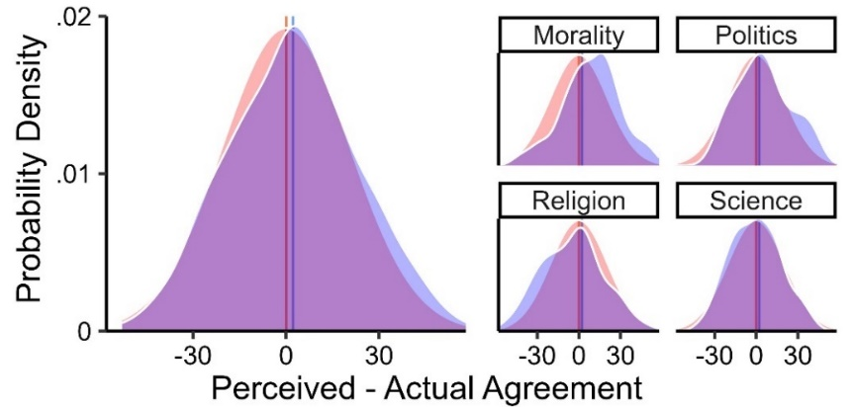
Prediction Errors in Perceptions of Societal Agreement

Note. Figure shows distribution of prediction errors overall (left) and by domain (right) in blue, and a normal distribution centered at 0 with the same variance in red for comparison; the red and blue lines show the means of the two distributions.

As before, we excluded participants who suspended judgment from analyses of persistence. We then investigated cross-domain variation in paths to persistence. Though we replicated the directionality of the previous effects we observed—with the informational path preferred for science and dispreferred for morality, and the ontological path preferred for religion and morality but dispreferred for science—the magnitudes of these effects were smaller in this sample, and only the effects for the ontological domain differences reached significance (see Supplementary Figure 9B). That we observed weaker cross-domain variation in this study could be random variation in the data, or a consequence of using a set of items that was too limited. For instance, the three items we used here compress two subpaths to one through a disjunction (i.e., ‘or’ clause), and it is plausible that participants prefer not indicating agreement with these items when they only agreed with one part (i.e., answered the questions as if we asked ‘and’). Moreover, note that responses to the functional path show floor effects: participants overwhelmingly indicate not agreeing that functional considerations explain why they persist in their beliefs.
Supplementary Figure 9B
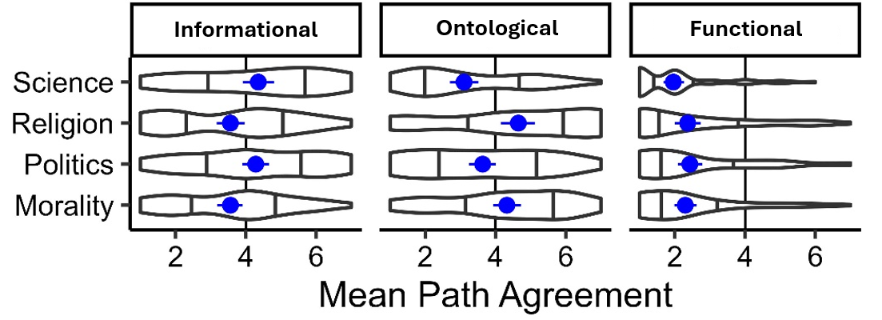
Cross-domain Variation in Paths to Persistence
Note. The blue point displays the mean, error bars show bootstrapped 95% confidence intervals, and the violin plots depict smoothed densities, with bars indicating the first and third quantiles.

We then investigated whether participants persisted when presented with novel evidence of disagreement. We found that persistence was once again overwhelmingly common, with 95.0% of participants persisting, 95% CI = [91.2, 98.0], test that the proportion was observed by chance: χ2 = 243.18, p < .001. There was some domain variation, with moral controversies showing the highest rate of persistence at 98.7%, and scientific controversies showing the lowest at 93.2%. We also pre-registered analyses predicting persistence from responses to the paths and prediction error. Though these analyses are available in our OSF repository, we do not include them here because the study design was not well suited to addressing this question: We provided participants who questioned their views with a different set of measures for the paths. Broadly, these analyses show that prediction error does not have a significant effect on persistence, and that the paths have significant effects, potentially due to differences in the wordings of the items.

Discussion
The results of SE3 support and extend our previous findings. Most importantly, we found that participants persisted when provided with novel evidence of controversy—even when their perceptions of the extent of disagreement were quite inaccurate. This suggests that persistence arises from the theoretically rich drivers of judgment suggested by the PPM, and that the modest rates of view questioning found in SE1 and SE2 were not an artifact of the method.
However, there were substantial limitations to this study. First, because we used differently worded PPM items for persisters and questioners, analyses predicting persistence were confounded. Second, though we provided participants with novel evidence of dissent, the evidence provided was always that dissent split the population in half. It is plausible that view change amid societal dissent could require not only novel evidence of dissent, but that the evidence received indicate that the participant is in a small minority. Third, this study again only used the view questioning item to measure persistence—participants could in fact be conciliating, polarizing, or suspending judgment amid dissent, but not identifying these changes as ‘view questioning.’ Supplementary Study 4 was intended to address these shortcomings.
There are two shortcomings that Supplementary Study 4 does not address: first, we again used one-item measures of the paths, potentially compressing variance in responses across the board, and second, we again used measures that asked participants to indicate whether the paths directly explained why they persisted in their views—potentially leading to floor effects for our functional items, as these questions in essence ask participants whether they persist because they are biased. If we had merely asked for agreement with an item that indirectly measures the inter- or intrapersonal significance of these beliefs, we could potentially observe meaningful variation in participant responses. As we will see, beyond compressing variance, this direct question leads to confusing patterns of responses, which is why our main study uses items that measure the perceived importance of beliefs instead.

SMB5: Supplementary Study 4

Methods
Participants
Participants were 813 adults (437 men, 356 women, 17 non-binary, 1 other, mean age = 41) recruited on Prolific in exchange for monetary compensation ($1.40 for a 7-minute study). Participation across all studies was restricted to users currently residing in the United States with an approval rating ≥ 98% on at least 100 tasks. Note that we intended to recruit 825 adults but a glitch on the platform resulted in 12 fewer participants in our sample than intended. We pre-registered exclusions for participants who completed the study in an unrealistically short amount of time (< 3 minutes), and excluded four participants who were under this threshold. We also pre-registered exclusions based on a self-report attention check measure, and excluded three further participants who indicated being distracted during the study. This study’s design and hypotheses were preregistered; see https://aspredicted.org/9LD_DZ4.
Materials and Procedure
The materials and design of this study were identical to those of the main study, with a few exceptions. In terms of materials, we used largely the same set of stimuli; 16 items were updated from SE4 for the main study. In terms of design, there were three main differences. First, in this study, we tested an alternative measure of persistence that contrasts it with conciliation, suspension, and polarization. This question (which we call the ‘response to disagreement’ item) started with a preamble that reminded participants of their own estimate, provided them with the actual public opinion statistic, and concluded with the following question: “Which of the following best describes your reaction to the disagreement? Learning about the disagreement…” This was followed by four multiple choice options shown in random order:
[Persistence]: “…does not change my opinion on this issue.”
[Suspension]: “...makes me neutral about this issue and I prefer to remain so until I obtain further evidence.”
[Conciliation]: “...brought me closer to the disagreeing group's view on this issue.”
[Polarization]: “...pushed me further away from the disagreeing group's view on this issue.”
Second, SE4 used the three combined measures for the paths in SE3, rather than the six we used in the main study. Finally, this study did not include any social outcome measures.

Results
As in our prior studies, we first investigated participants’ perceptions of dissent in society. Moving beyond SE1-3, we investigated both issues on which societal opinion was split, and issues on which a majority of the U.S disagreed with participants’ views. This resulted in larger and more biased prediction errors than in our previous studies (see Supplementary Figure 10B).
Supplementary Figure 10B
Prediction Errors in Perceptions of Societal Agreement

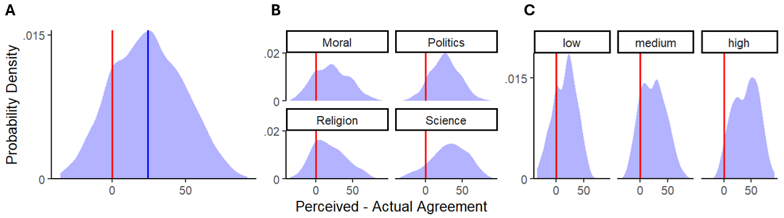
Note. Figure shows distribution of prediction errors overall (A), by domain (B) and by disagreement level (C). The red line at 0 indicates fully accurate perceptions of dissent.

The distribution of errors shows some clear patterns: participants were most accurate in their perceptions of dissent on religious issues (M_{error} = 17.9), and least accurate for scientific issues (M_{error} = 32.2), with politics and morality falling in between. Importantly, across all domains, most participants underestimated dissent, and there was substantial variability in the extent of errors. This difference across domains may be a consequence of the particular items we picked for each domain, or it could reflect variation in the accuracy of the polls underlying them. Another source of systematic variation across issues was the extent of actual dissent: Participants’ errors increased from issues on which there was relatively low levels of dissent with participants’ views (M_{error} = 15.5), to medium levels of dissent (M_{error} = 23.4), and high levels of dissent (M_{error} error = 40.0).
Do participants persist in their views in this dataset, when they encounter a more diverse set of disagreements—many on which they learned that they were in a small minority? Yes—most participants (86.8%) indicated not questioning their views after reflecting on novel information that larger portions of the population than they thought disagree with them (95% CI [84.9, 88.5]; test that proportion was observed by chance: χ2 = 433.7, p < .001). Our key question for this study was whether the distribution of participants’ responses to the four-option ‘response to disagreement’ item also resulted in high rates of persistence. We found that they did, though at a slightly lower rate: 74.0% of participants indicated persisting in their beliefs, 13.4% indicated suspending judgment, and 7.2% conciliated, and 5.3% polarized (test that the distribution was observed by chance: χ2 = 698.1, p < .001).
We next investigated participants’ inferences about the paths to persistence. As before, we excluded participants who suspended judgment from analyses of persistence. We again replicated the directionality of the previous effects we observed—with comparisons of the grand mean to domain-specific means showing that the informational path was significantly preferred for science (t(369) = 5.54, p < .001) and dispreferred for morality (t(289) = -5.49, p < .001), and the ontological path preferred for religion (t(369) = 7.11, p < .001) but dispreferred for science (t(302) = -9.96, p < .001; see Supplementary Figure 11B). Importantly, we again observed that the functional item resulted in floor effects and failed to reveal variation.

Supplementary Figure 11B
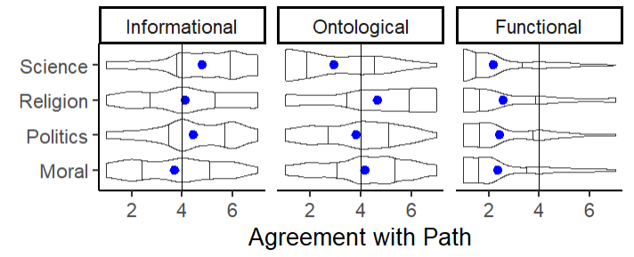
Cross-domain variation in responses to PPM items
Note. The blue point displays the mean, error bars show bootstrapped 95% confidence intervals, and the violin plots depict smoothed densities, with bars indicating the first and third quantiles. Our dataset is sufficiently large that the bootstrapped confidence intervals are small enough to be overlapping with the point showing the mean.

In sum, we broadly replicated the results of our prior studies, except for a confusing result: agreeing with functional reasons for persistence predicted higher likelihood of questioning. We hypothesized that this may have been due to the wording of our functional measure, which selected for very humble participants (it essentially asked whether participants persisted because they themselves were biased). In additional studies, we found this explanation to be supported by data: Participants who question their views, and report doing so because of social or intrapersonal pressures, tend to be humbler and more aware of the fallibility of their reasoning generally (e.g., they endorse statements such as “What my family, friends, and colleagues believe surely influences what I believe, even if my judgment feels objective to me.”). This finding led to an additional pilot, not reported here for sake of space, where we tested multiple measures of the functional path to locate ones that maximally differentiated between issues with similar public opinion distributions, but with substantial differences in interpersonal pressures (e.g., comparing the statement “having machines with the ability to think for themselves will help the economy” [Agree: 19, Disagree: 73] and “the earth is getting warmer mostly due to natural patterns [Agree: 24, Disagree: 76]; though we tested our measures across all four domains). We found that the measures we used in our main study discriminated between these issues best, and they ended up predicting questioning negatively, suggesting that they actually track the social pressures preventing people from questioning, rather than meta-cognitive attitudes (such as humility) that our previous measure seemed to track.
SMC1: Replicating the Main Study Results
Here, we replicate the analyses from the main manuscript without excluding participants on the basis of the (potentially problematic) second attention check. These analyses are also available in our OSF repository. We began by replicating perceptions of societal disagreement. We found again that participants substantially underestimated disagreement, on average, by 27.1% (see Figure 1C).

Supplementary Figure 1C
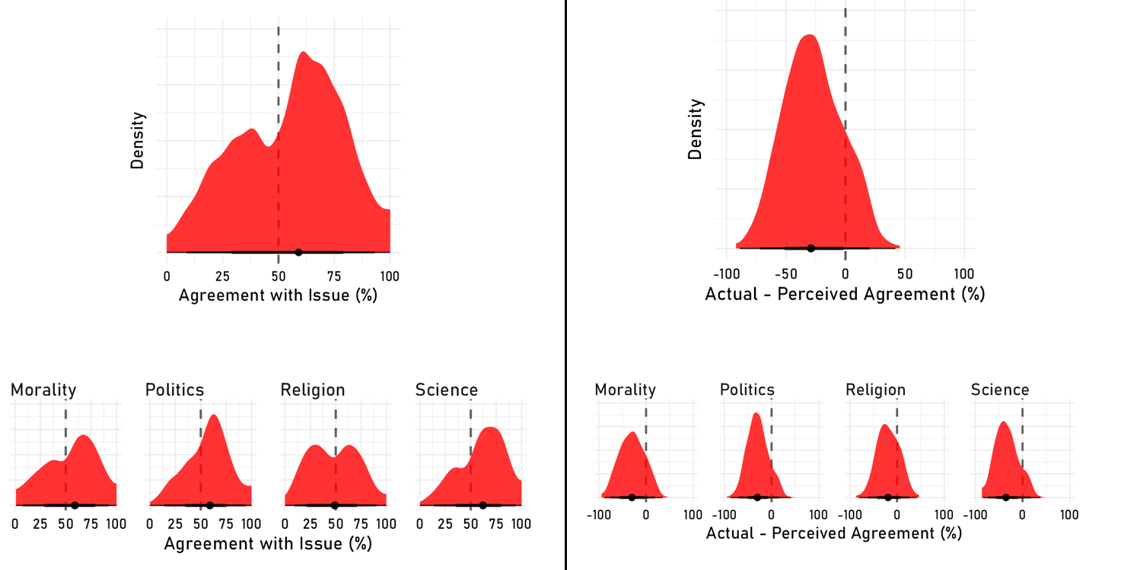
Perceived Agreement and Prediction Error
Note. Plots show the distribution of agreement (left) and errors in agreement estimates (right); top plot shows all judgments, bottom facets show this broken up by domain.

We then investigated whether participants tended to persist in their views amid dissent. We again found that participants typically persisted—whether operationalized as lack of view questioning (84.5%, χ²(1) = 1521.5, p < .001), lack of belief change (71.0%, χ²(1) = 559.7, p < .001), or lack of confidence change for participants who did not indicate belief change (81.6%, χ²(1) = 1078.2, p < .001). All of these estimates are within ~3% of those reported in the main manuscript.
Next, we investigated the factor analysis. We assessed the three-factor resulting model first using commonly accepted indices of fit: the Comparative Fit Index (CFI) of the resulting model was 0.996 (standard for a good fit > .95), the Tucker-Lewis Index (TLI) was 0.989 (standard for a good fit > .95), and the Root Mean Square Error of Approximation (RMSEA) was .038 (standard for a good fit < .06); indicating that the three-factor solution again fit our data well. This is also visible in the exploratory factor analysis structure.
Supplementary Figure 2C
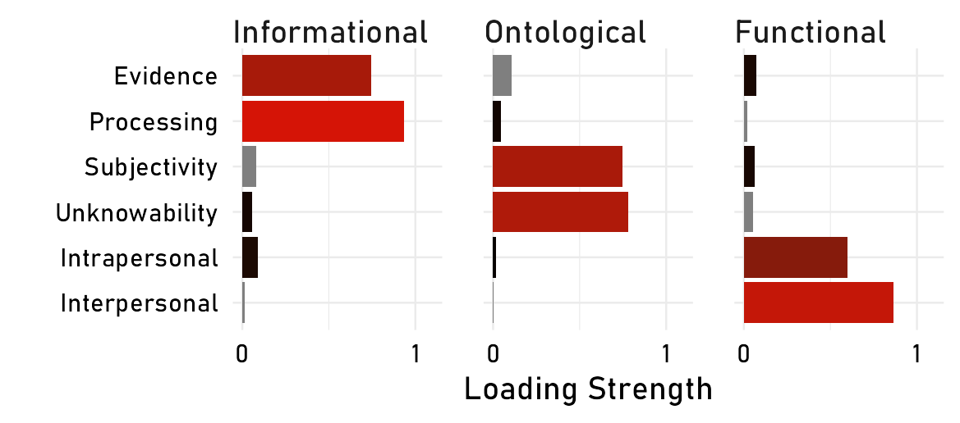
Exploratory Factor Analysis Loadings
Note. Note that this factor analysis is not the one used in generating the factor scores (the CFA has exclusive factor loadings). This is an EFA conducted to illustrate that the structure of our data is in fact well captured even without a priori constraints on the factor structure.

Investigating cross-domain variation in these factor scores reveals similar patterns to those reported in the manuscript (see Figure 3C).

Supplementary Figure 3C
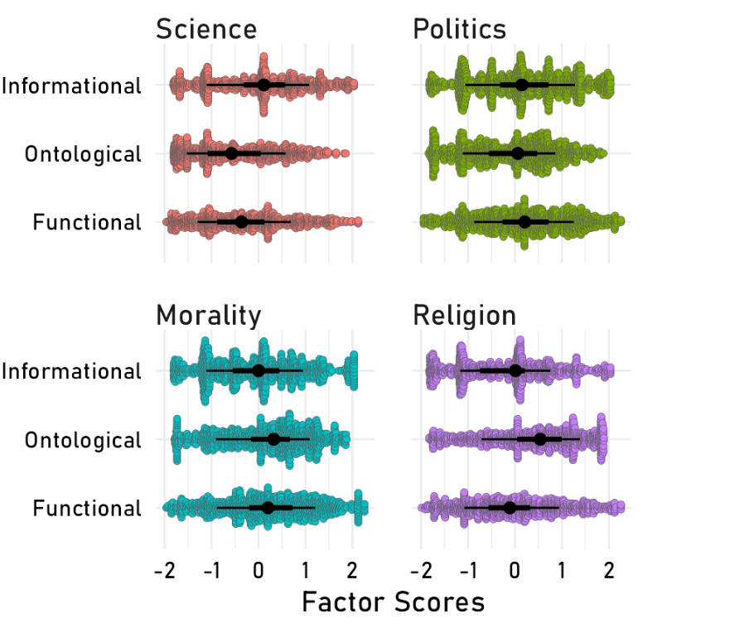
Cross-domain Variation in PPM
Note. The cross-domain ANOVAs were all significant at p < .001.

And we again see substantial within-domain variation (see Figures 4-7C).

Supplementary Figure 4C
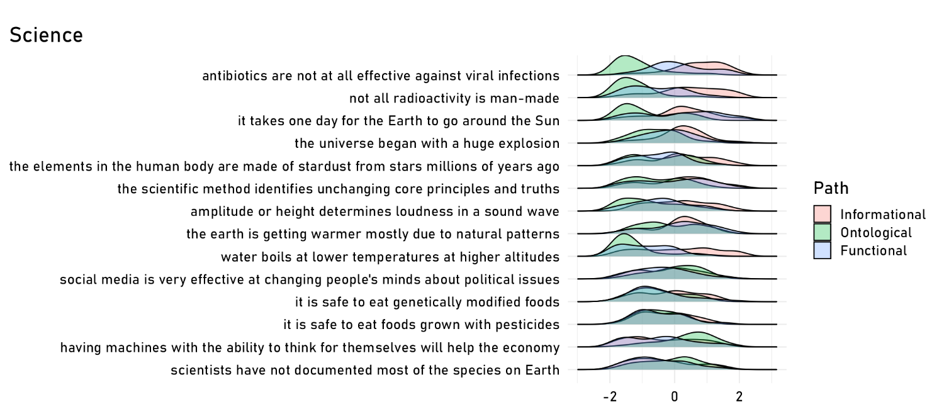
Within-domain Variation in PPM for Science Items
Note. Figure shows scaled density plots demonstrating variation for scientific controversies with at least 20 responses.

Supplementary Figure 5C
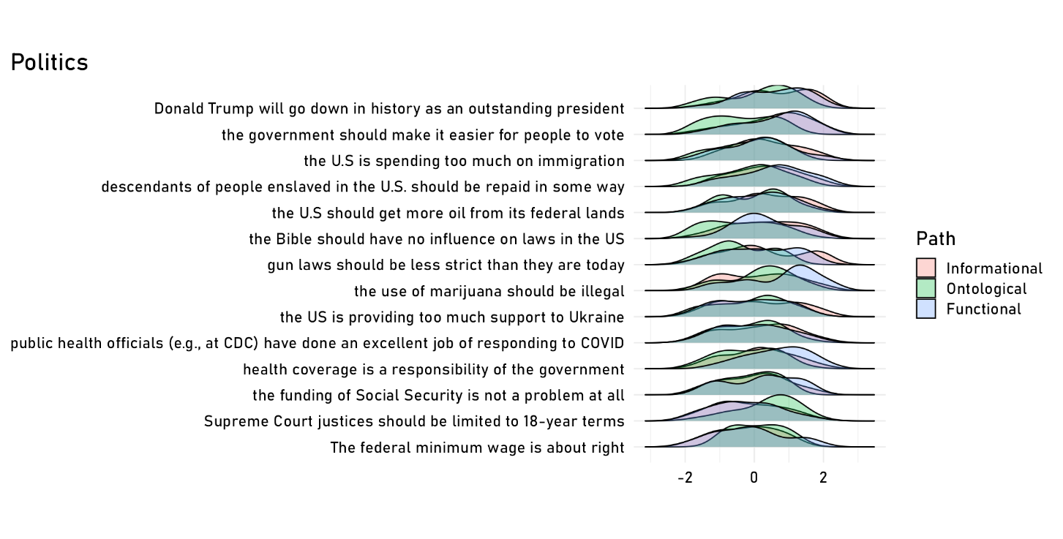
Within-domain Variation in PPM for Political Items
Note. Figure shows scaled density plots demonstrating variation for political controversies with at least 20 responses.

Supplementary Figure 4C
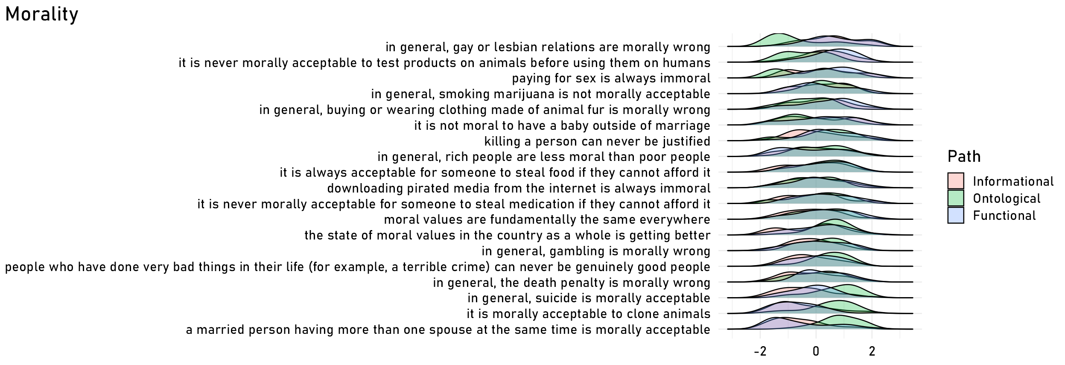
Within-domain Variation in PPM for Moral Items
Note. Figure shows scaled density plots demonstrating variation for moral controversies with at least 20 responses.

Supplementary Figure 5C
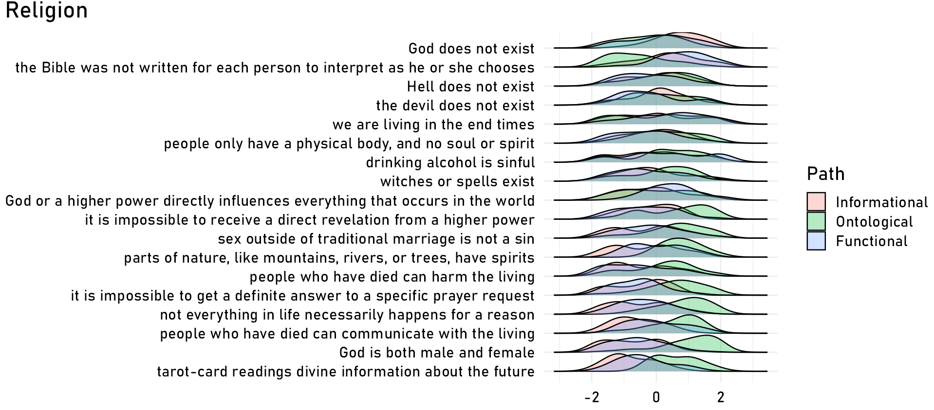
Within-domain Variation in PPM for Religion Items
Note. Figure shows scaled density plots demonstrating variation for religious controversies with at least 20 responses.

We then replicated our key nested model comparison analysis, predicting persistence from the paths, magnitude of disagreement, and prediction error. We again found largely the same ordering of best-performing models as in the original manuscript (see Figure 6C), though the more complex model was the third best for the view change models (see Figure 7C).

Supplementary Figure 6C
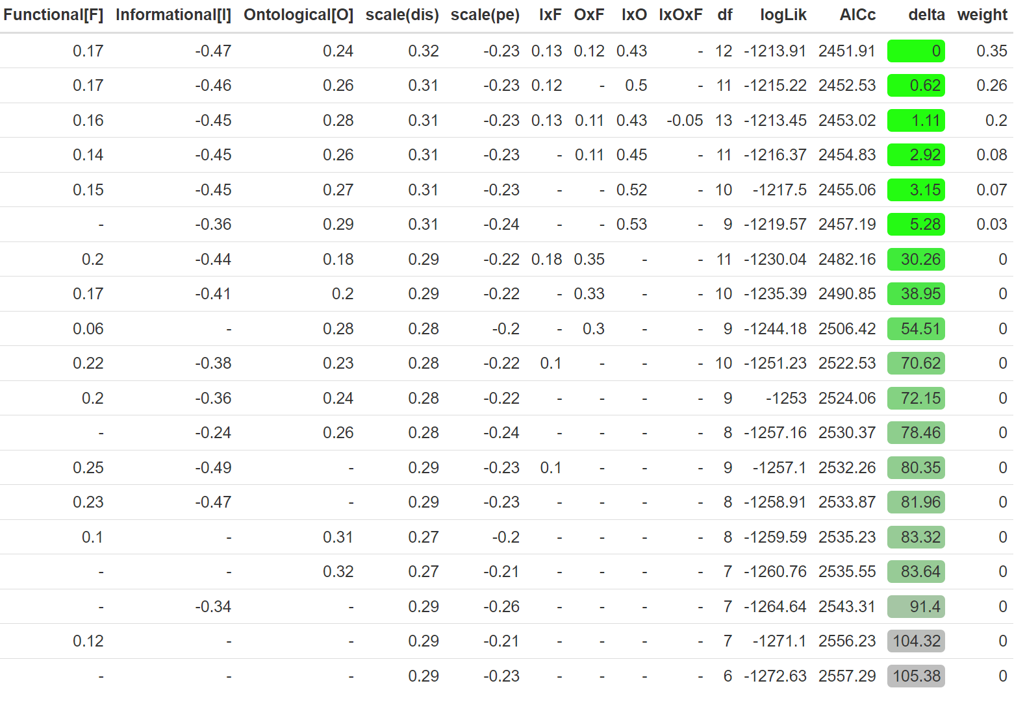
AIC-based Nested Model Comparisons Predicting View Questioning from Paths
Note. AICc denotes the bias-corrected AIC score, where lower values indicate better fit; delta shows the difference between the best performing model (at top) and all other models. Columns on the left show the estimated weights for the predictors in the nested regressions; if a regression does not include a predictor, its absence is indicated by ‘-’. Finally, logLik corresponds to the log likelihood of the data given the model, and is a measure of pure fit (that does not penalize complexity).

Supplementary Figure 7C
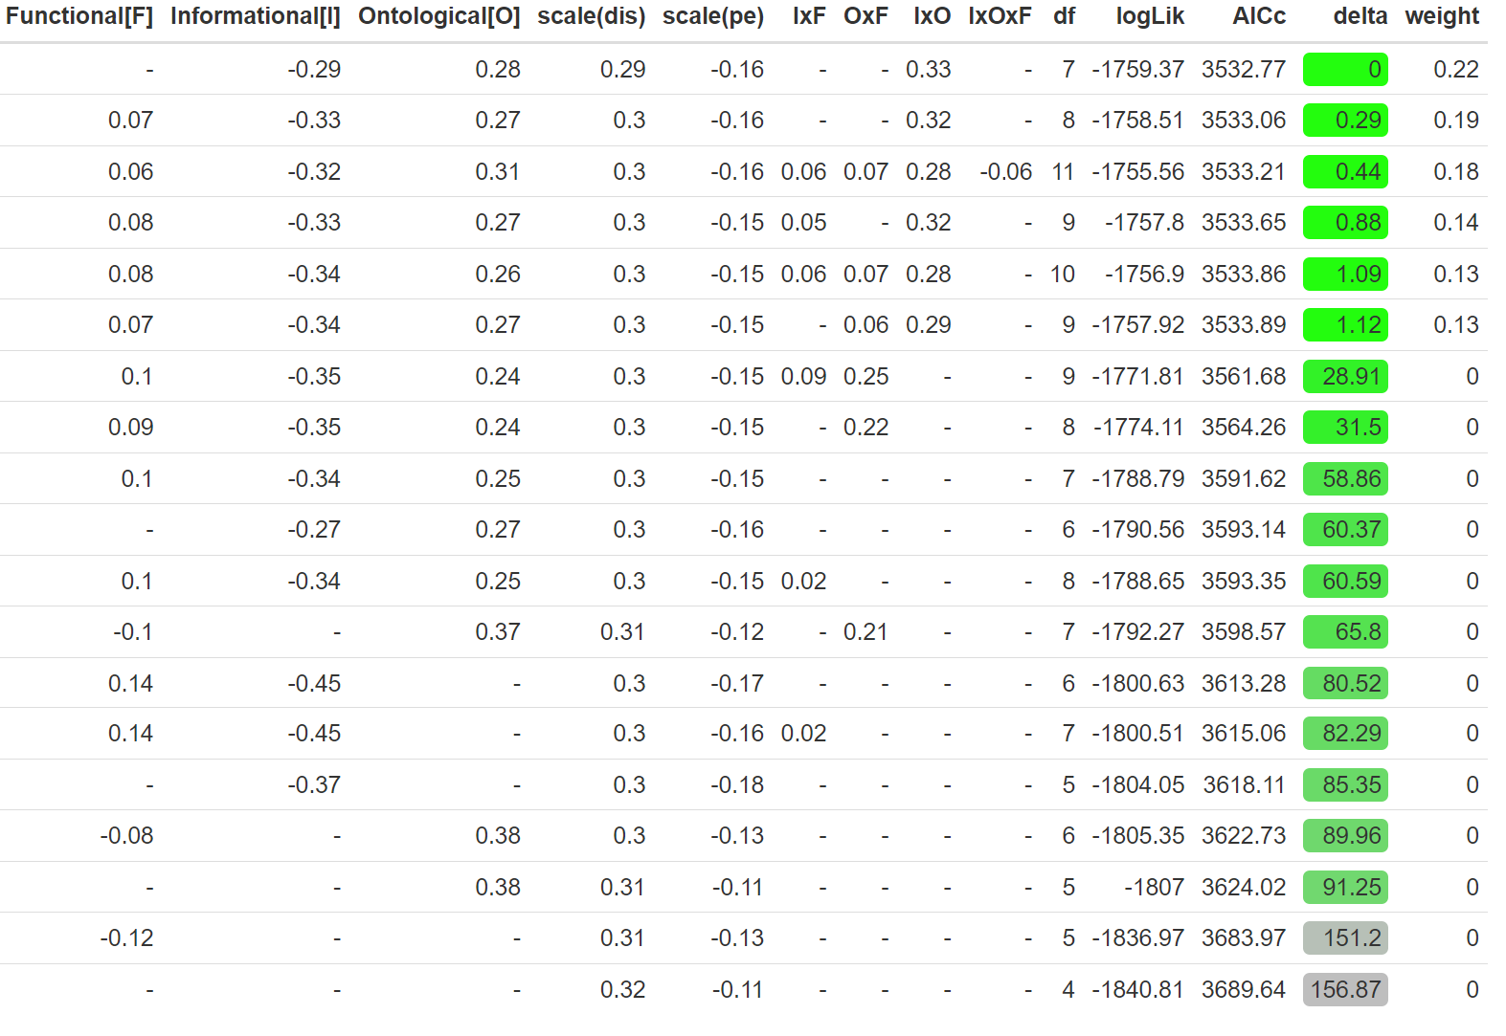
AIC-based Nested Model Comparisons Predicting View Change from Paths
Note. AICc denotes the bias-corrected AIC score, where lower values indicate better fit; delta shows the difference between the best performing model (at top) and all other models. Columns on the left show the estimated weights for the predictors in the nested regressions; if a regression does not include a predictor, its absence is indicated by ‘-’. Finally, logLik corresponds to the log likelihood of the data given the model, and is a measure of pure fit (that does not penalize complexity).

We again found that the best performing models had significant interaction terms (see Figure 8C); though in keeping with the nested comparisons, the view change model here did not find robust effects of the functional path (see Figure 9C).
Supplementary Figure 8C
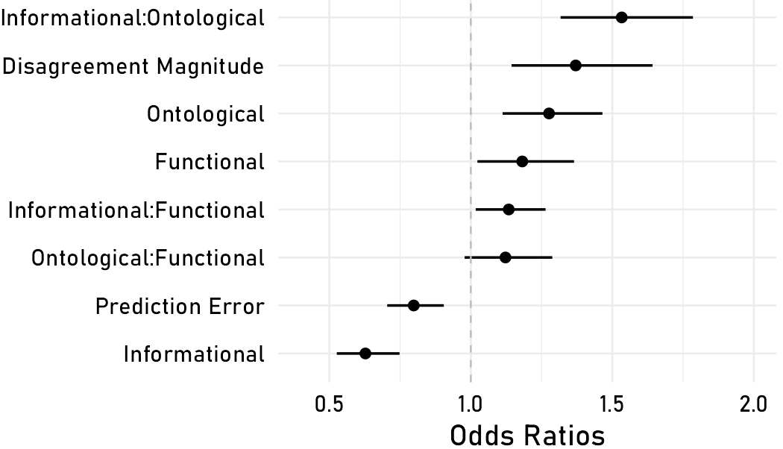
Coefficient Estimates for the Best Fitting Model for View Questioning
Note. Error bars show 95% confidence intervals.

Supplementary Figure 9C
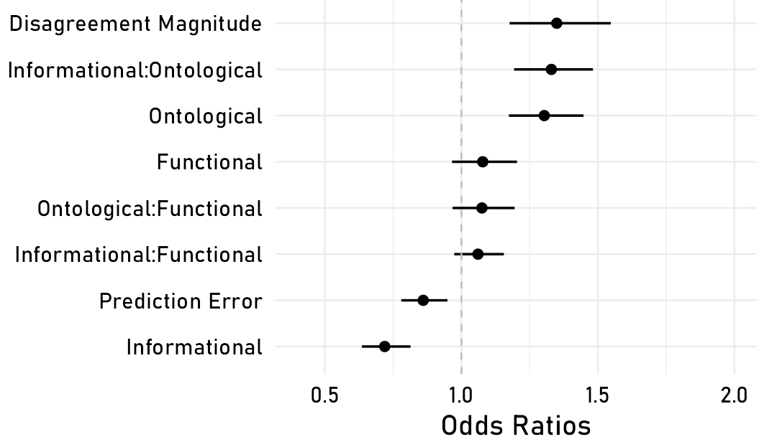
Coefficient Estimates for the Best Fitting Model for View Change
Note. Error bars show 95% confidence intervals.

We then investigated the effects of the directionality of the effects of the PPM on questioning. Plotting model predictions reveals the same general trends we observe as in the main manuscript, and shows that the slight upward slope for the subjective items in the main manuscript is even more substantial here. That this trend is more apparent in this dataset, which features more inattentive participants, lends support to the hypothesis that the upward slope is a consequence of a response bias (see Figure 10-12C).

Supplementary Figure 10C
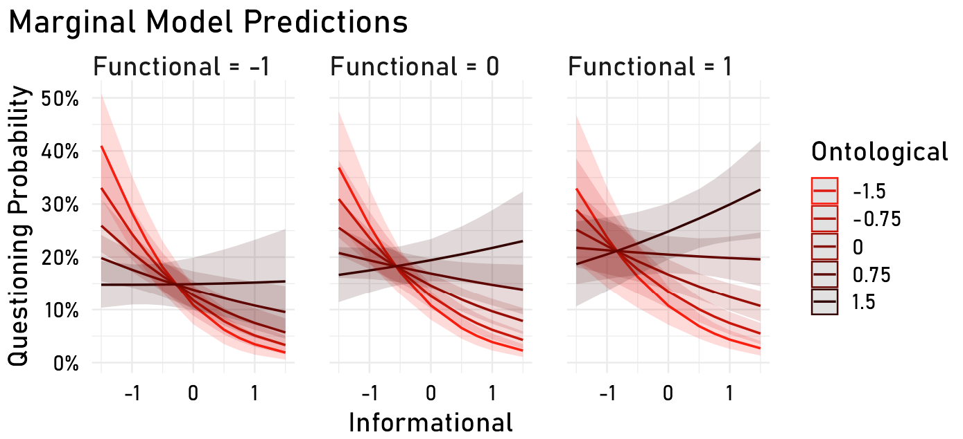
Model Predictions for the Effects of PPM on Questioning
Note. The figure plots the mean predicted view change across the PPM, and model-derived 95% confidence intervals. For clarity, the axes partition the standardized factor scores into different levels of granularity: the informational path is shown continuously on the x-axis, the ontological in five color bins, and the functional in three facets.

Supplementary Figure 11C
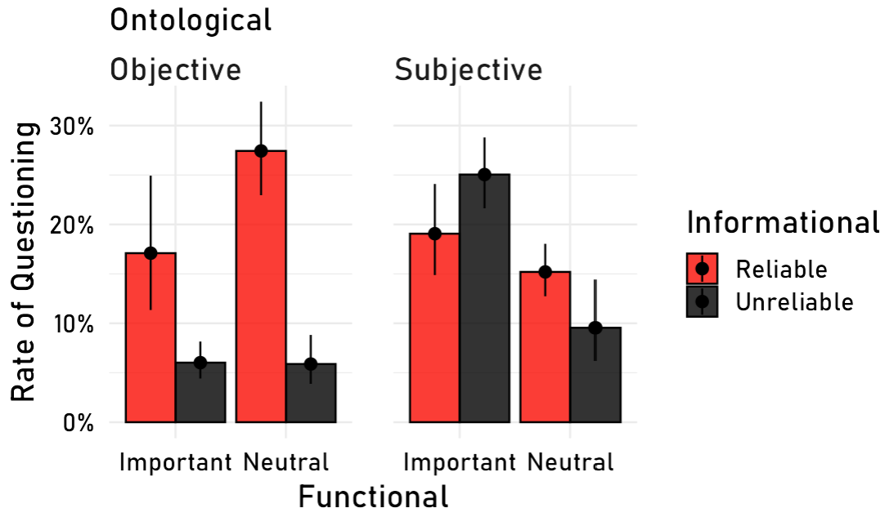
View Questioning Across Mean-split Binarized PPM
Note. Error bars show 95% Wilson confidence intervals. Note that the positive response bias inflates the questioning rate for the unreliable, subjective, and important cell. Besides this cell, the pattern of responses is roughly consistent.

Supplementary Figure 12C
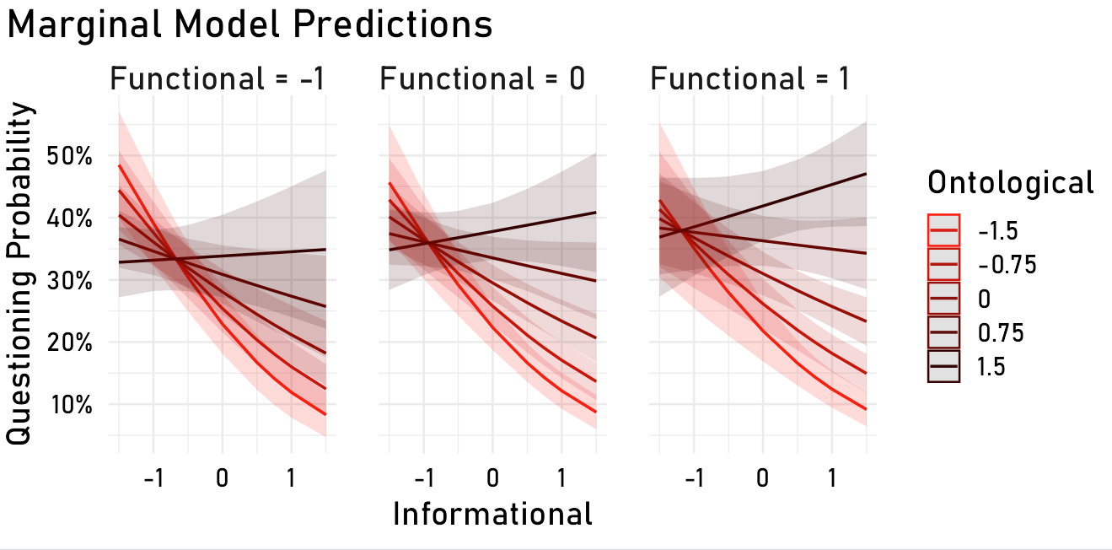
Model Predicted View Change Across PPM
Note. The figure plots the mean predicted view change across the PPM, and model-derived 95% confidence intervals. For clarity, the axes partition the standardized factor scores into different levels of granularity: the informational path is shown continuously on the x-axis, the ontological in five color bins, and the functional in three facets.

We finally investigated the relationships between the social outcomes and the PPM we found qualitatively the same set of relations (see Figure 13-14C).

Supplementary Figure 13C
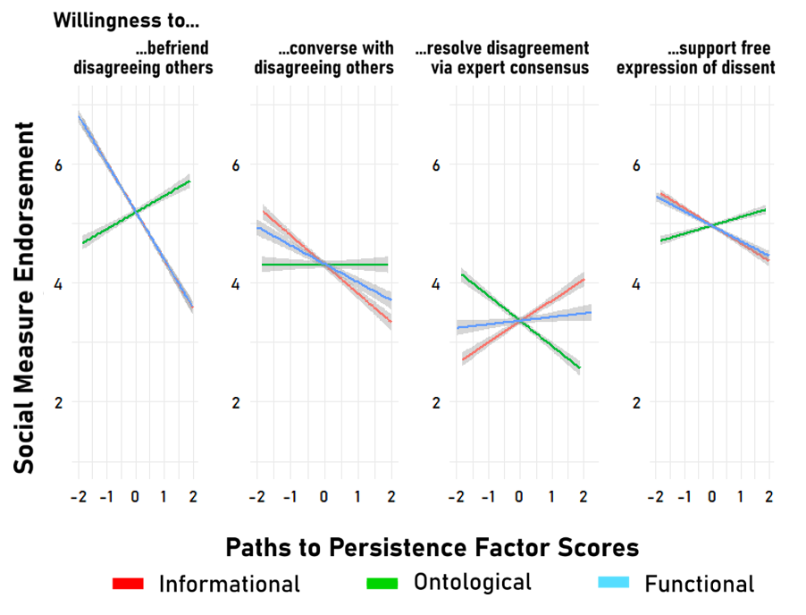
Relationships Between Social Items and PPM
Note. Error bars show 95% confidence intervals.

Supplementary Figure 14C
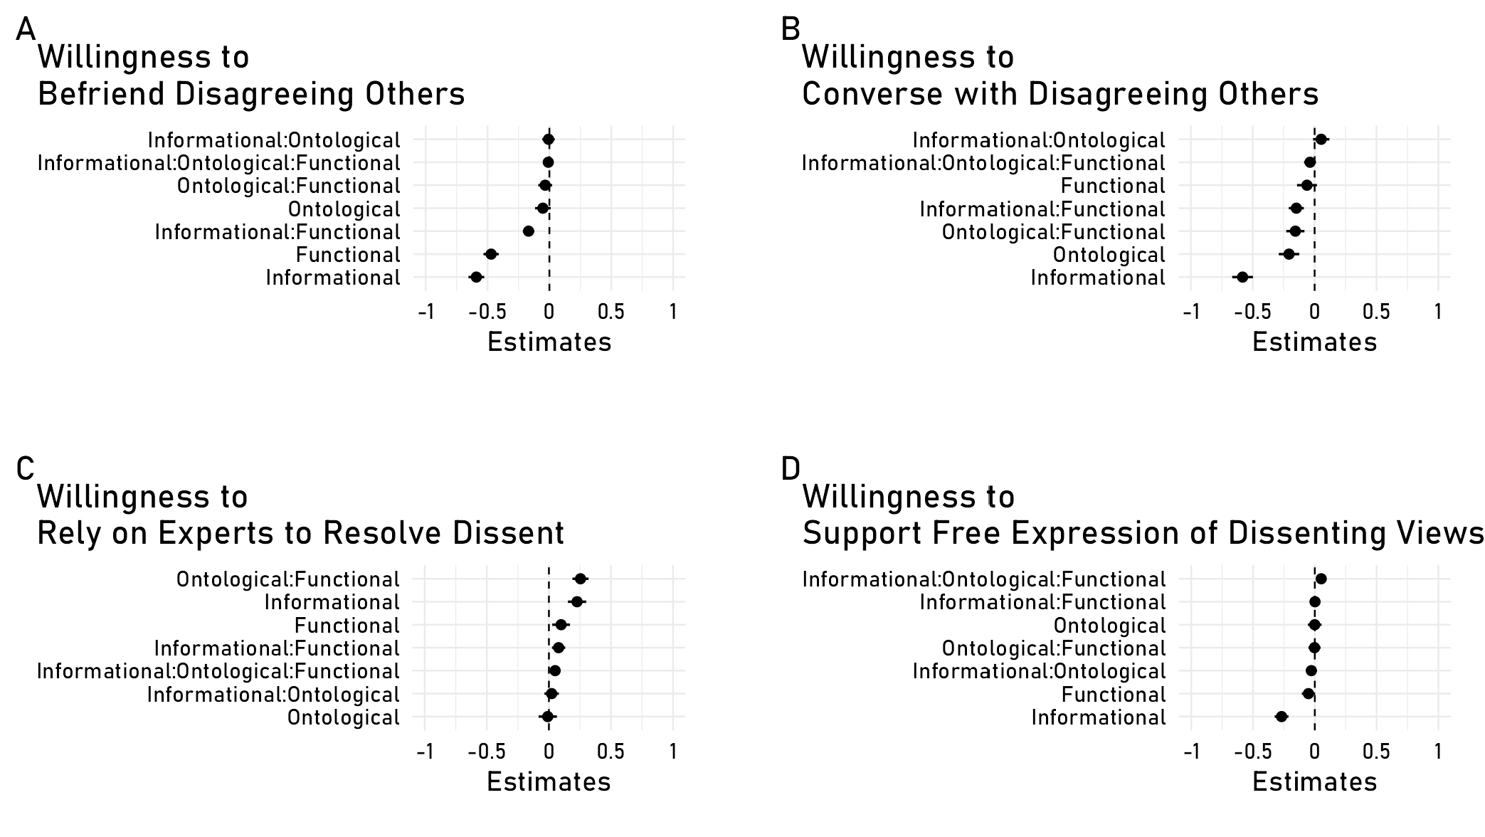
Regressions Predicting Social Outcomes from the PPM
Note. Error bars show 95% confidence intervals.

Note that there are two ways of defining persistence. One definition takes a lack of change in one’s stance towards an issue as persistence. According to this definition, both of the following cases would qualify as persistence: (i) someone who agrees that abortion is immoral, faces disagreement, and keeps on thinking that abortion is immoral; (ii) someone who is agnostic about the morality of abortion, faces disagreement, and remains unsure of the right answer. However, there are reasons to think that these two cases involve very different psychological mechanisms: For example, someone who has not made up their mind about an issue likely perceives there being a balance of evidence about it, and may therefore find split public opinion uninformative. An alternative definition of persistence would require having a non-agnostic belief that remains unchanged post-disagreement. Here, we take this latter, more conservative definition of persistence, and eliminate participants who suspended judgment from analyses of persistence. Our initial, pre-registered approach to analyzing data from Studies 1 and 2 used the former definition, and found the same key patterns of results as we report here. See our proceedings paper for these results (Oktar & Lombrozo, 2022).
The instructions provided to the coders are available in our repository as “E1_openended_codingrubric.doc.”
Reliability ratings were computed by assigning explanations that fit multiple categories (4.7% of responses) to single categories.
Here were the differences: nine items were changed in the main study for syntactic clarity and to correct typos (e.g., one item in SE4 reads ‘all radioactivity is not man-made’; this was changed to ‘not all radioactivity is man-made’ in the main study); 6 religious items were changed in the main study to focus less on Christian faiths and capture a broader set of spiritual questions (e.g., one item removed from SE4 reads ‘Catholic priests should not be able to get married’; this was replaced with ‘people only have a physical body, and no soul or spirit’), and one political item on Biden’s spending plan was replaced in the main study with an item about voting rights because the spending plan item had become outdated. Both sets of items can be found in our OSF repository.

