Supplemental Material
Transparency and Openness
The study’s design, hypotheses, and analysis plan were preregistered on AsPredicted ((https://aspredicted.org/46cq-8mv6.pdf). Below, we describe deviations from the preregistered plan and provide justification for each change, in line with best practices for transparent reporting.
Deviations From the Preregistered Analysis Plan
We initially planned to test anxiety and depression as moderators, but removed them because they have been found to be core predictors of suicidality (Veresova et al., 2024) and moderators should be conceptually distinct from the dependent variables.
We also planned to test disability identity and community engagement as a moderator, but removed it because we used a subset of the Disability Identity Development Scale (DIDS; Forber-Pratt et al., 2022) and later discovered that the measure is only valid when the full scale is administered.
Our preregistration also specified using lifetime passive suicidal thoughts, active suicidal thoughts, and suicide attempts as dependent variables. However, due to imbalanced passive versus active response categories, we combined these into “lifetime suicidal thoughts” and retained “lifetime suicide attempts.”
Furthermore, although we preregistered logistic regressions for Hypothesis 1 and mediation analyses for Hypothesis 2, we instead conducted a multinomial regression and structural equation model (SEM). Our reasoning is described in the main manuscript.
Finally, our data exclusion rules were expanded from the preregistered inclusion criteria to include a more comprehensive quality control plan, described in the main manuscript.
References
Forber-Pratt, A. J., Price, L. R., Merrin, G. J., Hanebutt, R. A., & Fairclough, J. A. (2022). Psychometric properties of the Disability Identity Development Scale: Confirmatory factor and bifactor analyses. Rehabilitation Psychology, 67(2), 120–127. https://doi.org/10.1037/rep0000445
Veresova, M., Lamblin, M., Robinson, J., & McKay, S. (2024). A systematic review and narrative synthesis of prevalence rates, risk and protective factors for suicidal behavior in international students. Frontiers in Psychiatry, 15, 1358041. https://doi.org/10.3389/fpsyt.2024.1358041
Supplemental Table 1
Participant Demographics Stratified by Suicidal Thoughts and Attempts
 |  | No Suicidal Thoughts | Suicidal Thoughts | Suicide Attempts | p-value
n (%) |  | 78 (28.0%) | 109 (39.1%) | 92 (33.0%)
Overt Discrimination (M (SD)) |  | 9.53 (6.62) | 11.50 (6.20) | 15.58 (5.30) | <0.001
Microaggressions (M (SD)) |  | 33.65 (19.42) | 37.79 (20.72) | 53.29 (16.57) | <0.001
Internalized Stigma (M (SD)) |  | 32.60 (10.40) | 37.54 (9.86) | 45.21 (9.95) | <0.001
Disability Concealment (M (SD)) |  | 22.50 (8.80) | 25.51 (8.80) | 31.08 (8.31) | <0.001
Age (M (SD)) |  | 38.27 (15.05) | 40.47 (16.26) | 32.90 (10.38) | 0.001
Gender (n, %) |  |  |  |  | <0.001
 | Cisgender male | 29 (37.2%) | 14 (12.8%) | 38 (41.3%)
 | Cisgender female | 44 (56.4%) | 87 (79.8%) | 49 (53.3%)
 | Transgender male | 0 (0.0%) | 2 (1.8%) | 2 (2.2%)
 | Transgender female | 0 (0.0%) | 0 (0.0%) | 0 (0.0%)
 | Nonbinary | 2 (2.6%) | 4 (3.7%) | 3 (3.3%)
 | Prefer not to answer | 3 (3.8%) | 2 (1.8%) | 0 (0.0%)
Race (n, %) |  |  |  |  | 0.315
 | American Indian or Alaska Native | 1 (1.3%) | 4 (3.7%) | 3 (3.3%)
 | Asian | 3 (3.8%) | 5 (4.6%) | 4 (4.3%)
 | Black or African American | 7 (9.0%) | 8 (7.3%) | 12 (13.0%)
 | Hispanic, Latino, or Spanish Origin | 2 (2.6%) | 7 (6.4%) | 9 (9.8%)
 | Middle Eastern or North African | 0 (0.0%) | 1 (0.9%) | 4 (4.3%)
 | Native Hawaiian or Other Pacific Islander | 0 (0.0%) | 3 (2.8%) | 3 (3.3%)
 | White | 60 (76.9%) | 75 (68.8%) | 53 (57.6%)
 | Multiracial | 5 (6.4%) | 5 (4.6%) | 4 (4.3%)
 | Other | 0 (0.0%) | 1 (0.9%) | 0 (0.0%)
Sexual Orientation (n, %) |  |  |  |  | 0.386
 | Heterosexual or straight | 61 (78.2%) | 73 (67.0%) | 70 (76.1%)
 | Gay or lesbian | 5 (6.4%) | 12 (11.0%) | 7 (7.6%)
 | Bisexual, pansexual, or queer | 7 (9.0%) | 17 (15.6%) | 10 (10.9%)
 | Asexual | 2 (2.6%) | 3 (2.8%) | 5 (5.4%)
 | Unsure | 1 (1.3%) | 3 (2.8%) | 0 (0.0%)
 | Prefer not to answer | 2 (2.6%) | 1 (0.9%) | 0 (0.0%)
Disability Visibility (n, %) |  |  |  |  | <0.001
 | No | 32 (41.0%) | 56 (51.4%) | 19 (20.7%)
 | Sometimes | 26 (33.3%) | 31 (28.4%) | 13 (14.1%)
 | Yes | 20 (25.6%) | 22 (20.2%) | 60 (65.2%)
Disability Type (n, %)
 | Attention Deficit Hyperactivity Disorder (ADHD) | 10 (12.8%) | 22 (20.2%) | 15 (16.3%) | 0.409
 | Autism Spectrum Disorder (ASD) | 6 (7.7%) | 17 (15.6%) | 16 (17.4%) | 0.158
 | Blind or visually impaired | 4 (5.1%) | 9 (8.3%) | 11 (12.0%) | 0.282
 | Deaf or hard of hearing | 9 (11.5%) | 13 (11.9%) | 8 (8.7%) | 0.736
 | Health-related disability | 35 (44.9%) | 64 (58.7%) | 34 (37.0%) | 0.007
 | Learning disability | 7 (9.0%) | 3 (2.8%) | 8 (8.7%) | 0.131
 | Psychiatric disability | 10 (12.8%) | 29 (26.6%) | 29 (31.5%) | 0.014
 | Mobility-related disability | 14 (17.9%) | 23 (21.1%) | 19 (20.7%) | 0.856
 | Speech-related disability | 4 (5.1%) | 5 (4.6%) | 1 (1.1%) | 0.284
 | Other | 15 (19.2%) | 25 (22.9%) | 6 (6.5%) | 0.006
Note. A chi-squared test and a one-way ANOVA were run to assess significance. N = 279. Participants could select multiple options for disability type.
Supplemental Table 2
Minority Stressors and Suicidal Thoughts and Attempts: Multinomial Regression Results
 | Suicidal Thoughts |  |  | Suicide Attempts
 | OR | 95% CI | p-value | OR | 95% CI | p-value
Overt Discrimination | 1.2 | 0.77 – 1.87 | 0.43 | 1.66 | 1.00 – 2.74 | 0.05
Microaggressions | 0.81 | 0.48 – 1.38 | 0.43 | 1.19 | 0.66 – 2.13 | 0.56
Internalized Stigma | 2.04 | 1.18 – 3.51 | 0.01 | 2.69 | 1.49 – 4.87 | <0.01
Disability Concealment | 1.07 | 0.66 – 1.73 | 0.78 | 1.18 | 0.70 – 1.99 | 0.54
Age | 1.24 | 0.90 – 1.70 | 0.19 | 0.72 | 0.47 – 1.10 | 0.13
Cisgender Female | 4.87 | 2.11 – 11.27 | <0.001 | 1.64 | 0.73 – 3.68 | 0.23
Other Gender | 3.3 | 0.76 – 14.38 | 0.11 | 1.92 | 0.35 – 10.41 | 0.45
Black | 0.87 | 0.26 – 2.97 | 0.83 | 0.65 | 0.20 – 2.17 | 0.49
Other Race | 1.5 | 0.61 – 3.67 | 0.38 | 1.14 | 0.44 – 3.01 | 0.79
Bisexual | 1.87 | 0.65 – 5.38 | 0.25 | 1.06 | 0.31 – 3.57 | 0.93
Other Sexual Orientation | 1.15 | 0.43 – 3.05 | 0.78 | 0.58 | 0.19 – 1.78 | 0.34
Note. OR = Odds Ratio; CI = Confidence Interval. The reference group for suicidal thoughts and attempts is participants with no suicidal thoughts. The reference group for gender is cisgender males. The reference group for race is white participants. The reference group for sexual orientation is heterosexual participants. χ²(2, 24) = 110.15, p < 0.001, McFadden’s R² = 0.18. N = 279.
Supplemental Figure 1
Perceived Burdensomeness and Thwarted Belongingness as Mediators Between Internalized Stigma and Suicidal Thoughts
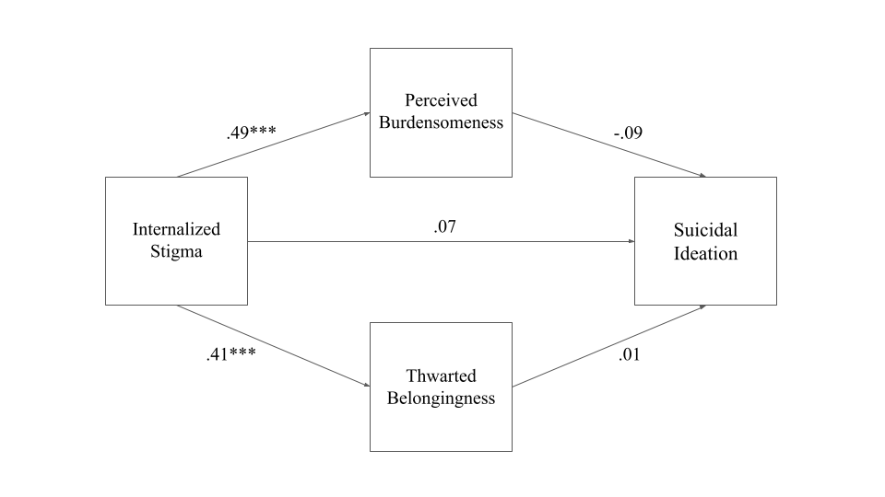
Note. The numbers represent effect sizes, and *** indicates a p-value < 0.05. χ²(1) = 4.36, p = 0.04, comparative fit index (CFI) = 0.99, root mean square error of approximation (RMSEA) = 0.11, standardized root mean square residual (SRMR) = 0.01. Perceived burdensomeness R² = 0.63, thwarted belongingness R² = 0.34, suicidal thoughts R² = 0.04. Analyses controlled for overt discrimination, microaggressions, and disability concealment. N = 279.

Supplemental Figure 2
Perceived Burdensomeness and Thwarted Belongingness as Mediators Between Internalized Stigma and Suicide Attempts
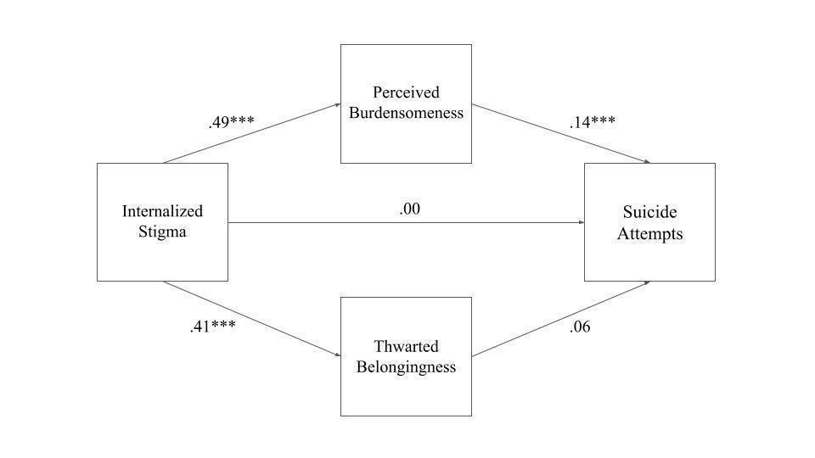
Note. The numbers represent effect sizes, and *** indicates a p-value < 0.05. χ²(1) = 4.36, p = 0.04, comparative fit index (CFI) = 0.99, root mean square error of approximation (RMSEA) = 0.11, standardized root mean square residual (SRMR) = 0.01. Perceived burdensomeness R² = 0.63, thwarted belongingness R² = 0.34, suicide attempts R² = 0.25. Analyses controlled for overt discrimination, microaggressions, and disability concealment. N = 279.

