Online Supplementary Materials

This OSM is an online document that provides additional analyses for the paper “They Are Trying to Harm Me, but the World Has a Hidden Plan for Me: Cognitive Correlates of Conspirituality and Its Links to Well-Being Indicators”.
Table of contents
1. Comparison of Conspirituality Models Using Confirmatory Factor Analysis 2
2. Additional Results of Latent Profile Analysis 11
Model specifications and summary 12
Latent Profiles’ Demographic Characteristics 14
Gender 14
Age 15
Education 16
(Non)religious affiliation 18
Place of residence 20
Alternative LPA Model Based Solely on Conspiracy Beliefs and New Age Spirituality 21
Latent Profiles’ Characteristics for the Alternative Model 24
3. Correlation plots of conspiracy beliefs and New Age spirituality for Studies 1-3 32
4. Conspirituality in different demographic groups (Study 2) 34
References 41

Comparison of Conspirituality Models Using Confirmatory Factor Analysis
This section of the supplementary material presents confirmatory factor analyses comparing alternative factor models, conducted to evaluate the factor structure of conspirituality and to assess whether there is psychometric evidence supporting its validity as a meaningful and distinct psychological construct.
The analysis was conducted using the lavaan package in R (Rosseel, 2012), applying confirmatory factor analysis (CFA). We compared a single-factor model (all items loading on one general conspirituality factor), a two-factor model (separating conspiracy beliefs and New Age spirituality), a three-factor model (distinguishing between non-spiritual conspiracy beliefs, spiritual conspiracy beliefs, and New Age spirituality), and a bifactor model (which includes a general conspirituality factor alongside specific factors for conspiracy beliefs and New Age spirituality). Table S1 presents the fit statistics for all four tested models based on multiple fit indices.
Table S1
Comparison of Factor Models: Fit Indices and Scaled Chi-Squared Difference Test
Model | df | AIC | BIC | χ² | χ² diff. | df diff. | p | CFI | RMSEA | SRMR
Bifactor | 700 | 96048 | 96644 | 4014.7 | — | — | — | 0.883 | 0.067 | 0.049
Three-Factor | 737 | 97080 | 97493 | 5121.5 | 698.55 | 37 | <.001 | 0.846 | 0.075 | 0.068
Two-Factor | 739 | 97175 | 97578 | 5219.8 | 65.72 | 2 | <.001 | 0.842 | 0.075 | 0.068
Single-Factor | 740 | 103183 | 103581 | 11230.0 | 1672.40 | 1 | <.001 | 0.631 | 0.115 | 0.117
Note. AIC = Akaike Information Criterion; BIC = Bayesian Information Criterion; χ² = Chi-Square Test Statistic; CFI = Comparative Fit Index; RMSEA = Root Mean Square Error of Approximation; SRMR = Standardized Root Mean Square Residual.
The bifactor model demonstrated the best fit, as indicated by the lowest AIC and BIC, the highest CFI, and the lowest RMSEA and SRMR. These results suggested that the bifactor model provided the best-fitting representation of the data among all tested models, even though its CFI remained slightly below the conventional threshold of .90. The three-factor and two-factor models exhibited progressively worse fit, as shown by increasing AIC and BIC values, lower CFI, and higher RMSEA and SRMR. The chi-squared difference tests indicated that each of these models was significantly worse than the preceding model, reinforcing the preference for a more complex factor structure. The single-factor model showed the poorest fit, with substantially worse indices across all measures. The low CFI and high RMSEA and SRMR suggested that a unidimensional representation did not adequately capture the data structure. The chi-squared difference test confirmed that this model was significantly worse than the two-factor model. Overall, based on fit indices, the bifactor model emerged as the most appropriate, supporting a structure that includes both a general factor alongside specific subfactors.
In the next step, we examined reliability estimates and the proportion of variance explained across all tested models. In the bifactor model, Omega Hierarchical (ωH) = 0.301 indicates that the general factor accounts for a moderate portion of the reliable variance, while Omega Total (ωT) = 0.522 suggests that the overall reliability of the model remains modest. The high Explained Common Variance (ECV = 0.612) suggests that the general factor dominates the common variance, reinforcing its role in explaining the data structure. In the two-factor model, Omega Hierarchical (ωH) is 0.250 for Conspiracy and 0.273 for Spirituality, both of which show relatively low values, suggesting that each factor accounts for a limited portion of reliable variance. However, Omega Total (ωT = 0.524) remains nearly identical to that of the bifactor model, indicating that both models capture a comparable overall variance. Additionally, ECV = 0.522 in the two-factor model, suggesting that while variance is fairly balanced, one factor is slightly more dominant. In the three-factor model, Omega Hierarchical values are 0.225 for Non-Spiritual Conspiracy, 0.067 for Spiritual Conspiracy, and 0.260 for Spirituality, with an Omega Total of 0.552. The low ωH for Spiritual Conspiracy suggests that this factor contributes little unique variance, and ECV = 0.471 indicates that variance is more evenly distributed across the three factors. These findings suggest that while all models exhibit similar total reliability, the bifactor model provides a clearer representation of a dominant overarching construct. The higher ECV in the bifactor model (0.612) further supports the presence of a general factor, aligning with model fit results that favor a bifactor structure.
Based on these findings, we selected the bifactor model—with one general factor representing conspirituality and two specific factors reflecting conspiracy beliefs and New Age spirituality—as the most appropriate representation of the data structure. The following Table S2 presents the standardized factor loadings for this bifactor solution.
Table S2
Standardized Factor Loadings for the Revised Bifactor Model Excluding UFO-Related Items (General Conspirituality Factor, Specific Factors for Conspiracy Beliefs and New Age Spirituality)
Item | Conspirituality (general factor) | Conspiracy beliefs | New Age Spirituality
GCBS 1 | 0.646 | 0.179⁺
GCBS 2 | 0.715 | 0.411
GCBS 3 | 0.736 | -0.322
GCBS 4 | 0.718 | 0.391
GCBS 5 | 0.733 | 0.416
GCBS 6 | 0.707 | 0.236⁺
GCBS 7 | 0.778 | 0.305
GCBS 8 | 0.771 | -0.308
GCBS 9 | 0.707 | 0.116⁺
GCBS 10 | 0.596 | 0.180⁺
GCBS 11 | 0.655 | 0.237⁺
GCBS 12 | 0.762 | 0.389
GCBS 13 | 0.768 | -0.250⁺
GCBS 14 | 0.720 | 0.293
GCBS 15 | 0.499 | 0.397
GCBS 16 | 0.726 | 0.272
GCBS 17 | 0.615 | 0.288
GCBS 18 | 0.637 | -0.093⁺
NAOS 1 | 0.443 |  | 0.509
NAOS 2 | 0.294 |  | 0.504
NAOS 3 | 0.438 |  | 0.598
NAOS 4 | 0.467 |  | 0.406
NAOS 5 | 0.490 |  | 0.558
NAOS 6 | 0.454 |  | 0.568
NAOS 7 | 0.451 |  | 0.583
NAOS 8 | 0.494 |  | 0.543
NAOS 9 | 0.503 |  | 0.588
NAOS 10 | 0.329 |  | 0.519
NAOS 11 | 0.473 |  | 0.552
NAOS 12 | 0.478 |  | 0.504
NAOS 13 | 0.470 |  | 0.559
NAOS 14 | 0.457 |  | 0.409
NAOS 15 | 0.454 |  | 0.561
NAOS 16 | 0.483 |  | 0.534
NAOS 17 | 0.396 |  | 0.595
NAOS 18 | 0.432 |  | 0.600
NAOS 19 | 0.399 |  | 0.593
NAOS 20 | 0.341 |  | 0.654
NAOS 21 | 0.292 |  | 0.409
NAOS 22 | 0.362 |  | 0.582
Note. All factor loadings are standardized. p < .05 for all loadings unless otherwise indicated. ⁺denotes a nonsignificant factor loading.
In the bifactor model, all items loaded positively and significantly on the general factor, supporting the presence of a shared latent structure across conspiracy and spiritual belief systems. New Age spirituality items (NAOS) demonstrated consistent moderate loadings on both the general factor (range = .292 to .503) and the specific New Age spirituality factor (range = .406 to .654), indicating that these items capture both shared and domain-specific variance. The stability and interpretability of this specific factor support the distinctiveness of alternative spirituality beliefs, even when accounting for their overlap with conspiracy beliefs.
Conspiracy beliefs items (GCBS), by contrast, while loading strongly and positively on the general factor (range = .499 to .778), showed a more complex pattern on the specific conspiracy beliefs factor. Four items displayed negative loadings on this specific factor, three of which referred to UFO-related conspiracy theories (GCBS 3, 8, and 13). Although these items loaded positively on the general factor, their negative loadings on the specific factor suggest a divergence in their residual variance from other conspiracy belief items. We hypothesize that this may be due to the ontological distinctiveness of UFO conspiracies: unlike most conspiracy theories that involve human agents (e.g., governments or pharmaceutical corporations), UFO-related beliefs typically presuppose the involvement of non-human entities. Therefore, it is possible that this non-anthropocentric focus introduces underlying metaphysical assumptions—such as belief in intelligent life beyond Earth, higher cosmic forces, or hidden dimensions of reality—that align more closely with supernatural or spiritual worldviews than with explanations grounded in distrust of social and political systems. As a result, these items may load more strongly on the general conspirituality factor, which captures the convergence between spiritual and conspiracy thinking, while diverging from the residual variance structure of more traditional, human-centered conspiracy beliefs. However, we acknowledge that this interpretation remains speculative and warrants further empirical investigation. It is also worth noting that the correlations between the specific factors were constrained to zero in the bifactor model. This restriction, while necessary for model identification, may have contributed to the emergence of negative loadings by preventing the model from accounting for any additional shared variance between the conspiracy beliefs and New Age spirituality factors beyond their overlap with the general factor.
Given the unexpected negative loadings observed on the specific conspiracy beliefs factor in the original bifactor model, we re-estimated the bifactor model after removing the three UFO-related items entirely. This alternative specification eliminated all negative loadings on the specific conspiracy beliefs factor and yielded improved model fit. As shown in Table S3, the revised model (Bifactor 2) outperformed the original model (Bifactor 1) across multiple indices. Both AIC (88730 vs. 96048) and BIC (89282 vs. 96644) were notably lower in the revised model, indicating better relative fit. In terms of incremental fit indices, the revised model showed a slightly higher CFI (.902 vs. .883) and a modest reduction in RMSEA (.063 vs. .067), while SRMR increased slightly (.057 vs. .049), though it remained within acceptable thresholds.
Table S3
Fit Indices for the Original and Revised Bifactor Models (Including and Excluding UFO-Related Items)
Model | df | AIC | BIC | χ² | p | CFI | RMSEA | SRMR
Bifactor 1 | 700 | 96048 | 96644 | 4014.7 | <.001 | 0.883 | 0.067 | 0.049
Bifactor 2 | 592 | 88730 | 89282 | 3134.2 | <.001 | 0.902 | 0.063 | 0.057
Note. AIC = Akaike Information Criterion; BIC = Bayesian Information Criterion; CFI = Comparative Fit Index; RMSEA = Root Mean Square Error of Approximation; SRMR = Standardized Root Mean Square Residual.
The standardized factor loadings for this reduced model are presented in Table S4 below. In the reduced bifactor model, the general conspirituality factor remained robust, with all GCBS and NAOS items loading positively and significantly, indicating a strong overarching structure that captures shared variance across conspiratorial and spiritual beliefs. Additionally, the specific New Age spirituality factor continued to show consistent and significant loadings for the NAOS items, supporting its structural coherence and domain-specific relevance. However, although the removal of the UFO-related items successfully resolved the issue of negative loadings on the specific conspiracy beliefs factor, a number of GCBS items no longer loaded significantly on this factor (see Table S4). This suggests that, for these items, the variance unique to conspiracy beliefs was minimal once the general conspirituality factor was accounted for. As a result, the internal coherence and distinctiveness of the conspiracy beliefs factor appear weakened in the reduced model.
This outcome raises concerns both psychometrically and conceptually. From a psychometric perspective, numerous non-significant loadings suggest that the items in question do not meaningfully contribute unique variance to the specific factor once the general conspirituality dimension is accounted for. In addition, this pattern suggests that the residual variance shared among the remaining conspiracy belief items may be too weak or heterogeneous to support a coherent domain-specific construct. It also raises an important trade-off: although removing the UFO items improved statistical fit and eliminated suppressor effects, it may have weakened the structural integrity of the specific conspiracy beliefs factor.
Table S4
Standardized Factor Loadings for the Bifactor Model Including All Items (General Conspirituality Factor, Specific Factors for Conspiracy Beliefs and New Age Spirituality)
Item | Conspirituality (general factor) | Conspiracy beliefs | New Age Spirituality
GCBS 1 | 0.440 | 0.617
GCBS 2 | 0.760 | 0.300⁺
GCBS 4 | 0.754 | 0.303
GCBS 5 | 0.770 | 0.320
GCBS 6 | 0.493 | 0.706
GCBS 7 | 0.818 | 0.240⁺
GCBS 9 | 0.655 | 0.251⁺
GCBS 10 | 0.501 | 0.371
GCBS 11 | 0.431 | 0.726
GCBS 12 | 0.804 | 0.302⁺
GCBS 14 | 0.692 | 0.346
GCBS 15 | 0.511 | 0.341
GCBS 16 | 0.738 | 0.263⁺
GCBS 17 | 0.638 | 0.238⁺
GCBS 18 | 0.507 | 0.207⁺
NAOS 1 | 0.400 |  | 0.541
NAOS 2 | 0.236 |  | 0.541
NAOS 3 | 0.416 |  | 0.613
NAOS 4 | 0.456 |  | 0.423
NAOS 5 | 0.384 |  | 0.634
NAOS 6 | 0.465 |  | 0.559
NAOS 7 | 0.487 |  | 0.558
NAOS 8 | 0.421 |  | 0.600
NAOS 9 | 0.454 |  | 0.627
NAOS 10 | 0.260 |  | 0.565
NAOS 11 | 0.515 |  | 0.528
NAOS 12 | 0.426 |  | 0.546
NAOS 13 | 0.443 |  | 0.581
NAOS 14 | 0.512 |  | 0.386
NAOS 15 | 0.448 |  | 0.566
NAOS 16 | 0.347 |  | 0.634
NAOS 17 | 0.356 |  | 0.618
NAOS 18 | 0.380 |  | 0.635
NAOS 19 | 0.313 |  | 0.652
NAOS 20 | 0.305 |  | 0.668
NAOS 21 | 0.128⁺ |  | 0.525
NAOS 22 | 0.242 |  | 0.664
Note. All factor loadings are standardized. p < .05 for all loadings unless otherwise indicated. ⁺denotes a nonsignificant factor loading.

Conclusion: We conducted a comprehensive confirmatory factor analysis comparing various models of conspirituality and found that a bifactor structure—comprising one general factor and two specific factors for conspiracy beliefs and New Age spirituality—provided the best fit to the data. These results provide tentative support for the notion that conspirituality may reflect a distinct psychological disposition, capturing shared variance across spiritual and conspiracy belief systems while also preserving some domain-specific variance. Nonetheless, challenges related to the specific conspiracy beliefs factor—particularly the emergence of negative loadings and the loss of significance for several items in the revised model—point to unresolved structural issues with this model and highlight the need for further validation of the factor structure, as well as continued conceptual refinement of the conspirituality construct.

Additional Results of Latent Profile Analysis
This section of the supplementary material presents additional results related to the latent profile analysis (LPA) of conspiratorial believers, offering further insights into the classification and demographic characteristics of the identified profiles, as well as an alternative LPA model based on different selections of variables.

Model specifications and summary
We performed LPA using the tidyLPA R package (Rosenberg et al., 2018), which implements model-based clustering via the mclust R package (Scrucca et al., 2017). Indicator variables were standardized prior to analysis. We tested one- to six-profile solutions. Parameter estimation was carried out using mclust’s default Expectation–Maximization (EM) algorithm, which uses hierarchical clustering for initialization and a maximum of 100 iterations. Model fit was assessed using the Akaike Information Criterion (AIC) and Bayesian Information Criterion (BIC), with lower values indicating better model fit. Classification quality was evaluated using entropy (with values > .80 indicating good classification) and posterior classification probabilities (i.e., the likelihood that participants were assigned to the correct latent class). We also conducted the parametric bootstrap likelihood ratio test (BLRT) to compare models, where a statistically significant result indicates that the model with k profiles fits significantly better than the model with k − 1 profiles.
Figure S1 presents the elbow plot of fit indices for the latent profile analysis presented in the main manuscript, while Figure S2 presents the original four subgroups identified in the latent profile analysis, now also including 95% confidence intervals.
Figure S1
Elbow plot of fit indices for the latent profile analysis
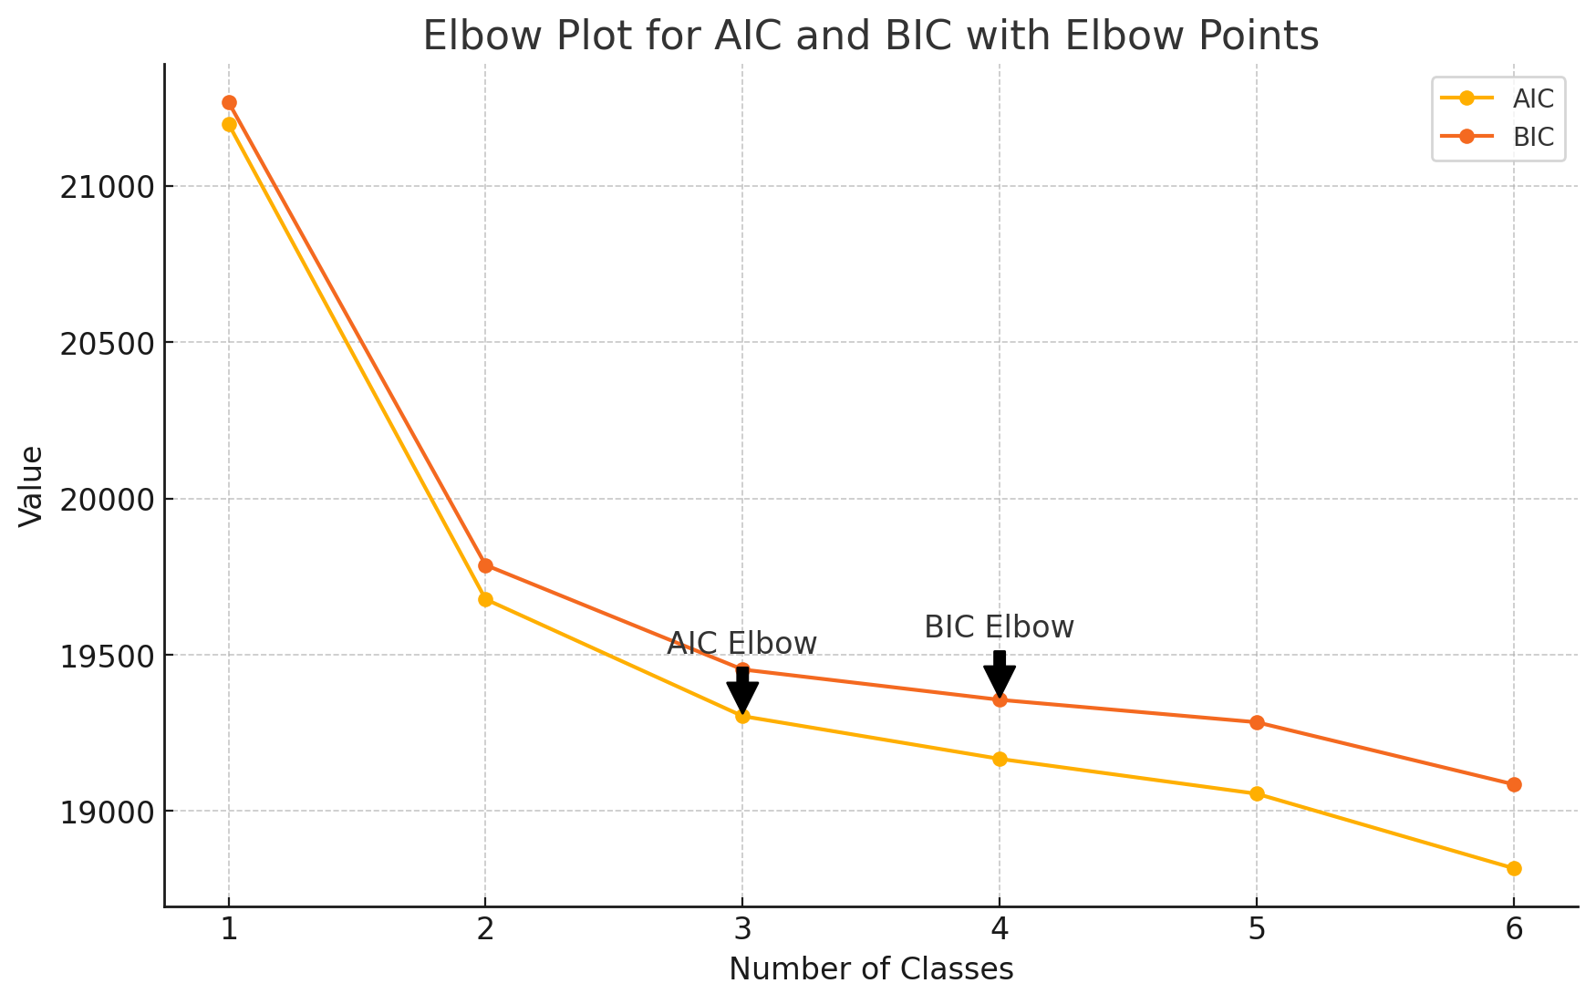
Figure S2
Line graph illustrating standardized scores for the four subgroups identified through latent profile analysis, including 95% confidence intervals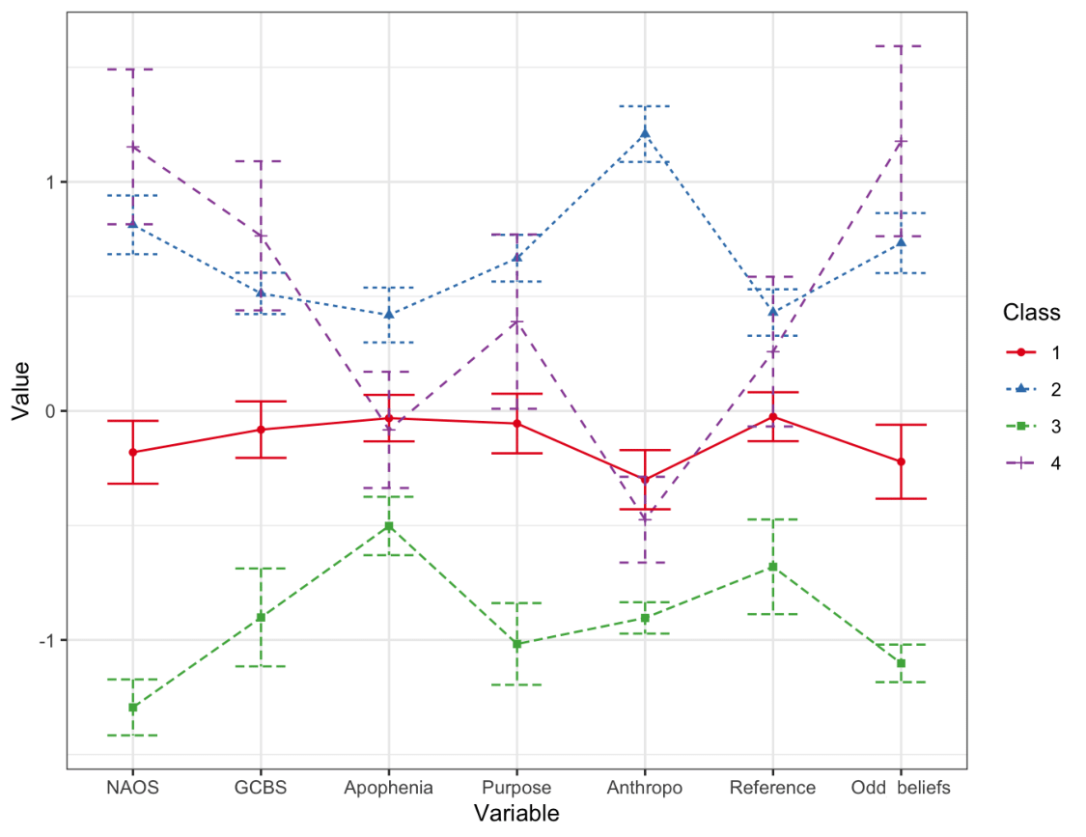

Latent Profiles’ Demographic Characteristics

Gender
A Pearson Chi-Square test revealed a significant association between gender and class membership, χ²(3) = 17.732, p < .001, suggesting that males and females are not randomly distributed across the four class categories (see Table S5 and Figure S3).
Table S5
Gender Distribution Across Latent Profiles
Gender | Class 1 | Class 2 | Class 3 | Class 4 | Total | % of Total Sample
Female | 251 | 174 | 84 | 56 | 565 | 53.2%
Male | 206 | 142 | 120 | 30 | 498 | 46.8%
Total | 457 | 316 | 204 | 86 | 1063 | 100%

Figure S3
Distribution of males and females across latent profiles
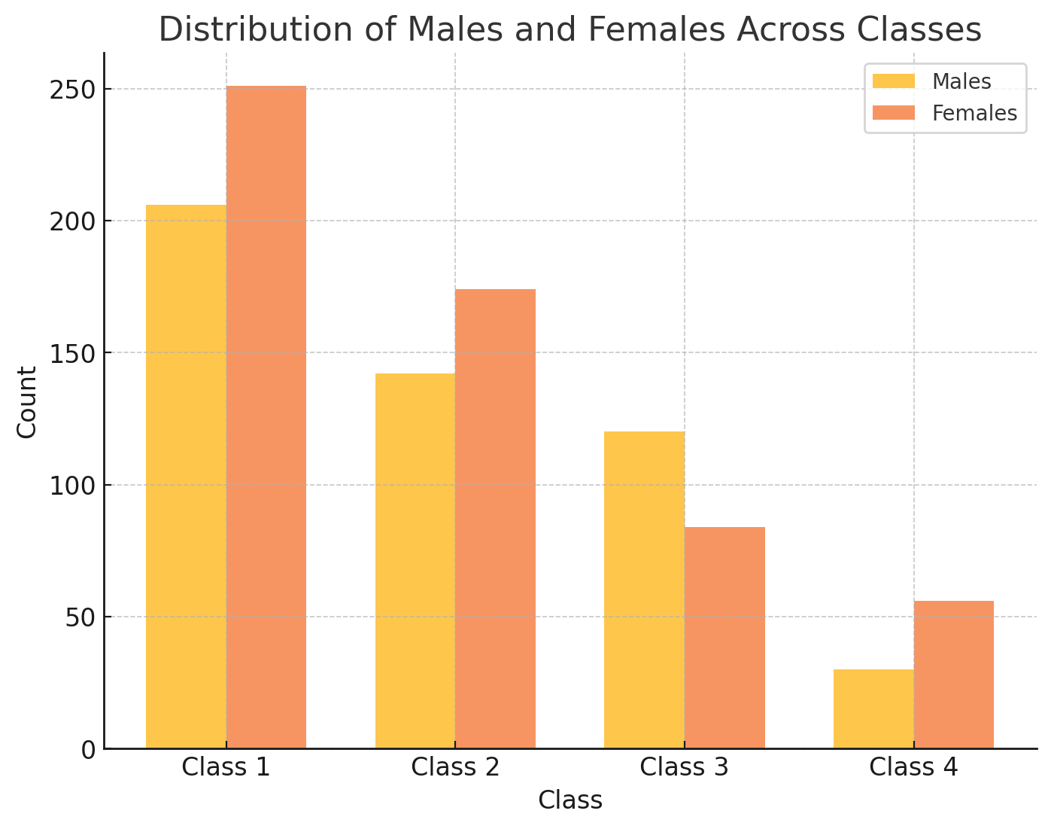
A multinomial logistic regression was performed with Class 1 as the reference category. The model was statistically significant, χ²(3) = 17.732, p < .001, indicating that gender significantly predicted class membership. The odds of being in Class 3 rather than Class 1 were 1.741 times higher for males compared to females (OR = 1.741, p = .001). In contrast, when Class 3 was set as the reference, results showed that males were significantly less likely than females to be in Classes 1, 2, and 4 (ORs = 0.575, 0.571, and 0.375, all p < .05). This suggests that Class 3 is disproportionately male-dominated, whereas females are more evenly distributed across other classes. The findings indicate a gender-based disparity in class membership, with males being significantly more likely to be in Class 3, while females are more prevalent in Classes 1, 2, and 4.

Summary: These results indicate that Class 3 (non-conspiritual, resistant to cognitive biases) is significantly more male-dominated compared to Class 1 (slightly below-average scores on all indicators), Class 2 (high conspirituality with associated cognitive biases), and Class 4 (high conspirituality without associated cognitive biases).

Age
A Welch’s ANOVA was conducted to examine whether age differed across the four latent classes, as Levene’s test for homogeneity of variance was significant (F(3, 1062) = 5.46, p = .001), indicating a violation of the homogeneity of variance assumption. The analysis revealed a statistically significant effect of class membership on age, Welch’s F(3, 332.79) = 7.72, p < .001, suggesting that at least some classes differed significantly in age. Post-hoc comparisons using the Games-Howell test, which accounts for unequal variances, indicated that Class 1 (slightly below-average scores across all indicators, 43% of the sample) was significantly older than Class 2 (high in conspiracy beliefs, New Age spirituality, and cognitive biases, 30% of the sample) (M_diff = 5.37, SE = 1.15, p < .001, 95% CI [2.40, 8.34]). Additionally, Class 2 was significantly younger than Class 3 (low in all measured variables, non-conspiritual, 19% of the sample) (M_diff = -4.70, SE = 1.48, p = .008, 95% CI [-8.51, -0.89]). There was no significant difference between Class 1 and Class 3 (M_diff = 0.67, p = .965), Class 1 and Class 4 (high conspirituality without typical cognitive predispositions, 8% of the sample) (M_diff = 1.57, p = .783), Class 3 and Class 4 (M_diff = -2.40, p = .253), or Class 2 and Class 4 (M_diff = -3.80, p = .098).
Summary: These results indicate that Class 2 (high conspirituality with associated cognitive biases) is significantly younger than both Class 1 (slightly below-average scores on all indicators) and Class 3 (non-conspiritual, resistant to cognitive biases), whereas other class comparisons were not statistically significant.

Education
A Pearson Chi-Square test examined whether participants’ highest completed education (primary, vocational, secondary, or higher) was associated with class membership (Classes 1 through 4). The distribution of education levels across the four classes was found to be non-random, χ²(9) = 28.092, p < .001, indicating a significant relationship between education level and class membership (see Table S6). This finding suggests that individuals with different educational backgrounds are not randomly distributed among the four classes.
Table S6
Education Distribution Across Latent Profiles
Education level | Class 1 | Class 2 | Class 3 | Class 4 | Total | % of Total Sample
Primary | 40 | 44 | 10 | 5 | 99 | 9.3%
Secondary | 194 | 144 | 72 | 38 | 448 | 42.0%
Higher | 224 | 128 | 124 | 43 | 519 | 48.7%
Total | 458 | 316 | 206 | 86 | 1066 | 100%

A series of multinomial logistic regressions were conducted to examine how education level (primary, secondary, higher) predicts class membership (1, 2, 3, 4), using Class 1 and Class 3 as alternative reference categories. In both models, higher education served as the reference group for the predictor. When Class 1 was the reference category, individuals with primary education (vs. higher) showed greater odds of being in Class 2 (B = 0.655, p = .008, OR = 1.93) and lower odds of belonging to Class 3 (B = –0.795, p = .032, OR = 0.45). Secondary education (vs. higher) did not significantly predict Class 2 (p = .094), but was associated with decreased odds of Class 3 (B = –0.400, p = .024, OR = 0.67). No significant effects emerged for Class 4. When Class 3 was used as the reference category, participants with primary education had increased odds of Class 1 (B = 0.795, p = .032, OR = 2.21) and Class 2 (B = 1.450, p < .001, OR = 4.26) relative to Class 3, whereas those with secondary education likewise showed higher odds of Class 1 (B = 0.400, p = .024, OR = 1.49) and Class 2 (B = 0.661, p < .001, OR = 1.94). Neither primary nor secondary significantly differentiated Class 4 from Class 3.
Summary: The results indicate that individuals with lower education (primary or secondary) are more likely to occupy Classes 1 (slightly below-average scores on all indicators) or 2 (high conspirituality with associated cognitive biases) than Class 3 (non-conspiritual, resistant to cognitive biases) when compared to those with higher education. Conversely, Class 3 shows comparatively fewer individuals with lower education. Class 4 (high in conspirituality without some associated cognitive biases) does not differ significantly from Classes 1 or 3 on education in either model.

(Non)religious affiliation
A Pearson Chi-Square test examined whether religious affiliation (Christian, Atheist, Agnostic, Spiritual but Not Religious, None) was associated with class membership (Classes 1 through 4). The distribution of religious affiliations across the four classes was found to be non-random, χ²(12) = 128.401, p < .001, indicating a significant relationship between religious affiliation and class membership. This finding suggests that individuals with different religious identities are not randomly distributed among the four classes (see Table S7 and Figure S4) .
Table S7
Non(religious) Affiliation Distribution Across Latent Profiles
(Non)religious Affiliation | Class 1 | Class 2 | Class 3 | Class 4 | Total | % of Total Sample
Christian | 350 | 257 | 108 | 54 | 769 | 72.7%
Atheist | 28 | 8 | 32 | 6 | 74 | 7.0%
Agnostic | 18 | 2 | 18 | 1 | 39 | 3.7%
Spiritual but Not Religious | 10 | 12 | 1 | 13 | 36 | 3.4%
None (not identified with any group) | 48 | 36 | 44 | 12 | 140 | 13.2%
Total | 454 | 315 | 203 | 86 | 1058 | 100%

Figure S4
Heatmap of the Distribution of Religious and (Non)religious Affiliations Across Latent Profiles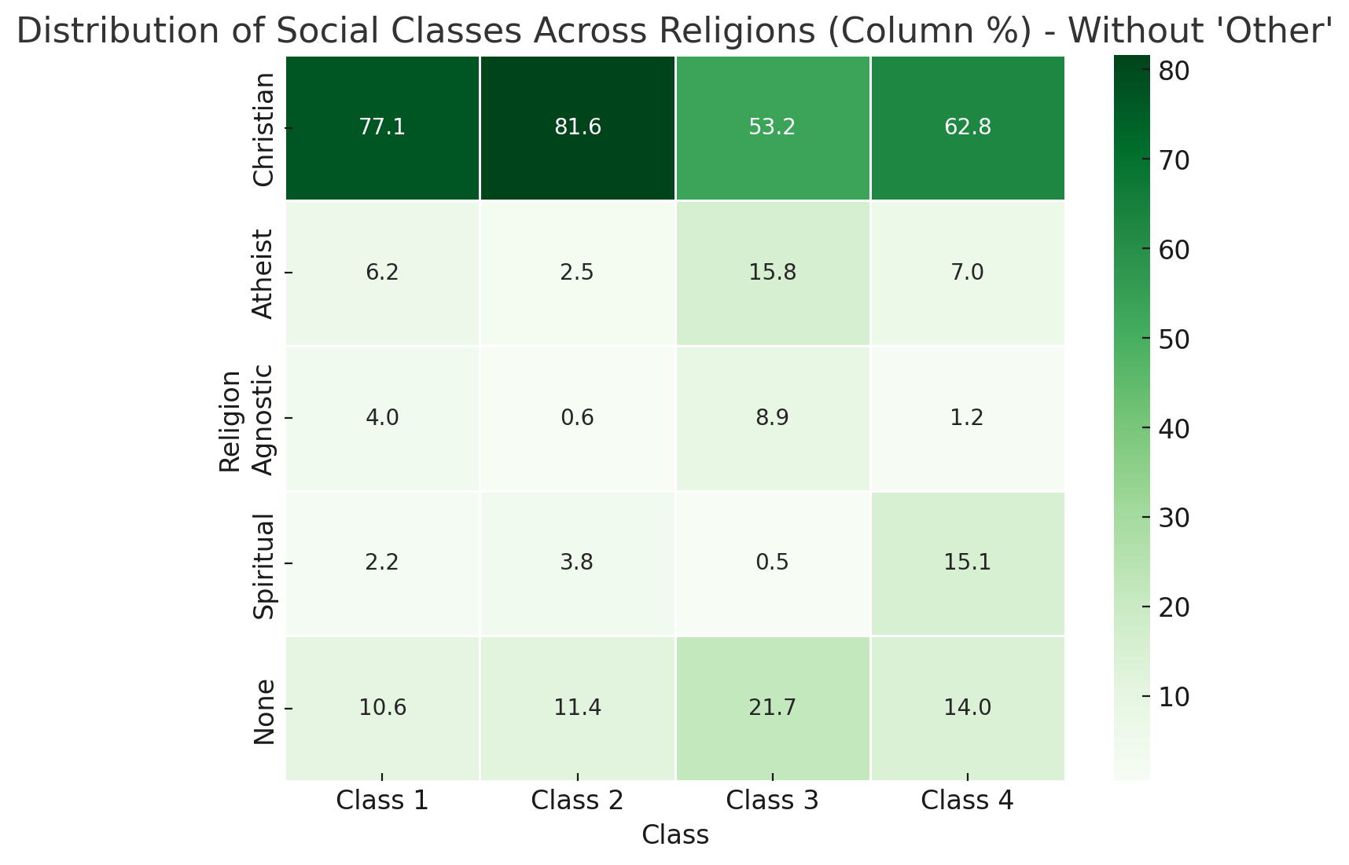
A multinomial logistic regression was conducted to examine how religious affiliation (coded as 1 = Christian, 2 = Atheist, 3 = Agnostic, 4 = Spiritual but Not Religious, 5 = None) predicts class membership. When Class 1 was the reference category, Christians were significantly more likely to be in Class 1 relative to Class 3 (B = 1.089, p < .001, OR = 2.97, 95% CI [1.87, 4.72]), and Spiritual but Not Religious individuals also showed increased odds of being in Class 1 (B = 2.216, p = .038, OR = 9.17, 95% CI [1.13, 74.55]). For Class 2 versus Class 1, Christians exhibited higher odds (B = 1.068, p < .001, OR = 2.91, 95% CI [1.77, 4.77]), whereas Atheists (B = –1.186, p = .009, OR = 0.31, 95% CI [0.13, 0.75]) and Agnostics (B = –1.997, p = .010, OR = 0.14, 95% CI [0.03, 0.63]) were less likely to be in Class 2. When Class 3 was used as the reference category, similar patterns emerged: Christians were more likely to be in Classes 1 and 2 relative to Class 3, while Atheists and Agnostics were less likely to be in Class 2. Notably, Spiritual but Not Religious individuals were significantly more likely to be in Class 4 versus Class 3 (B = 3.864, p < .001, OR = 47.67, 95% CI [5.66, 401.81]). These findings indicate that religious affiliation is a significant predictor of class membership, with different religious groups showing distinct patterns of distribution across the classes.
Summary: These results indicate that religious affiliation is a significant predictor of latent class membership, with Christians being more likely to belong to Classes 1 (slightly below-average scores on all indicators) and 2 (high conspirituality with associated cognitive biases), Atheists and Agnostics showing reduced odds of being in Class 2, and Spiritual but Not Religious individuals being particularly more likely to belong to Class 4 (high in conspirituality without some associated cognitive biases).

Place of residence
A chi-square test of independence was conducted to examine the relationship between place of residence and latent profile membership. The results indicated no statistically significant association between these variables, χ²(12) = 17.86, p = .120, suggesting that conspirituality profiles were not significantly different across different types of residential areas (see Table S8).
Table S8
Place of Residence Affiliation Distribution Across Latent Profiles
Place of Residence | Class 1 | Class 2 | Class 3 | Class 4 | Total | % of Total Sample
Rural (village) | 175 | 138 | 67 | 29 | 409 | 38.4%
Small town (<20k residents) | 57 | 38 | 26 | 8 | 129 | 12.1%
Medium-sized city (20k-99k residents) | 82 | 64 | 37 | 24 | 207 | 19.4%
Large city (100k-500k residents) | 87 | 48 | 42 | 14 | 191 | 17.9%
Major metropolitan area (>500k residents) | 57 | 28 | 34 | 11 | 130 | 12.2%
Total | 458 | 316 | 206 | 86 | 1066 | 100%

Summary: These results indicate that place of residence is not a significant predictor of latent class membership, as conspirituality profiles did not differ significantly across residential areas.

Alternative LPA Model Based Solely on Conspiracy Beliefs and New Age Spirituality
As an alternative to the model presented in the main manuscript, which incorporated a broader set of variables including various cognitive biases, we conducted an exploratory latent profile analysis (LPA) using only conspiracy beliefs and New Age spirituality as indicator variables. We performed latent profile analysis using the R package tidyLPA (Rosenberg et al., 2018), leveraging the model-based clustering approach of the mclust R package (Scrucca et al., 2017). We standardized the indicator variables prior to analysis and tested solutions ranging from one to six latent profiles, estimating parameters via the EM (Expectation–Maximization) algorithm to obtain maximum likelihood estimates. We then compared models using the Akaike Information Criterion (AIC) and Bayesian Information Criterion (BIC). The results of the LPA, including fit information and diagnostics, are presented in Table S9.
Table S9
Fit Indices and Diagnostic Criteria for the Latent Class Analysis
Models | AIC | BIC | Entropy | LPP | HPP | Smallest class size (%) | Largest class size (%) | BLRT p-value
1 class | 6056.35 | 6076.24 | 1.00 | 1.00 | 1.00 | 100 | 100
2 class | 5749.76 | 5784.56 | 0.66 | 0.82 | 0.93 | 31 | 69 | 0.01
3 class | 5655.06 | 5704.78 | 0.69 | 0.68 | 0.91 | 15 | 64 | 0.01
4 class | 5628.52 | 5693.15 | 0.65 | 0.61 | 0.88 | 5 | 55 | 0.01
5 class | 5633.93 | 5713.48 | 0.50 | 0.01 | 0.83 | 0 | 47 | 0.32
Note. LPP – the lowest posterior probability for class membership; HPP – the highest posterior probability for class membership; AIC- Akaike Information Criteria; BIC - Bayesian Information Criteria; BLRT p-value – Bootstrapped Likelihood Ratio Test p-value.
To determine the optimal number of clusters, we created an elbow plot using AIC and BIC (see Figure S5). Both indices suggested a four-cluster solution; however, this model included a smallest class comprising only 5% of the sample, raising concerns about its stability. Additionally, two of the four classes clustered around the mean scores for both variables, making them difficult to interpret meaningfully. Given these issues, we opted for a three-cluster solution, which had a more interpretable structure with distinct subgroups of individuals high, average, and low in conspirituality. This model also had a larger smallest class (15%) and satisfactory entropy of 0.69, which, while below the conventional 0.80 threshold, still indicated an acceptable level of distinction between profiles (see Figure S6).
Figure S5
Elbow plot of fit indices for the latent profile analysis based solely on the conspiracy beliefs and New Age spirituality
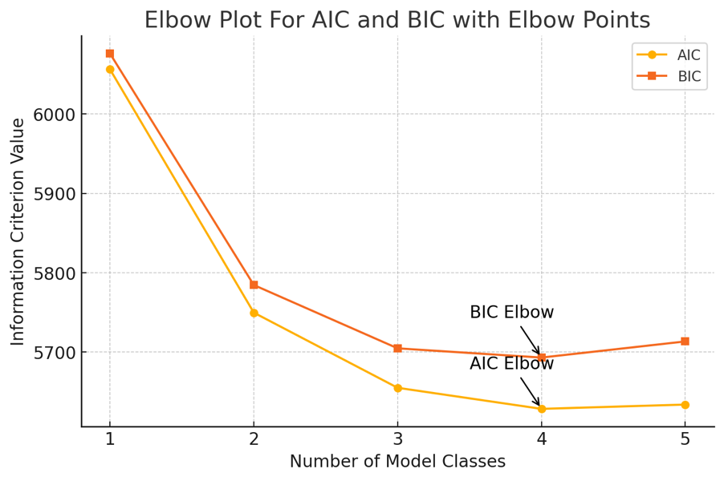
Figure S6
Line graph illustrating standardized scores for the three subgroups identified through an alternative Latent Profile Analysis (LPA), including 95% confidence intervals
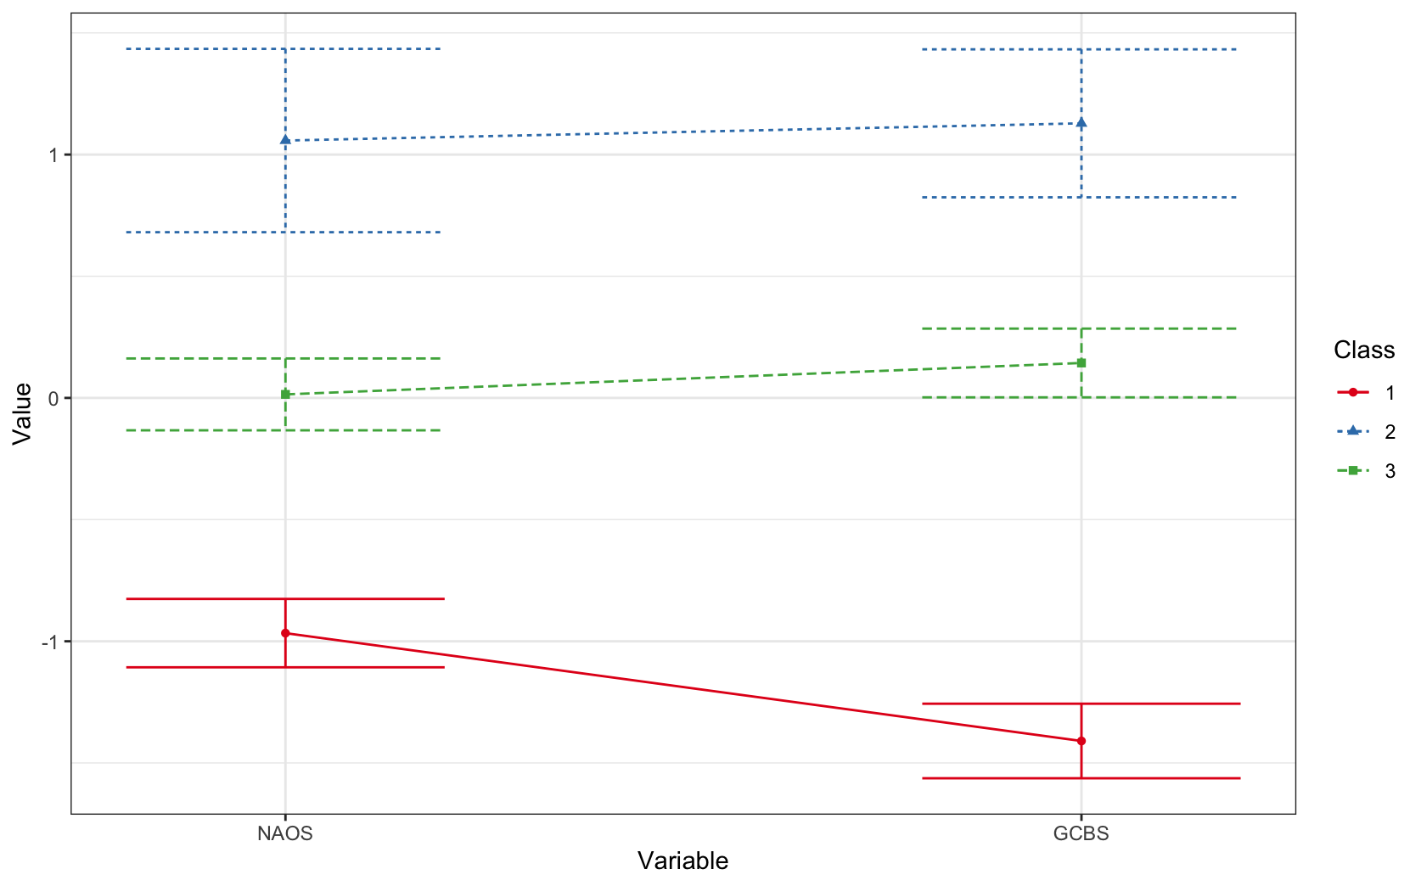
The first subgroup exhibited low levels of both conspiracy beliefs and New Age spirituality (Class 1, red line, 20% of the sample). The second subgroup demonstrated high levels of both conspiracy beliefs and New Age spirituality, representing a core conspiritual profile (Class 2, blue line, 15% of the sample). The third subgroup (Class 3, green line, 64% of the sample) scored around the average on both variables, indicating individuals who neither strongly reject nor fully endorse conspiritual beliefs.

Latent Profiles’ Characteristics for the Alternative Model
Cognitive biases. A Wald test was conducted to compare the three identified latent profiles on five cognitive variables: apophenia, teleological thinking, anthropomorphism, ideas of reference, and odd beliefs (see Figure S7). Given the significant results from Levene’s test for homogeneity of variances (all p < .001), Welch’s robust test of equality of means was used to account for violations of homogeneity. The results revealed significant differences between the latent profiles across all cognitive variables:
- Apophenia: W(2, 351.39) = 22.46, p < .001
- Teleological Thinking: W(2, 350.85) = 73.93, p < .001
- Anthropomorphism: W(2, 351.05) = 89.58, p < .001
- Ideas of Reference: W(2, 327.40) = 29.70, p < .001
- Odd Beliefs: W(2, 360.82) = 154.93, p < .001
Pairwise comparisons using Games-Howell tests revealed the following significant differences:
- Class 2 (high in conspiracy beliefs and New Age spirituality) scored significantly higher than both Class 1 (low in both) and Class 3 (average in both) across all cognitive variables (all p < .001).
- Class 3 (average in both) scored significantly higher than Class 1 (low in both) on all variables (all p < .01), except for apophenia (p = .056, n.s.), where the difference was marginal.
- The largest difference was observed in odd beliefs, where Class 2 scored significantly higher than both Class 1 and Class 3 (p < .001, large effect size, ω² = .21).
- The smallest, though still significant, difference was found for apophenia, where Class 2 scored significantly higher than both Class 1 and Class 3 (p < .01, small effect size, ω² = .04).
Figure S7
Mean Scores of Cognitive Variables Across the Three Latent Classes
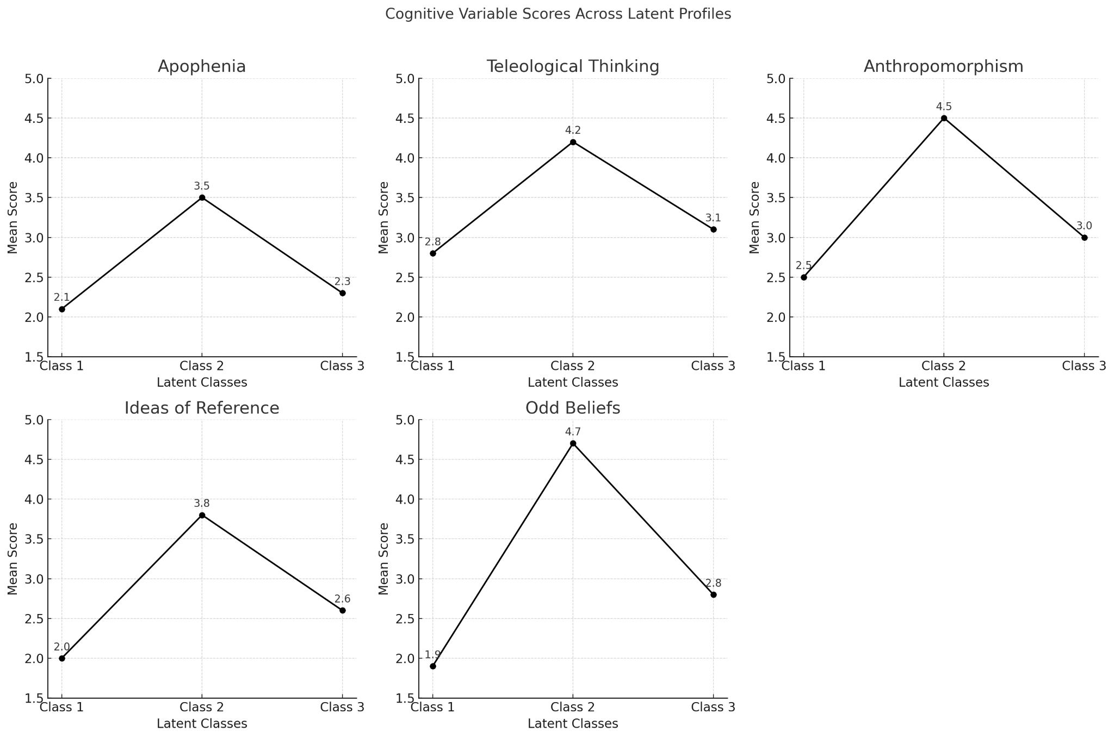
Summary: These findings suggest a clear cognitive differentiation between the three latent profiles. Class 2 (high conspirituality) exhibits elevated cognitive biases, particularly in teleological thinking, anthropomorphism, and odd beliefs, compared to the other two classes. Class 3 (average conspirituality) consistently scores higher than Class 1 (low conspirituality) on most variables, with the exception of apophenia.

Gender. A Pearson Chi-Square test was conducted to examine whether gender (male, female) was associated with class membership (Classes 1 through 3) in the alternative model. The results indicated no significant association, χ²(2) = 0.577, p = .749, suggesting that gender distribution across the three classes did not differ beyond what would be expected by chance (see Table S10).
Table S10
Gender Distribution Across Latent Profiles in the Alternative Model
Gender | Class 1 | Class 2 | Class 3 | Total | % of Total Sample
Male | 101 | 81 | 316 | 498 | 46.8%
Female | 113 | 83 | 369 | 565 | 53.2%
Total | 214 | 164 | 685 | 1063 | 100%

Summary: These results indicate that gender is not a significant predictor of latent class membership, as its distribution across the three classes did not differ beyond chance.

Age. A Welch’s ANOVA was conducted to examine whether age differed across the three latent classes, as Levene’s test for homogeneity of variance was significant (F(2, 1063) = 4.83, p = .008), indicating a violation of the homogeneity of variance assumption. The Welch’s ANOVA result did not reach statistical significance, Welch’s F(2, 358.81) = 2.55, p = .080, suggesting that there were no overall age differences between the latent classes. Post-hoc comparisons using the Games-Howell test, which accounts for unequal variances, indicated that none of the pairwise comparisons were statistically significant (all p > .05). The mean differences between Class 1 (low in both conspiracy beliefs and New Age spirituality) and Class 3 (average in both variables) (M_diff = 2.80, SE = 1.31, p = .085), Class 1 and Class 2 (M_diff = 3.14, SE = 1.63, p = .134), and Class 2 and Class 3 (M_diff = -0.34, SE = 1.30, p = .962) did not reach statistical significance.
Summary: These results suggest that age does not significantly differentiate the latent classes, as neither the overall test nor the pairwise comparisons showed significant effects.

Education. A Pearson Chi-Square test was conducted to examine whether education level (primary, secondary, higher education) was associated with class membership (Classes 1 through 3) in the alternative model. The results indicated a significant association, χ²(4) = 16.49, p = .002, suggesting that education level is not randomly distributed across the three latent profiles (see Table S11).
Table S11
Education Distribution Across Latent Profiles in the Alternative Model
Education Level | Class 1 | Class 2 | Class 3 | Total | % of Total Sample
Primary Education | 13 | 23 | 63 | 99 | 9.3%
Secondary Education | 75 | 70 | 303 | 448 | 42.0%
Higher Education | 128 | 71 | 320 | 519 | 48.7%
Total | 216 | 164 | 686 | 1066 | 100%

A multinomial logistic regression was conducted to examine how education level (1 = Primary, 2 = Secondary, 3 = Higher Education) predicts latent class membership, with Class 1 (low in both conspiracy beliefs and New Age spirituality) serving as the reference category. When comparing Class 2 (high in both conspiracy beliefs and New Age spirituality) to Class 1, individuals with primary education were significantly more likely to belong to Class 2 than Class 1 (B = 1.160, SE = 0.377, Wald = 9.454, p = .002, OR = 3.19, 95% CI [1.52, 6.71]). Similarly, individuals with secondary education also had higher odds of being in Class 2 compared to Class 1 (B = 0.520, SE = 0.223, Wald = 5.468, p = .019, OR = 1.68, 95% CI [1.09, 2.60]). When comparing Class 3 (average in both conspiracy beliefs and New Age spirituality) to Class 1, individuals with primary education were significantly more likely to belong to Class 3 than Class 1 (B = 0.662, SE = 0.322, Wald = 4.223, p = .040, OR = 1.94, 95% CI [1.03, 3.67]). Likewise, individuals with secondary education had significantly higher odds of being in Class 3 compared to Class 1 (B = 0.480, SE = 0.166, Wald = 8.355, p = .004, OR = 1.62, 95% CI [1.17, 2.25]).
Summary: These findings suggest that individuals with lower levels of education (primary and secondary) are more likely to belong to Class 2 (high conspirituality) and Class 3 (average conspirituality) compared to those with higher education, who are more concentrated in Class 1 (low conspirituality). This pattern indicates that higher education may be associated with a lower likelihood of engaging in conspiritual beliefs.

(Non)religious affiliation. A Pearson Chi-Square test was conducted to examine whether (non)religious affiliation (Christian, Atheist, Agnostic, Spiritual but Not Religious, None) was associated with class membership (Classes 1 through 3) in the alternative model. The results indicated a significant association, χ²(8)= 44.69, p < .001, suggesting that (non)religious affiliation is not randomly distributed across the three latent profiles (see Table S12).
Table S12
(Non)religious Affiliation Distribution Across Latent Profiles in the Alternative Model
(Non)Religious Affiliation | Class 1 | Class 2 | Class 3 | Total | % of Total Sample
Christian | 133 | 124 | 512 | 769 | 72.7%
Atheist | 29 | 5 | 40 | 74 | 7.0%
Agnostic | 15 | 2 | 22 | 39 | 3.7%
Spiritual but Not Religious | 4 | 13 | 19 | 36 | 3.4%
None (not identified with any group) | 33 | 20 | 87 | 140 | 13.2%
Total | 214 | 164 | 680 | 1058 | 100%

A multinomial logistic regression was conducted to examine how religious affiliation (1 = Christian, 2 = Atheist, 3 = Agnostic, 4 = Spiritual but Not Religious, 5 = None) predicts latent class membership, with Class 1 (low in both conspiracy beliefs and New Age spirituality) serving as the reference category. When comparing Class 2 (high in both conspiracy beliefs and New Age spirituality) to Class 1, atheists were significantly less likely to be in Class 2 compared to Class 1 (B = -1.257, SE = 0.561, Wald = 5.020, p = .025, OR = 0.284, 95% CI [0.095, 0.854]). Agnostics also showed reduced odds of being in Class 2 compared to Class 1, but this effect was marginal (B = -1.514, SE = 0.804, Wald = 3.544, p = .060, OR = 0.220, 95% CI [0.045, 1.064]). In contrast, Spiritual but Not Religious (SBNR) individuals were significantly more likely to belong to Class 2 than Class 1 (B = 1.679, SE = 0.638, Wald = 6.926, p = .008, OR = 5.362, 95% CI [1.535, 18.731]), reinforcing the strong association between SBNR identity and high conspirituality. Christians and those identifying as None did not significantly differ in their likelihood of being in Class 2 compared to Class 1 (p = .164 for Christians; the None group was the reference category). When comparing Class 3 (average in both conspiracy beliefs and New Age spirituality) to Class 1, atheists were significantly less likely to belong to Class 3 compared to Class 1 (B = -0.648, SE = 0.318, Wald = 4.144, p = .042, OR = 0.523, 95% CI [0.280, 0.976]). Agnostics, SBNR individuals, and Christians did not show statistically significant differences in their likelihood of being in Class 3 compared to Class 1 (all p > .05).
Summary: These findings suggest that atheists are generally less likely to be in both Class 2 (high conspirituality) and Class 3 (average conspirituality) compared to Class 1 (low conspirituality). In contrast, Spiritual but Not Religious individuals were significantly more likely to be in Class 2 (high conspirituality). Christians and those without religious affiliation did not show strong predictive effects in distinguishing class membership.

Place of residence. A Pearson Chi-Square test was conducted to examine whether place of residence (rural village, small town, medium-sized city, large city, major metropolitan area) was associated with class membership (Classes 1 through 3) in the alternative model. The results indicated a significant association, χ²(8, N = 1066) = 16.12, p = .041, suggesting that place of residence is not randomly distributed across the three latent profiles (see Table S13).
Table S13
Place of Residence Distribution Across Latent Profiles in the Alternative Model
Place of Residence | Class 1 | Class 2 | Class 3 | Total | % of Total Sample
Rural (village) | 77 | 62 | 270 | 409 | 38.4%
Small town (<20k residents) | 21 | 20 | 88 | 129 | 12.1%
Medium-sized city (20k-99k residents) | 38 | 45 | 124 | 207 | 19.4%
Large city (100k-500k residents) | 45 | 25 | 121 | 191 | 17.9%
Major metropolitan area (>500k residents) | 35 | 12 | 83 | 130 | 12.2%
Total | 216 | 164 | 686 | 1066 | 100%

A multinomial logistic regression was conducted to examine how place of residence (1 = Rural village, 2 = Small town (<20k residents), 3 = Medium-sized city (20k–99k residents), 4 = Large city (100k–500k residents), 5 = Major metropolitan area (>500k residents)) predicts latent class membership, with Class 1 (low in both conspiracy beliefs and New Age spirituality) serving as the reference category. When comparing Class 2 (high in both conspiracy beliefs and New Age spirituality) to Class 1, individuals living in a rural village were significantly more likely to belong to Class 2 than Class 1 (B = 0.854, SE = 0.376, Wald = 5.169, p = .023, OR = 2.35, 95% CI [1.13, 4.90]). Similarly, individuals from a small town had significantly greater odds of being in Class 2 than Class 1 (B = 1.022, SE = 0.458, Wald = 4.982, p = .026, OR = 2.78, 95% CI [1.13, 6.81]). Those from a medium-sized city were also significantly more likely to be in Class 2 than Class 1 (B = 1.240, SE = 0.401, Wald = 9.576, p = .002, OR = 3.45, 95% CI [1.58, 7.57]). In contrast, individuals living in a large city did not show significantly different odds of being in Class 2 compared to Class 1 (B = 0.483, SE = 0.417, Wald = 1.338, p = .247, OR = 1.62, 95% CI [0.72, 3.67]). The major metropolitan area served as the reference category. When comparing Class 3 (average in both conspiracy beliefs and New Age spirituality) to Class 1, none of the place of residence categories showed statistically significant differences. Individuals from rural villages (B = 0.391, p = .102), small towns (B = 0.569, p = .071), medium-sized cities (B = 0.319, p = .244), and large cities (B = 0.126, p = .638) did not have significantly different odds of being in Class 3 compared to Class 1.
Summary: These findings suggest that residence in a rural village, small town, or medium-sized city is associated with an increased likelihood of belonging to Class 2 (high conspirituality) compared to Class 1 (low conspirituality). However, place of residence did not significantly predict membership in Class 3 (average conspirituality) compared to Class 1. Individuals from large cities and major metropolitan areas did not show significant differences in class membership, suggesting that urbanization may not be a strong factor in differentiating conspiritual belief profiles.

Correlation plots of conspiracy beliefs and New Age spirituality for Studies 1-3
Figure S8
Scatter Plot of Correlation Between Non-spiritual Conspiracy Beliefs and New Age Spirituality in Study 1 (N=207)
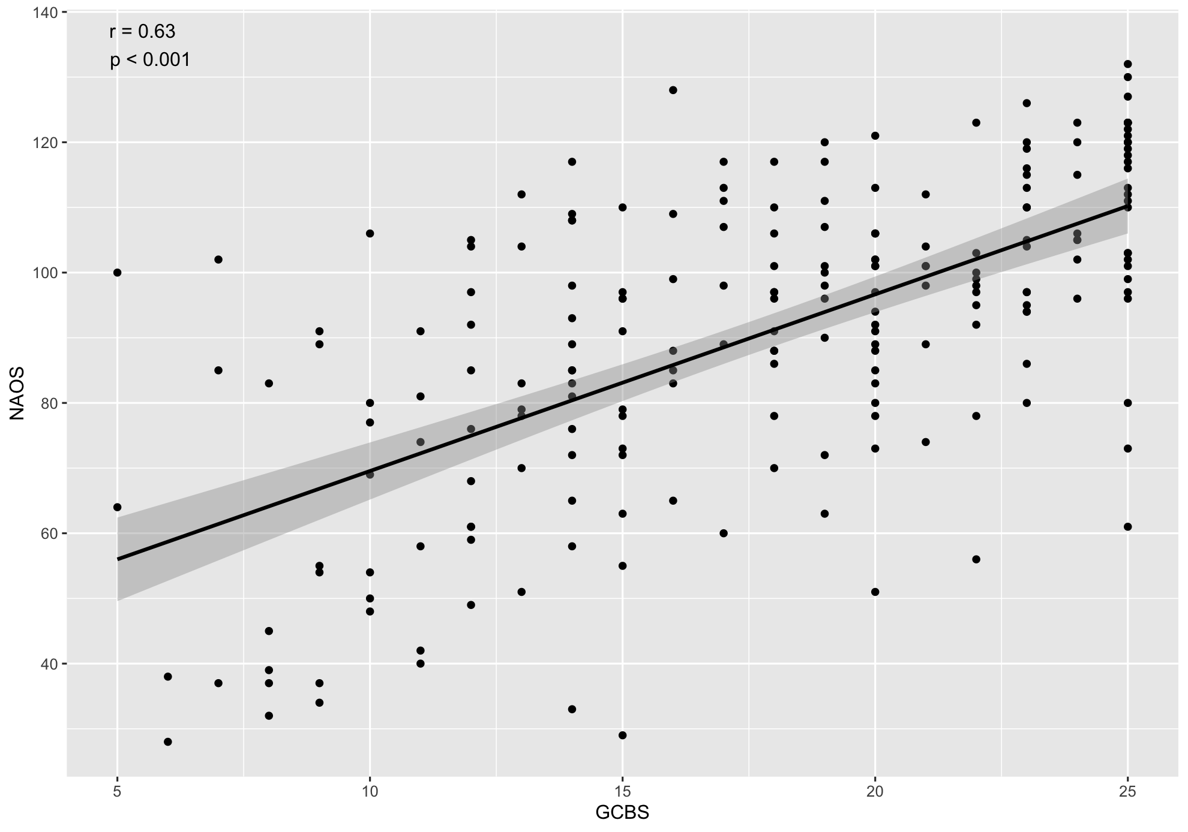
Note. NAOS - New Age Orientation Scale; GCBS - Generic Conspiracist Beliefs Scale
Figure S9
Scatter Plot of Correlation Between Non-spiritual Conspiracy Beliefs and New Age Spirituality in Study 2 (N=1066)
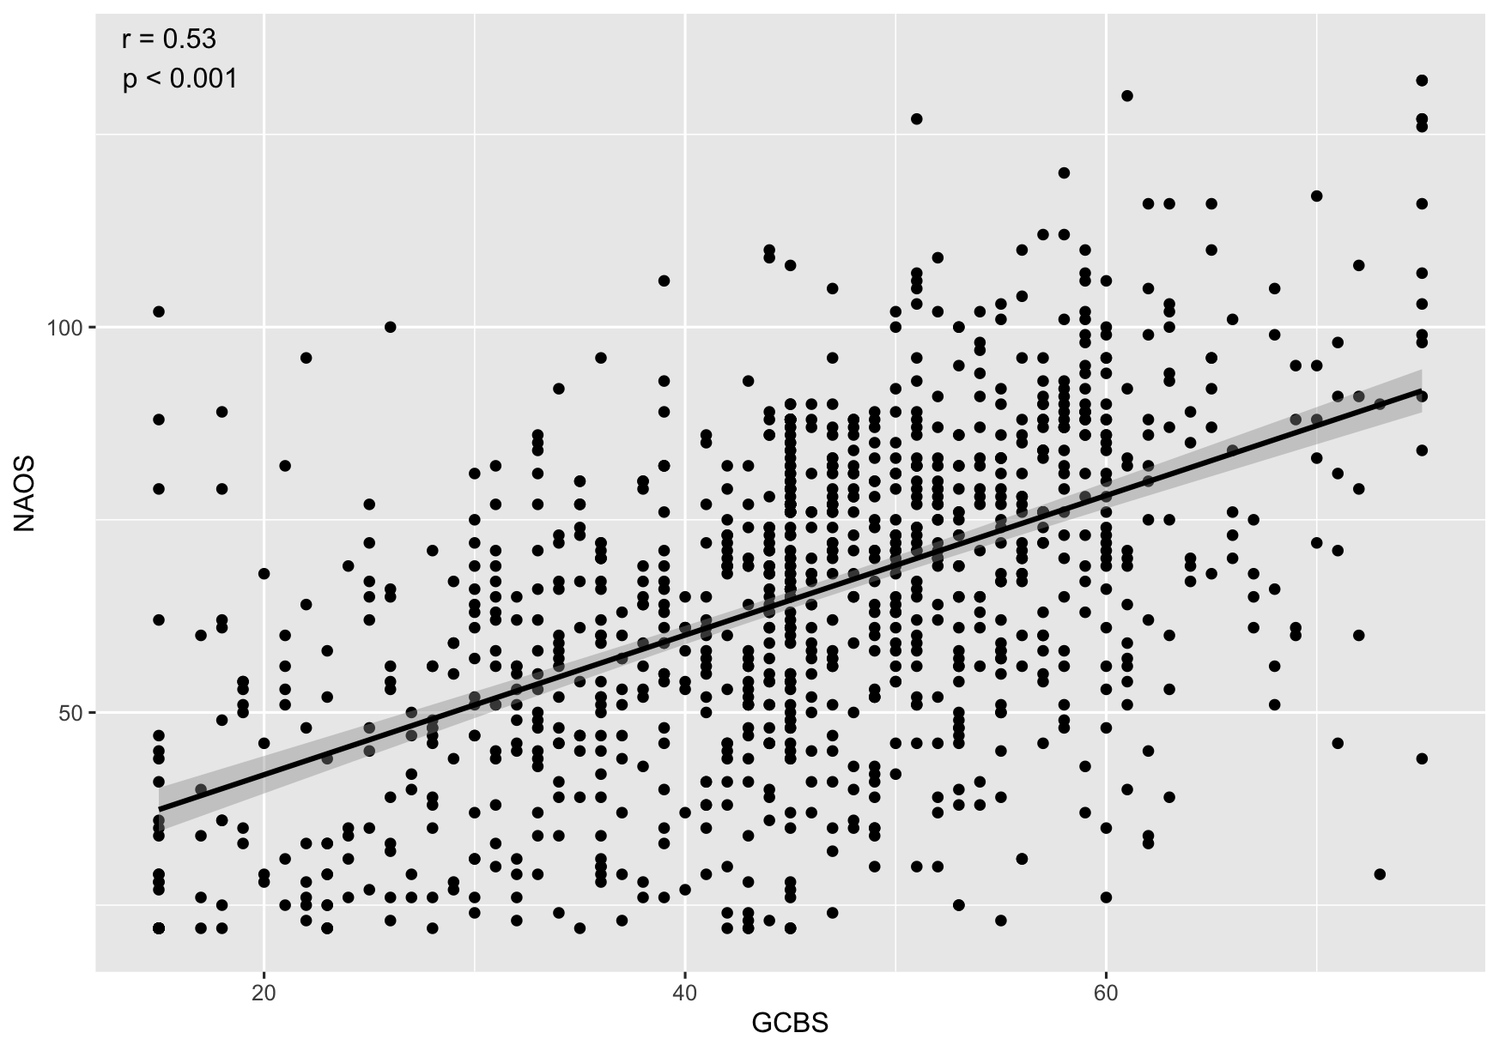
Note. NAOS - New Age Orientation Scale; GCBS - Generic Conspiracist Beliefs Scale
Figure S10
Scatter Plot of Correlation Between Non-spiritual Conspiracy Beliefs and New Age Spirituality in Study 3 (N=250)
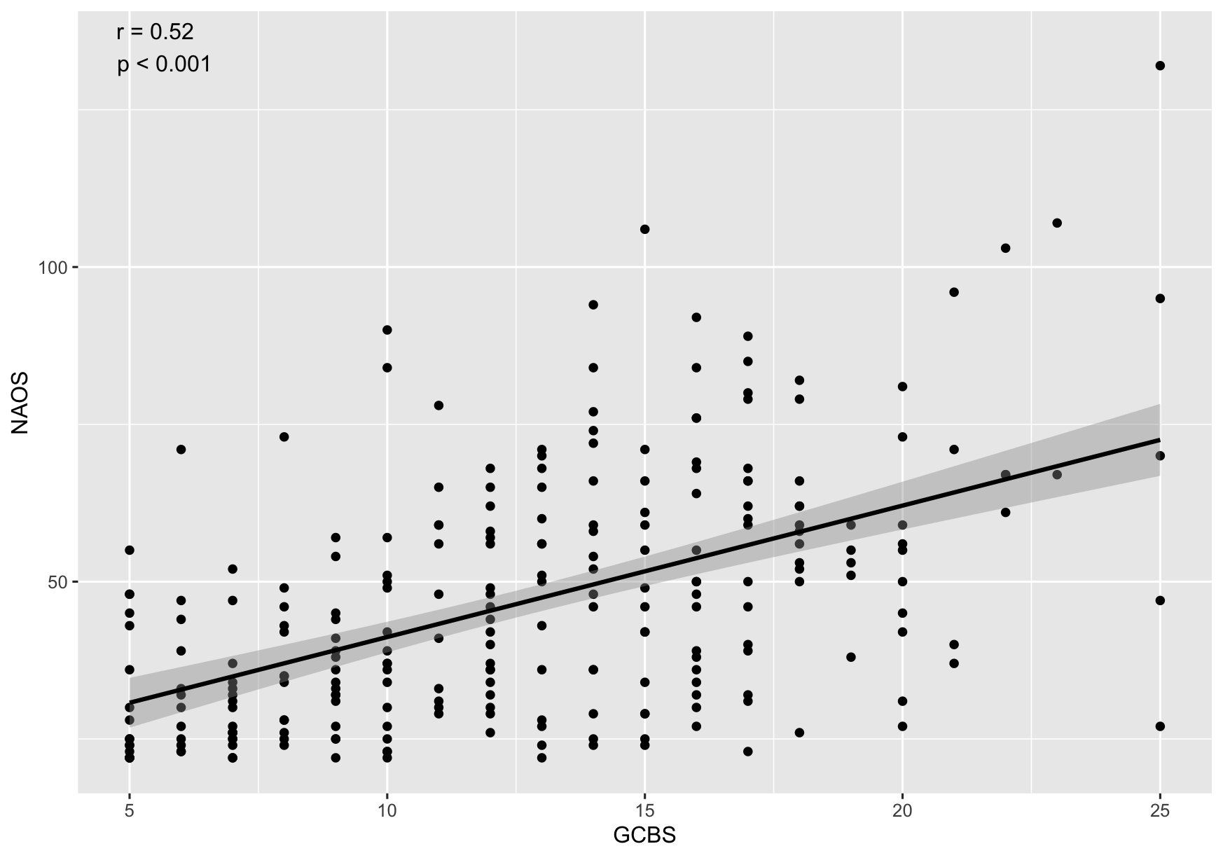
Note. NAOS - New Age Orientation Scale; GCBS - Generic Conspiracist Beliefs Scale

Conspirituality in different demographic groups (Study 2)
Below, we present the results of the analysis of conspiritual beliefs across different demographic groups from Study 2 (N = 1066; a representative sample of Polish adults). This includes a detailed examination of how these beliefs vary among genders, various age groups, places of residence, and educational levels.
Conspirituality and gender
The Mann-Whitney U test was conducted to examine possible differences between men and women regarding New Age spirituality and conspiracy beliefs. Three non-binary participants were excluded from the analysis. Women scored significantly higher on the New Age spirituality scale (p = .002; U = 156014). There were no gender differences in conspiracy beliefs (p = .164; U = 133739.50).
Figure S11
Distribution of the New Age Orientation Scale Results Among Men (N_{m} = 498)

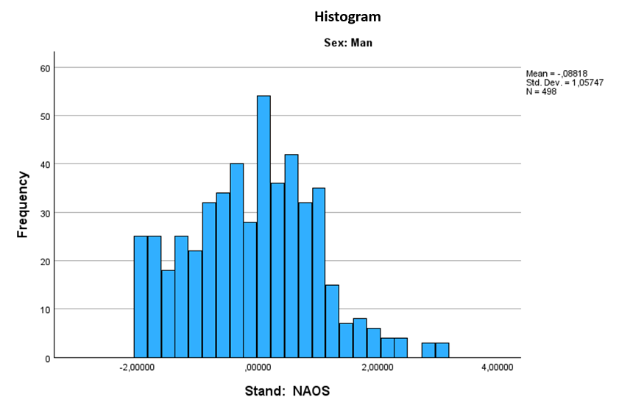
Stand: NAOS - Standardized New Age Orientation Scale score

Figure S12
Distribution of the New Age Orientation Scale Results Among Women (N_{w} = 565)
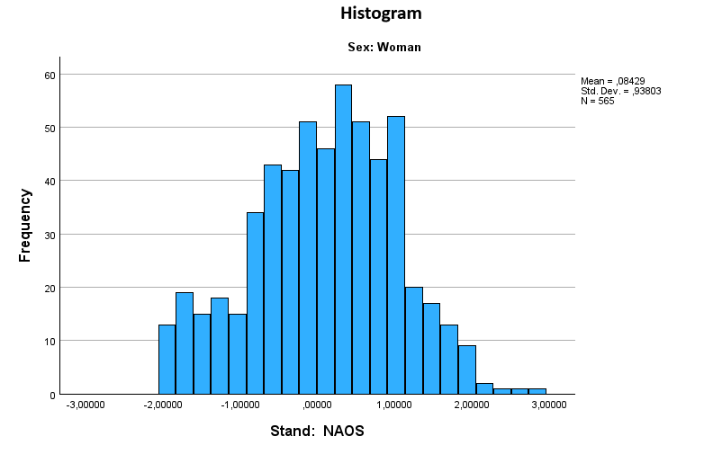
Stand: NAOS - Standardized New Age Orientation Scale score

Figure S13
Distribution of the Generic Conspiracist Beliefs Scale results among men (N_{m} = 498)
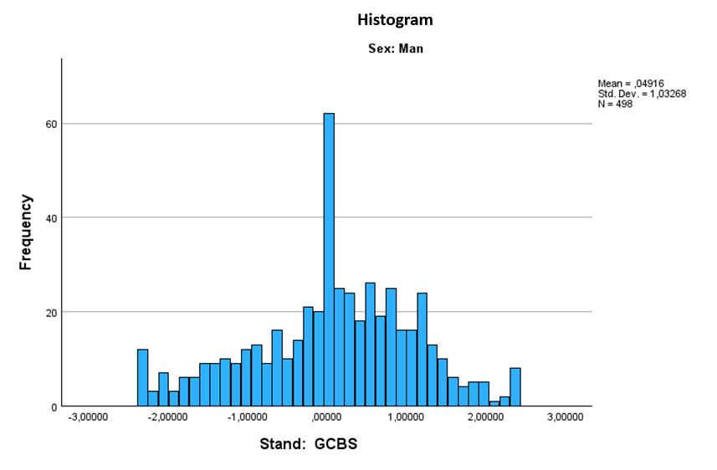
Stand: GCBS - Standardized Generic Conspiracist Beliefs Scale score
Figure S14
Distribution of the Generic Conspiracist Beliefs Scale results among women (N_{w} = 565)
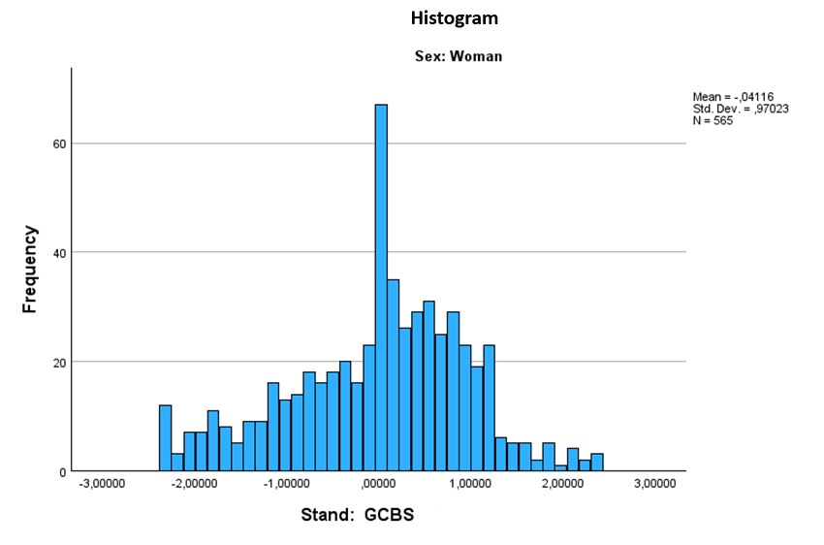
Stand: GCBS - Standardized Generic Conspiracist Beliefs Scale score
Conspirituality and age
The one-way ANOVA was used to verify possible age-related differences in New Age spirituality and conspiracy beliefs. A Tukey post hoc test was performed to check the specificity of the differences. Age differences in conspiracy beliefs (but not in New Age spirituality) were revealed, p < .001, F = 6.753.
There were statistically significant differences between the 55+ group and the 34-44 group (p < .001). The difference in means was -0.3950 (confidence interval from -0.6407 to -0.1493). The 55+ group also differed significantly from the 45-54 group (p < .001). The difference in means was -0.3520 (confidence interval from -0.5955 to -0.1090).
Figure S15
New Age Orientation Scale Results Across Age Cohorts
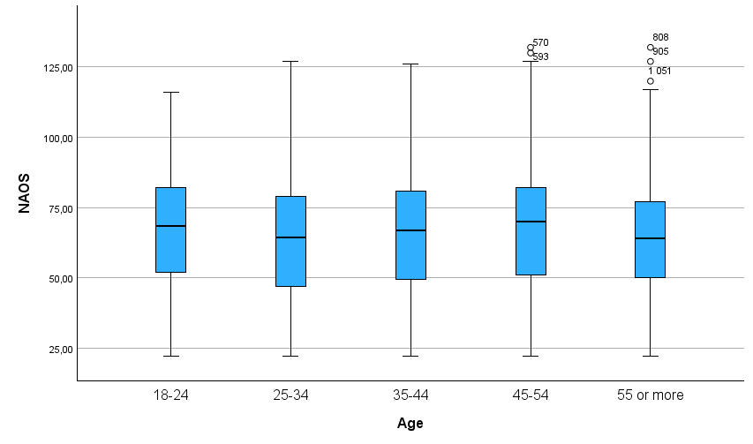

Figure S16
Generic Conspiracist Beliefs Scale results Across Age Cohorts
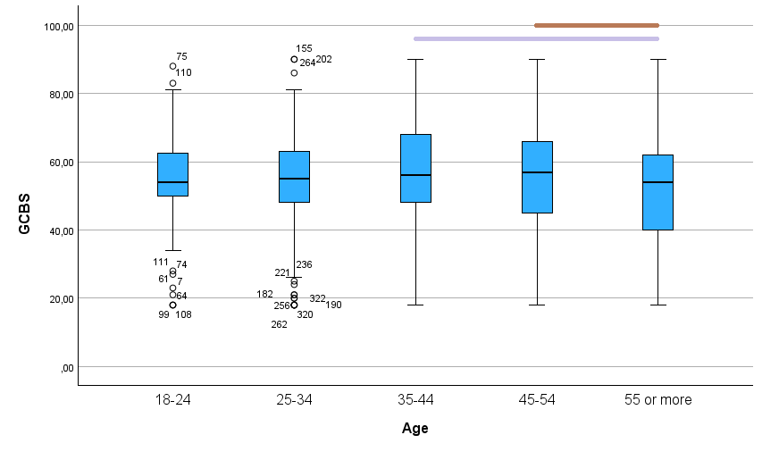
Conspirituality and place of residence
The one-way ANOVA was used to verify possible differences in New Age spirituality and conspiracy beliefs among participants living in different areas. The groups differed in terms of conspiracy beliefs, F = 2.912, p = .021 (but no in New Age Spirituality). Tukey’s post hoc test showed no significant intergroup differences. However, one-sided Dunnett’s test revealed that among participants living in small (population up to 20k; p = .022, difference in means 4.6827) and medium-sized (population from 20 to 99k; p = .016, difference in means 4.4332) cities, the intensity of conspiracy beliefs is higher than in large cities (population over 500k).
Figure S17
New Age Orientation Scale Results Among Participants Living in Different Areas
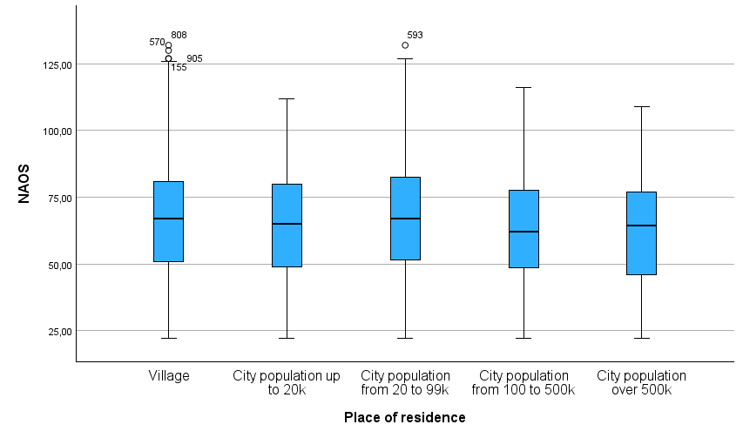

Figure S18
Generic Conspiracist Beliefs Scale Results Among Participants Living in Different Areas
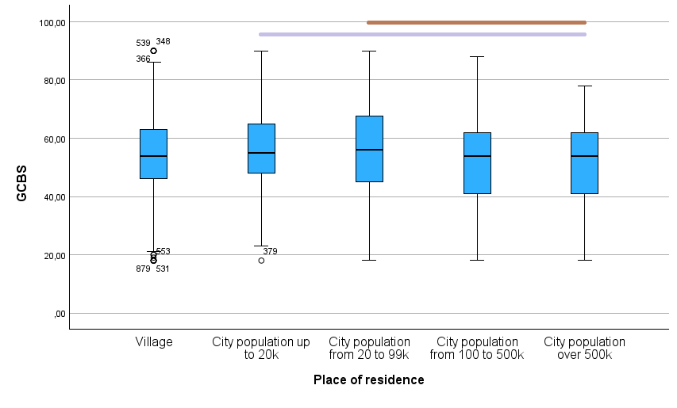
Conspirituality and education
The one-way ANOVA test revealed that participants with different educational backgrounds differed significantly in terms of both New Age spirituality (F = 2.808, p = .039) and conspiracy beliefs (F = 5.838, p < .001).
Regarding conspiracy beliefs, Tukey’s post hoc test showed that people with higher education scored lower than those with basic vocational education (p = .002, difference in means -0.4297, confidence interval from -0.7333 to -0.1259) and secondary education (p = .024, difference in means -0.1817, confidence interval from -0.3466 to -0.0169).
In terms of New Age Spirituality, Tukey’s post hoc test showed no significant intergroup differences. However, one-sided Dunnett’s test revealed that participants with basic vocational education scored significantly higher than those with higher education (p = .018; difference in means 6.5122).
Figure S19
New Age Orientation Beliefs Scale Results Among Participants with Different Education Levels
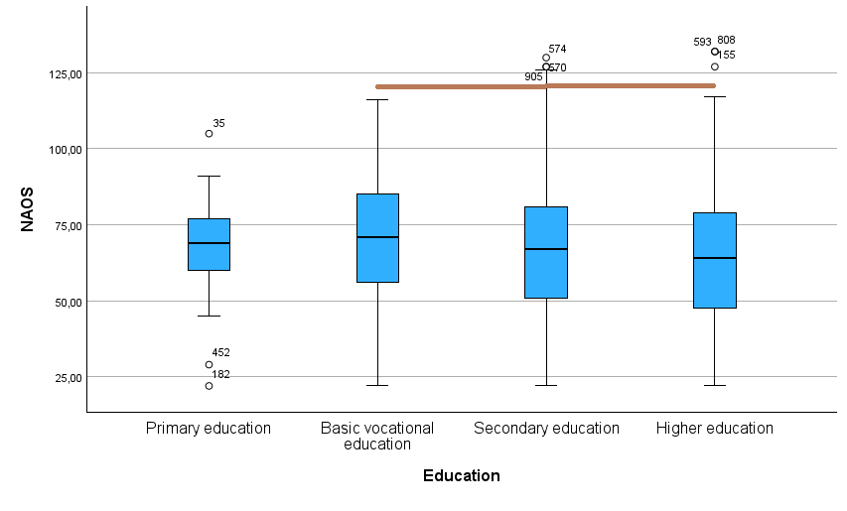
Figure S20
Generic Conspiracist Beliefs Scale Results Among Participants with Different Education Levels
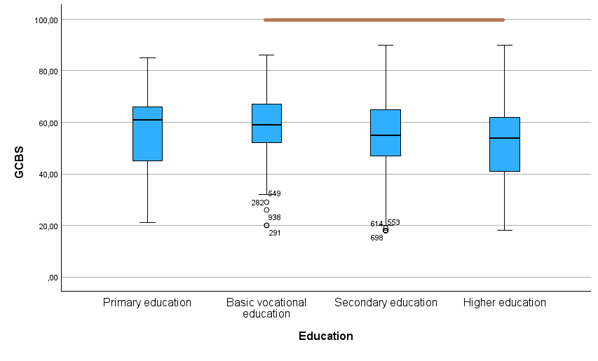

References
Rosseel, Y. (2012). lavaan: An R package for structural equation modeling. Journal of Statistical Software, 48(2), 1–36. https://doi.org/10.18637/jss.v048.i02
Scrucca, L., Fop, M., Murphy, T. B., & Raftery, A. E. (2016). mclust 5: clustering, classification and density estimation using Gaussian finite mixture models. The R Journal, 8(1), 289-317.

