Supplemental Materials
Figure 1. Dynamic Structural Equation Model for Client and Therapist Emotional Tone Synchrony
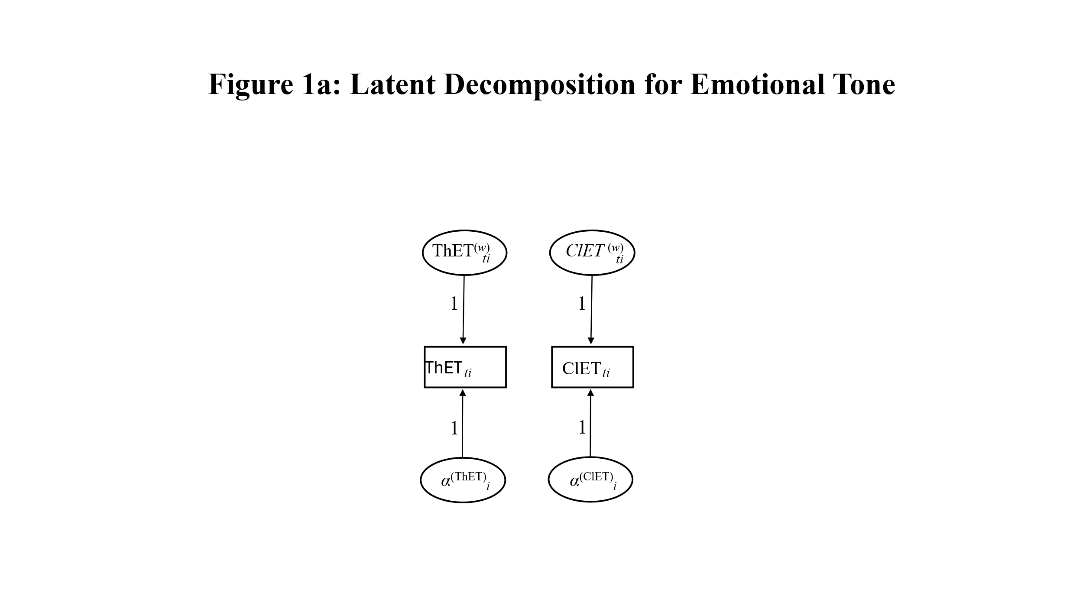
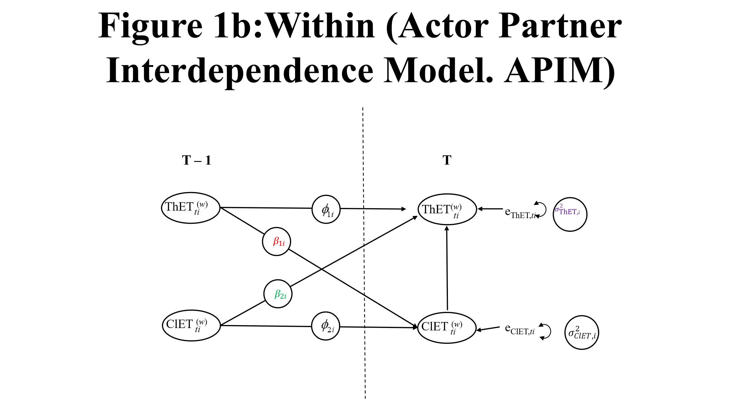
Note: Th = Therapist; Cl= Client; ET = Emotional Tone

Table 1. Mplus Syntax for the Dynamic Structural Equation Model for Client and Therapist Emotional Tone Synchrony
Title: DSEM EMOTIONAL SYNCHRONY
DATA: FILE IS C:\Users\dennisk\Box\LIWC Sessions\DSEM\LIWCDSEM3.csv;
VARIABLE: NAMES = Session Turn tWC tAna ORS2;
usevariables are tTone Turn cTone ORS2;
Within = Turn;
Between = ORS2;
LAGGED = tTone(1) cTone(1);
CLUSTER = Session;
MISSING = ALL(-999);
ANALYSIS: TYPE = TWOLEVEL RANDOM; ESTIMATOR = BAYES;
PROCESSORS = 10; THIN = 10; BITER = (20000);
MODEL:
%WITHIN%
tToontTo|tTone ON tTone&1; !Phi1
cToocTo|cTone ON cTone&1; Phi2
tTOoncTo|tTone ON cTone&1; !Beta1
cTOontTo|cTone ON tTone; !Beta2
Trend1|tTone ON Turn;
Trend2|cTone ON Turn;
logVtTO | tTone;
logVcTO | cTone;
%BETWEEN%
[tTone];
[cTone];
[tToontTo];
[cToocTo];
[tTOoncTo];
[cTOontTo] ;
[Trend1];
[Trend1];
[logVtTO];
[logVcTO];
tTone on ORS2;
cTone on ORS2;
tToontTo on ORS2;
cToocTo on ORS2;
tTOoncTo on ORS2;
cTOontTo on ORS2;
Trend1 on ORS2;
Trend2 on ORS2;
logVtTO on ORS2;
logVcTO on ORS2;
tTone;
cTone;
tToontTo;
cToocTo;
tTOoncTo;
cTOontTo;
Trend1;
Trend2;
logVtTO;
logVcTO;
OUTPUT: TECH1 TECH8 stdyx CINTERVAL (HPD);

