Supplementary material
Figure S1. Case selection flow chart
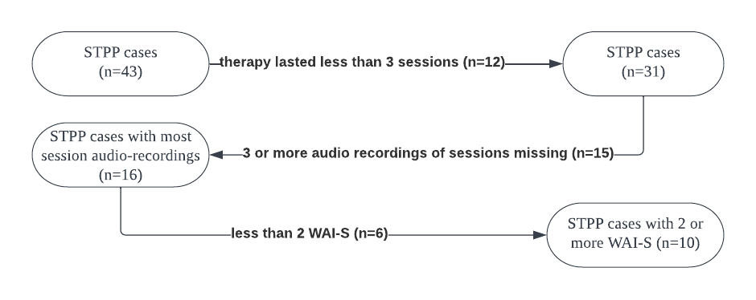

Table S1. Comparison between the IMPACT subsamples with and without the WAI-S at 6 weeks
 | Selected cases (N=10) |  | All STPP cases (N=43)
 | N | % | N | % | Chi2 | p
Gender
Male | 3 | 30% | 11 | 25.58% | 0.13 | 0.71
Female | 7 | 70% | 32 | 74.42%
Ethnicity
White British | 5 | 50% | 26 | 60.47% | 0.45 | 0.5
Other | 5 | 50% | 17 | 39.53%
 | Mean | SD | Mean | SD | t | p
Age | 16.14 | 1.31 | 15.88 | 1.84 | 0.5 | 0.61
MFQ baseline | 45.3 | 6.07 | 45.56 | 9.74 | -0.11 | 0.91
MFQ 36 weeks | 22.13 | 11.83 | 28.88 | 15.54 | -1.39 | 0.18
MFQ 86 weeks | 20.55 | 13.22 | 22.98 | 17.39 | -0.45 | 0.65
Note: MFQ=The Mood and Feelings Questionnaire

Table S2. 3RS scores on each session (n=16)
Decreased Alliance cases
Session | Overall Withdrawal |  | Overall Confrontation |  | Overall Repair
 | Impact | Freq | Impact | Freq | Impact | Freq
Kim
10 | 4 | 18 | 3 | 11 | 3 | 18
11 | 4 | 27 | 3 | 13 | 3 | 26
22 | 5 | 16 | 3 | 12 | 1 | 16
24 | 4 | 8 | 5 | 5 | 1 | 13
Mean | 4.25 | 17.25 | 3.5 | 10.25 | 2 | 18.25
Steven
1 | 4 | 14 | 3 | 6 | 2 | 12
3 | 4 | 9 | 2 | 5 | 3 | 20
8 | 5 | 15 | 4 | 7 | 1 | 24
9 | 4 | 15 | 4 | 12 | 3 | 25
Mean | 4.25 | 13.25 | 3.25 | 7.5 | 2.25 | 20.25
Increased Alliance cases
Alice
1 | 4 | 15 | 1 | 3 | 2 | 23
11 | 5 | 17 | 3 | 6 | 3 | 27
22 | 3 | 13 | 2 | 6 | 4 | 17
24 | 4 | 14 | 3 | 7 | 4 | 28
Mean | 4 | 14.75 | 2.25 | 5.5 | 3.25 | 23.75
Jade
1 | 4 | 10 | 2 | 2 | 4 | 12
7 | 5 | 13 | 4 | 4 | 3 | 17
18 | 3 | 5 | 2 | 2 | 4 | 9
25 | 5 | 13 | 1 | 0 | 1 | 20
Mean | 4.25 | 10.25 | 2.25 | 2 | 3 | 14.5

