Supplemental Materials

Link to OSF page:

https://osf.io/6jwh5

Table S1. Deviations from preregistration.

No. |  | Details | Original wording | Deviation description | Reader impact
1 | Type  Reason  Timing | Inclusion criteria  Gained insight  After data access | N/A | We identified participants with relationships > 100 years. These participants had not reported their age, so criterion #3 was ineffective (relationship > age). We exclude participants who did not report their age and who also reported a relationships > 80 years. | This should have no impact for the reader. Only 2 participants met this criteria out of 4,743, which is less than 0.001% of the sample.
2 | Type  Reason  Timing | Data collection  Typo  After data was collected | We plan to recruit as many participants as possible by the end of May 2023. Considering our subject pool allotment, we aim to recruit n=300 participants. | Typo. This should have said May 2024. The preregistration itself was not published until October 2023. | No impact.
3 | Type  Reason  Timing | Analytic approach  Typo  During analysis | We will treat TIME and TIME*CONDITION as random effects. | Typo. We meant to say we will include random effects for the intercept and for time. It is not possible to fit a random effect for a cross-level interaction. Simple error on our part. | No impact.

Table S2. In Study 1, correlation matrix.

 | 1 | 2 | 3 | 4 | 5 | 6 | 7
1. Lock screen | 1.000 | – | – | – | – | – | –
2. Global avoidance | -.034 | 1.000 | – | – | – | – | –
3. Global anxiety | .000 | .240 | 1.000 | – | – | – | –
4. Romantic avoidance | -.177 | .422 | .189 | 1.000 | – | – | –
5. Romantic anxiety | -.064 | .161 | .606 | .373 | 1.000 | – | –
6. Age | -.153 | -.072 | -.159 | .078 | -.095 | 1.000 | –
7. Relationship length | -.024 | .015 | -.135 | .006 | -.175 | .615 | 1.000

Table S3. In Study 1, logistic regression predicting lock screen (age included as a predictor).

Predictor | β | SE | z | p | 95% CI
Intercept | 0.102 | .0121 | 0.844 | .399 | [–0.134, 0.340]
Global anxiety | –0.042 | 0.036 | –1.153 | .249 | [–0.113, 0.029]
Global avoidance | –0.103 | 0.037 | –2.815 | .005 | [–0.175, –0.031]
Age | –0.039 | 0.004 | –10.432 | < .001 | [–0.046, –0.032]

Table S4. In Study 1, logistic regression predicting lock screen (age included as a predictor).

Predictor | β | SE | z | p | 95% CI
Intercept | –0.057 | 0.121 | –0.472 | .637 | [–0.295, 0.182]
Romantic anxiety | –0.048 | 0.039 | –1.222 | .222 | [–0.124, 0.029]
Romantic avoidance | –0.432 | 0.043 | –10.056 | < .001 | [–0.517, –0.349]
Age | –0.036 | 0.004 | –9.573 | < .001 | [–0.043, –0.028]

Table S5. In Study 2, survey completion rates across experimental conditions.

 |  | Group
Waves  completed | Total | Control | Experimental
6 | 87.0% (n =268) | 85.5% (n = 136) | 88.6% (n = 132)
5 | 10.4% (n = 32) | 12.6% (n = 20) | 8.1% (n = 12)
4 | 1.6% (n = 5) | 0.6% (n = 1) | 2.7% (n = 4)
3 | 0.3% (n = 1) | – | 0.7% (n = 1)
2 | 0.3% (n = 1) | 0.6% (n = 1) | –
1 | 0.3% (n = 1) | 0.6% (n = 1) | –

Table S6. Summary of linear mixed-effects models (STUDY 2; PREREGISTERED). We first modeled each dimension of attachment with random effects for both the intercept and the slope (a) then restricted the model to include only random effects for the intercepts (b). The column named “Converge” indicates whether or not there were issues with model convergence.

Model # | Converge | Predictor | γ | SE | t | p | σ | r
Global avoidance (a) | TRUE | Intercept | 2.614 | 0.064 | 40.578 | .000 | 0.771 | .035
 |  | Time | 0.003 | 0.003 | 1.064 | .288 | 0.026
 |  | Condition | 0.105 | 0.092 | 1.134 | .258
 |  | T x C | -0.004 | 0.004 | -0.875 | .382
Global avoidance (b) | TRUE | Intercept | 2.613 | 0.067 | 39.064 | .000 | 0.797
 |  | Time | 0.003 | 0.002 | 1.397 | .163
 |  | Condition | 0.107 | 0.096 | 1.118 | .264
 |  | T x C | -0.004 | 0.003 | -1.151 | .250
Global anxiety (a) | FALSE | Intercept | 3.093 | 0.089 | 34.576 | .000 | 1.076 | .061
 |  | Time | -0.006 | 0.004 | -1.403 | .162 | 0.040
 |  | Condition | 0.068 | 0.128 | 0.530 | .596
 |  | T x C | -0.004 | 0.006 | -0.685 | .494
Global anxiety (b) | TRUE | Intercept | 3.091 | 0.094 | 32.859 | .000 | 1.126
 |  | Time | -0.006 | 0.003 | -1.774 | .076
 |  | Condition | 0.073 | 0.135 | 0.541 | .589
 |  | T x C | -0.004 | 0.005 | -0.940 | .347
Romantic avoidance (a) | FALSE | Intercept | 1.460 | 0.040 | 36.504 | .000 | 0.455 | -.012
 |  | Time | 0.008 | 0.003 | 2.757 | .006 | 0.024
 |  | Condition | 0.113 | 0.057 | 1.969 | .050
 |  | T x C | 0.002 | 0.004 | 0.474 | .636
Romantic avoidance (b) | TRUE | Intercept | 1.460 | 0.043 | 34.142 | .000 | 0.484
 |  | Time | 0.008 | 0.002 | 3.667 | .000
 |  | Condition | 0.113 | 0.061 | 1.841 | .066
 |  | T x C | 0.002 | 0.003 | 0.573 | .566
Romantic anxiety (a) | FALSE | Intercept | 2.093 | 0.081 | 25.981 | .000 | 0.953 | .026
 |  | Time | -0.002 | 0.004 | -0.543 | .588 | 0.037
 |  | Condition | 0.115 | 0.115 | 0.996 | .320
 |  | T x C | -0.003 | 0.006 | -0.530 | .596
Romantic anxiety (b) | TRUE | Intercept | 2.090 | 0.084 | 24.794 | .000 | 0.992
 |  | Time | -0.001 | 0.003 | -0.440 | .660
 |  | Condition | 0.121 | 0.121 | 0.999 | .318
 |  | T x C | -0.005 | 0.005 | -0.939 | .348

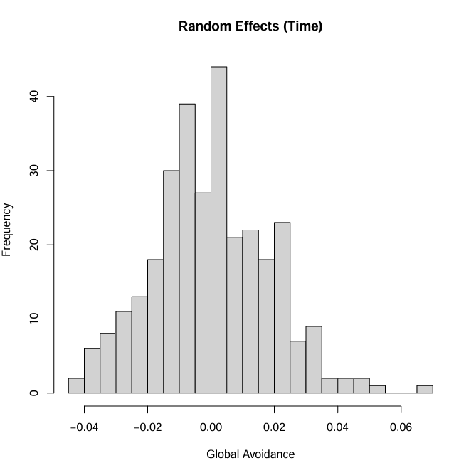
Figure S1. In Study 2, random effects for model predicting global avoidance. Global avoidance is unstandardized (range 1–5). Preregistered analyses.

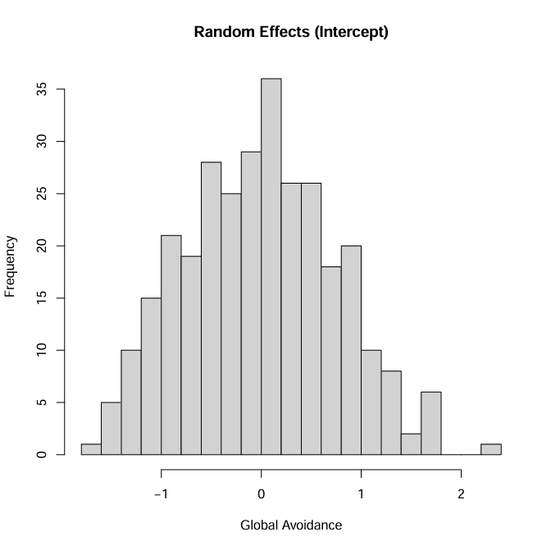

Figure S2. In Study 2, random effects for model predicting global anxiety. Global anxiety is unstandardized (range 1–5). Preregistered analyses.

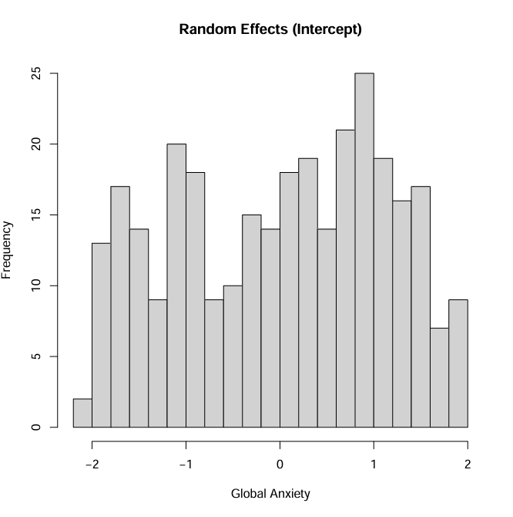
Figure S3. In Study 2, random effects for model predicting romantic avoidance. Romantic avoidance is unstandardized (range 1–5). Preregistered analyses.
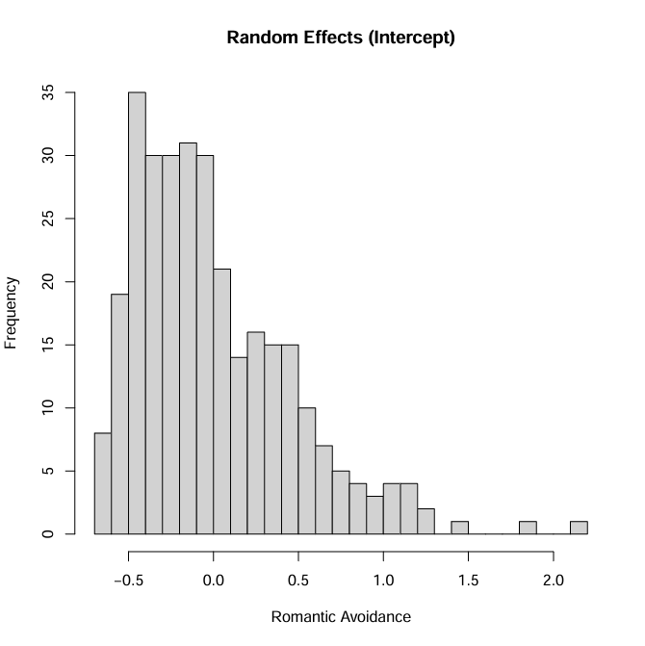

Figure S4. In Study 2, random effects for model predicting romantic anxiety. Romantic anxiety is unstandardized (range 1–5). Preregistered analyses.
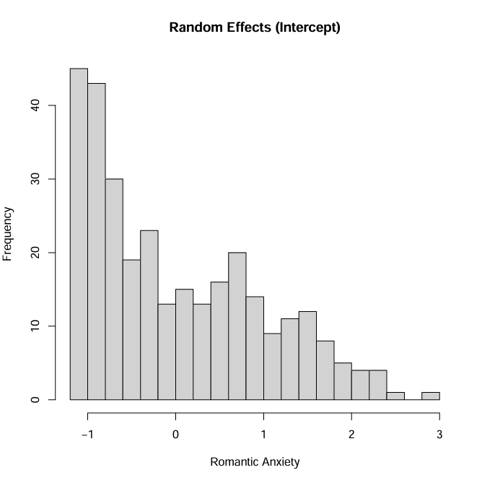
Figure S5. In Study 2, model predicted values of global avoidance over a period of two weeks. Global avoidance is unstandardized (range 1-5). Grey and blue shading = 95% prediction interval.

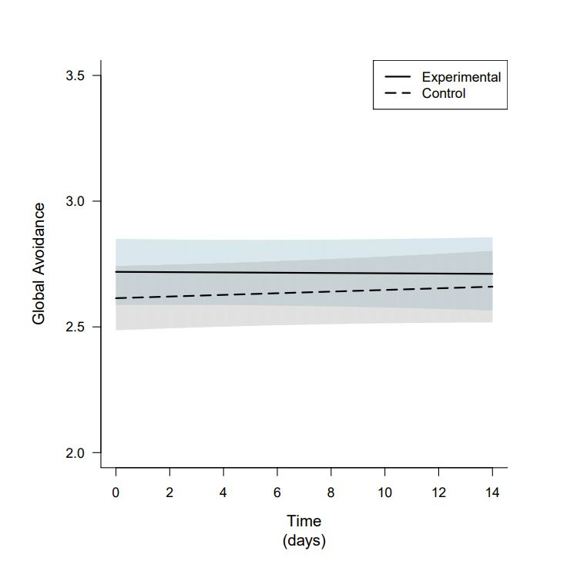

Figure S6. In Study 2, model predicted values of global anxiety over a period of two weeks. Global anxiety is unstandardized (range 1-5). Grey and blue shading = 95% prediction interval.

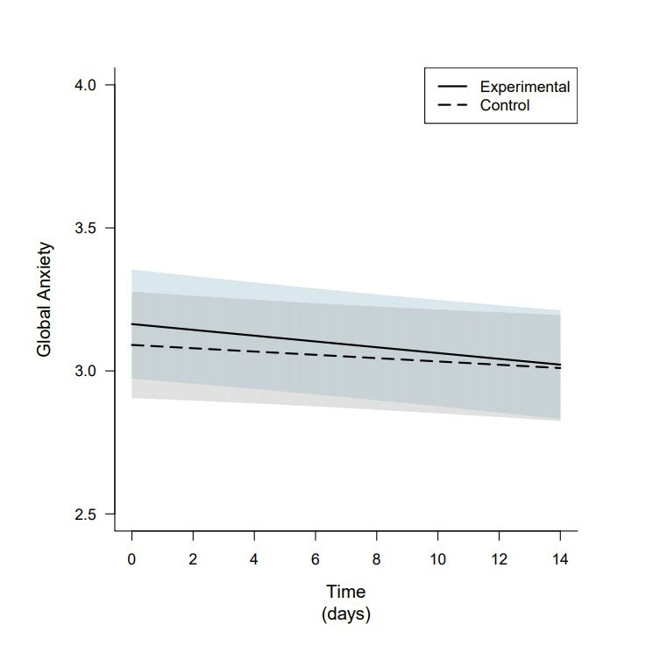

Figure S7. In Study 2, model predicted values of romantic anxiety over a period of two weeks. Romantic anxiety is unstandardized (range 1-5). Grey and blue shading = 95% prediction interval.

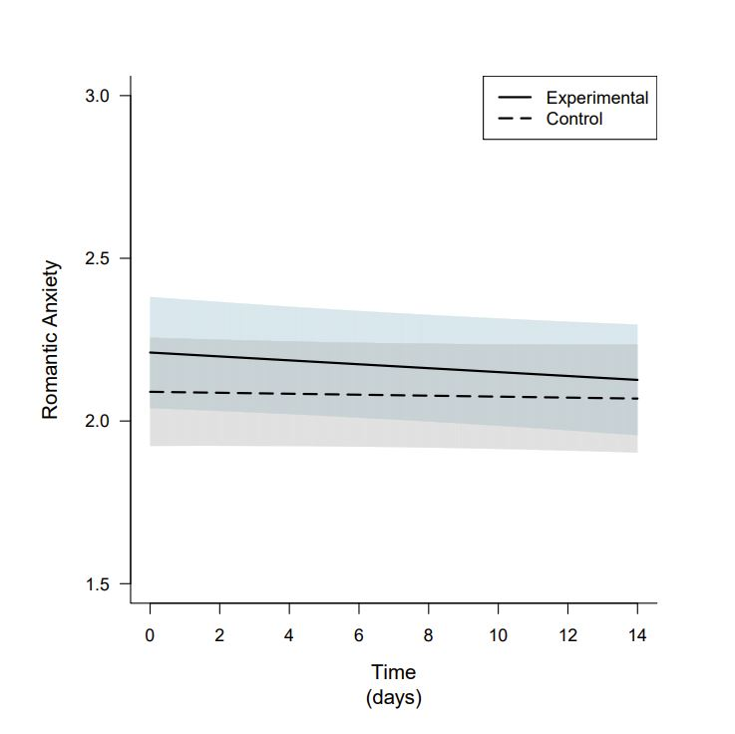

Table S7. Summary of linear mixed-effects models (STUDY 2; EXPLORATORY). We first modeled each dimension of attachment with random effects for both the intercept and the slope (a) then restricted the model to include only random effects for the intercepts (b). The column named “Converge” indicates whether or not there were issues with model convergence. Note. LSI = lock screen image before the experiment (1 = Romantic partner, 0 = Not romantic partner).

Model # | Converge | Predictor | γ | SE | t | p | σ | r
Global avoidance (a) | TRUE | Intercept | 2.586 | 0.085 | 30.470 | .000 | 0.773 | .029
 |  | Time | 0.002 | 0.004 | 0.540 | .589 | 0.026
 |  | Condition | 0.147 | 0.120 | 1.217 | .224
 |  | LSI | 0.066 | 0.131 | 0.507 | .613
 |  | T x C | 0.001 | 0.006 | 0.242 | .809
 |  | T x LSI | 0.003 | 0.006 | 0.409 | .683
 |  | C x LSI | -0.102 | 0.188 | -0.541 | .589
 |  | T x C x LSI | -0.013 | 0.009 | -1.457 | .146
Global avoidance (b) | TRUE | Intercept | 2.584 | 0.088 | 29.369 | .000 | 0.798
 |  | Time | 0.003 | 0.003 | 0.796 | .426
 |  | Condition | 0.149 | 0.125 | 1.197 | .232
 |  | LSI | 0.069 | 0.136 | 0.509 | .611
 |  | T x C | 0.001 | 0.005 | 0.245 | .806
 |  | T x LSI | 0.002 | 0.005 | 0.399 | .690
 |  | C x LSI | -0.103 | 0.195 | -0.528 | .598
 |  | T x C x LSI | -0.013 | 0.007 | -1.801 | .072
Global anxiety (a) | TRUE | Intercept | 2.976 | 0.117 | 25.341 | .000 | 1.076 | .069
 |  | Time | -0.001 | 0.006 | -0.122 | .903 | 0.040
 |  | Condition | 0.164 | 0.167 | 0.984 | .326
 |  | LSI | 0.277 | 0.181 | 1.529 | .127
 |  | T x C | -0.012 | 0.008 | -1.449 | .148
 |  | T x LSI | -0.013 | 0.009 | -1.445 | .149
 |  | C x LSI | -0.224 | 0.261 | -0.860 | .390
 |  | T x C x LSI | 0.018 | 0.013 | 1.419 | .157
Global anxiety (b) | TRUE | Intercept | 2.973 | 0.124 | 24.033 | .000 | 1.127
 |  | Time | -0.000 | 0.004 | -0.086 | .931
 |  | Condition | 0.172 | 0.175 | 0.980 | .328
 |  | LSI | 0.280 | 0.191 | 1.466 | .144
 |  | T x C | -0.012 | 0.006 | -2.046 | .041
 |  | T x LSI | -0.013 | 0.007 | -1.923 | .055
 |  | C x LSI | -0.232 | 0.275 | -0.843 | .400
 |  | T x C x LSI | 0.019 | 0.009 | 2.041 | .041
Romantic avoidance (a) | FALSE | Intercept | 1.557 | 0.051 | 30.599 | .000 | 0.438 | -.028
 |  | Time | 0.011 | 0.004 | 2.916 | .004 | 0.025
 |  | Condition | 0.133 | 0.072 | 1.845 | .066
 |  | LSI | -0.233 | 0.078 | -2.964 | .003
 |  | T x C | -0.002 | 0.005 | -0.389 | .698
 |  | T x LSI | -0.007 | 0.006 | -1.270 | .205
 |  | C x LSI | -0.066 | 0.113 | -0.580 | .562
 |  | T x C x LSI | 0.009 | 0.008 | 1.150 | .251
Romantic avoidance (b) | TRUE | Intercept | 1.558 | 0.054 | 28.623 | .000 | 0.465
 |  | Time | 0.011 | 0.003 | 3.850 | .000
 |  | Condition | 0.133 | 0.077 | 1.724 | .085
 |  | LSI | -0.232 | 0.084 | -2.771 | .006
 |  | T x C | -0.002 | 0.004 | -0.529 | .597
 |  | T x LSI | -0.007 | 0.004 | -1.634 | .103
 |  | C x LSI | -0.065 | 0.121 | -0.537 | .591
 |  | T x C x LSI | 0.009 | 0.006 | 1.468 | .142
Romantic anxiety (a) | TRUE | Intercept | 2.164 | 0.105 | 20.553 | .000 | 0.947 | .024
 |  | Time | 0.000 | 0.006 | 0.069 | .945 | 0.037
 |  | Condition | 0.179 | 0.149 | 1.196 | .233
 |  | LSI | -0.169 | 0.162 | -1.042 | .298
 |  | T x C | -0.007 | 0.008 | -0.917 | .360
 |  | T x LSI | -0.006 | 0.009 | -0.737 | .462
 |  | C x LSI | -0.170 | 0.234 | -0.729 | .466
 |  | T x C x LSI | 0.010 | 0.013 | 0.788 | .432
Romantic anxiety (b) | TRUE | Intercept | 2.160 | 0.110 | 19.598 | .000 | 0.987
 |  | Time | 0.001 | 0.004 | 0.318 | .751
 |  | Condition | 0.186 | 0.156 | 1.190 | .235
 |  | LSI | -0.167 | 0.170 | -0.981 | .327
 |  | T x C | -0.009 | 0.006 | -1.405 | .160
 |  | T x LSI | -0.007 | 0.007 | -0.991 | .322
 |  | C x LSI | -0.175 | 0.245 | -0.713 | .476
 |  | T x C x LSI | 0.010 | 0.010 | 1.051 | .294

Figure S8. In Study 2, random effects for model predicting global avoidance. Global avoidance is unstandardized (range 1–5). Exploratory analyses.
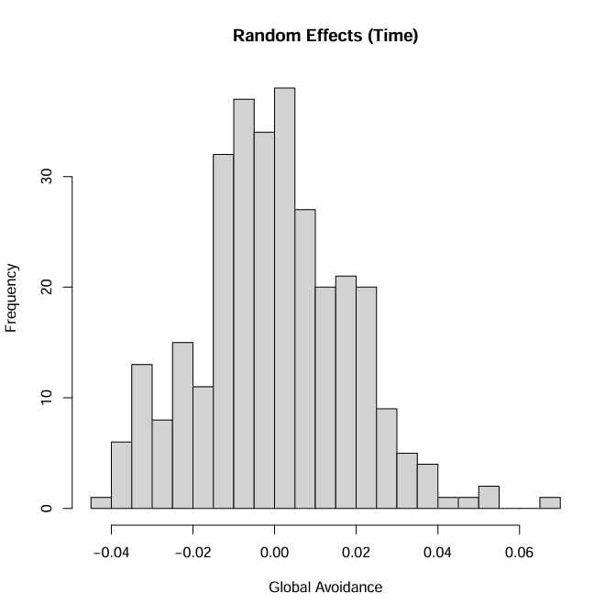
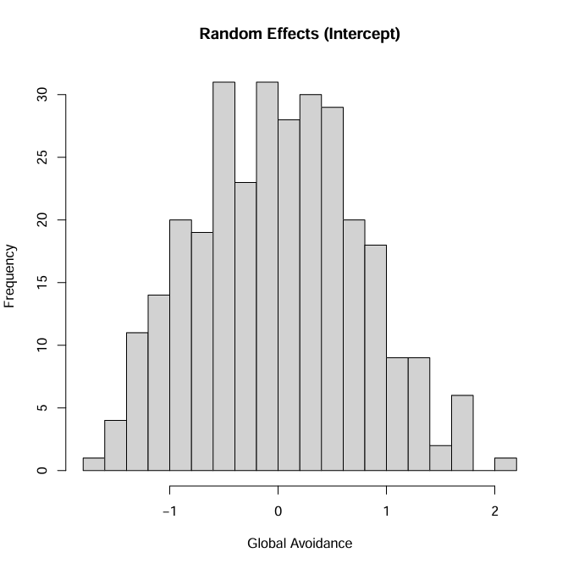

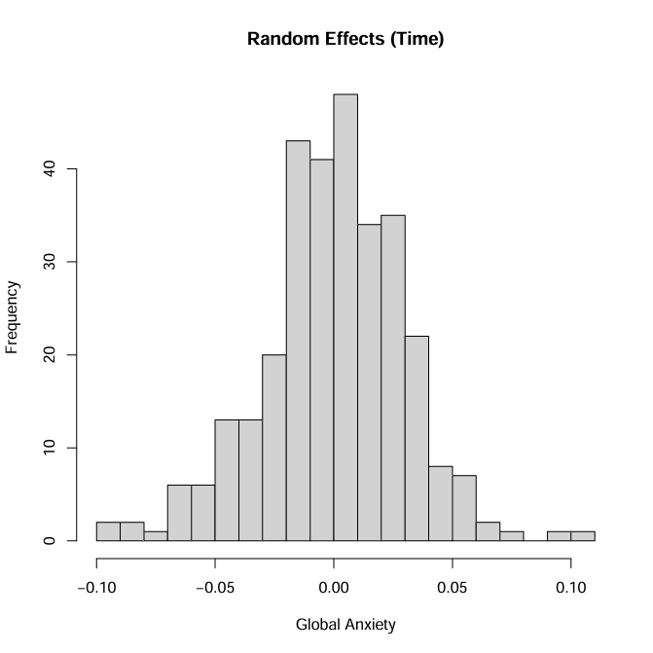
Figure S9. In Study 2, random effects for model predicting global anxiety. Global anxiety is unstandardized (range 1–5). Exploratory analyses.

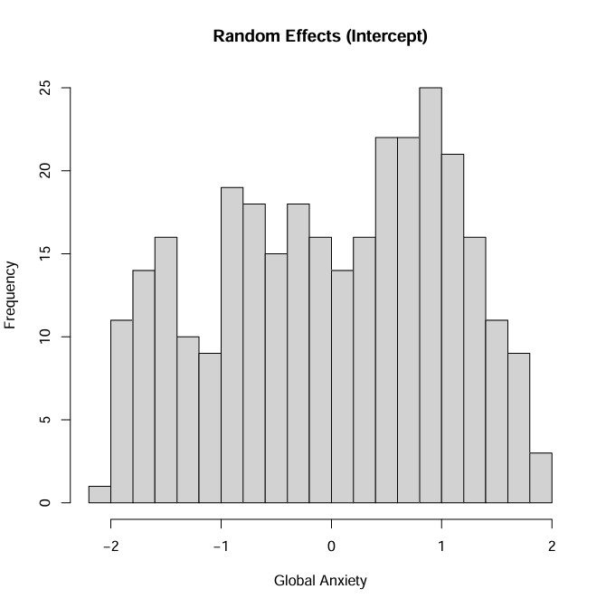

Figure S10. In Study 2, random effects for model predicting romantic avoidance. Global avoidance is unstandardized (range 1–5). Exploratory analyses.

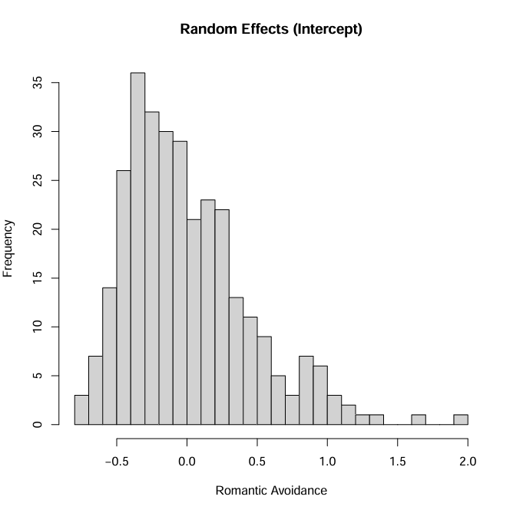

Figure S11. In Study 2, random effects for model predicting romantic anxiety. Global anxiety is unstandardized (range 1–5). Exploratory analyses.

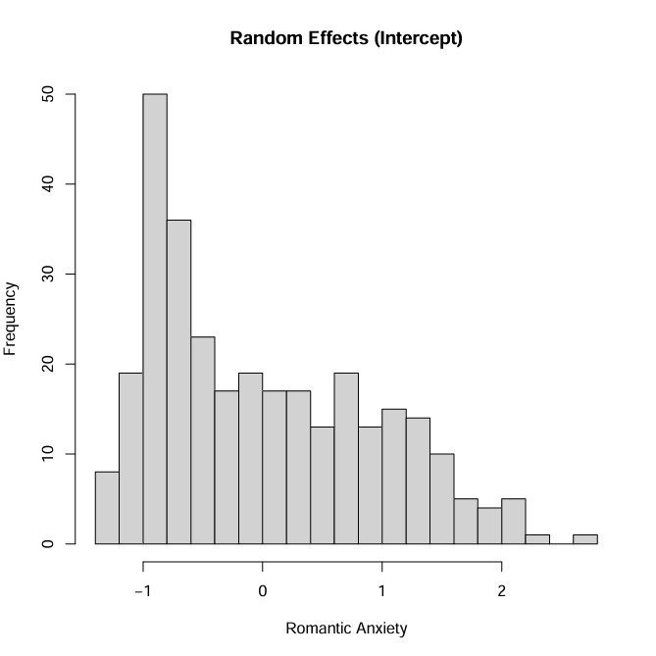
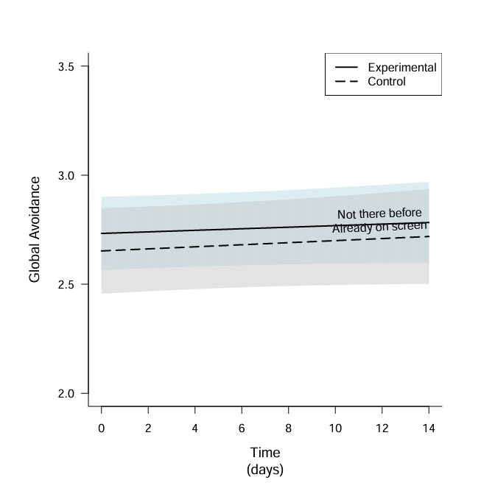
Figure S12. In Study 2, model predicted values with lock screen image before the experiment (coded 1 = Romantic partner, 0 = Not romantic partner) included as a predictor. Global avoidance is unstandardized (range 1–5). Grey and blue shading = 95% prediction interval. The solid line represents the predicted values for participants who did not have their partners on their screens before the experiment (“Not there before”) and who were randomly assigned to the experimental condition. The dashed line represents the predicted values for participants who did have their partners on their screens before the experiment (“Already on screen”) and who were assigned to the control condition.

Figure S13. In Study 2, model predicted values with lock screen image before the experiment (coded 1 = Romantic partner, 0 = Not romantic partner) included as a predictor. Global anxiety is unstandardized (range 1–5). Grey and blue shading = 95% prediction interval. The solid line represents the predicted values for participants who did not have their partners on their screens before the experiment (“Not there before”) and who were randomly assigned to the experimental condition. The dashed line represents the predicted values for participants who did have their partners on their screens before the experiment (“Already on screen”) and who were assigned to the control condition.

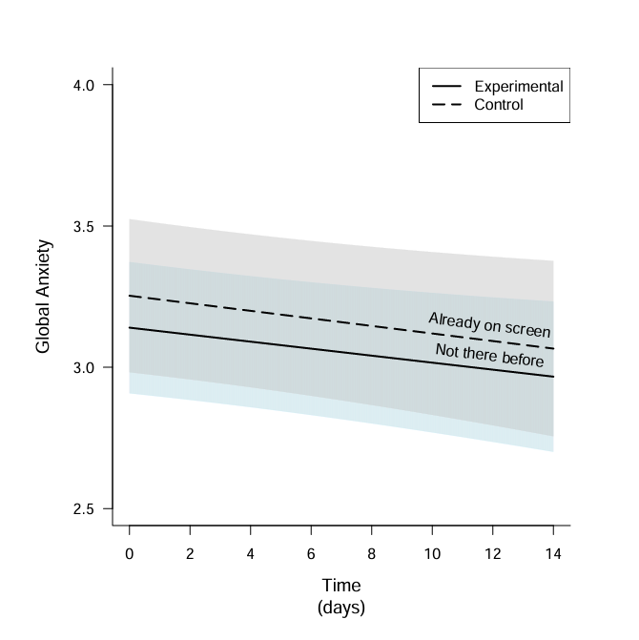

Figure S14. In Study 2, model predicted values with lock screen image before the experiment (coded 1 = Romantic partner, 0 = Not romantic partner) included as a predictor. Romantic anxiety is unstandardized (range 1–5). Grey and blue shading = 95% prediction interval. The solid line represents the predicted values for participants who did not have their partners on their screens before the experiment (“Not there before”) and who were randomly assigned to the experimental condition. The dashed line represents the predicted values for participants who did have their partners on their screens before the experiment (“Already on screen”) and who were assigned to the control condition.

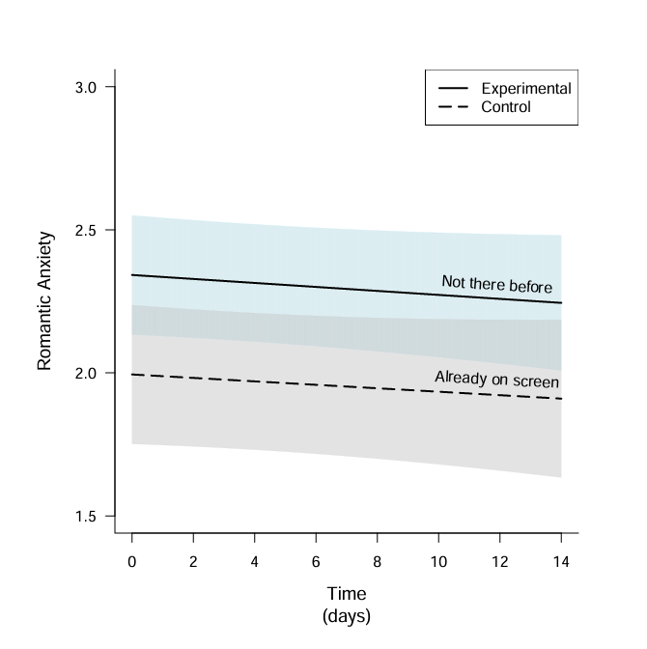
Figure S11. In Study 3, random effects for model predicting global avoidance. Global avoidance is unstandardized (range 1–5).
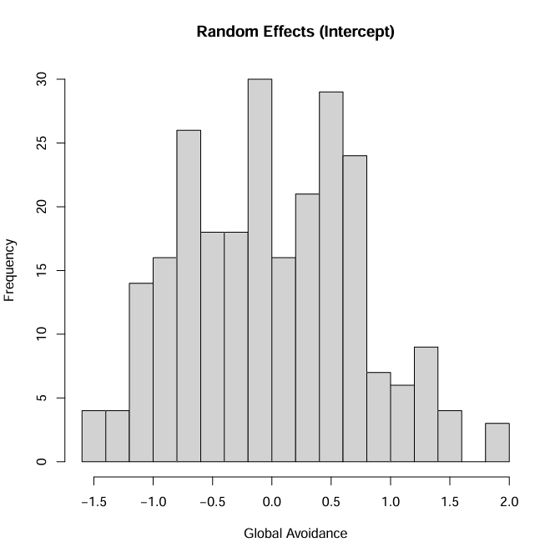

Figure S12. In Study 3, random effects for model predicting global anxiety. Global anxiety is unstandardized (range 1–5).
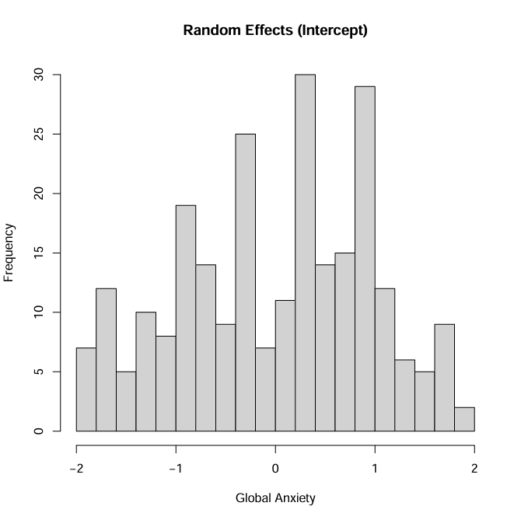

Figure S13. In Study 3, random effects for model predicting romantic avoidance. Romantic avoidance is unstandardized (range 1–5).
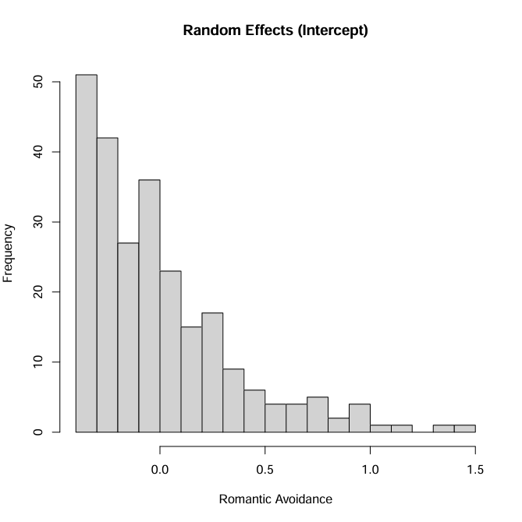

Figure S14. In Study 3, random effects for model predicting romantic anxiety. Romantic anxiety is unstandardized (range 1–5).
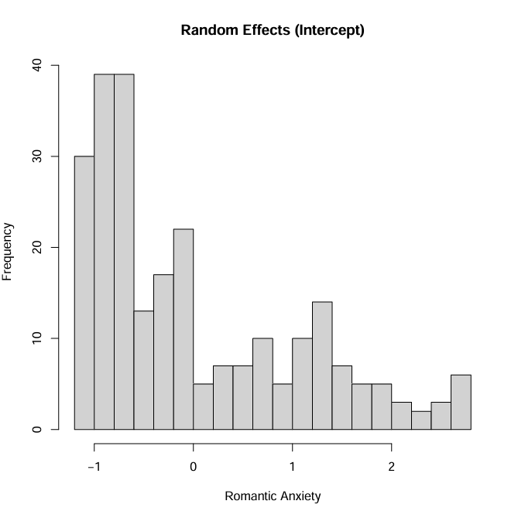

Figure S15. In Study 3, model predicted values of romantic anxiety over a period of three days. Romantic anxiety is unstandardized (range 1-5). Grey and blue shading = 95% prediction interval.

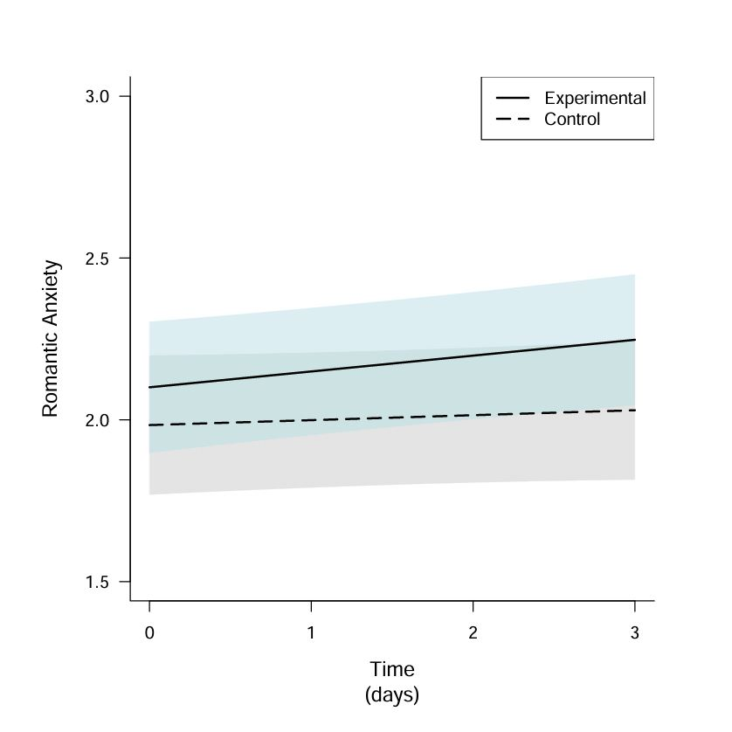

Figure S16. In Study 3, model predicted values of global avoidance over a period of three days. Global avoidance is unstandardized (range 1-5). Grey and blue shading = 95% prediction interval.

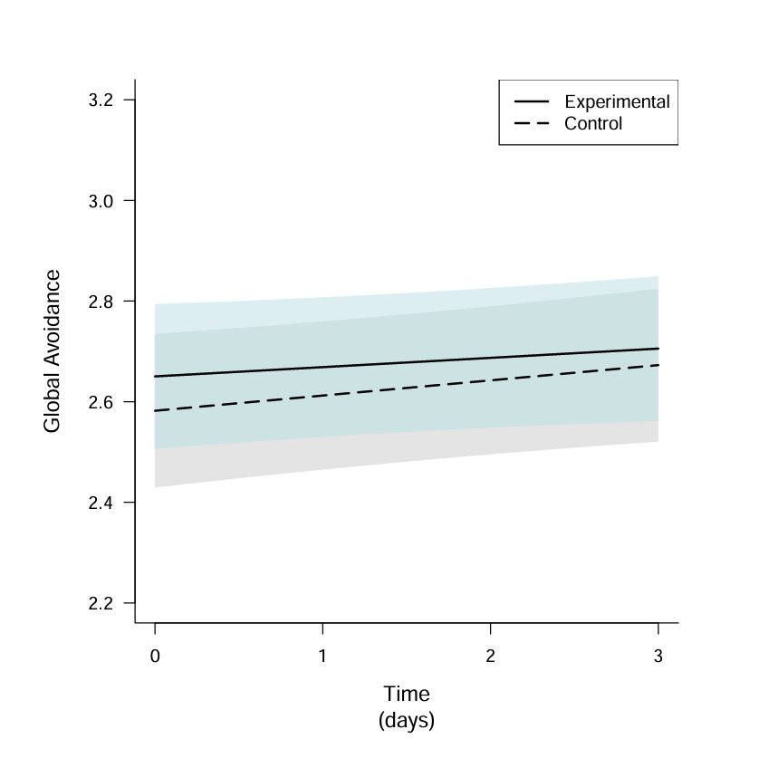

Figure S17. In Study 3, model predicted values of global anxiety over a period of three days. Global anxiety is unstandardized (range 1-5). Grey and blue shading = 95% prediction interval.

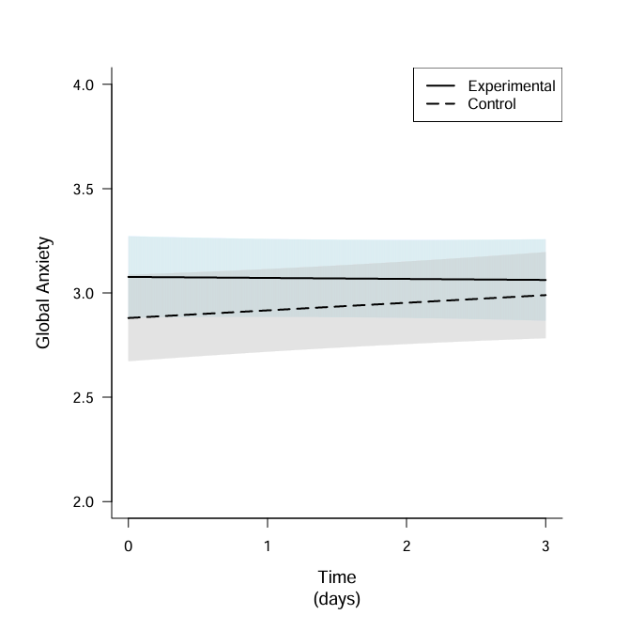

Table S8. Multiple regression models predicting attachment post-intervention (Time 6) from attachment at baseline (Time 1), experimental condition, and their interactions.

Model # | Predictor | Est | SE | t | p
Global avoidance | Intercept | 0.493 | 0.167 | 2.949 | .003
 | T1 | 0.843 | 0.063 | 13.335 | < .001
 | Condition | -0.014 | 0.227 | -0.063 | .950
 | T1 x Condition | -0.017 | 0.084 | -0.208 | .836
Global anxiety | Intercept | 0.428 | 0.193 | 2.213 | .028
 | T1 | 0.838 | 0.059 | 14.139 | < .001
 | Condition | -0.231 | 0.282 | -0.821 | .413
 | T1 x Condition | 0.070 | 0.086 | 0.820 | .413
Romantic avoidance | Intercept | 0.575 | 0.136 | 4.216 | < .001
 | T1 | 0.685 | 0.093 | 7.401 | < .001
 | Condition | -0.105 | 0.188 | -0.558 | .557
 | T1 x Condition | 0.113 | 0.123 | 0.919 | .359
Romantic anxiety | Intercept | 0.248 | 0.148 | 1.675 | .095
 | T1 | 0.917 | 0.066 | 13.797 | < .001
 | Condition | 0.002 | 0.215 | 0.011 | .991
 | T1 x Condition | -0.047 | 0.095 | -0.497 | .620
Note. T1 = baseline assessment of the outcome at Time 1.

Table S9. Correlations between qualitative variables (Sad/disappointed, Felt weird, No change) and measures of attachment.

Variable | Sad/disappointed | Felt weird | No change
T1 Romantic avoidance | -.110 | .092 | .023
T2 Romantic avoidance | .019 | -.047 | .029
T1 Romantic anxiety | -.114 | .152 | -.036
T2 Romantic anxiety | -.013 | .056 | -.046
T1 Global avoidance | .026 | -.040 | .014
T2 Global avoidance | .030 | -.014 | -.018
T1 Global anxiety | .053 | -.065 | .010
T2 Global anxiety | .091 | -.080 | -.014
Note. All correlations are non-significant at p < .05; qualitative variables are mutually exclusive.

