Online Supplementary Materials (SOM) for “Individualism-Collectivism:
Reconstructing Hofstede’s Dimension of Cultural Differences”

Part A
Table S1
Correlations Between Measures of I-C and Related Dimensions (n = 37)
Variables | (1) | (2) | (3) | (4) | (5)
(1) I-C (Hofstede) | -
(2) I-C (Minkov) | .74 | -
(3) Combined WVS-based I-C indices | .70 | .90 | -
(4) I-C (GLOBE) | .71 | .87 | .83 | -
(5) Autonomy-embeddedness values (Schwartz) | .79 | .84 | .92 | .81 | -
Note. All correlations are significant at p < .001.
Figure S1
Deviations of Hofstede’s I-C Scores from Combined I-C Scores Measured with More Recent Data (n = 37)
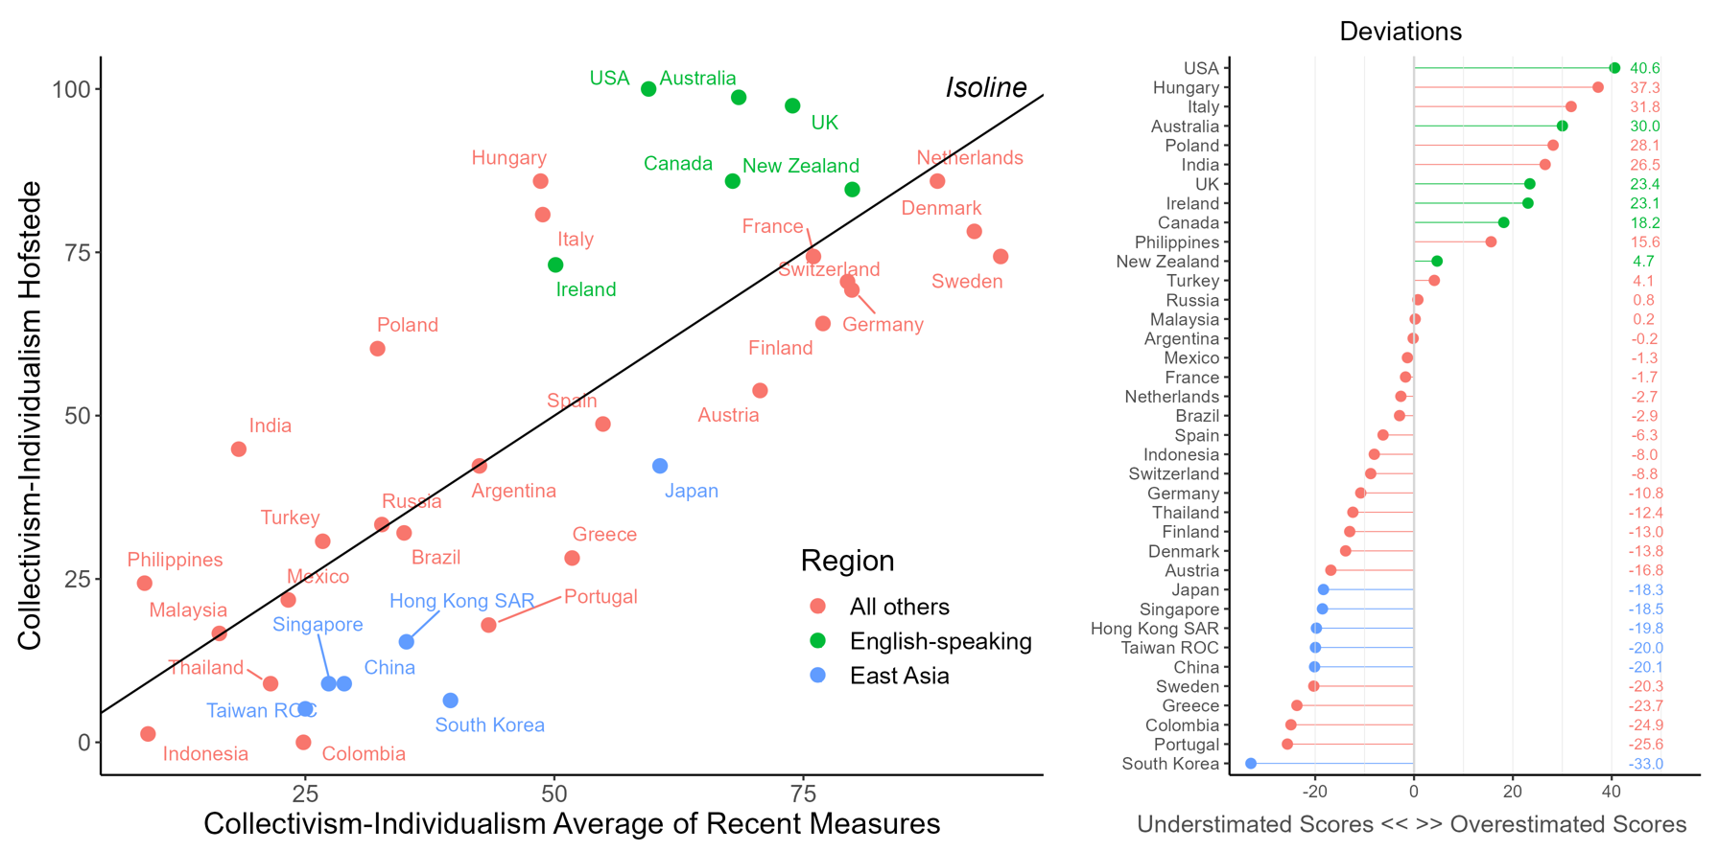
Figure S2
Difference between Hofstede's and Beugelsdijk and Welzel's (2018) I-C scores
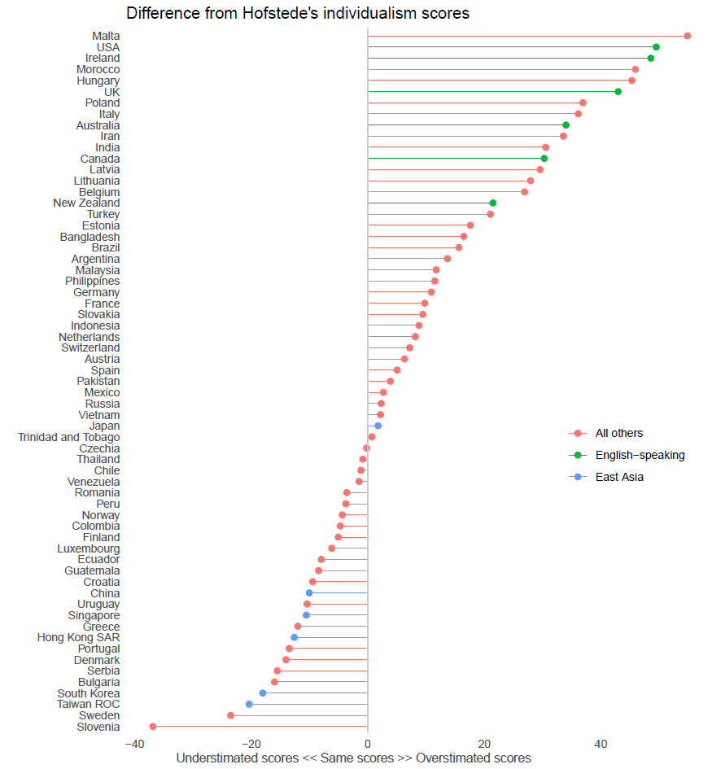

Figure S3
Difference between Hofstede's and Minkov’s (2017) I-C scores
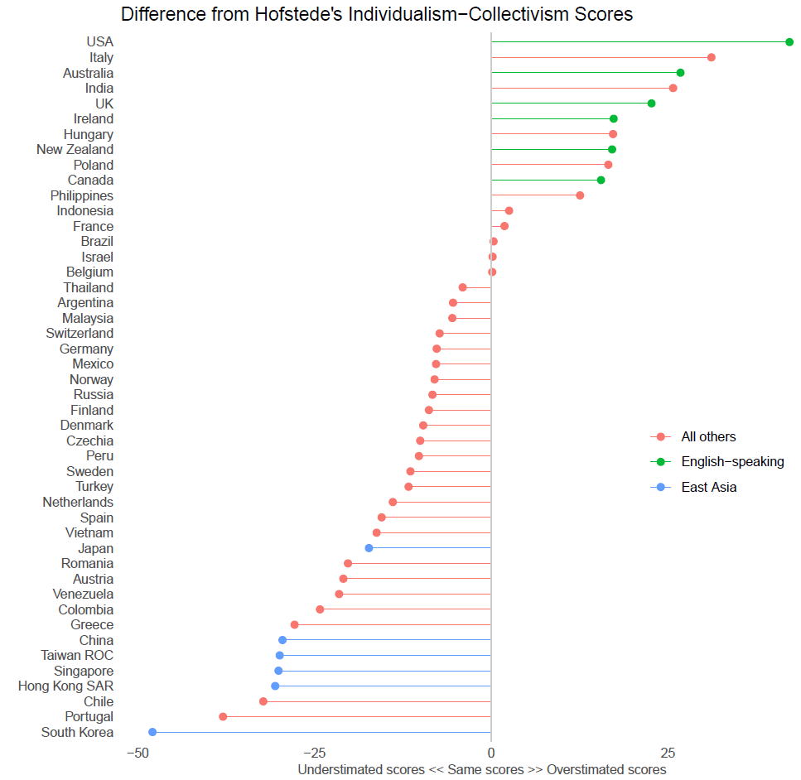

Figure S4
Difference between Hofstede's and GLOBE’s I-C scores
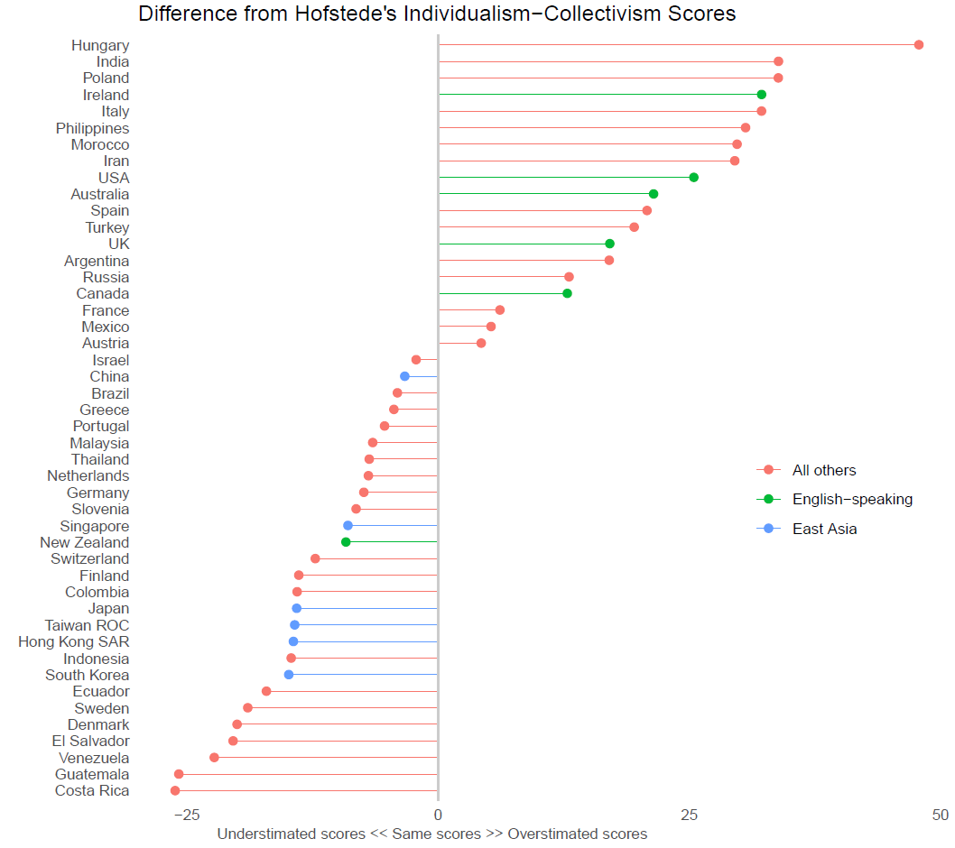

Figure S5
Difference between Hofstede's and Inglehart’s I-C scores
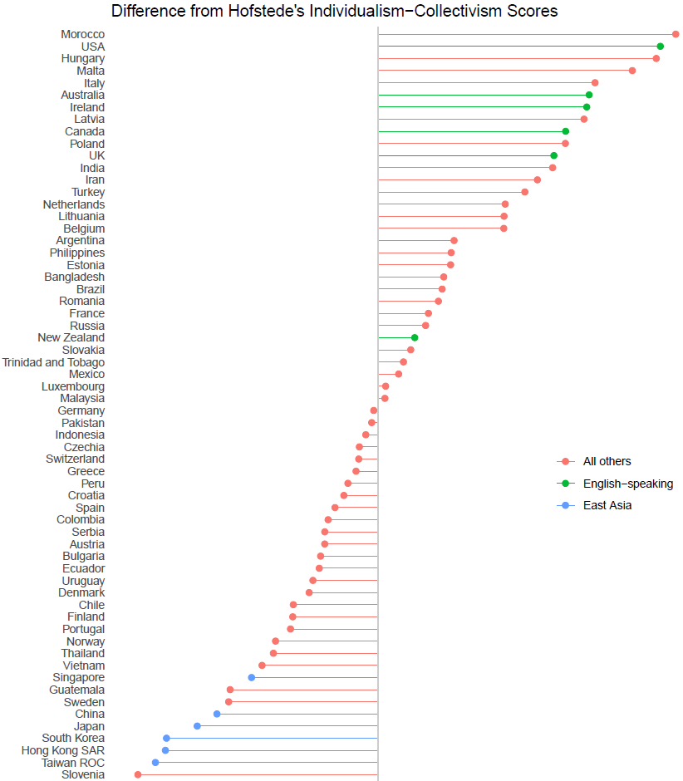

Figure S6
Difference between Hofstede's I-C and Emancipative Values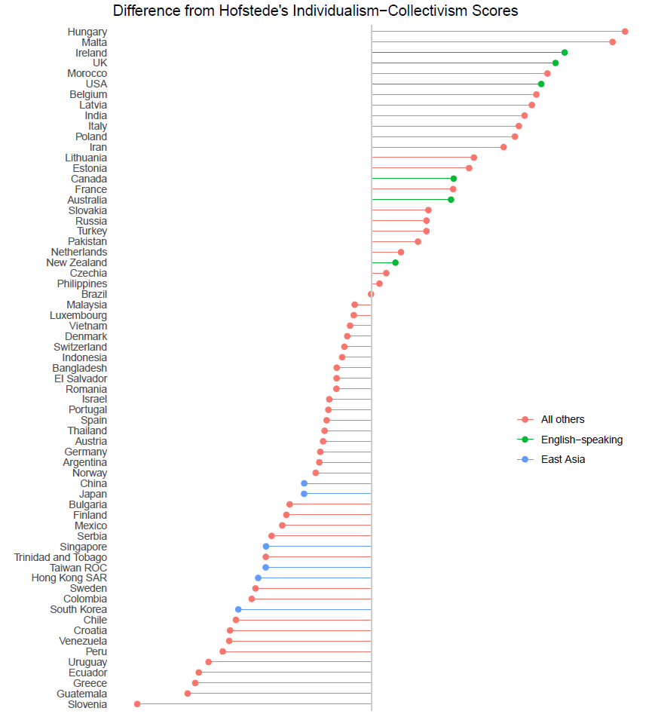

Figure S7
Difference between Hofstede's I-C and Autonomy-Embeddedness
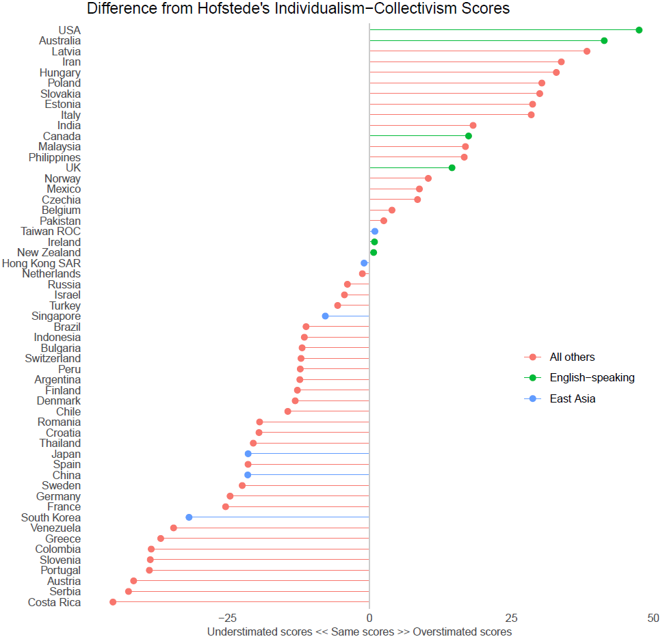

Part B
List of indicators from the Quality of Government Institute used for Nomological Network Analysis

Corruption Perceptions Index (ti_cpi)
Corruption Perceptions Index. Scale of 0-100 where a 0 equals the highest level of perceived corruption and 100 equals the lowest level of perceived corruption.

Index of Democratization (van_index)
The index of democratization is formed by multiplying the competition and the participation variables and then dividing the outcome by 100.

Political corruption index (vdem_corr) [reverse coded]
Political corruption. Question: How pervasive is political corruption?
Clarification: The directionality of the V-Dem corruption index runs from less corrupt to more corrupt (unlike the other V-Dem variables that generally run from less democratic to more democratic situation). The corruption index includes measures of six distinct types of corruption that cover both different areas and levels of the polity realm, distinguishing between executive, legislative and judicial corruption. Within the executive realm, the measures also distinguish between corruption mostly pertaining to bribery and corruption due to embezzlement. Finally, they differentiate between corruption in the highest echelons of the executive (at the level of the rulers/cabinet) on the one hand, and in the public sector at large on the other. The measures thus tap into several distinguished types of corruption: both 'petty' and 'grand'; both bribery and theft; both corruption aimed and influencing law making and that affecting implementation. Aggregation: The index is arrived at by taking the average of (a) public sector corruption index; (b) executive corruption index; (c) the indicator for legislative corruption; and (d) the indicator for judicial corruption. In other words, these
four different government spheres are weighted equally in the resulting index. V-Dem replace missing values for countries with no legislature by only taking the average of (a), (b) and (d).

Liberal democracy index (vdem_libdem)
Liberal democracy index. Question: To what extent is the ideal of liberal democracy achieved? Clarifications: The liberal principle of democracy emphasizes the importance of protecting individual and minority rights against the tyranny of the state and the tyranny of the majority. The liberal model takes a “negative” view of political power insofar as it judges the quality of democracy by the limits placed on government. This is achieved by constitutionally protected civil liberties, strong rule of law, an independent judiciary, and effective checks and balances that, together, limit the exercise of executive power. To make this a measure of liberal democracy, the index also takes the level of electoral democracy into account.

Rule of Law, Estimate (wbgi_rle)
Rule of Law - Estimate: Rule of Law includes several indicators which measure the extent to
which agents have confidence in and abide by the rules of society. These include perceptions of the incidence of crime, the effectiveness and predictability of the judiciary, and the enforceability of contracts. Together, these indicators measure the success of a society in developing an environment in which fair and predictable rules form the basis for economic and social interactions and the extent to which property rights are protected.

Government Effectiveness, Estimate (wbgi_gee)
Government Effectiveness - Estimate: “Government Effectiveness” combines into a single grouping responses on the quality of public service provision, the quality of the bureaucracy, the competence of civil servants, the independence of the civil service from political pressures, and the credibility of the government's commitment to policies. The main focus of this index is on “inputs” required for the government to be able to produce and implement good policies and deliver public goods.

Overall Global Gender Gap Index (gggi_ggi)
The Global Gender Gap Index (0 to 1, where 1 indicates no gap) examines the gap between men and women in four fundamental categories (subindexes): Economic Participation and Opportunity, Educational Attainment, Health and Survival and Political Empowerment.

Human Development Index (undp_hdi)
The HDI was created to emphasize that people and their capabilities should be the ultimate criteria for assessing the development of a country, not economic growth alone. The HDI can also be used to question national policy choices, asking how two countries with the same level of GNI per capita can end up with different human development outcomes. These contrasts can stimulate debate about government policy priorities. The Human Development Index (HDI) is a summary measure of average achievement in key dimensions of human development: a long and healthy life, being knowledgeable and have a decent standard of living. The HDI is the geometric mean of normalized indices for each of the three dimensions.
The health dimension is assessed by life expectancy at birth, the education dimension is measured by mean of years of schooling for adults aged 25 years and more and expected years of schooling for children of school entering age. The standard of living dimension is measured by gross national income per capita. The HDI uses the logarithm of income, to reflect the diminishing importance of income with increasing GNI. The scores for the three HDI dimension indices are then aggregated into a composite index using geometric mean.
The HDI simplifies and captures only part of what human development entails. It does not reflect on inequalities, poverty, human security, empowerment, etc. The HDRO offers the other composite indices as broader proxy on some of the key issues of human development, inequality, gender disparity and human poverty.

GDP per capita, PPP (current international dollar) (wdi_gdpcappppcur)
GDP per capita based on purchasing power parity (PPP). PPP GDP is gross domestic product
converted to international dollars using purchasing power parity rates. An international dollar has the same purchasing power over GDP as the U.S. dollar has in the United States. GDP at purchaser's prices is the sum of gross value added by all resident producers in the economy plus any product taxes and minus any subsidies not included in the value of the products. It is calculated without making deductions for depreciation of fabricated assets or for depletion and degradation of natural resources. Data are in current international dollars based on the 2011 ICP round.
Index of Globalization (dr_ig)
The overall index of globalization (scale of 1 to 100) is the weighted average of the following variables: economic globalization, social globalization and political globalization (dr_eg, dr_sg and dr_pg). Most weight has been given to economic followed by social globalization.

Human Capital Index (egov_hci)
The Human Capital Index (HCI) consists of four components, namely: (i) adult literacy rate; (ii) the combined primary, secondary and tertiary gross enrolment ratio; (iii) expected years of schooling; and (iv) average years of schooling.

Gender Inequality Index (0 to 1 higher disparity) (gii_gii) [reverse coded]
The GII is an inequality index. It measures gender inequalities in three important aspects of human development-reproductive health, measured by maternal mortality ratio and adolescent birth rates; empowerment, measured by proportion of parliamentary seats occupied by females and proportion of adult females and males aged 25 years and older with at least some secondary education; and economic status, expressed as labour market participation and measured by labour force participation rate of female and male populations aged 15 years and older. The GII is built on the same framework as the IHDI-to better expose differences in the distribution of achievements between women and men. It measures the human development costs of gender inequality. Thus the higher the GII value the more
disparities between females and males and the more loss to human development.

Economic Freedom Index (hf_efiscore)
The Economic Freedom index uses 10 specific freedoms, some as composites of even further detailed and quantifiable components:
- Business freedom (hf_business)
- Trade freedom (hf_trade)
- Fiscal freedom (hf_scal)
- Freedom from government (hf_govt)
- Monetary freedom (hf_monetary)
- Investment freedom (hf_invest)
- Financial freedom (hf_nanc)
- Property rights (hf_prights)
- Freedom from corruption (hf_corrupt)
- Labor freedom (hf_labor)
Each of these freedoms is weighted equally and turned into an index ranging from 0 to 100, where 100 represents the maximum economic freedom. Although changes in methodology have been undertaken throughout the measurement period, continuous backtracking has been used to maximize comparability over time.

Press Freedom Index (rsf_pfi)
The Press Freedom index measures the amount of freedom journalists and the media have in each country and the efforts made by governments to see that press freedom is respected. It does not take account of all human rights violations, only those that affect press freedom. Neither is it an indicator of the quality of a country's media.
Note: With the exception of the year 2012 the index ranges between 0 (total press freedom) and 100 (no press freedom).

Opportunity (SPI) (spi_opp)
Opportunity is one of the three components of the SPI, which are used to calculate the overall Social Progress Index. Indicators on personal rights, personal freedom and choice, inclusiveness, and access to advanced education are used to assess the level of opportunity.

Social Progress Index (spi_ospi)
Overall Social Progress Index. It aims to assess the capacity of a society to meet the basic human needs of its citizens, establish the building blocks that allow citizens and communities to enhance and sustain the quality of their lives, and create the conditions for all individuals to reach their full potential.

Media corruption (vdem_mecorrpt) [reverse coded]
Media corrupt. Question: Do journalists, publishers, or broadcasters accept payments in exchange for altering news coverage? V-Dem uses a specifically designed measurement model to provide country year point estimates, aggregated from multiple codings submitted by country experts by taking disagreement and measurement error into account. In this version of the variable, used in the QoG dataset, V-Dem has linearly translated the measurement model point estimates back to the original ordinal scale of each variable as an interval measure.

Life expectancy at birth, total (years) (wdi_lifexp)
Life expectancy at birth indicates the number of years a newborn infant would live if prevailing patterns of mortality at the time of its birth were to stay the same throughout its life.

Mortality rate, infant (per 1,000 live births) (wdi_mortinf) [reverse coded]
Infant mortality rate is the number of infants dying before reaching one year of age, per 1,000 live births in a given year.

Employment in services (% of total employment) (modeled ILO) (wdi_empser).
Total employment in services as percentage of total employment. Employment is defined as persons of working age who were engaged in any activity to produce goods or provide services for pay or profit, whether at work during the reference period or not at work due to temporary absence from a job, or to working-time arrangement. The services sector consists of wholesale and retail trade and restaurants and hotels; transport, storage, and communications; financing, insurance, real estate, and business services; and community, social, and personal services, in accordance with divisions 6-9 (ISIC 2) or categories G-Q (ISIC 3) or categories G-U (ISIC 4). Modeled ILO estimate.
Voice and Accountability, Estimate (wbgi_vae)
Voice and Accountability - Estimate: “Voice and Accountability” includes a number of indicators measuring various aspects of the political process, civil liberties and political rights. These indicators measure the extent to which citizens of a country are able to participate in the selection of governments. This category also includes indicators measuring the independence of the media, which serves an important role in monitoring those in authority and holding them accountable for their actions.

Property Rights (hf_prights)
This factor scores the degree to which a country's laws protect private property rights and the degree to which its government enforces those laws. It also accounts for the possibility that private property will be expropriated. In addition, it analyzes the independence of the judiciary, the existence of corruption within the judiciary, and the ability of individuals and businesses to enforce contracts. The less certain the legal protection of property is and the greater the chances of government expropriation of property are, the higher a country's score is. The country's property rights score ranges from 0 and 100, where 100 represents the maximum degree of protection of property rights.

Business Freedom (hf_business)
The business freedom score encompasses 10 components, all weighted equally, based on objective data from the World Bank's Doing Business study (in 2005-2006; previously other data sources were being used):
- Starting a business - procedures (number)
- Starting a business - time (days)
- Starting a business - cost (% of income per capita)
- Starting a business - minimum capital (% of income per capita)
- Obtaining a license - procedures (number)
- Obtaining a license - time (days)
- Obtaining a license - cost (% of income per capita)
- Closing a business - time (years)
- Closing a business - cost (% of estate)
- Closing a business - recovery rate (cents on the dollar)
Each of these raw components is converted into a scale graded from 0 to 100, where 100 represents the maximum degree of business freedom.

Safety and Security (1-5 Less secure) (gpi_ss) [reverse coded]
Societal Safety and Security (Scaled 1 to 5, 5 being less secure) is one of the three subdomains of the GPI. Low crime rates, minimal terrorist activity and violent demonstrations, harmonious relations with neighbouring countries, a stable political scene and a small proportion of the population being internally displaced or made refugees can be equated with peacefulness.

State Legitimacy (ffp_sl)
State Legitimacy - Corruption and lack of representativeness in the government directly undermine the social contract. Includes pressures and measures related to corruption, government effectiveness, political participation, electoral process, level of democracy, illicit economy, drug trade, protests and demonstrations, power struggles.

Human Rights and Rule of Law (ffp_hr)
Human Rights and Rule of Law - When human rights are violated or unevenly protected, the state is failing in its ultimate responsibility. Includes pressures and measures related to press freedom, civil liberties, political freedoms, human trafficking, political prisoners, incarceration, religious persecution, torture, executions.

Part C
Figure S8
Individualism-Collectivism Measures as Predictors of Obesity Rates (Marginal Effects, With 95% CI, n = 35)
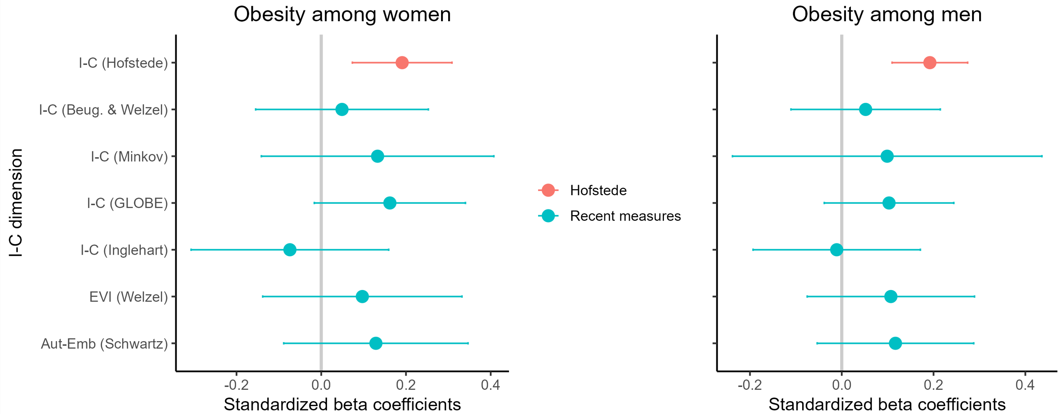
Note. The sample was fixed to the countries that were available in all seven datasets. The beta coefficients are extracted from multiple regression analyses with the following control variables: GDP per capita (log), years of schooling, a globalization index, the share of population undernourished, an indicator of uneven economic development indicator, size of government, average Worldwide Government Indices, and health expenditure per capita as share of the GDP. Variance Inflation Factors for the I-C measures were lower than 6 in all models, except for Minkov’s I-C which was 8.4.

Part D
Notes on Imputation of Missing Values
The data for some countries with missing values on items were imputed as the mean of the remaining (non-missing) items in the same domain. Below we provide details on the missing countries and data. We also report the correlation between the items with missing values and the remaining items in the same domain for the countries with non-missing data.
Wave 7
Data on “Justifiable: Homosexuality” for Tajikistan, Uzbekistan, and Egypt were missing. To address this, we used regression imputation, leveraging the four items within the same scale without missing values (excluding “Justifiable: Casual sex”) as predictors. Evaluation of the imputation model's fit yielded an R-squared value of .86 (n = 89). This demonstrates that 86% of the variance in the imputed values is accounted for by the model's predictors, suggesting a high level of model fit and instilling confidence in the imputed values for further analysis. Without imputing missing values, the coefficient alpha for the subindex remains the same (α = .96, n = 86).
Data on “Justifiable: Casual sex” were missing for Iran, Iraq, Jordan, and Egypt. To address this, we used regression imputation, leveraging the five items within the same scale without missing values as predictors. Evaluation of the imputation model's fit yielded an R-squared value of .83 (n = 88). This demonstrates that 83% of the variance in the imputed values is accounted for by the model's predictors, suggesting a high level of model fit and instilling confidence in the imputed values for further analysis. Without imputing missing values, the alpha for the subindex remains the same (α = .96, n = 86).
Data on “Preference for not having homosexuals as neighbors” were missing for Iran and Tajikistan. To address this, we used regression imputation, leveraging the two items within the same scale without missing values as predictors. Evaluation of the imputation model's fit yielded an R-squared value of .35 (n = 90). This demonstrates that 35% of the variance in the imputed values is accounted for by the model's predictors, suggesting a moderate level of model fit. Without imputing missing values, the alpha for the subindex remains the same (α = .76, n = 92).
Data on “Homosexual couples are as good parents as other couples” were missing for Iran, Iraq, Jordan, Lebanon, Morocco, Tajikistan, Tunisia, Egypt, and Uzbekistan. To address this, we used regression imputation, leveraging the three items within the same scale without missing values as predictors. Evaluation of the imputation model's fit yielded an R-squared value of .67 (n = 83). This demonstrates that 67% of the variance in the imputed values is accounted for by the model's predictors, suggesting a good level of model fit and instilling confidence in the imputed values for further analysis. Without imputing missing values, the alpha for the subindex remains the same (α = .95, n = 83).
For the items on important child qualities, respondents were supposed to choose “up to 5 qualities” from a list of 11. However, some respondents choose more than 5 qualities. These responses may be considered invalid, but they do not introduce considerable bias in our “Childrearing for self-direction (vs. conformity)” subscale because, as we had two individualism and two collectivism items in our subscale, respondents who chose more than five were equally likely to choose an individualism as well as a collectivism item. A small share of respondents also chose none of the qualities. This may have meant that respondents found none of the qualities important as socialization goals and would thus score in the middle of the scale. Another possibility is that these respondents wished not to respond to this set of items. Even though none of these invalid responses affect the validity of our subscale, it nevertheless worsens the measures of internal reliability as countries in which a larger share of the respondents chose more than five items would score higher on both the individualism and collectivism items. For that reason, we decided to recode all respondents who chose more than five (between 4,242 and 4,532 per item; up to 2.89% of the sample) or none (between 435 and 448 per item; up to 0.29% of the sample) of the qualities as missing values. To ensure reliability, we also created the subscale without recoding any responses to missing. The alpha in that case was .74, compared to .78 when invalid responses were recoded as missing. The correlation between the two versions of the subscale was .9996 (n = 92), and the means were 51.64 and 51.62, respectively, indicating the two versions were virtually identical.

Wave 6
Egypt lacked data on any of the three items comprising the “Accepting (vs. excluding) diverse others” subscale and was thus dropped from the analysis. Similarly, New Zealand lacked data on any of the six items used to create the “Equal (vs. group-based) trust” subscale and was thus dropped.
Data on “Attendance of religious services” were missing for Kuwait, Morocco, and Qatar. To address this, we used regression imputation, leveraging the two items within the same scale without missing values as predictors. Evaluation of the imputation model's fit yielded an R-squared value of .70 (n = 55). This demonstrates that 70% of the variance in the imputed values is accounted for by the model's predictors, suggesting a good level of model fit and instilling confidence in the imputed values for further analysis.
Data on “Justifiable: Homosexuality” were missing for Kuwait. To address this, we used regression imputation, leveraging the three items within the same scale without missing values (excluding “Justifiable: Euthanasia” – see below) as predictors. Evaluation of the imputation model's fit yielded an R-squared value of .89 (n = 57). This demonstrates that 89% of the variance in the imputed values is accounted for by the model's predictors, suggesting a good level of model fit and instilling confidence in the imputed values for further analysis. Without imputing missing values, the alpha for the subindex remains the same (α = .95, n = 28).
Data on “Justifiable: Euthanasia” were missing for 29 countries. To address this, we used regression imputation, leveraging the four items within the same scale without missing values (after computing the missing value on “Justifiable: Euthanasia” for Kuwait – see above) as predictors. Evaluation of the imputation model's fit yielded an R-squared value of .80 (n = 29). This demonstrates that 80% of the variance in the imputed values is accounted for by the model's predictors, suggesting a good level of model fit and instilling confidence in the imputed values for further analysis. Without imputing missing values, the alpha for the subindex remains the same (α = .95, n = 28).
The items “Justifiable: Casual sex”, “Child’s duty: Taking care of ill parents”, and “Homosexual couples are as good parents as other couples” were unavailable in wave 6 and they were not imputed. The subindices were created without these items.
Data on “Preference for not having homosexuals as neighbors” were missing for Japan and Kuwait. To address this, we used regression imputation, leveraging the two items within the same scale without missing values as predictors. Evaluation of the imputation model's fit yielded an R-squared value of .27 (n = 56). This demonstrates that 27% of the variance in the imputed values is accounted for by the model's predictors, suggesting a moderate level of model fit. Without imputing missing values, the alpha for the subindex remains the same (α = .72, n = 58).
Data on “When jobs are scarce, local nationals should have more rights to jobs” were missing for Algeria, Palestine, Iraq, Lebanon, and Tunisia. To address this, we used regression imputation, leveraging the two items within the same scale without missing values as predictors. Evaluation of the imputation model's fit yielded an R-squared value of .36 (n = 53). This demonstrates that 36% of the variance in the imputed values is accounted for by the model's predictors, suggesting a moderate level of model fit. Without imputing missing values, the alpha for the subindex remains the same (α = .76, n = 53).
For the items on important child qualities, respondents were supposed to choose “up to 5 qualities” from a list of 11. However, some respondents choose more than 5 qualities. These responses may be considered invalid, but they do not introduce considerable bias in our “Childrearing for self-direction (vs. conformity)” subscale because, as we had two individualism and two collectivism items in our subscale, respondents who chose more than five were equally likely to choose an individualism as well as a collectivism item. A small share of respondents also chose none of the qualities. This may have meant that respondents found none of the qualities important as socialization goals and would thus score in the middle of the scale. Another possibility is that these respondents wished not to respond to this set of items. Even though none of these invalid responses affect the validity of our subscale, it nevertheless worsens the measures of internal reliability as countries in which a larger share of the respondents chose more than five items would score higher on both the individualism and collectivism items. For that reason, we decided to recode all respondents who chose more than five (n = 6,706; 7.49% of the sample) or none (n = 906; 1.01% of the sample) of the qualities as missing values. To ensure reliability, we also created the subscale without recoding any responses to missing. The alpha in that case was .61, compared to .69 when invalid responses were recoded as missing. The correlation between the two versions of the subscale was .9985 (n = 58), and the means were 47.16 and 47.08, respectively, indicating the two versions were virtually identical.

Part E
Table S2
Unadjusted Principal Component Loadings (Unrotated and Normalized to Eigenvalues) With Eigenvalues and Proportion Explained Variance for Each Component (Left Panel), Loadings on First Factor from Explanatory Factory Analysis (EFA) (Middle Panel) and on a Single Factor in Confirmatory Factor Analysis (CFA) (Right Panel) Using Data From WVS/EVS Wave 7 (Study 2a)
 | Component from Principal Component Analysis (Eigenvalue; proportion explained variance) |  |  |  |  |  |  | Factor loadings on EFA (Principal Factors) | Standardized factor loadings on CFA
Variable | Comp 1  (4.51; 75%) | Comp 2  (.81; 13%) | Comp 3  (.33; 5%) | Comp 4  (.18; 3%) | Comp 5  (.12; 2%) | Comp 6  (.06; 1%) |  | Factor 1  (4.32; 91%) | Standardized factor loadings on CFA
Childrearing for self-direction | 0.79 | -0.53 | 0.20 | 0.19 | 0.10 | 0.08 |  | 0.77 | 0.69
Distancing from traditional duties | 0.92 | -0.28 | 0.15 | -0.12 | -0.12 | -0.16 |  | 0.92 | 0.88
Egalitarian beliefs | 0.91 | 0.28 | 0.01 | -0.14 | 0.26 | -0.03 |  | 0.90 | 0.88
Equal trust | 0.87 | -0.06 | -0.47 | 0.15 | -0.02 | -0.04 |  | 0.82 | 0.82
Accepting diverse others | 0.74 | 0.60 | 0.20 | 0.21 | -0.09 | 0.00 |  | 0.70 | 0.69
Accepting diverse life choices | 0.96 | 0.04 | -0.05 | -0.21 | -0.12 | 0.16 |  | 0.95 | 0.99

Robustness Check Using Exploratory and Confirmatory Factor Analyses (Study 2a)
As a robustness check for our Study 2a findings, we ran two sets of alternative analyses adopting commonly used factor analytic approaches instead of our theoretically based choice of principal component analysis. We ran a principal‐factor exploratory factor analysis of the six subindices with the Wave 7 date (n = 92) which strongly favored a one factor-solution. The first factor had an eigenvalue of 4.32, alone accounting for 91.1% of the common variance, while the second’s eigenvalue was just 0.56 (≈11.7% of the common variance). As shown in Table S2, all six items loaded highly on the first factor (ranging from .70 to .95), consistent with a single underlying Individualism–Collectivism factor. Factor scores saved from this first factor correlated with our composite I-C index at r = .9943, indicating that they are virtually identical.
We also conducted a confirmatory factor analysis representing the six subindices comprising our Individualism-Collectivism index with a single latent factor. Based on modification indices, we freed the covariances for two pairs of residuals: Childrearing for Self-Direction and Distancing from Traditional Duties, as well as Egalitarian Beliefs and Accepting Diverse Others. The resulting model showed a nonsignificant departure from the observed data, χ²(7) = 13.91, p = .053, and a pattern of acceptable and good fit indices: RMSEA = .104, 90% CI [.000, .184], with pclose = .122; CFI = .988; TLI = .975; and SRMR = .040. Although the point estimate for RMSEA was higher than the desirable range of < .08, this was considered acceptable considering that the 90% confidence interval for RMSEA included zero. The coefficient of determination was .990, indicating that the model explains nearly all the observed variance. As shown in Table S2, standardized loadings ranged from .69 to .99. While this analysis was not our preferred measurement strategy for theoretical reasons, it demonstrates that the covariation among our six subindices can plausibly be captured by a single Individualism-Collectivism factor.
Figure S10
Scree Plot of Eigenvalues from Exploratory Factor Analysis (Principal Factors) of Subindices with Wave 7 (Study 2a)
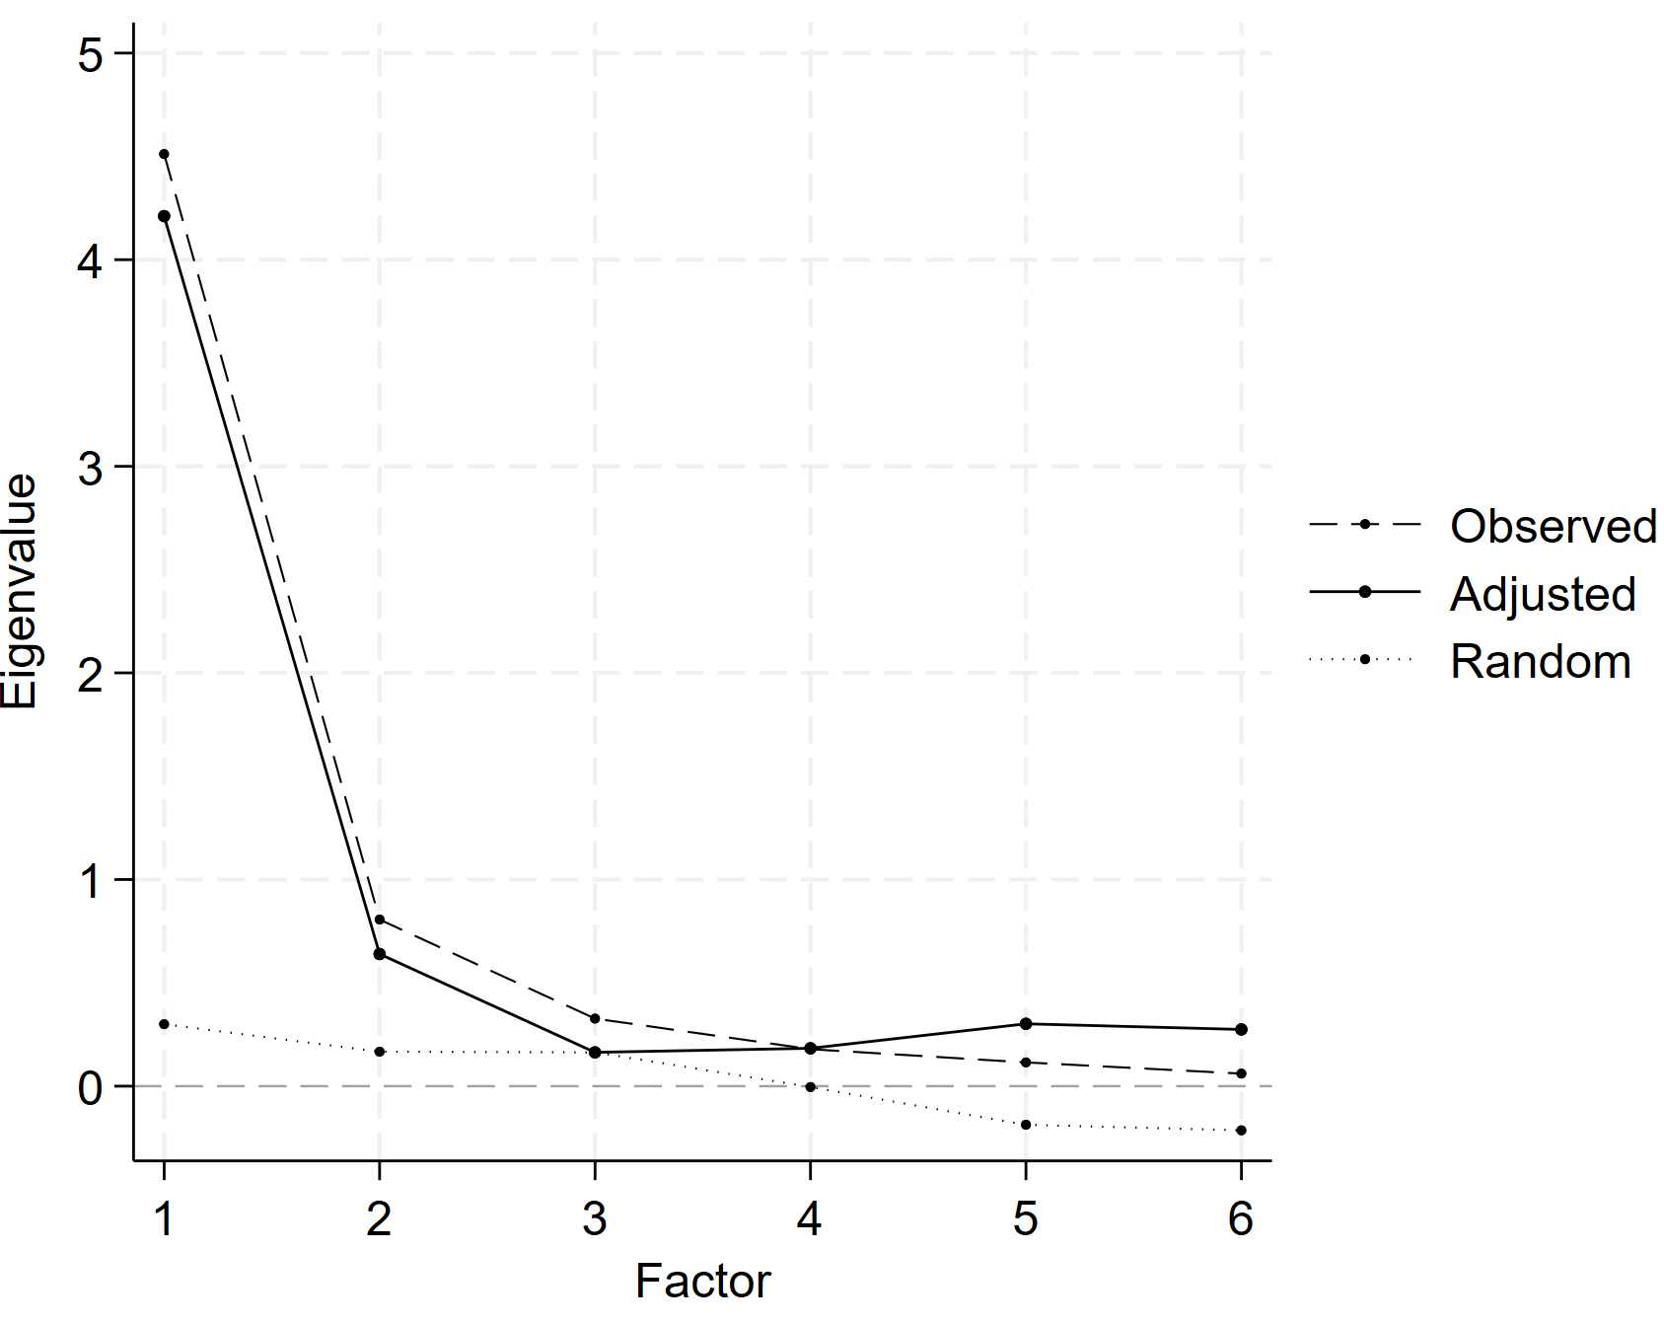

Table S3
Unadjusted Principal Component Loadings (Unrotated and Normalized to Eigenvalues) With Eigenvalues and Proportion Explained Variance for Each Component (Left Panel), Loadings on First Factor from Explanatory Factory Analysis (EFA) (Middle Panel) and on a Single Factor in Confirmatory Factor Analysis (CFA) (Right Panel) Using Data from WVS/EVS Wave 6 (Study 2b)
 | Component from Principal Component Analysis (Eigenvalue; proportion explained variance) |  |  |  |  |  |  | Factor loadings on EFA (Principal Factors) | Factor loadings on CFA
Variable | Comp 1  (4.15; 69%) | Comp 2  (.88; 15%) | Comp 3  (.47; 8%) | Comp 4  (.18; 3%) | Comp 5  (.16; 3%) | Comp 6  (.16; 2%) |  | Factor 1  (3.87; 92%) | Factor loadings on CFA
Childrearing for self-direction | 0.77 | 0.57 | -0.07 | 0.19 | -0.18 | -0.10 |  | 0.74 | 0.67
Distancing from traditional duties | 0.85 | 0.40 | -0.18 | -0.7 | 0.21 | 0.20 |  | 0.83 | 0.77
Egalitarian beliefs | 0.89 | -0.30 | -0.07 | -0.16 | -0.26 | 0.14 |  | 0.87 | 0.84
Equal trust | 0.78 | -0.07 | 0.61 | 0.07 | 0.05 | 0.05 |  | 0.72 | 0.72
Accepting diverse others | 0.76 | -0.54 | -0.23 | 0.25 | 0.09 | -0.01 |  | 0.72 | 0.72
Accepting diverse life choices | 0.93 | -0.06 | -0.03 | -0.20 | 0.09 | -0.27 |  | 0.92 | 0.98

Robustness Check Using Exploratory and Confirmatory Factor Analyses (Study 2b)
As a robustness check for our Study 2b findings, we ran two sets of alternative analyses adopting commonly used factor analytic approaches instead of our theoretically based choice of principal component analysis. We conducted a principal-factor exploratory factor analysis of the six subindices constructed from Wave 6 data (n = 58). The results again strongly supported a one-factor solution. The first factor had an eigenvalue of 3.87, accounting for 91.7% of the common variance. The second factor’s eigenvalue was just 0.60 (14.1% of the common variance), indicating a steep drop in explained variance. All six subindices loaded highly on the first factor, with standardized loadings ranging from 0.72 to 0.92. These results suggest that the subindices cohere around a single underlying Individualism–Collectivism factor. Factor scores saved from the first factor correlated with our composite I-C index at r = .996, indicating that they are virtually identical.
To further assess this structure, we conducted a confirmatory factor analysis specifying a single latent factor underlying the six subindices. Modification indices suggested allowing residual covariances between Childrearing for Self-Direction and Distancing from Traditional Duties, and between Egalitarian Beliefs and Accepting Diverse Others (identical to the Wave 7 model). The model demonstrated excellent fit: χ²(7) = 9.01, p = .252; RMSEA = .071, 90% CI [.000, .187], p = .343; CFI = .993; TLI = .984; SRMR = .043; and CD = .961. These results confirm that the Wave 6 subindices can be meaningfully modeled as expressions of a single latent construct, even though this CFA was performed primarily demonstration purposes rather than to guide our measurement strategy.

Figure S11
Scree Plot of Eigenvalues from Exploratory Factor Analysis (Principal Factors) of Subindices with Wave 6 (Study 2b)

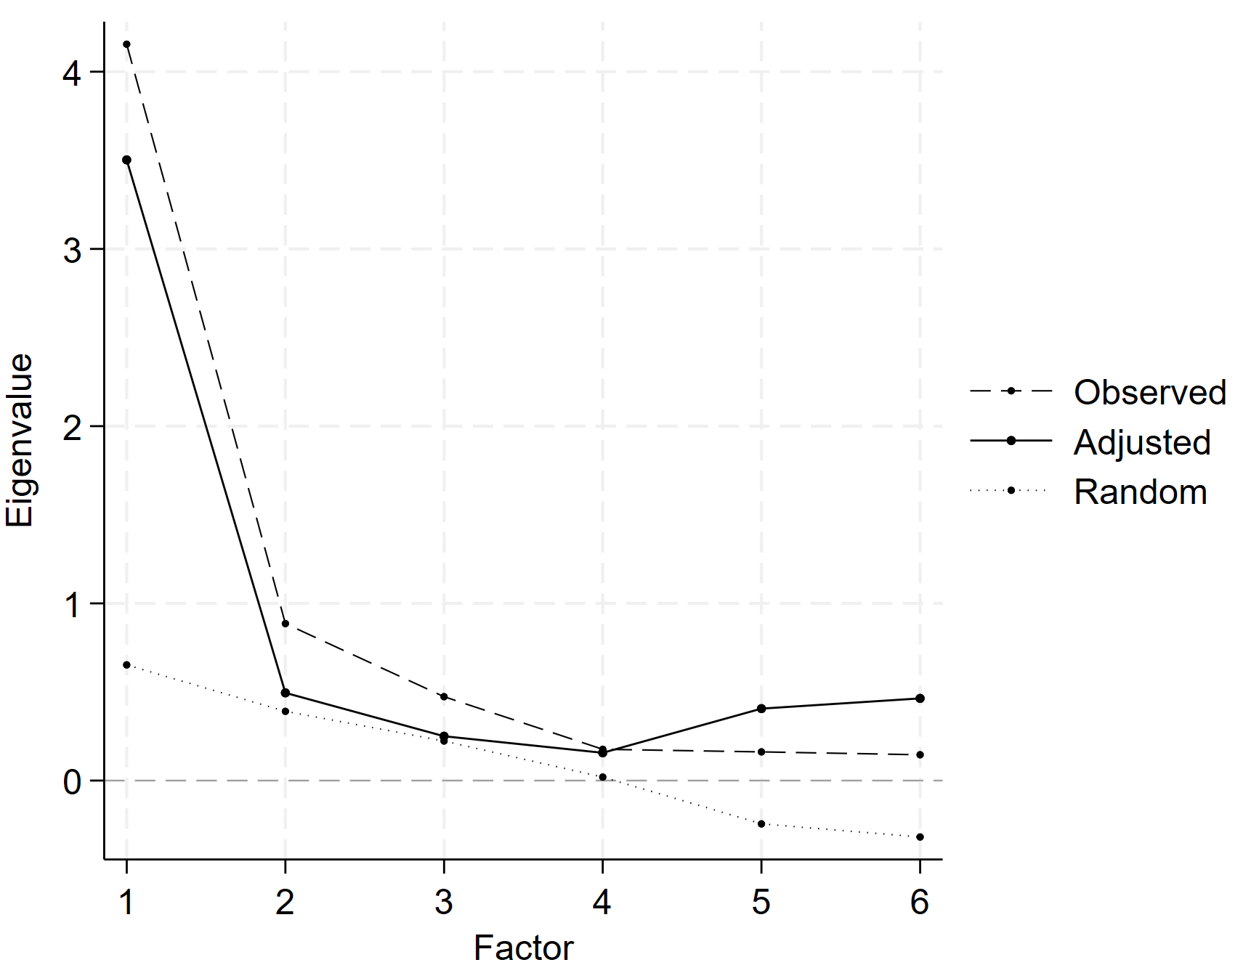

Part F
Table S5
Predicting the Missing Values in Wave 7 (n = 10) with Regressions (n = 48) for the Final I-C Index (n = 102)
Childrearing for self-direction (vs. obedience) | R²
Important child qualities: independence | .83
Important child qualities: imagination | .49
Important child qualities: obedience (r) | .83
Important child qualities: religious faith (r) | .92
Distancing from (vs. prioritizing) traditional duties
Making parents proud is one of the main goals in life (r) | .85
Adult children have the duty to provide long-term care for their parents (r) [Wave 7] | .63
Attendance of religious services (r) | .90
Religion is important in life (r) | .97
Egalitarian (vs. discriminatory) beliefs
When jobs are scarce, men should have more rights to a job than women (r) | .89
When jobs are scarce, employers should give priority to people of this country over immigrants (r) | .85
A university education is more important for a boy than for a girl (r) | .76
Men make better business executives than women do (r) | .87
Men make better political leaders than women do (r) | .93
Homosexual couples are as good parents as other couples [Wave 7] | .69
Equal (vs. group-based) trust
Reversed SD score based on Trust in six targets of varying social groups: (i) family, (ii) people you know personally, (iii) people from the same neighbourhood, (iv) people of another nationality, (v) people of another religion, (vi) people you meet for the first time. | .69
Accepting (vs. excluding) diverse others
Not wanting as neighbours: homosexuals (r) | .82
Not wanting as neighbours: people from another race (r) | .47
Not wanting as neighbours: immigrants/foreign workers (r) | .60
Accepting (vs. condemning) diverse life choices
Justifiable: homosexuality | .92
Justifiable: abortion | .90
Justifiable: divorce | .88
Justifiable: suicide | .75
Justifiable: euthanasia | .79
Justifiable: casual sex [Wave 7] | .80

Part G
Modifications of Welzel’s (2013) classification of culture zones:
- “Sinic East” was renamed “East Asia”, which we believe is a more common and intuitive label for this cultural region – see e.g., Akaliyski (2023).
- “Indic East” was renamed “South and Southeast Asia” due to the inclusion of more countries in that part of the world that may not identify as strongly with Indian culture. We borrowed this label from the latest Inglehart-Welzel WVS cultural map of the world.
- Vietnam was moved from “Sinic East” (now “East Asia”) to the newly labeled “South and Southeast Asia” zone. Although Vietnam has been influenced by China, it has always been part of “South Asia” in the WVS cultural map of the world and in the “South and Southeast Asia” in the most recent version of the map, instead of the “Confucian” culture zone, which corresponds to “East Asia”.
- Singapore was moved from “Indic East” (now “South and Southeast Asia”). The reason is that even though the country belongs geographically to Southeast Asia, approximately three quarters of its citizens and permanent residents are ethnic Chinese (for a discussion, see Akaliyski, 2023).
- Kyrgyzstan was moved from “Orthodox East” to “Islamic”. The reason is that approximately 90% of the population is Muslim and the country clusters within the “African-Islamic” cultural zone on the latest WVS cultural map, instead of the “Orthodox” one.
List of Countries in each Culture Zone:
Reformed West (West European Protestant): Germany, Great Britain, Denmark, Finland, Iceland, Netherlands, Northern Ireland, Norway, Sweden, and Switzerland.
New West (developed former British colonies): Australia, Canada, New Zealand, and the US.
Old West (Western European Catholic): Andorra, Austria, France, Italy, Portugal, and Spain.
Returned West (former communist Catholic or Protestant): Croatia, Czechia, Estonia, Hungary, Latvia, Lithuania, Poland, Slovakia, and Slovenia.
East Asia (Confucianism-influenced cultures): China, Japan, Hong Kong SAR, Macao SAR, Mongolia, South Korea, Singapore, and Taiwan.
Latin America: Argentina, Bolivia, Brazil, Chile, Colombia, Ecuador, Guatemala, Haiti, Mexico, Nicaragua, Peru, Puerto Rico, Trinidad and Tobago, Uruguay, and Venezuela.
Orthodox (or European Muslim/Orthodox): Albania, Armenia, Bosnia and Herzegovina, Bulgaria, Belarus, Cyprus, Georgia, Greece, Montenegro, Romania, Russia, Serbia, Ukraine, and North Macedonia.
South and South-East Asia: India, Indonesia, Myanmar, Malaysia, Maldives, Philippines, Vietnam, Thailand.
Islamic: Algeria, Azerbaijan, Bangladesh, Egypt, Iran, Iraq, Kazakhstan, Jordan, Kuwait, Kyrgyzstan, Lebanon, Libya, Maldives, Morocco, Palestine, Pakistan, Qatar, Tajikistan, Tunisia, Türkiye, Uzbekistan, and Yemen.
Sub-Saharan Africa: Ethiopia, Ghana, Nigeria, Kenya, Rwanda, South Africa, and Zimbabwe.

Part H
Table S6
Comparison of Nomological and Concurrent Validity of Hofstede’s and the New I-C Indices
Indicator | Full Sample |  | Same sample
Indicator | r with New I-C | n | r with New I-C | r with Hofstede I-C | n
Business Freedom | .62 | 96 | .67 | .53 | 58
Corruption Perception | .91 | 95 | .87 | .69 | 58
Economic Freedom | .58 | 94 | .59 | .49 | 58
Education | .72 | 97 | .78 | .68 | 58
Employment in Services (%) | .69 | 95 | .81 | .57 | 57
GDP/capita | .69 | 93 | .80 | .62 | 57
Gender Inequality Index (r) | .76 | 92 | .80 | .59 | 56
Global Collectivism (r) | .86 | 96 | .87 | .73 | 58
Global Gender Gap Index (r) | .71 | 89 | .73 | .47 | 57
Globalization | .71 | 96 | .79 | .68 | 57
Government Effectiveness | .82 | 97 | .83 | .67 | 58
Human Development Index (HDI) | .79 | 96 | .85 | .66 | 57
Human Capital | .72 | 96 | .79 | .62 | 57
Human Rights & Rule of Law | .84 | 95 | .81 | .64 | 57
Index of Democratization | .67 | 97 | .63 | .56 | 58
Infant mortality (r) | .60 | 96 | .67 | .47 | 57
Liberal Democracy | .76 | 96 | .74 | .61 | 58
Life expectancy | .68 | 95 | .80 | .52 | 57
Media corruption (r) | .63 | 96 | .68 | .52 | 58
Opportunity | .87 | 92 | .89 | .71 | 56
Political Corruption | .78 | 96 | .82 | .66 | 58
Press Freedom | .66 | 97 | .73 | .59 | 58
Property Rights | .77 | 95 | .80 | .65 | 58
Rule of Law | .81 | 97 | .84 | .70 | 58
Safety & Security | .68 | 95 | .71 | .58 | 58
Social Progress Index | .83 | 92 | .87 | .65 | 56
State Legitimacy | .86 | 95 | .86 | .68 | 57
Voice & Accountability | .80 | 97 | .79 | .68 | 58

Part I
Table S7
Zero-Order Correlations Among Predictors of Individualism-Collectivism (n = 52)
 | NI-CI | HI-CI | GDP/cap | E | FSI | EiS | CWI | DfNAC | HPL | WFP
New I-C Index (NI-CI) | -
Hofstede I-C Index (HI-CI) | .73 | -
GDP per capita (GDP/cap) | .86 | .72 | -
Education (E) | .78 | .70 | .70 | -
Fragile States Index (FSI) | -.91 | -.71 | -.82 | -.83 | -
Employment in Service (EiS) | .84 | .64 | .75 | .78 | -.81 | -
Cool Water Index (CWI) | .91 | .79 | .80 | .84 | -.90 | .81 | -
Distance from Nearest Agrarian Center (DfNAC) | .48 | .32 | .30 | .45 | -.44 | .49 | .41 | -
Historical Pathogen Load (HPL) | -.62 | -.66 | -.61 | -.80 | .67 | -.57 | -.76 | -.28 | -
Western Family Patterns in 1850 (WFP) | .85 | .65 | .77 | .79 | -.87 | .73 | .80 | .49 | -.56 | -
Kinship Intensity Index (KII) | -.52 | -.26 | -.38 | -.53 | .42 | -.63 | -.40 | -.45 | .21 | -.48

Part J
Table S8
Zero-Order Correlations Among Variables Used in Discriminant Validity Analyses
 |  | World Giving Index (reversed) | Self (vs. Other) Care | Cooperation (reversed) | Egoism (vs. Altruism) | Anomie | Perception of anomie | Competition is good (WVS) | We need larger income differences as incentives (WVS) | People can only get rich at the expense of others (WVS) | Belief in a Zero-Sum Game | Flexibility (vs. Monumentalism)
Self (vs. Other) Care | r | .23* | -
Self (vs. Other) Care | n | 82
Cooperation (reversed) | r | .14 | .08 | -
Cooperation (reversed) | n | 39 | 39
Egoism (vs. Altruism) | r | .16 | .46** | .30 | -
Egoism (vs. Altruism) | n | 41 | 42 | 26
Anomie | r | -.13 | .13 | .04 | .09 | -
Anomie | n | 89 | 83 | 40 | 45
Perception of anomie | r | .52* | .52* | .06 | .45 † | .20 | -
Perception of anomie | n | 26 | 26 | 21 | 20 | 27
Competition is good (WVS) | r | .10 | .07 | .12 | .24 | -.47** | -.13 | -
Competition is good (WVS) | n | 89 | 83 | 40 | 45 | 97 | 27
We need larger income differences as incentives (WVS) | r | .02 | .03 | -.19 | .18 | .11 | .19 | .11 | -
We need larger income differences as incentives (WVS) | n | 89 | 83 | 40 | 45 | 97 | 27 | 97
People can only get rich at the expense of others (WVS) | r | -.12 | .11 | .10 | .17 | .39** | -.24 | -.36* | -.41** | -
People can only get rich at the expense of others (WVS) | n | 50 | 45 | 26 | 31 | 56 | 15 | 56 | 56
Belief in a Zero-Sum Game | r | .05 | .16 | .32 | .31 | .11 | .10 | .21 | .21 | -.05 | -
Belief in a Zero-Sum Game | n | 35 | 33 | 24 | 23 | 36 | 19 | 36 | 36 | 23
Flexibility (vs. Monumentalism) | r | .04 | -.20 | .27 | .08 | -.30* | -.43* | .02 | -.20 | .28 | .18 | -
Flexibility (vs. Monumentalism) | n | 47 | 47 | 35 | 31 | 48 | 24 | 48 | 48 | 28 | 25
Relational Mobility | r | -.36* | -.32† | -.43* | -.61** | .18 | -.13 | -.40* | -.28 | -.18 | -.17 | -.36†
Relational Mobility | n | 33 | 31 | 25 | 23 | 34 | 16 | 34 | 34 | 26 | 18 | 26
Notes. † p < .10, * p < 0.05, ** p < 0.01, *** p < 0.001.

Part K
Figure S12
Scatter Plot Showing Differences between I-C Country Scores According to Hofstede and This Study’s New Index
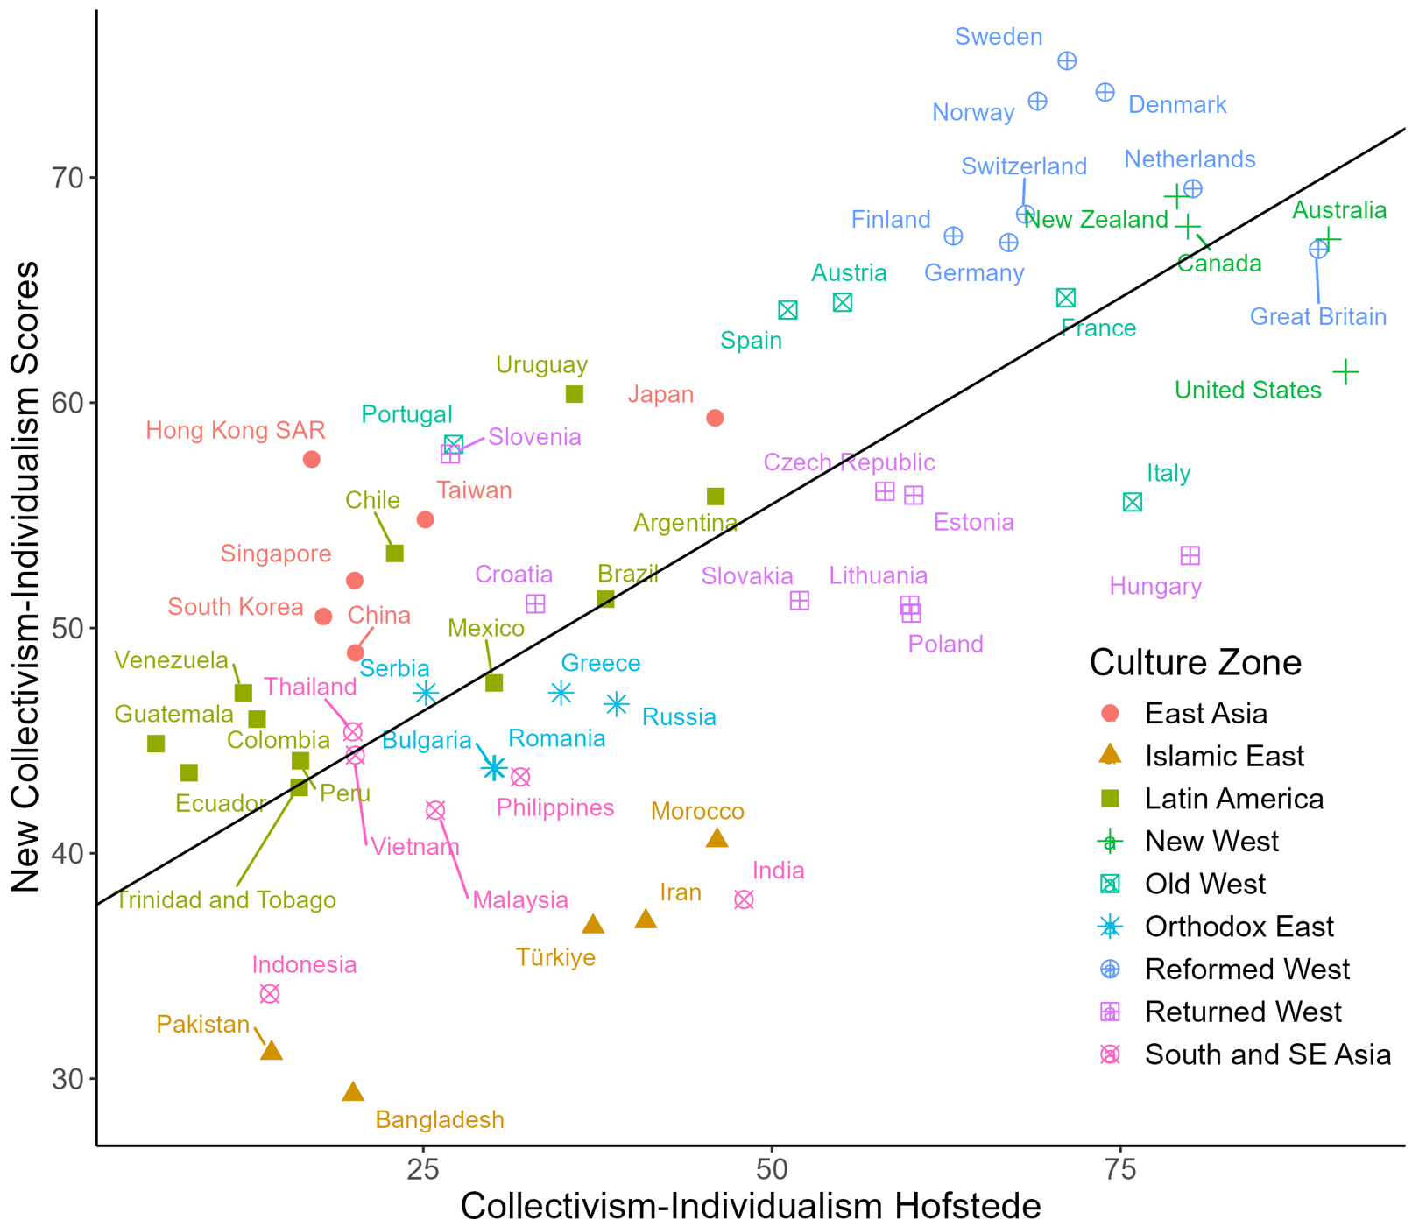
Note. The black line represents the first principal component minimizing perpendicular distances and capturing the maximum shared variance between Hofstede's scores and the new I-C scores.

The descriptions were obtained from Teorell, Jan, Aksel Sundström, Sören Holmberg, Bo Rothstein, Natalia Alvarado Pachon & Cem Mert Dalli. 2021. The Quality of Government Standard Dataset, version Jan21. University of Gothenburg: The Quality of Government Institute, http://www.qog.pol.gu.se doi:10.18157/qogstdjan21
Akaliyski, P. (2023). Distinct conceptions of freedom in East Asia and the Protestant West underpin unique pathways of societal development. Journal of Cross-Cultural Psychology, 54(2), 173–194.

