Low Self-Esteem as a Risk Factor for Depression:
A Longitudinal Study With Continuous Time Modeling

Supplemental Material
February 5, 2025

Table S1
Tests of Longitudinal Measurement Invariance
 | Configural invariance model |  |  |  | Metric invariance model |  |  |  | Δχ² | Δdf | RMSEA_{D}
 | χ² | df | CFI | RMSEA [90% CI] | χ² | df | CFI | RMSEA [90% CI]
RSE | 122.5 | 75 | .998 | .015 [.010; .020] | 166.4 | 85 | .996 | .018 [.014; .022] | 43.9* | 10 | .035
CES-D | 112.9* | 75 | .998 | .013 [.008; .018] | 128.0* | 85 | .998 | .013 [.008; .018] | 15.1 | 10 | .013
Note. Metric measurement invariance was tested by comparing the fit of a measurement model where the factor loadings were constrained to be equal across time (metric invariance model) with a measurement model that did not impose these constraints (configural invariance model), using the RMSEA_{D} (Savalei et al., 2024). For both constructs, the RMSEA_{D} values were smaller than .08, indicating that metric measurement invariance held. CFI = comparative fit index; RMSEA = root-mean-square error of approximation; CI = confidence interval; RMSEA_{D} = RMSEA associated with the difference test. RSE = Rosenberg Self-Esteem Scale. CES-D = Center for Epidemiologic Studies Depression Scale.
* p < .05
Table S2
Sample Characteristics of Generations 1 to 4 at Time 1
Sample | N | Age range | Mean age (SD) | Female (%) | Mean self-esteem (SD) | Mean depression (SD)
Generation 1 | 181 | 60 - 95 | 80.1 (5.5) | 64 | 3.4 (0.4) | 0.6 (0.4)
Generation 2 | 662 | 41 - 77 | 60.3 (5.3) | 56 | 3.5 (0.5) | 0.4 (0.4)
Generation 3 | 1047 | 19 - 56 | 36.2 (3.8) | 54 | 3.5 (0.5) | 0.5 (0.4)
Generation 4ª | 964 | 16 - 33 | 20.0 (3.8) | 50 | 3.3 (0.5) | 0.8 (0.5)
Note. Age is given in years. Self-esteem was measured with the Rosenberg Self-Esteem Scale (Rosenberg, 1965), and depression was measured with the Center for Epidemiologic Studies Depression Scale (Radloff, 1977). Both constructs were measured on a 4-point scale where higher values indicate higher levels of the constructs.
ª For Generation 4, sample characteristics are reported for Time 2 (i.e., 1991) because this generation was not part of the study at Time 1 (i.e., 1988).

Table S3
Continuous and Discrete Parameter Estimates for Auto- and Cross-Effects of Self-Esteem (SE) and Depression (DE) for Generation 1
Effect | Continuous time parameters |  |  | Discrete estimates
Effect | Estimate | SD | 95% CI | 1 year | 2 years | 5 years | 10 years | 17 years
Auto-effects
SE SE | -2.14 | 0.58 | [-3.40, -1.15] | .81 (.05)  [.70; .90] | .66 (.07)  [.49; .79] | .35 (.09)  [.17; .54] | .12 (.06)  [.03; .29] | .03 (.03)  [.00; .12]
DE DE | -5.98 | 1.56 | [-9.15, -3.03] | .54 (.08)  [.42; .73] | .29 (.09)  [.17; .54] | .05 (.05)  [.00; .21] | .00 (.01)  [-.02; .05] | .00 (.00)  [-.01; .01]
Cross-effects
SE DE | -1.20 | 0.74 | [-2.65, 0.27] | -.07 (.05)  [-.19; .01] | -.10 (.07)  [-.27; .02] | -.08 (.07)  [-.26; .01] | -.03 (.04)  [-.15; .00] | -.00 (.02)  [-.06; 00]
DE SE | 0.13 | 0.72 | [-1.27, 1.54] | .00 (.05)  [-.08; .12] | .01 (.07)  [-.11; .18] | .01 (.07)  [-.09; .09] | .00 (.03)  [-.05; .09] | .00 (.01)  [-.02; .04]
Note. Parameter estimates were controlled for stable between-person variance via latent trait variables. The correlation between the latent trait variables was r = -.13. Continuous time parameters reflect instantaneous changes. Continuous time parameters of auto-effects are expected to be negative and values closer to zero indicate higher stability. Continuous time parameters of cross-effects represent how changes in self-esteem predict subsequent changes in depression and vice versa, where negative values indicate inverse effects. Discrete estimates are reported as standardized regression coefficients with standard deviations in brackets (in continuous time modeling, standard deviations can be interpreted as standard errors since Bayesian methods estimate parameters directly for the population). For parameters depicted in bold, credible intervals do not include zero. CI = credible interval.
Table S4
Continuous and Discrete Parameter Estimates for Auto- and Cross-Effects of Self-Esteem (SE) and Depression (DE) for Generation 2
Effect | Continuous time parameters |  |  | Discrete estimates
Effect | Estimate | SD | 95% CI | 1 year | 2 years | 5 years | 10 years | 17 years
Auto-effects
SE SE | -2.14 | 0.25 | [-2.61, -1.64] | .81 (.02)  [.77; .84] | .65 (.03)  [.59; .71] | .34 (.04)  [.26; .41] | .11 (.03)  [.07; .16] | .02 (.01)  [.01; .05]
DE DE | -6.30 | 0.82 | [-7.91, -4.75] | .54 (.04)  [.46; .62] | .29 (.04)  [.20; .38] | .04 (.02)  [.01; .08] | .00 (0.00)  [-.01; .01] | .00 (.00)  [.00; .00]
Cross-effects
SE DE | -0.86 | 0.34 | [-1.51, -0.19] | -.07 (.03)  [-.12; -.01] | -.09 (.03)  [-.15; -.02] | -.07 (.03)  [-.12; -.02] | -.03 (.01)  [-.05; -.01] | -.01 (.00)  [-.01; .00]
DE SE | 0.51 | 0.44 | [-0.35, 1.37] | .03 (.02)  [-.01; .08] | .04 (.03)  [-.02; .10] | .03 (.03)  [-.02; .10] | .01 (.01)  [-.01; .04] | .00 (.00)  [.00; .01]
Note. Parameter estimates were controlled for stable between-person variance via latent trait variables. The correlation between the latent trait variables was r = -.33. Continuous time parameters reflect instantaneous changes. Continuous time parameters of auto-effects are expected to be negative and values closer to zero indicate higher stability. Continuous time parameters of cross-effects represent how changes in self-esteem predict subsequent changes in depression and vice versa, where negative values indicate inverse effects. Discrete estimates are reported as standardized regression coefficients with standard deviations in brackets (in continuous time modeling, standard deviations can be interpreted as standard errors since Bayesian methods estimate parameters directly for the population). For parameters depicted in bold, credible intervals do not include zero. CI = credible interval.
Table S5
Continuous and Discrete Parameter Estimates for Auto- and Cross-Effects of Self-Esteem (SE) and Depression (DE) for Generation 3
Effect | Continuous time parameters |  |  | Discrete estimates
Effect | Estimate | SD | 95% CI | 1 year | 2 years | 5 years | 10 years | 17 years
Auto-effects
SE SE | -2.90 | 0.30 | [-3.50, -2.36] | .75 (.02)  [.70; .79] | .56 (.03)  [.50; .62] | .24 (.03)  [.18; .30] | .06 (.02)  [.03; .09] | .01 (.00)  [.00; .02]
DE DE | -5.28 | 0.56 | [-6.41, -4.20] | .59 (.03)  [.53; .65] | .35 (.04)  [.28; .42] | .07 (.02)  [.04; .11] | .01 (.00)  [.00; .01] | .00 (.00)  [.00; .00]
Cross-effects
SE DE | 0.03 | 0.34 | [-0.64, 0.69] | .00 (.02)  [-.03; .04] | .00 (.03)  [-.05; .06] | .00 (.02)  [-.04; .05] | .00 (.01)  [-.01; .01] | .00 (.00)  [.00; .00]
DE SE | 0.55 | 0.35 | [-0.14, 1.23] | .04 (.03)  [-.01; .08] | .05 (.03)  [-.02; .10] | .04 (.03)  [-.02; .09] | .01 (.01)  [.00; .03] | .00 (.00)  [.00; .01]
Note. Parameter estimates were controlled for stable between-person variance via latent trait variables. The correlation between the latent trait variables was r = -.39. Continuous time parameters reflect instantaneous changes. Continuous time parameters of auto-effects are expected to be negative and values closer to zero indicate higher stability. Continuous time parameters of cross-effects represent how changes in self-esteem predict subsequent changes in depression and vice versa, where negative values indicate inverse effects. Discrete estimates are reported as standardized regression coefficients with standard deviations in brackets (in continuous time modeling, standard deviations can be interpreted as standard errors since Bayesian methods estimate parameters directly for the population). For parameters depicted in bold, credible intervals do not include zero. CI = credible interval.
Table S6
Continuous and Discrete Parameter Estimates for Auto- and Cross-Effects of Self-Esteem (SE) and Depression (DE) for Generation 4
Effect | Continuous time parameters |  |  | Discrete estimates
Effect | Estimate | SD | 95% CI | 1 year | 2 years | 5 years | 10 years | 17 years
Auto-effects
SE SE | -5.00 | 0.58 | [-6.16, -3.88] | .61 (.03)  [.54; .69] | .38 (.04)  [.30; .48] | .10 (.02)  [.05; .17] | .01 (.01)  [.00; .03] | .00 (.00)  [.00; .00]
DE DE | -4.24 | 0.52 | [-5.29, -3.24] | .66 (.04)  [.59; .73] | .44 (.05)  [.36; .54] | .13 (.04)  [.08; .23] | .02 (.01)  [.01; .06] | .00 (.00)  [.00; .01]
Cross-effects
SE DE | -0.77 | 0.11 | [-0.99, -0.56] | -.05 (.01)  [-.06; -.04] | -.06 (.01)  [-.08; -.05] | -.04 (.01)  [-.06; -.02] | -.01 (.00)  [-.02; .00] | -.00 (.00)  [.00; .00]
DE SE | -1.36 | 0.42 | [-2.18, -0.54] | -.09 (.02)  [-.14; -.04] | -.12 (.03)  [-.18; -.05] | -.07 (.03)  [-.14; -.03] | -.02 (.01)  [-.05; .00] | -.00 (.00)  [-.01; .00]
Note. Parameter estimates were controlled for stable between-person variance via latent trait variables. The correlation between the latent trait variables was r = -.35. Continuous time parameters reflect instantaneous changes. Continuous time parameters of auto-effects are expected to be negative and values closer to zero indicate higher stability. Continuous time parameters of cross-effects represent how changes in self-esteem predict subsequent changes in depression and vice versa, where negative values indicate inverse effects. Discrete estimates are reported as standardized regression coefficients with standard deviations in brackets (in continuous time modeling, standard deviations can be interpreted as standard errors since Bayesian methods estimate parameters directly for the population). For parameters depicted in bold, credible intervals do not include zero. CI = credible interval.
Table S7
Moderator Effects of Age on Continuous Time Parameters
 | Estimate | SD | p | 95% CI
Auto-effects
SE SE | 0.00 | 0.01 | .477 | [0.00, 0.02]
DE DE | -0.09 | 0.01 | .000 | [-0.11, -0.07]
Cross-effects
SE DE | -0.02 | 0.01 | .045 | [-0.04, 0.00]
DE SE | 0.08 | 0.01 | .000 | [0.11, 0.07]
Note. Estimates are unstandardized regression coefficients of age at Time 1 predicting the continuous time parameters. In continuous time modeling, standard deviations can be interpreted as standard errors since Bayesian methods estimate parameters directly for the population. Parameters printed in bold are significant with p < .05. CI = credible interval; SE = self-esteem; DE = depression.

Table S8
Continuous and Discrete Parameter Estimates for Auto- and Cross-Effects of Self-Esteem (SE) and Depressive Affect (DEP)
Effect | Continuous time parameters |  |  | Discrete estimates
Effect | Estimate | SD | 95% CI | 1 year | 2 years | 5 years | 10 years | 17 years
Auto-effects
SE SE | -3.46 | 0.30 | [-4.07, -2.89] | .71 (.02)  [.66; .75] | .50 (.03)  [.45; .56] | .18 (.03)  [.14; .23] | .03 (.01)  [.02; .05] | .00 (.00)  [.00; .01]
DEP DEP | -5.92 | 0.51 | [-6.91, -4.96] | .55 (.03)  [.51; .61] | .31 (.04)  [.26; .38] | .05 (.02)  [.03; .09] | .00 (.00)  [.00; .01] | .00 (.00)  [.00; .00]
Cross-effects
SE DEP | -1.10 | 0.31 | [-1.69, -0.50] | -.08 (.02)  [-.11; -.04] | -.10 (.03)  [-.15; -.05] | -.06 (.02)  [-.10; -.03] | -.01 (.01)  [-.03; -.01] | -.00 (.00)  [.00; .00]
DEP SE | -0.02 | 0.36 | [-0.73, 0.70] | -.00 (.02)  [-.03; .04] | -.00 (.03)  [-.04; .05] | -.00 (.02)  [-.03; .04] | -.00 (.00)  [-.01; .01] | -.00 (.00)  [.00; .00]
Note. Parameter estimates were controlled for stable between-person variance via latent trait variables. The correlation between the latent trait variables was r = -.32. Continuous time parameters reflect instantaneous changes. Continuous time parameters of auto-effects are expected to be negative and values closer to zero indicate higher stability. Continuous time parameters of cross-effects represent how changes in self-esteem predict subsequent changes in depressive affect and vice versa, where negative values indicate inverse effects. Discrete estimates are reported as standardized regression coefficients with standard deviations in brackets (in continuous time modeling, standard deviations can be interpreted as standard errors since Bayesian methods estimate parameters directly for the population). For parameters depicted in bold, credible intervals do not include zero. CI = credible interval.
Table S9
Continuous and Discrete Parameter Estimates for Auto- and Cross-Effects of Self-Esteem (SE) and Lack of Positive Affect (POS)
Effect | Continuous time parameters |  |  | Discrete estimates
Effect | Estimate | SD | 95% CI | 1 year | 2 years | 5 years | 10 years | 17 years
Auto-effects
SE SE | -2.43 | 0.23 | [-2.91, -1.99] | .78 (.02)  [.75; .83] | .61 (.03)  [.57; .69] | .29 (.03)  [.24; .37] | .09 (.02)  [.06; .13] | .01 (.01)  [.01; .03]
POS POS | -6.62 | 0.63 | [-7.89, -5.41] | .52 (.03)  [.44; .59] | .26 (.04)  [.19; .35] | .03 (.02)  [.01; .07] | .00 (.00)  [-.01; .01] | .00 (.00)  [.00; .00]
Cross-effects
SE POS | -1.16 | 0.31 | [-1.76, -0.56] | -.09 (.02)  [-.12; -.04] | -.11 (.03)  [-.16; .05] | -.08 (.02)  [-.13; -.04] | -.03 (.01)  [-.05; .01] | -.00 (.00)  [-.01; .00]
POS SE | 0.36 | 0.34 | [-0.31, 1.04] | .02 (.02)  [-.03; .06] | .03 (.03)  [-.04; .08] | .02 (.02)  [-.03; .06] | .01 (.01)  [-.01; .02] | .00 (0.00)  [.00; .00]
Note. Parameter estimates were controlled for stable between-person variance via latent trait variables. The correlation between the latent trait variables was r = -.25. Continuous time parameters reflect instantaneous changes. Continuous time parameters of auto-effects are expected to be negative and values closer to zero indicate higher stability. Continuous time parameters of cross-effects represent how changes in self-esteem predict subsequent changes in lack of positive affect and vice versa, where negative values indicate inverse effects. Discrete estimates are reported as standardized regression coefficients with standard deviations in brackets (in continuous time modeling, standard deviations can be interpreted as standard errors since Bayesian methods estimate parameters directly for the population). For parameters depicted in bold, credible intervals do not include zero. CI = credible interval.
Table S10
Continuous and Discrete Parameter Estimates for Auto- and Cross-Effects of Self-Esteem (SE) and Somatic Complaints (SOM)
Effect | Continuous time parameters |  |  | Discrete estimates
Effect | Estimate | SD | 95% CI | 1 year | 2 years | 5 years | 10 years | 17 years
Auto-effects
SE SE | -3.48 | 0.28 | [-4.04, -2.94] | .71 (.02)  [.67; .74] | .50 (.03)  [.45; .55] | .18 (.03)  [.14; .22] | .03 (.01)  [.02; .05] | .00 (.00)  [.00; .01]
SOM SOM | -5.14 | 0.53 | [-6.18, -4.11] | .60 (.03)  [.54; .66] | .36 (.04)  [.29; .43] | .08 (.02)  [.05; .12] | .01 (.01)  [.00; .02] | .00 (.00)  [.00; .00]
Cross-effects
SE SOM | -0.25 | 0.15 | [-0.54, 0.04] | -.04 (.02)  [-.08; .01] | -.05 (.03)  [-.10; .02] | -.04 (.02)  [-.07; .01] | -.01 (.01)  [-.02; .00] | -.00 (.00)  [.00; .00]
SOM SE | -0.59 | 0.64 | [-1.86, 0.67] | -.02 (.02)  [-.05; .02] | -.02 (.02)  [-.06; .03] | -.02 (.01)  [-.05; .02] | -.00 (.00)  [-.01; .01] | -.00 (.00)  [.00; .00]
Note. Parameter estimates were controlled for stable between-person variance via latent trait variables. The correlation between the latent trait variables was r = -.39. Continuous time parameters reflect instantaneous changes. Continuous time parameters of auto-effects are expected to be negative and values closer to zero indicate higher stability. Continuous time parameters of cross-effects represent how changes in self-esteem predict subsequent changes in lack of positive affect and vice versa, where negative values indicate inverse effects. Discrete estimates are reported as standardized regression coefficients with standard deviations in brackets (in continuous time modeling, standard deviations can be interpreted as standard errors since Bayesian methods estimate parameters directly for the population). For parameters depicted in bold, credible intervals do not include zero. CI = credible interval.
Table S11
Continuous and Discrete Parameter Estimates for Auto- and Cross-Effects of Self-Esteem (SE) and Interpersonal Difficulties (IPD)
Effect | Continuous time parameters |  |  | Discrete estimates
Effect | Estimate | SD | 95% CI | 1 year | 2 years | 5 years | 10 years | 17 years
Auto-effects
SE SE | -2.35 | 0.21 | [-2.78, -1.95] | .79 (.02)  [.76; .82] | .62 (.03)  [.57; .67] | .30 (.03)  [.24; .36] | .08 (.02)  [.06; .13] | .01 (.01)  [.01; .02]
IPD IPD | -6.29 | 1.17 | [-8.62, -4.04] | .54 (.06)  [.42; .67] | .29 (.07)  [.17; .44] | .04 (.03)  [.01; .12] | .00 (.01)  [.00; .01] | .00 (.00)  [.00; .00]
Cross-effects
SE IPD | -0.84 | 0.39 | [-1.59, -0.08] | -.08 (.03)  [-.14; -.03] | -.11 (.04)  [-.17; -.05] | -.08 (.03)  [-.13; -.04] | -.03 (.01)  [-.05; -.01] | -.00 (.00)  [-.01; .00]
IPD SE | 0.91 | 0.52 | [-0.09, 1.92] | .04 (.02)  [.00; .08] | .05 (.03)  [-.01; .11] | .04 (.03)  [.00; .10] | .01 (.01)  [.00; .04] | .00 (.00)  [.00; .01]
Note. Parameter estimates were controlled for stable between-person variance via latent trait variables. The correlation between the latent trait variables was r = -.17. Continuous time parameters reflect instantaneous changes. Continuous time parameters of auto-effects are expected to be negative and values closer to zero indicate higher stability. Continuous time parameters of cross-effects represent how changes in self-esteem predict subsequent changes in interpersonal difficulties and vice versa, where negative values indicate inverse effects. Discrete estimates are reported as standardized regression coefficients with standard deviations in brackets (in continuous time modeling, standard deviations can be interpreted as standard errors since Bayesian methods estimate parameters directly for the population). For parameters depicted in bold, credible intervals do not include zero. CI = credible interval.

Table S12
Continuous and Discrete Parameter Estimates of Self-Esteem (SE) and Depression (DE), with SE Items Removed from the CES-D
Effect | Continuous time parameters |  |  | Discrete estimates
Effect | Estimate | SD | 95% CI | 1 year | 2 years | 5 years | 10 years | 17 years
Auto-effects
SE SE | -3.35 | 0.30 | [-3.96, -2.77] | .72 (.02)  [.67; .75] | .52 (.03)  [.45; .56] | .19 (.03)  [.14; .23] | .04 (.01)  [.02; .05] | .00 (.00)  [.00; .01]
DE DE | -5.65 | 0.45 | [-6.55, -4.79] | .56 (.03)  [.52; .62] | .32 (.03)  [.26; .38] | .06 (.02)  [.03; .09] | .00 (.00)  [.00; .01] | .00 (.00)  [.00; .00]
Cross-effects
SE DE | -1.15 | 0.36 | [-1.89, -0.42] | -.07 (.02)  [-.10; -.02] | -.09 (.03)  [-.13; -.02] | -.06 (.02)  [-.09; -.02] | -.01 (.01)  [-.03; -.10] | -.00 (.00)  [.00; .00]
DE SE | 0.13 | 0.28 | [-0.41, 0.67] | .01 (.02)  [-.02; 05] | .02 (.03)  [-.03; .07] | .00 (.02)  [-.02; .05] | .00 (.01)  [.00; .01] | .00 (.00)  [.00; .00]
Note. Parameter estimates were controlled for stable between-person variance via latent trait variables. The correlation between the latent trait variables was r = -.34. The self-esteem items removed from the CES-D were Item 4 (I felt I was just as good as other people) and Item 9 (I thought my life had been a failure). Continuous time parameters reflect instantaneous changes. Continuous time parameters of auto-effects are expected to be negative and values closer to zero indicate higher stability. Continuous time parameters of cross-effects represent how changes in self-esteem predict subsequent changes in depression and vice versa, where negative values indicate inverse effects. Discrete estimates are reported as standardized regression coefficients with standard deviations in brackets (in continuous time modeling, standard deviations can be interpreted as standard errors since Bayesian methods estimate parameters directly for the population). For parameters depicted in bold, credible intervals do not include zero. CES-D = Center for Epidemiologic Studies Depression Scale; CI = credible interval.
Figure S1
Cross-Effects of Self-Esteem and Depression as a Function of Time Interval, for 100 Randomly Selected Individuals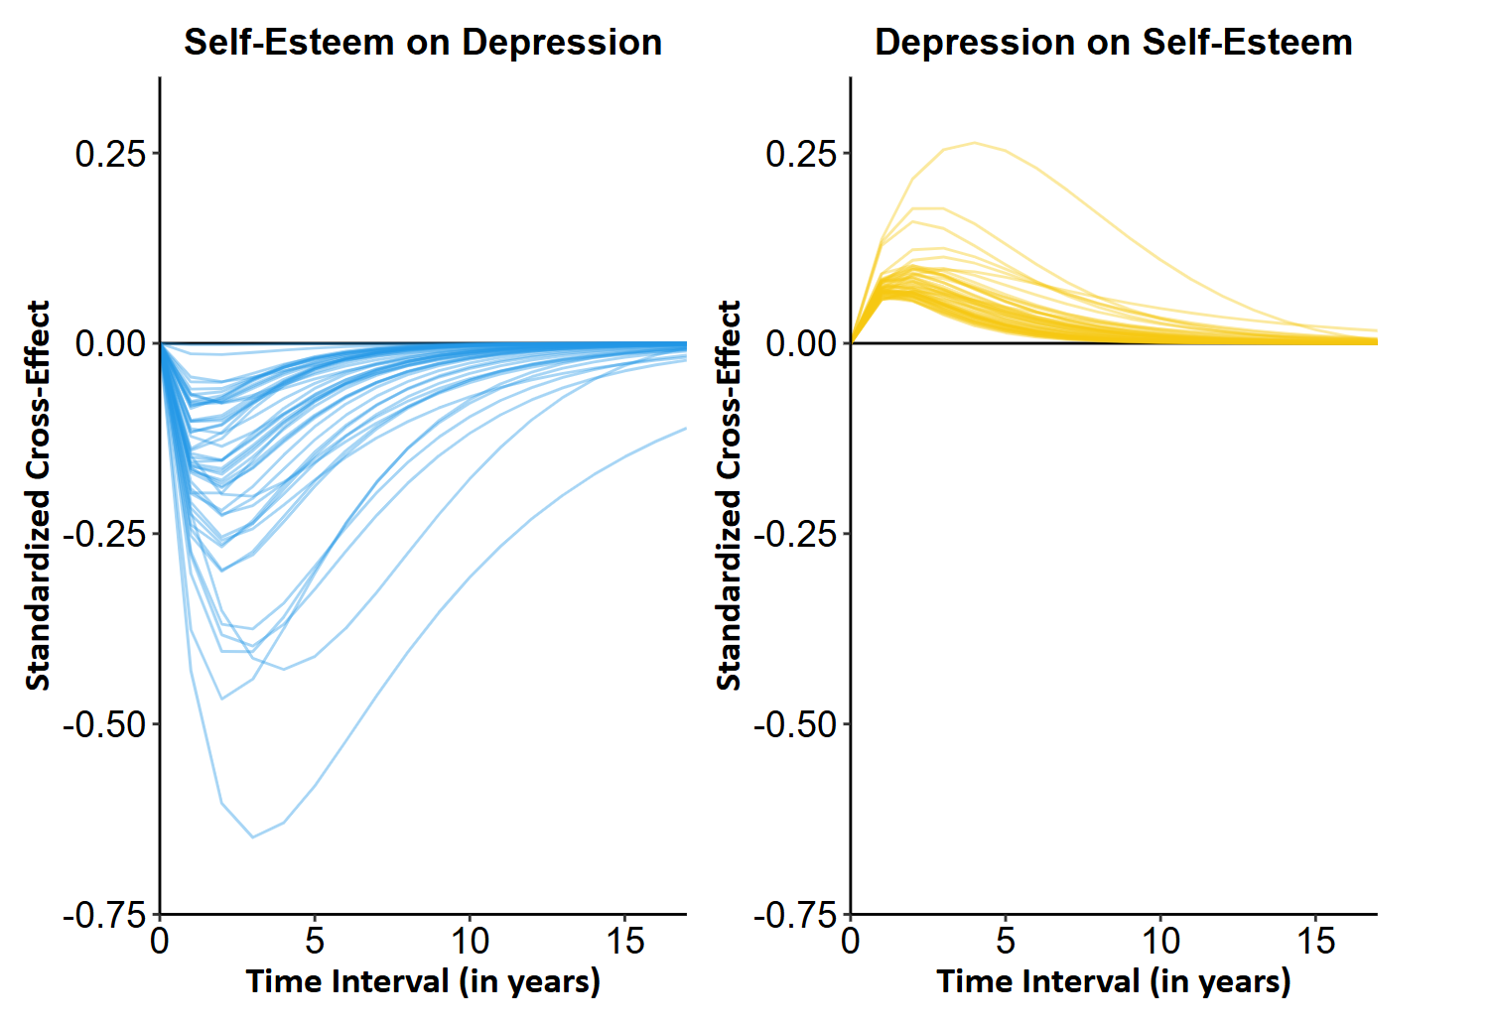
Note. The figure shows discrete estimates of cross-lagged effects for self-esteem on depression and for depression on self-esteem as a function of time interval for 100 individuals who were randomly selected from the sample. Each colored line represents one individual. To generate the figure, the model allowed for individually varying drift parameters. In this model, population means of cross-effects were larger than in the main model that did not allow for individually varying drift parameters.
Figure S2
Auto-Effects of Self-Esteem and Depression Factors
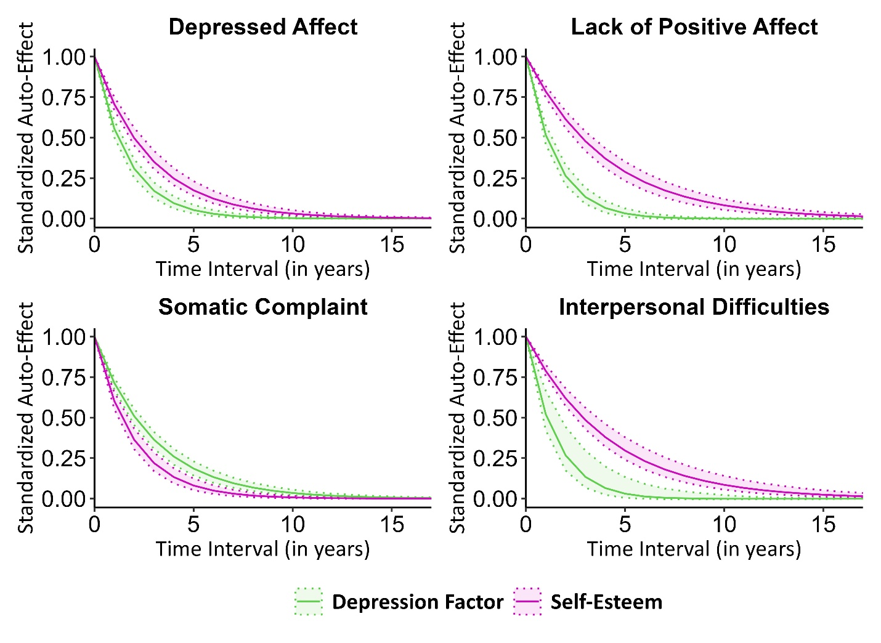
Note. The figure shows discrete estimates of autoregressive effects for self-esteem and the four depression factors as a function of time interval. The estimates are presented as standardized coefficients. Dashed areas indicate 95% credible intervals.

Figure S3
Cross-Effects of Self-Esteem and Depression as a Function of Time Interval, with Self-Esteem Items Removed from the CES-D
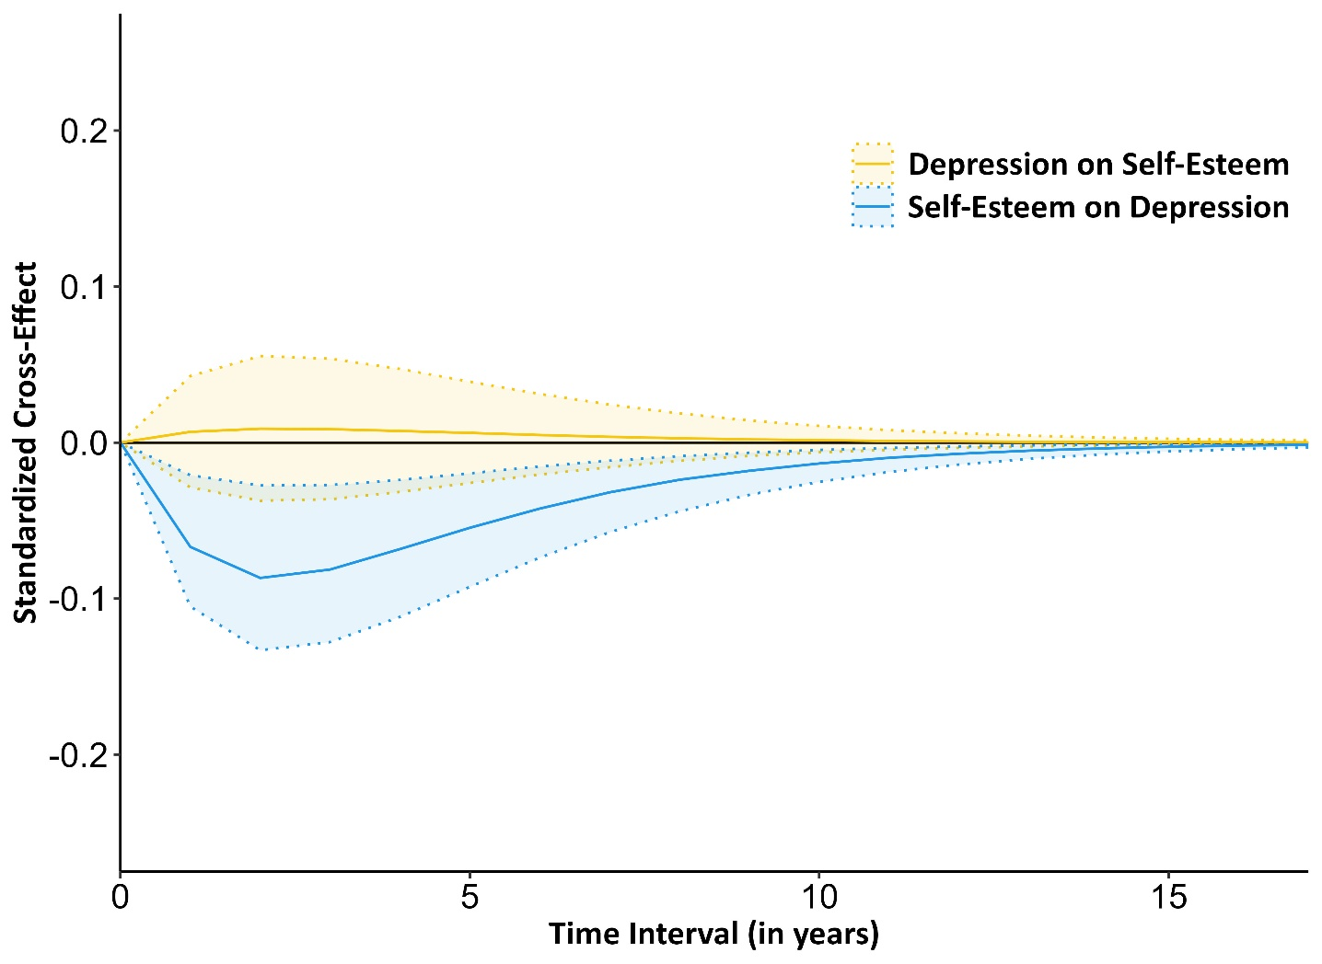
Note. Self-esteem items removed from the CES-D were Item 4 (I felt I was just as good as other people) and Item 9 (I thought my life had been a failure). The figure shows discrete estimates of cross-lagged effects for self-esteem on depression and depression on self-esteem as a function of time interval. The estimates are presented as standardized coefficients. Dashed areas indicate 95% credible intervals.

Figure S4
Auto-Effects of Self-Esteem and Depression as a Function of Time Interval, with Self-Esteem Items Removed from the CES-D
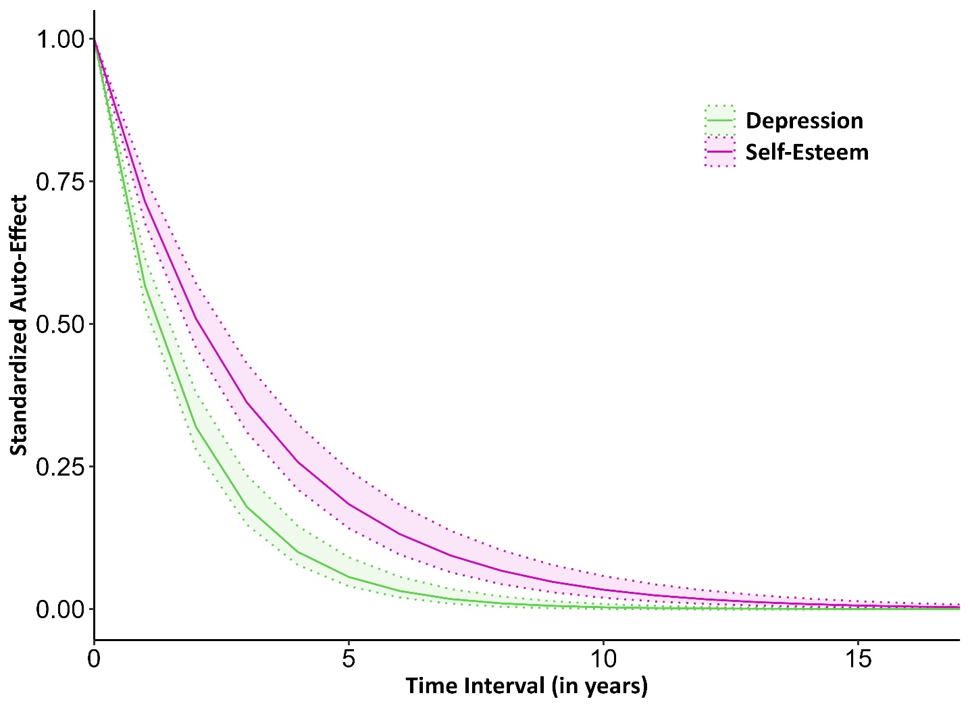
Note. Self-esteem items removed from the CES-D were Item 4 (I felt I was just as good as other people) and Item 9 (I thought my life had been a failure). The figure shows discrete estimates of autoregressive effects for self-esteem and depression as a function of time interval. The estimates are presented as standardized coefficients. Dashed areas indicate 95% credible intervals.

