Supplementary information to manuscript
Affiliation Motive and Social Interactions in People’s Daily Life: A Temporal Processes Approach Using Ecological Momentary Assessment and Mobile Sensing

Overview of supplementary material

A1: Examples for Model Equations ……………………………………………..…………….2
Table S1 Study 1: Between- and Within-Person Correlations Among Study Variables 4
Table S2 Study 1: Fixed Effects of Extraversion-Models Predicting Contact at Next Measurement or Desire to Interact 5
Table S3 Study 1 and 2: Correlations of Affiliation and Extraversion with Contact Duration in Specific Relationship Types 6
Table S4 Study 2: Between- and Within-Person Correlations Among Study Variables 7
Table S5 Study 2: Fixed Effects of Extraversion-Models Predicting Contact during Next Day and Social Desires 8
Figure S1 Study 1: Multilevel Regression Coefficients Predicting Future Contact and Current Social Desires based on Situational Characteristics as well as Extraversion and its Facets 9
Figure S2 Study 1: Multilevel Regression Coefficients Predicting Future Contact and Current Social Desires based on Situational Characteristics as well as Agreeableness and its Facets. 10
Figure S3 Study 1: Multilevel Regression Coefficients Predicting Future Contact and Current Social Desires based on Situational Characteristics as well as Social Anxiety. 11
Figure S4 Study 1: Multilevel Regression Coefficients Predicting Future Contact and Current Social Desires as well as Interaction Effects Separately for Fridays and Saturdays. 12
Figure S5 Study 2: Multilevel Regression Coefficients Predicting Future Contact and Current Social Desires as well as Interaction Effects Separately for Weekdays and Weekends. 13

Examples for Model Equations
Study 1
An exemplary model equation for the models used in Study 1 is given below. In this case, referring to situations where participants were currently alone, social interaction at the next assessment are predicted by affiliation motive, the contact ratio in the previous episode of about 80 min, the perceived possibility of social interactions, as well as interaction effects between the quantity of previous social interactions and (a) affiliation motive and (b) the possibility of social interactions. Level 1 variables are split in a within-person (“wp”) and a between-person (“bp”) component.

Level 1
$${interaction}_{\left(t+1\right)i}= β_{0i}+ β_{1i}{contact ratio wp}_{ti}+β_{2i}{contact possibility wp}_{ti}+ β_{3i}{contact ratio wp}_{ti}{*contact possibility wp}_{ti}+e_{ti}$$
Level 2
$$β_{0i}= γ_{00}+{γ_{01}{affiliation}_{i}+γ_{02}{contact ratio bp}_{i}+γ_{03}{contact possibility bp}_{i} +γ_{06}{gender}_{i}+γ_{07}{age}_{i}+ υ}_{0i}$$
$$β_{1i}= γ_{10}+γ_{11}{affiliation}_{i}+ υ_{1i}$$
$$β_{2i}= γ_{20}+ υ_{2i}$$
$$β_{3i}= γ_{30}$$
where at time t for participant i $e_{ti} \sim N(0,σ_{e}^{2})$ and $\left[\begin{aligned}υ_{0i} \\ υ_{1i} \\ υ_{2i}\end{aligned}\right] \sim MVN\left(\left[\begin{aligned}\begin{aligned}0 \\ 0\end{aligned} \\ 0\end{aligned}\right],\left[\begin{matrix}τ_{00} & & \\ τ_{10} & τ_{11} & \\ τ_{20} & τ_{21} & τ_{22}\end{matrix}\right]\right)$.

Study 2
An exemplary equation for the models used in Study 2 is given below. Here, the amount of contact during the next day is predicted by the amount of contact on the current day, contact valence, affiliation motive, as well as the interaction effect of the amount of contact on the current day and affiliation. Gender and age were added as control variables. Level 1 variables are split in a within-person (“wp”) and a between-person (“bp”) component.
Level 1
$${contact amount}_{\left(t+1\right)i}= β_{0i}+ β_{1i}{contact amount wp}_{ti}+β_{2i}{contact valence wp}_{ti}+ β_{3i}{contact amount wp}_{ti}{*contact valence wp}_{ti}+e_{ti}$$
Level 2
$$β_{0i}= γ_{00}+{γ_{01}{affiliation}_{i}+γ_{02}{contact amount bp}_{i}+γ_{03}{contact valence bp}_{i} +γ_{06}{gender}_{i}+γ_{07}{age}_{i}+ υ}_{0i}$$
$$β_{1i}= γ_{10}+γ_{11}{affiliation}_{i}+ υ_{1i}$$
$$β_{2i}= γ_{20}+ υ_{2i}$$
$$β_{3i}= γ_{30}$$
where at time t for participant i $e_{ti} \sim N(0,σ_{e}^{2})$ and $\left[\begin{aligned}υ_{0i} \\ υ_{1i} \\ υ_{2i}\end{aligned}\right] \sim MVN\left(\left[\begin{aligned}\begin{aligned}0 \\ 0\end{aligned} \\ 0\end{aligned}\right],\left[\begin{matrix}τ_{00} & & \\ τ_{10} & τ_{11} & \\ τ_{20} & τ_{21} & τ_{22}\end{matrix}\right]\right)$.

Supplementary Tables
Table S1

Study 1: Between- and Within-Person Correlations Among Study Variables
 | Variable | 1 | 2 | 3 | 4 | 5 | 6 | 7 | 8 | 9 | 10
1 | Affiliation |  | / | / | / | / | / | / | / | / | /
2 | Extraversion | .43 |  | / | / | / | / | / | / | / | /
3 | Social contact quantity (EMA)ª | .00 | .07 |  | .24 | .01 | -.19 | .14 | .06 | .03 | /
4 | Social contact quantity (MS)^{b} | .09 | .08 | .20 |  | .06 | -.09 | .05 | .03 | .01 | /
5 | Desire interact | .44 | .07 | -.06 | .04 |  | / | .03 | .13 | -.11 | /
6 | Desire alone | -.33 | -.17 | -.28 | -.07 | -.23 |  | -.40 | / | .09 | /
7 | Contact valence | .16 | .20 | .14 | .04 | .07 | -.31 |  | 0.1 | -.08 | /
8 | Contact possible | .04 | .01 | .25 | .05 | -.04 | -.02 | .11 |  | .06 | /
9 | Contact initiated | -.05 | -.04 | -.04 | -.01 | .02 | .17 | -.14 | .07 |  | /
10 | Age | -.12 | .02 | -.05 | -.15 | -.02 | .12 | .06 | .01 | -.07 | /
11 | Gender | -.01 | -.14 | -.08 | -.03 | .18 | .07 | -.13 | -.02 | -.06 | -.02
Note. Between-person correlations from Study 1 are displayed below the diagonal and within-person correlations are displayed above the diagonal. ªProportion of time between two EMA spent in social interactions. ^{b}Proportion of time that conversations were detected in mobile sensing (MS)

Table S2

Study 1: Fixed Effects of Extraversion-Models Predicting Contact at Next Measurement or Desire to Interact
Variable | Contact t+1 |  |  | Social desire
Variable | b | 95% CI |  | b | 95% CI
Currently Alone
Intercept | -0.20 | [-0.47,0.07] |  | 3.28 | [3.12,3.45]
Extraversion | -0.02 | [-0.21,0.18] |  | 0.04 | [-0.11,0.20]
Contact ratio bp | 0.76 | [0.56,0.96] |  | -0.05 | [-0.19,0.10]
Contact ratio wp | -0.10 | [-0.38,0.19] |  | 0.00 | [-0.12,0.12]
Contact possible bp | 0.26 | [0.14,0.39] |  | -0.02 | [-0.15,0.11]
Contact possible wp | 0.27 | [0.10,0.43] |  | 0.12 | [0.05,0.20]
Gender | 0.01 | [-0.11,0.13] |  | 0.19 | [0.07,0.31]
Age | 0.17 | [0.05,0.29] |  | -0.03 | [-0.15,0.10]
Contact ratio wp x extraversion | -0.08 | [-0.28,0.13] |  | -0.05 | [-0.14,0.05]
Contact ratio wp x contact possible wp | -0.04 | [-0.22,0.15] |  | -0.01 | [-0.09,0.08]
Currently in Contact
Intercept | 0.75 | [0.62,0.88] |  | 3.41 | [3.28,3.53]
Extraversion | -0.06 | [-0.18,0.06] |  | -0.12 | [-0.24,0.00]
Contact ratio bp | 0.87 | [0.74,1.00] |  | -0.27 | [-0.39,-0.15]
Contact ratio wp | 0.04 | [-0.08,0.16] |  | -0.22 | [-0.28,-0.16]
Contact initiated bp | -0.03 | [-0.14,0.07] |  | 0.13 | [0.03,0.24]
Contact initiated wp | 0.03 | [-0.08,0.15] |  | 0.04 | [-0.02,0.11]
Contact valence bp | -0.10 | [-0.21,0.00] |  | -0.26 | [-0.37,-0.14]
Contact valence wp | 0.02 | [-0.09,0.12] |  | -0.51 | [-0.58,-0.44]
Gender | -0.01 | [-0.12,0.09] |  | 0.01 | [-0.10,0.13]
Age | 0.06 | [-0.05,0.17] |  | 0.12 | [0.01,0.24]
Contact ratio wp x extraversion | -0.01 | [-0.12,0.10] |  | 0.00 | [-0.06,0.06]
Contact ratio wp x contact initiated wp | 0.02 | [-0.09,0.13] |  | 0.09 | [0.03,0.15]
Contact ratio wp x contact valence wp | 0.00 | [-0.10,0.11] |  | -0.08 | [-0.14,-0.03]
Note. bp = between-person component, wp = within-person components. The top left model (Contact t+1, when currently alone) is based on 1832 observations from 291 participants. The top right model is based on 1949 observations from 293 participants. The bottom left and right models are based on 2378 and 2571 observations from 297 and 299 participants, respectively. Significant effects are printed in bold (p < .05).

Table S3

Study 1 and 2: Correlations of Affiliation and Extraversion with Social Contact Quantity in Specific Relationship Types
Relationship Type | Study 1 |  |  | Study 2
Relationship Type | Affiliation | Extraversion |  | Affiliation | Extraversion
Partner | -.16 [-.27,-.05] | -.01 [-.12, .10] |  | .06 [-.05,.17] | .07 [-.05, .18]
Kids | -.02 [-.14,.09] | .04 [-.07, .15] |  | -.04 [-.15,.07] | .06 [-.06, .17]
Family | .01 [-.11,.12] | -.09 [-.19,.03] |  | .05 [-.06,.16] | .02 [-.09,.14]
Friends | .17 [.06,.27] | .10 [-.02,.20] |  | .27 [.16,.37] | .15 [.03,.26]
Colleagues | .16 [.05,.27] | .14 [.03,.25] |  | .06 [-.05,.17] | .03 [-.09,.14]
Strangers | .05 [-.06,.16] | .06 [-.05,.17] |  | .11 [-.00,.22] | -.01 [-.13,.10]
All types, EMA | .02 [-.09,.13] | .09 [-.02,.20] |  | .09 [-.02,.19] | .10 [-.01,.21]
All types, MS | .13 [.02,.24] | .12 [.01, .23] |  | .14 [.02,.25] | .05 [-.07, .17]
Note. In Study 1, social interactions with people from multiple relationship types were counted towards the total interaction duration for each relationship type. EMA = ecological momentary assessment (i.e., person mean of total winsorized contact duration). MS = mobile sensing (i.e., person mean of proportion of conversation). Estimates in bold indicate p < .05.

Table S4

Study 2: Between- and Within-Person Correlations Among Study Variables
 | Variable | 1 | 2 | 3 | 4 | 5 | 6 | 7 | 8
1 | Affiliation |  | / | / | / | / | / | / | /
2 | Extraversion | .44 |  | / | / | / | / | / | /
3 | Social contact quantity (EMA)ª | .09 | .10 |  | .20 | -.17 | -.02 | .14 | /
4 | Social contact quantity (MS)^{b} | .14 | .05 | .15 |  | -.09 | -.02 | .06 | /
5 | Desire for more contact | .04 | -.06 | -.14 | .00 |  | -.04 | -.04 | /
6 | Desire for more solitude | -.13 | -.07 | .07 | .10 | .13 |  | -.13 | /
7 | Contact valence | .25 | .19 | .21 | .08 | -.14 | -.18 |  | /
8 | Age | .07 | .10 | -.03 | -.09 | -.10 | -.17 | .15
9 | Gender | .11 | .12 | .05 | .08 | -.11 | .03 | .13 | -.07
Note. Between-person correlations from Study 2 are displayed below the diagonal and within-person correlations are displayed above the diagonal. ªProportion of time between two EMA spent in social interactions. ^{b}Proportion of time that conversations were detected in mobile sensing (MS)

Table S5

Study 2: Fixed Effects of Extraversion-Models Predicting Contact during Next Day and Social Desires
Variable | Contact t+1 |  |  | Desire for more contact |  |  | Desire for more solitude
Variable | b | 95% CI |  | b | 95% CI |  | b | 95% CI
Intercept | 14.01 | [13.77,14.25] |  | 3.03 | [2.88,3.18] |  | 3.01 | [2.86,3.16]
Extraversion | -0.01 | [-0.25,0.23] |  | -0.02 | [-0.18,0.13] |  | -0.06 | [-0.21,0.09]
Contact duration bp | 9.14 | [8.90,9.38] |  | -0.08 | [-0.23,0.07] |  | 0.11 | [-0.04,0.26]
Contact duration wp | 1.72 | [1.48,1.96] |  | -0.30 | [-0.38,-0.22] |  | 0.01 | [-0.05,0.07]
Contact valence bp | 0.02 | [-0.23,0.27] |  | -0.12 | [-0.28,0.03] |  | -0.28 | [-0.44,-0.13]
Contact valence wp | -0.22 | [-0.46,0.02] |  | -0.02 | [-0.06,0.03] |  | -0.19 | [-0.24,-0.14]
Gender | -0.03 | [-0.27,0.21] |  | -0.15 | [-0.29,0.00] |  | 0.04 | [-0.11,0.19]
Age | 0.03 | [-0.21,0.27] |  | -0.11 | [-0.26,0.03] |  | -0.18 | [-0.33,-0.03]
Contact duration wp x extraversion | -0.06 | [-0.31,0.20] |  | -0.05 | [-0.13,0.04] |  | -0.07 | [-0.13,0.00]
Contact duration wp x contact valence wp | -0.17 | [-0.41,0.08] |  | -0.08 | [-0.13,-0.02] |  | -0.10 | [-0.15,-0.05]
Note. bp = between-person component, wp = within-person components. The model with Contact t+1 as outcome is based on 3124 observations from 292 participants, and both models with desires as outcomes are based on 3388 observations from 293 participants. Significant effects are printed in bold (p < .05).

Figure S1

Study 1: Multilevel Regression Coefficients Predicting Future Contact and Current Social Desires based on Situational Characteristics as well as Extraversion and its Facets
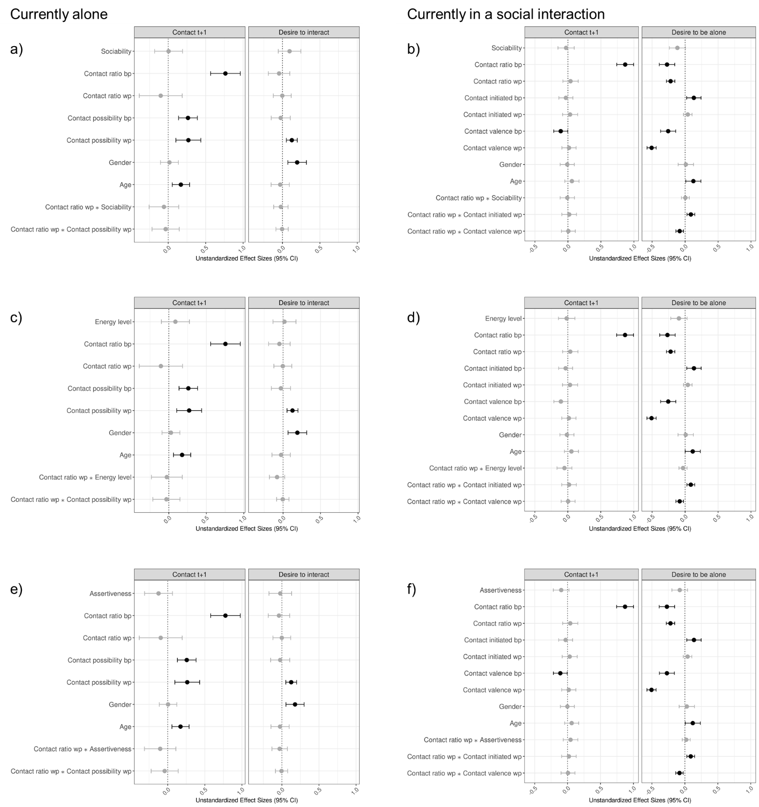

Summary of results
Analyses were repeated with agreeableness replacing the affiliation motive as person-predictor in all models to examine to what extent results were specific for affiliation or generalized to other related social traits. Results showed that when people were alone they reported a greater desire to interact and were more likely to interact at next assessment with higher levels of agreeableness (Figures S2a and S2b). These effects were largely due to the facets trust (when predicting desire to interact, Figures 2c) and compassion (when predicting contact at the next assessment, Figure 2g).
Figure S2

Study 1: Multilevel Regression Coefficients Predicting Future Contact and Current Social Desires based on Situational Characteristics as well as Agreeableness and its Facets.
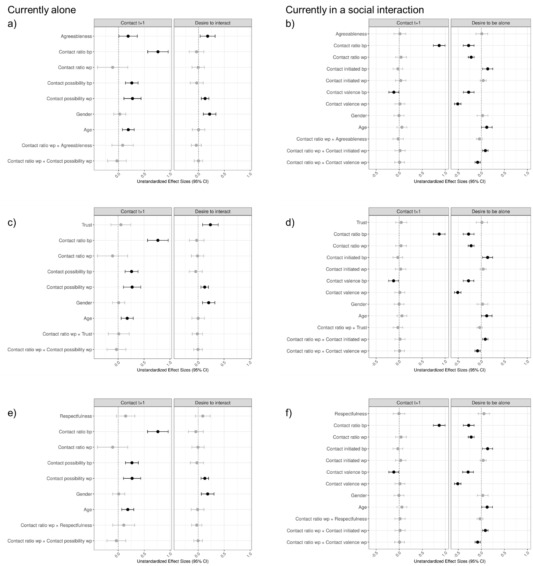
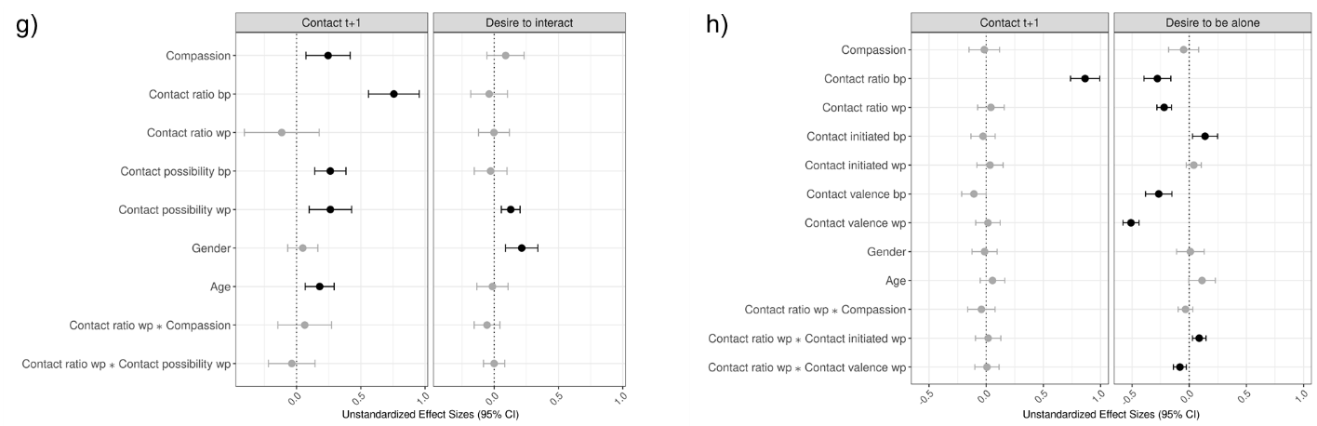
Note. Agreeableness was measured with 15 items using the German version of the BFI-2 (Danner et al., 2016; Soto & John, 2017), which also allowed facet analyses. Agreeableness items were answered on a 5-point scale (1 = strongly disagree to 5 = strongly agree).
Summary of results:
Individual differences in social anxiety did not predict social desires or changes in social interactions (Figures S3a and S3b). This might be partly attributable to rather low levels of social anxiety in the current sample with reduced variance (M = 1.71, SD = 0.71 on 1-5 scale, see Figure note of S3).
Figure S3

Study 1: Multilevel Regression Coefficients Predicting Future Contact and Current Social Desires based on Situational Characteristics as well as Social Anxiety.
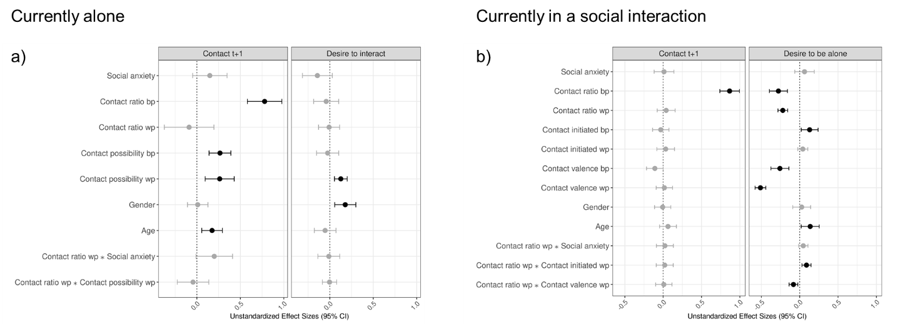

Note. Social anxiety was measured using the short form of the Social Interaction Anxiety Scale (Peters et al., 2012). Participants answered 6 items on a 1-5 scale.

Peters, L., Sunderland, M., Andrews, G., Rapee, R. M., & Mattick, R. P. (2012). Development of a short form Social Interaction Anxiety (SIAS) and Social Phobia Scale (SPS) using nonparametric item response theory: The SIAS-6 and the SPS-6. Psychological assessment, 24(1), 66-76.

Figure S4

Study 1: Multilevel Regression Coefficients Predicting Future Contact and Current Social Desires as well as Interaction Effects Separately for Fridays and Saturdays.
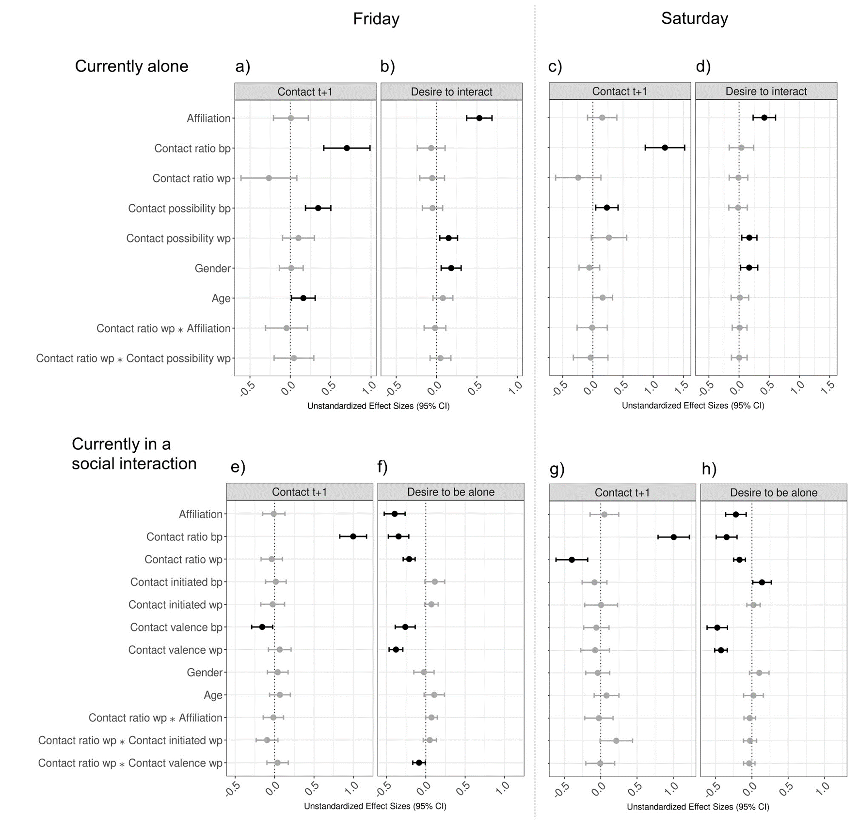
Note. Effects with CIs that included zero are displayed in grey. Positive effect sizes indicate a higher probability of being in in-person contact during the next measurement or a higher social desire. Sample sizes range from 841 observations from 246 participants to 1313 observations from 284 participants.
Figure S5

Study 2: Multilevel Regression Coefficients Predicting Future Contact and Current Social Desires as well as Interaction Effects Separately for Weekdays and Weekends.
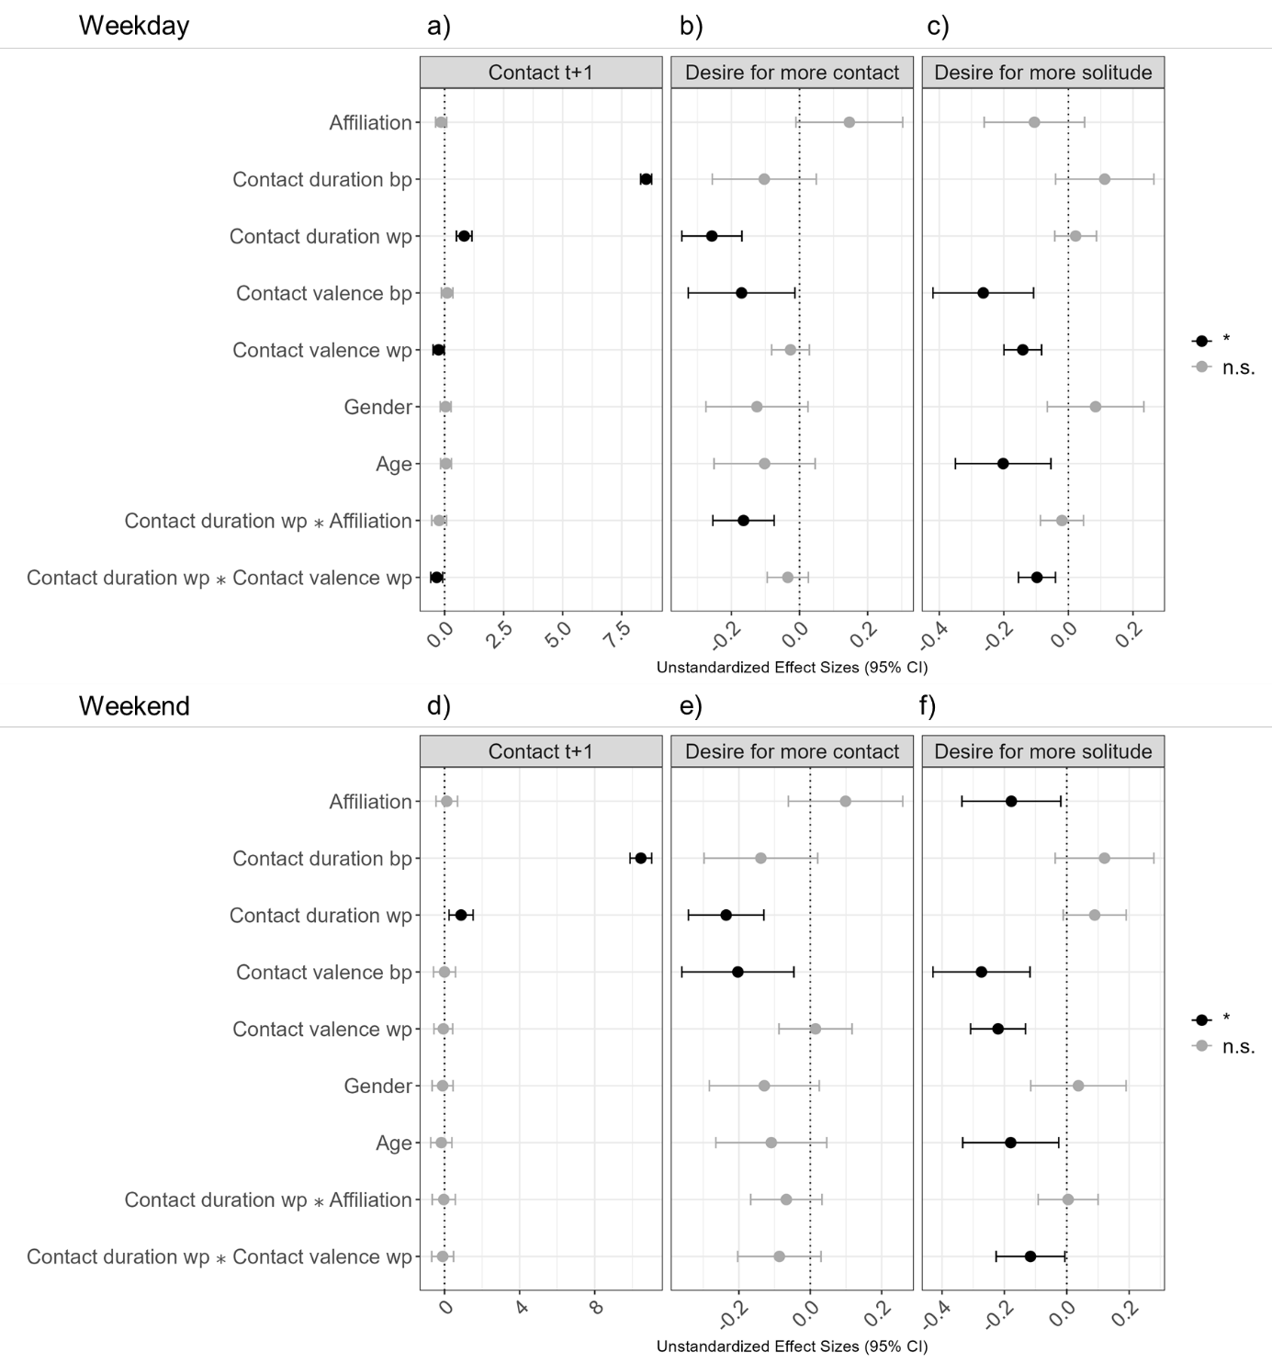
Note. Effects with CIs that included zero are displayed in grey. Positive effect sizes indicate a higher probability of being in in-person contact during the next measurement or a higher social desire. The data were split as follows: For panel a) the data was filtered to 938 observations from 299 participants, including only Fridays and Saturdays. Accordingly, Contact t+1 always referred to a weekend day in panel a). For panel b) and c), the data were filtered to 1018 observations from 302 participants, only including Saturdays and Sundays. For panel d), data were filtered to 2361 observations from 308 participants, including all days but Fridays and Saturdays. For panel e) and f) data were filtered to 2563 observations from 310 participants, only including days from Monday to Friday.

